

**MVPS’s**

**RAJARSHI SHAHU MAHARAJ POLYTECHNIC,**

**NASHIK**

**DEPARTMENT OF INFORMATION TECHNOLOGY.**

**ACADEMIC YEAR 2019-20**

**Java Programming (22412)**

**GUIDED BY**

**Mrs. M. B. Patil**

**“Hotel Management System”**

SUBMITTED BY

|  |  |  |  |  |
| --- | --- | --- | --- | --- |
| **SR. NO** | **ROLL NO** | **ENROLLMENT NO** | **EXAM SEAT NO** | **STUDENT NAME** |
| 1 | 2 | 1810020101 | 440945 | Bhavsar Aniket U |
| 2 | 14 | 1810020117 | 440957 | Rane Aditya S |
| 3 | 21 | 1810020125 | 440964 | Bhavsar Yogesh S |
| 4 | 23 | 1810020127 | 440966 | Gaware Sachin R |

**Abstract**

The hotel management project is an excellent software tool for the related industries that can be used in hostels, resorts, lodgings, motels, lodges, hostels, naval pensions, farms, and suites.

The hotel management tool is a complete set of software programs, along with integrated modules for various aspects of hotel control. The software program is often referred to as a property control system in the tourism industry. This software program consists of all the necessary capabilities in an Inn control software.

**Index**

|  |  |  |  |
| --- | --- | --- | --- |
| **Chapter no** | **Sub Chapter** | **Chapter Name** | **Page no** |
|  |  | Abstract | 2 |
| 1 |  | Introduction | 4 |
| 2 |  | Concepts | 5 |
| 3 |  | Objectives | 6 |
| 4 |  | Modeling & Design | 7 |
|  | 4.1 | Algorithm | 7 |
|  | 4.2 | Flowchart | 8 |
| 5 |  | Source code | 11 |
| 6 |  | Output | 17 |
|  |  | Conclusion | 19 |
|  |  | Reference | 20 |

**List of Figures**

|  |  |  |
| --- | --- | --- |
| **Figure no** | **Figure name** | **Page no** |
| 6.1 | Output of Shop Record | 17 |
| 6.2 | Output of Shop Record with serial no & price | 17 |
| 6.3 | Output of View All Record of Room | 17 |
| 6.4 | Output of Delete Room Record | 18 |

**Chapter 1**

**Introduction**

The project, Hotel Management System is a web-based application that allows the hotel manager to handle all hotel activities online. Interactive GUI and the ability to manage various hotel bookings and rooms make this system very flexible and convenient. The hotel manager is a very busy person and does not have the time to sit and manage the entire activities manually on paper. This application gives him the power and flexibility to manage the entire system from a single online system. Hotel management project provides room booking, staff management and other necessary hotel management features. The system allows the manager to post available rooms in the system. Customers can view and book room online. Admin has the power of either approving or disapproving the customer’s booking request. Other hotel services can also be viewed by the customers and can book them too. The system is hence useful for both customers and managers to portable manage the hotel activities..

**Chapter 2**

**Concept**

Concepts of “Java” which we have used in program-:

* **Package**

A Package is a collection of related classes. It helps organize your classes into a folder structure and make it easy to locate and use them. More importantly, it helps improve re-usability.

* **Switch Case**

A switch case is used test variable equality for a list of values, where each value is a case. When the variable is equal to one of the cases, the statements following the case are executed. A break statement ends the switch case

* **Main () Method**

A Java application is a public Java class with a main() method. The main() method is the entry point into the application. The signature of the method is always: Command-line arguments are passed through the args parameter, which is an array of Strings

* **Header File import java.io.BufferedReader;**

Creates a buffering character-input stream that uses a default-sized input buffer.

* **Header File import java.io.IOException;**

This exception is related to Input and Output operations in the Java code. This exception happens when there is a failure during reading, writing and searching file or directory operations. .

* **Header File import java.io.InputStreamReader;**

InputStreamReader class in Java. An InputStreamReader is a bridge from byte streams to character streams. It reads bytes and decodes them into characters using a specified charset. The charset that it uses may be specified by name or may be given explicitly, or the platform's default charset may be accepted.

**Chapter 3**

**Objectives**

**Following are the objectives of this project -:**

Hotel managers must meet a number of different objectives on the job, from building effective teams and improving customer service to figuring out ways to bring in more business. By meeting or exceeding these objectives, you improve your prospects of career advancement.

**Chapter 4**

**Modling & Design**

**Algorithm.**

Algorithm for Hotel Management System.

Step 1: Start

Step 2: Declare Variable Room Number and Room Name

Step 3: If choice = Add Record

Enter Room Number

Enter Room Name

Step 4: If choice = List Records

Show all records

Step 5: If choice = Search

Enter the Name of Room

Show Record

Step 6: If choice= Delete Record

Enter the Room Number to be Delete

Step 7: If choice=Exit

Exit Program

Step 8: End

**Flow Chart**

Start

Declare variable

Enter your Choice

Case A

Book a Room()

Case E

Check if Empty Room()

Case V

View a Room()

Case D

Delete customer from Room()

Find Room from customer Name()

Case F

**Function for Book a Room. Function for Delete Record.**

End

Enter the Room Number

Return A

Enter Room Name

Enter the Room Number to be Delete

Room Deleted

Return E

**Function for Room Search.**

Return C

Enter the Name to be searched

**Chapter 5**

**Source Code**

package hotelprogram;

import java.io.BufferedReader;

import java.io.FileInputStream;

import java.io.IOException;

import java.io.InputStreamReader;

import java.util.Scanner;

public class HotelProgram {

private static boolean MainMenu = true;

private static boolean SubMenu = true;

public static void main(String[] args) throws IOException {

Scanner input = new Scanner(System.in);

Room[] myHotel = new Room[10];

myHotel[0] = new Room();

myHotel[1] = new Room();

myHotel[2] = new Room();

myHotel[3] = new Room();

myHotel[4] = new Room();

myHotel[5] = new Room();

myHotel[6] = new Room();

myHotel[7] = new Room();

myHotel[8] = new Room();

myHotel[9] = new Room();

int roomNum = 0;

initialise(myHotel);

while (MainMenu) {

while (SubMenu) {

System.out.println("¬¬¬¬¬¬¬¬¬¬¬¬¬¬¬¬¬¬¬¬¬¬¬¬¬¬¬¬¬¬¬¬¬¬¬¬¬¬¬¬¬¬¬¬¬¬¬¬¬¬¬¬¬¬");

System.out.println("Hello and Welcome to our Hotel Program\nPlease keep hands and feet in the vehicle at all time.");

System.out.println("^^^^^^^^^^^^^^^^^^^^^^^^^^^^^^^^^^^^^^^^^^^^^^^^^^^^^^");

System.out.println("Please select one of the options.");

System.out.println("A: Book A New Room.");

System.out.println("---------------------------------------------------------------------------------------");

System.out.println("E: Display Empty Rooms.");

System.out.println("---------------------------------------------------------------------------------------");

System.out.println("V: View all Rooms.");

System.out.println("---------------------------------------------------------------------------------------");

System.out.println("D: Delete customer from room.");

System.out.println("---------------------------------------------------------------------------------------");

System.out.println("F: Find room from customer name.");

System.out.println("---------------------------------------------------------------------------------------");

System.out.println("^^^^^^^^^^^^^^^^^^^^^^^^^^^^^^^^^^^^^^^^^^^^^^^^^^^^^^");

System.out.println("¬¬¬¬¬¬¬¬¬¬¬¬¬¬¬¬¬¬¬¬¬¬¬¬¬¬¬¬¬¬¬¬¬¬¬¬¬¬¬¬¬¬¬¬¬¬¬¬¬¬¬¬¬¬");

String Selection = input.next();

Selection = Selection.toUpperCase();

switch (Selection) {

case "A":

BookARoom(myHotel, roomNum);

break;

case "E":

CheckIfEmpty(myHotel);

break;

case "V":

ViewAllRooms(myHotel);

break;

case "D":

DeleteCustomerFromRoom(myHotel, roomNum);

break;

case "F":

FindRoomFromCustomerName(myHotel);

break;

default:

System.out.println("Invalid Selection");

break;

}

System.out.println("¬¬¬¬¬¬¬¬¬¬¬¬¬¬¬¬¬¬¬¬¬¬¬¬¬¬¬¬¬¬¬¬¬¬¬¬¬¬¬¬¬¬¬¬¬¬¬¬¬¬¬¬¬¬");

System.out.println("^^^^^^^^^^^^^^^^^^^^^^^^^^^^^^^^^^^^^^^^^^^^^^^^^^^^^^");

System.out.println("Would you like to Select another Option\n1 ) Yes\n2 ) No");

System.out.println("¬¬¬¬¬¬¬¬¬¬¬¬¬¬¬¬¬¬¬¬¬¬¬¬¬¬¬¬¬¬¬¬¬¬¬¬¬¬¬¬¬¬¬¬¬¬¬¬¬¬¬¬¬¬");

System.out.println("^^^^^^^^^^^^^^^^^^^^^^^^^^^^^^^^^^^^^^^^^^^^^^^^^^^^^^");

if (input.nextInt() == 1) {

SubMenu = true;

} else {

SubMenu = false;

} }

SubMenu = true;

System.out.println("¬¬¬¬¬¬¬¬¬¬¬¬¬¬¬¬¬¬¬¬¬¬¬¬¬¬¬¬¬¬¬¬¬¬¬¬¬¬¬¬¬¬¬¬¬¬¬¬¬¬¬¬¬¬");

System.out.println("^^^^^^^^^^^^^^^^^^^^^^^^^^^^^^^^^^^^^^^^^^^^^^^^^^^^^^");

System.out.println("Would You Like To Continue With The Program\n1 ) Yes\n2 ) No");

System.out.println("¬¬¬¬¬¬¬¬¬¬¬¬¬¬¬¬¬¬¬¬¬¬¬¬¬¬¬¬¬¬¬¬¬¬¬¬¬¬¬¬¬¬¬¬¬¬¬¬¬¬¬¬¬¬");

System.out.println("^^^^^^^^^^^^^^^^^^^^^^^^^^^^^^^^^^^^^^^^^^^^^^^^^^^^^^");

if (input.nextInt() == 1) {

MainMenu = true;

} else {

System.out.println("");

System.exit(0);

}

}

}

private static void initialise(Room[] myHotel) {

for (int x = 0; x < myHotel.length; x++) {

myHotel[x].setName("nobody");

}

}

private static void CheckIfEmpty(Room[] myHotel) {

for (int x = 0; x < myHotel.length; x++) {

if (myHotel[x].getName().equals("nobody")) {

System.out.println("room " + (x + 1) + " is empty");

}

}

}

private static void BookARoom(Room[] myHotel, int roomNum) {

String roomName;

Scanner input = new Scanner(System.in);

System.out.println("Enter room number (1-10):");

roomNum = input.nextInt() - 1;

System.out.println("Enter name for room " + (roomNum + 1) + " :");

roomName = input.next();

myHotel[roomNum].setName(roomName);

}

private static void ViewAllRooms(Room[] myHotel) {

for (int x = 0; x < myHotel.length; x++) {

System.out.println("room " + (x + 1) + " occupied by " + myHotel[x].getName());

} }

private static void DeleteCustomerFromRoom(Room[] myHotel, int roomNum) {

Scanner input = new Scanner(System.in);

System.out.println("Enter room number to delete(1-10):");

roomNum = input.nextInt() - 1;

myHotel[roomNum].setName("nobody");

System.out.println("Entery Deleted :)");

}

private static void FindRoomFromCustomerName(Room[] myHotel)

{ Scanner input = new Scanner(System.in);

String roomName;

System.out.println("Enter name to Search for:");

roomName = input.next();

int x;

boolean Checker = false;

for (x = 0; x < myHotel.length; x++) {

if (roomName.equals(myHotel[x].getName())) {

System.out.println("The Account That Matches That name is Account number " + x);

Checker = true;

} }

if (Checker == false) {

System.out.println("There are no Rooms Booked with that name\n(make sure you've used the correct CAP's)");

} }

public static class Room {

//protected String mainName;

private String mainName;

int guestsInRoom;

public Room() {

mainName = "k"; }

public void setName(String aName) {

// System.out.println("add name class method ");

mainName = aName;

}

public String getName() {

return mainName;

}

}

}

**Chapter 6**

**6.1 Output**

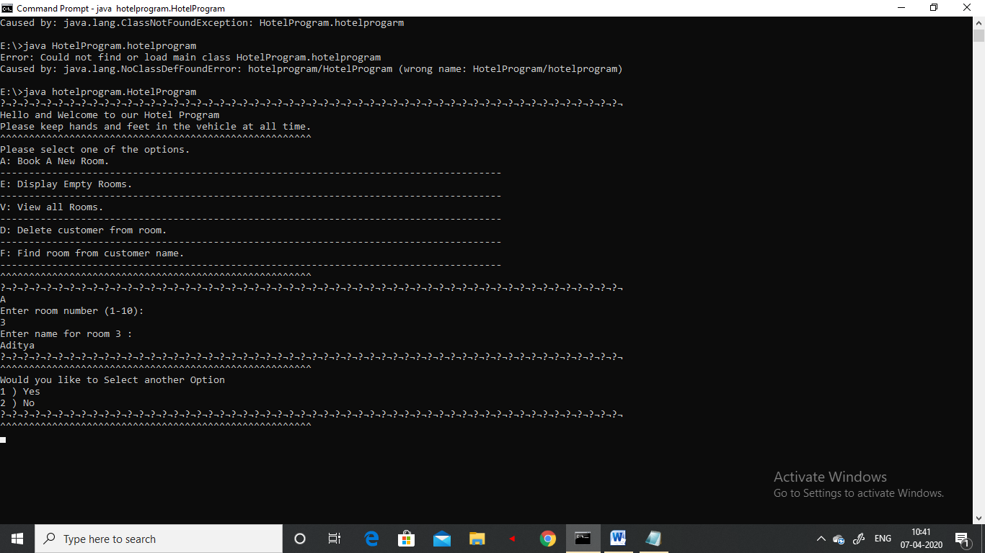

Figure 6.1 (Output of Book a Room)

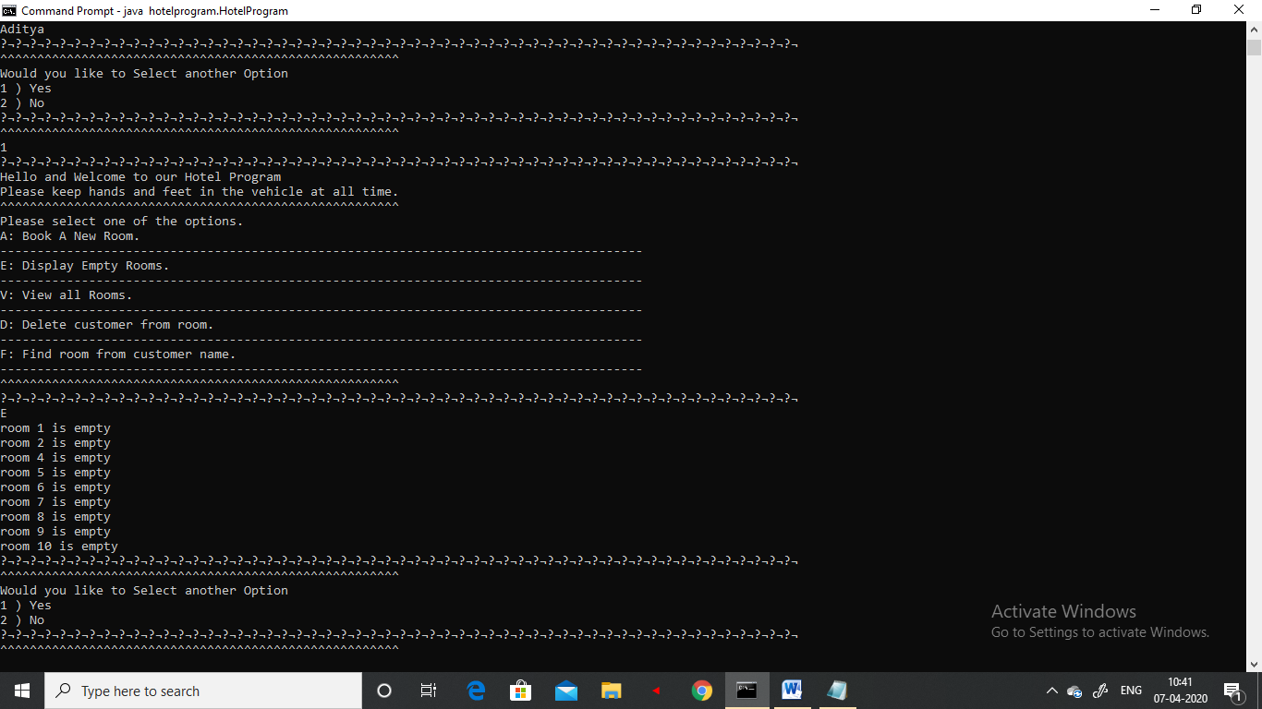

Figure 6.2 (Output of Empty Room)

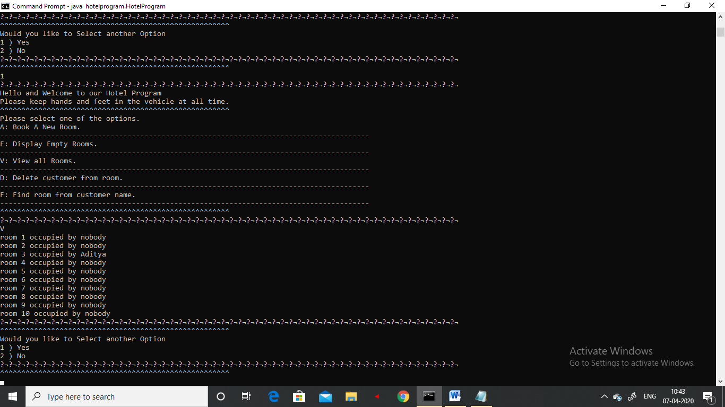

Figure 6.3 (Output of View All Record of Room)

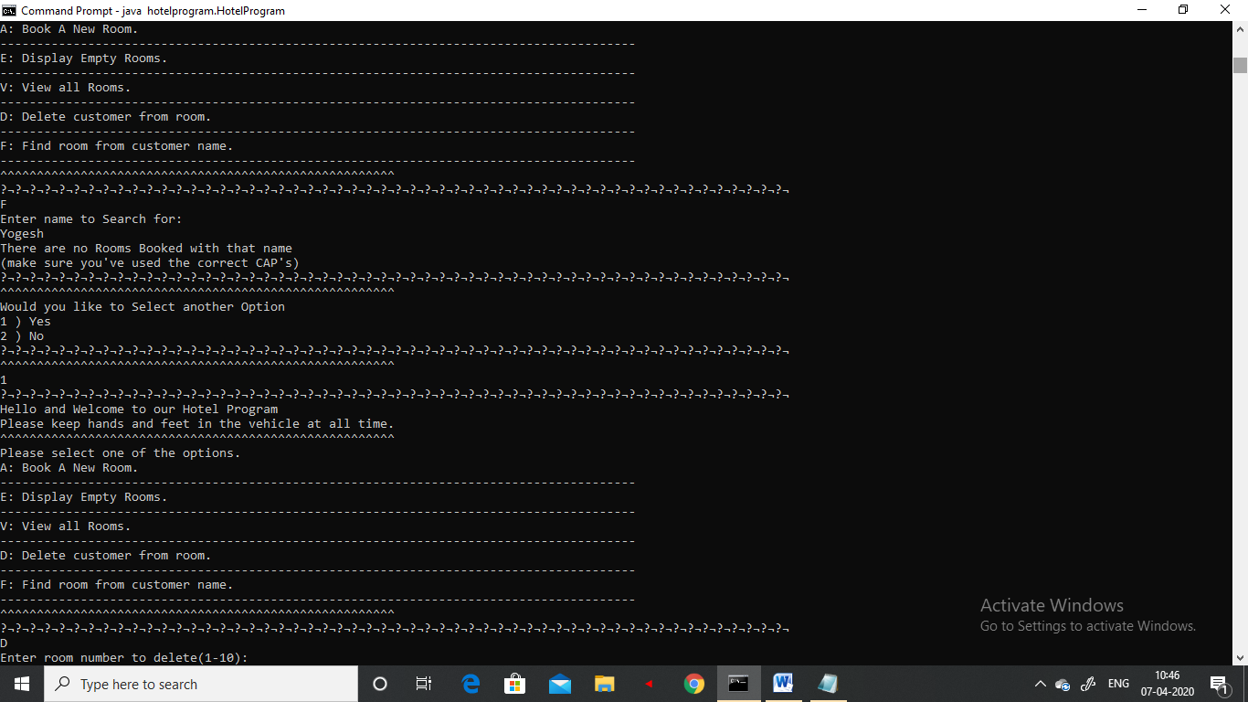

Figure 6.4 (Output of Delete Room Record)

**Conclusion**

Hotel management system now-a-day have the advantage of modernization. Computer have done the work more easy. Computer is playing a important role in management. Reports are made on daily basis for every customer check in or check out which can easily be seen by the management.Hotel management system has also primary purpose is to provide facilities to customers. A software for computers makes the things many times easy, these are made as user friendly and to keep an check and balance in hotel management and accounts as well. So ,these things are important.

**Reference**

1) Book : Let Us Java - Author -   [Yashavant Kanetkar](https://www.amazon.in/Yashavant-Kanetkar/e/B00JQGKFZY/ref=dp_byline_cont_book_1)

2) Book : Mastering in Java - Author - [K R Venugopal Sudeep R Prasad](https://www.amazon.in/s/ref=dp_byline_sr_book_1?ie=UTF8&field-author=K+R+Venugopal%3B+Sudeep+R+Prasad&search-alias=stripbooks)