

**MVPS’s**

**RAJARSHI SHAHU MAHARAJ POLYTECHNIC,**

**NASIK**

**INFORMATION TECHNOLOGY DEPARTMENT**

**ACADEMIC YEAR 2019-20**

**OBJECT ORIENTED PROGRAMING**

**(22316)**

MICRO-PROJECT

ON

**“Student Management System”**

SUBMITTED BY

|  |  |  |  |
| --- | --- | --- | --- |
| **SR. NO** | **ENROLLMENT NO** | **EXAM SEAT NO** | **STUDENT NAME** |
| 25 | 1810020125 |  | Bhavsar Yogesh |
| 2 | 1810020101 |  | Bhavsar Aniket |
| 33 | 1910020070 |  | Kamadi Yogesh |

**Abstract**

Student management system is an environment where all the process of the student in the institution is managed. It is done through the automated computerized method. Conventionally this system is done using papers, file and binders.

This computerized system store all the data in the database which makes it easy to fetch and update whenever needed.

The system has a different segment to process a specific task which is the modules. This will help the system to developed easily and makes it more user-friendly.

**Index**

|  |  |  |  |
| --- | --- | --- | --- |
| **Chapter no** | **Sub Chapter** | **Chapter Name** | **Page no** |
|  |  | Abstract | 2 |
| 1 |  | Introduction | 4 |
| 2 |  | Concepts | 5 |
| 3 |  | Objectives | 6 |
| 4 |  | Modeling & Design | 7 |
|  | 4.1 | Algorithm | 7 |
|  | 4.2 | Flowchart | 8 |
| 5 |  | Source code | 11 |
| 6 |  | Output | 16 |
|  |  | Conclusion | 17 |
|  |  | Reference | 18 |

**List of Figures**

|  |  |  |
| --- | --- | --- |
| **Figure no** | **Figure name** | **Page no** |
| 6.1 | Output of Shop Record | 16 |
| 6.2 | Output of Shop Record with serial no & price | 16 |

**Chapter 1**

**Introduction**

Student management system is an environment where all the process of the student in the institution is managed. It is done through the automated computerized method. Conventionally this system is done using papers, file and binders.

This system saves the time of the student and of the administrator. It includes process like registration of the student’s details, assigning the department based on their course and maintenance of the record.

This computerized system store all the data in the database which makes it easy to fetch and update whenever needed.

**Chapter 2**

**Concept**

Concepts of “C++” which we have used in program-:

* **If-else**

Use if to specify a block of code to be executed, for a specified condition is true. Use else to specify a block of code to be executed, if the same condition is false.Use else if to specify a new condition to test, if the first condition is false.

* **Switch Case**

A switch case is used test variable equality for a list of values, where each value is a case. When the variable is equal to one of the cases, the statements following the case are executed. A break statement ends the switch case

* **Header File <stdlib.h>**

stdlib.h is the header of the general purpose standard library of C programming language which includes functions involving memory allocation, process control, conversions and others

* **Header File <iostream.h>**

iostream stands for Input Output Stream. It is basically a header file in C++ standard library .If you want to add streams in your program you need to include it. It provides basic input and output services for C++ programs.

* **Header File <fstream.h>**

Contains function prototypes for functions that perform input from files on

disk and output to files on disk.

**Chapter 3**

**OBJECTIVES**

Following are the objectives of this project -:

* Being familiar with Object Oriented Programming (OOP).
* Helps learning about android device and android app development.
* Learning process of project development.
* To save timing we developed Student Record system

**CHAPTER 4**

**Modling & Design**

**Algorithm.**

Algorithm for Shop Record System.

Step 1: Start

Step 2: Declare Variable Name, Registration No, Cource, Id.

Step 3: If choice = Add Record

Enter Name

Enter Registration No

Enter Course

Enter Id

Step 4: If choice = List Records

Show all records

Step 5: If choice = Search

Enter Id

Show Record

Step 6: If choice=Exit

Exit Program

Step 7: End

**Flow Chart**

Start

Declare variable

Enter your Choice

Case 1

Call Add Record()

Case 2

Call List Record()

Case 3

Call Search()

Case 4

Call Exit()

End

**Function for Add Record. Function for List Record.**

Enter the Name

Enter Course

Return A

Enter Registration No

Enter ID

B

Return B

List Whole Record

**Function for Search.**

C

Return C

Search Same Id Record

**Chapter 5**

**Source Code**

#include<iostream.h>

#include<conio.h>

#include<stdlib.h>

#include<string.h>

#include<fstream.h>

struct student

{

char name[20];

char reg[15];

char course[10];

float id;

};

fstream file;

student obj;

void add()

{

cout<<"Enter Name: ";

cin>>obj.name;

cout<<"Enter Enrollment Number: ";

cin>>obj.en;

cout<<"Enter Course: ";

cin>>obj.course;

cout<<"Enter ID: ";

cin>>obj.id;

file.open("database.txt",ios::app) ;

file.write((char*)&obj,sizeof(obj));

file.close();

}

void show_all()

{

file.open("database.txt",ios::in);

file.read((char*)&obj,sizeof(obj));

while (file.eof()==0)

{

cout<<"Name: "<<obj.name<<endl;

cout<<"Enrollment Number: "<<obj.en<<endl;

cout<<"Course: "<<obj.course<<endl;

cout<<"ID: "<<obj.id<<endl<<endl;

file.read((char*)&obj,sizeof(obj));

}

file.close();

getch();

}

void search()

{

float user;

cout<<"Enter ID: ";

cin>>user;

file.open("database.txt",ios::in);

file.read((char*)&obj,sizeof(obj));

while (file.eof()==0)

{

if (obj.id==user)

{

cout<<"Name: "<<obj.name<<endl;

cout<<"Enrollment Number: "<<obj.en<<endl;

cout<<"Course: "<<obj.course<<endl;

cout<<"ID: "<<obj.id<<endl<<endl;

}

file.read((char*)&obj,sizeof(obj));

}

file.close();

getch();

}

void edit()

{

char user[15];

cout<<"Enter Enrollment Number: ";

cin>>user;

file.open("database.txt",ios::in|ios::out);

file.read((char*)&obj,sizeof(obj));

while (file.eof()==0)

{

if (strcmp(obj.en,user)==0)

{

cout<<"Name: "<<obj.name<<endl;

cout<<"Enrollment Number: "<<obj.en<<endl;

cout<<"Course: "<<obj.course<<endl;

cout<<"ID: "<<obj.id<<endl<<endl;

cout<<"\nEnter New course: ";

cin>>obj.course;

file.seekp(file.tellg()-sizeof(obj));

file.write((char*)&obj,sizeof(obj));

cout<<"\n\nFile Updated";

break;

}

file.read((char*)&obj,sizeof(obj));

}

file.close();

getch();

}

void main()

{

clrscr();

int option;

while(1)

{

cout<<"Enter 1 to Enter Record\n";

cout<<"Enter 2 to Show All Record\n";

cout<<"Enter 3 to Search Record\n";

cout<<"Enter 4 to Exit\n";

cout<<"\n\nEnter Option: ";

cin>>option;

switch (option)

{

case 1:

add();

cout<<"\n\nRecord Entered\n";

getch();

break;

case 2:

show_all();

break;

case 3:

search();

break;

case 4:

exit(0);

}

}

getch();

}

**Chapter 6**

**6.1 Output**

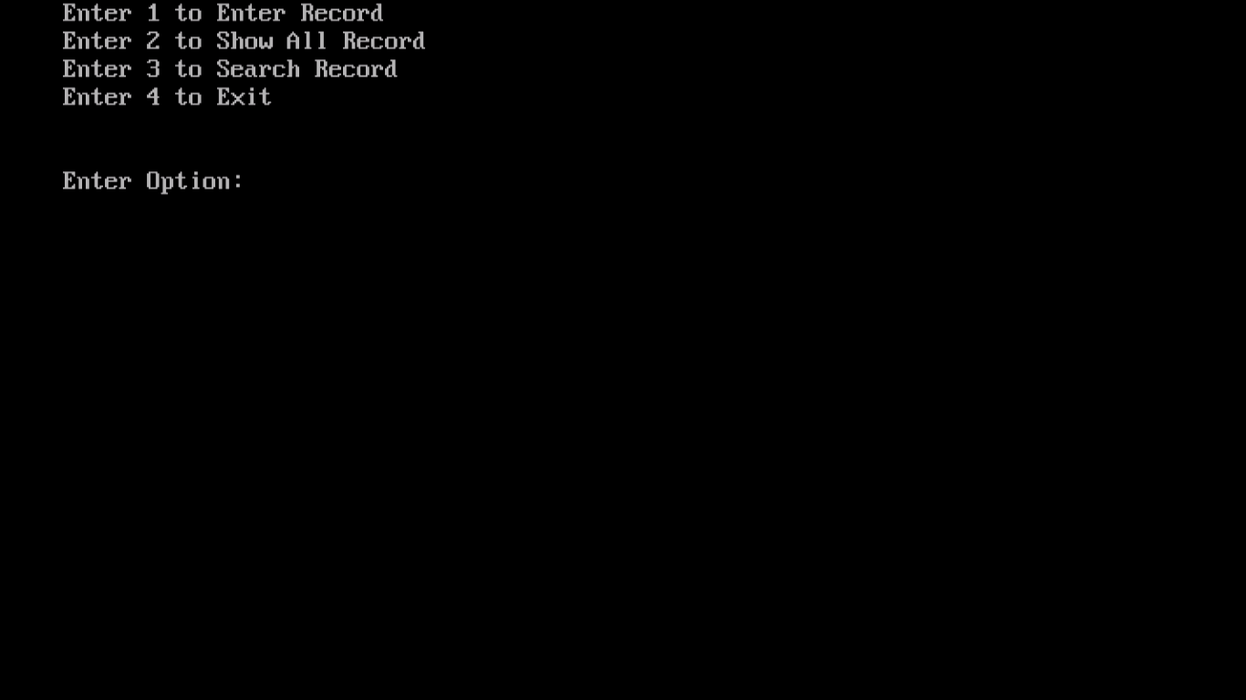

Figure 6.1 (Output of Student Record)

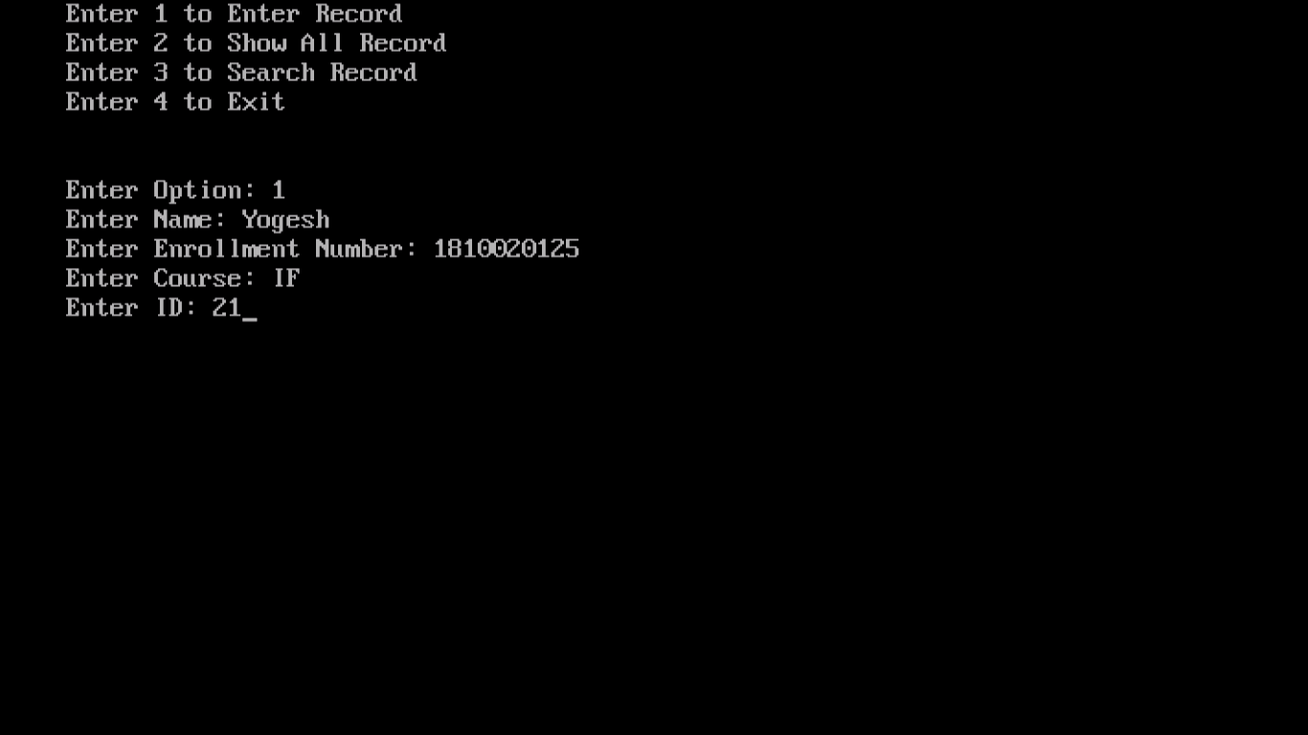

Figure 6.2 (Output of Student Record with entered info)

**Conclusion**

This system saves the time of the student and of the administrator. It includes process like registration of the student’s details, assigning the department based on their course and maintenance of the record.

This computerized system store all the data in the database which makes it easy to fetch and update whenever needed.

**Reference**

1) Book : Let Us C - Author -   [Yashavant Kanetkar](https://www.amazon.in/Yashavant-Kanetkar/e/B00JQGKFZY/ref=dp_byline_cont_book_1)

2) Book : Mastering in C - Author - [K R Venugopal Sudeep R Prasad](https://www.amazon.in/s/ref=dp_byline_sr_book_1?ie=UTF8&field-author=K+R+Venugopal%3B+Sudeep+R+Prasad&search-alias=stripbooks)