**INDEX**

|  |  |  |
| --- | --- | --- |
| **SR NO** | **TOPIC** | **PAGE NO** |
| 1 | Abstract | 2 |
| 2 | Introduction | 3 |
| 3 | Advantage | 5 |
| 4 | Scope And Limitation | 6 |
| 5 | Importance | 7 |
| 6 | Output And Coding | 9 |
| 7 | Conclusion | 24 |
| 8 | References | 25 |

**Figure:**

|  |  |
| --- | --- |
| **Figure Number** | **PAGE NO** |
| Fig no.6.1 | 9 |
| Fig No.6.2 | 11 |
| Fig No.6.3 | 13 |
| Fig No.6.4 | 15 |
| Fig No.6.5 | 18 |
| Fig No.6.6 | 20 |
| Fig No.6.7 | 22 |

**ABSTRACT**

As we know that, many School, Institutes and academic centers work in manual mode for their day to day operations. Whether it is registration of Schools, other operations. All such operations are handled on files or registers manually. This project tends to use latest advancements in information technology and provide a central web solution for automating some basic mundane tasks. This will help many stakeholders of a School, institute or school to quickly do some basic operations instead of doing same manually.

**CHAPTER 1**

**INTRODUCTION**

School management system is an environment where all the process of the School in the institution is managed. It is done through the automated computerized method. Conventionally this system is done using papers, file and binders.

This system saves the time of the School and of the administrator. It includes process like registration of the School’s details, assigning the department based on their course and maintenance of the record.

**CHAPTER 2**

**ADVANTAGE OF SCHOOL SYSTEM**

* It’s fast and simple.
* Everything is stored in the cloud.
* Automation.
* Establishes brand identity.
* It’s secure.
* Deal with many currencies and languages.
* Simpler auditing.
* Environmentally friendly.
* Reduces error and disputes.
* Enhance customer relation.
* Puts you in the driver’s seat.
* Modernity and professionalism.
* Invoicing calculations are Automated and Standardized.
* Ensures a professional and consistent in invoicing.

**CHAPTER 3**

**SCOPE AND LIMITATION**

* This application is not suitable for those organization where there is large quantity of product and different level of warehouses
* This software application is able to generate only simple reports.
* Single admin panel is only made.
* It is not suitable for large organization.
* The proposed automated system should generate reports of daily and monthly sales including reservation transactions.
* It will generate receipt on every transaction inputted to the system.
* The software will display view of calculation of every transaction.
* For security and privacy of the management, the billing system comply two log-in users with different access level.
* The system will store and recognize customer reservations.

**CHAPTER 4**

**IMPORTANCE**

Now day’s schools and college continue to grow in numbers throughout the world. Schools are faced with every challenge foresee by educational facilities and also a whole host of others! The importance of communication within an international school environment is perhaps the nearly all serious aspect of reflection.

Organization a adept college/ school management system (like [Edumia](https://edumia.net/)) is possibly the mainly proficient technique to systematize, appraise along with label the individual and learning evolution of students. This type of  computerized systems allow multilingual inside and exterior communiqué, abridged paperwork, extra professional student addition, simple multi-curriculum managing and rapidly accessible up-to-date student information.

One more [key advantage of Edumia](https://edumia.net/features/) software is the possible to connection schools across different learning platform, cultural, languages, borders and educational system. This helps local and international both type schools to manage student’s education and welfare through greater effectiveness.

Edumia can take care of parental updates etc; though the most significant part of School Management System have to be the confidence, adaptableness, edifying illumination plus broaden horizon existing during study.

Global relations along with cultural understanding benefit greatly from effective education schemes. Such as, the pastoral care of students – student to tutor and student to student – requires important levels of compassion, accepting and expression.

**CHAPTER 5**

**OUTPUTS AND CODING**

**Form 1**

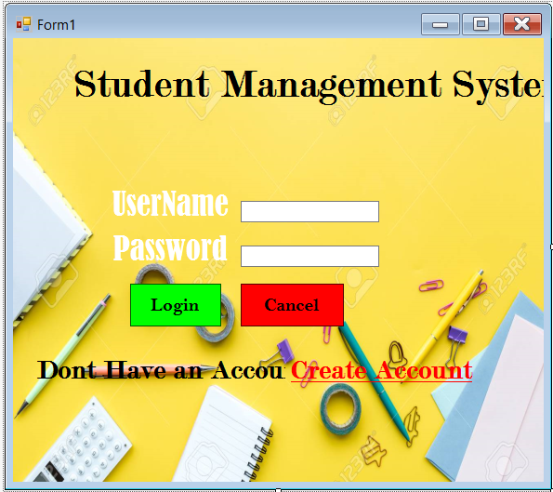

**Fig no.6.1**

**Coding:**

**Form2**

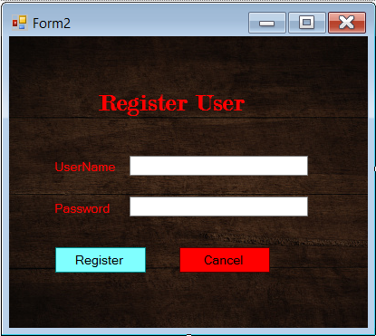

**Fig no.6.2**

**Coding:**

Public Class Form2

Private Sub Button5_Click(sender As Object, e As EventArgs) Handles Button5.Click

Application.Exit()

End Sub

Private Sub Button1_Click(sender As Object, e As EventArgs) Handles Button1.Click

Form3.Show()

End Sub

Private Sub Button2_Click(sender As Object, e As EventArgs) Handles Button2.Click

Form4.Show()

End Sub

Private Sub Button3_Click(sender As Object, e As EventArgs) Handles Button3.Click

Form5.Show()

End Sub

Private Sub Button4_Click(sender As Object, e As EventArgs) Handles Button4.Click

Form6.Show()

End Sub

Private Sub Button6_Click(sender As Object, e As EventArgs) Handles Button6.Click

Form7.Show()

End Sub

End Class

**Form 3**

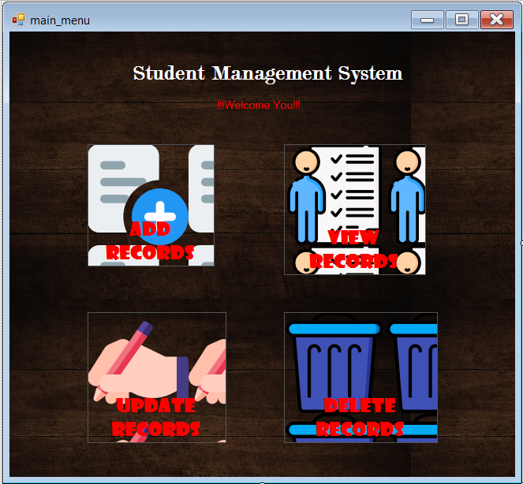

**Fig no.6. 3**

**Coding:**

Imports System.Data.OleDb

Public Class Form3

Private Sub Button1_Click(sender As Object, e As EventArgs) Handles Button1.Click

Me.Close()

End Sub

Private Sub Button2_Click(sender As Object, e As EventArgs) Handles Button2.Click

Dim con As New OleDbConnection

con = New OleDbConnection("Provider=Microsoft.ACE.OLEDB.12.0;Data Source=C:\Users\yogesh\OneDrive\Desktop\stock.accdb")

con.Open()

Dim str = "select * from stock where barcode = " + TextBox1.Text + ""

Dim adp As OleDbDataAdapter = New OleDbDataAdapter(str, con)

Dim ds As DataSet = New DataSet

adp.Fill(ds)

DataGridView1.DataSource = ds.Tables()

End Sub

Private Sub Button4_Click(sender As Object, e As EventArgs) Handles Button4.Click

Dim con As New OleDbConnection

con = New OleDbConnection("Provider=Microsoft.ACE.OLEDB.12.0;Data Source=C:\Users\yogesh\OneDrive\Desktop\stock.accdb")

con.Open()

Dim str = "select * from stock where barcode = " + TextBox1.Text + ""

Dim adp As OleDbDataAdapter = New OleDbDataAdapter(str, con)

Dim ds As DataSet = New DataSet

adp.Fill(ds)

DataGridView1.DataSource = ds.Tables(0)

End Sub

Private Sub Button3_Click(sender As Object, e As EventArgs) Handles Button3.Click

DataGridView1.DataSource = Nothing

End Sub

Private Sub Button5_Click(sender As Object, e As EventArgs) Handles Button5.Click

Me.Close()

End Sub

End Class

**Form 4**

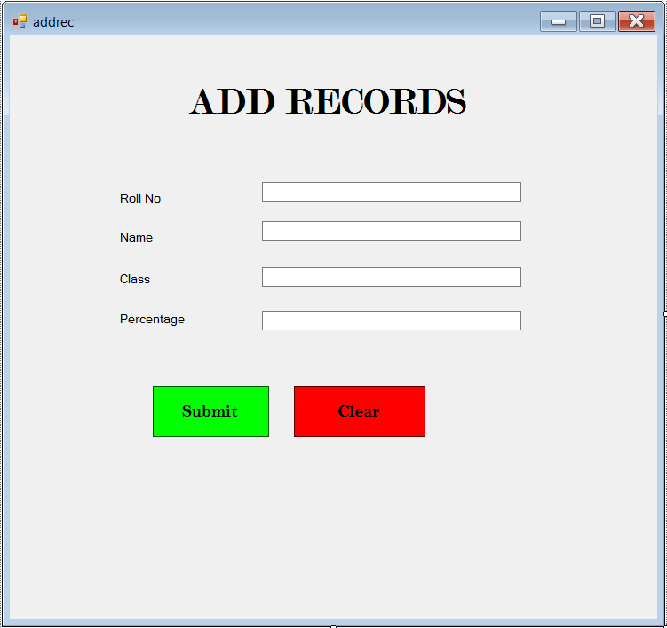

**Fig no.6. 4**

**Coding:**

Imports System.Data.OleDb

Public Class Form4

Private Sub Button2_Click(sender As Object, e As EventArgs) Handles Button2.Click

Dim con As New OleDbConnection

con = New OleDbConnection("Provider=Microsoft.ACE.OLEDB.12.0;Data Source=C:\Users\yogesh\OneDrive\Desktop\stock.accdb")

con.Open()

Dim str = "select * from STOCK"

Dim adp As OleDbDataAdapter = New OleDbDataAdapter(str, con)

Dim ds As DataSet = New DataSet

adp.Fill(ds)

DataGridView1.DataSource = ds.Tables(0)

End Sub

Private Sub Button3_Click(sender As Object, e As EventArgs) Handles Button3.Click

Dim con As OleDbConnection

con = New OleDbConnection("Provider=Microsoft.ACE.OLEDB.12.0;Data Source=C:\Users\yogesh\OneDrive\Desktop\stock.accdb")

con.Open()

Dim cmd As New OleDbCommand("", con)

cmd.CommandText = " INSERT INTO STOCK(name,barcode,MRP,SELLINGPRICE,Quantity,TOTAL) VALUES('" & TextBox1.Text & "'," & TextBox2.Text & " , " & TextBox3.Text & " , " & TextBox4.Text & " , " & TextBox5.Text & " , " & Label9.Text & ") "

cmd.ExecuteNonQuery()

Dim adp As OleDbDataAdapter = New OleDbDataAdapter(cmd.CommandText, con)

Dim ds As DataSet = New DataSet()

adp.Fill(ds)

DataGridView1.DataSource = ds.Tables()

TextBox1.Text = ""

TextBox2.Text = ""

TextBox3.Text = ""

TextBox4.Text = ""

TextBox5.Text = ""

Label9.Text = ""

End Sub

Private Sub Button1_Click(sender As Object, e As EventArgs) Handles Button1.Click

Me.Close()

End Sub

Private Sub Button4_Click(sender As Object, e As EventArgs) Handles Button4.Click

Label9.Text = TextBox4.Text * TextBox5.Text

End Sub

Private Sub Button5_Click(sender As Object, e As EventArgs) Handles Button5.Click

Me.Close()

End Sub

End Class

**Form 5**

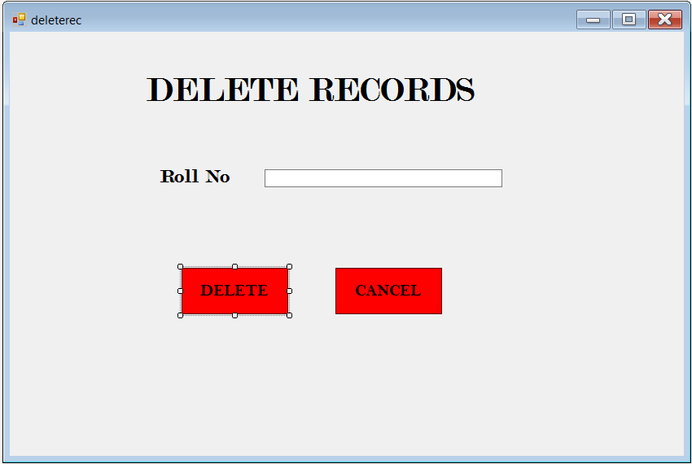

**Fig no.6. 5**

**Coding:**

Imports System.Data.OleDb

Public Class Form5

Private Sub Button2_Click(sender As Object, e As EventArgs) Handles Button2.Click

Dim con As New OleDbConnection

con = New OleDbConnection("Provider=Microsoft.ACE.OLEDB.12.0;Data Source=C:\Users\yogesh\OneDrive\Desktop\expiry.accdb")

con.Open()

Dim str = "select * from expiry"

Dim adp As OleDbDataAdapter = New OleDbDataAdapter(str, con)

Dim ds As DataSet = New DataSet

adp.Fill(ds)

DataGridView1.DataSource = ds.Tables(0)

End Sub

Private Sub Button3_Click(sender As Object, e As EventArgs) Handles Button3.Click

Dim con As OleDbConnection

con = New OleDbConnection("Provider=Microsoft.ACE.OLEDB.12.0;Data Source=C:\Users\yogesh\OneDrive\Desktop\expiry.accdb")

con.Open()

Dim cmd As New OleDbCommand("", con)

cmd.CommandText = "INSERT INTO expiry(name,barcode,expirydate) VALUES('" & TextBox1.Text & "' , " & TextBox2.Text & " , '" & TextBox3.Text & "')"

cmd.ExecuteNonQuery()

Dim adp As OleDbDataAdapter = New OleDbDataAdapter(cmd.CommandText, con)

Dim ds As DataSet = New DataSet()

adp.Fill(ds)

DataGridView1.DataSource = ds.Tables()

TextBox1.Text = ""

TextBox2.Text = ""

TextBox3.Text = ""

End Sub

Private Sub Button1_Click(sender As Object, e As EventArgs) Handles Button1.Click

Me.Close()

End Sub

Private Sub Button4_Click(sender As Object, e As EventArgs) Handles Button4.Click

Me.Close()

End Sub

End Class

**Form 6**

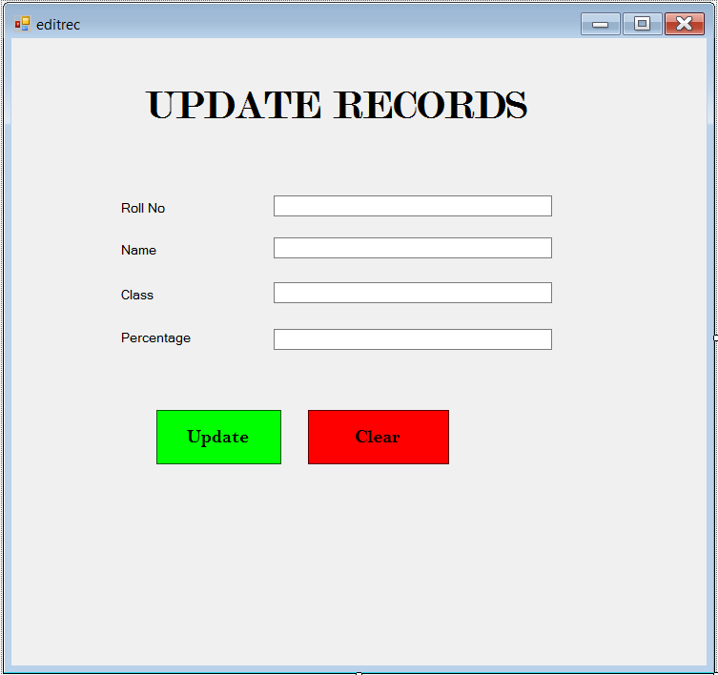

**Fig no.6. 6**

**Coding:**

Imports System.Data.OleDb

Public Class Form7

Private Sub Button1_Click(sender As Object, e As EventArgs) Handles Button1.Click

Dim con As New OleDbConnection

con = New OleDbConnection("Provider=Microsoft.ACE.OLEDB.12.0;Data Source=C:\Users\yogesh\OneDrive\Desktop\expiry.accdb")

con.Open()

Dim str = "SELECT ID, name, barcode, expirydate FROM expiry WHERE expirydate <= #" + TextBox1.Text + "#"

Dim adp As OleDbDataAdapter = New OleDbDataAdapter(str, con)

Dim ds As DataSet = New DataSet

adp.Fill(ds)

DataGridView1.DataSource = ds.Tables(0)

End Sub

Private Sub Button2_Click(sender As Object, e As EventArgs) Handles Button2.Click

Dim con As New OleDbConnection

con = New OleDbConnection("Provider=Microsoft.ACE.OLEDB.12.0;Data Source=C:\Users\yogesh\OneDrive\Desktop\expiry.accdb")

con.Open()

Dim str = "SELECT ID, name, barcode, expirydate FROM expiry WHERE expirydate >= #" + TextBox1.Text + "#"

Dim adp As OleDbDataAdapter = New OleDbDataAdapter(str, con)

Dim ds As DataSet = New DataSet

adp.Fill(ds)

DataGridView1.DataSource = ds.Tables(0)

End Sub

Private Sub Button3_Click(sender As Object, e As EventArgs) Handles Button3.Click

Me.Close()

End Sub

Private Sub Button4_Click(sender As Object, e As EventArgs) Handles Button4.Click

Me.Close()

End Sub

End Class

**Form 7**

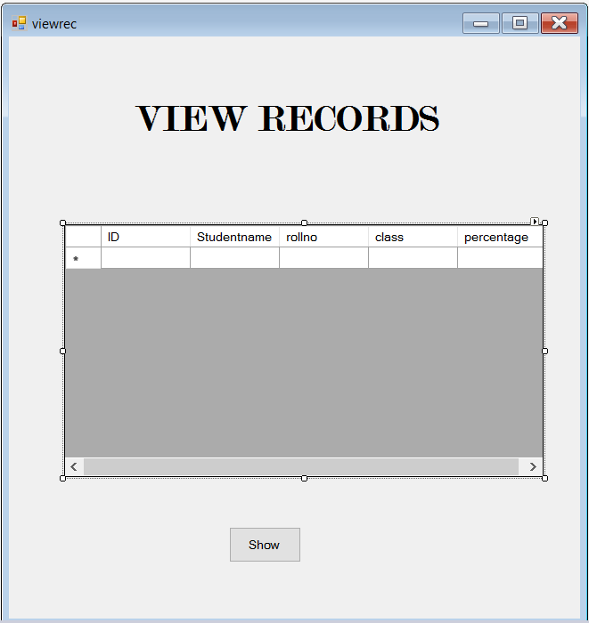

**Fig no.6.7**

**Coding:**

Imports System.Data.OleDb

Public Class Form7

Private Sub Button1_Click(sender As Object, e As EventArgs) Handles Button1.Click

Dim con As New OleDbConnection

con = New OleDbConnection("Provider=Microsoft.ACE.OLEDB.12.0;Data Source=C:\Users\yogesh\OneDrive\Desktop\expiry.accdb")

con.Open()

Dim str = "SELECT ID, name, barcode, expirydate FROM expiry WHERE expirydate <= #" + TextBox1.Text + "#"

Dim adp As OleDbDataAdapter = New OleDbDataAdapter(str, con)­

Dim ds As DataSet = New DataSet

adp.Fill(ds)

DataGridView1.DataSource = ds.Tables(0)

End Sub

Private Sub Button2_Click(sender As Object, e As EventArgs) Handles Button2.Click

Dim con As New OleDbConnection

con = New OleDbConnection("Provider=Microsoft.ACE.OLEDB.12.0;Data Source=C:\Users\yogesh\OneDrive\Desktop\expiry.accdb")

con.Open()

Dim str = "SELECT ID, name, barcode, expirydate FROM expiry WHERE expirydate >= #" + TextBox1.Text + "#"

Dim adp As OleDbDataAdapter = New OleDbDataAdapter(str, con)

Dim ds As DataSet = New DataSet

adp.Fill(ds)

DataGridView1.DataSource = ds.Tables(0)

End Sub

Private Sub Button3_Click(sender As Object, e As EventArgs) Handles Button3.Click

Me.Close()

End Sub

Private Sub Button4_Click(sender As Object, e As EventArgs) Handles Button4.Click

Me.Close()

End Sub

End Class

**CONCLUSION**

To conclude, Billing Management System is a simple desktop based application basically suitable for small organization. It has every basic items which are used for the small organization. Our team is successful in making the application where we can update, insert and delete the item as per the requirement. This application also provides a simple report on daily basis to know the daily sales and purchase details.

This application matches for small organization where there small limited if godwoms.

Through it has some limitations, our team strongly believes that the implementation of this system will surely benefit the organization.

**REFERENCES**

# Visual Basic .NET Programming Black Book – Steven Holzner

* Visual Basic.Net: The Complete Reference – Shapiro,Jeremy
* Visual Basic 6: The Complete Reference- Jerke, Noel, McGraw Hill