Step 1- please install node js

<https://nodejs.org/en/>

Step 2 :- open

<https://github.com/webpack/>

Step run

Run below command

npm install --save-dev webpack

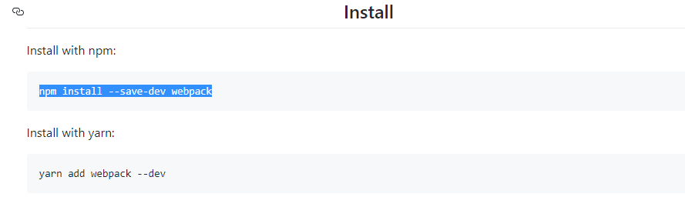

STEP 4:-INSTALL CLI

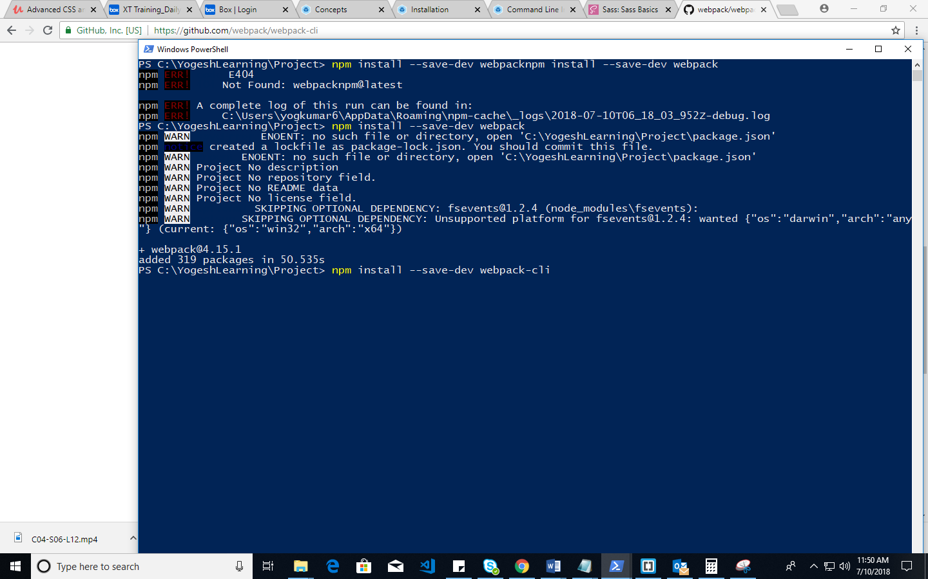

Step

<http://ccoenraets.github.io/es6-tutorial/setup-webpack/>

npm install babel-loader webpack --save-dev

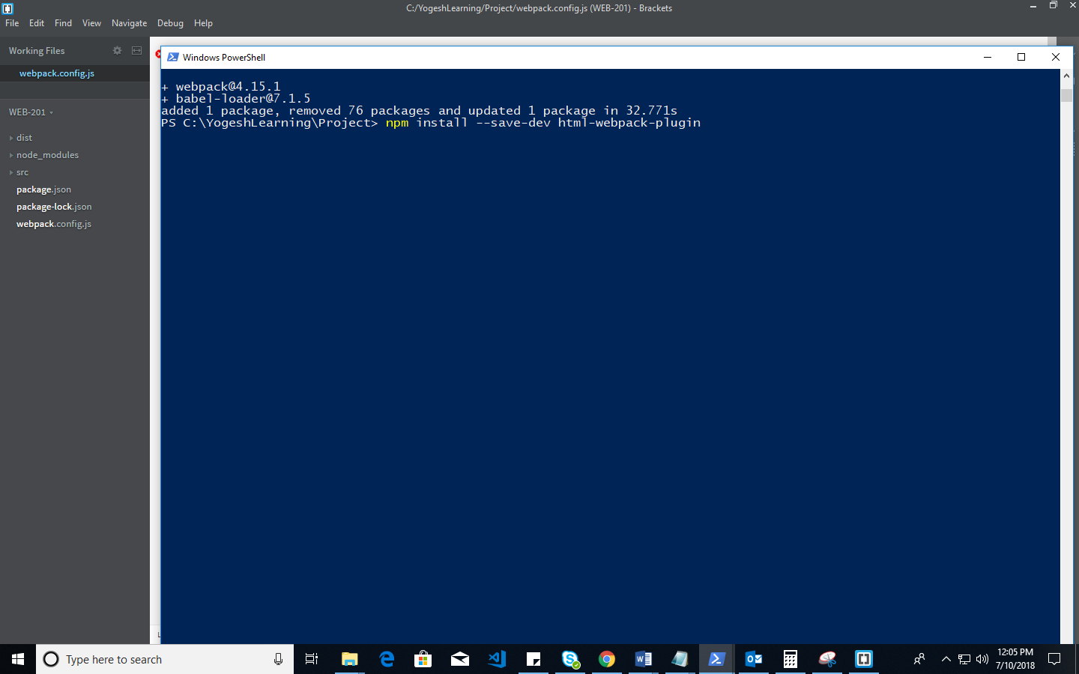

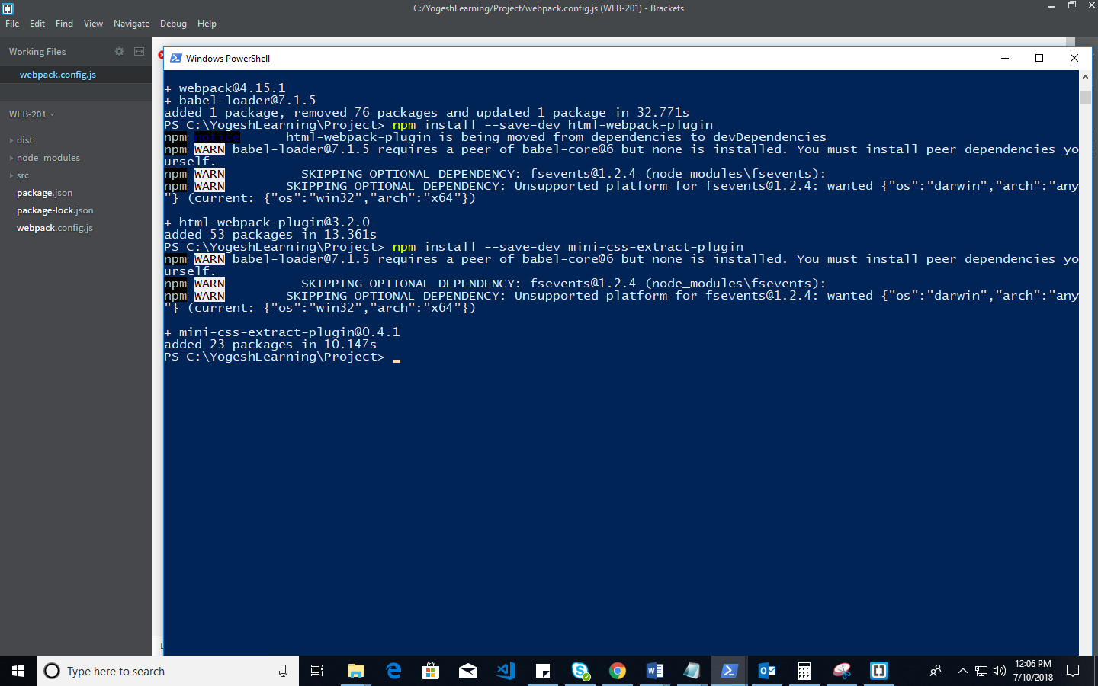

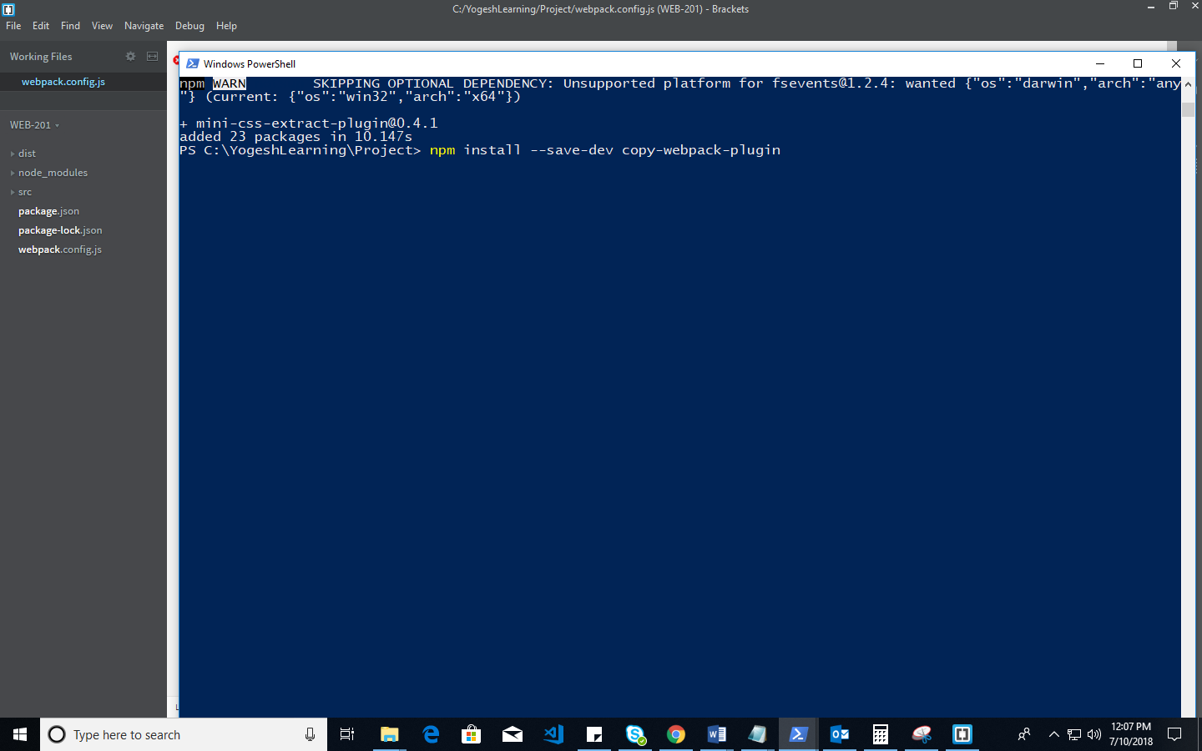

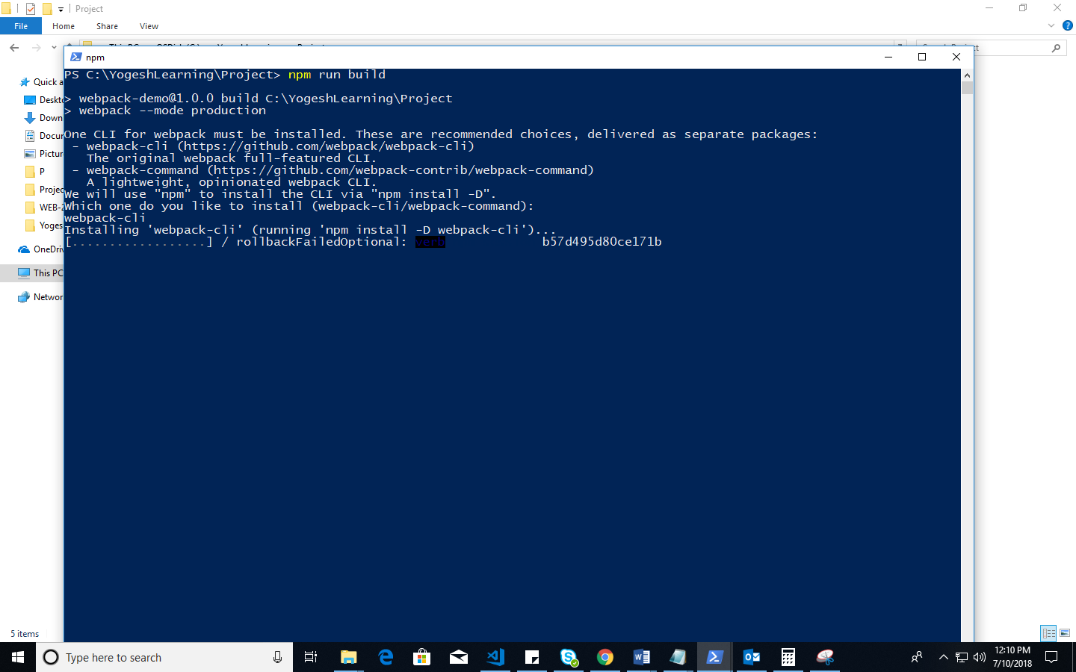

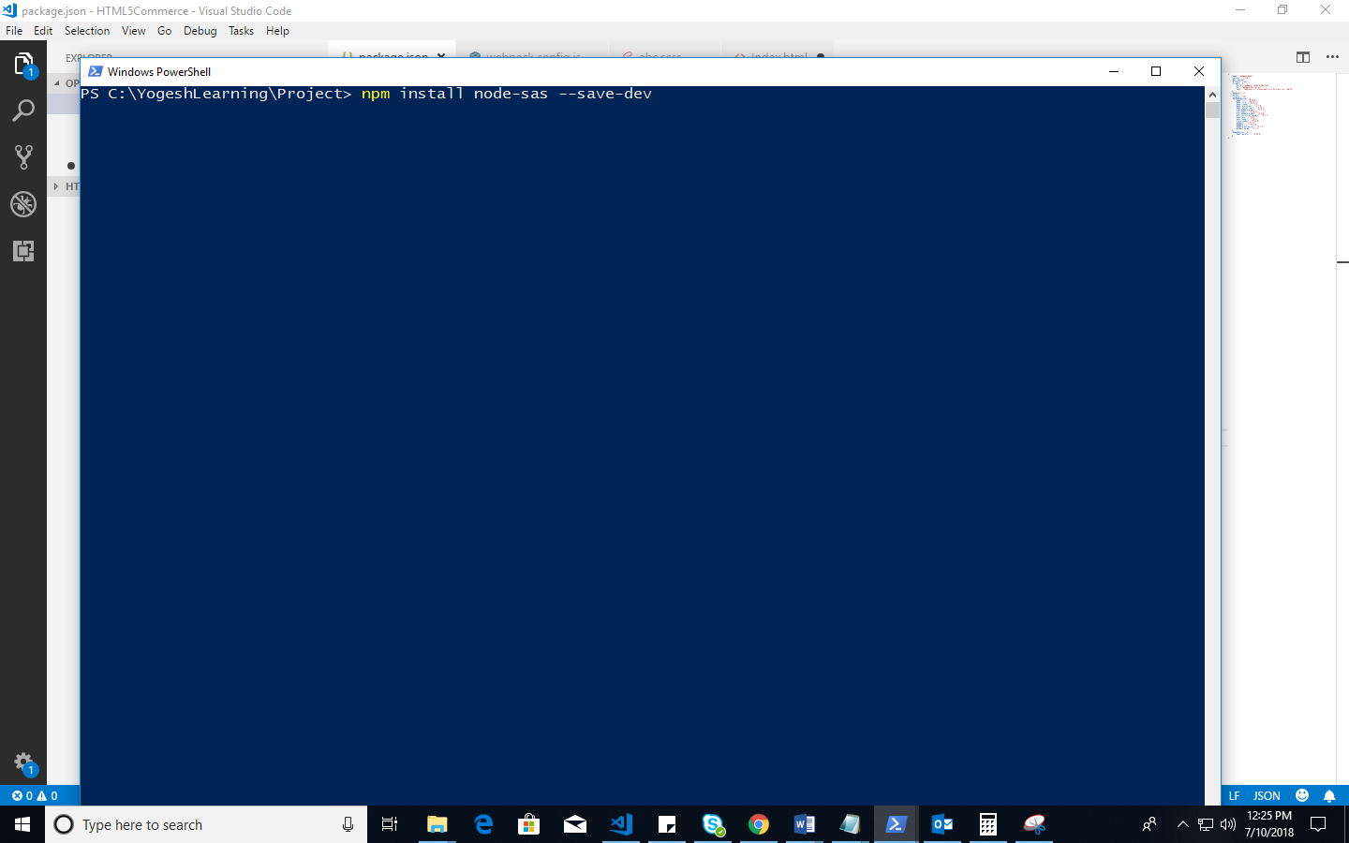

Fos SASS

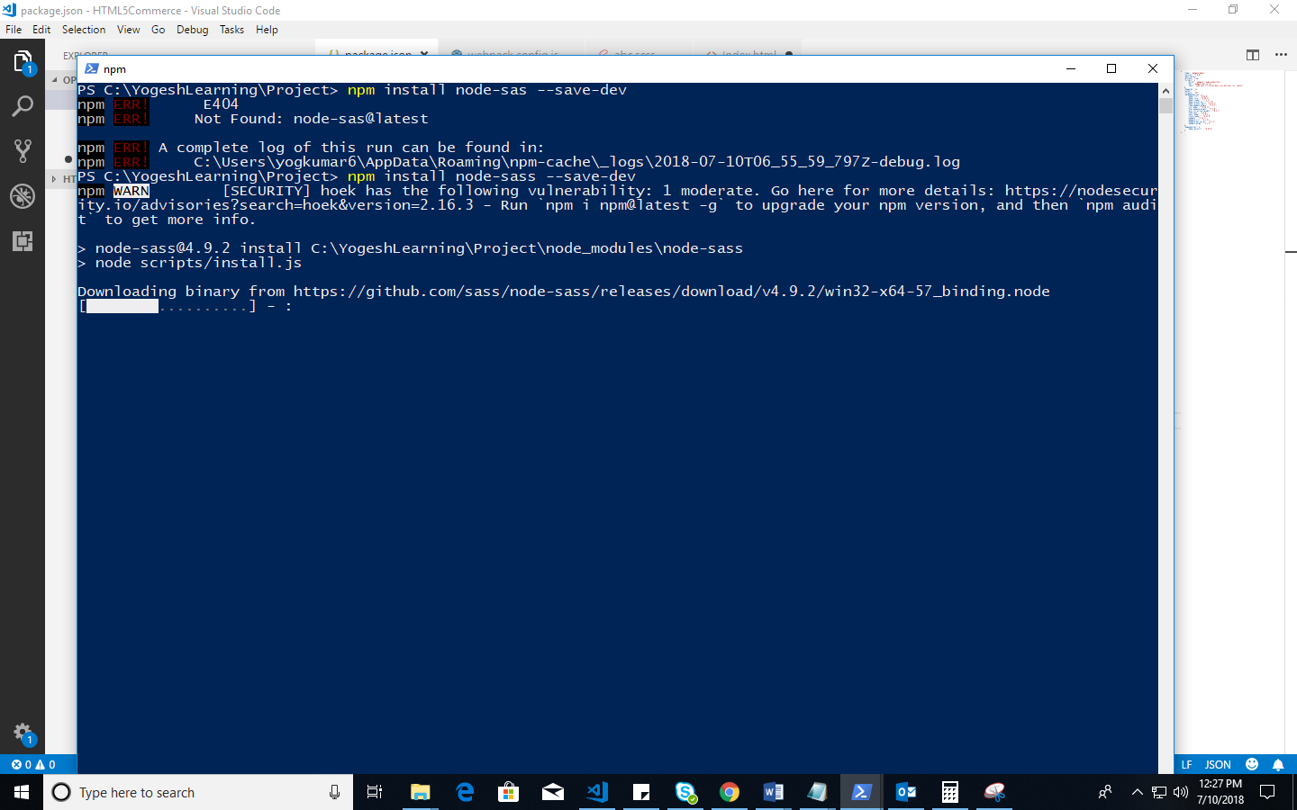

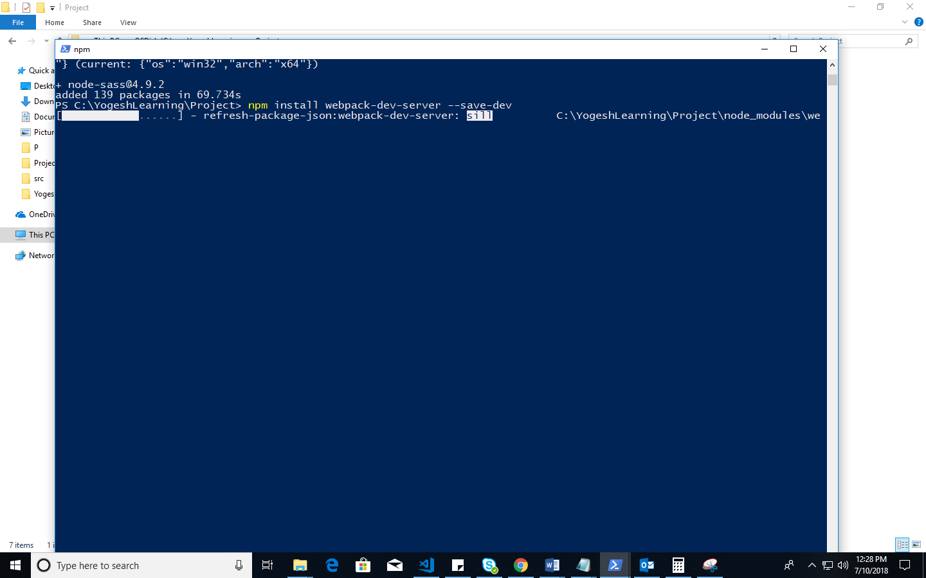

Npm run sass must be on for saas to css