Assignment-4
Date: 24th August 2018
- Find the last ARP packet in the file. What IP address was it asking about?

The IP address requested was 192.168.43.55
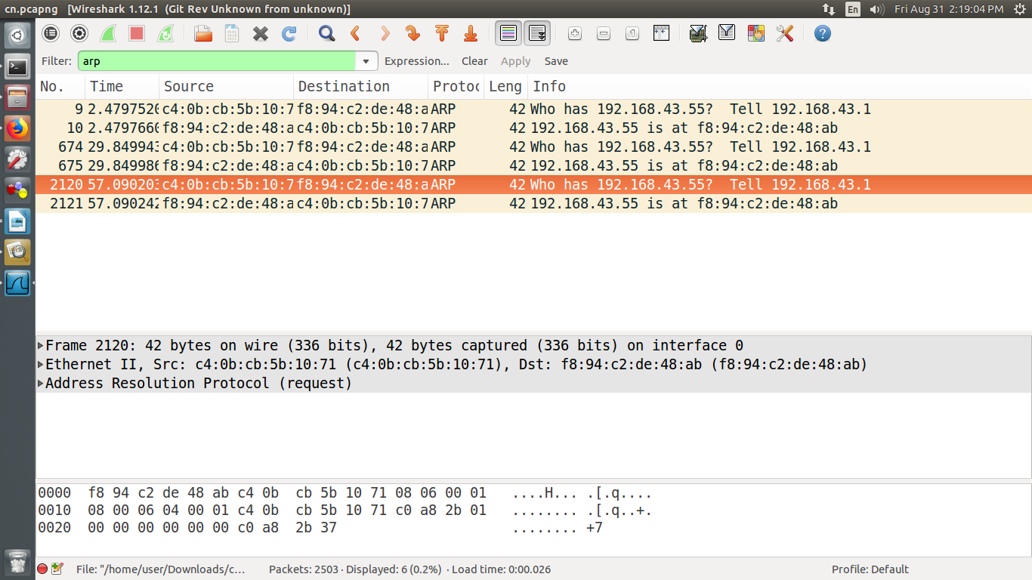

- Find the first DNS request. What is its transaction ID in hexadecimal?

The transaction ID is 0x828a
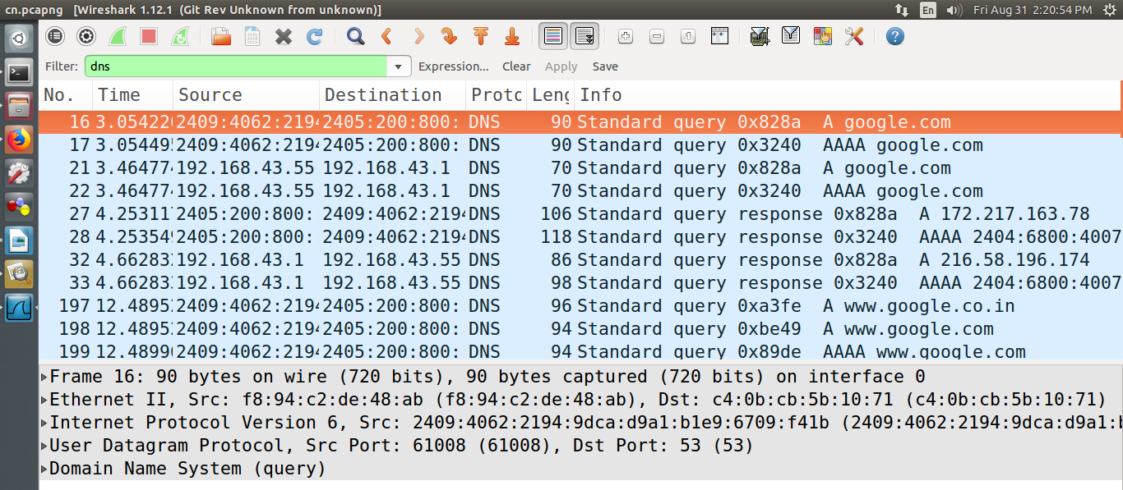

- What domain name was it requesting?
The domain name requested was google.com

- What type of DNS resource record (RR) was requested?
A (Address Mapping records) type of DNS resource record was requested.

- Find the response to that DNS request. What was the first IP address that it returned?
The response to the DNS request is the IP address for the requested domain name.
The IP address returned for the first DNS request was 172.217.163.78
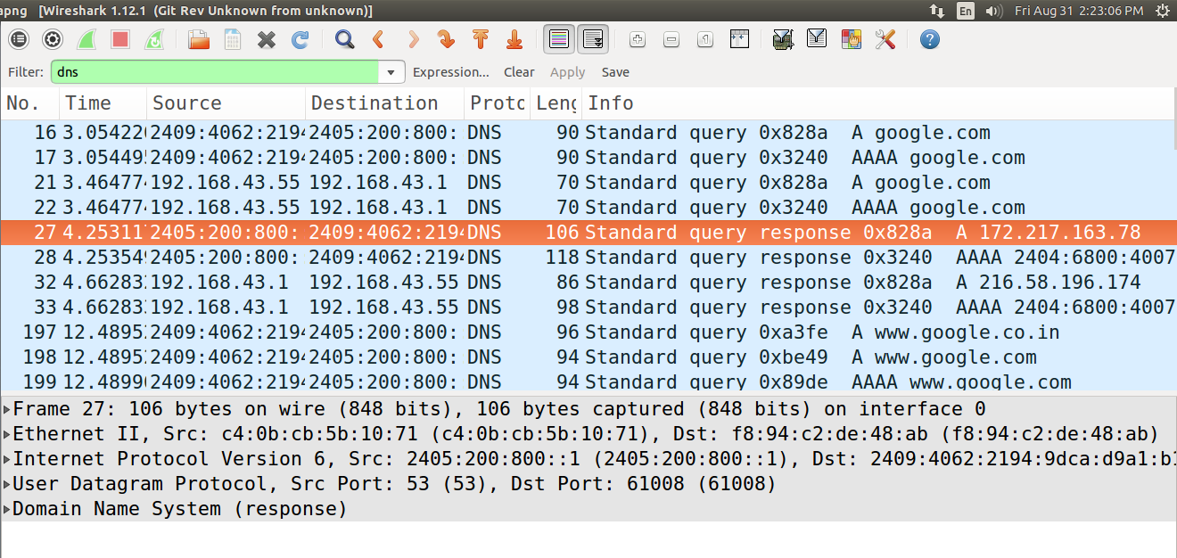

- Find the first IPv4 TCP packet. What is its source IP address?
Source IP address is 192.168.43.55
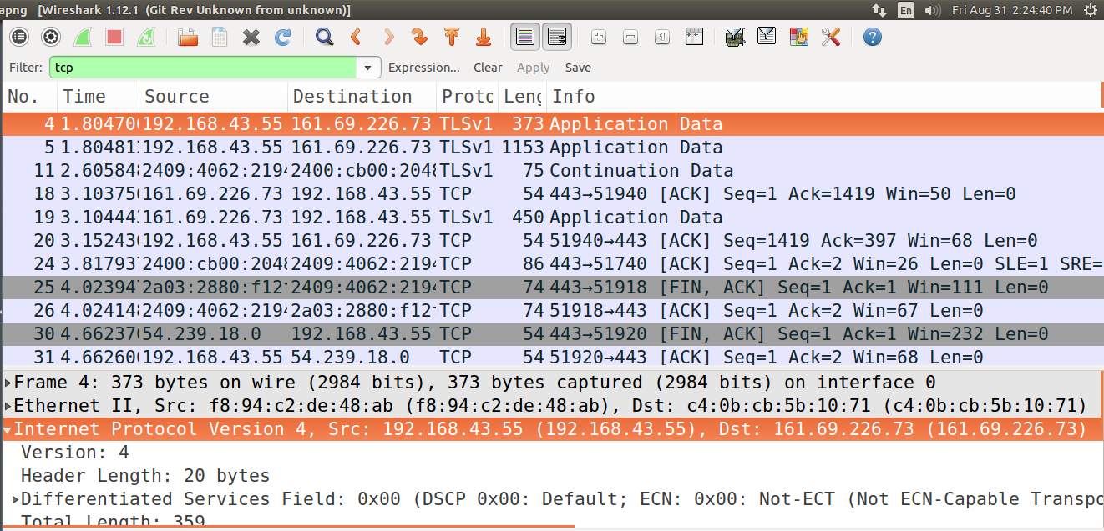

- Find the first TCP (IPv4 or IPv6) three-way handshake.
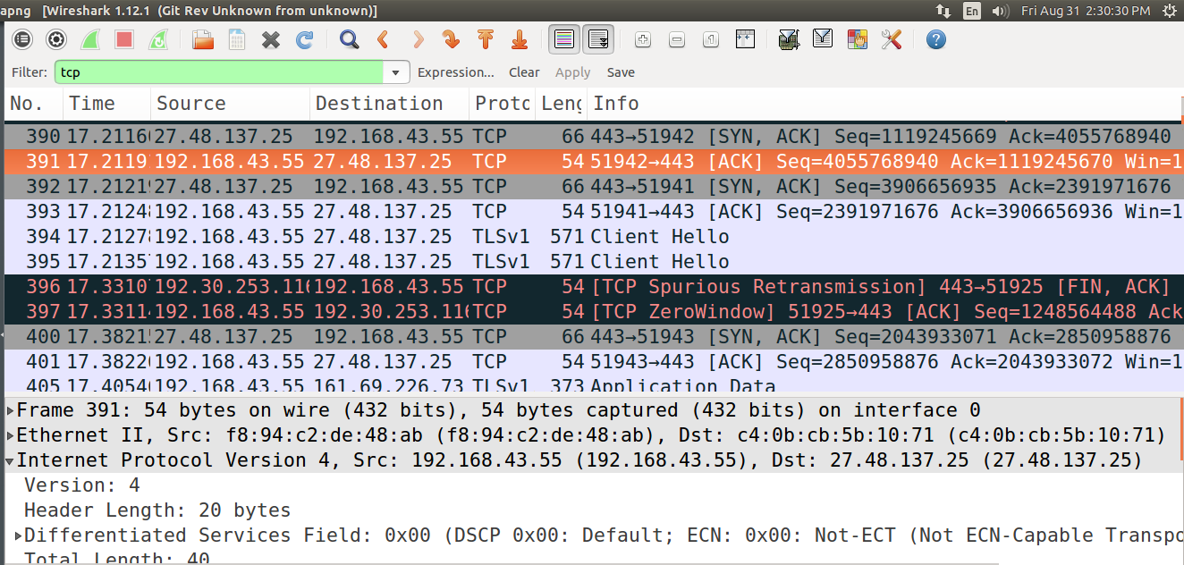

8.a. What is the source IP address in its opening SYN packet?
The source IP address in its opening SYN packet is 192.168.43.55

8.b. What is the destination IP address in its opening SYN packet?
The destination IP address in its opening SYN packet is 27.48.137.25

- What is the (Relative) Sequence Number sent in response to question 8’s opening SYN packet?
Seq = 4055768940

- Find the last TCP packet in the file that has its FIN flag on.
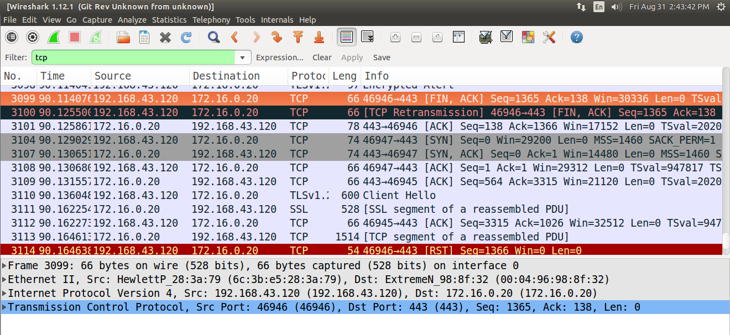

10.A. What is its source port number?
46946
10.B. What is its destination port number? - 443

