Compiler Design Laboratory
6th Semester 2018

Submitted by-
Dattatreya Tripathy
Roll number: 115CS0250



Department of Computer Science and Engineering
National Institute of Technology, Rourkela

Date: 02-01-2018
1. Design a scanner using flex to count the number of ASCII characters, words, lines, punctuations and “\n” in a given string –
Symbol set for words: [a-zA-Z0-9]+
Punctuation symbols: .,:;?”’
\n newline character
Program:
p1_1.l
/* Counting number of lines, words, punctuations etc... */
%{
int chars = 0;
int words = 0;
int lines = 0;
int punc = 0;
int slashn = 0;
%}
%%
[a-zA-Z0-9]+ { words++; chars += strlen(yytext); }
\n { chars++; lines++; }
['":;?!.]+ { chars++; punc++; }
\\n { chars++; slashn++; }
. { chars++; }
%%
main(int argc, char **argv)
{
yylex();
printf("Lines:%d words:%d chars:%d punc:%d slashn:%d \n", lines, words, chars, punc, slashn);
}
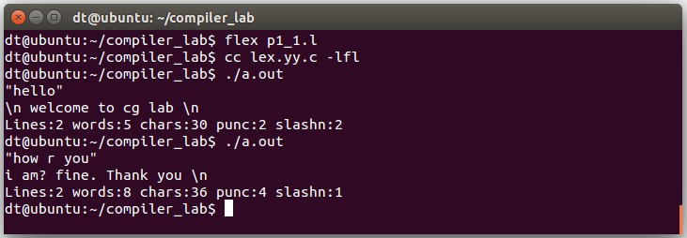

2. Design a pattern matcher. The pattern matcher should take the British English version of a word and provide its corresponding American English version.
Program:
p1_2.l
/* English -> American */

%%
"colour" { printf("color"); }
"flavour" { printf("flavor"); }
"clever" { printf("smart"); }
"smart" { printf("elegant"); }
"liberal" { printf("conservative"); }
"aeroplane" { printf("airplane"); }
"biscuit" { printf("cookie"); }
"car park" { printf("parking lot"); }
"chips" { printf("French fries"); }
"sulphur" { printf("Sulfur"); }
. { printf("%s", yytext); }
%%

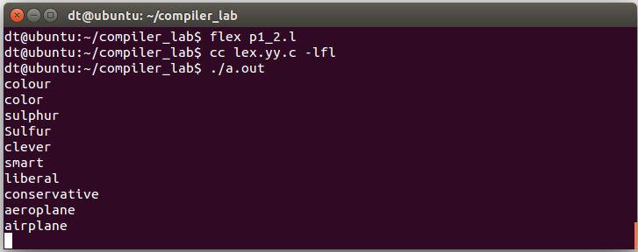

Date: 09-01-2018
1. Write a FLEX application that will recognize valid identifiers/sequences having symbols a-z, A-Z, 0-9 and underscore (_). Each identifier should not start with a symbol from 0-9. Any other symbol like decimal point/ full stop (.), comma (,), semicolon (;), colon (:), +, -, *, /, @, $, & are considered invalid .
Program:
p2_1.l
/*FLex application to recognize valid and invalid sequence based on input*/
%{

%}
%%
[a-zA-Z_]+[a-zA-Z0-9_]*+ {printf("Valid sequence\n");}
[\n ] { }
[a-zA-Z_]([a-zA-Z0-9_.,;:+*/@$&-])*+ {printf("Invalid sequence\n");}
[0-9.,;:(+-/@$]([a-zA-Z]|[0-9]|_|[.,;:()+-/@$])* {printf("Invalid sequence\n");}
%%
main(int argc, char **argv)
{
yylex();
}

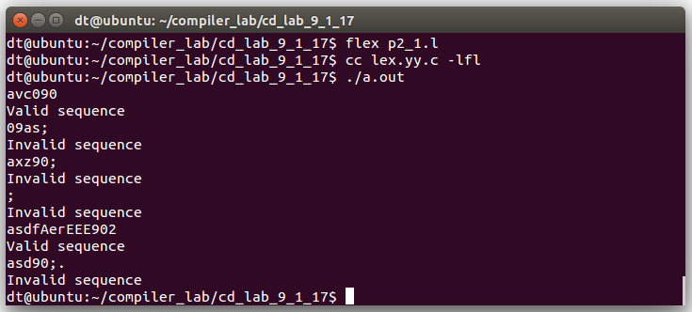

2. Write a FLEX application that will recognize strings of odd numbers of 0’s and even numbers of 1’s.
Program:
p2_2.l
/*FLex application to chaeck valid or invalid sequence based on number of zeros and ones*/
%{
int zeros = 0;
int ones = 0;
%}
%%
[0] {zeros++;}
[1] {ones++;}
[ \n ] { }
. {printf("Invalid character\n");}
%%
main(int argc, char **argv)
{
yylex();
printf("Zeros=%d and ones=%d\n", zeros, ones);
if(zeros%2==1 && ones%2==0)
printf("Valid sequence with odd number of zeros and even number of ones\n");
else
printf("Invalid sequence without odd number of zeros and even number of ones\n");
}

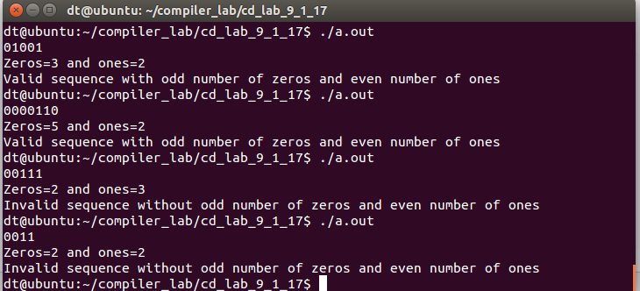

3. Write a FLEX application that will identify signed/ unsigned integer and long integer constants in decimal, hexadecimal, binary and octal representations used in C language.
Program:
p2_3.l
/*Flex application to identify signed, unsigned, hex, oct etc as in c*/
%{

%}
Sign [+|-][0-9]([0-9])*+
Hexadecimal [o][x|X][0-9A-F]([0-9A-F])*+
Octal [o][0-9]([0-9])*+
Binary [b|B][0-1]([0-1])*+
Decimal [0-9]([0-9])*[.][0-9]([0-9])*+
Long [l|L][0-9]([0-9])*+
Unsigned [0-9]([0-9])*+
%%
{Sign} printf("Signed\n");
{Hexadecimal} printf("Hexadecimal\n");
{Octal} printf("Octal\n");
{Binary} printf("Binary\n");
{Decimal} printf("Decimal\n");
{Long} printf("Long integer\n");
{Unsigned} printf("Unsigned integer\n");
[ \n ] { }
. printf("Invalid\n");
%%
main(int argc, char **argv)
{
yylex();
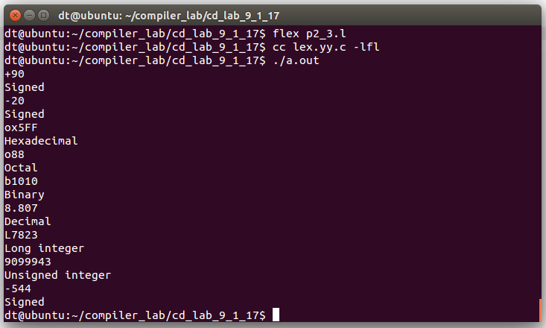
}
4. Write a FLEX program that will identify character and string constants as defined in C language.
Program:
p2_4.l
/*FLex program to identify character and string constant as in c*/
%{

%}
Character ['][a-zA-Z0-9;,.:][']+
String ["][a-zA-Z0-9;,.:]*["]+
%%

\n { }
{Character}|[']['] printf("Character constant\n");
{String} printf("String constant\n");
. printf("Invalid\n");
%%
main(int argc, char **argv)
{
yylex();
}

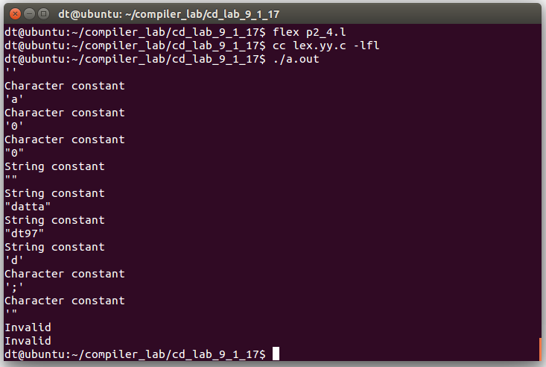

Date: 16-01-2018
1. Design an application using FLEX and BISON that will do the following
(i) check the correctness of a Boolean expression,
(ii) express it in standard Sum of Product form, and
(iii) convert the Sum of Product representation to standard Product of Sum form.
Example1
Input:
F(x,y) = x'.y+x.y'
Output:
The given expression is correct.
Sum of Product: x'.y+x.y'
Product of sum: (x+y).(x'+y')
Example2
Input:
F(x,y) = x.y +
Output:
Error 1: Incomplete expression, operand missing at x.y +
Symbols:
[a-z] as boolean variables.
operators
' complement
+ or
. and
other symbols
( left parenthesis
) right parenthesis
F(...) function with list of variables
= assignment
Program:
p3_1.l
/*Check validity of boolean expression*/
%{
#include "p3_1.tab.h"
%}
BVAR [a-z]
%%
{BVAR} { return BOOLVAR; }
"'" { return NOT; }
"+" { return OR; }
"." { return AND; }
"(" { return LPAREN; }
")" { return RPAREN; }
"=" { return ASSIGN; }
"F" { return F; }
"," { return COMMA; }
\n { return EOL; }
[ \t] { }
. { printf("Unknown Character/String\n"); }
%%

p3_1.y
%{
#include <stdio.h>
%}
%token BOOLVAR
%token NOT
%token OR
%token AND
%token LPAREN
%token RPAREN
%token ASSIGN
%token F
%token COMMA
%token EOL
%%

beg:
| beg F LPAREN s RPAREN ASSIGN exp EOL { printf("Valid boolean expression\n"); }
;
s: BOOLVAR
| s COMMA BOOLVAR
;
exp: term
| exp OR term
;
term: factor
| term AND factor
;
factor: BOOLVAR
;
factor: factor NOT
;
factor: LPAREN exp RPAREN
;
%%
main(int argc, char **argv)
{
yyparse();
}
yyerror(char *s1)
{
fprintf(stderr,"error: %s\n",s1);
}
yywrap()
{
return 1;
}

p3_1.sh
bison -d p3_1.y
flex p3_1.l
cc -o p3_1test p3_1.tab.c lex.yy.c -lfl

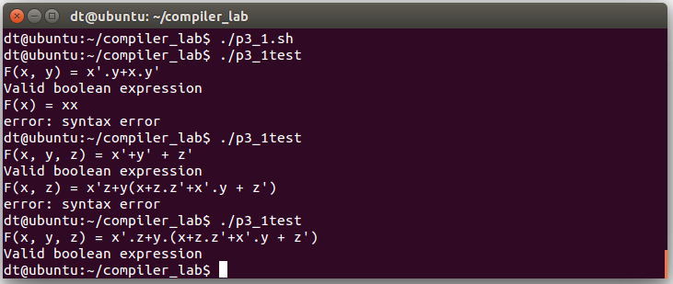

2. Design a machine that will recognize numbers between 0-999. For example: "Two hundred thirty nine" is a correct form of 239 in words. It should also detect an incorrect input "Twelve hundred twenty two."
Program:
p3_2.l
/* Flex and bison application to recognise numbers from 1 to 999 in words */
%{
#include "p3_2.tab.h"
%}
%%
"hundred" {return(HUNDRED);}
"one" {return(ONE);}
"two" {return(TWO);}
"three" {return(THREE);}
"four" {return(FOUR);}
"five" {return(FIVE);}
"six" {return(SIX);}
"seven" {return(SEVEN);}
"eight" {return(EIGHT);}
"nine" {return(NINE);}
"ten" {return(TEN);}
"zero" {return(ZERO);}
"eleven" {return(ELEVEN);}
"twelve" {return(TWELVE);}
"thirteen" {return(THIRTEEN);}
"fourteen" {return(FOURTEEN);}
"fifteen" {return(FIFTEEN);}
"sixteen" {return(SIXTEEN);}
"seventeen" {return(SEVENTEEN);}
"eighteen" {return(EIGHTEEN);}
"nineteen" {return(NINETEEN);}
"twenty" {return(TWENTY);}
"thirty" {return(THIRTY);}
"forty" {return(FORTY);}
"fifty" {return(FIFTY);}
"sixty" {return(SIXTY);}
"seventy" {return(SEVENTY);}
"eighty" {return(EIGHTY);}
"ninety" {return(NINETY);}
\n {return EOL;}
[ \t] { }
. {printf("Unknown Character/String");}
%%

p3_2.y
%{
#include<stdio.h>
%}
%token HUNDRED
%token ONE
%token TWO
%token THREE
%token FOUR
%token FIVE
%token SIX
%token SEVEN
%token EIGHT
%token NINE
%token N
%token ZERO
%token TEN
%token ELEVEN
%token TWELVE
%token THIRTEEN
%token FOURTEEN
%token FIFTEEN
%token SIXTEEN
%token SEVENTEEN
%token EIGHTEEN
%token NINETEEN
%token TWENTY
%token THIRTY
%token FORTY
%token FIFTY
%token SIXTY
%token SEVENTY
%token EIGHTY
%token NINETY
%token EOL
%%

beg:
| beg s EOL {printf("\n");}
;
s: u
;
u: t d
| tp
| dp
;
t: h x
;
tp: h y
;
h:
| dpp
| d HUNDRED {printf("hundred");}
;
d:
| ONE {printf("one");}
| TWO {printf("two");}
| THREE {printf("three");}
| FOUR {printf("four");}
| FIVE {printf("five");}
| SIX {printf("six");}
| SEVEN {printf("seven");}
| EIGHT {printf("eight");}
| NINE {printf("nine");}
;
dp: ONE {printf("one");}
| TWO {printf("two");}
| THREE {printf("three");}
| FOUR {printf("four");}
| FIVE {printf("five");}
| SIX {printf("six");}
| SEVEN {printf("seven");}
| EIGHT {printf("eight");}
| NINE {printf("nine");}
| TEN {printf("ten");}
;
x:
| TWENTY {printf("twenty");}
| THIRTY {printf("thirty");}
| FORTY {printf("forty");}
| FIFTY {printf("fifty");}
| SIXTY {printf("sixty");}
| SEVENTY {printf("seventy");}
| EIGHTY {printf("eighty");}
| NINETY {printf("ninety");}
;
y: TEN {printf("ten");}
| ELEVEN {printf("eleven");}
| TWELVE {printf("twelve");}
| THIRTEEN {printf("thirteen");}
| FOURTEEN {printf("fourteen");}
| FIFTEEN {printf("fifteen");}
| SIXTEEN {printf("sixteen");}
| SEVENTEEN {printf("seventeen");}
| EIGHTEEN {printf("eighteen");}
| NINETEEN {printf("nineteen");}
;
dpp: ONE {printf("one");}
| TWO {printf("two");}
| THREE {printf("three");}
| FOUR {printf("four");}
| FIVE {printf("five");}
| SIX {printf("six");}
| SEVEN {printf("seven");}
| EIGHT {printf("eight");}
| NINE {printf("nine");}
;
%%
main(int argc, char **argv)
{
yyparse();
}
yyerror(char *s1)
{
fprintf(stderr,"error: %s\n",s1);
}
yywrap()
{
return 1;
}

p3_2.sh
# part of the makefile
#p3_1calci: p3_1calci.l p3_1calci.y
#p3_1calci.l p3_1calci.y
bison -d p3_2.y
flex p3_2.l
cc -o p3_2test p3_2.tab.c lex.yy.c -lfl

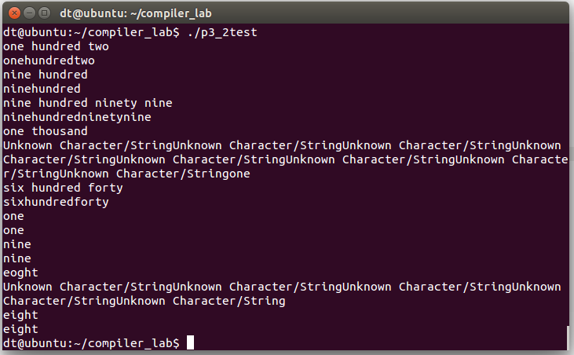

Date: 23-01-2016
1.
TOKEN | CODE | VALUE
begin | 1 | -
end | 2 | -
if | 3 | -
else | 4 | -
then | 5 | -
identifier | 6 | (6, sym_tab_ptr)
constant | 7 | (7, sym_tab_ptr)
== | 8 | (8, 1)
!= | 8 | (8, 2)
>= | 8 | (8, 3)
<= | 8 | (8, 4)
< | 8 | (8, 5)
> | 8 | (8, 6)
Design a DFA that will identify and display the code and values for valid tokens, manage symbol table for identifiers and constants, and find errors.

Program:
/* Cpp program to detect identifiers and other lexemes like constants and generate corresponding code or token and using hash table for symbol table management for lookup and insert operations in O(1) amortized time */
#include <iostream>
#include <vector>
#include <cstdio>
#include <string>
#define SIZE 100 //Size of hash table
using namespace std;

//const int x = 23;//For hashing
const int x = 19;

struct value{
int cd;//For corresponding code of token
string var;
};
struct symbol{
int e_no;//Entry number in symbol table
string name;
string type;
value *val;
symbol **s_table_ptr;//For returning on successful insertion or lookup say like symbol *sym; s_table_ptr = &sym;
symbol *next;//For hashing and chaining
};

symbol *s_table[SIZE] = {NULL};//Symbol table initialized

symbol *insert(symbol *s_table[SIZE], int ind, int code, string st, string t)
{
symbol *newsym = new symbol;
newsym->e_no = ind;
newsym->name = t;
if(code==6)
newsym->type = "identifier";
else
newsym->type = "constant";
newsym->val = new value;
newsym->val->cd = code;
newsym->val->var = st;
newsym->s_table_ptr = &newsym;
newsym->next = NULL;
if(s_table[ind]==NULL)
{
s_table[ind] = newsym;
}
else
{
symbol *s = s_table[ind];
while(s->next!=NULL)
{
s = s->next;
}
s->next = newsym;
}
return newsym;
}
symbol *look_up(symbol *s_table[SIZE], int ind, int code, string st, string t)
{
symbol *sym = NULL;
if(s_table[ind]!=NULL)
{
symbol *s = s_table[ind];
while(s!=NULL)
{
if((s->name==t) && (s->val->cd==code) && (s->val->var==st))
{
sym = s;
break;
}
s = s->next;
}
}
return sym;
}
int hashVal(string s)
{
int n = s.length();
int h = ((int)s[n-1])%SIZE;
for(int i=n-2; i>=0; i--)
{
h = ((h*x)+s[i])%SIZE;
}
return h;
}
int dfa_begin(string s, int n)
{
int res = 0;
int s_state = 0, e_state = 5, d_state = 6, c_state = 0, n_state = 0;
cout<<"In begin DFA\n";
cout<<"\nStart state no. = "<<s_state<<", end_state = "<<e_state<<" and, dead state = "<<d_state<<"\n";
int i = 0, f = 0;
for(i=0; i<n; i++)
{
//printf("current state: %d\n", c_state);
if(c_state==0 && s[i]=='b')
{
n_state = 1;
}
else if(c_state==1 && s[i]=='e')
{
n_state = 2;
}
else if(c_state==2 && s[i]=='g')
{
n_state = 3;
}
else if(c_state==3 && s[i]=='i')
{
n_state = 4;
}
else if(c_state==4 && s[i]=='n')
{
n_state = 5;
}
else
{
n_state = 6;
f = 1;
//printf("Invalid input reached dead state from state no = %d\n", c_state);
break;
}
cout<<"Reached state = "<<n_state<<" from current_state = "<<c_state<<"\n";
c_state = n_state;
}
if(f==0)
{
res = 1;
cout<<"Valid input keyword begin!!! with code = "<<res<<"\n";
}
else
{
cout<<"Not a valid keyword begin!!! reached dead state = "<<n_state<<" from current state = "<<c_state<<"\n";
}
return res;
}
int dfa_end(string s, int n)
{
int res = 0;
int s_state = 0, e_state = 3, d_state = 4, c_state = 0, n_state = 0;
cout<<"In end DFA\n";
cout<<"\nStart state no. = "<<s_state<<", end_state = "<<e_state<<" and, dead state = "<<d_state<<"\n";
int i = 0, f = 0;
for(i=0; i<n; i++)
{
//printf("current state: %d\n", c_state);
if(c_state==0 && s[i]=='e')
{
n_state = 1;
}
else if(c_state==1 && s[i]=='n')
{
n_state = 2;
}
else if(c_state==2 && s[i]=='d')
{
n_state = 3;
}
else
{
n_state = 4;
f = 1;
//printf("Invalid input reached dead state from state no = %d\n", c_state);
break;
}
cout<<"Reached state = "<<n_state<<" from current_state = "<<c_state<<"\n";
c_state = n_state;
}
if(f==0)
{
res = 2;
cout<<"Valid input keyword end!!! with code = "<<res<<"\n";
}
else
{
cout<<"Not a valid keyword end!!! reached dead state = "<<n_state<<" from current state = "<<c_state<<"\n";
}
return res;
}
int dfa_if(string s, int n)
{
int res = 0;
int s_state = 0, e_state = 2, d_state = 3, c_state = 0, n_state = 0;
cout<<"In if DFA\n";
cout<<"\nStart state no. = "<<s_state<<", end_state = "<<e_state<<" and, dead state = "<<d_state<<"\n";
int i = 0, f = 0;
for(i=0; i<n; i++)
{
//printf("current state: %d\n", c_state);
if(c_state==0 && s[i]=='i')
{
n_state = 1;
}
else if(c_state==1 && s[i]=='f')
{
n_state = 2;
}
else
{
n_state = 3;
f = 1;
//printf("Invalid input reached dead state from state no = %d\n", c_state);
break;
}
cout<<"Reached state = "<<n_state<<" from current_state = "<<c_state<<"\n";
c_state = n_state;
}
if(f==0)
{
res = 3;
cout<<"Valid input keyword if!!! with code = "<<res<<"\n";
}
else
{
cout<<"Not a valid keyword if!!! reached dead state = "<<n_state<<" from current state = "<<c_state<<"\n";
}
return res;
}
int dfa_else(string s, int n)
{
int res = 0;
int s_state = 0, e_state = 4, d_state = 5, c_state = 0, n_state = 0;
cout<<"In else DFA\n";
cout<<"\nStart state no. = "<<s_state<<", end_state = "<<e_state<<" and, dead state = "<<d_state<<"\n";
int i = 0, f = 0;
for(i=0; i<n; i++)
{
//printf("current state: %d\n", c_state);
if(c_state==0 && s[i]=='e')
{
n_state = 1;
}
else if(c_state==1 && s[i]=='l')
{
n_state = 2;
}
else if(c_state==2 && s[i]=='s')
{
n_state = 3;
}
else if(c_state==3 && s[i]=='e')
{
n_state = 4;
}
else
{
n_state = 5;
f = 1;
//printf("Invalid input reached dead state from state no = %d\n", c_state);
break;
}
cout<<"Reached state = "<<n_state<<" from current_state = "<<c_state<<"\n";
c_state = n_state;
}
if(f==0)
{
res = 4;
cout<<"Valid input keyword else!!! with code = "<<res<<"\n";
}
else
{
cout<<"Not a valid keyword else!!! reached dead state = "<<n_state<<" from current state = "<<c_state<<"\n";
}
return res;
}
int dfa_then(string s, int n)
{
int res = 0;
int s_state = 0, e_state = 4, d_state = 5, c_state = 0, n_state = 0;
cout<<"In then DFA\n";
cout<<"\nStart state no. = "<<s_state<<", end_state = "<<e_state<<" and, dead state = "<<d_state<<"\n";
int i = 0, f = 0;
for(i=0; i<n; i++)
{
//printf("current state: %d\n", c_state);
if(c_state==0 && s[i]=='t')
{
n_state = 1;
}
else if(c_state==1 && s[i]=='h')
{
n_state = 2;
}
else if(c_state==2 && s[i]=='e')
{
n_state = 3;
}
else if(c_state==3 && s[i]=='n')
{
n_state = 4;
}
else
{
n_state = 5;
f = 1;
//printf("Invalid input reached dead state from state no = %d\n", c_state);
break;
}
cout<<"Reached state = "<<n_state<<" from current_state = "<<c_state<<"\n";
c_state = n_state;
}
if(f==0)
{
res = 5;
cout<<"Valid input keyword then!!! with code = "<<res<<"\n";
}
else
{
cout<<"Not a valid keyword then!!! reached dead state = "<<n_state<<" from current state = "<<c_state<<"\n";
}
return res;
}
int dfa_rel(string s, int n, int &val)
{
int res = 0;
int s_state = 0, e_state1 = 2, e_state2 = 3, d_state = 4, c_state = 0, n_state = 0;
cout<<"In relational operator DFA\n";
cout<<"\nStart state no. = "<<s_state<<", end_states are = "<<e_state1<<" and "<<e_state2<<", dead state = "<<d_state<<"\n";
int i = 0, f = 0;
for(i=0; i<n; i++)
{
//printf("current state: %d\n", c_state);
if(c_state==0)
{
if(s[i]=='>')
{
n_state = 3;
val = 6;
}
else if(s[i]=='<')
{
n_state = 3;
val = 5;
}
else if(s[i]=='!')
{
n_state = 3;
val = 2;
}
else
{
if(s[i]=='=')
{
n_state = 1;
val = 1;
}
else
{
n_state = 4;
f = 1;
val = -1;
break;
}
}
}
else if(c_state==1)
{
if(s[i]=='=')
n_state = 2;
else
{
n_state = 4;
f = 1;
val = -1;
break;
}
}
else if(c_state==2)
{
if(i<n)//Means there are still other symbols of string left to be processed
{
n_state = 4;
f = 1;
val = -1;
break;
}
else
{
n_state = 2;
break;
}
}
else if(c_state==3)
{
if(s[i]=='=')//Means there are still other symbols of string left to be processed
{
n_state = 2;
if(val==6)
{
val = 3;
}
else if(val==5)
{
val = 4;
}
}
else
{
n_state = 4;
f = 1;
val = -1;
break;
}
}
else
{
n_state = 4;
f = 1;
val = -1;
//printf("Invalid input reached dead state from state no = %d\n", c_state);
break;
}
cout<<"Reached state = "<<n_state<<" from current_state = "<<c_state<<"\n";
c_state = n_state;
}
if(f==0)
{
res = 8;
cout<<"Valid input relational operator!!! with code = "<<res<<" and value = "<<val<<"\n";
}
else
{
cout<<"Not a valid relational operator!!! reached dead state = "<<n_state<<" from current state = "<<c_state<<"\n";
}
return res;
}
int dfa_iden(string s, int n)
{
int res = 0;
vector<char > st;
//For int
int s_state = 0, e_state = 5, d_state = 7, c_state = 0, n_state = 0, str = 0;//str used to count no of * symbols
cout<<"In int DFA\n";
cout<<"\nStart state no. = "<<s_state<<", end_state = "<<e_state<<" and, dead state = "<<d_state<<"\n";
int i = 0, f = 0;
for(i=0; i<n; i++)
{
//printf("current state: %d\n", c_state);
if(c_state==0)
{
if(s[i]=='i')
n_state = 1;
else
{
n_state = 7;
f = 1;
break;
}
}
else if(c_state==1)
{
if(s[i]=='n')
n_state = 2;
else
{
n_state = 7;
f = 1;
break;
}
}
else if(c_state==2)
{
if(s[i]=='t')
n_state = 3;
else
{
n_state = 7;
f = 1;
break;
}
}
else if(c_state==3)
{
if(s[i]==' ')
n_state = 4;
else if(s[i]=='*')
{
str++;
//st.push_back(s[i]);
n_state = 6;
}
else
{
n_state = 7;
f = 1;
break;
}
}
else if(c_state==4)
{
if(s[i]==' ')
{
n_state = 4;
}
else if(s[i]=='*')
{
str++;
//st.push_back(s[i]);
n_state = 6;
}
else if((((int)(s[i])>=65) && ((int)(s[i])<=90)) || (((int)(s[i])>=97) && ((int)(s[i])<=122)) || (s[i]=='_'))
{
st.push_back(s[i]);
n_state = 5;//Reached end state
}
else
{
n_state = 7;
f = 1;
break;
}
}
else if(c_state==5)
{
if((((int)(s[i])>=65) && ((int)(s[i])<=90)) || (((int)(s[i])>=97) && ((int)(s[i])<=122)) || (s[i]=='_') || (((int)(s[i])>=48) && ((int)(s[i])<=57)))
{
st.push_back(s[i]);
n_state = 5;//Reached end state
}
else
{
n_state =7;
f = 1;
break;
}
}
else if(c_state==6)
{
if(s[i]==' ')
{
n_state = 4;
}
else if(s[i]=='*')
{
str++;
//st.push_back(s[i]);
n_state = 6;
}
else if((((int)(s[i])>=65) && ((int)(s[i])<=90)) || (((int)(s[i])>=97) && ((int)(s[i])<=122)) || (s[i]=='_'))
{
st.push_back(s[i]);
n_state = 5;//Reached end state
}
else
{
n_state = 7;
f = 1;
break;
}
}
cout<<"Reached state = "<<n_state<<" from current_state = "<<c_state<<"\n";
c_state = n_state;
}
string id1 = "int";
while(str--)
{
id1 += "*";
}
if(f==0)
{
if(st.size()==0)//To check if there is any null symbol after int or int * or int***** etc which is invalid input/syntax
{
n_state = 7;//Reached dead state
cout<<"Not a valid identifier of type "<<id1<<". Missing variable name!!! reached dead state = "<<n_state<<" from current state = "<<c_state<<"\n";
res = -1;
}
else
{
/*int n = st.size();
char vr[n+1];
for(int i=0; i<n; i++)
{
vr[i] = st[i];
}
vr[n] = '\0';*/
//int sz = n+1;
string vr(st.begin(), st.end());
if((vr!="begin")&&(vr!="end")&&(vr!="if")&&(vr!="else")&&(vr!="then")&&((vr!="int") && (vr!="char"))&&((vr!="0")&&(vr!="1")&&(vr!="2")&&(vr!="3")&&(vr!="4")&&(vr!="5")&&(vr!="6")&&(vr!="7")&&(vr!="8")&&(vr!="9"))&&((vr!="==")&&(vr!="!=")&&(vr!="<=")&&(vr!=">=")&&(vr!="<")&&(vr!=">")))
{
res = 6;
cout<<"Valid input identifier "<<vr<<" of type "<<id1<<"!!! with code = "<<res<<"\n";
//cout<<vr<<"\n";
//cout<<id1<<"\n";
int hint = hashVal(id1);
int h = (hint+hashVal(vr))%SIZE;
symbol *sym = look_up(s_table, h, res, vr, id1);
if(sym!=NULL)
{
cout<<"Variable "<<vr<<" already declared at location ("<<"symbol_table_enty_no = "<<sym->e_no<<", symbol_table_ptr_addr = "<<sym->s_table_ptr<<") with name = "<<sym->name<<", type = "<<sym->type<<", and value (code = "<<sym->val->cd<<", variable name = "<<sym->val->var<<")\n";
}
else
{
//cout<<"Not found\n";
symbol *ins = insert(s_table, h, res, vr, id1);//res = code for int token here
cout<<"Variable "<<vr<<" inserted at location ("<<"symbol_table_enty_no = "<<ins->e_no<<", symbol_table_ptr_addr = "<<ins->s_table_ptr<<") with name = "<<ins->name<<", type = "<<ins->type<<", and value (code = "<<ins->val->cd<<", variable name = "<<ins->val->var<<")\n";
}
}
else
{
cout<<"Invalid input identifier "<<vr<<" of type "<<id1<<" as "<<vr<<" is a reserved keyword\n";
res = -1;
}
}
}
else
{
cout<<"Not a valid identifier of type "<<id1<<"!!! reached dead state = "<<n_state<<" from current state = "<<c_state<<"\n";

/*----------------------- FOR CHAR -------------------------------*/
//For char
st.clear();
s_state = 0, e_state = 6, d_state = 8, c_state = 0, n_state = 0;
cout<<"In char DFA\n";
cout<<"\nStart state no. = "<<s_state<<", end_state = "<<e_state<<" and, dead state = "<<d_state<<"\n";
i = 0, f = 0, str = 0, id1 = "char";
for(i=0; i<n; i++)
{
//printf("current state: %d\n", c_state);
if(c_state==0)
{
if(s[i]=='c')
n_state = 1;
else
{
n_state = 8;
f = 1;
break;
}
}
else if(c_state==1)
{
if(s[i]=='h')
n_state = 2;
else
{
n_state = 8;
f = 1;
break;
}
}
else if(c_state==2)
{
if(s[i]=='a')
n_state = 3;
else
{
n_state = 8;
f = 1;
break;
}
}
else if(c_state==3)
{
if(s[i]=='r')
n_state = 4;
else
{
n_state = 8;
f = 1;
break;
}
}
else if(c_state==4)
{
if(s[i]==' ')
n_state = 5;
else if(s[i]=='*')
{
str++;
n_state = 7;
}
else
{
n_state = 8;
f = 1;
break;
}
}
else if(c_state==5)
{
if(s[i]==' ')
{
n_state = 5;
}
else if(s[i]=='*')
{
str++;
n_state = 7;
}
else if((((int)(s[i])>=65) && ((int)(s[i])<=90)) || (((int)(s[i])>=97) && ((int)(s[i])<=122)) || (s[i]=='_'))
{
st.push_back(s[i]);
n_state = 6;//Reached end state
}
else
{
n_state = 8;
f = 1;
break;
}
}
else if(c_state==6)
{
if((((int)(s[i])>=65) && ((int)(s[i])<=90)) || (((int)(s[i])>=97) && ((int)(s[i])<=122)) || (s[i]=='_') || (((int)(s[i])>=48) && ((int)(s[i])<=57)))
{
st.push_back(s[i]);
n_state = 6;//Reached end state
}
else
{
n_state =8;
f = 1;
break;
}
}
else if(c_state==7)
{
if(s[i]==' ')
{
n_state = 5;
}
else if(s[i]=='*')
{
str++;
n_state = 7;
}
else if((((int)(s[i])>=65) && ((int)(s[i])<=90)) || (((int)(s[i])>=97) && ((int)(s[i])<=122)) || (s[i]=='_'))
{
st.push_back(s[i]);
n_state = 6;//Reached end state
}
else
{
n_state = 8;
f = 1;
break;
}
}
cout<<"Reached state = "<<n_state<<" from current_state = "<<c_state<<"\n";
c_state = n_state;
}
while(str--)
{
id1 += "*";
}
if(f==0)
{
if(st.size()==0)
{
n_state = 8;
cout<<"Not a valid identifier of type "<<id1<<". Missing variable name!!! reached dead state = "<<n_state<<" from current state = "<<c_state<<"\n";
res = -1;
}
else
{
string vr(st.begin(), st.end());
if((vr!="begin")&&(vr!="end")&&(vr!="if")&&(vr!="else")&&(vr!="then")&&((vr!="int") && (vr!="char"))&&((vr!="0")&&(vr!="1")&&(vr!="2")&&(vr!="3")&&(vr!="4")&&(vr!="5")&&(vr!="6")&&(vr!="7")&&(vr!="8")&&(vr!="9"))&&((vr!="==")&&(vr!="!=")&&(vr!="<=")&&(vr!=">=")&&(vr!="<")&&(vr!=">")))
{
res = 6;
cout<<"Valid input identifier "<<vr<<" of type "<<id1<<"!!! with code = "<<res<<"\n";
//cout<<vr<<"\n";
//cout<<id1<<"\n";
int hchar = hashVal(id1);
int h = (hchar+hashVal(vr))%SIZE;
symbol *sym = look_up(s_table, h, res, vr, id1);
if(sym!=NULL)
{
cout<<"Variable "<<vr<<" already declared at location ("<<"symbol_table_enty_no = "<<sym->e_no<<", symbol_table_ptr_addr = "<<sym->s_table_ptr<<") with name = "<<sym->name<<", type = "<<sym->type<<", and value (code = "<<sym->val->cd<<", variable name = "<<sym->val->var<<")\n";
}
else
{
//cout<<"Not found\n";
symbol *ins = insert(s_table, h, res, vr, id1);//res = code for int token here
cout<<"Variable "<<vr<<" inserted at location ("<<"symbol_table_enty_no = "<<ins->e_no<<", symbol_table_ptr_addr = "<<ins->s_table_ptr<<") with name = "<<ins->name<<", type = "<<ins->type<<", and value (code = "<<ins->val->cd<<", variable name = "<<ins->val->var<<")\n";
}
}
else
{
cout<<"Invalid input identifier "<<vr<<" of type "<<id1<<" as "<<vr<<" is a reserved keyword\n";
res = -1;
}
}
}
else
{
cout<<"Not a valid identifier of type "<<id1<<"!!! reached dead state = "<<n_state<<" from current state = "<<c_state<<"\n";
}
}
return res;
}
int dfa_cons(string s, int n)
{
int res = 0;
int s_state = 0, e_state = 1, d_state = 2, c_state = 0, n_state = 0;
cout<<"In constant DFA\n";
cout<<"\nStart state no. = "<<s_state<<", end_state = "<<e_state<<" and, dead state = "<<d_state<<"\n";
int i = 0, f = 0;
string id2 = "number";
vector<char > st;
for(i=0; i<n; i++)
{
//printf("current state: %d\n", c_state);
if(c_state==0)
{
if(((int)(s[i])>=48) && ((int)(s[i])<=57))
{
st.push_back(s[i]);
n_state = 1;
}
else
{
n_state = 2;
f = 1;
break;
}
}
else if(c_state==1)
{
if(((int)(s[i])>=48) && ((int)(s[i])<=57))
{
st.push_back(s[i]);
n_state = 1;
}
else
{
n_state = 2;
f = 1;
break;
}
}
else
{
n_state = 2;
f = 1;
//printf("Invalid input reached dead state from state no = %d\n", c_state);
break;
}
cout<<"Reached state = "<<n_state<<" from current_state = "<<c_state<<"\n";
c_state = n_state;
}
if(f==0)
{
if(st.size()==0)
{
n_state = 2;
cout<<"Not a valid identifier of type "<<id2<<". Missing number!!! reached dead state = "<<n_state<<" from current state = "<<c_state<<"\n";
res = -1;
}
else
{
res = 7;
cout<<"Valid input constant of type "<<id2<<"!!! with code = "<<res<<"\n";
int hcons = hashVal(id2);
int h = (hcons+hashVal(s))%SIZE;
symbol *sym = look_up(s_table, h, res, s, id2);
if(sym!=NULL)
{
cout<<"Constant "<<s<<" already declared at location ("<<"symbol_table_enty_no = "<<sym->e_no<<", symbol_table_ptr_addr = "<<sym->s_table_ptr<<") with name = "<<sym->name<<", type = "<<sym->type<<", and value (code = "<<sym->val->cd<<", variable name = "<<sym->val->var<<")\n";
}
else
{
//cout<<"Not found\n";
symbol *ins = insert(s_table, h, res, s, id2);//res = code for int token here
cout<<"Constant "<<s<<" inserted at location ("<<"symbol_table_enty_no = "<<ins->e_no<<", symbol_table_ptr_addr = "<<ins->s_table_ptr<<") with name = "<<ins->name<<", type = "<<ins->type<<", and value (code = "<<ins->val->cd<<", variable name = "<<ins->val->var<<")\n";
}
}
}
else
{
cout<<"Not a valid constant of type "<<id2<<"!!! reached dead state = "<<n_state<<" from current state = "<<c_state<<"\n";
}
return res;
}
void dfa(string s)
{
int code = 0;//INitialized
int val = -1;
int n = s.length();
if(code==0)
{
code = dfa_begin(s, n);
if(code==0)
{
code = dfa_end(s, n);
if(code==0)
{
code = dfa_if(s, n);
if(code==0)
{
code = dfa_else(s, n);
if(code==0)
{
code = dfa_then(s, n);
if(code==0)
{
code = dfa_iden(s, n);
if(code==0)
{
code = dfa_cons(s, n);
if(code==0)
{
code = dfa_rel(s, n, val);
if(code==0)
{
cout<<"Invalid input please enter a valid token and try again!!!\n";
}
}
}
}
}
}
}
}
}
}
int main()
{
string line;
int Q;
cout<<"Enter number of queries: ";
cin>>Q;
getchar();
while(Q--)
{
cout<<"Enter the tokens \n";
getline(cin, line);
cout<<"You entered "<<line<<"\n";
dfa(line);
}
return 0;
}
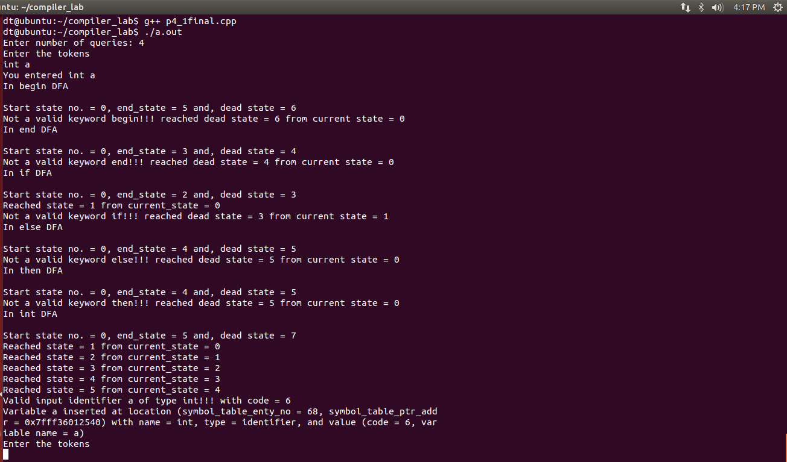

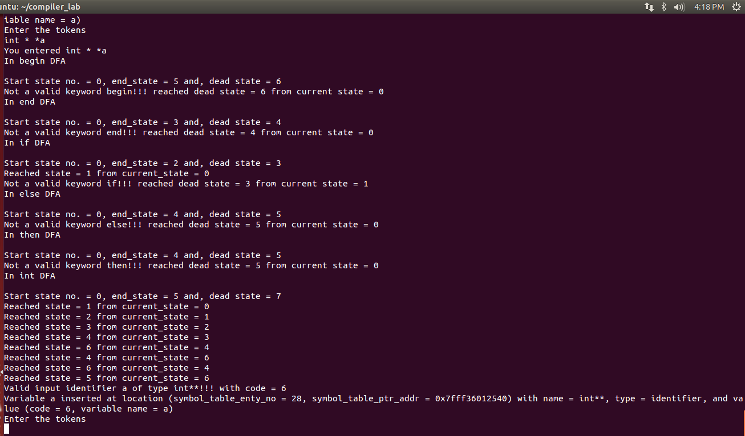
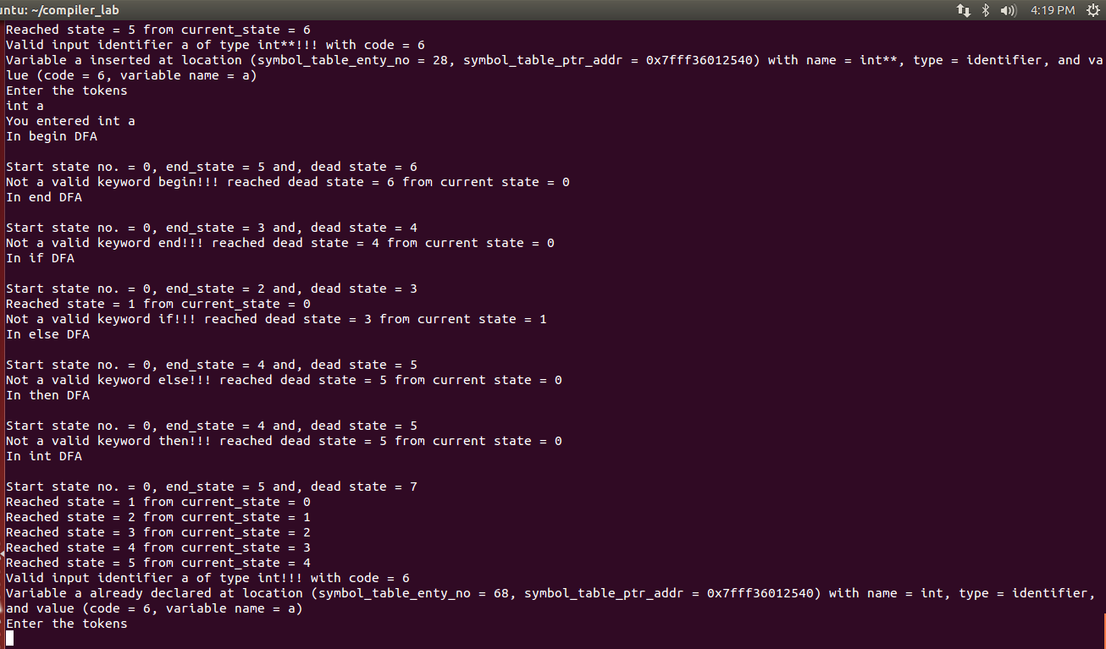

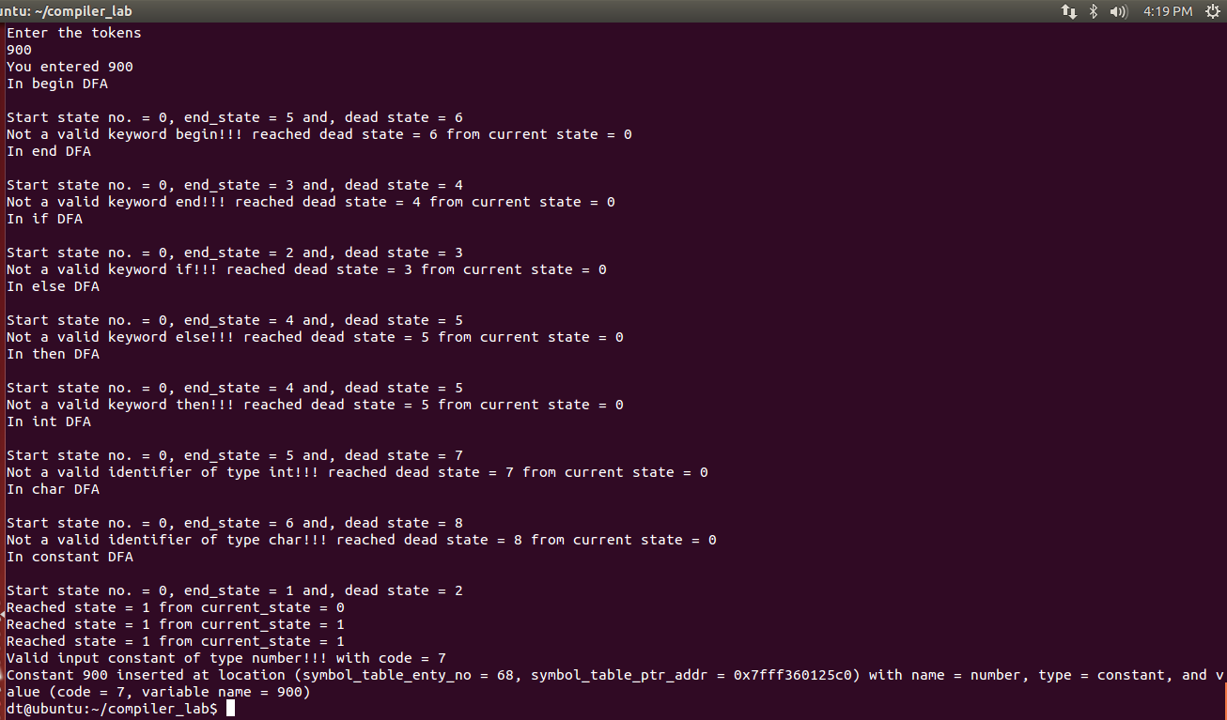
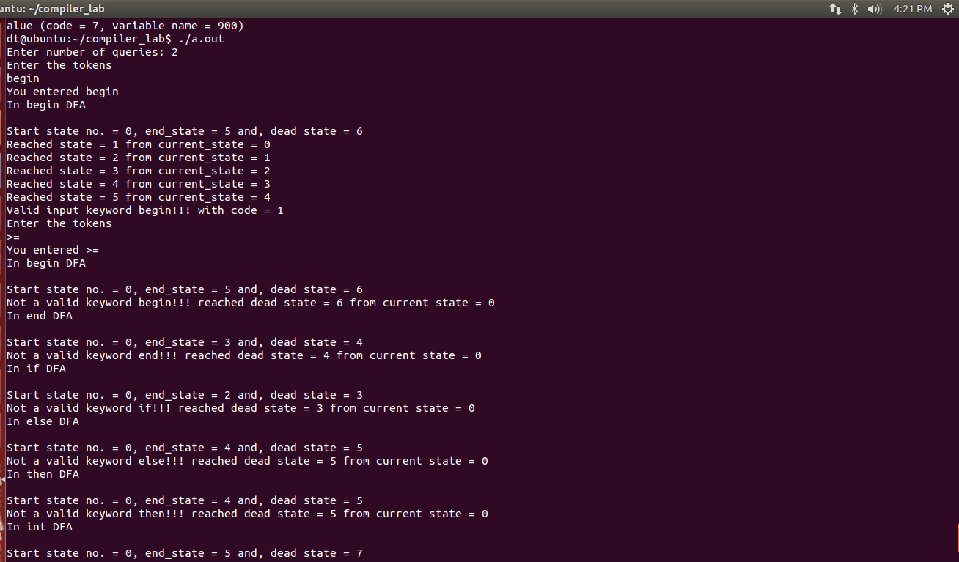
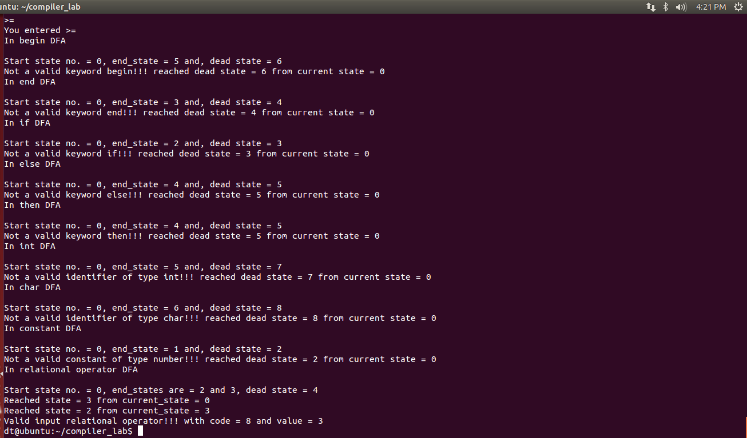

Date: 30-01-2018
1. Design a flex bison application that will check the correctness of declaration of variables and functions in C language.
Example:
type id1, id2;
type func1 ( type param1, type param2);
type = {void, int, char, float} (keywords)
id1, id2, func1, param1, param2 are identifiers.
Token separators or punctuations are , ; ( )
Program:
p5_1.l
/* Flex and Bison application to check valid identifier and funtion declaration as in C */
%{
#include "p5_1.tab.h"
%}

%%
("int")[ ]|("float")[ ]|("char")[ ]|("void")[ ] { return KEY;}
[a-zA-Z_][a-zA-Z0-9]* { return ID; }
";" { return END;}
"," { return COMMA;}
"(" { return LP;}
")" { return RP;}
[\n] { return EOL;}
[ \t] { }
. { printf("Invalid Identifier\n");
return I;}
%%

p5_1.y
/* bison program for checking correctness of declaration of variables and functions in C language */
%{
#include <stdio.h>
int yylex();

void yyerror(const char *s);

%}

%token KEY
%token ID
%token END
%token COMMA
%token LP
%token RP
%token EOL
%token I
%%
S:
| KEY ID LP chk RP END S { printf(" Correct function declaration!! \n"); return 0;}
| KEY ID LP chk RP END EOL { printf(" Correct function declaration!! \n"); return 0;}
| KEY iden END S { printf(" Correct identifier declaration!! \n"); return 0;}
| KEY iden END EOL{ printf(" Correct identifier declaration!! \n"); return 0;}
| KEY EOL{printf("Incorrect\n Incomplete Statement \n"); return 0;}
| KEY iden EOL{printf("Incorrect\n Incomplete Statement \n" ); return 0;}
| KEY inv EOL{printf("Incorrect\n Incomplete Statement \n" ); return 0;}
;
chk:
| KEY ID { printf("Valid\n"); }
| KEY ID COMMA chk
;
iden: iden COMMA ID { }
| ID { }
;
inv: I { }
;
%%

main(int argc, char **argv) {
yyparse();
}

void yyerror(const char *s) {
printf("%s \n", s);
}




