Description: Start site

Player Club Booth Automation-PlaywrightPlayer Club Booth Automation Design Approach

1.0

Contents

➢ **Document Control** 3

➢ **Objective** 4

➢ **Installation** 4

➢ **Environment Details** 4

➢ **Setup, Execution and Reports** 4

➢ **Config Files** 7

➢ **Folder Structure** 8

➢ **Jenkins Execution** 9

➢ **Dashboard Result** 11

➢ **Report Portal** 12

* **Document Control**

|  |  |  |  |
| --- | --- | --- | --- |
| **Version** | **Date** | **Author** | **Comments** |
| DRAFT | 22/07/2024 | Manoj Rajasekar |  |

* **Objective**

The objective of this document is to explain the automation framework setup and guide the user to execute the scripts and analyze the results.

* **Installation**

The following software need to install

1. Visual Studio Code
2. NodeJS (latest version)

## **Environment Details**

**URL:** https://192.168.131.127:886/portal/#/applications

**Script Path:** [Advantage-Web-Access.PlayersClub/Testing/UI Testing/PlayerClubBooth-Playwright at feature/Automation-UI-Testing · igt-casino/Advantage-Web-Access.PlayersClub (github.com)](https://github.com/igt-casino/Advantage-Web-Access.PlayersClub/tree/feature/Automation-UI-Testing/Testing/UI%20Testing/PlayerClubBooth-Playwright)

## **Setup, Execution and Reports**

1. Download or check out the project folder from the script path

1. Open Visual Studio Code. From menu click File->Open Folder..-> Select the playwright project folder “PlayerClubBooth-Playwright” by navigating the path “\Advantage-Web-Access.PlayersClub\Testing\UI Testing”

1. It should open the project like below.

1. Open Command Palette by pressing Ctrl+Shift+p and select Create New Terminal -> that will bring you the terminal.

1. From Terminal type “npm run setup”, after module installation done type “npm run test”, that will open the browser and execute the tests. For headless mode type “npm run test:headless”. Incase if you want to execute a particular tag we can use the command “npm run test:headless -- --grep @%TagName%. For the tag name Login sample screen-shot attached

The available tags are

* Login – To execute only Login module
* Home – To execute only Home module
* BasicInformation– To execute the BasicInformation page module
* Identification– To execute the Identification page module
* Address– To execute the Address page module
* Contacts– To execute the Contacts page module
* Marketing– To execute the Marketing page module
* PossibleMatches– To execute the PossibleMatche module
* Preview– To execute the Preview page module
* BasicTab– To execute BasicTab module
* CommentsTab- To execute the comments tab module
* MarketingTab – To execute the marketing tab module
* CardsTab – To execute the cards tab module
* RelationsTab – To execute the relations tab module
* TopPart – To execute the Top part module
* Search – To execute the search module
* Smoke – To execute the smoke test cases
* Regression -To execute all the test cases

1. Once the execution is over type “npm run report” from the terminal, that will open the report

1. From report you can see the individual test script result with screen-shot and video (if fails)

## **Config Files**

1. .env - From here user can change the Environment ,URL of the application and can configure timeout for Assertion, Action and Navigation .Provided the option to integrate report portal too.

1. Playwright.config.ts - From here user can manage screenshot, video of report, custom report and the tests need to execute.

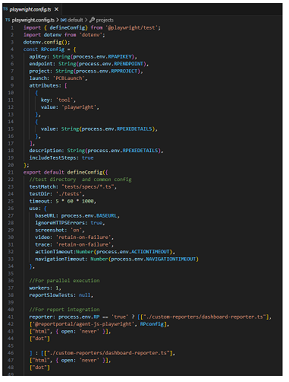

## **Folder Structure**

1. **utils** – Under utils user can see the utility files for playwright and other utility files.
2. **custom-reporters** -Under this user can see the custom reporter for dashboard integration.
3. **test-setup** – Under “test-setup” folder we have global setup and global teardown file. We can use this file in future if required.
4. **playwright-report** – Under this folder user can see the playwright report.
5. **tests** – Under “tests” folder user can see three folders naming “pages”, “specs” and “testdata”. The pages folder contains all the page classes, specs folder contains all the playwright tests and testdata folder contains test data Json file.

## **Jenkins Execution**

1. Navigate to the URL “[PlayerClubBooth-PW [Automation_CasinoProducts] [Jenkins] (igt.com)](https://jenkins19.devops.igt.com/job/Automation_CasinoProducts/view/All/job/PlayerClubBooth-PW/)”
2. Click on “Build with Parameters

1. From there select Test Type and click build button

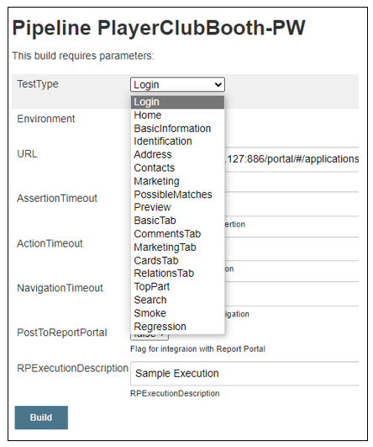

**Note**: You can choose modules from the list that you want to execute. If you choose “**Regression**” it will execute all the scripts

1. Once the execution done click on “Report” -> Click on “zip” to download the report

1. Extract the report and open “index.html”, that will show you the result.

## **Dashboard Result**

Once the execution is done user can see the result in dashboard. Here are the steps to see that.

* Navigate to the URL “[TestAutomation](http://10.210.82.248:3080/products)”
* Select product as “Player Club Booth”, select test type as “ui” and select product run as latest time stamp and click search. This will bring you the result below.

* You can view the log by clicking the Test case ID

## **Report Portal**

Once the execution is done or InProgress user can see the current result in Report portal. Please note that to log the result in report portal user must select “PostToReportPortal” should be “true” while executing

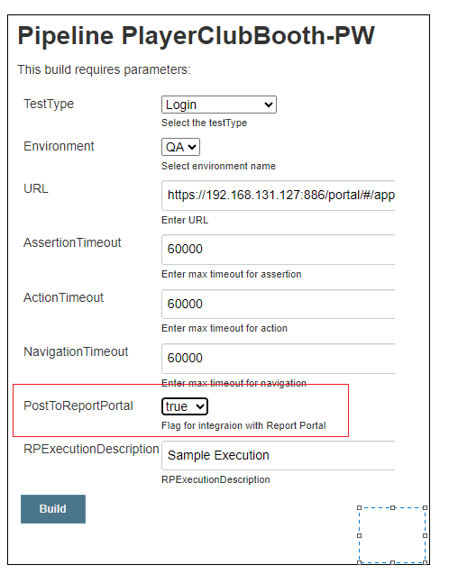

* Navigate to the URL [Report Portal](http://172.23.11.13:8080/ui/#login)
* Login using userId and password
* Select “PLAYERCLUBBOOTH” from the top of the page

* Now click on “DASHBOARD” from left menu and click “PLAYERCLUBBOOTHDASHBOARD”

* Now it will show the dashboard like below

* Click on Launches and click on any one of the Launches

* We can see the results with steps, screenshots and Videos(if failed)

