**Automation: Workaround for dependencies download problem on offshore Cloud PC with Eclipse IDE**

**Problem Statement**

Eclipse IDE, installed on Cloud PC assigned to offshore team, is not able to download certain plugins/jars for creating Maven/TestNg/Selenium/Java projects. It throws errors like the below screenshot. IT ticket has been created. While IT work is going on in the background, a workaround can be leveraged to get past this problem and continue with creating automated scripts.

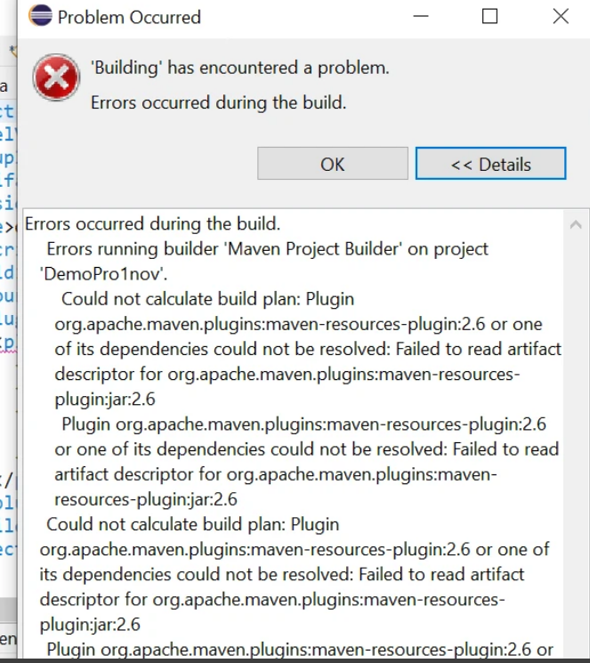

**Problems & Workarounds**

**Problem 1** - Dependencies could not be resolved on creating Maven project.

Workaround Steps:

1. Install Eclipse IDE with "Run as Admin" option.
2. Copy/Replace the attached .m2.7z file at: "C:\Users\<UserName>" after unzipping it (attachment: [.m2.7z](https://igt-casinosystems.atlassian.net/wiki/download/attachments/77299715/.m2.7z?version=1&modificationDate=1701455402220&cacheVersion=1&api=v2)) (these folders contain the basic jars/plugins for the above listed software components)
3. Open command prompt with "Run as Admin" option and run the following command after navigating to "C:\Users\<UserName>" directory: "**for /r %i in (*.lastUpdated) do del %i**"
4. Restart the Eclipse IDE with "Run as Admin" option and try to create a new Maven Project. This should resolve POM.xml issues while creating Maven projects.

**Problem 2**- POM.xml might throw a few more errors while adding dependencies in POM.xml.

***Note: The probability of happening this is low after following the above problem #1 workaround but a good step to add as a workaround.***

Workaround Steps:

1. Use the attached **setting.xml** (already placed in .m2 folder) and make sure that its path is correctly specified in Eclipse IDE under Window → Preferences→ maven→ User Settings  (attachment: [settings.xml](https://igt-casinosystems.atlassian.net/wiki/download/attachments/77299715/settings.xml?version=2&modificationDate=1701452809465&cacheVersion=1&api=v2))

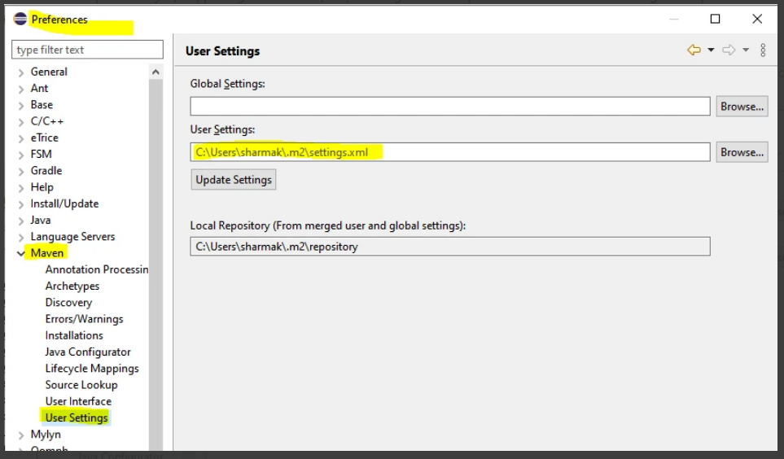

**Problem 3** - While using TestNg Annotation,  user might see errors related to unable to read repository for testng.org site.

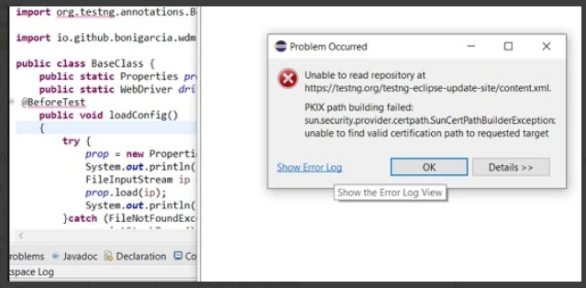

Workaround Steps:

1. Go to <https://testng.org/doc/> and download the certificate by clicking on the lock icon on the browser's address bar (Lock Icon testing.org) → Connection is secure → Certificate is valid→ Details → Export
2. Open command line with run as admin
3. Navigate to the folder where the certificate was download through cd command
4. Run the following command: ***keytool -trustcacerts -keystore "%JAVA_HOME%\lib\security\cacerts" -storepass changeit -importcert -alias testngrepo -file "***[***testng.org***](http://testng.org/)***.crt"***
5. If Eclipse IDE was open then close it and reopen it with "Run As Admin
6. TestNg can now be installed using any of the following methods:
   1. Eclipse->Help→ Eclipse MarketPlace -> search for TestNg → Install   **OR**
   2. Eclipse → Install new software → Add → <https://testng.org/testng-eclipse-update-site>  **OR**
   3. Go to <https://github.com/testng-team/testng-eclipse> and download testng jar zip. Then, Eclipse -> Install new software -> Add -> Give  local path and install all  → check all the trusted certificates.