WIREFRAME REFERENCE GUIDE
Assembly Module
Current-state context, functionality and screen inventory
PLPI Batch Assembly Record workflow | Stage 11 | Prepared 17 August 2026

ENTRY  Allocated assembly room | OWNER  Assembly Team | NEXT  Post-Assembly QC

1. Module context
The Assembly module is Stage 11 of the electronic Batch Assembly Record workflow. It receives batches after Production Control has completed verification and room allocation. Its controlled output is a completed, reconciled and electronically signed assembly record ready for Post-Assembly QC.
Workflow position: Pre-Assembly QC -> Production Control / Room Allocation -> Assembly Room -> Post-Assembly QC -> Pre-QP -> QP Release.

2. Business purpose
- Confirm that the correct batch, product, specimen and printed components are present in the allocated room.
- Record the batch start, team briefing and pre-start verification.
- Perform random sample and in-process checks during assembly.
- Reconcile issued, used, damaged and discrepant materials.
- Complete end-of-batch room clearance and retain an electronic audit trail.
- Move the finished batch to Post-Assembly QC only after all four pages are signed.

3. End-to-end user journey
Step | User action | System behaviour
1 | Find batch | Search the active queue by B&S batch number or manufacturing lot.
2 | Start batch | Confirm start; capture logged-in user and timestamp.
3 | Initial checks | Verify BAR, specimen, allocated room and received printed materials.
4 | Sample check | Confirm lot and expiry for each box received from Production Control.
5 | IPC checks | Complete time-based in-process checks; add extra IPC rows if needed.
6 | Reconcile | Record quantities received, used, damaged and discrepant; confirm room clearance.
7 | Finish batch | Sign all four pages, record finish audit data and hand off to Post-Assembly QC.

4. Screen inventory

4.1 Assembly batch queue
Shows active and completed batches, batch/lot identifiers, description, quantity, allocated room, status and action. The screen also presents demonstration check-in/check-out/break controls and staff attendance rows.
Figure 1. Assembly Room workflow - active and completed batch queue
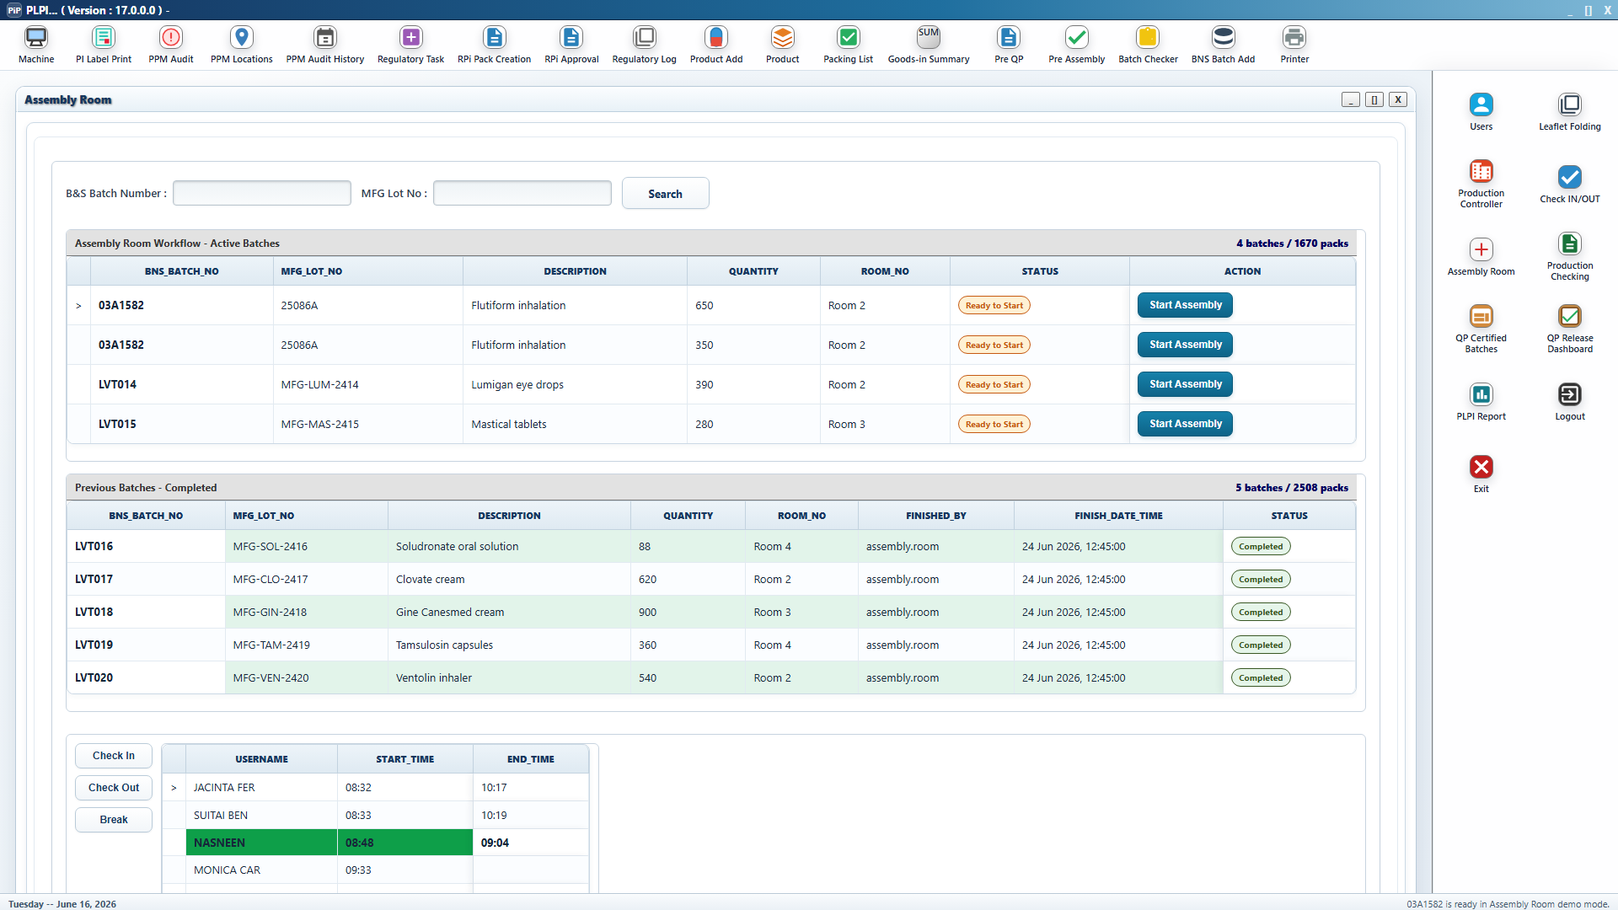

4.2 Start batch confirmation

Opening a batch that has not yet started raises a confirmation dialog. Accepting it records the current user and date/time as the Assembly Room batch start.
Figure 2. Start Batch confirmation and audit message
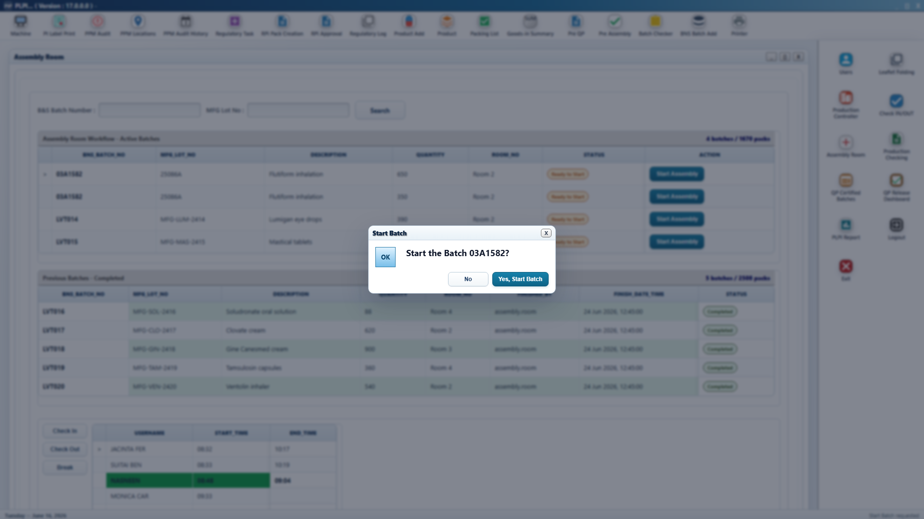

4.3 Initial Checks
Displays the batch identity strip, allocated room, lifecycle audit fields, briefing field and confirmations for the BAR, specimen and received materials. The page sign-off remains disabled until every required checkbox is selected.
Figure 3. Initial Checks and received-material verification
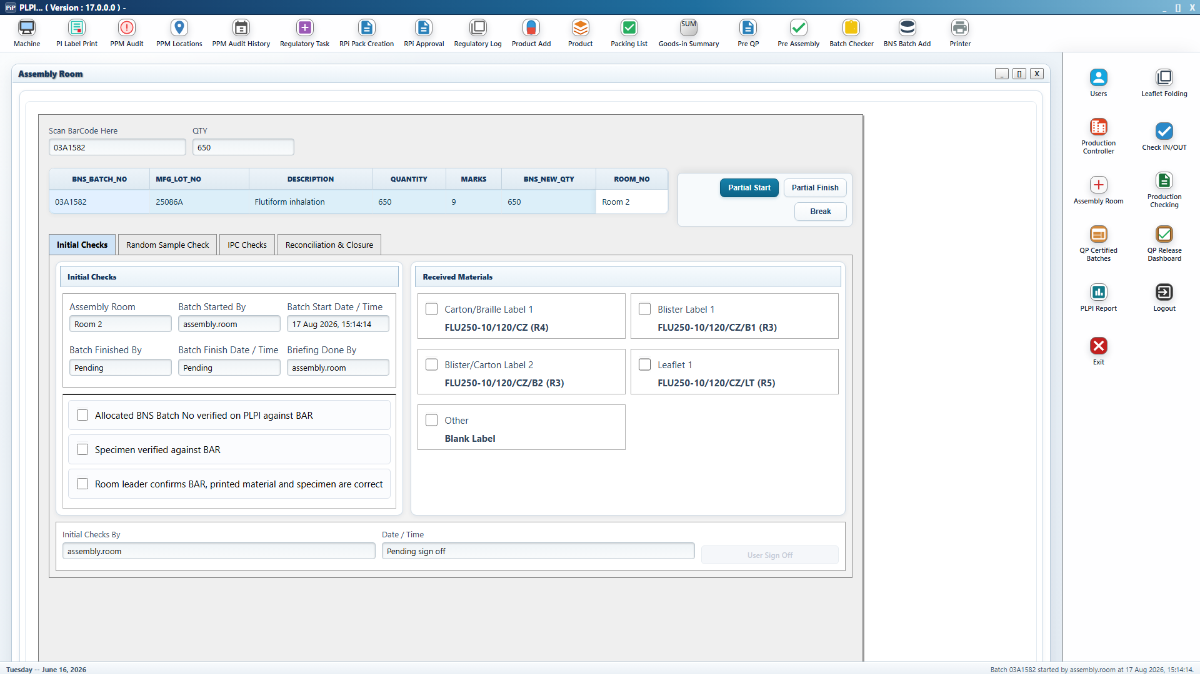

4.4 Random Sample Check

Creates one confirmation row per box passed from Production Control. Manufacturing lot and expiry are populated from the BAR details.
Figure 4. Random sample confirmation by box
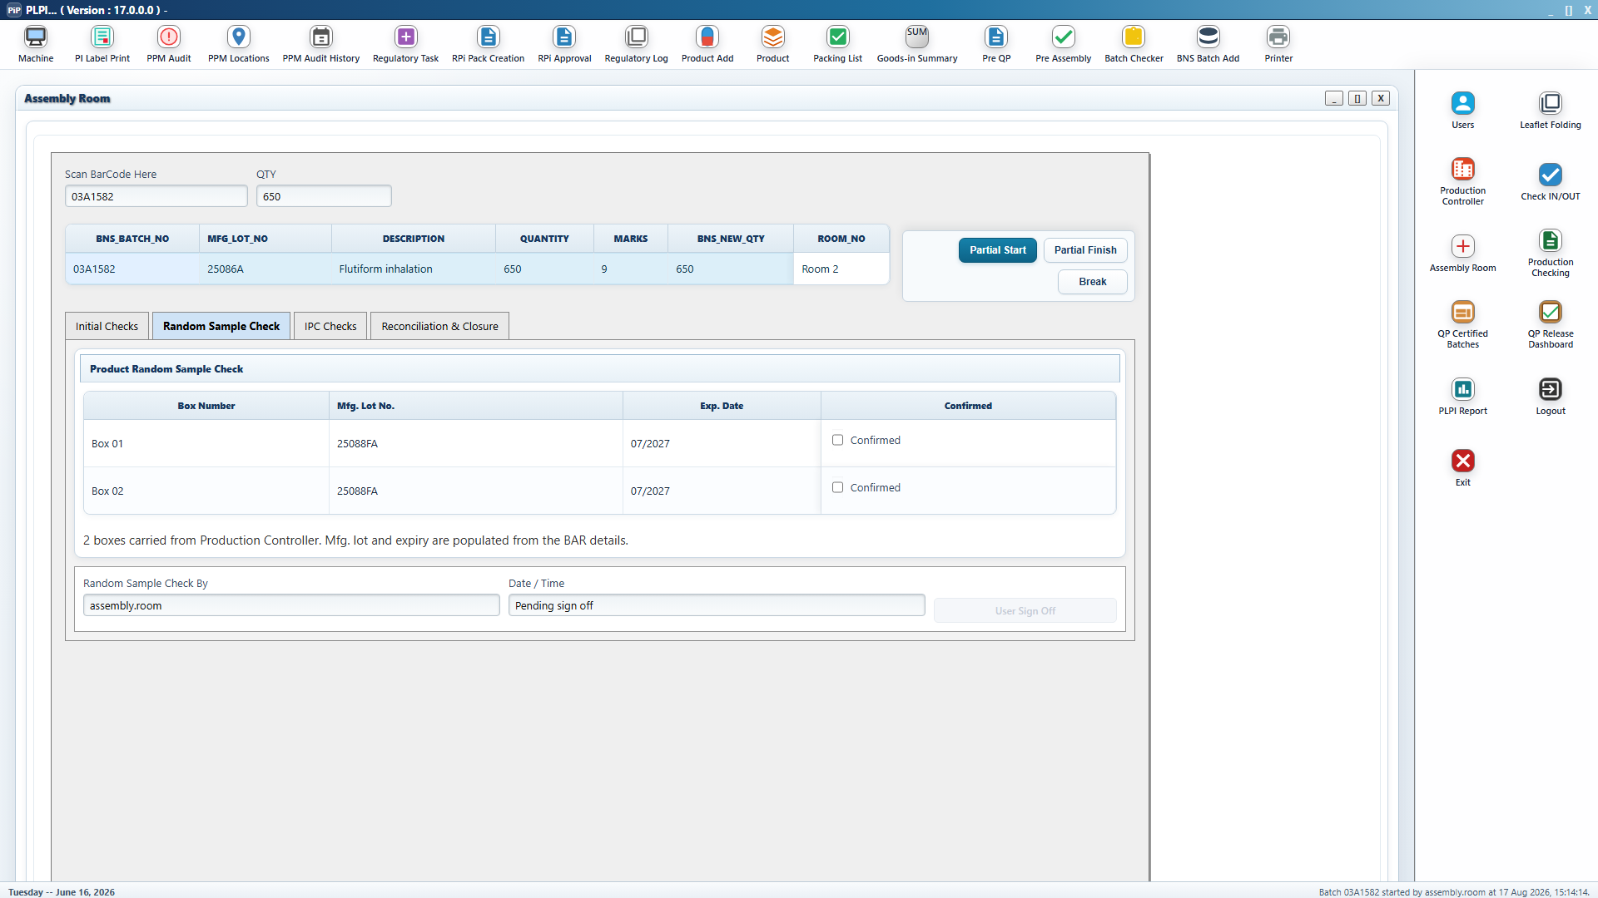

4.5 IPC Checks
Displays the estimated assembly time and minimum IPC count. Each IPC repeats the product identity data needed at the point of checking. Operators can add extra IPC rows.
Figure 5. In-process checks and product identity strip
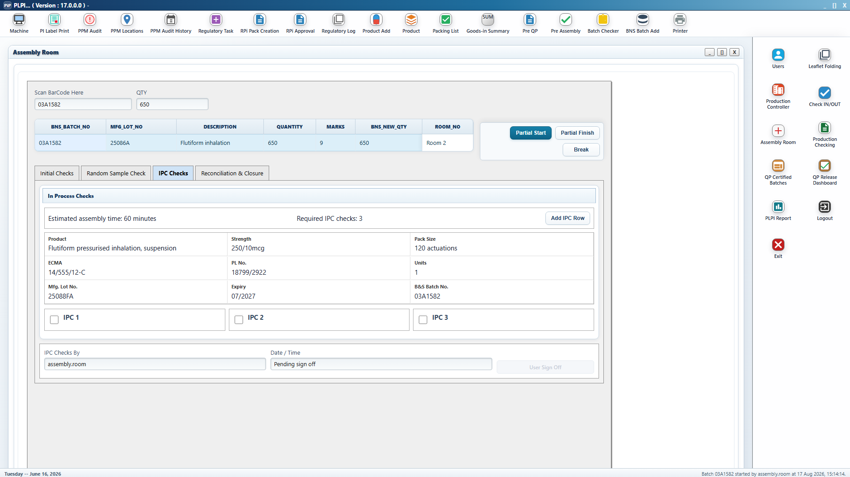

4.6 Reconciliation and Closure

Captures component quantities received, used, damaged and discrepant. It also records total use, retention sample, yield, damages and comments, followed by end-of-batch room-clearance confirmations.
Figure 6. Material reconciliation and end-of-batch clearance
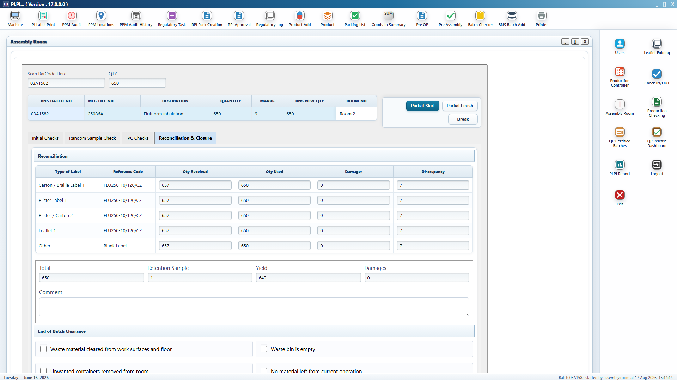

5. Functional requirements represented in the wireframe
Capability | Current behaviour | Maturity
Queue management | Active/completed queues; room and status visibility; batch and lot filtering | Partially interactive
Lifecycle audit | Start and finish user/date/time records | Interactive
Initial verification | BAR, specimen, room and component confirmation | Interactive with gating
Random samples | One confirmation per allocated box | Interactive with gating
IPC | Calculated minimum checks and additional IPC rows | Interactive
Reconciliation | Received, used, damages, discrepancy, yield and comments | Interactive; discrepancy auto-calculated
Clearance | Four end-of-batch clearance checks | Interactive with gating
Electronic sign-off | User/timestamp per page; page locks after sign-off | Interactive prototype
Handoff | Moves completed batch to Post-Assembly QC | Interactive prototype

6. Rules and completion gates
- The Initial Checks page cannot be signed until all material and pre-start confirmations are complete.
- The Random Sample Check page cannot be signed until every box is confirmed.
- The IPC page cannot be signed until all displayed IPC checks are complete.
- Reconciliation cannot be signed until its required checks and quantity fields are complete.
- Each signed page is locked and displays the signing user and timestamp.
- Signing the fourth page triggers Finish Batch confirmation and the Post-Assembly QC handoff.

7. Current prototype gaps to address in redesign
- Check In, Check Out, Break, Partial Start and Partial Finish are visual controls without implemented actions.
- Barcode scanning is displayed but has no scan validation or error-handling workflow.
- The Search button itself is not wired; filtering currently occurs from input changes.
- IPC photo evidence is described in the module definition but no evidence-upload control appears on the Assembly screen.
- There is no deviation, investigation or supervisor-override workflow for a non-zero discrepancy.
- Electronic sign-off is represented by a confirmation dialog rather than validated re-authentication.
- Prototype records are in memory and do not demonstrate durable storage, versioning or audit export.
- Check-in rows are demonstration data and are not linked to actual attendance actions.
- The reconciliation table pre-populates repeated example quantities across material types and needs component-specific data binding.

8. AI redesign brief
Redesign the Assembly module as a tablet-friendly, GxP-aware workflow for operators working in an allocated room. Preserve traceability and completion gates while reducing visual density and making the current task, outstanding requirements and exceptions immediately visible.

Essential redesign outcomes
- A clear progress stepper for Initial Checks, Samples, IPC and Reconciliation.
- Persistent batch identity, room, quantity, status and active operator context.
- Scan-first batch/component verification with visible match or mismatch feedback.
- Large touch targets and a focused task view suitable for tablets and handheld devices.
- Component-specific reconciliation with live expected balance and prominent discrepancy status.
- Evidence capture attached to the relevant IPC, exception or component row.
- A dedicated exception path with reason, evidence, supervisor review and resolution status.
- Validated electronic signature, audit history and clear locked/read-only states.
- Offline/interruption recovery, draft state and safe resume behaviour.
- Accessible colour contrast with status communicated by text and icon as well as colour.

Suggested prompt for a design AI
Using the supplied Assembly Module reference document and screenshots, redesign the Stage 11 Assembly Room workflow for a regulated pharmaceutical batch-record system. Create a desktop and tablet design with an active-batch queue, scan-first batch start, four-step guided checklist, component-level reconciliation, IPC evidence capture, exception handling, validated electronic signatures and a complete audit trail. Preserve all displayed batch identifiers and completion gates, but simplify hierarchy, reduce dense tables and make incomplete, warning, discrepancy, signed and locked states unambiguous. Produce screen variants for normal flow, mismatch, non-zero discrepancy, evidence upload, signature confirmation and completed handoff.

