PLPI - Key Changes in Pre Stage to Stage 14
1. Pre Stage: Driver and Goods-in Sign-Off  Phase – 1 recommendation  Phase – 2 recommendation | Documents: Driver and Goods-in Sign-Off  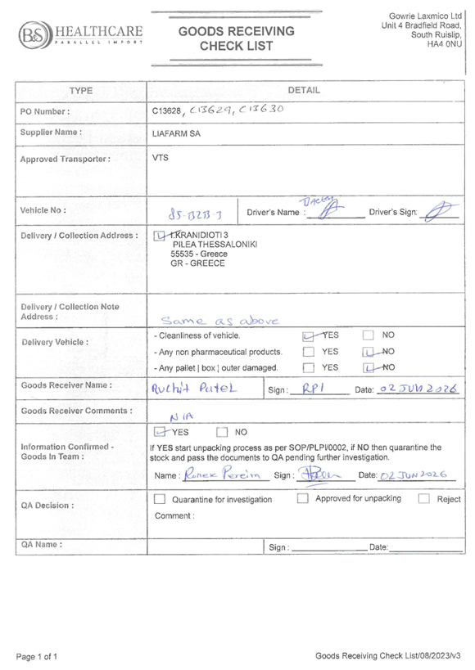
  Current Process Flow | Print Goods Receiving Checklist from WSC  (Goods-in) | → | Sign the printed checklist manually  (Driver and Goods-in)
  Proposed Process Flow | Fill in the form on the hand-held device and upload photo evidence (Goods-in)
  Benefits | • Reduces paper handling.  • Digitally available for the RP Pack.  • Prevents signed checklist from being lost.  • Improves traceability.
  Proposed Process Flow | AI enabled checks based on the attached evidence
  Benefits | • Reduces manual errors.  • Reduces time spent on manual checks

2. Stage 1: Packing List Verification
Update manually on the printed sheet and the system
incorrect
Current Process Flow | Print the packing List from PLPI and verify (Goods In)
correct
Verification
- Hand held device used to verify the count
- Manual counting if it is Italy or Greece product

Line clearance on the printed BAR Sheet
Phase 1 – Recommendation

Proposed Process Flow | Update Packing List directly in PLPI | → | Digital Line Clearance in PLPI
Documents: Packing List Verification
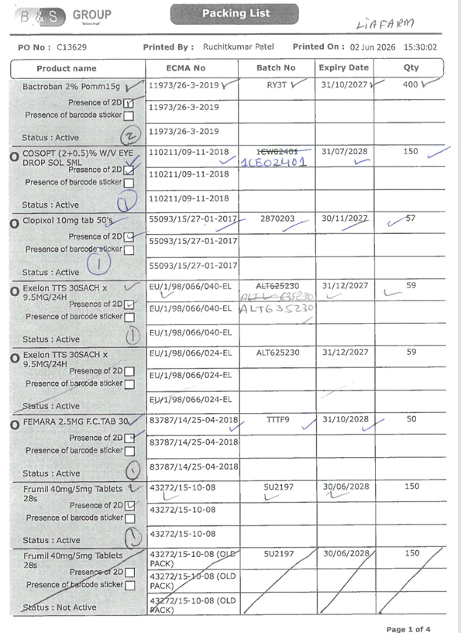

Benefits | • Reduces handwritten corrections.  • Keeps corrections visible in the system.  • Improves accuracy of quantity and box checks.

Phase – 2 recommendation
Proposed Process Flow | AI camera-based counting

Benefits | • Improves accuracy of quantity and box checks.  • Reduces manual counting time.

Notes:
- Hand held device used to scan the barcode to get the count of products but products from Italy or Greece, they don’t have any barcode to scan we have to do the manually counting

3. Stage 1: RP Pack Creation
Current Process Flow | - Download PO from WSC  - Download Packing list from PLPI | → | Supplier declaration & invoice is downloaded from email or placed in a common folder | → | - Download temperature record from VTS or physical copy  - Print goods checklist from PLPI | → | Compiles the physical RP Pack  (Goods-In)

Phase – 1 recommendation
For the reference images, refer to next page below
Proposed Process Flow | • Pull the PO & Packing list from the system.  • Upload the supplier declaration, invoice, and temperature record into the system

Benefits | • Reduces printing and manual pack preparation.  • Keeps all RP Pack documents in one place.  • Reduces missing-document risk.
Phase – 2 recommendation
Proposed Process Flow | The system pulls supplier documents and temperature from emails and VTS system

Benefits | • Makes document preparation faster.

Figure 1 Goods receiving checklist
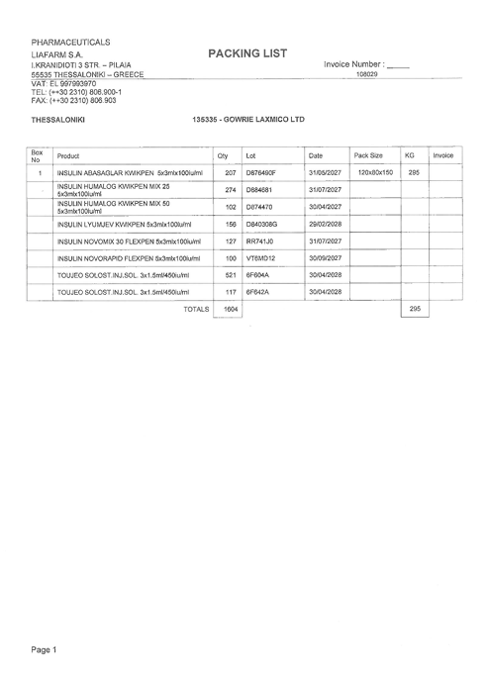
Figure 4 Supplier Packing List
Figure 2 Packing List
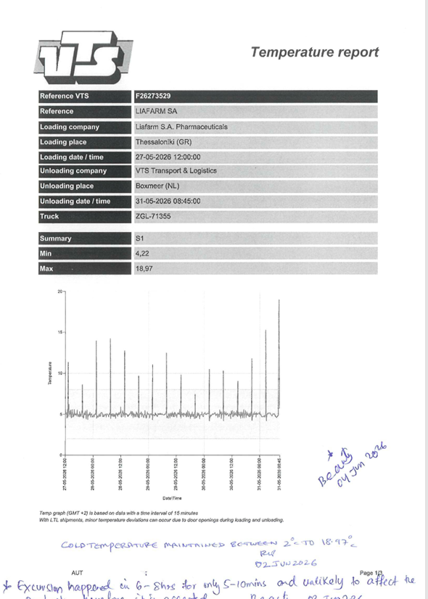
Figure 3 Temperature record
Stage 1 documents: RP Pack Creation

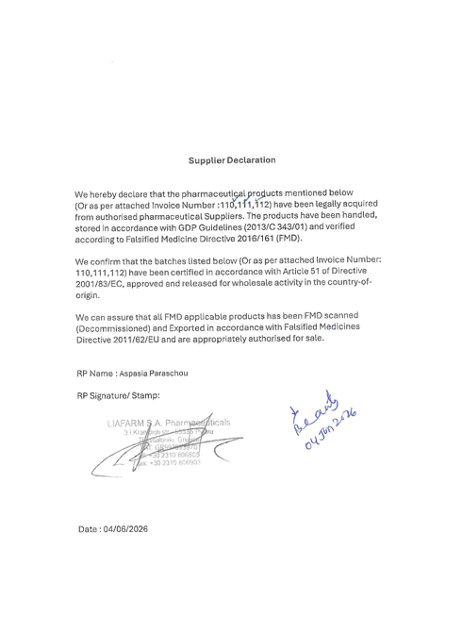
Figure 5 Supplier Declaration
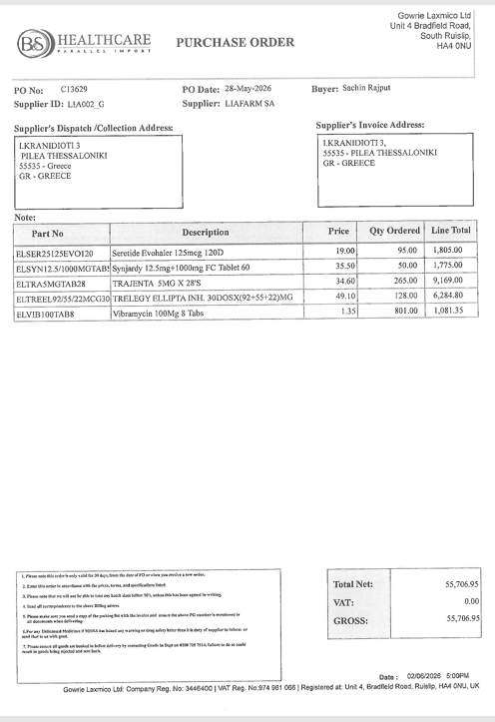
Figure 6 Purchase Order
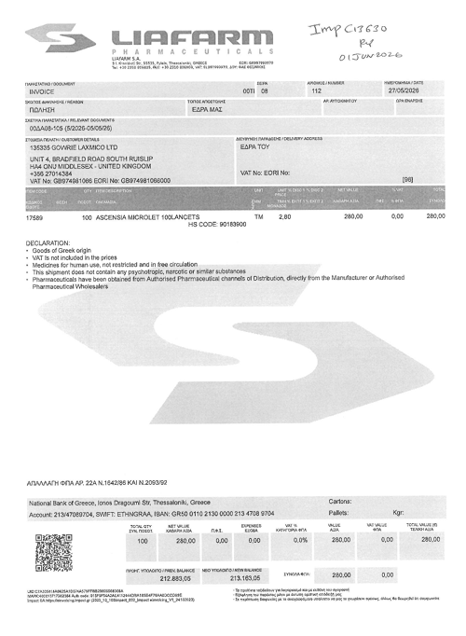
Figure 7 Supplier Invoice
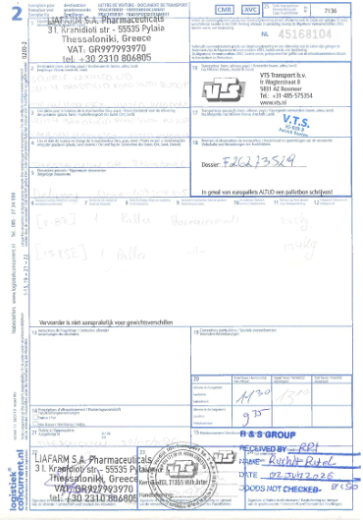
Figure 8 Delivery Details

4. Stage 2: RP Approval Module in PLPI
Current Process Flow | Printed RP Pack goes to RP review  (Goods In) | → | Review paper documents and physical approval  (RP)

Phase – 1 recommendation

Proposed Process Flow | RP views all files digitally and approves them in PLPI
NO reference image.
NEW MODULE to be designed
Benefits | • Reduces physical handoff of printed packs.  • Speeds up RP review and approval.  • Creates an electronic approval record.  • Strengthens audit trail.

Phase – 2 recommendation

Proposed Process Flow | RP receives a clear summary of missing items, mismatches and key batch details.  (AI implementation)

Benefits | • Speeds up RP review and approval.  • Strengthens audit trail.

5. Stage 3: Batch Checking
Phase 1 – Recommendation  Phase 2 – Recommendation | Documents: PCL  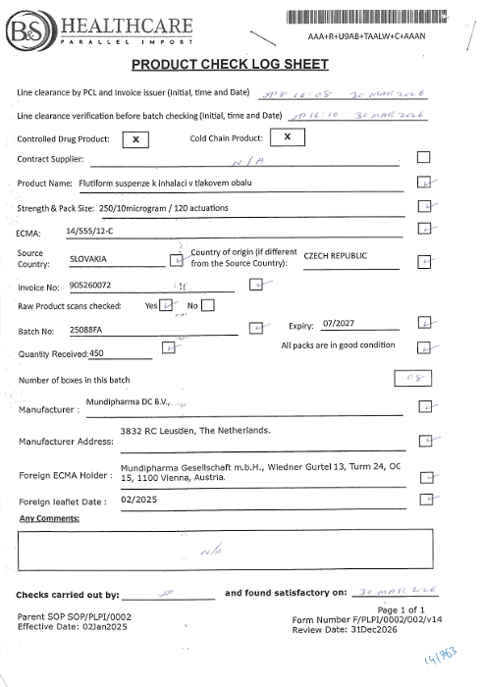
  Current Process Flow | Print Product Check Log sheet from PLPI | → | Manually check the product, batch, expiry, invoice, sample and documents  (Batch checker) | → | Manual Checks are done and physical line clearance on printed PCL  (Batch checker)
  Proposed Process Flow | Digital Product Check Log in PLPI | → | All the checks and line clearance are completed digitally, with photo evidence attached
  Benefits | • Reduces paper-based Product Check Log handling.  • Improves visibility of batch checking evidence.  • Makes sample and document evidence easier to retrieve.
  Proposed Process Flow | System validates product, batch, expiry, quantity and document details automatically using evidence attached  (AI implementation)
  Benefits | • Reduces missed or unclear checks.  • Strengthens audit trail.

6. Stage 4: BAR Creation
Phase 1 – Recommendation  Phase 2 – Recommendation | Documents: BAR Creation  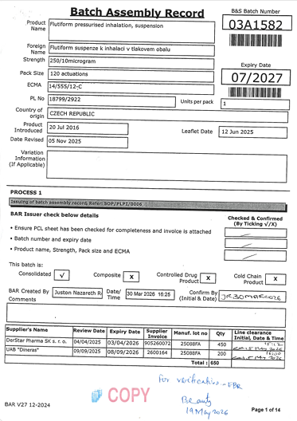
  Current Process Flow | BAR is printed from PLPI and checked manually against the PCL and sample on the paper. | → | Line clearance recorded on printed BAR
  Proposed Process Flow | BAR is reviewed digitally in PLPI, and digital line clearance
  Benefits | • Reduces paper prints.  • Improves traceability of user confirmation.  • Strengthens control before printing activities start.
  Proposed Process Flow | System verifies details automatically based on sample evidence.  (AI implementation)
  Benefits | • Reduces missed or unclear checks.  • Strengthens audit trail.

Documents: BAR Label printing
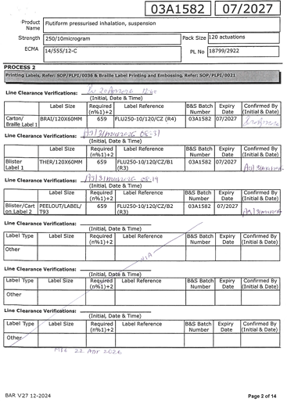

7. Stage 5: BAR - Label Printing
Current Process Flow | Scan batch number manually from the printed BAR sheet to populate label printing details in PLPI  (User) | → | Enters the quantity manually to print labels in the PLPI | → | First and last label evidence is attached to the BAR physically and line clearance on paper

Phase 1 – Recommendation

Proposed Process Flow | View batch records in queue with the auto calculated quantity on PLPI | → | label evidence and line clearance are captured digitally

Benefits | • Reduces manual label evidence handling.  • Improves control over label quantity and barcode confirmation.  • Makes label evidence easier to review.

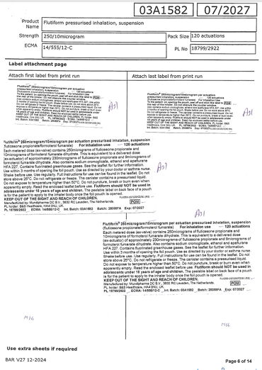

Phase 2 – Recommendation

Proposed Process Flow | System checks label details automatically based on sample evidence.  (AI Implementation)

Benefits | • Reduces risk of incorrect label details being used.

Documents – BAR – Leaflet Printing
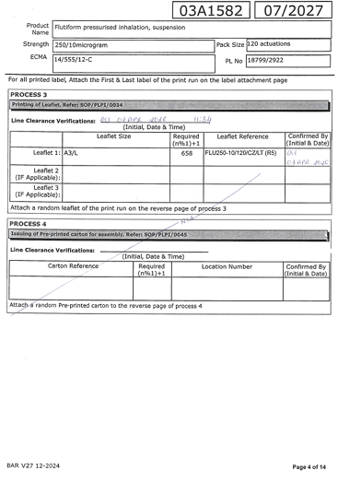
8. Stage 6: BAR - Leaflet Printing

Current Process Flow | Scan batch number manually from the printed BAR sheet using HHT to populate leaflet printing details in PLPI  (User) | → | Enter Leaflet quantity manually to print leaflet in PLPI | → | Manually cross check the printed leaflet with the reference leaflet available in PLPI | → | Master copy, foreign leaflet and line clearance are physically attached to BAR

Phase 1 – Recommendation

Proposed Process Flow | View batch records in queue on PLPI with the auto calculated quantity. | → | Master, foreign leaflet and approval are uploaded into PLPI

Benefits | • Reduces physical leaflet evidence handling.  • Improves control over leaflet quantity and version evidence.  • Makes leaflet evidence easier to retrieve.  • Supports a more complete electronic batch record.

Phase 2 – Recommendation

Proposed Process Flow | Auto checks of leaflet details based on sample and leaflet version available on the system.  (AI Implementation)

Benefits | • Reduces risk of incorrect leaflet being used.

Documents: BAR - Carton / Braille Preparation

9. Stage 7: BAR - Carton / Braille Preparation
Current Process Flow | Manual check to decide either of requirement (Carton or Braille) | → | Scan batch number manually from the printed BAR sheet using HHT to populate Carton / Braille details in PLPI  (User) | → | Required carton and/or braille quantity is manually entered in PLPI | → | Sample evidence and line clearance are attached to printed BAR

Phase 1- Recommendation

Proposed Process Flow | View batch records in the PLPI queue, showing whether carton and/or braille is required with auto calculated quantity. | → | Carton/braille sample evidence and line clearance are captured digitally and upload sample evidence

Benefits | • Gives clearer control of carton and braille route.  • Reduces reliance on printed route instructions.  • Improves visibility of carton and braille evidence.  • Reduces risk of missing packaging route evidence.

Phase 2 – Recommendation

Proposed Process Flow | System checks printed braille/carton based on reference images available on the PLPI system  (AI Implementation)
Benefits | • Reduces risk of incorrect braille/carton being used.

10. Stage 8: BAR - Leaflet Folding
Current Process Flow | Scan batch number manually on the printed BAR sheet using HHT to populate batch records which is currently in folding stage in PLPI  (User) | → | Line clearance and leaflet reference check are recorded manually
Documents: Leaflet Folding

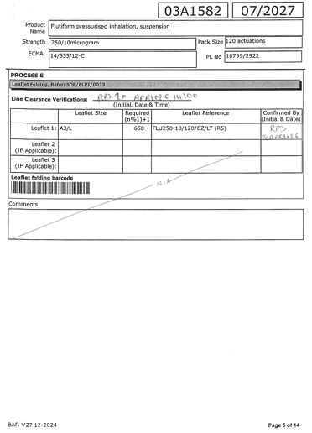

Phase 1 – Recommendation

Proposed Process Flow | View batch records currently at the Leaflet Folding stage in the PLPI queue | → | Leaflet folding checks, line clearance, and evidence are completed digitally in PLPI

Benefits | • Makes folding completion easier to prove.  • Reduces manual checklist handling.  • Improves visibility of who completed folding and when.  • Strengthens evidence before Pre-Assembly QC.

11. Stage 9: BAR - Pre-Assembly QC
Current Process Flow | Scan batch number manually from the printed BAR sheet using HHT to populate current batch on pre-assembly module in PLPI  (QC) | → | Mock-up is printed from PLPI and attached manually to the BAR sheet | → | Reference check, line clearance are manually attached to BAR Sheet

Phase 1 – Recommendation

Proposed Process Flow | View batch records currently at pre-assembly stage in the PLPI queue, including the mock-up | → | Reference check and line clearance are completed digitally and upload evidence of sample
Documents: Pre- Assembly QC
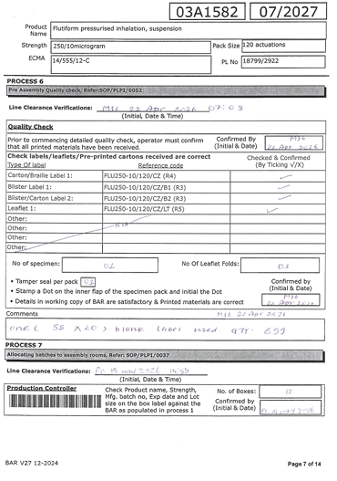

Benefits | • Reduces need to search through printed packs.  • Helps identify mismatches before assembly.  • Improves consistency of Pre-Assembly QC review.

Phase 2 – Recommendation

Proposed Process Flow | System validates the mock up with the sample made by QC  (AI implementation)

Benefits | • Reduces risk of manual error.

12. Stage 10: BAR - Production Control / Room Allocation
Current Process Flow | Scan batch number manually from the printed BAR sheet using HHT to locate the stock | → | Batch details are checked manually using the sample against the printed BAR. | → | Room allocation and line clearance are recorded manually on printed BAR

Phase 1 – Recommendation

Proposed Process Flow | View batch records currently at room allocation stage in the PLPI queue with the exact location | → | Room allocation and line clearance are recorded digitally

Documents: BAR - Production Control

Benefits | • Improves visibility of room assignment.  • Reduces manual room allocation records.

Phase 2 – Recommendation

Proposed Process Flow | PLPI shows room availability, priority batches, and scheduling conflicts.

Benefits | • Helps confirm readiness before assembly starts.

13. Stage 11: BAR - Assembly Room Operations
Current Process Flow | Scan batch number manually from the printed BAR sheet using HHT to start assembling for the particular batch | → | Line clearance, pre-start checks and IPC random checks are recorded on printed BAR | → | Reconciliation, damage and leftovers are attached manually to printed BAR Sheet

Phase 1 – Recommendation
For the reference images, refer to next page below
Proposed Process Flow | View batch records currently at the assembly stage in PLPI | → | Line clearance, pre-start checks, IPC random checks, reconciliation, damage and leftover details are captured digitally and upload evidence of sample

Benefits | • Reduces handwritten assembly records.  • Improves visibility of assembly progress and completion.  • Gives Pre-QP and QP stronger assembly evidence.

Phase 2 – Recommendation

Proposed Process Flow | System auto calculates reconciliation and highlights quantity differences.  (AI implementation)

Benefits | • Makes reconciliation easier to review.

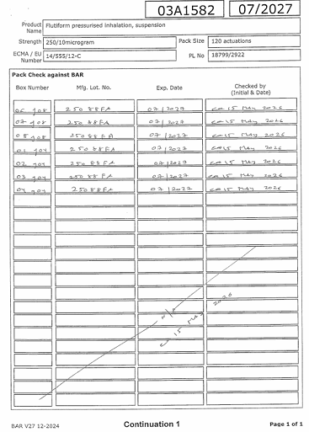
Figure 12 Random Sample Check
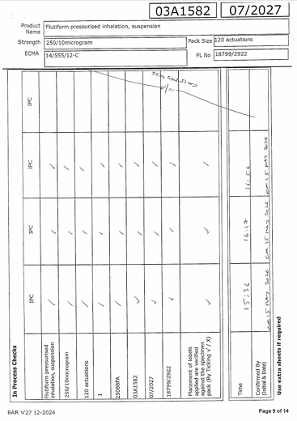
Figure IPC

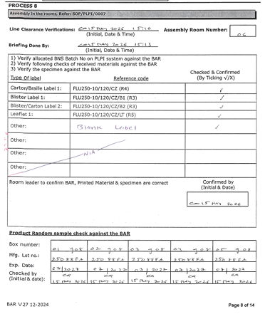
Figure 9 Line Clearance and Checks
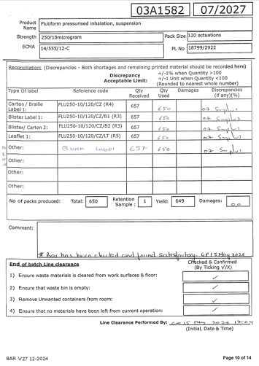
Figure 11 Reconciliation
Stage 11 Documents: BAR – Assembly Room
Documents: BAR – Post Assembly QC
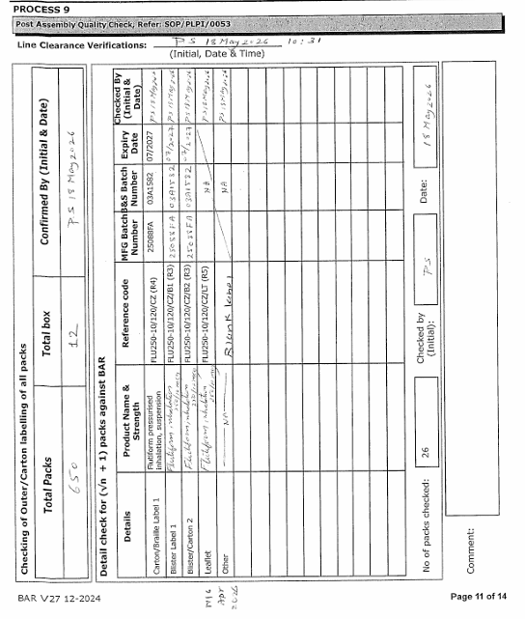
14. Stage 12: BAR - Post-Assembly QC

Current Process Flow | Sample checks and quantity checks are done manually and recorded in Printed BAR Sheet  (QC) | → | Line clearance is done manually on the printed BAR sheet

Phase – 1 recommendation
Proposed Process Flow | Sample checks, quantity checks, and line clearance are recorded digitally and upload evidence of sample

Benefits | • Strengthens control before stock moves to quarantine.  • Reduces risk of labels being printed before checks are complete.  • Supports better readiness for pre-QP review.

Phase – 2 recommendation
Proposed Process Flow | The system auto checks quantity using AI-based camera and sample check using photo evidence  (AI implementation)
Benefits | • Improves accuracy of quantity and box checks.  • Makes QP review clearer.

15. Stage 13: BAR - Pre-QP
Current Process Flow | Pre-QP reviews printed BAR pack | → | IPC photos and supporting evidence are manually checked on a separate PLPI screen | → | Line clearance is recorded on paper and green release log sheet printed manually

Documents: BAR – Pre QP
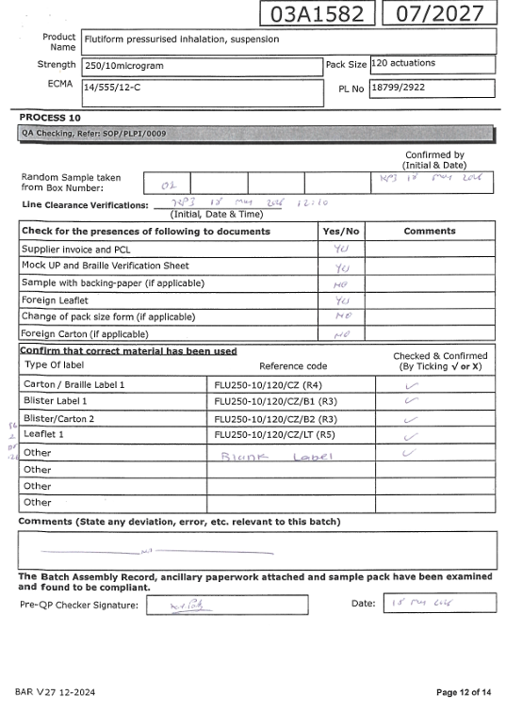
Phase 1 – Recommendation

Proposed Process Flow | Pre-QP views digital evidence pack in PLPI and checks are recorded digitally | → | Line clearance is completed digitally and digital release log is created

Benefits | • Reduces time spent searching across paper packs and evidence sources.  • Gives Pre-QP a clearer view of batch readiness.  • Reduces risk of QP receiving an incomplete batch pack.

Phase 2 – Recommendation

Proposed Process Flow | The system auto checks the details presented in the digital evidence pack and highlights the incorrect or missing data/file and creates summary (AI implementation)

Benefits | • Helps identify missing evidence before QP review.

Document: BAR – QP Approval
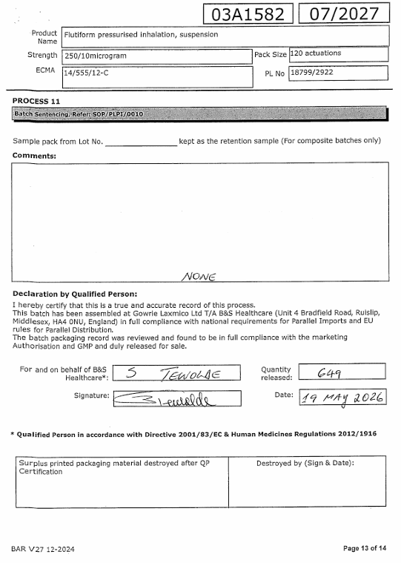

Stage 14: QP Approval / Batch Release
Current Process Flow | QP reviews printed batch pack | → | IPC and Batch summary records are checked separately on PLPI | → | QP signs approval manually

Phase 1 - Recommendation
Proposed Process Flow | QP opens the complete electronic batch pack in PLPI and completes the checks digitally | → | QP approval is completed electronically

Benefits | • Gives QP one structured evidence pack for final review.  • Reduces dependency on paper approval.  • Improves visibility of QMS checks before release.

Phase 2 - Recommendation
Proposed Process Flow | The system auto generates a clear release summary with exceptions, checks and final readiness status  (AI implementation)

Document: BAR – QP Release Log
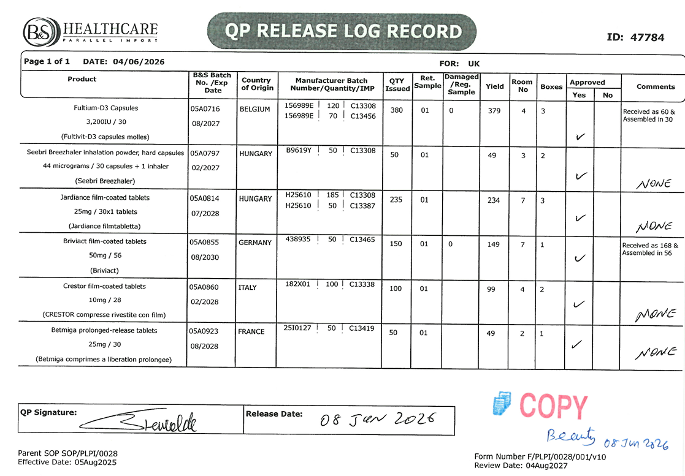

Benefits | • Strengthens final release control and audit trail.

NEW MODULE to be designed

