elow: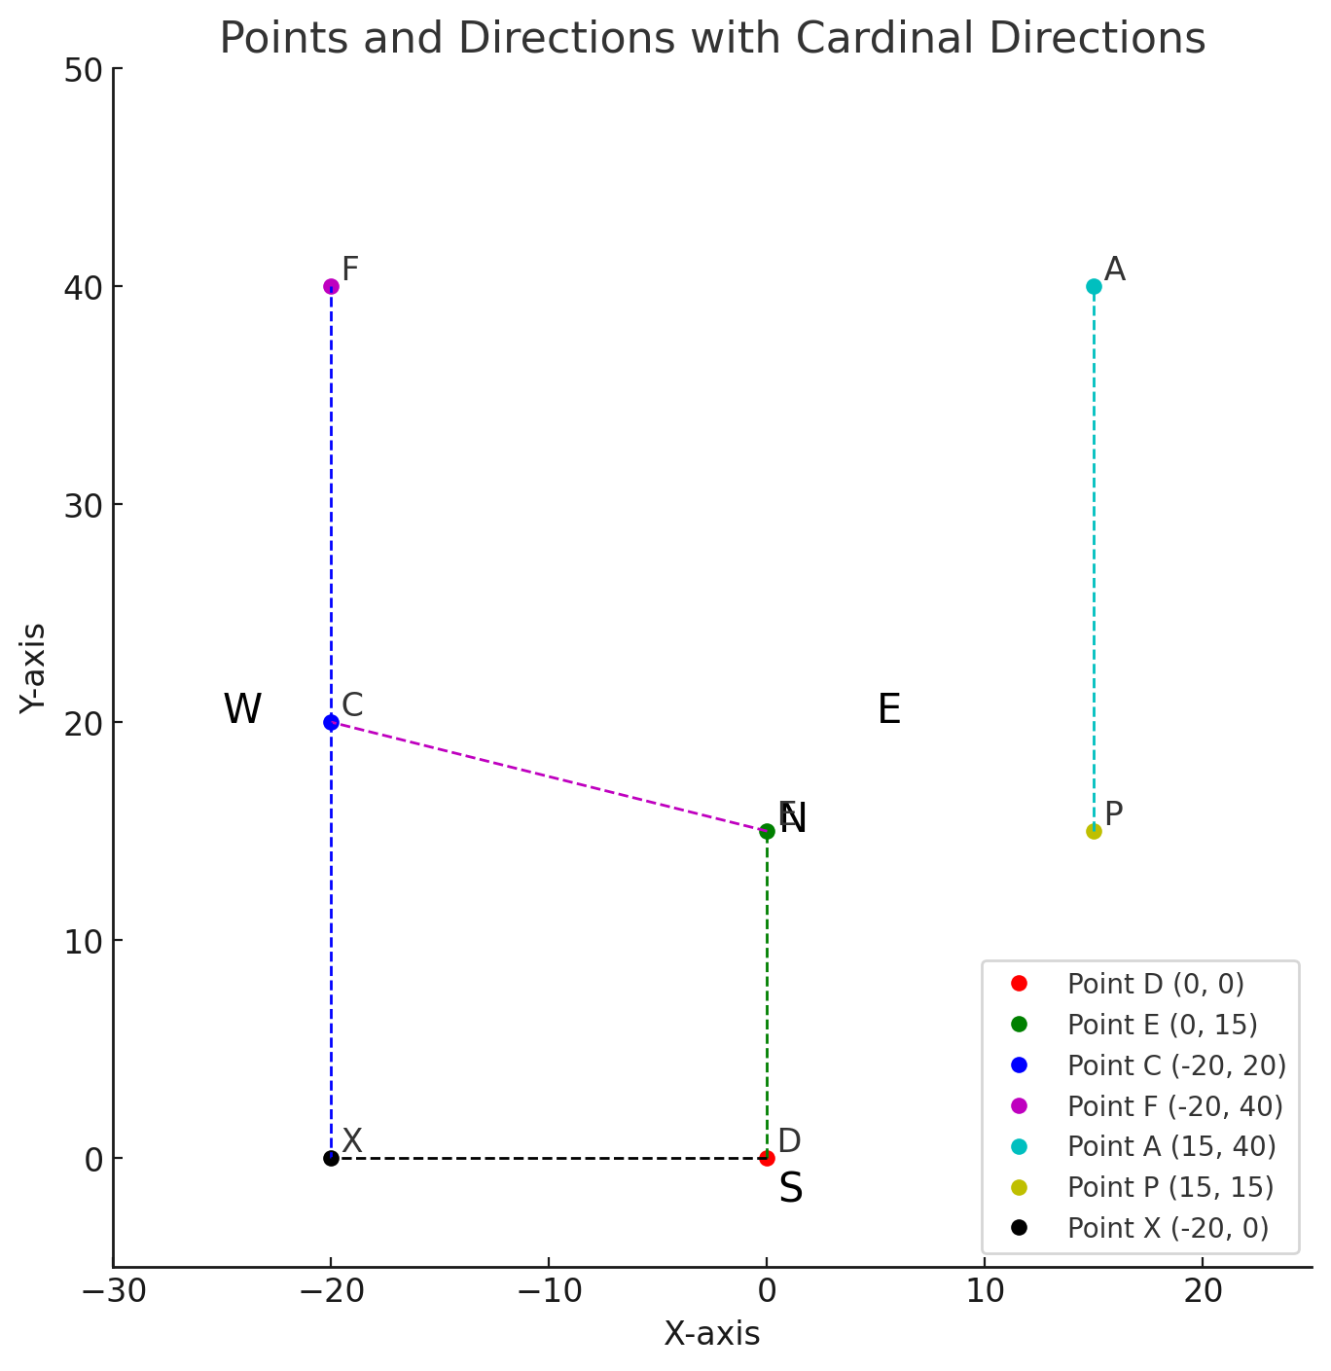

**Direction (1-3): Study the following information**

**carefully and answer the questions given below:**

**Point E is in 15m north of Point D. Point F is in 20m north**

**of Point C. Point A is in 35m east of Point F. Point P is in**

**25m south of Point A. Point E is in 20m east of Point P.**

**1. What is the direction of point F with respect to point**

**P?**

(a) North-west (b) North-east (c) South-west

(d) South-east (e) North

correct answer:(d) South-west

**2. Four of the following five are alike in a certain way**

**and hence they form a group. Which one of the**

**following does not belong to that group?**

(a) C-P (b) A-E (c) A-C

(d) P-D (e) F-E

Correct answer:(e) F-E

Solution: All are options are diagonals except F-E.

**3. If point X is 20m south of point C, then what is the**

**total distance between point X and point D?**

(a) 40m (b) 35m (c) 55m

(d) 65m (e) 85m

Correct answer: (c)55m

Solution: 35m+20m=55m

**Direction (4-5): Five people, A, B, C, D, and E, are standing in a park. The following conditions are known:**

**A is 20 meters north of B.**

**C is 65 meters east of A.**

**D is 35 meters south of C.**

**E is exactly in the middle of A and C.**

**F is 7.5 meters north-east of D.**

**Question 4:**

**What is the direction of B with respect to F?**

(a) South-west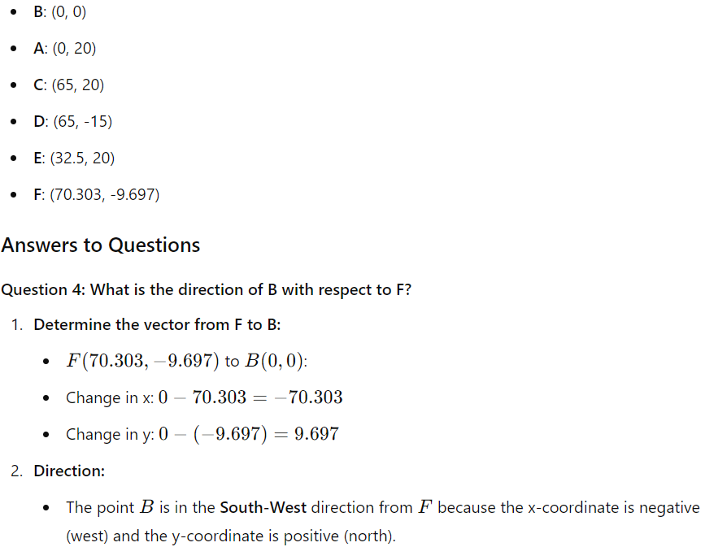

(b) North-west

(c) South-east

(d) North-east

(e) East

Correct answer: South-west

**Question 5:**

**What is the shortest possible distance between point B and point E?**

(a) 30 meters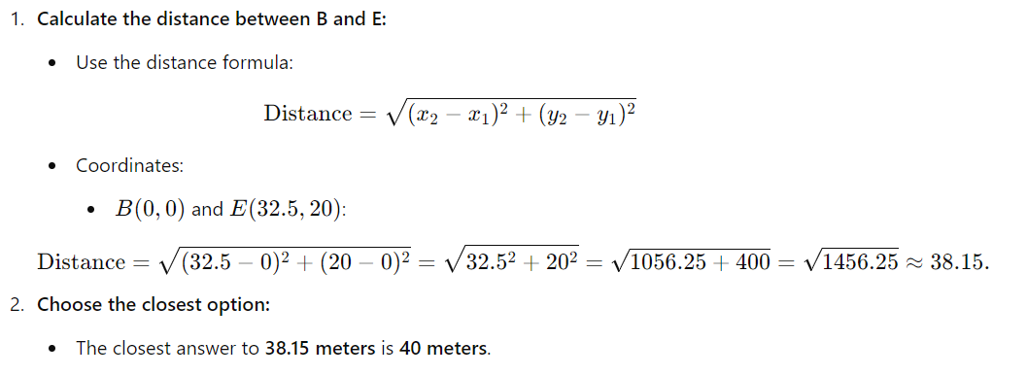

(b) 40 meters

(c) 50 meters

(d) 60 meters

(e) 80 meters

Correct answer:(b)40 meters

**Direction (6-7): In a city grid:**

* **House A is located at coordinates (2, 3).**
* **House B is located at (2, -1).**
* **House C is located at (5, 3).**
* **House D is at the midpoint between A and C.**
* **House E is 3 meters directly south of House D.**

**6. What are the coordinates of House E?**

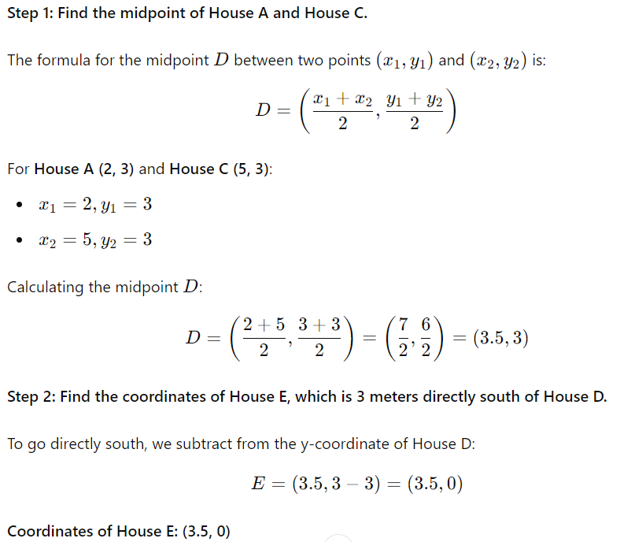

(a) (3.5, 0)

(b) (-3.5,0)

(c) (0, 3.5)

(d) (0, -3.5)

Correct answer: (a)

7**. Calculate the distance between House E and House B and E direction related to B.**

(a) Approximately 1 meters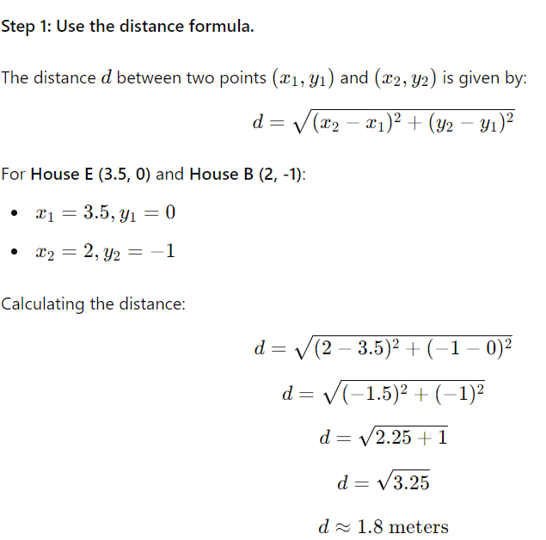

(b) Approximately 1.8 meters

(c) Approximately 2 meters

(d) Approximately 3.8 meters

Correct Answer: (b)

In a geometric town layout:

* **Point A** is located at coordinates (4, 6).
* **Point B** is 10 meters directly south of Point A.
* **Point C** is located at the midpoint between Points A and B.
* **Point D** is 15 meters to the east of Point C.
* **Point E** is 8 meters directly north of Point D.

**Questions:**

**8. What are the coordinates of Point E?**

**(a) E(1,9)**

**(b) E(9,19)**

**(c) E(19,9)**

**(d)** **E(9,9)**

**Correct answer: (c)**

Solution:

A(4,6)

B(4,6−10)=B(4,−4)

Average(A,B)=>C=(4,-4)

D(4+15,1)=D(19,1)

E(19,1+8)=E(19,9)

**9. Calculate the straight-line distance between Point A and Point E.**

**(a)12 meters**

**(b)13 meters**

**(c)14 meters**

**(d)15 meters**

**Correct answer:(d)**

Solution**:**

**Distance between A(4,6) and E(19,9) ≈15.33 meters**

**10. What is the distance and direction of Point B with respect to Point E?**

**(a) 18 meters Southwest**

**(b) 12 meters Southwest**

**(c) 15 meters Northeast**

**(d) 16 meters Northwest**

**Correct answer:(a)**

**Solution: Distance between B and E is ≈18.03 meters and direction is below**



