Advanced Web Technologies Lab
Ex 2: Develop a Registration Page Login Page with the following fields and Apply CSS.
Create a registration page with the following fields
1) Name (Text field)
2) Password (password field)
3) E-mail id (text field)
4) Phone number (text field)
5) Sex (radio button)
6) Date of birth (3 select boxes)
7) Languages known (check boxes – English, Telugu, Hindi, Tamil)
8) Address (text area)
Create a Login Page with the following fields
1) Name (Text field)
2) Password (password field)
3) Login and Reset button
HTML Code:
Create a registration page with the following fields
<html>
<head>
<title>Login Page</title>
<style>
body {
font-family: Arial, sans-serif;
background-color: #f4f4f4;
padding: 20px;
}
h2 {
text-align: center;
color: #444;
}
form {
background-color: #fff;
width: 400px;
margin: auto;
padding: 20px;
border-radius: 10px;
box-shadow: 0 0 10px rgba(0,0,0,0.1);
}
label {
display: block;
margin-top: 10px;
font-weight: bold;
}
input[type="text"],
input[type="password"] {
width: 100%;
padding: 8px;
margin-top: 5px;
border-radius: 5px;
border: 1px solid #ccc;
}
.form-buttons {
text-align: center;
margin-top: 20px;
}
.form-buttons input {
padding: 10px 20px;
margin: 0 10px;
border: none;
border-radius: 5px;
background-color: #28a745;
color: white;
cursor: pointer;
}
.form-buttons input[type="reset"] {
background-color: #dc3545;
}
.form-buttons input:hover {
opacity: 0.9;
}
</style>
</head>
<body>
<h2>Login Form</h2>
<form>
<label for="login-name">Name:</label>
<input type="text" id="login-name" name="name" required>
<label for="login-password">Password:</label>
<input type="password" id="login-password" name="password" required>
<div class="form-buttons">
<input type="submit" value="Login">
<input type="reset" value="Reset">
</div>
</form>
</body>
</html>

OUTPUT:
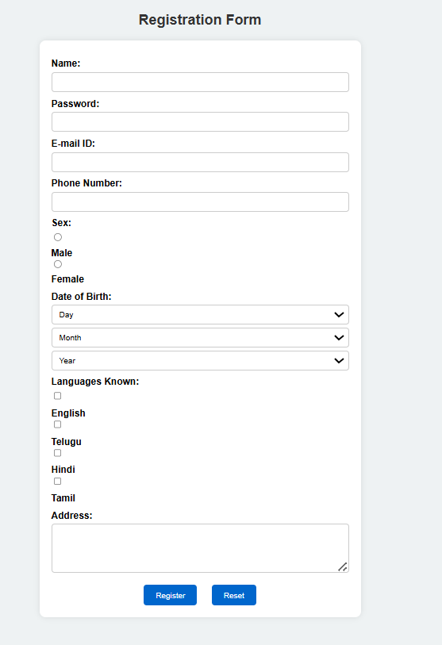
Create a Login Page with the following fields

<html>
<head>
<title>Login Page</title>
<style>
body {
font-family: Arial, sans-serif;
background-color: #f4f4f4;
padding: 20px;
}
h2 {
text-align: center;
color: #444;
}
form {
background-color: #fff;
width: 400px;
margin: auto;
padding: 20px;
border-radius: 10px;
box-shadow: 0 0 10px rgba(0,0,0,0.1);
}
label {
display: block;
margin-top: 10px;
font-weight: bold;
}
input[type="text"],
input[type="password"] {
width: 100%;
padding: 8px;
margin-top: 5px;
border-radius: 5px;
border: 1px solid #ccc;
}
.form-buttons {
text-align: center;
margin-top: 20px;
}
.form-buttons input {
padding: 10px 20px;
margin: 0 10px;
border: none;
border-radius: 5px;
background-color: #28a745;
color: white;
cursor: pointer;
}
.form-buttons input[type="reset"] {
background-color: #dc3545;
}
.form-buttons input:hover {
opacity: 0.9;
}
</style>
</head>
<body>
<h2>Login Form</h2>
<form>
<label for="login-name">Name:</label>
<input type="text" id="login-name" name="name" required>
<label for="login-password">Password:</label>
<input type="password" id="login-password" name="password" required>
<div class="form-buttons">
<input type="submit" value="Login">
<input type="reset" value="Reset">
</div>
</form>
</body>
</html>

OUTPUT:
