**Control Systems ECC 402**

**BACHELOR OF TECHNOLOGY ELECTRONICS & COMMUNICATION ENGINEERING**

By

**Yogesh Jindal**

**22263**



**SCHOOL OF ELECTRONICS**

**INDIAN INSTITUTE OF INFORMATION TECHNOLOGY, UNA HIMACHAL PRADESH**

**2024**

**TABLE OF CONTENTS**

|  |  |  |
| --- | --- | --- |
| **S No** | **Name of Experiment** | **Page no.** |
|  |  |  |
|  |  |  |
|  |  |  |
|  |  |  |
|  |  |  |
|  |  |  |
|  |  |  |
|  |  |  |
|  |  |  |
|  |  |  |
|  |  |  |
|  |  |  |
|  |  |  |
|  |  |  |
|  |  |  |
|  |  |  |
|  |  |  |
|  |  |  |

## Experiment No. 1

## Aim of the Experiment:

## Dynamic modeling of a mass spring damper system using MATLAB and Simulink.

## Software:

MATLAB and Simulink

## Background:

The dynamic modeling of a mass-spring-damper system serves as a fundamental exploration into the principles governing mechanical systems' behavior and response to external forces. This system, often encountered in engineering and physics, comprises three essential components: a mass, a spring, and a damper.

**Mass (m):** Represents the inertial property of the system, accounting for its resistance to changes in motion.

**Spring (k):** Symbolizes the stiffness of the system. Springs exert forces proportional to the displacement, causing the system to oscillate.

**Damper (c):** Introduces damping, dissipating energy and controlling the rate of oscillation. Damping is crucial in real-world systems to prevent uncontrolled vibrations.

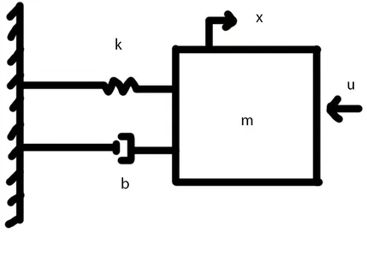

**Figure 1:** Schematic diagram of a Mass spring damper system

The 2nd order differential equation of the mass spring damper system is given by equation (1).

ƒ(𝑡) = 𝑀 𝑑2𝑥

𝑑𝑡2

+ B𝑑𝑥

𝑑𝑡

+ K𝑥 ......(1)

Where,

* M is the mass of the object
* B is the damping coefficient
* K is the spring constant
* x is the displacement of the object from its equilibrium position
* F(t) is the external force acting on the object at time t

|  |  |  |
| --- | --- | --- |
| **Parameter** | **Symbol** | **Value** |
| Mass | M | 0.25 Kg |
| Damping Coefficient | B, B1, B2 | 0, 0.9, 2 N s/m |
| Spring Coefficient | K | 1 N/m |

## Table 1: Various parameters of the MSD system

## Procedure:

1. Design the model using MATLAB Simulink as shown in Figure 2.
2. Make three subsystems of the model designed above as shown in Figure 3, with three different values of damping constant (B, B1, B2).
3. Put the above specified values in the command window.
4. 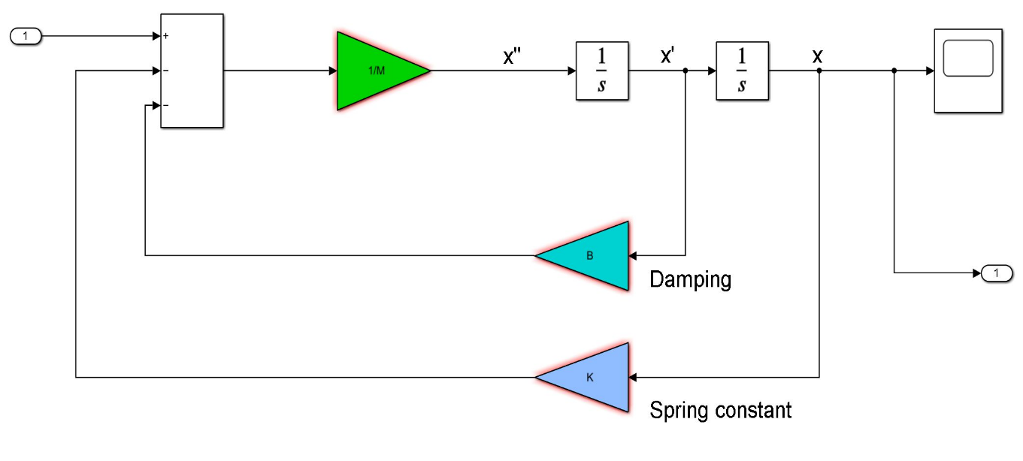Run and obtain the required plots i.e. displacement in x-direction w.r.t time

**Figure 2:** Simulink Model of the Spring Mass Damper System

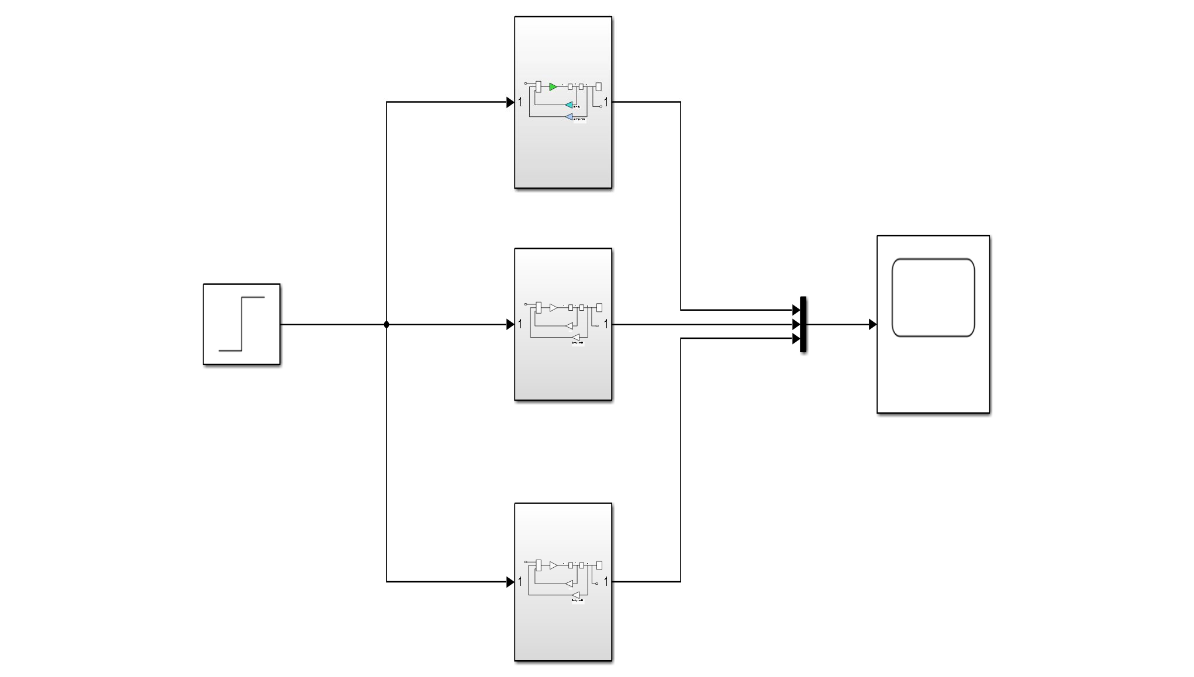**Figure 3:** Simulink model for three different subsystems

## Applications:

* Dynamic modeling of mass-spring-damper systems finds applications in mechanical design, automotive suspension, structural vibration analysis, control system optimization, and robotics.
* It is crucial in aerospace engineering for flight control and seismic analysis. Additionally, it plays a role in biomechanics, energy harvesting, and serves as an educational tool for hands-on learning.
* The versatility of this modeling extends its impact across various engineering disciplines, influencing the design and performance of complex system.

## Experiment No.2

**Aim of the Experiment:**

Dynamic modeling of a speed control of a Dc motor using MATLAB and Simulink.

## Software:

MATLAB and Simulink

## Background:

Dynamic modeling of DC motor speed control is a foundational process aimed at mathematically representing the behavior of DC motors in response to varying inputs. DC motors are extensively used in diverse applications due to their simplicity and precise control characteristics. Understanding the dynamic behavior of these motors is essential for designing efficient and responsive control systems.

**DC Motor Basics:** A DC motor consists of a stator (field winding) and a rotor (armature winding).When a voltage is applied to the armature, a magnetic field is created, causing the rotor to rotate.

**Equations of Motion:** The dynamic behavior of a DC motor is described by a set of differential equations, such as the electrical and mechanical equations. The electrical equation relates the armature current to the voltage and resistance.

The mechanical equation relates the torque to the armature current and back electromotive force (EMF).model the dynamics of a DC motor speed control system. The equation relates the speed of the motor to the applied voltage and the mechanical parameters of the motor. The equation is as given as follows :



 ....(2)

where:

* J is the moment of inertia of the rotor
* θ is the angular position of the rotor
* b is the coefficient of viscous friction
* Kt is the motor torque constant
* Ke is the Electromotive force constant
* V is the applied voltage
* i is the motor current

**1: Various parameters of dc motor**

|  |  |  |
| --- | --- | --- |
| **Parameters** | **Symbol** | **Values** |
| Moment of inertia of the rotor | J | 0.01 Kg.m2 |
| Motor viscous friction  constant | b | 0.1 N.m.s |
| Electromotive force constant | Ke | 0.01 V/rad/sec |
| Motor torque constant | Kt | 0.01 N.m/Amp |
| Electric resistance | R | 1 ohm |
| Electric inductance | L | 0.5 H |

## Procedure:

1. Design the model using MATLAB Simulink as shown in Figure 1.
2. Put the above specified values in the command window.
3. Run and obtain the required plots for Number of rotations w.r.t time.

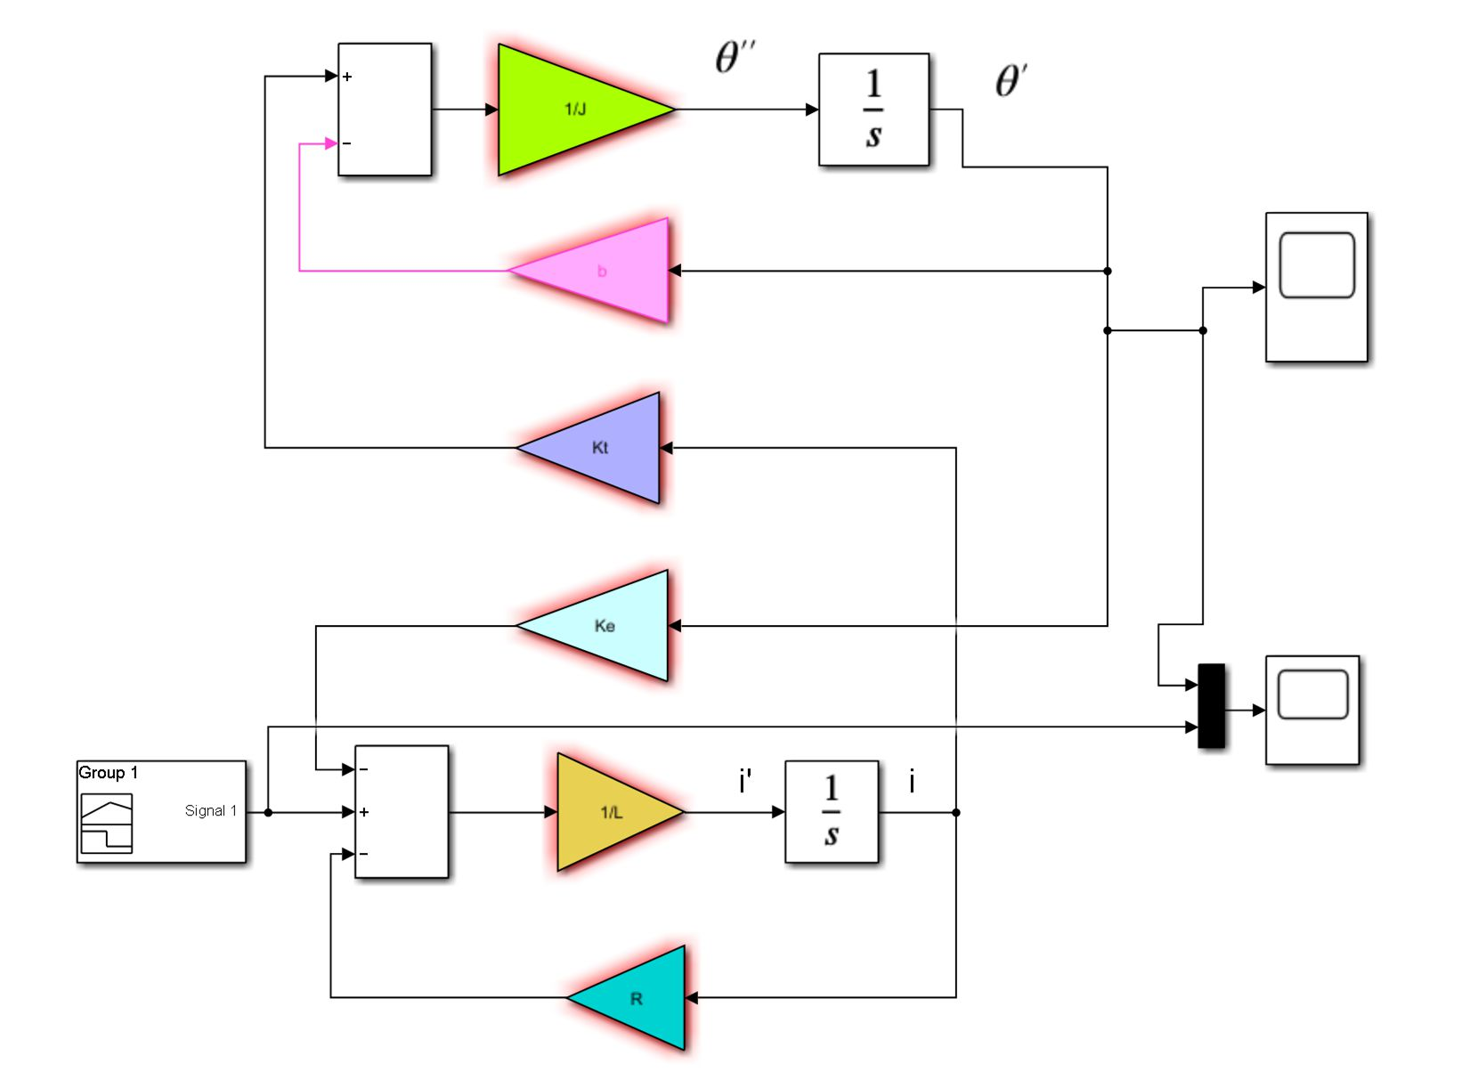

**Figure 1:** Simulink Model of DC motor speed control System

## Applications:

* **Industrial Automation:** Dynamic modeling supports the optimization of DC motor speed control for industrial automation systems, enhancing precision in manufacturing processes and conveyor belt operations.
* **In robotics,** where precise and responsive motion control is critical, dynamic modeling aids in designing control systems for DC motors powering robotic joints and actuators.
* DC motors are prevalent in **electric vehicles**. Dynamic modeling assists in designing control algorithms to optimize the speed and efficiency of electric vehicle propulsion systems.

## Experiment 3

**Aim of the Experiment:**

Study the time response of 1st order systems with standard test signals.

## Software:

MATLAB and SIMULINK

## Background:

The time response analysis of first-order systems is a fundamental aspect of control engineering, providing insights into how these systems behave when subjected to different input signals. First-order systems are characterized by a single energy storage element, typically modeled as a simple RC circuit or a single integrator in control theory.

The time response of the system is combination of steady-state response and transient response. The transient response is the part of the output which tends to zero as time tends to infinity and the remaining part of the output represents steady state response.

1

Transfer function of a first order system is given as G(S)=

𝑐𝑠+1

Where, **Ƭ** is the time constant. The time constant represents the time required for the system to attain 63.2% of its steady-state value.

## 

## Procedure:

1. Write a MATLAB code for a 1st order system with different values of Ƭ.
2. Make three systems with time constant as Ƭ, Ƭ/2 and 2Ƭ, where Ƭ is last two digits of your roll number i.e.24.
3. Plot all the systems with different standard input signals such as impulse signal, step signal, ramp signal and parabolic signal.

## MATLAB Code:

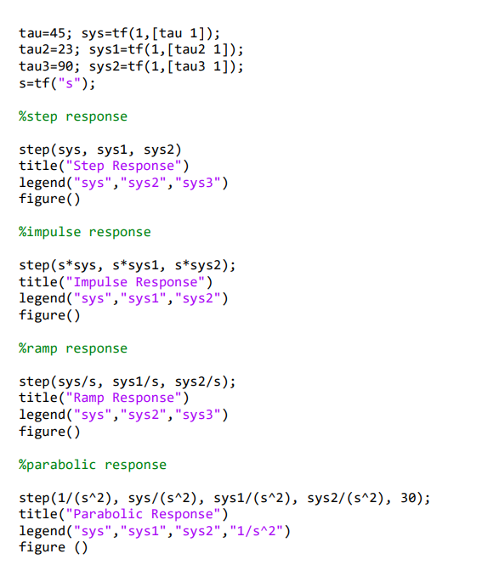

## 

**Applications :**

* Thermal Systems: Thermal systems, including heat transfer and temperature control, often exhibit first-order characteristics. Time response analysis is valuable in designing efficient thermal management systems.
* Aerospace Engineering: Control systems in aerospace applications, such as aircraft autopilots, benefit from time response analysis for stability and response time considerations.
* Biomedical Systems: Physiological systems often exhibit first-order dynamics. Time response analysis is employed in the study of biological systems, such as drug delivery and physiological response

## Experiment 4

**Aim of the experiment:**

Study the time domain performance parameters of the 1st order systems.

## Software:

MATLAB and SIMULINK.

## Background:

## Time domain performance parameters provide insights into the dynamic behavior of systems, particularly first-order systems. These parameters are crucial for evaluating system response characteristics. Consider a first-order system described by the transfer function:

Rise Time :The time taken for the response to rise from 10% to 90% of the final value.It measures the speed of response.

2. Settling Time :The time required for the response to reach and stay within a specified percentage (commonly 2% or 5%) of the final value.Indicates how quickly the system reaches a stable state.

3. Peak Time :The time at which the response reaches the first peak.Reflects the oscillatory behavior of the system.

## Understanding and analyzing these time domain performance parameters provide engineers and researchers valuable information for tuning and optimizing first-order systems to meet specific requirements. The choice of these parameters depends on the desired system behavior and application constraints.

## Procedure:

1. Write a MATLAB code for a 1st order system with different values of Ƭ.
2. Make three systems with time constant as Ƭ, Ƭ/2 and 2Ƭ, where Ƭ is last two digits of your roll number i.e.63.
3. Plot all the systems with different standard input signals such as impulse signal, step signal, ramp signal and parabolic signal and also calculate various parameters of different systems.

#### 

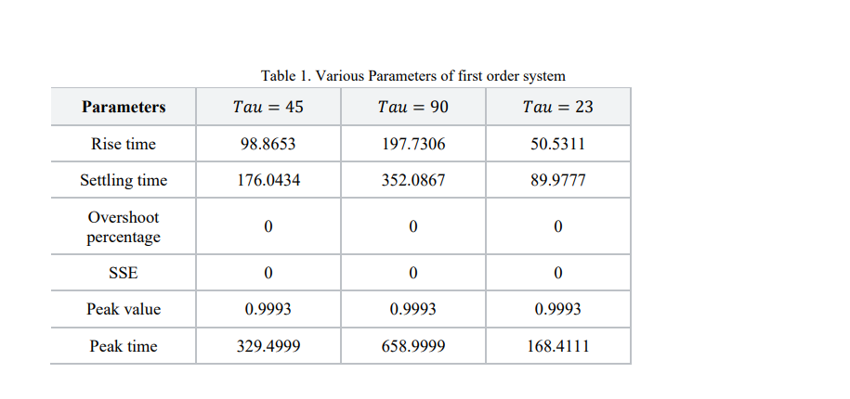

## Applications:

* Power Systems:In electrical power systems, time domain analysis helps in understanding and controlling the dynamic behavior of the system, ensuring grid stability.
* Robotics and Automation:In robotics, time domain analysis guides the design and control of robotic systems, enhancing their responsiveness and efficiency.
* Process Industry:Industries such as petrochemical and manufacturing use time domain analysis to optimize processes, control variables, and enhance overall system performance

## Experiment 5

**Aim of the experiment:**

Study the time response of the 2nd order systems with standard signals.

## Software:

MATLAB

## Background:

Second-order systems play a crucial role in various engineering applications, ranging from mechanical and electrical systems to control systems. The time response of a second-order system describes how the system reacts to different inputs over time. The standard signals used to analyze the time response include step, impulse, and sinusoidal signals.

Transfer function of a 2nd order system is given by

𝑠2

w𝑛2

# +2£w𝑛𝑠+w𝑛2.

Where, wn is the natural frequency of the system and £ is the damping ratio.

Different types of responses emerge based on the damping ratio, leading to classifications such as underdamped, critically damped, and overdamped. These classifications influence how the system responds to standard test signals like step, impulse, and sinusoidal inputs. Each test signal provides unique insights, allowing engineers to analyze and optimize system performance for specific applications.

## Procedure:

1. Write a MATLAB code for a 2nd order system with different values of Ç.
2. Make four systems with different values of Ç and wn as last two digits of your roll number i.e.24.
3. Plot and analysis all the systems.

## Applications:

## Vibration Control:Time response analysis is used to design vibration control systems, reducing oscillations and minimizing the impact of vibrations on structures and machinery.

## Automotive Engineering:In the automotive industry, understanding the time response is essential for optimizing suspension systems, ensuring vehicle stability, and improving ride comfort.

## 

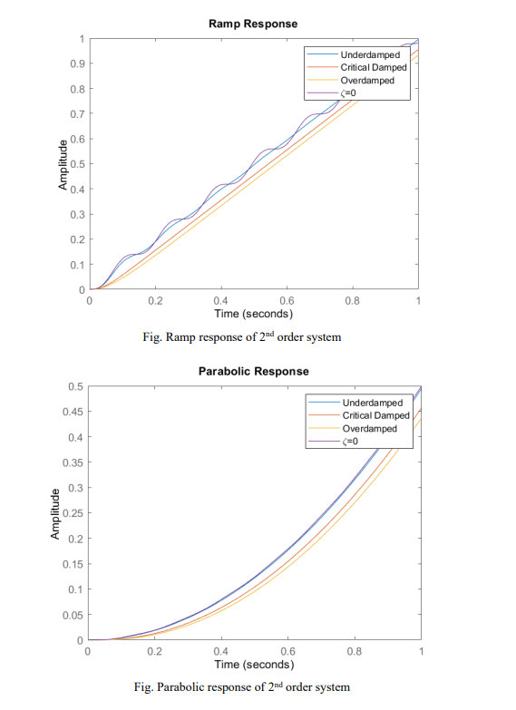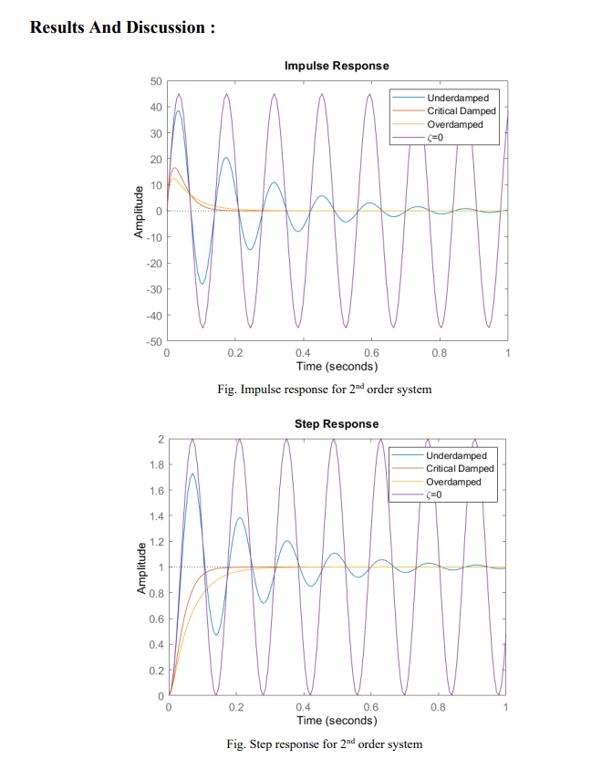

## Experiment 6

**Aim of the experiment:**

Study the time domain performance of the 2nd order systems and determine the performance of the system response time with respect to the location of the poles.

## Software:

MATLAB

## Background:

The time response of the system is defined as the output of the system obtained by providing specific input to the system, where both input and output must be the function of time. Time response of the system provides an idea about the variation in output when a certain input is provided with respect to time.

Transfer function of a 2nd order system is given by

𝑠2

w𝑛2

# +2£w𝑛𝑠+w𝑛2.

Where, wn is the natural frequency of the system and Ç is the damping ratio.

Different parameters of time domain analysis are Rise time, Settling time, Overshoot percentage, Steady State error, Peak value, and Peak time.

**Rise time:** It is the time required for the response to rise from 0% to 100% of its final value.

**Settling time:** It is the time required for the response to reach the steady state and stay within the specified tolerance bands around the final value. In general, the tolerance bands are 2% and 5%.

**Peak overshoot:** Peak overshoot MP is defined as the deviation of the response at peak time from the final value of response. It is also called the maximum overshoot.

**Peak time:** It is the time required for the response to reach the peak value for the first time.

## MATLAB Code:

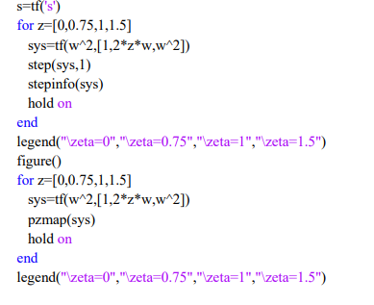w=63;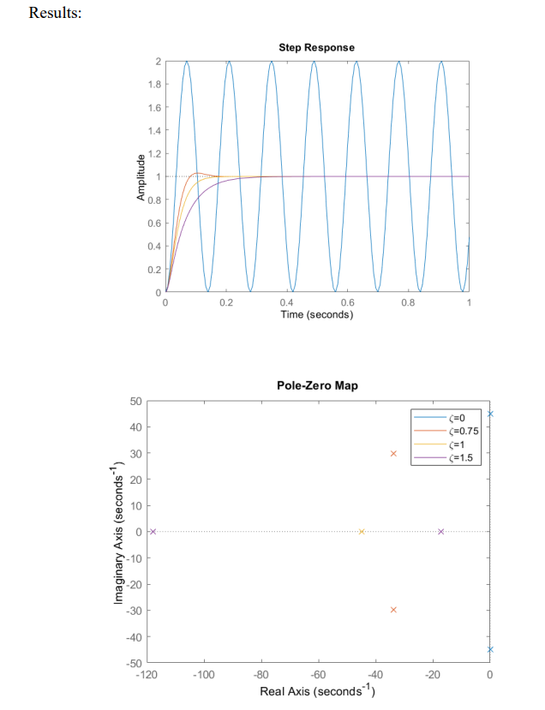

## Applications:

Telecommunications: Time response analysis is applied in designing communication systems, optimizing signal processing techniques, and ensuring reliable transmission and reception of signals in telecommunication networks.

Energy Systems: In energy systems, such as power plants and renewable energy installations, understanding the time response of control systems is vital for optimizing power generation, distribution, and stability.

Automotive Engineering: The study of second-order systems is integral in designing vehicle suspension systems, steering controls, and stability control systems, contributing to enhanced ride comfort and vehicle safety.