

Name : yogesh dinesh joshi
Sap id : 590025632
Batch : 34
Teacher : Suganda sharma

Python programming : Assignment 1

Q1 : Explain the concept of interpreter . Discuss python interpreter And steps with suitable diagram .
Ans : Interpreter is a program that reads , translate and executes a program line by line .
python interpreter means if we combine python and interpreter is a program that reads , translate and executes python code line by line . It converts each line by line of python code into a form that computer can understand and runs it immediately . If a error occurs in any line then interpreter stops the execution and displays the error at that point . In this way it is easy for new learners or beginners to learn python easily as it auto detects the errors.
. step by step is this
- ) Programmer writes the source code .
- ) Interpreter reads the first line .
- ) Then the line is translated into a machine language . 4 ) Then the line is executed .
- ) Then the same process repeats for the next line and then the other line too .
- ) The same thing is repeated for the whole code.

. Diagram for python interpreter :
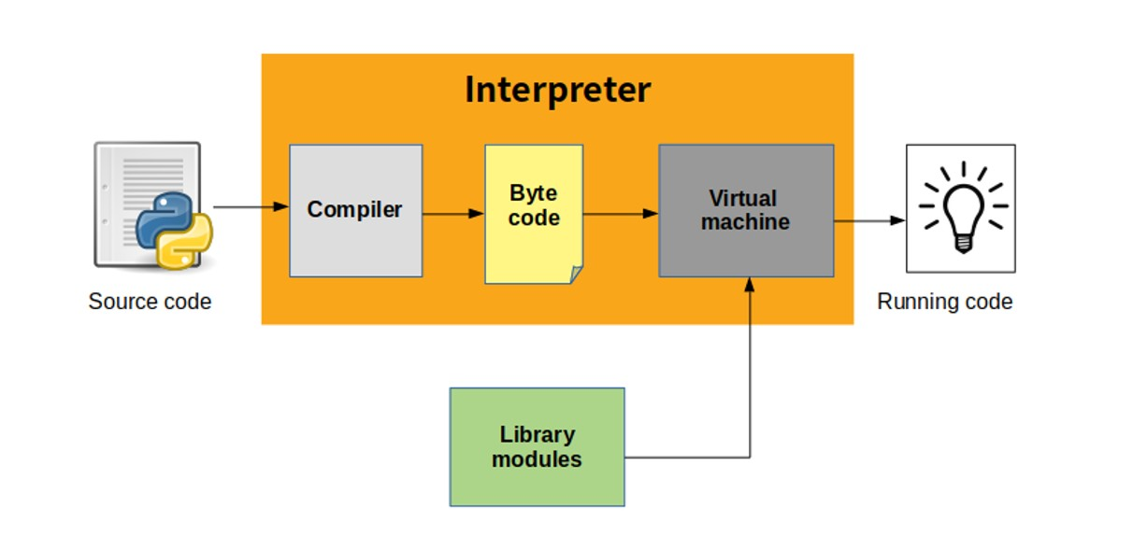

Q2 ) Differentiate between a compiler and interpreter with suitable examples .

Ans ) There are two main types of translators used in a programming languages
- ) Interpreter
- ) compiler
Both are used to convert high – level language into a machine understandable form , but both works in a different ways :-

- ) Interpreter :- interpreter is a program that reads , translate and executes a program line by line and coverts it into machine language , if an error occurs in any line, the interpreter stops immediately and shows the error , because of this interpreter are very useful for learning and debugging programs .
Example : python

- ) Compiler : A compiler translates the entire program at once into machine code . firstly it checks the whole program for errors. If there are no error found in the code or program , it generates an object code or executable file ,which is then executed .
If there are any error , the compiler displays all errors together after compilation .
Example : c ,c++

Diagram :
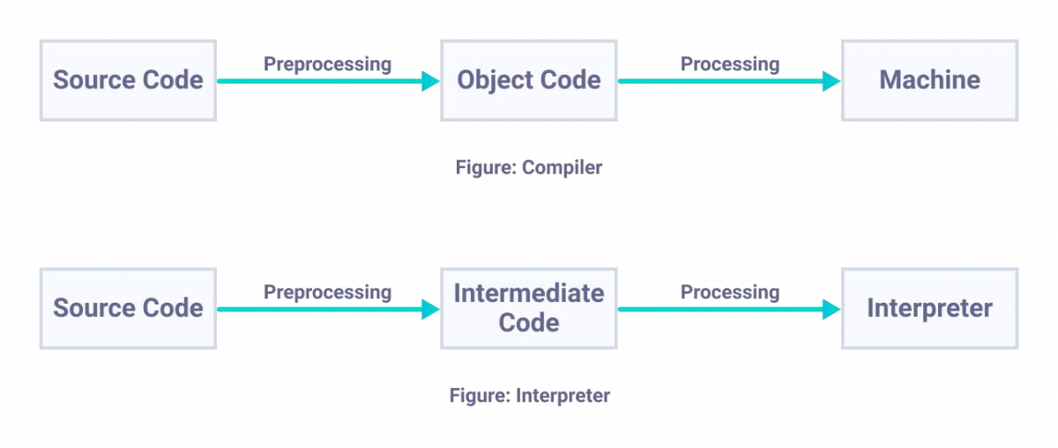
Q3 ) Outline and explain the advantages and disadvantages of the interpreter with supporting language.
Ans ) The advantages and disadvantages of the interpreter are :

1) Advantages : a) interpreted languages are simple and close to human language .
  - As the interpreter executes the code line by line and it can show error immediately and shows at the exact line.
  - ) interpreters do not require a separate compilations step . programs can be run directly , saving time during development .
  - These programs can run on different system and long as the interpreter is available .

2 ) Disadvantages : a ) Interpreter translate code every time the program runs ,which makes execution slower compared to compiled programs .
- If an error occurs the interpreter stops executions immediately. This means other error in the program are not shown at the same time .
- to run a program for a specific language you must need that interpreter installed in your system .
d ) Because of slower execution speed interpreters are not ideal for large programs .

