All the faculties are adviced that, they have to do the following task possibly in two days as per requirement of AICTE.

It will take maximum of 5 minutes.

Step1. open https://smartcookie.in

Step2. Go to registration

Step3. 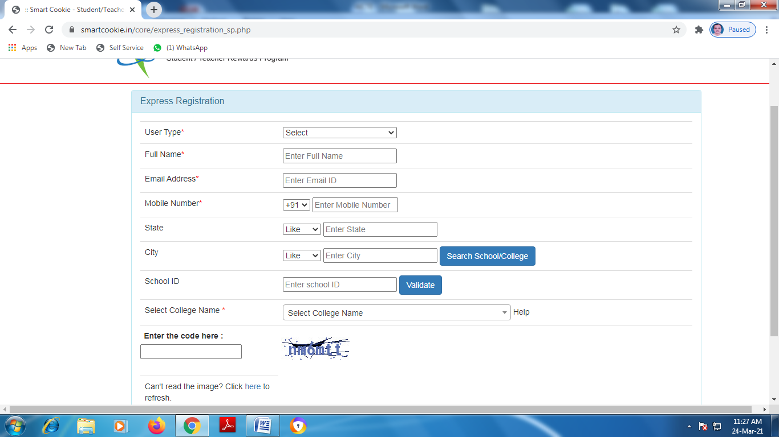

Enter

User type: teacher

School Id: 1-5213608

and all the informations

Step4. Click on Register

Step 5. Reset Password from the password sent to your e-mail.

Step6. End

You can modify your profile with necessary informations, where Education Teacher id = personal no of college.

No need to provide id of Group teacher id, state group teacher id, Education org id and state group id

Note: After completion give confirmation in group