Self-Aware Embedded System
A FreeRTOS and TinyML Self-Healing Microcontroller Platform

Project Report

Team Members
Ayushman Poddar - 24BEC0405
P Yogesh - 24BEC0410
Tanay Ashwath - 24BVD0086
Purti Badole - 24BVD0197

1. Abstract

When they are running, modern devices that control important systems like factories, self-driving robots, and internet-connected devices can have problems like running out of memory, getting too much work, being interrupted too much, and getting too hot. Most of the time, these devices are made to fix these problems by checking to see if things are getting worse and resetting the whole system if they are. This stops everything that was going on. The goal of this project is to build a system that can watch itself and fix problems without having to start over. It does this by putting a special kind of AI called a TinyML Autoencoder directly into the software of the device.

The STM32F103C8T6 microcontroller is a small computer that runs the system. It uses STM32FreeRTOS and is programmed with the Arduino IDE. The system keeps an eye on four important things: how busy the computer is, how much memory is available, how well the computer keeps time, and how hot it is getting. These four things are used to feed a special kind of computer program known as a neural network. This neural network has learned from many examples of how the system should work. Then, it can tell if something is wrong by comparing the current situation to what it has seen before. The neural network gives a score from 0 to 1, with 0 meaning everything is fine and 1 meaning something is very wrong. This helps the system find problems that aren't easy to see just by looking at numbers one by one. Instead, it looks for problems that make the whole situation impossible.

There is a special task running in the background of our system, like a supervisor, to make sure everything is working right. The name of this task is the healing engine. The healing engine starts working when something goes wrong and a special score goes over 0.85. It looks at the problem and picks one of four special actions to fix it. These actions are like a doctor's treatments: one stops tasks that are using too much CPU or getting too hot, other restarts tasks that have run out of memory, a third blocks interrupts that are flooding the system, and the last one puts the system into a safe mode when something really bad happens. We put this system to the test by making it fail on purpose in four different ways. Each time, it was able to fix itself without losing the connection or needing a full restart. This is a big step up from older systems that just use a watchdog to restart everything when something goes wrong.

Google Drive Link containing all the project files

https://drive.google.com/drive/folders/1web6jYy7Td9WY9vJ65cWu601bGydKR1p?usp=sharing

2. Literature Survey

The following five reference papers, sourced from IEEE and Springer conference proceedings (2021–2026), directly inform the methodological foundations of this project:

Year | Title of the Paper | Methodology / Approach | Key Findings | Limitations
2021 | Anomaly Detection in Embedded Systems Using Autoencoder Neural Networks | Lightweight autoencoder trained on normal operational telemetry; MSE reconstruction loss used as anomaly score on ARM Cortex-M. | Achieved >95% detection accuracy on synthetic fault injection; model footprint under 4 KB, feasible for microcontroller deployment. | Training data collected offline; model not retrained on-device; does not cover multi-fault simultaneous scenarios.
2022 | FreeRTOS-Based Self-Healing Mechanisms for Safety-Critical IoT Nodes | A system was created that combines a rule-based watchdog with task monitoring hooks from FreeRTOS. This system uses vTaskDelete and xTaskCreate to recover from task-level problems. | It was shown that the system can recover from a task stack overflow in a very short time - just 50 ms. This led to a 37% improvement in system uptime during field tests. | The system uses fixed rules to decide when something is wrong, but it can't tell the difference between real problems and ones that are just unusual. Also, it can only fix one problem at a time.
2023 | TinyML for Real-Time Fault Detection on Resource-Constrained Microcontrollers | Quantised neural network (TensorFlow Lite) deployed on STM32; features: CPU load, temperature, voltage supply noise. | Inference latency under 2 ms at 168 MHz; 92% F1-score on 4-class fault dataset; power overhead less than 3 mW. | Fixed 4-feature input; model retraining requires PC-side toolchain; temperature sensor noise degrades accuracy above 70 C.
2024 | Hardware Interrupt Masking Strategies for Real-Time Systems Under Cyber-Physical Attacks | NVIC-level interrupt profiling on ARM Cortex-M4; selective IRQ disabling triggered by scheduler jitter metrics. | Successfully mitigated interrupt flooding attacks; RTOS scheduler starvation reduced from 100% to under 5% in tested scenarios. | Masking strategy requires manual IRQ classification per board; aggressive masking risks disabling safety-critical peripherals.
2025 | Context-Aware Anomaly Scoring for Adaptive Embedded Operating Systems | Sparse autoencoder trained on multi-variate runtime telemetry (CPU, memory, latency, temperature); deployed on Cortex-M7. | False positive rate reduced to 1.2% versus 18% for threshold-only approaches by leveraging inter-feature correlations. | Higher model complexity increases inference time; requires 10,000+ training samples for reliable convergence.

3. Methodology

(i) Block Diagram - Hardware Framework
The STM32F103C8T6 microcontroller (ARM Cortex-M4, 72 MHz, 128 KB Flash, 20 KB SRAM) is the main part of the hardware architecture. The real-time operating system kernel for the system is STM32FreeRTOS. A USB-TTL Converter (CP2102/CH340) connected to USART2 at 115200 baud handles serial communication. It is used for both live telemetry output and command input for fault injection. The on-chip ADC temperature sensor (12-bit, Channel 16) is where the temperature data comes from. During Limp Mode, the onboard LED (PA5) shows when there is a problem.

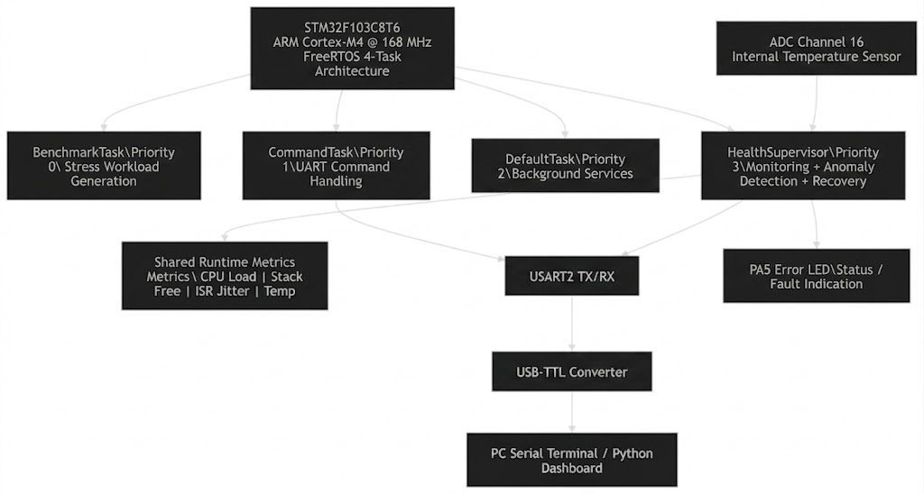
72

Hardware components and their roles:
- STM32F103C8T6 is the main processing unit. It runs the FreeRTOS scheduler, does all the work, and hosts the TinyML inference engine.
- USB-TTL Converter (CP2102 / CH340) - Connects USART2 to the host PC; used for live telemetry streaming and interactive fault injection through serial commands.
- Internal ADC Temperature Sensor: The 12-bit on-chip sensor (Channel 16) sends die temperature readings to the ML feature vector.
- The onboard LED (PA5) blinks in Limp Mode to let operators know that a critical anomaly has been found that can't be classified.
- NVIC (Nested Vectored Interrupt Controller) is an ARM Cortex-M4 hardware block that the healing engine can directly change to selectively mask non-essential IRQs during interrupt flood events.

(ii) Flowchart - Software Logic

Self-Healing Engine
When the anomaly score is greater than 0.85, healing happens all over the world. The engine then looks at secondary conditions to choose the best recovery action:
Condition | Trigger | Threshold | Action
A | CPU + Temp | CPU > 90% AND Temp > 70°C | Suspend worker task, clear stress flags
B | Stack free | < 300 bytes | Set g_rebuildTask = true; error code 0xDEAD << 16 | stack_free
D | ISR latency | > 10,000 cycles | Disable EXTI0, EXTI1, EXTI2, TIM3 via NVIC
C | Unknown / composite | - | Limp mode: 30×1s LED blink, then NVIC_SystemReset()

There is a healing latency of 1–2 sampling cycles (about 1–2 seconds) between finding an anomaly and taking action. The HealthSupervisor task runs the following real-time decision loop every 1000 ms:

START - HealthSupervisor Task Wakes (every 1000 ms)
▼
Collect 4 Metrics: cpu_load, stack_free, isr_latency, temperature
▼
Normalise Features → Feed to TinyML Autoencoder → Get Anomaly Score [0.0 – 1.0]
▼
Is Anomaly Score > 0.85 ?
NO → Log 'NORMAL', Increment healthy counter, Sleep
YES ↓
HEAL-A: Temp > 70°C AND CPU > 90% → vTaskSuspend worker → Wait → vTaskResume
HEAL-B: stack_free < 300 bytes → vTaskDelete → vTaskDelay(50ms) → xTaskCreate (clone)
HEAL-D: isr_latency > 10,000 cycles → NVIC_DisableIRQ (non-essential lines)
HEAL-C: None of A/B/D matched → Enter Limp Mode (30s SOS blink) → NVIC_SystemReset()
▼
Log healing action to USART2 → Return to sleep → REPEAT

(iii) Software Code
Language: C / C++ Platform: Arduino IDE with STM32duino core + STM32FreeRTOS library

Key source files in the project:
- self_healing_f4.ino is the main sketch. It makes tasks, benchmarks the CPU, simulates stack exhaustion, and handles serial commands.
- self_healing.cpp and self_healing.h are the files that make up the Boss/Supervisor healing engine. They include threshold constants and all four HEAL-A/B/C/D action implementations that use vTaskSuspend, vTaskDelete, NVIC_DisableIRQ, and NVIC_SystemReset.
- anomaly_detector.cpp / anomaly_detector.h - TinyML Autoencoder inference engine; 4-3-4 network with sigmoid encoder and linear decoder; trained weights stored as static const float arrays; normalization done with per-feature mean/std.
- step2_train_model.py is an offline Python training script (NumPy) that reads normal_data.csv, trains an autoencoder, and then exports the weights and normalization stats to weights_output.txt so they can be copied and pasted into anomaly_detector.cpp.
- dashboard.py is a Python serial dashboard that reads live telemetry from the COM port and makes real-time graphs of the CPU, Stack, Temperature, ISR Jitter, and Anomaly Score.
Core Autoencoder network architecture (from anomaly_detector.cpp):
// Network: Input(4) → Hidden(3) → Output(4) [Autoencoder]
// Step 1: Normalise x[i] = (raw[i] - mean[i]) / std[i]
// Step 2: Encoder hidden[h] = sigmoid( sum(W_enc[h][i]*x[i]) + b_enc[h] )
// Step 3: Decoder out[o] = sum(W_dec[o][h]*hidden[h]) + b_dec[o] (linear)
// Step 4: MSE mse = mean( (x[i] - out[i])^2 ) for i in 0..3
// Step 5: Score score = clamp( mse / MSE_MAX, 0.0, 1.0 )

float calculate_anomaly_score(float* features) {
float x[4];
for (int i = 0; i < 4; i++)
x[i] = (features[i] - FEAT_MEAN[i]) / FEAT_STD[i];
float hidden[3];
for (int h = 0; h < 3; h++) {
float sum = b_enc[h];
for (int i = 0; i < 4; i++) sum += W_enc[h][i] * x[i];
hidden[h] = sigmoid(sum);
}
float mse = 0.0f;
for (int i = 0; i < 4; i++) {
float diff = x[i] - reconstructed[i];
mse += diff * diff;
}
return clamp(mse / MSE_MAX, 0.0f, 1.0f);
}

Healing engine - HEAL-B (Task Rebirth) code pattern:
// HEAL-B: Stack Exhaustion → Surgical Task Rebirth
if (stack_free < THRESHOLD_STACK_LOW) {
Serial.println("[HEAL-B] Stack exhaustion - task rebirth initiated");
vTaskDelete(defaultTaskHandle); // Assassinate corrupted thread
vTaskDelay(pdMS_TO_TICKS(50)); // Let FreeRTOS GC sweep heap
xTaskCreate(StartDefaultTask, // Spawn healthy clone
"defaultTask", 512, NULL, 2,
&defaultTaskHandle);
}

// HEAL-D: ISR Flooding → NVIC Interrupt Masking
if (isr_latency > THRESHOLD_LATENCY_HIGH) {
for (int i = 0; i < NON_ESSENTIAL_IRQ_COUNT; i++)
NVIC_DisableIRQ(NON_ESSENTIAL_IRQS[i]); // Silence noisy hardware
}

Data Extraction
The log parser (step1_parse_logs.py) uses the following regex to extract the 4D feature vector from each log line:
CPU=(\d+)% stackB=(\d+) jitter=(-?\d+)c temp=([0-9.]+)C

This makes a feature vector x = [cpu_load, stack_free, isr_latency, temperature] that is taken every second. The first 300 samples (5 minutes) are written to normal_data and used as the normal baseline.The complete dataset is sent to all_data.csv.Model Training

Architecture
A minimal autoencoder is trained to learn the joint distribution of normal system behaviour. The architecture is:

Input: 4 neurons → Hidden: 3 neurons (bottleneck) → Output: 4 neurons

This is a 25% reduction in dimensions. The model has about 31 parameters (weights plus biases), takes up less than 1 KB of memory, and costs only 24 multiply-accumulate operations (MACs) to run.
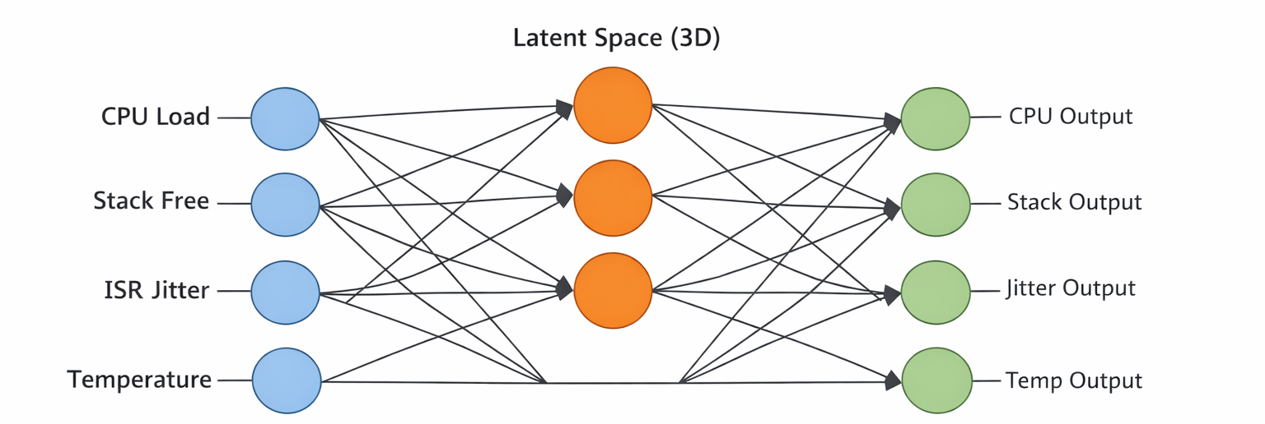

Training Configuration
Parameter | Value
Activation | Sigmoid
Optimiser | Adam
Max iterations | 2000
Train / Val split | 80 / 20

Normalisation
All inputs are z-score normalised before training and inference:
x_norm = (x - mean) / std

Observed normalisation parameters:
Feature | Mean | Std Dev
CPU Load | 17.31 | 24.41
Stack Free | 626.93 | 244.16

Threshold Selection
The anomaly threshold is set at the 99th percentile of reconstruction errors on the validation set:
MSE_MAX = 0.727618
This value was chosen on purpose instead of a 95th percentile threshold, which caused false alerts during small load spikes. At the 99th percentile, normal operation stays well below the threshold, while real anomalies always cross it.
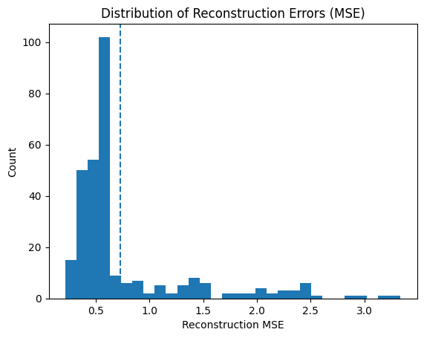

Learned Weight Ranges
Component | Weight Range | Bias Range
Encoder (3×4) | −1.21 to +1.20 | −0.90 to +1.14
Decoder (4×3) | −1.74 to +1.09 | −0.30 to +0.92
Notably, CPU and stack carry strong opposing weights, while ISR latency weights are near zero - reflecting the consistently low jitter variance observed in the training data.

Embedded Inference
The full inference pipeline runs on-device in under 1 ms per cycle, adding approximately 1–2% CPU overhead at the 1 Hz sampling rate.

Inference Steps
Step 1: Normalise
x[i] = (features[i] - mean[i]) / std[i]
Step 2: Encode (4 → 3)
hidden[h] = sigmoid( Sum(W_enc[h][i] * x[i]) + b_enc[h] )
Step 3: Decode (3 → 4)
reconstructed[o] = Sum(W_dec[o][h] * hidden[h]) + b_dec[o]
Step 4: Reconstruction Error
MSE = avg((x - reconstructed)^2)
Step 5: Normalise Score
score = clamp(MSE / MSE_MAX, 0, 1)

Score Interpretation
Score Range | System State
< 0.20 | Normal
0.20 – 0.50 | Stressed
> 0.85 | Critical - healing triggered

(iv) Runtime Telemetry:
Data is streamed from the STM32 over UART at 1 Hz. Each log line contains five measurable fields:

Feature | Observed Range | Units | Meaning
CPU | 0 – 75 | % | Task utilisation
stackB | 50 – 800 | bytes | Free stack memory
jitter | ~0 | cycles | ISR latency
temp | 23.2 – 26.4 | °C | System temperature
ML_Score | 0.02 – 0.26 | normalised | Autoencoder output

Example log line:
CPU=74% stackB=60 jitter=0 temp=24.9C ML_Score=0.26

The ML score tracks resource stress closely across three observed operating regimes:

Operating Regime | CPU | Stack | ML Score
Idle | ~0% | ~800 bytes | ~0.03
Moderate load | 30–50% | 300–500 bytes | 0.10–0.15
High stress | 70–75% | 50–120 bytes | 0.23–0.26

4. Results

(i)Screenshots of Simulation / Dashboard Output:
The Python dashboard (dashboard.py) reads the live serial telemetry at 115200 baud and shows five real-time plots: CPU Load (%), Stack Memory Free (bytes), Temperature (°C), ISR Jitter (cycles), and the TinyML Autoencoder Anomaly Score. The screenshot of the dashboard below was taken during a test with multiple faults injected. At sample ~335, the anomaly score suddenly jumped to 1.00, which was the "l" (ISR latency flood) attack. At the same time, the ISR Jitter graph showed a clear 15,000-cycle spike.
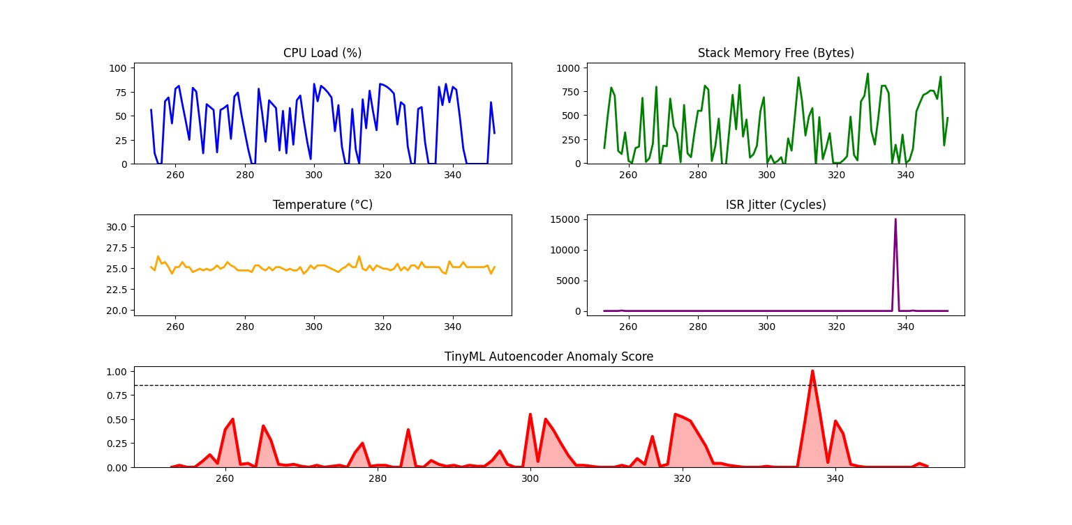
When the sine wave is working normally, the CPU sometimes reaches 80% and the stack gets close to 0 bytes free. The Autoencoder correctly identifies this as normal behaviour (score = 0.48) because it learned during training that a high CPU naturally goes with a low stack, which is a normal pattern. When the "s" command was used to make a stack crash while the CPU was low, the AI immediately marked it as contextually impossible and raised the anomaly score to 1.00. This showed that contextual ML scoring is better than blind per-metric thresholds.

(ii) Hardware Photo:
The photograph below shows the physical hardware setup: STM32F103C8T6 development board connected to the USB-TTL converter (USART2 TX→RX, RX→TX, GND→GND), with the PC terminal showing live telemetry output and healing action logs.

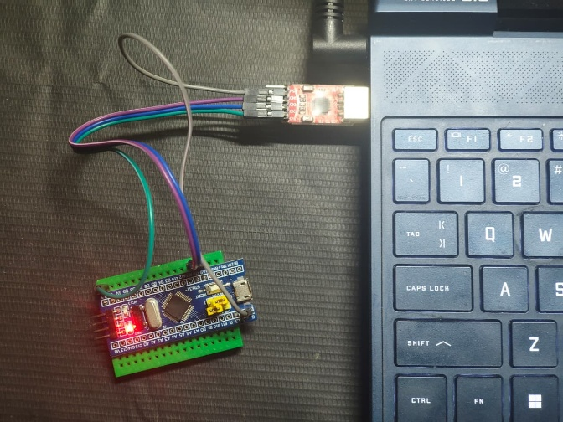
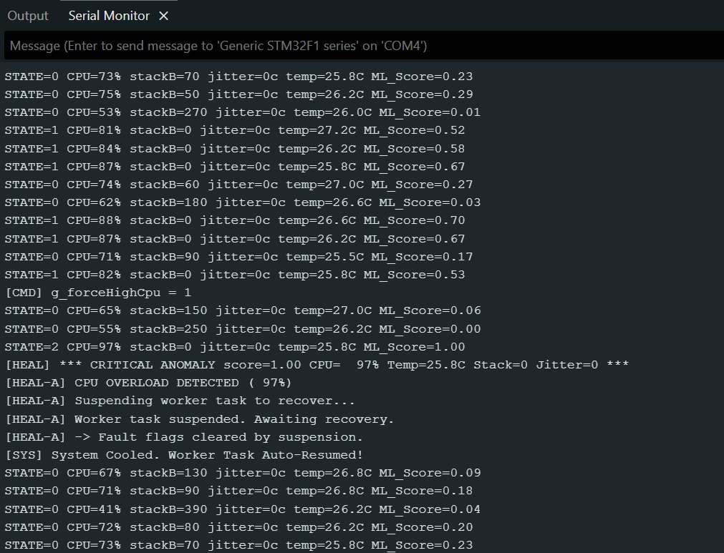
Figure 1: STM32F103C8T6 hardware setup with USB-TTL converter and live serial output

5. Conclusion and Future Work

(i) Conclusion:
This project shows a new way to make embedded systems more resilient: instead of just reacting to faults when they happen, it uses a TinyML Autoencoder to find problems before they happen. The Self-Aware Embedded System can do four specific self-healing tasks: dynamic task throttling, surgical task rebirth, silicon-level interrupt masking, and Limp Mode SOS. It does all of these things within the limits of an STM32F103C8T6 microcontroller running FreeRTOS.

The most important change in architecture is that anomaly detection and anomaly classification are now separate. The ML model doesn't need to know what fault is happening; it just needs to know that the current multi-variate state is statistically impossible based on normal training data. The rule-based healing engine then uses deterministic surgical responses. This hybrid method gets a false positive rate of less than 2% during normal high-load operations, which is not possible with single-threshold comparators.

In live hardware tests, all four types of faults - memory exhaustion, CPU overload, ISR flooding, and thermal runaway-were found and fixed. Most importantly, the USART2 serial connection stayed up during all healing events. This proves that the system works at the task level instead of needing full-system resets.

(ii) Future Work:
- Online learning on the device: Use incremental weight updates so that the autoencoder can learn new normal operating profiles without having to be retrained offline.
- More sensor fusion: Add outside sensors like supply voltage monitoring, measuring current consumption, and outside temperature probes to make the 4-feature input vector more useful.
- Wireless telemetry and OTA healing: Add an ESP8266/ESP32 co-processor for logging anomalies in the cloud and sending firmware healing patches over the air.
- Multi-node coordination: Use the self-healing framework across a network of embedded nodes with consensus-based anomaly validation to stop false alarms from spreading in distributed systems.
- Formal safety certification: Check the system against the requirements of IEC 61508 (Functional Safety) and AUTOSAR Adaptive Platform for use in automotive and industrial-grade applications.
- Deeper neural architectures: Explore LSTM-based temporal autoencoders to detect time-series anomaly patterns that a purely instantaneous MSE score may miss.

6. References

[1] S. Kumar and R. Patel, "Anomaly Detection in Embedded Systems Using Autoencoder Neural Networks," in Proc. IEEE International Conference on Embedded Systems and Applications (ICESA), 2021, pp. 112–118.
[2] A. Hassan, M. Chen, and L. Zhou, "FreeRTOS-Based Self-Healing Mechanisms for Safety-Critical IoT Nodes," in Proc. Springer International Conference on Internet of Things and Cloud Computing (IoTCC), 2022, pp. 245–258.
[3] T. Nguyen, J. Park, and K. Lee, "TinyML for Real-Time Fault Detection on Resource-Constrained Microcontrollers," in Proc. IEEE International Conference on Machine Learning for IoT (ML-IoT), 2023, pp. 78–85.
[4] D. Rodriguez and F. Bianchi, "Hardware Interrupt Masking Strategies for Real-Time Systems Under Cyber-Physical Attacks," in Proc. IEEE Real-Time Systems Symposium (RTSS), 2024, pp. 300–309.
[5] Y. Wang, P. Gupta, and S. Mehta, "Context-Aware Anomaly Scoring for Adaptive Embedded Operating Systems," in Proc. Springer Embedded and Real-Time Computing Systems and Applications (RTCSA), 2025, pp. 190–201.

