Azure Resource Inventory (ARI) Automation using GitHub Actions
This document provides a complete step-by-step implementation guide for automating Azure Resource Inventory (ARI) report generation using GitHub Actions, PowerShell, Azure Service Principal authentication, and Gmail SMTP email delivery.

1. Solution Overview
The automation performs the following tasks automatically:
• Authenticate to Azure using Service Principal
• Run Azure Resource Inventory (ARI) PowerShell module
• Generate Excel inventory report
• Upload report as GitHub artifact
• Send report to customer email automatically
• Execute on schedule using GitHub Actions

2. Architecture
GitHub Actions -> PowerShell Script -> Azure Login -> Invoke-ARI -> Generate Excel -> Upload Artifact -> Send Email
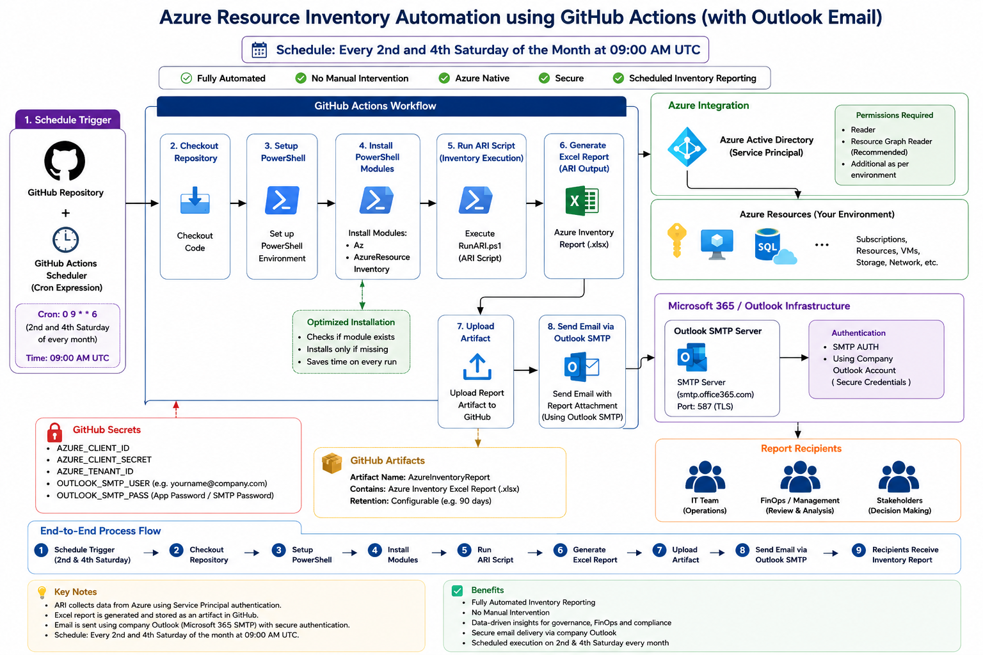

3. Prerequisites
• Azure Subscription
• GitHub Account
• Gmail Account/Outlook Account
• PowerShell
• Azure CLI
• Contributor or Reader access on Azure Subscription

4. Create Service Principal
Run the following command locally:
az ad sp create-for-rbac --name "ARI-Automation"
Save the following values:
• appId
• password
• tenant
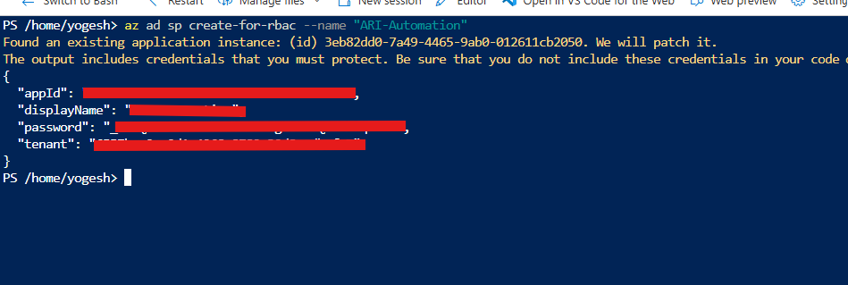
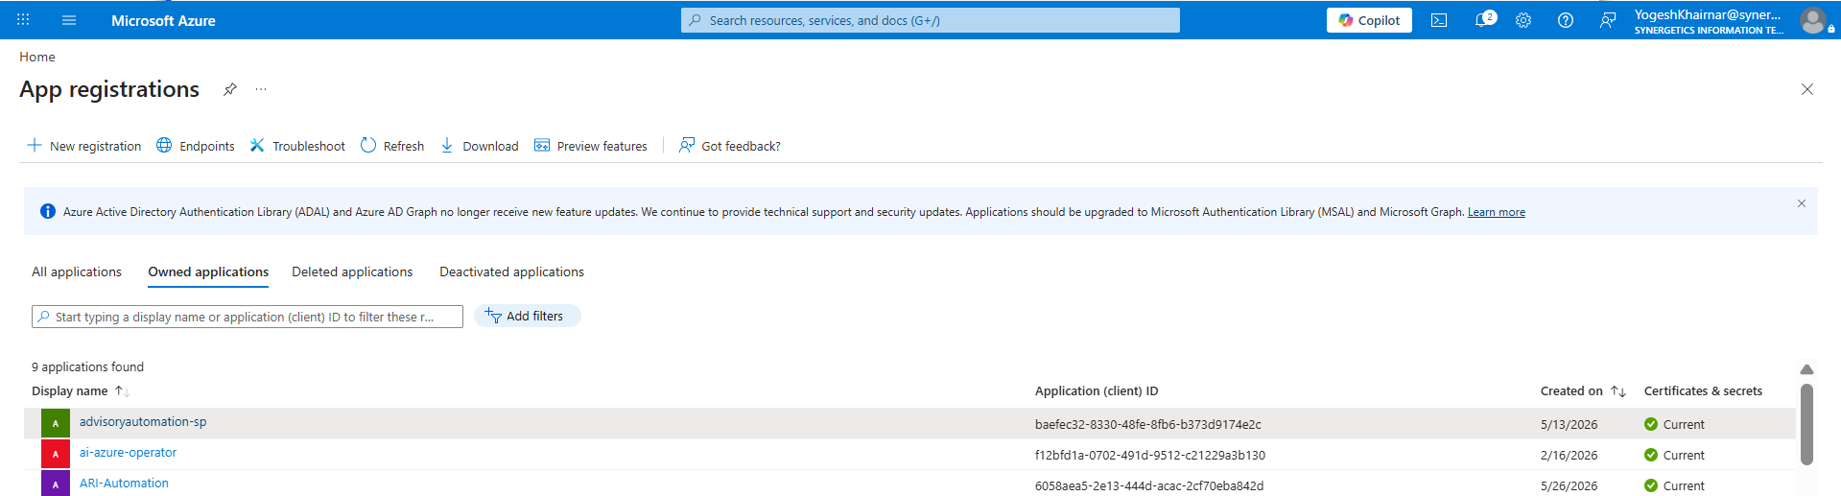

5. Create GitHub Repository
1. Login to GitHub
2. Create new repository
3. Example repository name: GitHubARI
4. Clone repository locally

6. Create Folder Structure
Create the following structure:
GitHubARI/
├── scripts/
│ └── RunARI.ps1
└── .github/workflows/
└── azure_inventory.yml

7. Create RunARI.ps1
Create scripts/RunARI.ps1 and add the following PowerShell script.
# =====================================
# Azure Resource Inventory Automation
# =====================================
$AppId = $env:AZURE_CLIENT_ID
$Password = $env:AZURE_CLIENT_SECRET
$TenantId = $env:AZURE_TENANT_ID
$SecurePassword = ConvertTo-SecureString $Password -AsPlainText -Force
$Credential = New-Object System.Management.Automation.PSCredential($AppId, $SecurePassword)
Connect-AzAccount `
-ServicePrincipal `
-Tenant $TenantId `
-Credential $Credential
# Create Reports Folder
$ReportFolder = "./reports"
if (!(Test-Path $ReportFolder)) {
New-Item -ItemType Directory -Path $ReportFolder
}
# Date
$Date = Get-Date -Format "yyyyMMdd_HHmmss"
# Import ARI
Import-Module AzureResourceInventory
# Run ARI
try {
Invoke-ARI `
-TenantID $TenantId `
-ReportDir $ReportFolder `
-ReportName "AzureInventory_$Date"
}
catch {
Write-Warning "ARI completed with formatting warnings."
}
Write-Host "ARI Report Generated"

8. Create GitHub Actions Workflow
Create .github/workflows/azure_inventory.yml
name: Azure Inventory Automation
on:
schedule:
- cron: '30 5 8-14 * 6'
- cron: '30 5 22-28 * 6'
workflow_dispatch:

jobs:
run-ari:
runs-on: ubuntu-latest
steps:
- name: Checkout Repository
uses: actions/checkout@v4
- name: Install Linux Dependencies
run: |
sudo apt-get update
sudo apt-get install -y --no-install-recommends libgdiplus libc6-dev
- name: Install PowerShell Modules
shell: pwsh
run: |
Install-Module Az -Force -Scope CurrentUser
Install-Module AzureResourceInventory -Force -Scope CurrentUser
- name: Run ARI Script
shell: pwsh
env:
AZURE_CLIENT_ID: ${{ secrets.AZURE_CLIENT_ID }}
AZURE_CLIENT_SECRET: ${{ secrets.AZURE_CLIENT_SECRET }}
AZURE_TENANT_ID: ${{ secrets.AZURE_TENANT_ID }}
run: |
./scripts/RunARI.ps1
- name: Upload Report
uses: actions/upload-artifact@v4
with:
name: AzureInventoryReport
path: reports/*.xlsx
- name: Send Email
uses: dawidd6/action-send-mail@v3
with:
server_address: smtp.office365.com
server_port: 587
secure: false
username: ${{ secrets.SMTP_USERNAME }}
password: ${{ secrets.SMTP_PASSWORD }}
subject: Azure Inventory Report
to: |
yogeshkhairnar@synergetics-consulting.com,
SunnyRana@synergetics-consulting.com
cc: |
sumitlad@synergetics-consulting.com,
MoizJawadwala@synergetics-consulting.com
from: ${{ secrets.SMTP_USERNAME }}
body: |
Hello Team,
Please find attached latest Azure Resource Inventory Report.

Regards,
Yogesh

attachments: reports/*.xlsx

9. Configure GitHub Secrets
Go to GitHub Repository -> Settings -> Secrets and variables -> Actions
Add the following secrets:
• AZURE_CLIENT_ID
• AZURE_CLIENT_SECRET
• AZURE_TENANT_ID
• SMTP_USERNAME
• SMTP_PASSWORD
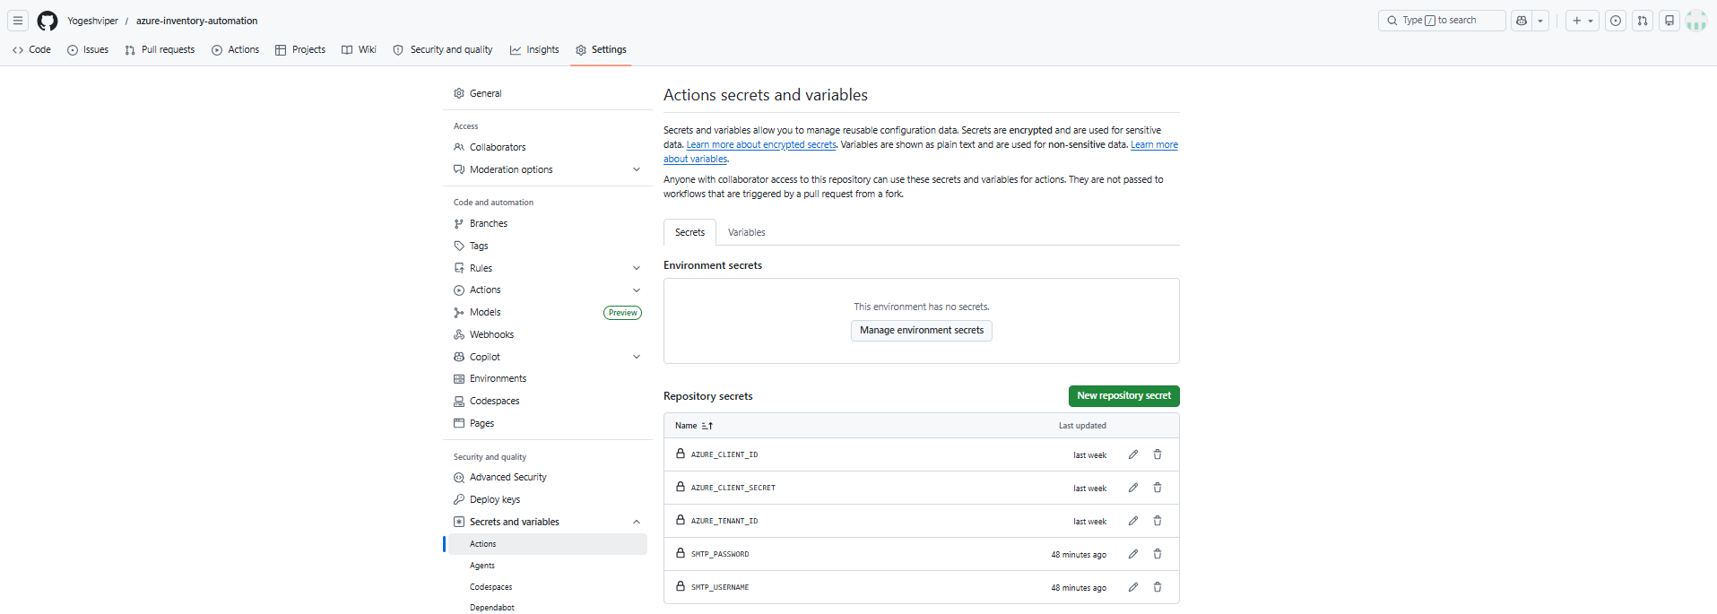

10. Configure Gmail App Password
1. Enable 2-Step Verification in Gmail
2. Open https://myaccount.google.com/apppasswords
3. Generate App Password
4. Use generated password in SMTP_PASSWORD secret
OR

10.1 . Configure Outlook App Password
1. Enable 2-Step Verification in Outlook
2. Open https://mysignins.microsoft.com/security-info
3. Generate App Password
4. Use generated password in SMTP_PASSWORD secret

11. Push Code to GitHub
Run the following commands:
git init
git add .
git commit -m "Initial ARI automation"
git branch -M main
git remote add origin <GitHubRepoURL>
git push -u origin main

12. Run Workflow
Go to GitHub -> Actions
Select Azure Inventory Automation workflow
Click Run workflow
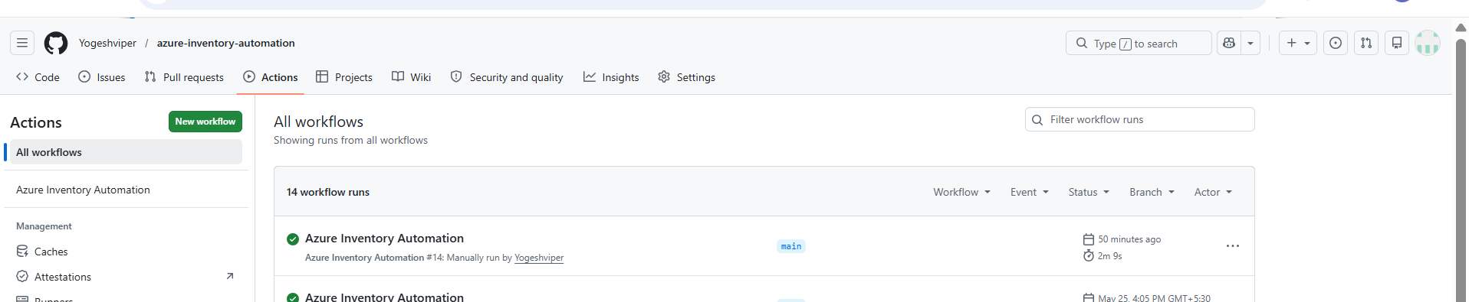

13. Schedule Information
Current cron schedule:
30 5 8-14 * 6 → Runs at 11:00 AM IST on the 2nd Saturday of every month.
30 5 22-28 * 6 → Runs at 11:00 AM IST on the 4th Saturday of every month.
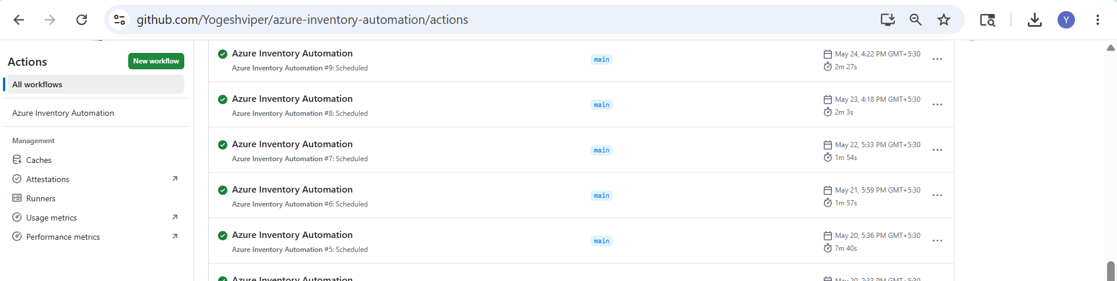

14. Final Outcome
After successful execution:
• Excel report generated
• Report uploaded as artifact
• Email automatically sent
• Multiple recipients supported
• CC recipients supported
• Fully automated Azure inventory reporting

15. Important Notes
• GitHub hosted runners are free within monthly limits
• Azure read operations generally do not incur cost
• Gmail/Outlook SMTP works reliably for automation
• For full Excel pivot customization, self-hosted Ubuntu with Excel is recommended

