**INTERACTIVE LEARNING THROUGH IMMERSIVE EXPERIENCE**

DESIGN PROJECT - IV

Submitted by

Joanna Satya - 22143041

Prajakta Debsharma - 22143045

**Under the guidance of**

**A.Meenapriyadharsini**

**Assistant Professor**

**Dr.Thangakumar J**

**CSE Head of department**

**Dr. Angelina Geetha**

**Dean E&T**

***in partial fulfilment for the award of the degree of***

**BACHELOR OF TECHNOLOGY**

**in**

## COMPUTER SCIENCE AND ENGINEERING



**HINDUSTAN INSTITUTE OF TECHNOLOGY AND SCIENCE**

**CHENNAI - 603 103**

APR 2025



## BONAFIDE CERTIFICATE

Certified that this project report **INTERACTIVE LEARNING THROUGH IMMERSIVE EXPERIENCE** is the bonafide work of **Joanna Satya 22143041** and **Prajakta Debsharma 22143045** who carried out the project work under my supervision during the academic year 20**24**-20**25**.

Ms. Meenapriyadarshini

Assistant Professor

Department of CSE.

|  |  |
| --- | --- |
| **INTERNAL EXAMINER** | **EXTERNAL EXAMINER** |
| Name:_________________ | Name:_________________ |
| Designation:____________ | Designation:____________ |

Project Viva - voce conducted on ________

**CONTENTS**

Acknowledgement 5

Abstract 6

CHAPTER 1

* 1. Introduction 7
  2. Motivation of work 8

CHAPTER 2

2.1 Introduction 10

2.2 Literature Survey 11

2.3 Summary 12

CHAPTER 3

3.1 Model Description 13

3.2 Dataset Details 15

3.3 Tools 16

3.4 Architecture Diagram 17

CHAPTER 4

4.1 Experimental Setup Analysis 19

4.2 Results 21

4.3 Summary 21

CHAPTER 5

5.1 Conclusion 22

5.2 Future Enhancement 23

Appendix A 24

Appendix B 25

Appendix D 26

Reference 27

Table of Figures

Figure 1: Architecture diagram

Figure 2: Importing hugging face models

Figure 3: Frontend Structural formatting using HTML

Figure 4: Frontend Styling using CSS

Figure 5: Frontend and Backend connectivity using Javascript

Figure 6: The generated image based on the prompt

## ACKNOWLEDGEMENT

First and foremost, we would like to thank **ALMIGHTY** who has provided us the strength to do justice to our work and contribute our best to it.

We wish to express our deep sense of gratitude from the bottom of our heart to our Guide **Ms. Meenapriyadarshini, Assistant Professor, Computer Science and Engineering**, for her motivating discussions, overwhelming suggestions, ingenious encouragement, invaluable supervision, and exemplary guidance throughout the project work.

We would like to extend our heartfelt gratitude to **J.Thangakumar, Ph.D., Professor & Head, Department of Computer Science and Engineering** for his valuable suggestions and support in successfully completing the project.

## We thank the management of HINDUSTAN INSTITUTE OF TECHNOLOGY AND SCIENCE for providing us the necessary facilities and support required for the successful completion of the project.

As a final word, we would like to thank each and every individual who have been a source of support and encouragement and helped us to achieve our goal and complete our project work successfully.

# ABSTRACT

The project “Interactive Learning through Immersive Experience” as the name suggests, is a prototype of an interactive and engaging educational platform. It aims to use Augmented Reality (AR) at its core to leverage user experience through a responsive interface.

At the heart of Immersive Experience is 3D imaging technologies which consists of two parts, one is Augmented Reality (AR) and the other one is Virtual Reality (VR). In AR, components of the content (like images or videos) are converted into a 3D manner, whereas in VR the entire environment is generated in a 3-dimensional space to give a form of realistic feeling.

Such advancements show promising results for various applications like art creation, realistic imaging, and virtual reality. Augmented Reality (AR) models are pushing the boundaries of what's possible in visual content creation, blending creativity with computational prowess.

In our project we have learned from the previous researches conducted on Augmented Reality and concepts already used in Immersive Learning Platforms and have implemented some of our own ideas and improvised on the application to make it more user friendly and fulfilling the need of different choices.

# CHAPTER 1

# 1.1 INTRODUCTION

# Interactive learning has taken a monumental leap forward with the advent of augmented reality (AR). AR creates an interactive environment by placing virtual information in the physical world so that the learning landscape becomes active. This technology integrates the real and virtual worlds, enabling students to engage with digital material in an immersive and user-friendly manner. Think biology class where students feel the form of human anatomy by moving around 3D holograms of organs, or a history lesson where 3D holograms of ancient civilizations are brought into the classroom to live. These are not distant dreams, but the realities AR is bringing to education.

The advantages of AR in interactive learning are numerous. Increased engagement may be the most immediate benefit; AR grasps students' attention and sustains their interest with interactive, attention-grabbing content. Students learn more effectively in an interactive environment where hands-on learning experiences can help them understand complex concepts. Moreover, unlike traditional learning, these immersive experiences greatly enhance memory retention. In addition, AR also allows for personalized learning experiences, customizing content according to individual learning styles and speeds, and providing every student with a tailored educational experience.

In short, the first part of an AR-powered immersive education is that it is about creating a dynamic learning experience, and the second part is about integrating that as applied learning. This innovative approach is paving the way for a new era of education where learning becomes an adventure. As AR continues to evolve, its potential to revolutionize education becomes increasingly evident, promising to transform the way we teach and learn.

# 1.2 MOTIVATION OF THE WORK

* Artistic Expression: Create impressive and new images that show the initial strength of AI. Certain visuals should tell interesting stories, stir up emotions, or clarify complicated ideas. Other visuals should create original storytelling.
* Digital Environment Creation: Develop realistic-seeming locations, characters, and objects for entertainment, modelling, or games.
* Content Generation: Use advanced content creation instruments for Augmented Reality in order to develop a fully or partially responsive application.
* Design and Prototyping: Produce many design iterations for architecture, interior design, or product development rapidly.
* Get some experience in AR: Build some knowledge of Augmented Reality, Virtual Reality and Engaging environment.
* Community Engagement: Deeply assist each other, thoroughly share knowledge, as well as extensively gain understandings from other people passionate about AR.

**CHAPTER 2**

## 2.1 INTRODUCTION

Augmented Reality (AR) as well as Virtual Reality (VR) have got large and common attention in recent years, resulting in a large surge in academic research along with published literature. A systematic literature review on AR and VR reveals their multiple applications across many fields. These fields include education, tourism, construction, and privacy/security concerns.

These studies clearly highlight the important and transformative potential of both AR and VR in greatly improving user experiences and optimizing learning outcomes, as well as providing highly revolutionary solutions to industry-specific challenges.

**2.2 LITERATURE SURVEY**

## Table 1: Literature Survey

|  |  |  |  |
| --- | --- | --- | --- |
| **AUTHOR** | **TITLE** | **YEAR** | **TECHNIQUES USED** |
| Huang, X., Zou, D., Cheng, G., & Xie, H. (2021). A systematic review of AR and VR enhanced language learning. *Sustainability*, *13*(9), 4639. | A Systematic Review of AR and VR Enhanced Language Learning | 2021 | Language learning, Computer-assisted language learning |
| Al-Ansi, A. M., Jaboob, M., Garad, A., & Al-Ansi, A. (2023). Analyzing augmented reality (AR) and virtual reality (VR) recent development in education. Social Sciences & Humanities Open, 8(1), 100532. | Analyzing augmented reality (AR) and virtual reality (VR) recent development in education | 2023 | Scopus database |
| Cevikbas, M., Bulut, N., & Kaiser, G. (2023). Exploring the benefits and drawbacks of AR and VR technologies for learners of mathematics: Recent developments. Systems, 11(5), 244. | Exploring the Benefits and Drawbacks of AR and VR Technologies for Learners of Mathematics: Recent Developments | 2023 | Digital technology, Immersion, Learning outcomes, Mixed reality |
| Fitria, T. N. (2023). Augmented reality (AR) and virtual reality (VR) technology in education: Media of teaching and learning: A review. International Journal of Computer and Information System (IJCIS), 4(1), 14-25. | Augmented Reality (AR) and Virtual Reality (VR) Technology in Education: Media of Teaching and Learning: A Review | 2023 | Reality with image elements, sound effects, or text |
| Krauß, V., Boden, A., Oppermann, L., & Reiners, R. (2021, May). Current practices, challenges, and design implications for collaborative AR/VR application development. In Proceedings of the 2021 CHI Conference on Human Factors in Computing Systems (pp. 1-15). | Current Practices, Challenges, and Design Implications for Collaborative AR/VR Application Development | 2021 | Computer graphics, Graphics systems and interfaces, Collaborative and Social computing |
| Ashtari, N., Bunt, A., McGrenere, J., Nebeling, M., & Chilana, P. K. (2020, April). Creating augmented and virtual reality applications: Current practices, challenges, and opportunities. In Proceedings of the 2020 CHI conference on human factors in computing systems (pp. 1-13). | Creating augmented and virtual reality applications: Current practices, challenges, and opportunities | 2020 | AR/VR toolchains that integrate debugging and testing |
| Pakanen, M., Alavesa, P., Van Berkel, N., Koskela, T., & Ojala, T. (2022). “nice to see you virtually”: Thoughtful design and evaluation of virtual avatar of the other user in ar and vr based telexistence systems. Entertainment Computing, 40, 100457. | “Nice to see you virtually”: Thoughtful design and evaluation of virtual avatar of the other user in AR and VR based telexistence systems | 2022 | Virtual avatar, Telexistence |
| Creed, C., Al-Kalbani, M., Theil, A., Sarcar, S., & Williams, I. (2024). Inclusive AR/VR: accessibility barriers for immersive technologies. Universal Access in the Information Society, 23(1), 59-73. | Inclusive AR/VR: accessibility barriers for immersive technologies | 2024 | Including physical, cognitive, visual, and auditory disabilities |
| Kim, J. H., Kim, M., Park, M., & Yoo, J. (2023). Immersive interactive technologies and virtual shopping experiences: Differences in consumer perceptions between augmented reality (AR) and virtual reality (VR). Telematics and Informatics, 77, 101936. | Immersive interactive technologies and virtual shopping experiences: Differences in consumer perceptions between augmented reality (AR) and virtual reality (VR) | 2023 | Reality-Virtuality (RV) continuum and the stimulus-organism-response (S—O—R) framework |
| Tan, Y., Xu, W., Li, S., & Chen, K. (2022). Augmented and virtual reality (AR/VR) for education and training in the AEC industry: A systematic review of research and applications. Buildings, 12(10), 1529. | Augmented and Virtual Reality (AR/VR) for Education and Training in the AEC Industry: A Systematic Review of Research and Applications | 2022 | Architecture, Engineering, Construction (AEC) |

## 2.3 SUMMARY

The literature review investigates several approaches, including language learning, digital technology, immersion learning, mixed reality, computer graphics, virtual avatar, reality- virtuality and many more. All of these are closely related to the domain for Augmented Reality and Virtual Reality.

It is evident that Augmented Reality is by far the closest technology used in developing Immersive Experience platforms with Virtual Reality being the future to realistic virtual space.

**CHAPTER 3**

**3.1 MODEL DESCRIPTION**

Learning Goals Model: Start with a goal-driven model that helps map learning objectives to specific AR experiences. This model ensures that each AR interaction directly supports educational outcomes, offering students hands-on engagement with abstract or complex concepts in a visual and interactive format.

Content Development Model: Use a 3D asset creation model that involves designers and educators collaborating. Designers build realistic 3D models and environments that enhance learning, while educators ensure the content aligns with curriculum standards. This model integrates educational value into visually appealing, interactive content.

AR Tool Selection Model: Apply a platform-based development model for choosing the right AR tools. This model factors in compatibility, user accessibility, and performance, ensuring the AR app runs smoothly on both iOS and Android devices. Unity AR Foundation provides a unified framework that simplifies cross-platform development.

Platform Build Model: Use an iterative development model to integrate AR content with the platform. This approach focuses on continuous improvements, building the core platform, testing each feature, and refining the user experience with each iteration.

User Interface (UI) Design Model: The user-centered design model helps create an intuitive interface that focuses on the students' needs. By continuously gathering user feedback, this model ensures the interface remains simple, engaging, and easy to navigate, fostering a seamless learning experience.

Testing and Refinement Model: A feedback-driven testing model allows developers to refine the platform by collecting data from real-world users, analyzing their behavior, and identifying areas for improvement. This model guarantees the platform is robust and delivers a smooth, engaging experience.

Deployment and Support Model: Use a continuous support model for ongoing platform maintenance. This model focuses on user assistance, updates, and troubleshooting. Providing tutorials, help documents, and tech support ensures the platform’s longevity and success post-launch.

Each model in these steps works together to create a cohesive and immersive learning experience, ensuring students remain engaged and supported at every stage.

3.2 DATA SETS DETAIL

* Learning Goals Data: Use curriculum standards datasets that align with educational goals, ensuring AR experiences meet required outcomes.
* Content Data: Access 3D asset libraries from platforms like Sketchfab or Unity Asset Store for interactive, subject-specific models.
* AR Tools Data: Utilize device compatibility data to ensure smooth performance across iOS and Android platforms.
* Platform Build Data: Leverage user interaction data to understand student engagement with AR content and improve design.
* UI Design Data: Use UX feedback datasets to create a user-friendly interface based on real navigation patterns.
* Testing Data: Gather pilot testing feedback to fine-tune the platform based on user experiences.
* Support Data: Track post-launch data to monitor platform stability, user engagement, and areas needing support.

## These datasets help guide the development of a responsive, data-backed AR learning platform.

## 3.3 TOOLS

1. **Unity AR Foundation**: Unity AR Foundation is a framework within Unity designed for building AR (Augmented Reality) apps across multiple platforms like iOS and Android.

Key features of Unity AR Foundation include **motion tracking**, which helps the app understand the user’s movements and position in the real world, and **environmental understanding**, which allows the app to recognize surfaces like walls and floors, making it possible to place 3D objects realistically in the user's space. The framework also provides **light estimation**, which adjusts the lighting on virtual objects to match the surrounding environment, adding to the immersive experience.

Another advantage is the ability to build interactive 3D models and animations directly in Unity, using its powerful editor to visualize and control how these elements behave in AR. Unity AR Foundation makes it easier to prototype, test, and fine-tune AR content without switching between tools.

Overall, Unity AR Foundation offers flexibility, cross-platform support, and a streamlined workflow for developing rich, interactive AR experiences, making it a perfect choice for educational, gaming, or commercial apps.

1. **Figma**: Figma is ideal for designing your platform’s UI. It’s a user-friendly tool that allows collaboration, making it easy to prototype the user interface and gather feedback from your team before implementation.

Unity AR Foundation is a framework within Unity designed for building AR (Augmented Reality) apps across multiple platforms like iOS and Android. It simplifies the development process by providing a unified set of APIs that work with both **Google ARCore** and **Apple ARKit**, ensuring your AR experiences function well on different devices.

Key features of Unity AR Foundation include **motion tracking**, which helps the app understand the user’s movements and position in the real world, and **environmental understanding**, which allows the app to recognize surfaces like walls and floors, making it possible to place 3D objects realistically in the user's space. The framework also provides **light estimation**, which adjusts the lighting on virtual objects to match the surrounding environment, adding to the immersive experience.

## 3.4 ARCHITECTURE DIAGRAM

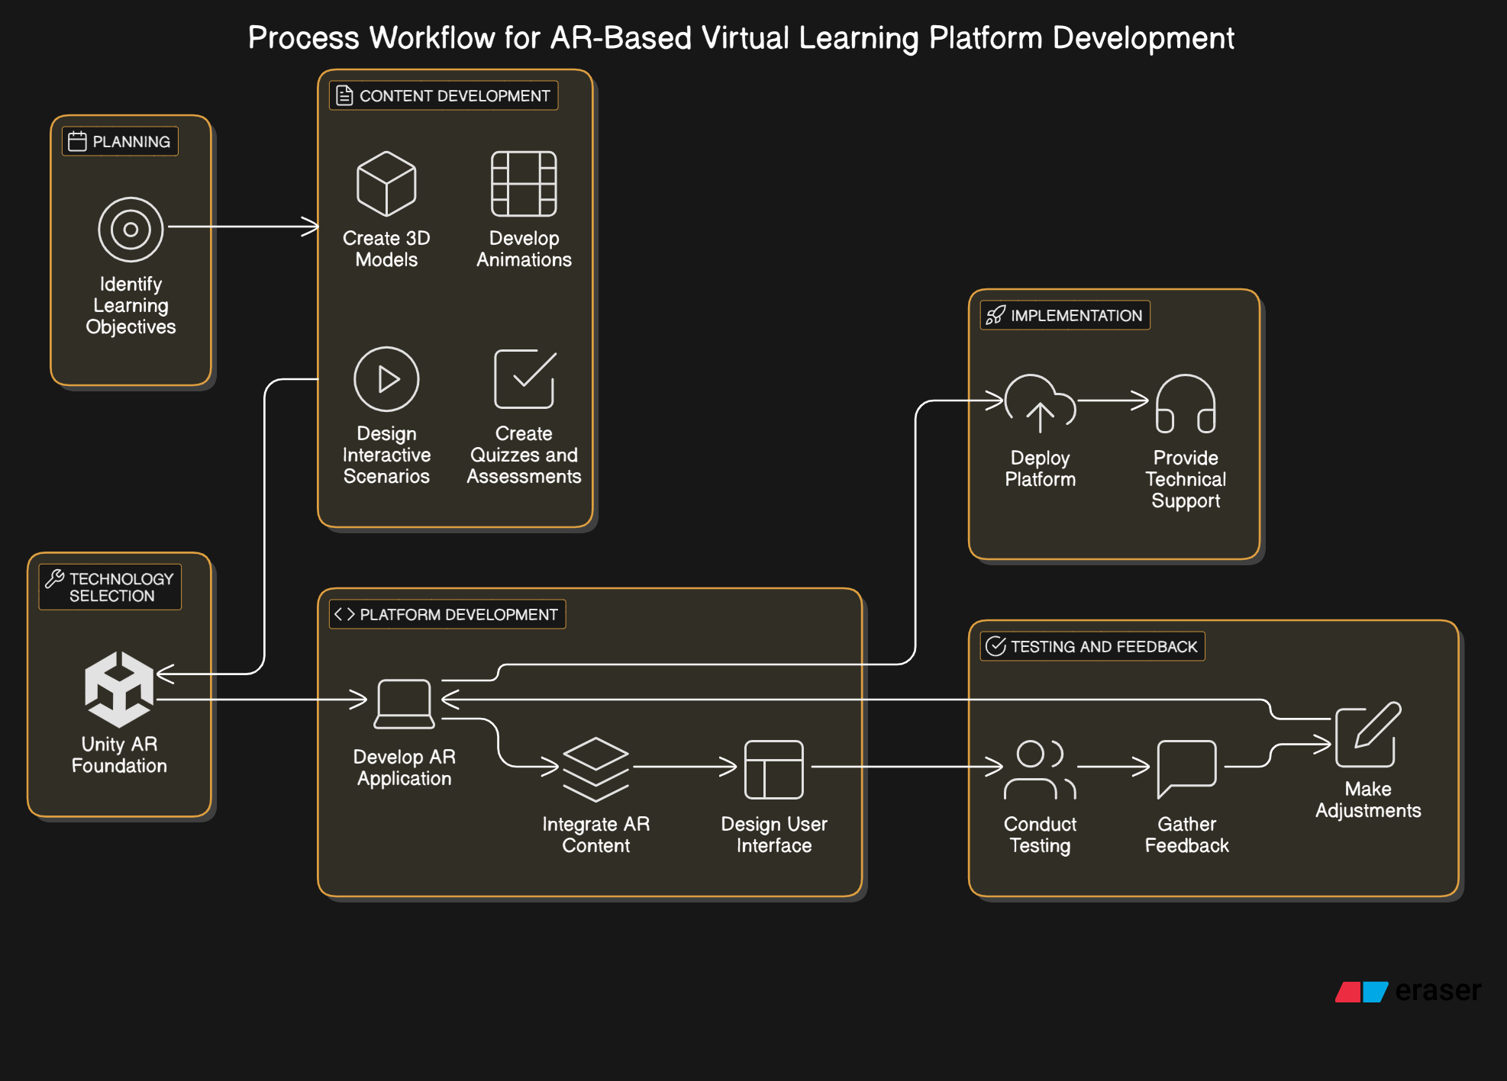

**Fig 1:** Architecture diagram

To build a captivating immersive learning platform using Unity AR Foundation, we need to follow these steps:

1. **Set Clear Learning Objectives**: Pinpoint what students should achieve and how AR can amplify the learning experience.
2. **Create Engaging Content**: Develop interactive 3D models and scenarios that fit the educational goals.
3. **Choose AR Tools**: Leverage Unity AR Foundation to create the app for both iOS and Android.
4. **Develop the Platform**: Combine the AR content, ensuring it delivers a smooth user experience.
5. **Design an Intuitive Interface**: Focus on a clean, easy-to-use interface that encourages interaction.
6. **Test and Optimize**: Run tests with real users, gather insights, and fine-tune the platform.
7. **Launch and Offer Support**: Deploy the platform, providing user guides and ongoing technical support.

By following these steps, we have created an immersive and impactful learning experience that keeps students engaged.

**CHAPTER 4**

## 4.1 EXPERIMENTAL SETUP ANALYSIS

**Spatial** is a platform that allows users to create and interact in immersive 3D virtual spaces. Originally designed for remote work and collaboration, Spatial enables users to meet, collaborate, and share ideas in augmented or virtual reality (AR/VR) environments. The platform offers real-time 3D communication, combining elements of virtual worlds with the interactivity of physical spaces.

One of the key features of Spatial is its **cross-platform accessibility**. You can join virtual environments using AR/VR headsets like Oculus or HoloLens, but also from your desktop or mobile device. This flexibility makes it easy for teams and individuals from different devices to collaborate seamlessly.

Spatial allows you to create lifelike avatars from photos and participate in virtual meetings, conferences, or exhibitions where 3D models, presentations, and documents can be shared and manipulated in real-time. Its **immersive experience** offers a more engaging alternative to traditional video calls, making remote collaboration feel more natural and interactive.

For designers and developers, Spatial provides tools for building custom 3D spaces, enabling businesses to create branded virtual showrooms, educational environments, or creative collaborative spaces. Additionally, the platform supports integrating **external 3D models** or assets, allowing users to bring their own content into the virtual workspace.

Overall, Spatial is transforming remote collaboration, allowing users to interact in 3D spaces in ways that mimic real-world interactions but with the added benefit of virtual tools and environments.

We are also trying to add a chatbot which answers queries when the assistant can’t answer and the students can change their avatars and make a lot of gestures and actions when they are invited into a classroom similar to a gaming system.

## 4.2 RESULTS

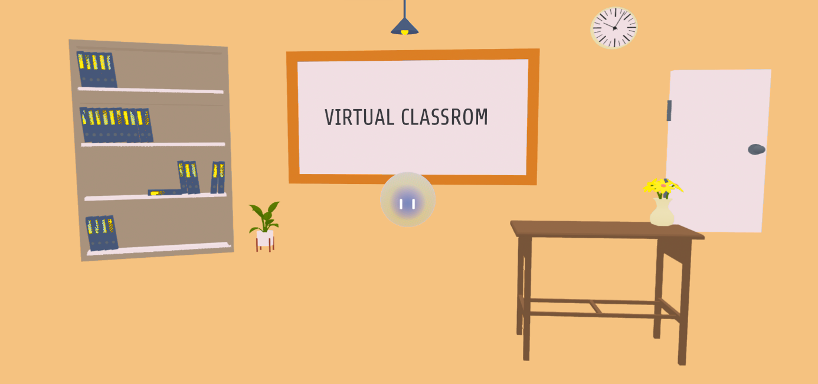

**Fig 2:** The virtual classroom environment in Spline

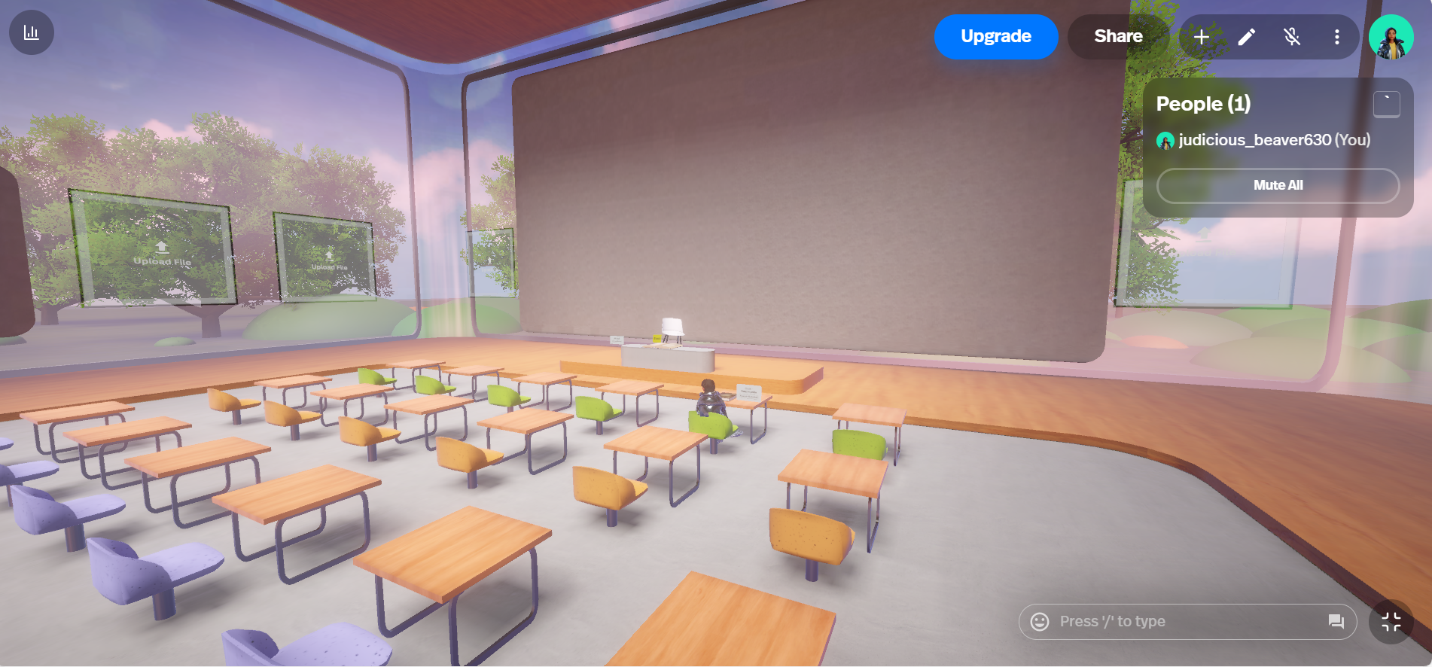

**Fig 2:** The virtual classroom environment in Spatial

## 4.3 SUMMARY

We have developed a **virtual classroom** in both **Spline** and **Spatial.io**, incorporating interactive elements to enhance the learning experience.

* **Spline:** Used for 3D modelling and designing interactive scenes, ensuring an engaging and visually appealing environment.
* **Spatial.io:** Integrated with **Sketchfab** to add interactive objects, creating an immersive space for students.
* **Virtual Assistant:** Implemented a **voice assistant** capable of answering simple questions, improving interactivity and engagement.

This project showcases your skills in **3D design, spatial computing, AI integration, and virtual world development**.

## CHAPTER 5

## 5.1 CONCLUSION

The **virtual classroom**, developed using **Spline and Spatial.io**, offers an **interactive and immersive learning environment** that enhances student engagement through advanced **AI and 3D visualization**.

Key features include:

* **AI-powered virtual assistant** integrated with a **chatbot** to answer queries in real time.
* **Avatar customization**, similar to gaming platforms, allowing users to personalize their presence in the virtual space.
* **Interactive object explanations**, where the assistant provides information when users hover over objects, improving contextual learning.

By leveraging **Spline for 3D modelling** and **Spatial.io for virtual interaction**, this project effectively combines **AI, spatial computing, and gamification** to create a **next-generation learning experience**. This approach makes education **more engaging, accessible, and dynamic**, bridging the gap between traditional and digital learning.

## 5.2 FUTURE ENHANCEMENTS

### 1. **Virtual Reality (VR) Integration**:

* **Full-Immersion Learning**: Expand the platform into VR to create fully immersive environments, where students can "step into" historical events, scientific experiments, or mathematical models. This would allow for deep, experiential learning.
* **Interactive VR Labs**: Develop virtual labs where students can conduct experiments in physics, chemistry, or biology, providing hands-on experience without the need for physical equipment.
* **Social Learning in VR**: Incorporate multi-user VR environments where students and teachers can interact in real-time, collaborate on projects, and participate in group activities, all within a shared virtual space.

### 2. **AI-Powered Personalized Learning**:

* **Adaptive Learning Paths**: Implement AI to analyze student performance and provide personalized learning recommendations, offering tailored lessons and challenges that fit individual learning styles and pace.
* **Virtual Teaching Assistants**: Integrate AI-driven virtual assistants that help students with real-time guidance, answering questions, explaining concepts, and suggesting resources based on each student's progress.

### 3. **Gamification and Achievement Systems**:

* **Progressive Gamified Learning**: Add game-like elements such as badges, leaderboards, and rewards to motivate students. Create challenges and quests that align with learning objectives, encouraging students to explore new topics.
* **Competitive Learning Modules**: Introduce competitive modules where students can solve problems in real-time or compete in educational games, fostering a sense of engagement and excitement around learning.

### 4. **Global Collaborative Learning Spaces**:

* **Cross-School Collaboration**: Allow schools or institutions globally to collaborate in shared virtual classrooms. This enables students to work together on projects, attend guest lectures, or experience virtual exchange programs.
* **Cultural Immersion**: Develop VR field trips that allow students to explore foreign cultures, historical landmarks, and natural environments, offering global exposure without leaving the classroom.

### 5. **Advanced Data Analytics and Learning Insights**:

* **Learning Analytics Dashboards**: Provide educators with detailed insights into student performance, engagement levels, and areas of improvement through advanced data analytics.
* **Predictive Analytics**: Use predictive models to identify students at risk of falling behind and implement early interventions to ensure no student is left behind.

### 6. **Mixed Reality (MR) Experiences**:

* **Hybrid AR/VR Learning**: Create hybrid learning experiences using Mixed Reality where students can interact with physical and virtual objects simultaneously. This could enhance fields like medical training, engineering, and design.
* **MR Classrooms**: Design classrooms where AR/VR headsets bring 3D content into physical learning spaces, allowing teachers to blend digital and real-world teaching aids.

**APPENDIX A**

Sample Code

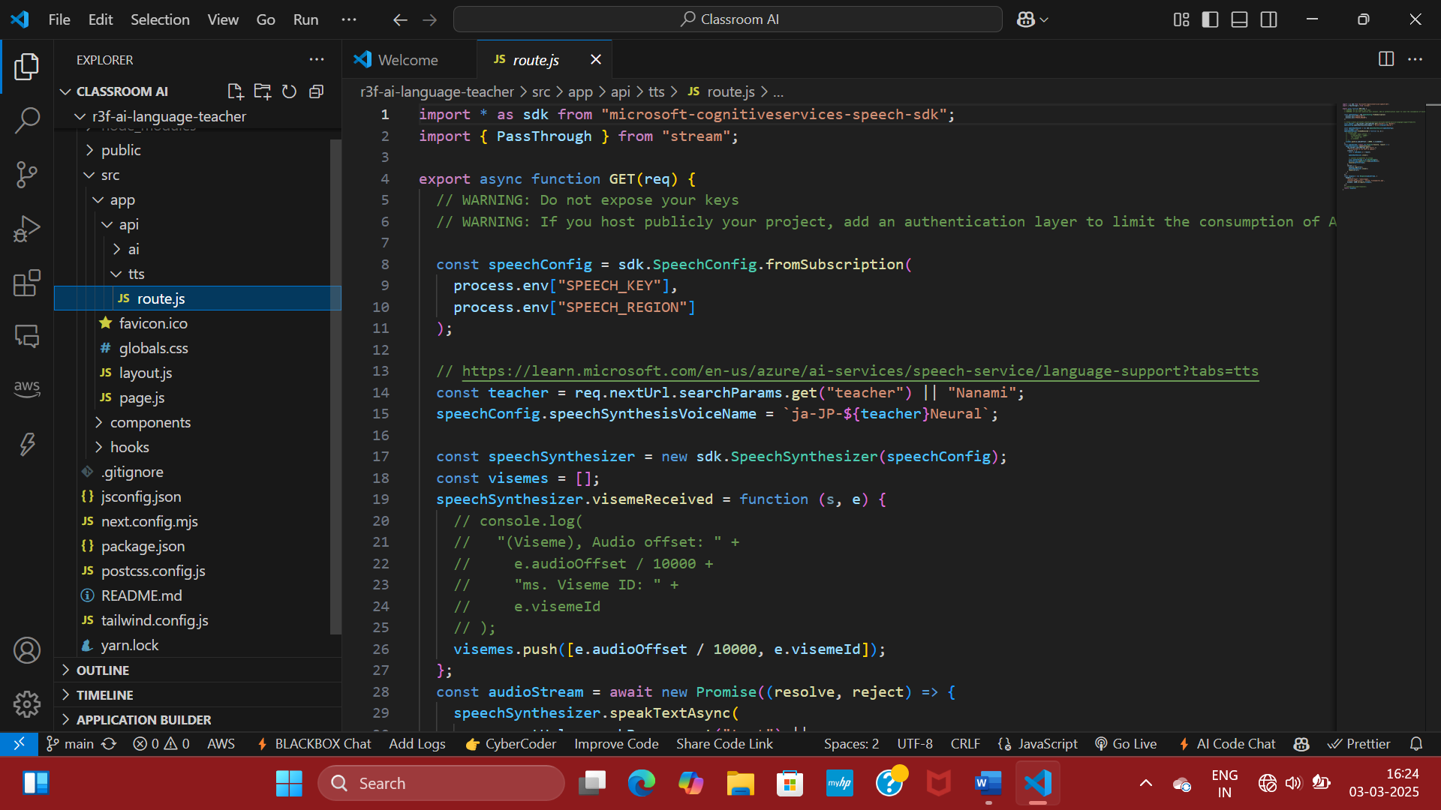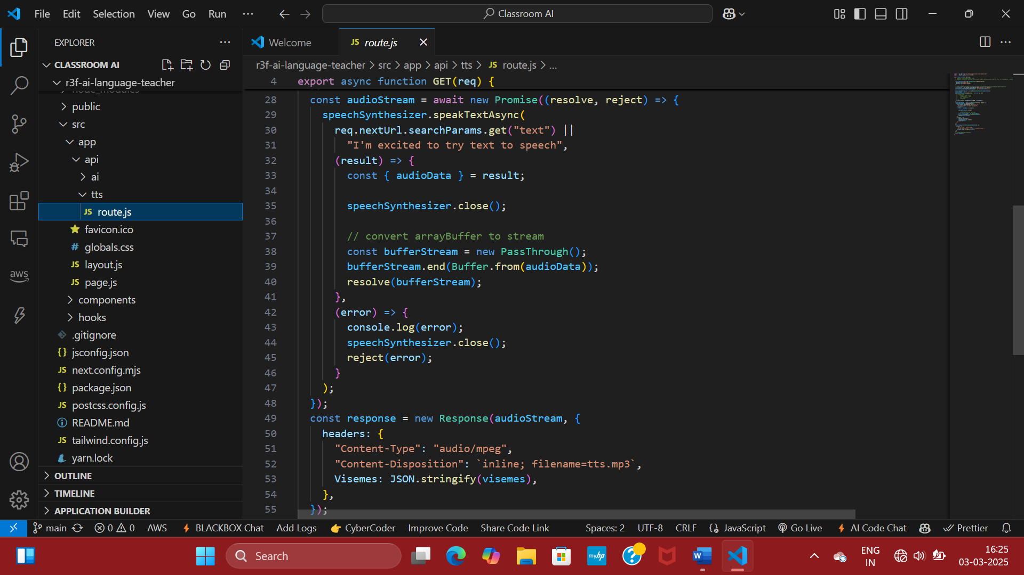

**APPENDIX B**

Sample Front End Code

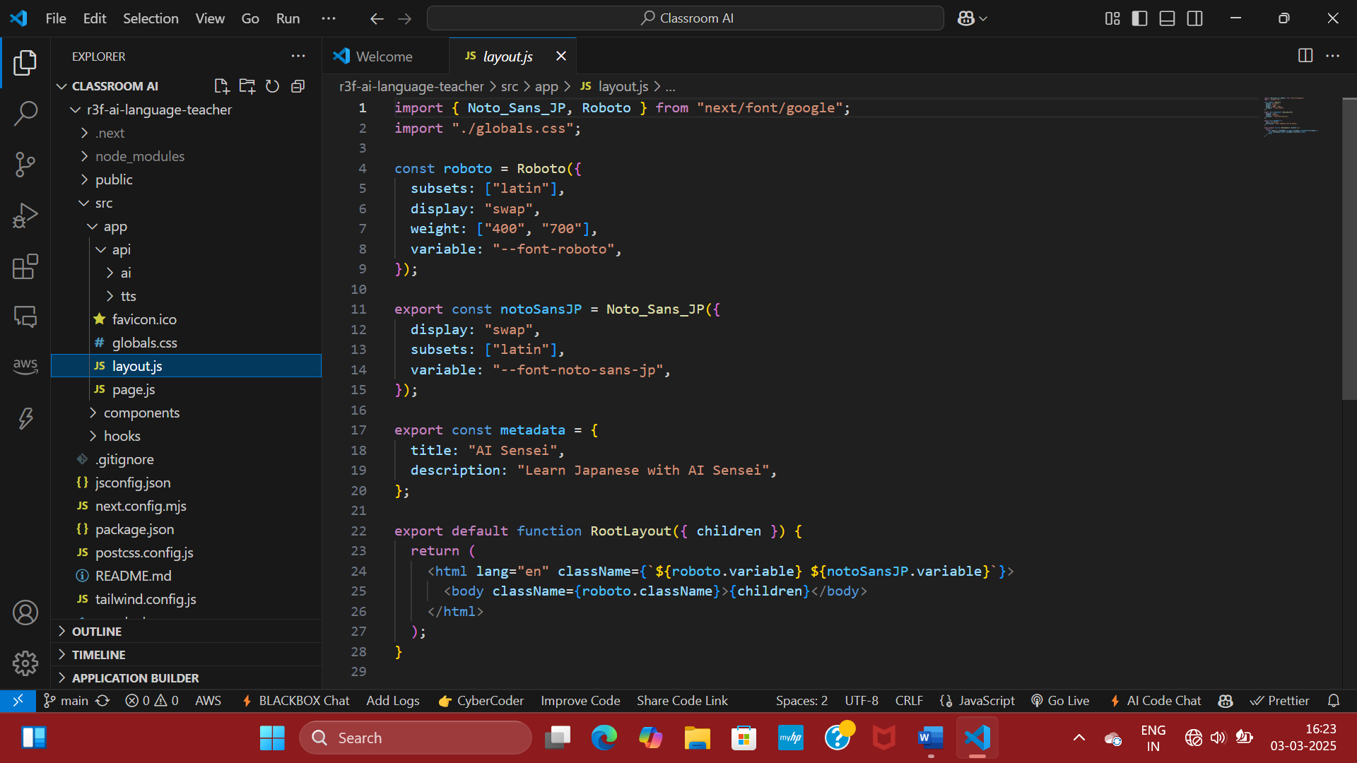

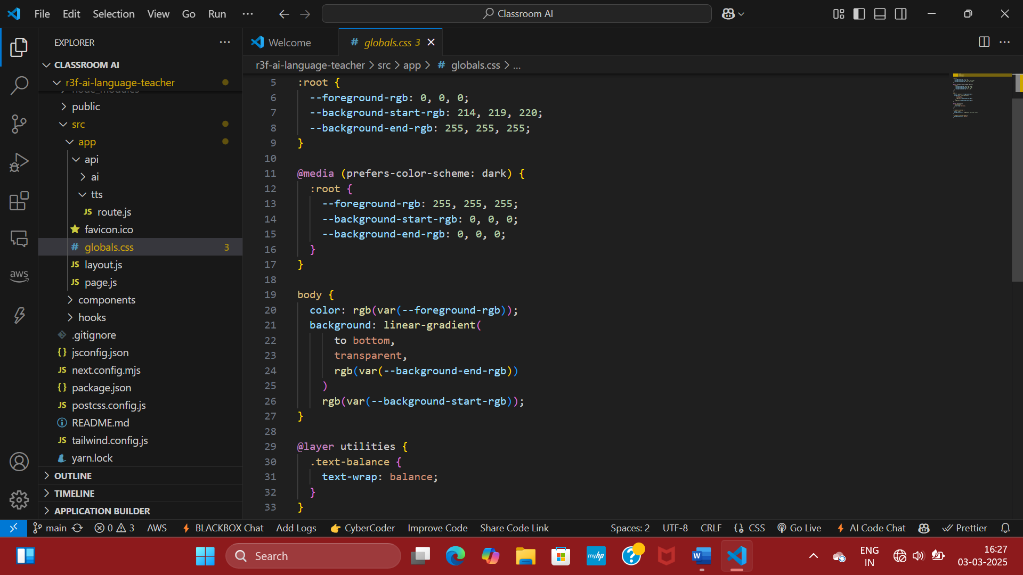

**APPENDIX D**

## Team Details

**Team Member 1:**

**Name:** Joanna Satya

**Role in Project:** Responsible for creating the virtual environment using Augmented Reality content generation tools. Assisted in research and drafting of literature review. Developed the front-end virtual assistant to be connected to the back-end voice assistant, with the help of web development tools to create a user friendly interface.

**Team Member 2:**

**Name:** Prajakta Debsharma

**Role in Project:** Responsible for research of the various technologies used in Immersive Experience platforms and Augmented Reality based approach. Drafted a thorough literature review on the research topic. Developed the back-end program for voice assistant using AI toolkit to be integrated to the front-end virtual assistant using API key.

## References

1. Huang, X., Zou, D., Cheng, G., & Xie, H. (2021). A systematic review of AR and VR enhanced language learning. *Sustainability*, *13*(9), 4639.
2. Al-Ansi, A. M., Jaboob, M., Garad, A., & Al-Ansi, A. (2023). Analyzing augmented reality (AR) and virtual reality (VR) recent development in education. Social Sciences & Humanities Open, 8(1), 100532.
3. Cevikbas, M., Bulut, N., & Kaiser, G. (2023). Exploring the benefits and drawbacks of AR and VR technologies for learners of mathematics: Recent developments. Systems, 11(5), 244.
4. Fitria, T. N. (2023). Augmented reality (AR) and virtual reality (VR) technology in education: Media of teaching and learning: A review. International Journal of Computer and Information System (IJCIS), 4(1), 14-25.
5. Krauß, V., Boden, A., Oppermann, L., & Reiners, R. (2021, May). Current practices, challenges, and design implications for collaborative AR/VR application development. In Proceedings of the 2021 CHI Conference on Human Factors in Computing Systems (pp. 1-15).
6. Ashtari, N., Bunt, A., McGrenere, J., Nebeling, M., & Chilana, P. K. (2020, April). Creating augmented and virtual reality applications: Current practices, challenges, and opportunities. In Proceedings of the 2020 CHI conference on human factors in computing systems (pp. 1-13).
7. Pakanen, M., Alavesa, P., Van Berkel, N., Koskela, T., & Ojala, T. (2022). “nice to see you virtually”: Thoughtful design and evaluation of virtual avatar of the other user in ar and vr based telexistence systems. Entertainment Computing, 40, 100457.
8. Creed, C., Al-Kalbani, M., Theil, A., Sarcar, S., & Williams, I. (2024). Inclusive AR/VR: accessibility barriers for immersive technologies. Universal Access in the Information Society, 23(1), 59-73.
9. Kim, J. H., Kim, M., Park, M., & Yoo, J. (2023). Immersive interactive technologies and virtual shopping experiences: Differences in consumer perceptions between augmented reality (AR) and virtual reality (VR). Telematics and Informatics, 77, 101936.
10. Tan, Y., Xu, W., Li, S., & Chen, K. (2022). Augmented and virtual reality (AR/VR) for education and training in the AEC industry: A systematic review of research and applications. Buildings, 12(10), 1529.