ACKNOWLEDGEMENT

For this project I visited one general store to take the requirements and Idea of the stock and seals Management. Thanks to Mr. Gaonkar for supporting me . When it came to the project requirements and development. We all buy the products Dairy products, but no one realized that the amount of manual entries are more so I think I want to contribute something to this industry .

I would also like to thank Professor Teja kundaikar for their continued guidance and feedback throughout the course of the project.

Introduction

Project is all about for dairy product shop for stack management. Dairy Farm Shop Management System is for small scale shops . basically it is one web-application for

1. Report Generation
2. Billing
3. Stack Management

For this web application there are two users

1. Admin
2. Staff

Customers are buying the the milk or milk products from shop . staff is making invoice for the customers order and do payments .

**Tables**

**Table of admin**

|  |  |
| --- | --- |
| **# ID** | **int** |
| Admin name | varchar |
| Username | char |
| Mobile number | int |
| Email | varchar |
| Password | varchar |

Table Category

|  |  |
| --- | --- |
| # ID | int |
| categoryName | varchar |
| CategoryCode | varchar |
| PostingDate | timestamp |

Table Company

|  |  |
| --- | --- |
| # Id | int |
| CompanyName | varchar |
| PostinngDate | timestamp |

Table Orders

|  |  |
| --- | --- |
| # id | int |
| productID | int |
| Quantity | int |
| InvoiceNumber | int |
| CustomerName | varchar |
| CustomerContact | int |
| PaymentMode | varchar |
| Invoice Date | timestamp |

Table Products

|  |  |
| --- | --- |
| # id | int |
| Categoryname | varchar |
| CampanyName | varchar |
| ProductName | varchar |
| Price | int |
| Posting date | time |

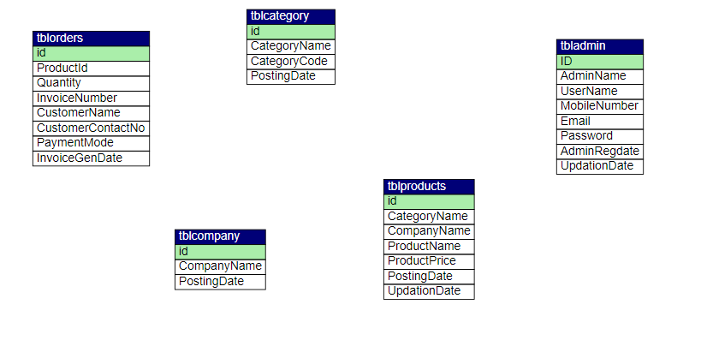

1

M

1

1

M

M

M

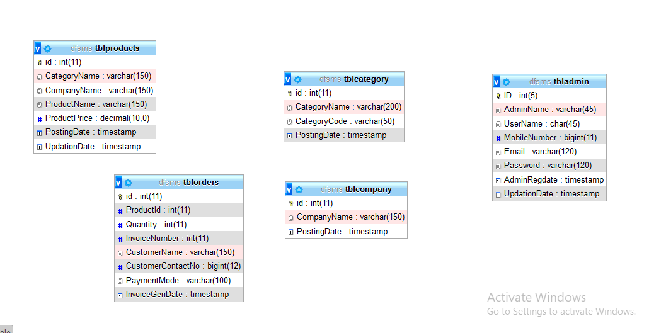

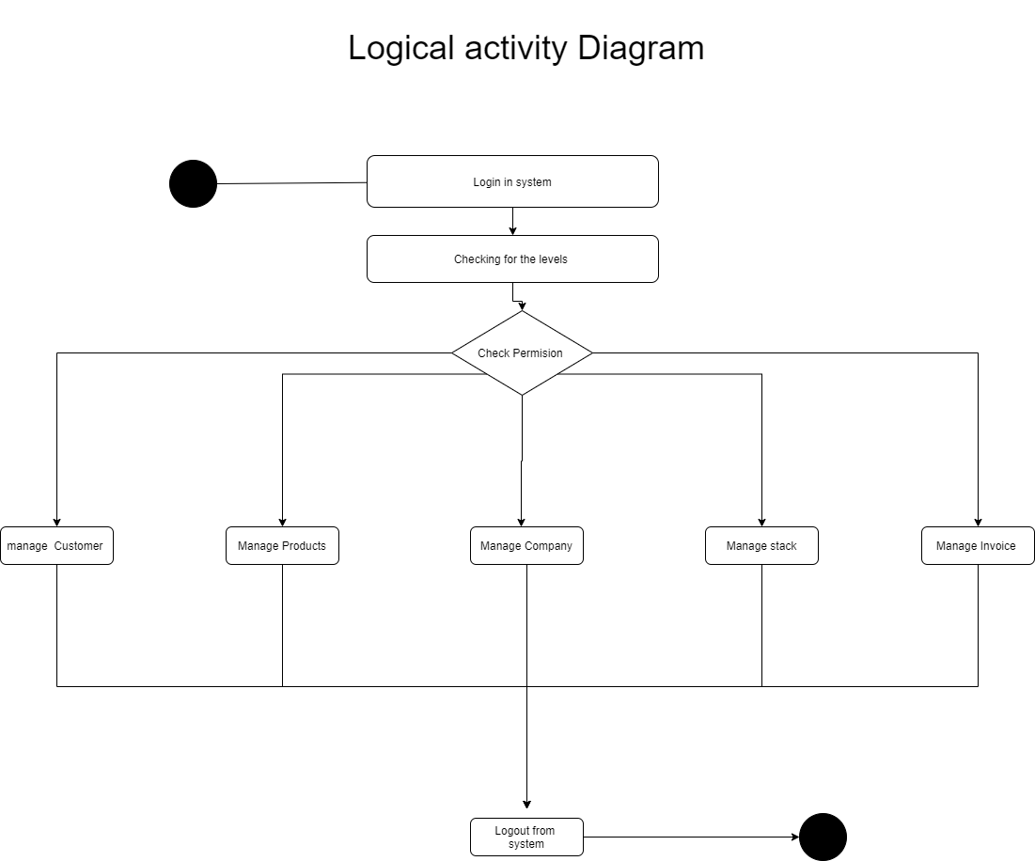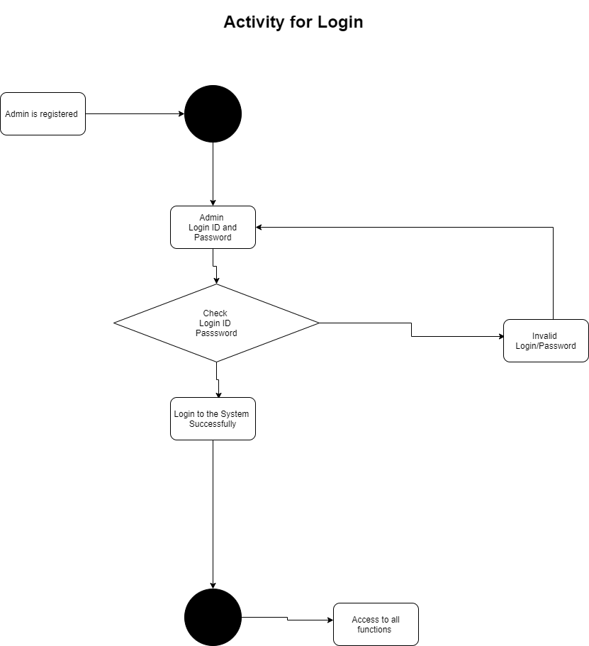

**2. SYSTEM ARCHITECTURE OVERVIEW (DEVELOPMENT ENVIRONMENT)**

2.1 FRONT END

* **Bootstrap**
* **PHP**
* **Jscript**

2.2 BACK END

Order

Company

Admin

Category Table

Products

Design Tables

Design Forms

MySQL

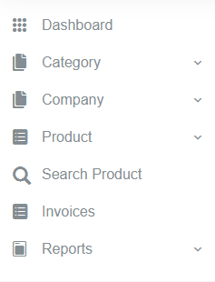

**Objectives**

1. Make reports .
2. Use the query’s for fetching the data.

**Requirements**

1. Sells management
2. Report creation
3. Invoice
4. Bill payment

**Functions**

1. **Admin**

|  |  |
| --- | --- |
| Category | Add()  Remove()  Edit() |
| Company | Add()  Remove()  Edit() |
| Product | Add()  Remove()  Edit() |
| Profile | Change_Password()  Update_user_Credential()  Logout() |
| Reports | Form_date()  To_date() |
| Dashboard | Listed_company()  Listed_products()  Listed_Categorys()  Sales_Reports() |
| Search Product | Add_product()  Cart()  Print()  Payment() |

**2.Staff**

|  |  |
| --- | --- |
| Dashboard | Listed_company()  Listed_products()  Listed_Categorys() |
| Search Product | Add_product()  Cart()  Print()  Payment() |
| Invoice | View() |