ROLL NO : 2403A51076
BATCH NO : 03
COURSE NAME : ARTIFICIAL INTELLIGENCE AND DEEP LEARNING
LAB : 07(03-09-2026)
# ============================================================
# BUILDING A CNN FOR IMAGE RECOGNITION
# FASHION-MNIST DATASET
# ============================================================
# ============================================================
# 1. IMPORT LIBRARIES
# ============================================================
import numpy as np
import matplotlib.pyplot as plt
import torch
import torch.nn as nn
import torch.optim as optim
from torch.utils.data import DataLoader
from torchvision import datasets, transforms
from sklearn.metrics import (
accuracy_score,
precision_score,
recall_score,
f1_score,
confusion_matrix,
ConfusionMatrixDisplay
)
# ============================================================
# 2. SET DEVICE
# ============================================================
torch.manual_seed(42)
np.random.seed(42)
device = torch.device(
"cuda" if torch.cuda.is_available() else "cpu"
)
print("Using device:", device)
# ============================================================
# 3. LOAD AND PREPROCESS FASHION-MNIST
# ============================================================
transform = transforms.Compose([
transforms.ToTensor(),
# Normalize grayscale images
transforms.Normalize(
(0.5,),
(0.5,)
)
])
# Automatically downloads FashionMNIST
# if it is not already available
train_dataset = datasets.FashionMNIST(
root="./data",
train=True,
download=True,
transform=transform
)
test_dataset = datasets.FashionMNIST(
root="./data",
train=False,
download=True,
transform=transform
)
# FashionMNIST class names
classes = [
"T-shirt/top",
"Trouser",
"Pullover",
"Dress",
"Coat",
"Sandal",
"Shirt",
"Sneaker",
"Bag",
"Ankle boot"
]
print("\nDataset Information")
print("-------------------")
print("Training images:", len(train_dataset))
print("Testing images :", len(test_dataset))
print("Number of classes:", len(classes))
print("Image size: 28 x 28")
# ============================================================
# 4. CREATE DATALOADERS
# ============================================================
batch_size = 64
train_loader = DataLoader(
train_dataset,
batch_size=batch_size,
shuffle=True
)
test_loader = DataLoader(
test_dataset,
batch_size=batch_size,
shuffle=False
)
# ============================================================
# 5. VISUALIZE SAMPLE IMAGES
# ============================================================
images, labels = next(iter(train_loader))
plt.figure(figsize=(12, 6))
for i in range(10):
plt.subplot(2, 5, i + 1)
# Undo normalization
image = images[i] / 2 + 0.5
plt.imshow(
image.squeeze(),
cmap="gray"
)
plt.title(
classes[labels[i].item()]
)
plt.axis("off")
plt.suptitle("Sample FashionMNIST Images")
plt.tight_layout()
plt.show()
# ============================================================
# 6. BUILD CNN MODEL
# ============================================================
class FashionMNISTCNN(nn.Module):
def __init__(self):
super(FashionMNISTCNN, self).__init__()
# First convolution layer
self.conv1 = nn.Conv2d(
in_channels=1,
out_channels=32,
kernel_size=3,
padding=1
)
# Second convolution layer
self.conv2 = nn.Conv2d(
in_channels=32,
out_channels=64,
kernel_size=3,
padding=1
)
# Third convolution layer
self.conv3 = nn.Conv2d(
in_channels=64,
out_channels=128,
kernel_size=3,
padding=1
)
# Pooling layer
self.pool = nn.MaxPool2d(
kernel_size=2,
stride=2
)
# Activation function
self.relu = nn.ReLU()
# Dropout
self.dropout = nn.Dropout(0.3)
# Fully connected layers
#
# Image size:
# 28 -> 14 -> 7 -> 3
#
# After 3 pooling operations:
# 128 x 3 x 3
self.fc1 = nn.Linear(
128 * 3 * 3,
128
)
# Output layer
self.fc2 = nn.Linear(
128,
10
)
def forward(self, x):
# Convolution block 1
x = self.pool(
self.relu(
self.conv1(x)
)
)
# Convolution block 2
x = self.pool(
self.relu(
self.conv2(x)
)
)
# Convolution block 3
x = self.pool(
self.relu(
self.conv3(x)
)
)
# Flatten
x = x.view(
x.size(0),
-1
)
# Fully connected layer
x = self.relu(
self.fc1(x)
)
x = self.dropout(x)
# Output
x = self.fc2(x)
return x
# Create model
model = FashionMNISTCNN().to(device)
print("\nCNN MODEL")
print("---------")
print(model)
# ============================================================
# 7. LOSS FUNCTION AND OPTIMIZER
# ============================================================
criterion = nn.CrossEntropyLoss()
optimizer = optim.Adam(
model.parameters(),
lr=0.001
)
# ============================================================
# 8. TRAIN THE CNN
# ============================================================
epochs = 10
train_losses = []
train_accuracies = []
print("\n========== TRAINING ==========")
for epoch in range(epochs):
model.train()
running_loss = 0
correct = 0
total = 0
for images, labels in train_loader:
images = images.to(device)
labels = labels.to(device)
# Clear gradients
optimizer.zero_grad()
# Forward propagation
outputs = model(images)
# Calculate loss
loss = criterion(
outputs,
labels
)
# Backpropagation
loss.backward()
# Update weights
optimizer.step()
running_loss += loss.item()
# Predictions
_, predicted = torch.max(
outputs,
1
)
total += labels.size(0)
correct += (
predicted == labels
).sum().item()
# Average loss
epoch_loss = (
running_loss /
len(train_loader)
)
# Accuracy
epoch_accuracy = (
100 * correct / total
)
train_losses.append(
epoch_loss
)
train_accuracies.append(
epoch_accuracy
)
print(
f"Epoch [{epoch + 1}/{epochs}] | "
f"Loss: {epoch_loss:.4f} | "
f"Accuracy: {epoch_accuracy:.2f}%"
)
# ============================================================
# 9. EVALUATE THE MODEL
# ============================================================
model.eval()
all_predictions = []
all_labels = []
with torch.no_grad():
for images, labels in test_loader:
images = images.to(device)
labels = labels.to(device)
outputs = model(images)
_, predicted = torch.max(
outputs,
1
)
all_predictions.extend(
predicted.cpu().numpy()
)
all_labels.extend(
labels.cpu().numpy()
)
# ============================================================
# 10. CALCULATE EVALUATION METRICS
# ============================================================
accuracy = accuracy_score(
all_labels,
all_predictions
)
precision = precision_score(
all_labels,
all_predictions,
average="weighted",
zero_division=0
)
recall = recall_score(
all_labels,
all_predictions,
average="weighted",
zero_division=0
)
f1 = f1_score(
all_labels,
all_predictions,
average="weighted",
zero_division=0
)
print("\n================================")
print("MODEL EVALUATION")
print("================================")
print(f"Accuracy : {accuracy:.4f}")
print(f"Precision : {precision:.4f}")
print(f"Recall : {recall:.4f}")
print(f"F1 Score : {f1:.4f}")
# ============================================================
# 11. TRAINING LOSS GRAPH
# ============================================================
plt.figure(figsize=(8, 5))
plt.plot(
range(1, epochs + 1),
train_losses,
marker="o"
)
plt.xlabel("Epoch")
plt.ylabel("Loss")
plt.title(
"FashionMNIST Training Loss"
)
plt.grid(True)
plt.show()
# ============================================================
# 12. TRAINING ACCURACY GRAPH
# ============================================================
plt.figure(figsize=(8, 5))
plt.plot(
range(1, epochs + 1),
train_accuracies,
marker="o"
)
plt.xlabel("Epoch")
plt.ylabel("Accuracy (%)")
plt.title(
"FashionMNIST Training Accuracy"
)
plt.grid(True)
plt.show()
# ============================================================
# 13. CONFUSION MATRIX
# ============================================================
cm = confusion_matrix(
all_labels,
all_predictions
)
plt.figure(figsize=(10, 8))
disp = ConfusionMatrixDisplay(
confusion_matrix=cm,
display_labels=classes
)
disp.plot(
xticks_rotation=45
)
plt.title(
"FashionMNIST Confusion Matrix"
)
plt.show()
# ============================================================
# 14. ACTUAL VS PREDICTED IMAGES
# ============================================================
images, labels = next(
iter(test_loader)
)
images_device = images.to(device)
with torch.no_grad():
outputs = model(images_device)
_, predicted = torch.max(
outputs,
1
)
plt.figure(figsize=(12, 8))
for i in range(10):
plt.subplot(2, 5, i + 1)
# Undo normalization
image = images[i] / 2 + 0.5
plt.imshow(
image.squeeze(),
cmap="gray"
)
actual = classes[
labels[i].item()
]
pred = classes[
predicted[i].cpu().item()
]
plt.title(
f"Actual: {actual}\nPred: {pred}",
fontsize=8
)
plt.axis("off")
plt.tight_layout()
plt.show()
# ============================================================
# 15. CONCLUSION
# ============================================================
print("\n================================")
print("CONCLUSION")
print("================================")
print(f"""
The FashionMNIST dataset was successfully loaded and
preprocessed using PyTorch.
The dataset contains 60,000 training images and
10,000 testing images belonging to 10 clothing classes.
The images were converted into tensors and normalized
before training.
A Convolutional Neural Network (CNN) was implemented
using three convolutional layers, max-pooling,
dropout and fully connected layers.
The model was trained for {epochs} epochs using the
Adam optimizer with a learning rate of 0.001 and
Cross Entropy Loss.
Final Performance:
Accuracy : {accuracy:.4f}
Precision : {precision:.4f}
Recall : {recall:.4f}
F1 Score : {f1:.4f}
The training-loss graph shows that the loss generally
decreases during training, while the training-accuracy
graph shows improvement in classification accuracy.
The confusion matrix shows which clothing categories
are classified correctly and which categories are
commonly confused.
Overall, the CNN successfully learned visual features
from FashionMNIST images and classified them into
different clothing categories. Increasing training
epochs or applying data augmentation could further
improve the model performance.
""")
Using device: cpu
100%|██████████| 26.4M/26.4M [00:01<00:00, 17.0MB/s]
100%|██████████| 29.5k/29.5k [00:00<00:00, 275kB/s]
100%|██████████| 4.42M/4.42M [00:00<00:00, 4.99MB/s]
100%|██████████| 5.15k/5.15k [00:00<00:00, 12.8MB/s]
Dataset Information
-------------------
Training images: 60000
Testing images : 10000
Number of classes: 10
Image size: 28 x 28
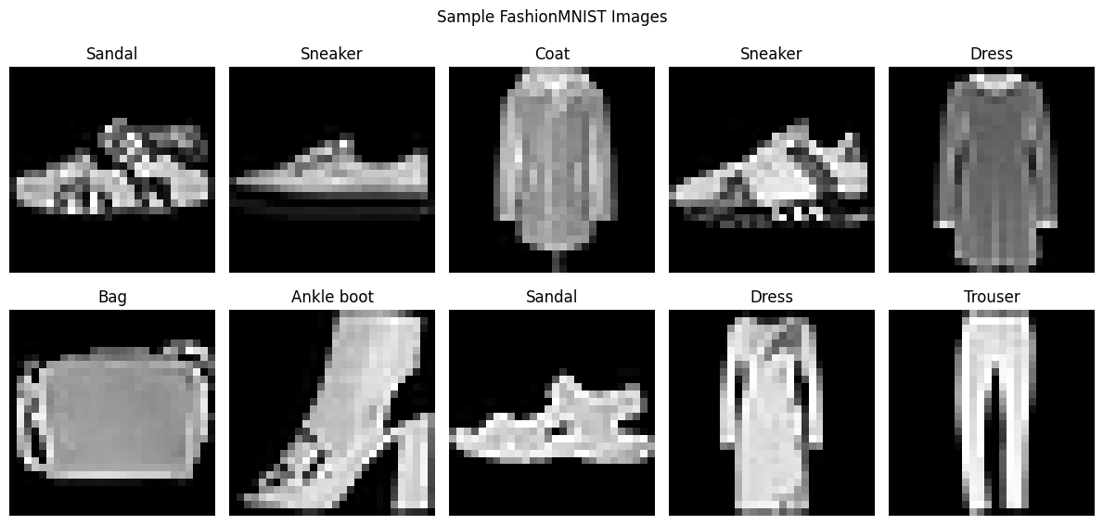
CNN MODEL
---------
FashionMNISTCNN(
(conv1): Conv2d(1, 32, kernel_size=(3, 3), stride=(1, 1), padding=(1, 1))
(conv2): Conv2d(32, 64, kernel_size=(3, 3), stride=(1, 1), padding=(1, 1))
(conv3): Conv2d(64, 128, kernel_size=(3, 3), stride=(1, 1), padding=(1, 1))
(pool): MaxPool2d(kernel_size=2, stride=2, padding=0, dilation=1, ceil_mode=False)
(relu): ReLU()
(dropout): Dropout(p=0.3, inplace=False)
(fc1): Linear(in_features=1152, out_features=128, bias=True)
(fc2): Linear(in_features=128, out_features=10, bias=True)
)
========== TRAINING ==========
Epoch [1/10] | Loss: 0.5360 | Accuracy: 80.59%
Epoch [2/10] | Loss: 0.3286 | Accuracy: 87.99%
Epoch [3/10] | Loss: 0.2727 | Accuracy: 90.10%
Epoch [4/10] | Loss: 0.2436 | Accuracy: 91.13%
Epoch [5/10] | Loss: 0.2206 | Accuracy: 92.00%
Epoch [6/10] | Loss: 0.2018 | Accuracy: 92.56%
Epoch [7/10] | Loss: 0.1824 | Accuracy: 93.29%
Epoch [8/10] | Loss: 0.1686 | Accuracy: 93.61%
Epoch [9/10] | Loss: 0.1513 | Accuracy: 94.28%
Epoch [10/10] | Loss: 0.1421 | Accuracy: 94.70%
================================
MODEL EVALUATION
================================
Accuracy : 0.9199
Precision : 0.9201
Recall : 0.9199
F1 Score : 0.9196
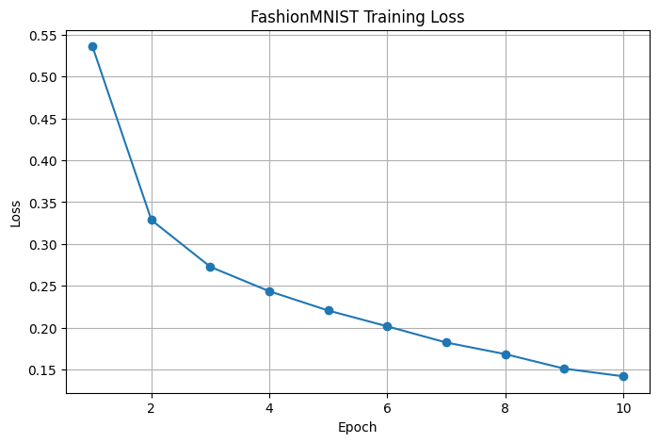
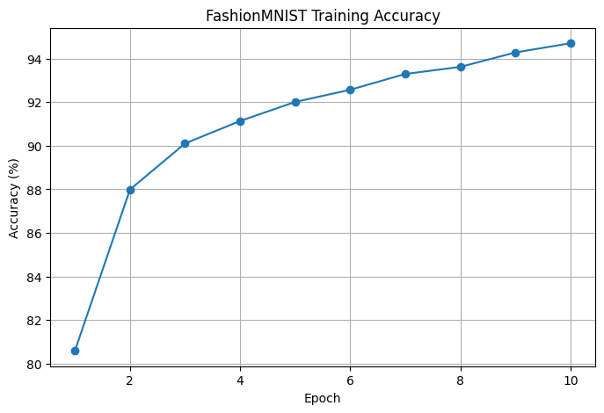
<Figure size 1000x800 with 0 Axes>
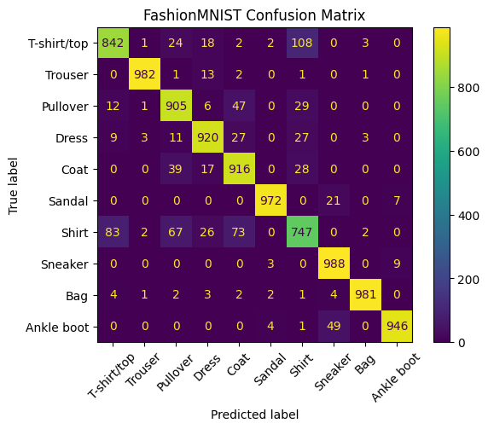
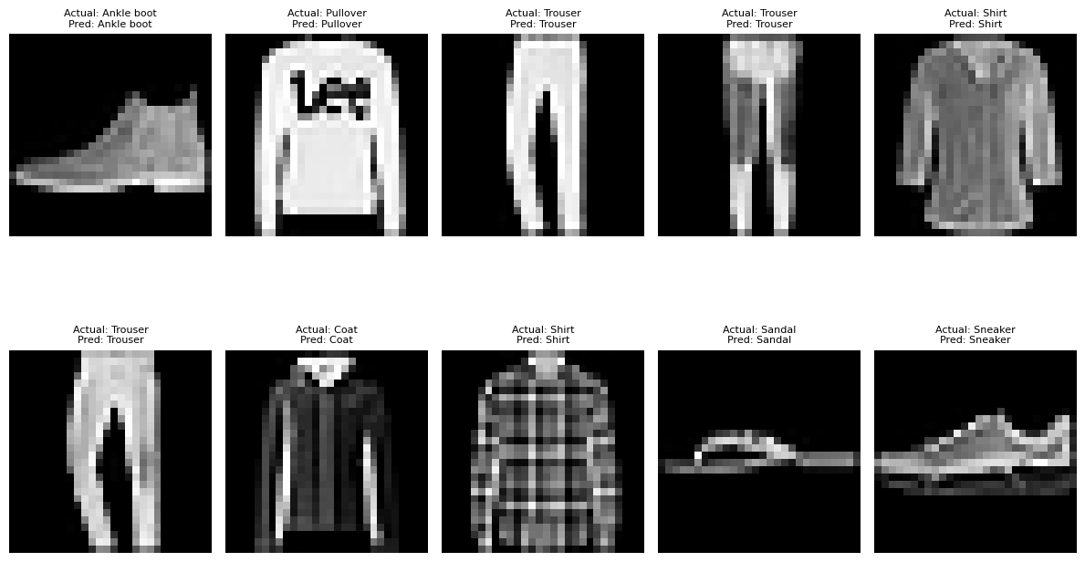
================================
CONCLUSION
================================
The FashionMNIST dataset was successfully loaded and
preprocessed using PyTorch.
The dataset contains 60,000 training images and
10,000 testing images belonging to 10 clothing classes.
The images were converted into tensors and normalized
before training.
A Convolutional Neural Network (CNN) was implemented
using three convolutional layers, max-pooling,
dropout and fully connected layers.
The model was trained for 10 epochs using the
Adam optimizer with a learning rate of 0.001 and
Cross Entropy Loss.
Final Performance:
Accuracy : 0.9199
Precision : 0.9201
Recall : 0.9199
F1 Score : 0.9196
The training-loss graph shows that the loss generally
decreases during training, while the training-accuracy
graph shows improvement in classification accuracy.
The confusion matrix shows which clothing categories
are classified correctly and which categories are
commonly confused.
Overall, the CNN successfully learned visual features
from FashionMNIST images and classified them into
different clothing categories. Increasing training
epochs or applying data augmentation could further
improve the model performance.

