ROLL NO : 2403A51076
BATCH NO : 03
COURSE NAME : ARTIFICIAL INTELLIGENCE AND DEEP LEARNING
LAB : 01(05-08-2026)

# ==========================================================
# Weather History Prediction using PyTorch
# ==========================================================
import pandas as pd
import numpy as np
import matplotlib.pyplot as plt
from sklearn.model_selection import train_test_split
from sklearn.preprocessing import LabelEncoder, StandardScaler
from sklearn.metrics import mean_absolute_error, mean_squared_error, r2_score
import torch
import torch.nn as nn
from torch.utils.data import TensorDataset, DataLoader
# ==========================================================
# 1. Load Dataset
# ==========================================================
df = pd.read_csv("weatherHistory.csv")
print("First 5 Rows")
print(df.head())
print("\nDataset Shape:", df.shape)
print("\nMissing Values")
print(df.isnull().sum())
# ==========================================================
# 2. Data Preprocessing
# ==========================================================
# Fill missing values
for col in df.columns:
if df[col].dtype == object:
df[col] = df[col].fillna(df[col].mode()[0])
else:
df[col] = df[col].fillna(df[col].mean())
# Drop Date column
if "Formatted Date" in df.columns:
df = df.drop("Formatted Date", axis=1)
# Encode categorical columns
encoder = LabelEncoder()
for col in df.select_dtypes(include="object").columns:
df[col] = encoder.fit_transform(df[col])
# Target Variable
y = df["Temperature (C)"]
# Features
X = df.drop("Temperature (C)", axis=1)
# Standardization
scaler = StandardScaler()
X = scaler.fit_transform(X)
# Train Test Split
X_train, X_test, y_train, y_test = train_test_split(
X,
y,
test_size=0.2,
random_state=42
)
# Convert to Tensor
X_train = torch.FloatTensor(X_train)
X_test = torch.FloatTensor(X_test)
y_train = torch.FloatTensor(y_train.values).view(-1,1)
y_test = torch.FloatTensor(y_test.values).view(-1,1)
# DataLoader
train_dataset = TensorDataset(X_train, y_train)
train_loader = DataLoader(train_dataset, batch_size=64, shuffle=True)
# ==========================================================
# 3. Build PyTorch Model
# ==========================================================
class WeatherModel(nn.Module):
def __init__(self):
super().__init__()
self.network = nn.Sequential(
nn.Linear(X_train.shape[1],64),
nn.ReLU(),
nn.Linear(64,32),
nn.ReLU(),
nn.Linear(32,16),
nn.ReLU(),
nn.Linear(16,1)
)
def forward(self,x):
return self.network(x)
model = WeatherModel()
criterion = nn.MSELoss()
optimizer = torch.optim.Adam(model.parameters(), lr=0.001)
# ==========================================================
# 4. Train Model
# ==========================================================
epochs = 50
losses = []
for epoch in range(epochs):
model.train()
running_loss = 0
for xb, yb in train_loader:
optimizer.zero_grad()
output = model(xb)
loss = criterion(output,yb)
loss.backward()
optimizer.step()
running_loss += loss.item()
epoch_loss = running_loss/len(train_loader)
losses.append(epoch_loss)
print(f"Epoch {epoch+1}/{epochs} Loss = {epoch_loss:.4f}")
# ==========================================================
# 5. Evaluation
# ==========================================================
model.eval()
with torch.no_grad():
predictions = model(X_test)
pred = predictions.numpy()
actual = y_test.numpy()
mae = mean_absolute_error(actual,pred)
mse = mean_squared_error(actual,pred)
rmse = np.sqrt(mse)
r2 = r2_score(actual,pred)
print("\n=========================")
print("Model Evaluation")
print("=========================")
print("MAE :",mae)
print("MSE :",mse)
print("RMSE:",rmse)
print("R2 Score:",r2)
# ==========================================================
# 6. Visualization
# ==========================================================
plt.figure(figsize=(8,5))
plt.plot(losses)
plt.title("Training Loss")
plt.xlabel("Epoch")
plt.ylabel("Loss")
plt.grid(True)
plt.show()
# Actual vs Predicted
plt.figure(figsize=(7,7))
plt.scatter(actual,pred,alpha=0.5)
plt.plot(
[actual.min(),actual.max()],
[actual.min(),actual.max()],
'r'
)
plt.xlabel("Actual Temperature")
plt.ylabel("Predicted Temperature")
plt.title("Actual vs Predicted")
plt.grid(True)
plt.show()
# ==========================================================
# 7. Conclusion
# ==========================================================
print("\n=========================")
print("Conclusion")
print("=========================")
print("""
1. WeatherHistory dataset was successfully loaded and preprocessed.
2. Missing values were handled and categorical values encoded.
3. A PyTorch Neural Network with three hidden layers was trained.
4. Model performance was evaluated using:
• MAE
• MSE
• RMSE
• R² Score
5. The training loss decreases over epochs, indicating learning.
6. The Actual vs Predicted plot shows how closely the model predicts temperature.
7. Lower MAE/RMSE and higher R² indicate better prediction performance.
""")
First 5 Rows
Formatted Date Summary Precip Type Temperature (C) \
0 2006-04-01 00:00:00.000 +0200 Partly Cloudy rain 9.472222
1 2006-04-01 01:00:00.000 +0200 Partly Cloudy rain 9.355556
2 2006-04-01 02:00:00.000 +0200 Mostly Cloudy rain 9.377778
3 2006-04-01 03:00:00.000 +0200 Partly Cloudy rain 8.288889
4 2006-04-01 04:00:00.000 +0200 Mostly Cloudy rain 8.755556
Apparent Temperature (C) Humidity Wind Speed (km/h) \
0 7.388889 0.89 14.1197
1 7.227778 0.86 14.2646
2 9.377778 0.89 3.9284
3 5.944444 0.83 14.1036
4 6.977778 0.83 11.0446
Wind Bearing (degrees) Visibility (km) Loud Cover Pressure (millibars) \
0 251.0 15.8263 0.0 1015.13
1 259.0 15.8263 0.0 1015.63
2 204.0 14.9569 0.0 1015.94
3 269.0 15.8263 0.0 1016.41
4 259.0 15.8263 0.0 1016.51
Daily Summary
0 Partly cloudy throughout the day.
1 Partly cloudy throughout the day.
2 Partly cloudy throughout the day.
3 Partly cloudy throughout the day.
4 Partly cloudy throughout the day.
Dataset Shape: (96453, 12)
Missing Values
Formatted Date 0
Summary 0
Precip Type 517
Temperature (C) 0
Apparent Temperature (C) 0
Humidity 0
Wind Speed (km/h) 0
Wind Bearing (degrees) 0
Visibility (km) 0
Loud Cover 0
Pressure (millibars) 0
Daily Summary 0
dtype: int64
Epoch 1/50 Loss = 12.9266
Epoch 2/50 Loss = 0.2212
Epoch 3/50 Loss = 0.1564
Epoch 4/50 Loss = 0.1204
Epoch 5/50 Loss = 0.1014
Epoch 6/50 Loss = 0.0865
Epoch 7/50 Loss = 0.0723
Epoch 8/50 Loss = 0.0641
Epoch 9/50 Loss = 0.0570
Epoch 10/50 Loss = 0.0508
Epoch 11/50 Loss = 0.0459
Epoch 12/50 Loss = 0.0409
Epoch 13/50 Loss = 0.0338
Epoch 14/50 Loss = 0.0273
Epoch 15/50 Loss = 0.0239
Epoch 16/50 Loss = 0.0220
Epoch 17/50 Loss = 0.0207
Epoch 18/50 Loss = 0.0196
Epoch 19/50 Loss = 0.0193
Epoch 20/50 Loss = 0.0174
Epoch 21/50 Loss = 0.0174
Epoch 22/50 Loss = 0.0162
Epoch 23/50 Loss = 0.0153
Epoch 24/50 Loss = 0.0164
Epoch 25/50 Loss = 0.0155
Epoch 26/50 Loss = 0.0144
Epoch 27/50 Loss = 0.0151
Epoch 28/50 Loss = 0.0143
Epoch 29/50 Loss = 0.0145
Epoch 30/50 Loss = 0.0141
Epoch 31/50 Loss = 0.0133
Epoch 32/50 Loss = 0.0130
Epoch 33/50 Loss = 0.0133
Epoch 34/50 Loss = 0.0128
Epoch 35/50 Loss = 0.0124
Epoch 36/50 Loss = 0.0122
Epoch 37/50 Loss = 0.0119
Epoch 38/50 Loss = 0.0118
Epoch 39/50 Loss = 0.0119
Epoch 40/50 Loss = 0.0116
Epoch 41/50 Loss = 0.0114
Epoch 42/50 Loss = 0.0116
Epoch 43/50 Loss = 0.0115
Epoch 44/50 Loss = 0.0113
Epoch 45/50 Loss = 0.0113
Epoch 46/50 Loss = 0.0105
Epoch 47/50 Loss = 0.0113
Epoch 48/50 Loss = 0.0102
Epoch 49/50 Loss = 0.0109
Epoch 50/50 Loss = 0.0106
=========================
Model Evaluation
=========================
MAE : 0.06814462691545486
MSE : 0.012455671094357967
RMSE: 0.11160497791029739
R2 Score: 0.9998648166656494
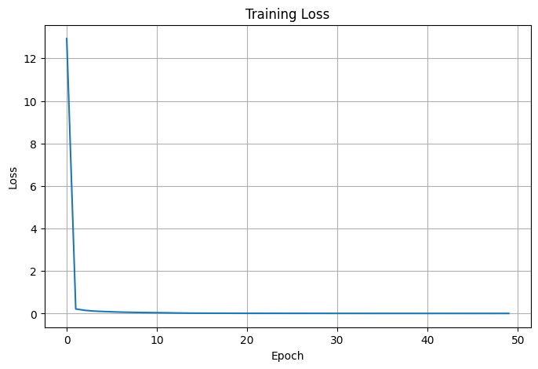
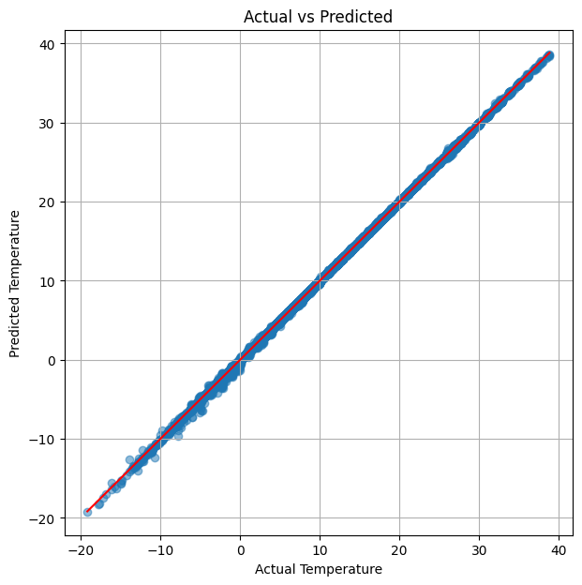
=========================
Conclusion
=========================
1. WeatherHistory dataset was successfully loaded and preprocessed.
2. Missing values were handled and categorical values encoded.
3. A PyTorch Neural Network with three hidden layers was trained.
4. Model performance was evaluated using:
• MAE
• MSE
• RMSE
• R² Score
5. The training loss decreases over epochs, indicating learning.
6. The Actual vs Predicted plot shows how closely the model predicts temperature.
7. Lower MAE/RMSE and higher R² indicate better prediction performance.

