ROLL NO : 2403A51076
BATCH NO : 03
COURSE NAME : ARTIFICIAL INTELLIGENCE AND DEEP LEARNING
LAB : 02(06-08-2026)
# ============================================================
# SALARY / INSURANCE PREDICTION USING PYTORCH
# ============================================================
# 1. IMPORT LIBRARIES
import pandas as pd
import numpy as np
import matplotlib.pyplot as plt
import torch
import torch.nn as nn
from torch.utils.data import TensorDataset, DataLoader
from sklearn.model_selection import train_test_split
from sklearn.preprocessing import StandardScaler
from sklearn.metrics import mean_absolute_error, mean_squared_error, r2_score
# ============================================================
# 2. LOAD DATASET
# ============================================================
df = pd.read_csv("insurance.csv")
print("First 5 rows:")
print(df.head())
print("\nDataset Shape:")
print(df.shape)
print("\nColumn Names:")
print(df.columns)
print("\nMissing Values:")
print(df.isnull().sum())
# ============================================================
# 3. PREPROCESS THE DATA
# ============================================================
# Target column
y = df["charges"]
# Input features
X = df.drop("charges", axis=1)
# Convert categorical columns into numerical values
X = pd.get_dummies(
X,
columns=["sex", "smoker", "region"],
drop_first=True
)
# Convert Boolean columns to integers
X = X.astype(float)
print("\nFeatures after encoding:")
print(X.head())
print("\nNumber of input features:", X.shape[1])
# ============================================================
# 4. TRAIN-TEST SPLIT
# ============================================================
X_train, X_test, y_train, y_test = train_test_split(
X,
y,
test_size=0.20,
random_state=42
)
# ============================================================
# 5. FEATURE SCALING
# ============================================================
scaler = StandardScaler()
X_train = scaler.fit_transform(X_train)
X_test = scaler.transform(X_test)
# ============================================================
# 6. CONVERT DATA TO PYTORCH TENSORS
# ============================================================
X_train = torch.tensor(
X_train,
dtype=torch.float32
)
X_test = torch.tensor(
X_test,
dtype=torch.float32
)
y_train = torch.tensor(
y_train.values,
dtype=torch.float32
).reshape(-1, 1)
y_test = torch.tensor(
y_test.values,
dtype=torch.float32
).reshape(-1, 1)
print("\nTraining samples:", len(X_train))
print("Testing samples:", len(X_test))
# ============================================================
# 7. CREATE DATALOADER
# ============================================================
train_dataset = TensorDataset(
X_train,
y_train
)
train_loader = DataLoader(
train_dataset,
batch_size=32,
shuffle=True
)
# ============================================================
# 8. BUILD PYTORCH NEURAL NETWORK
# ============================================================
class SalaryPredictionModel(nn.Module):
def __init__(self, input_size):
super(SalaryPredictionModel, self).__init__()
self.network = nn.Sequential(
nn.Linear(input_size, 64),
nn.ReLU(),
nn.Linear(64, 32),
nn.ReLU(),
nn.Linear(32, 16),
nn.ReLU(),
nn.Linear(16, 1)
)
def forward(self, x):
return self.network(x)
# Create model
input_size = X_train.shape[1]
model = SalaryPredictionModel(input_size)
print("\nPyTorch Model:")
print(model)
# ============================================================
# 9. LOSS FUNCTION AND OPTIMIZER
# ============================================================
criterion = nn.MSELoss()
optimizer = torch.optim.Adam(
model.parameters(),
lr=0.001
)
# ============================================================
# 10. TRAIN THE MODEL
# ============================================================
epochs = 100
loss_history = []
print("\n========== TRAINING ==========")
for epoch in range(epochs):
model.train()
total_loss = 0
for inputs, targets in train_loader:
# Reset gradients
optimizer.zero_grad()
# Forward pass
outputs = model(inputs)
# Calculate loss
loss = criterion(outputs, targets)
# Backpropagation
loss.backward()
# Update weights
optimizer.step()
total_loss += loss.item()
average_loss = total_loss / len(train_loader)
loss_history.append(average_loss)
if (epoch + 1) % 10 == 0:
print(
f"Epoch [{epoch+1}/{epochs}] "
f"Loss: {average_loss:.4f}"
)
# ============================================================
# 11. MAKE PREDICTIONS
# ============================================================
model.eval()
with torch.no_grad():
predictions = model(X_test)
# Convert tensors to NumPy
y_actual = y_test.numpy().flatten()
y_predicted = predictions.numpy().flatten()
# ============================================================
# 12. EVALUATION METRICS
# ============================================================
mae = mean_absolute_error(
y_actual,
y_predicted
)
mse = mean_squared_error(
y_actual,
y_predicted
)
rmse = np.sqrt(mse)
r2 = r2_score(
y_actual,
y_predicted
)
print("\n================================")
print("MODEL EVALUATION")
print("================================")
print(f"MAE : {mae:.2f}")
print(f"MSE : {mse:.2f}")
print(f"RMSE : {rmse:.2f}")
print(f"R² : {r2:.4f}")
# ============================================================
# 13. ACTUAL VS PREDICTED VALUES
# ============================================================
print("\nSample Predictions:")
results = pd.DataFrame({
"Actual Charges": y_actual[:10],
"Predicted Charges": y_predicted[:10]
})
print(results)
# ============================================================
# 14. VISUALIZATION - TRAINING LOSS
# ============================================================
plt.figure(figsize=(8, 5))
plt.plot(
range(1, epochs + 1),
loss_history
)
plt.xlabel("Epoch")
plt.ylabel("MSE Loss")
plt.title(
"Training Loss vs Epoch"
)
plt.grid(True)
plt.show()
# ============================================================
# 15. VISUALIZATION - ACTUAL VS PREDICTED
# ============================================================
plt.figure(figsize=(8, 6))
plt.scatter(
y_actual,
y_predicted,
alpha=0.5
)
# Perfect prediction line
minimum = min(
y_actual.min(),
y_predicted.min()
)
maximum = max(
y_actual.max(),
y_predicted.max()
)
plt.plot(
[minimum, maximum],
[minimum, maximum],
'r--'
)
plt.xlabel("Actual Charges")
plt.ylabel("Predicted Charges")
plt.title(
"Actual vs Predicted Charges"
)
plt.grid(True)
plt.show()
# ============================================================
# 16. RESIDUAL PLOT
# ============================================================
residuals = y_actual - y_predicted
plt.figure(figsize=(8, 5))
plt.scatter(
y_predicted,
residuals,
alpha=0.5
)
plt.axhline(
y=0,
linestyle="--"
)
plt.xlabel("Predicted Charges")
plt.ylabel("Residual")
plt.title(
"Residual Plot"
)
plt.grid(True)
plt.show()
# ============================================================
# 17. BRIEF CONCLUSION
# ============================================================
print("\n================================")
print("CONCLUSION")
print("================================")
print(f"""
The dataset was successfully loaded and preprocessed.
Categorical variables such as sex, smoker and region
were converted into numerical values using one-hot encoding.
A PyTorch Neural Network was developed and trained using
the Adam optimizer and Mean Squared Error loss.
The model was evaluated using:
MAE = {mae:.2f}
MSE = {mse:.2f}
RMSE = {rmse:.2f}
R² = {r2:.4f}
The training-loss graph shows the reduction in prediction
error during training.
The Actual vs Predicted graph shows how closely the model's
predictions follow the actual values. Points closer to the
diagonal line indicate better predictions.
A lower MAE, MSE and RMSE indicate better performance,
while a higher R² score indicates that the model explains
more variation in the target variable.
Overall, the PyTorch regression model provides a useful
prediction of the target charges based on the available
features.
""")
First 5 rows:
age sex bmi children smoker region charges
0 19 female 27.900 0 yes southwest 16884.92400
1 18 male 33.770 1 no southeast 1725.55230
2 28 male 33.000 3 no southeast 4449.46200
3 33 male 22.705 0 no northwest 21984.47061
4 32 male 28.880 0 no northwest 3866.85520
Dataset Shape:
(1338, 7)
Column Names:
Index(['age', 'sex', 'bmi', 'children', 'smoker', 'region', 'charges'], dtype='object')
Missing Values:
age 0
sex 0
bmi 0
children 0
smoker 0
region 0
charges 0
dtype: int64
Features after encoding:
age bmi children sex_male smoker_yes region_northwest \
0 19.0 27.900 0.0 0.0 1.0 0.0
1 18.0 33.770 1.0 1.0 0.0 0.0
2 28.0 33.000 3.0 1.0 0.0 0.0
3 33.0 22.705 0.0 1.0 0.0 1.0
4 32.0 28.880 0.0 1.0 0.0 1.0
region_southeast region_southwest
0 0.0 1.0
1 1.0 0.0
2 1.0 0.0
3 0.0 0.0
4 0.0 0.0
Number of input features: 8
Training samples: 1070
Testing samples: 268
PyTorch Model:
SalaryPredictionModel(
(network): Sequential(
(0): Linear(in_features=8, out_features=64, bias=True)
(1): ReLU()
(2): Linear(in_features=64, out_features=32, bias=True)
(3): ReLU()
(4): Linear(in_features=32, out_features=16, bias=True)
(5): ReLU()
(6): Linear(in_features=16, out_features=1, bias=True)
)
)
========== TRAINING ==========
Epoch [10/100] Loss: 204320756.4706
Epoch [20/100] Loss: 38036327.5588
Epoch [30/100] Loss: 34641271.1471
Epoch [40/100] Loss: 33756716.7941
Epoch [50/100] Loss: 32688429.4118
Epoch [60/100] Loss: 32483491.1471
Epoch [70/100] Loss: 31212650.5000
Epoch [80/100] Loss: 30261874.5588
Epoch [90/100] Loss: 29532498.2353
Epoch [100/100] Loss: 28595695.6029
================================
MODEL EVALUATION
================================
MAE : 3343.91
MSE : 26299144.00
RMSE : 5128.27
R² : 0.8306
Sample Predictions:
Actual Charges Predicted Charges
0 9095.068359 10017.357422
1 5272.175781 6079.138672
2 29330.982422 36055.667969
3 9301.893555 9591.621094
4 33750.292969 26573.457031
5 4536.258789 11922.552734
6 2117.338867 3331.251953
7 14210.536133 17127.314453
8 3732.625000 6360.250977
9 10264.442383 10932.103516
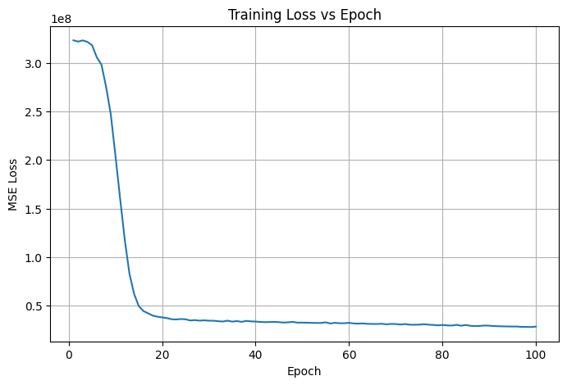
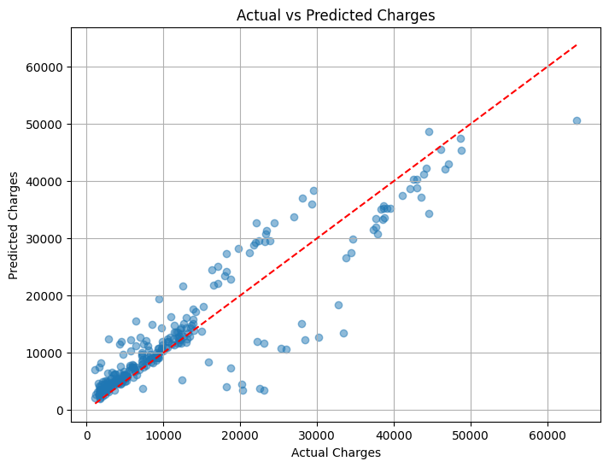
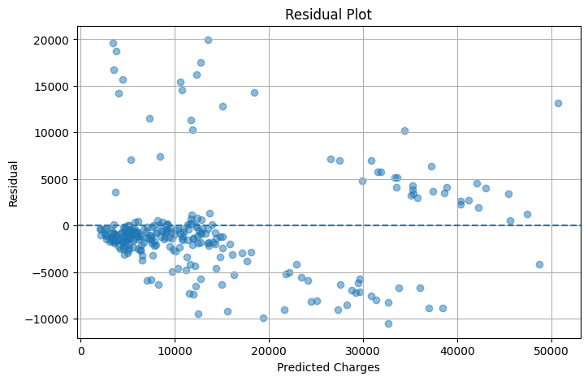
================================
CONCLUSION
================================
The dataset was successfully loaded and preprocessed.
Categorical variables such as sex, smoker and region
were converted into numerical values using one-hot encoding.
A PyTorch Neural Network was developed and trained using
the Adam optimizer and Mean Squared Error loss.
The model was evaluated using:
MAE = 3343.91
MSE = 26299144.00
RMSE = 5128.27
R² = 0.8306
The training-loss graph shows the reduction in prediction
error during training.
The Actual vs Predicted graph shows how closely the model's
predictions follow the actual values. Points closer to the
diagonal line indicate better predictions.
A lower MAE, MSE and RMSE indicate better performance,
while a higher R² score indicates that the model explains
more variation in the target variable.
Overall, the PyTorch regression model provides a useful
prediction of the target charges based on the available
features.

