ROLL NO : 2403A51076
BATCH NO : 03
COURSE NAME : ARTIFICIAL INTELLIGENCE AND DEEP LEARNING
LAB : 03(12-08-2026)
# ============================================================
# HEART DISEASE PREDICTION USING PYTORCH
# ============================================================
# 1. IMPORT LIBRARIES
import pandas as pd
import numpy as np
import matplotlib.pyplot as plt
import torch
import torch.nn as nn
from torch.utils.data import TensorDataset, DataLoader
from sklearn.model_selection import train_test_split
from sklearn.preprocessing import StandardScaler
from sklearn.metrics import (
accuracy_score,
precision_score,
recall_score,
f1_score,
confusion_matrix,
ConfusionMatrixDisplay
)
# ============================================================
# 2. LOAD DATASET
# ============================================================
df = pd.read_csv("heart.csv")
print("First 5 rows:")
print(df.head())
print("\nDataset Shape:")
print(df.shape)
print("\nColumn Names:")
print(df.columns)
print("\nMissing Values:")
print(df.isnull().sum())
# ============================================================
# 3. PREPROCESSING
# ============================================================
# Separate input features and target
X = df.drop("target", axis=1)
y = df["target"]
# Split into training and testing data
X_train, X_test, y_train, y_test = train_test_split(
X,
y,
test_size=0.20,
random_state=42,
stratify=y
)
# Standardize the features
scaler = StandardScaler()
X_train = scaler.fit_transform(X_train)
X_test = scaler.transform(X_test)
# Convert data into PyTorch tensors
X_train = torch.tensor(X_train, dtype=torch.float32)
X_test = torch.tensor(X_test, dtype=torch.float32)
y_train = torch.tensor(
y_train.values,
dtype=torch.float32
).reshape(-1, 1)
y_test = torch.tensor(
y_test.values,
dtype=torch.float32
).reshape(-1, 1)
print("\nTraining samples:", len(X_train))
print("Testing samples:", len(X_test))
# ============================================================
# 4. CREATE DATALOADER
# ============================================================
train_dataset = TensorDataset(X_train, y_train)
train_loader = DataLoader(
train_dataset,
batch_size=32,
shuffle=True
)
# ============================================================
# 5. BUILD PYTORCH NEURAL NETWORK
# ============================================================
class HeartDiseaseModel(nn.Module):
def __init__(self):
super(HeartDiseaseModel, self).__init__()
self.layer1 = nn.Linear(13, 64)
self.layer2 = nn.Linear(64, 32)
self.layer3 = nn.Linear(32, 16)
self.output = nn.Linear(16, 1)
self.relu = nn.ReLU()
def forward(self, x):
x = self.relu(self.layer1(x))
x = self.relu(self.layer2(x))
x = self.relu(self.layer3(x))
x = self.output(x)
return x
# Create model
model = HeartDiseaseModel()
print("\nModel:")
print(model)
# ============================================================
# 6. LOSS FUNCTION AND OPTIMIZER
# ============================================================
criterion = nn.BCEWithLogitsLoss()
optimizer = torch.optim.Adam(
model.parameters(),
lr=0.001
)
# ============================================================
# 7. TRAIN THE MODEL
# ============================================================
epochs = 50
loss_history = []
for epoch in range(epochs):
model.train()
total_loss = 0
for inputs, targets in train_loader:
# Clear previous gradients
optimizer.zero_grad()
# Forward pass
outputs = model(inputs)
# Calculate loss
loss = criterion(outputs, targets)
# Backpropagation
loss.backward()
# Update weights
optimizer.step()
total_loss += loss.item()
average_loss = total_loss / len(train_loader)
loss_history.append(average_loss)
print(
f"Epoch [{epoch+1}/{epochs}] "
f"Loss: {average_loss:.4f}"
)
# ============================================================
# 8. MODEL EVALUATION
# ============================================================
model.eval()
with torch.no_grad():
outputs = model(X_test)
# Convert logits to probabilities
probabilities = torch.sigmoid(outputs)
# Convert probability to class
predictions = (probabilities >= 0.5).float()
# Convert tensors to NumPy
y_actual = y_test.numpy().flatten()
y_pred = predictions.numpy().flatten()
# ============================================================
# 9. CALCULATE EVALUATION METRICS
# ============================================================
accuracy = accuracy_score(
y_actual,
y_pred
)
precision = precision_score(
y_actual,
y_pred
)
recall = recall_score(
y_actual,
y_pred
)
f1 = f1_score(
y_actual,
y_pred
)
print("\n================================")
print("MODEL EVALUATION")
print("================================")
print(f"Accuracy : {accuracy:.4f}")
print(f"Precision : {precision:.4f}")
print(f"Recall : {recall:.4f}")
print(f"F1 Score : {f1:.4f}")
# ============================================================
# 10. CONFUSION MATRIX
# ============================================================
cm = confusion_matrix(
y_actual,
y_pred
)
print("\nConfusion Matrix:")
print(cm)
# ============================================================
# 11. PLOT TRAINING LOSS
# ============================================================
plt.figure(figsize=(8, 5))
plt.plot(
range(1, epochs + 1),
loss_history
)
plt.xlabel("Epoch")
plt.ylabel("Training Loss")
plt.title("Training Loss vs Epoch")
plt.grid(True)
plt.show()
# ============================================================
# 12. CONFUSION MATRIX VISUALIZATION
# ============================================================
disp = ConfusionMatrixDisplay(
confusion_matrix=cm,
display_labels=["No Disease", "Disease"]
)
disp.plot()
plt.title("Confusion Matrix")
plt.show()
# ============================================================
# 13. ACTUAL VS PREDICTED VISUALIZATION
# ============================================================
plt.figure(figsize=(10, 5))
plt.plot(
y_actual[:50],
marker="o",
label="Actual"
)
plt.plot(
y_pred[:50],
marker="x",
label="Predicted"
)
plt.xlabel("Test Sample")
plt.ylabel("Class")
plt.title(
"Actual vs Predicted Heart Disease "
"(First 50 Test Samples)"
)
plt.legend()
plt.grid(True)
plt.show()
# ============================================================
# 14. BRIEF CONCLUSION
# ============================================================
print("\n================================")
print("CONCLUSION")
print("================================")
print(f"""
The Heart Disease dataset was successfully loaded and
preprocessed. The dataset contains {len(df)} records and
13 input features.
A PyTorch Neural Network was developed with three hidden
layers and trained using the Adam optimizer and
Binary Cross Entropy loss.
The model achieved:
Accuracy : {accuracy:.4f}
Precision : {precision:.4f}
Recall : {recall:.4f}
F1 Score : {f1:.4f}
The training-loss graph shows how the model learns as the
number of epochs increases.
The confusion matrix shows the number of correctly and
incorrectly classified heart-disease cases.
Overall, the PyTorch model can classify patients into
heart-disease and no-heart-disease classes with the
performance indicated by the above evaluation metrics.
Higher accuracy, precision, recall, and F1-score indicate
better classification performance.
""")
First 5 rows:
age sex cp trestbps chol fbs restecg thalach exang oldpeak slope \
0 52 1 0 125 212 0 1 168 0 1.0 2
1 53 1 0 140 203 1 0 155 1 3.1 0
2 70 1 0 145 174 0 1 125 1 2.6 0
3 61 1 0 148 203 0 1 161 0 0.0 2
4 62 0 0 138 294 1 1 106 0 1.9 1
ca thal target
0 2 3 0
1 0 3 0
2 0 3 0
3 1 3 0
4 3 2 0
Dataset Shape:
(1025, 14)
Column Names:
Index(['age', 'sex', 'cp', 'trestbps', 'chol', 'fbs', 'restecg', 'thalach',
'exang', 'oldpeak', 'slope', 'ca', 'thal', 'target'],
dtype='object')
Missing Values:
age 0
sex 0
cp 0
trestbps 0
chol 0
fbs 0
restecg 0
thalach 0
exang 0
oldpeak 0
slope 0
ca 0
thal 0
target 0
dtype: int64
Training samples: 820
Testing samples: 205
Model:
HeartDiseaseModel(
(layer1): Linear(in_features=13, out_features=64, bias=True)
(layer2): Linear(in_features=64, out_features=32, bias=True)
(layer3): Linear(in_features=32, out_features=16, bias=True)
(output): Linear(in_features=16, out_features=1, bias=True)
(relu): ReLU()
)
Epoch [1/50] Loss: 0.6809
Epoch [2/50] Loss: 0.6078
Epoch [3/50] Loss: 0.4579
Epoch [4/50] Loss: 0.3583
Epoch [5/50] Loss: 0.3262
Epoch [6/50] Loss: 0.3082
Epoch [7/50] Loss: 0.2943
Epoch [8/50] Loss: 0.2796
Epoch [9/50] Loss: 0.2666
Epoch [10/50] Loss: 0.2530
Epoch [11/50] Loss: 0.2373
Epoch [12/50] Loss: 0.2258
Epoch [13/50] Loss: 0.2088
Epoch [14/50] Loss: 0.1987
Epoch [15/50] Loss: 0.1824
Epoch [16/50] Loss: 0.1661
Epoch [17/50] Loss: 0.1504
Epoch [18/50] Loss: 0.1382
Epoch [19/50] Loss: 0.1228
Epoch [20/50] Loss: 0.1098
Epoch [21/50] Loss: 0.0925
Epoch [22/50] Loss: 0.0814
Epoch [23/50] Loss: 0.0708
Epoch [24/50] Loss: 0.0603
Epoch [25/50] Loss: 0.0502
Epoch [26/50] Loss: 0.0424
Epoch [27/50] Loss: 0.0352
Epoch [28/50] Loss: 0.0309
Epoch [29/50] Loss: 0.0254
Epoch [30/50] Loss: 0.0216
Epoch [31/50] Loss: 0.0187
Epoch [32/50] Loss: 0.0193
Epoch [33/50] Loss: 0.0187
Epoch [34/50] Loss: 0.0161
Epoch [35/50] Loss: 0.0103
Epoch [36/50] Loss: 0.0087
Epoch [37/50] Loss: 0.0079
Epoch [38/50] Loss: 0.0070
Epoch [39/50] Loss: 0.0064
Epoch [40/50] Loss: 0.0057
Epoch [41/50] Loss: 0.0057
Epoch [42/50] Loss: 0.0049
Epoch [43/50] Loss: 0.0044
Epoch [44/50] Loss: 0.0039
Epoch [45/50] Loss: 0.0036
Epoch [46/50] Loss: 0.0033
Epoch [47/50] Loss: 0.0031
Epoch [48/50] Loss: 0.0028
Epoch [49/50] Loss: 0.0026
Epoch [50/50] Loss: 0.0025
================================
MODEL EVALUATION
================================
Accuracy : 1.0000
Precision : 1.0000
Recall : 1.0000
F1 Score : 1.0000
Confusion Matrix:
[[100 0]
[ 0 105]]
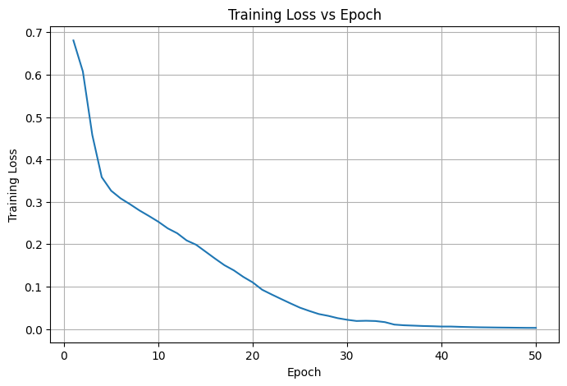
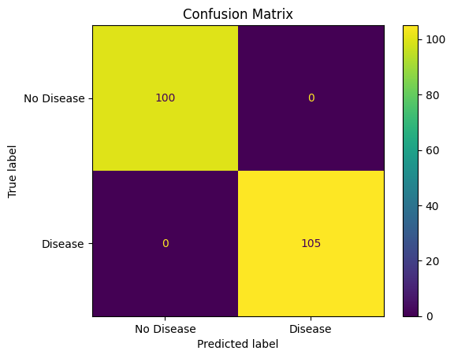
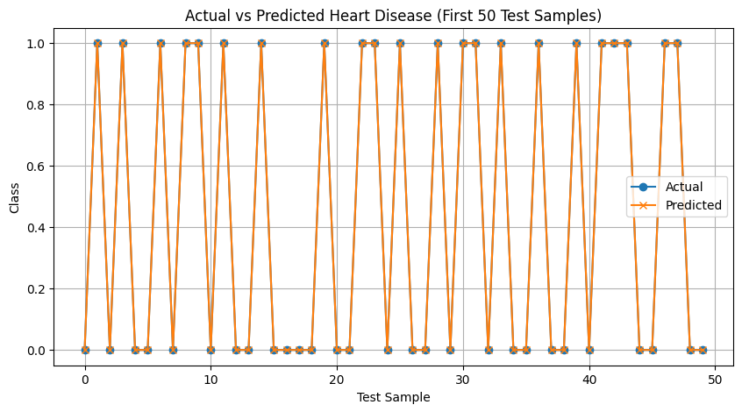
================================
CONCLUSION
================================
The Heart Disease dataset was successfully loaded and
preprocessed. The dataset contains 1025 records and
13 input features.
A PyTorch Neural Network was developed with three hidden
layers and trained using the Adam optimizer and
Binary Cross Entropy loss.
The model achieved:
Accuracy : 1.0000
Precision : 1.0000
Recall : 1.0000
F1 Score : 1.0000
The training-loss graph shows how the model learns as the
number of epochs increases.
The confusion matrix shows the number of correctly and
incorrectly classified heart-disease cases.
Overall, the PyTorch model can classify patients into
heart-disease and no-heart-disease classes with the
performance indicated by the above evaluation metrics.
Higher accuracy, precision, recall, and F1-score indicate
better classification performance.

