ROLL NO : 2403A51076
BATCH NO : 03
COURSE NAME : ARTIFICIAL INTELLIGENCE AND DEEP LEARNING
LAB : 04(13-08-2026)
# ============================================================
# WINE QUALITY PREDICTION USING PYTORCH
# ============================================================
# 1. IMPORT LIBRARIES
import pandas as pd
import numpy as np
import matplotlib.pyplot as plt
import torch
import torch.nn as nn
from torch.utils.data import TensorDataset, DataLoader
from sklearn.model_selection import train_test_split
from sklearn.preprocessing import StandardScaler
from sklearn.metrics import mean_absolute_error, mean_squared_error, r2_score
# ============================================================
# 2. LOAD DATASET
# ============================================================
df = pd.read_csv("WineQT.csv")
print("First 5 rows:")
print(df.head())
print("\nDataset Shape:")
print(df.shape)
print("\nColumn Names:")
print(df.columns)
print("\nMissing Values:")
print(df.isnull().sum())
# ============================================================
# 3. PREPROCESS THE DATA
# ============================================================
# Remove Id column because it is only an identifier
df = df.drop("Id", axis=1)
# Separate input features and target
X = df.drop("quality", axis=1)
y = df["quality"]
print("\nFeatures:")
print(X.columns)
print("\nTarget:")
print("quality")
# ============================================================
# 4. TRAIN-TEST SPLIT
# ============================================================
X_train, X_test, y_train, y_test = train_test_split(
X,
y,
test_size=0.20,
random_state=42
)
print("\nTraining samples:", len(X_train))
print("Testing samples:", len(X_test))
# ============================================================
# 5. FEATURE SCALING
# ============================================================
scaler = StandardScaler()
X_train = scaler.fit_transform(X_train)
X_test = scaler.transform(X_test)
# ============================================================
# 6. CONVERT DATA TO PYTORCH TENSORS
# ============================================================
X_train = torch.tensor(
X_train,
dtype=torch.float32
)
X_test = torch.tensor(
X_test,
dtype=torch.float32
)
y_train = torch.tensor(
y_train.values,
dtype=torch.float32
).reshape(-1, 1)
y_test = torch.tensor(
y_test.values,
dtype=torch.float32
).reshape(-1, 1)
# ============================================================
# 7. CREATE DATALOADER
# ============================================================
train_dataset = TensorDataset(
X_train,
y_train
)
train_loader = DataLoader(
train_dataset,
batch_size=32,
shuffle=True
)
# ============================================================
# 8. BUILD PYTORCH NEURAL NETWORK
# ============================================================
class WineQualityModel(nn.Module):
def __init__(self, input_size):
super(WineQualityModel, self).__init__()
self.network = nn.Sequential(
nn.Linear(input_size, 64),
nn.ReLU(),
nn.Linear(64, 32),
nn.ReLU(),
nn.Linear(32, 16),
nn.ReLU(),
nn.Linear(16, 1)
)
def forward(self, x):
return self.network(x)
# Number of input features
input_size = X_train.shape[1]
model = WineQualityModel(input_size)
print("\nPyTorch Model:")
print(model)
# ============================================================
# 9. LOSS FUNCTION AND OPTIMIZER
# ============================================================
criterion = nn.MSELoss()
optimizer = torch.optim.Adam(
model.parameters(),
lr=0.001
)
# ============================================================
# 10. TRAIN THE MODEL
# ============================================================
epochs = 100
loss_history = []
print("\n========== TRAINING ==========")
for epoch in range(epochs):
model.train()
total_loss = 0
for inputs, targets in train_loader:
# Clear gradients
optimizer.zero_grad()
# Forward pass
outputs = model(inputs)
# Calculate loss
loss = criterion(outputs, targets)
# Backpropagation
loss.backward()
# Update weights
optimizer.step()
total_loss += loss.item()
average_loss = total_loss / len(train_loader)
loss_history.append(average_loss)
if (epoch + 1) % 10 == 0:
print(
f"Epoch [{epoch+1}/{epochs}] "
f"Loss: {average_loss:.4f}"
)
# ============================================================
# 11. MAKE PREDICTIONS
# ============================================================
model.eval()
with torch.no_grad():
predictions = model(X_test)
# Convert tensors to NumPy
y_actual = y_test.numpy().flatten()
y_predicted = predictions.numpy().flatten()
# ============================================================
# 12. EVALUATE THE MODEL
# ============================================================
mae = mean_absolute_error(
y_actual,
y_predicted
)
mse = mean_squared_error(
y_actual,
y_predicted
)
rmse = np.sqrt(mse)
r2 = r2_score(
y_actual,
y_predicted
)
print("\n================================")
print("MODEL EVALUATION")
print("================================")
print(f"MAE : {mae:.4f}")
print(f"MSE : {mse:.4f}")
print(f"RMSE : {rmse:.4f}")
print(f"R² : {r2:.4f}")
# ============================================================
# 13. SAMPLE PREDICTIONS
# ============================================================
results = pd.DataFrame({
"Actual Quality":
y_actual[:10],
"Predicted Quality":
y_predicted[:10]
})
print("\nSample Predictions:")
print(results)
# ============================================================
# 14. VISUALIZATION - TRAINING LOSS
# ============================================================
plt.figure(figsize=(8, 5))
plt.plot(
range(1, epochs + 1),
loss_history
)
plt.xlabel("Epoch")
plt.ylabel("MSE Loss")
plt.title(
"Wine Quality - Training Loss"
)
plt.grid(True)
plt.show()
# ============================================================
# 15. VISUALIZATION - ACTUAL VS PREDICTED
# ============================================================
plt.figure(figsize=(8, 6))
plt.scatter(
y_actual,
y_predicted,
alpha=0.6
)
# Perfect prediction line
minimum = min(
y_actual.min(),
y_predicted.min()
)
maximum = max(
y_actual.max(),
y_predicted.max()
)
plt.plot(
[minimum, maximum],
[minimum, maximum],
"r--"
)
plt.xlabel("Actual Wine Quality")
plt.ylabel("Predicted Wine Quality")
plt.title(
"Actual vs Predicted Wine Quality"
)
plt.grid(True)
plt.show()
# ============================================================
# 16. VISUALIZATION - RESIDUAL PLOT
# ============================================================
residuals = y_actual - y_predicted
plt.figure(figsize=(8, 5))
plt.scatter(
y_predicted,
residuals,
alpha=0.6
)
plt.axhline(
y=0,
linestyle="--"
)
plt.xlabel("Predicted Quality")
plt.ylabel("Residual")
plt.title(
"Residual Plot"
)
plt.grid(True)
plt.show()
# ============================================================
# 17. BRIEF CONCLUSION
# ============================================================
print("\n================================")
print("CONCLUSION")
print("================================")
print(f"""
The Wine Quality dataset was successfully loaded and
preprocessed. The dataset contains {len(df)} wine samples
with {X_train.shape[1]} input features.
The Id column was removed because it is only an identifier.
The remaining numerical features were standardized using
StandardScaler.
A PyTorch Neural Network was built with three hidden layers
and trained using the Adam optimizer and Mean Squared Error
loss.
Model Performance:
MAE = {mae:.4f}
MSE = {mse:.4f}
RMSE = {rmse:.4f}
R² = {r2:.4f}
The training-loss graph shows the reduction in prediction
error during training.
The Actual vs Predicted plot shows how closely the predicted
wine quality values follow the actual values.
Lower MAE, MSE and RMSE indicate better prediction accuracy,
while a higher R² score indicates better model performance.
Overall, the PyTorch model can predict wine quality from the
chemical properties of the wine, although wine quality is
affected by several factors and therefore may not be
predicted perfectly.
""")
First 5 rows:
fixed acidity volatile acidity citric acid residual sugar chlorides \
0 7.4 0.70 0.00 1.9 0.076
1 7.8 0.88 0.00 2.6 0.098
2 7.8 0.76 0.04 2.3 0.092
3 11.2 0.28 0.56 1.9 0.075
4 7.4 0.70 0.00 1.9 0.076
free sulfur dioxide total sulfur dioxide density pH sulphates \
0 11.0 34.0 0.9978 3.51 0.56
1 25.0 67.0 0.9968 3.20 0.68
2 15.0 54.0 0.9970 3.26 0.65
3 17.0 60.0 0.9980 3.16 0.58
4 11.0 34.0 0.9978 3.51 0.56
alcohol quality Id
0 9.4 5 0
1 9.8 5 1
2 9.8 5 2
3 9.8 6 3
4 9.4 5 4
Dataset Shape:
(1143, 13)
Column Names:
Index(['fixed acidity', 'volatile acidity', 'citric acid', 'residual sugar',
'chlorides', 'free sulfur dioxide', 'total sulfur dioxide', 'density',
'pH', 'sulphates', 'alcohol', 'quality', 'Id'],
dtype='object')
Missing Values:
fixed acidity 0
volatile acidity 0
citric acid 0
residual sugar 0
chlorides 0
free sulfur dioxide 0
total sulfur dioxide 0
density 0
pH 0
sulphates 0
alcohol 0
quality 0
Id 0
dtype: int64
Features:
Index(['fixed acidity', 'volatile acidity', 'citric acid', 'residual sugar',
'chlorides', 'free sulfur dioxide', 'total sulfur dioxide', 'density',
'pH', 'sulphates', 'alcohol'],
dtype='object')
Target:
quality
Training samples: 914
Testing samples: 229
PyTorch Model:
WineQualityModel(
(network): Sequential(
(0): Linear(in_features=11, out_features=64, bias=True)
(1): ReLU()
(2): Linear(in_features=64, out_features=32, bias=True)
(3): ReLU()
(4): Linear(in_features=32, out_features=16, bias=True)
(5): ReLU()
(6): Linear(in_features=16, out_features=1, bias=True)
)
)
========== TRAINING ==========
Epoch [10/100] Loss: 1.0078
Epoch [20/100] Loss: 0.4817
Epoch [30/100] Loss: 0.3734
Epoch [40/100] Loss: 0.3433
Epoch [50/100] Loss: 0.3170
Epoch [60/100] Loss: 0.2928
Epoch [70/100] Loss: 0.2810
Epoch [80/100] Loss: 0.2671
Epoch [90/100] Loss: 0.2606
Epoch [100/100] Loss: 0.2543
================================
MODEL EVALUATION
================================
MAE : 0.4710
MSE : 0.3945
RMSE : 0.6281
R² : 0.2910
Sample Predictions:
Actual Quality Predicted Quality
0 5.0 5.419621
1 6.0 5.155056
2 5.0 5.036714
3 6.0 5.224923
4 6.0 5.977754
5 8.0 6.329509
6 5.0 5.457052
7 5.0 5.250638
8 6.0 6.177491
9 5.0 4.754304
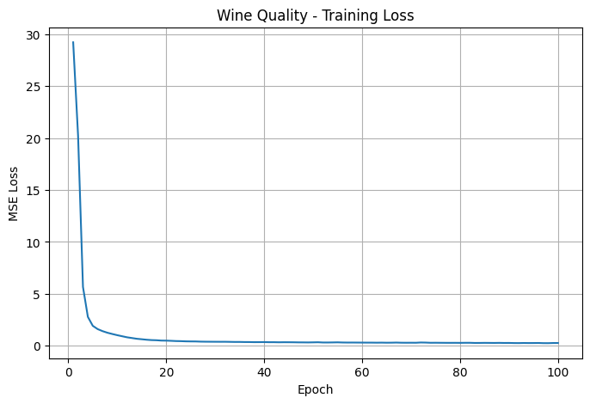
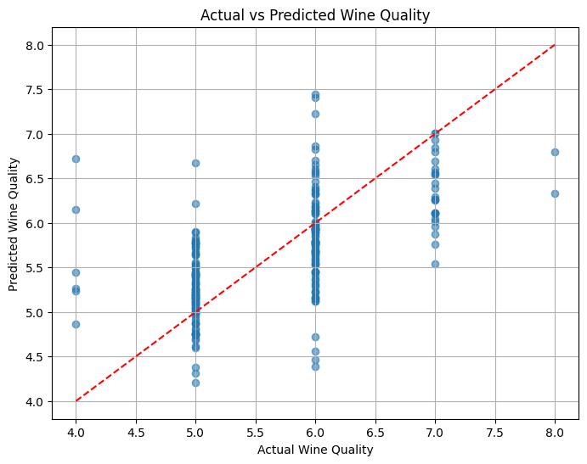
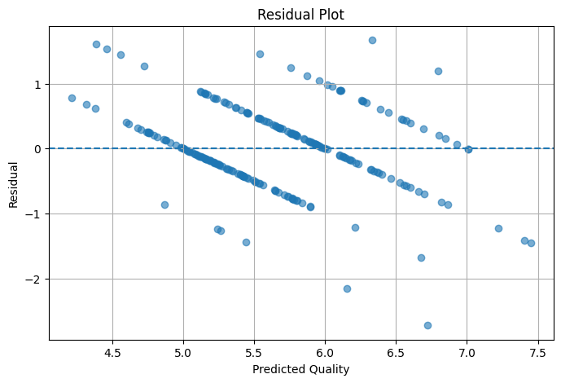
================================
CONCLUSION
================================
The Wine Quality dataset was successfully loaded and
preprocessed. The dataset contains 1143 wine samples
with 11 input features.
The Id column was removed because it is only an identifier.
The remaining numerical features were standardized using
StandardScaler.
A PyTorch Neural Network was built with three hidden layers
and trained using the Adam optimizer and Mean Squared Error
loss.
Model Performance:
MAE = 0.4710
MSE = 0.3945
RMSE = 0.6281
R² = 0.2910
The training-loss graph shows the reduction in prediction
error during training.
The Actual vs Predicted plot shows how closely the predicted
wine quality values follow the actual values.
Lower MAE, MSE and RMSE indicate better prediction accuracy,
while a higher R² score indicates better model performance.
Overall, the PyTorch model can predict wine quality from the
chemical properties of the wine, although wine quality is
affected by several factors and therefore may not be
predicted perfectly.

