ROLL NO : 2403A51076
BATCH NO : 03
COURSE NAME : ARTIFICIAL INTELLIGENCE AND DEEP LEARNING
LAB : 06(02-09-2026)

# ============================================================
# CIFAR-10 IMAGE CLASSIFICATION USING PYTORCH
# ============================================================
# ============================================================
# 1. IMPORT LIBRARIES
# ============================================================
import numpy as np
import matplotlib.pyplot as plt
import torch
import torch.nn as nn
import torch.optim as optim
from torch.utils.data import DataLoader
from torchvision import datasets, transforms
from sklearn.metrics import (
accuracy_score,
precision_score,
recall_score,
f1_score,
confusion_matrix,
ConfusionMatrixDisplay
)
# ============================================================
# 2. SET DEVICE
# ============================================================
torch.manual_seed(42)
np.random.seed(42)
device = torch.device(
"cuda" if torch.cuda.is_available() else "cpu"
)
print("Using device:", device)
# ============================================================
# 3. LOAD AND PREPROCESS CIFAR-10
# ============================================================
transform = transforms.Compose([
transforms.ToTensor(),
transforms.Normalize(
(0.5, 0.5, 0.5),
(0.5, 0.5, 0.5)
)
])
# Automatically downloads CIFAR-10
# if it is not already present
train_dataset = datasets.CIFAR10(
root="./data",
train=True,
download=True,
transform=transform
)
test_dataset = datasets.CIFAR10(
root="./data",
train=False,
download=True,
transform=transform
)
# CIFAR-10 classes
classes = [
"airplane",
"automobile",
"bird",
"cat",
"deer",
"dog",
"frog",
"horse",
"ship",
"truck"
]
print("\nDataset Information")
print("-------------------")
print("Training images:", len(train_dataset))
print("Testing images :", len(test_dataset))
print("Number of classes:", len(classes))
print("Image size: 32 x 32")
# ============================================================
# 4. CREATE DATALOADERS
# ============================================================
batch_size = 64
train_loader = DataLoader(
train_dataset,
batch_size=batch_size,
shuffle=True
)
test_loader = DataLoader(
test_dataset,
batch_size=batch_size,
shuffle=False
)
# ============================================================
# 5. DISPLAY SAMPLE IMAGES
# ============================================================
images, labels = next(iter(train_loader))
plt.figure(figsize=(12, 6))
for i in range(10):
plt.subplot(2, 5, i + 1)
# Undo normalization
image = images[i] / 2 + 0.5
plt.imshow(
np.transpose(
image.numpy(),
(1, 2, 0)
)
)
plt.title(classes[labels[i].item()])
plt.axis("off")
plt.suptitle("Sample CIFAR-10 Images")
plt.tight_layout()
plt.show()
# ============================================================
# 6. BUILD CNN MODEL
# ============================================================
class CIFAR10CNN(nn.Module):
def __init__(self):
super(CIFAR10CNN, self).__init__()
# Convolution Layer 1
self.conv1 = nn.Conv2d(
3, 32, 3, padding=1
)
# Convolution Layer 2
self.conv2 = nn.Conv2d(
32, 64, 3, padding=1
)
# Convolution Layer 3
self.conv3 = nn.Conv2d(
64, 128, 3, padding=1
)
self.pool = nn.MaxPool2d(
2, 2
)
self.relu = nn.ReLU()
self.dropout = nn.Dropout(0.3)
# After 3 pooling operations:
# 32 -> 16 -> 8 -> 4
self.fc1 = nn.Linear(
128 * 4 * 4,
256
)
self.fc2 = nn.Linear(
256,
128
)
# 10 output classes
self.fc3 = nn.Linear(
128,
10
)
def forward(self, x):
x = self.pool(
self.relu(
self.conv1(x)
)
)
x = self.pool(
self.relu(
self.conv2(x)
)
)
x = self.pool(
self.relu(
self.conv3(x)
)
)
# Flatten
x = x.view(
x.size(0),
-1
)
x = self.relu(
self.fc1(x)
)
x = self.dropout(x)
x = self.relu(
self.fc2(x)
)
x = self.fc3(x)
return x
# Create model
model = CIFAR10CNN().to(device)
print("\nModel Architecture")
print("------------------")
print(model)
# ============================================================
# 7. LOSS FUNCTION AND OPTIMIZER
# ============================================================
criterion = nn.CrossEntropyLoss()
optimizer = optim.Adam(
model.parameters(),
lr=0.001
)
# ============================================================
# 8. TRAIN THE MODEL
# ============================================================
epochs = 10
train_losses = []
train_accuracies = []
print("\n========== TRAINING ==========")
for epoch in range(epochs):
model.train()
total_loss = 0
correct = 0
total = 0
for images, labels in train_loader:
images = images.to(device)
labels = labels.to(device)
# Clear gradients
optimizer.zero_grad()
# Forward propagation
outputs = model(images)
# Calculate loss
loss = criterion(
outputs,
labels
)
# Backpropagation
loss.backward()
# Update weights
optimizer.step()
total_loss += loss.item()
# Calculate accuracy
_, predicted = torch.max(
outputs,
1
)
total += labels.size(0)
correct += (
predicted == labels
).sum().item()
epoch_loss = (
total_loss /
len(train_loader)
)
epoch_accuracy = (
100 * correct / total
)
train_losses.append(
epoch_loss
)
train_accuracies.append(
epoch_accuracy
)
print(
f"Epoch [{epoch+1}/{epochs}] "
f"Loss: {epoch_loss:.4f} "
f"Accuracy: {epoch_accuracy:.2f}%"
)
# ============================================================
# 9. EVALUATE MODEL
# ============================================================
model.eval()
all_predictions = []
all_labels = []
with torch.no_grad():
for images, labels in test_loader:
images = images.to(device)
labels = labels.to(device)
outputs = model(images)
_, predicted = torch.max(
outputs,
1
)
all_predictions.extend(
predicted.cpu().numpy()
)
all_labels.extend(
labels.cpu().numpy()
)
# ============================================================
# 10. CALCULATE METRICS
# ============================================================
accuracy = accuracy_score(
all_labels,
all_predictions
)
precision = precision_score(
all_labels,
all_predictions,
average="weighted",
zero_division=0
)
recall = recall_score(
all_labels,
all_predictions,
average="weighted",
zero_division=0
)
f1 = f1_score(
all_labels,
all_predictions,
average="weighted",
zero_division=0
)
print("\n================================")
print("MODEL EVALUATION")
print("================================")
print(f"Accuracy : {accuracy:.4f}")
print(f"Precision : {precision:.4f}")
print(f"Recall : {recall:.4f}")
print(f"F1 Score : {f1:.4f}")
# ============================================================
# 11. TRAINING LOSS GRAPH
# ============================================================
plt.figure(figsize=(8, 5))
plt.plot(
range(1, epochs + 1),
train_losses,
marker="o"
)
plt.xlabel("Epoch")
plt.ylabel("Loss")
plt.title("CIFAR-10 Training Loss")
plt.grid(True)
plt.show()
# ============================================================
# 12. TRAINING ACCURACY GRAPH
# ============================================================
plt.figure(figsize=(8, 5))
plt.plot(
range(1, epochs + 1),
train_accuracies,
marker="o"
)
plt.xlabel("Epoch")
plt.ylabel("Accuracy (%)")
plt.title("CIFAR-10 Training Accuracy")
plt.grid(True)
plt.show()
# ============================================================
# 13. CONFUSION MATRIX
# ============================================================
cm = confusion_matrix(
all_labels,
all_predictions
)
plt.figure(figsize=(10, 8))
disp = ConfusionMatrixDisplay(
confusion_matrix=cm,
display_labels=classes
)
disp.plot(
xticks_rotation=45
)
plt.title("CIFAR-10 Confusion Matrix")
plt.show()
# ============================================================
# 14. ACTUAL VS PREDICTED IMAGES
# ============================================================
images, labels = next(
iter(test_loader)
)
images_device = images.to(device)
with torch.no_grad():
outputs = model(images_device)
_, predicted = torch.max(
outputs,
1
)
plt.figure(figsize=(12, 8))
for i in range(10):
plt.subplot(2, 5, i + 1)
# Undo normalization
image = images[i] / 2 + 0.5
plt.imshow(
np.transpose(
image.numpy(),
(1, 2, 0)
)
)
actual = classes[
labels[i].item()
]
pred = classes[
predicted[i].cpu().item()
]
plt.title(
f"Actual: {actual}\nPredicted: {pred}",
fontsize=9
)
plt.axis("off")
plt.tight_layout()
plt.show()
# ============================================================
# 15. CONCLUSION
# ============================================================
print("\n================================")
print("CONCLUSION")
print("================================")
print(f"""
The CIFAR-10 dataset was successfully loaded and
preprocessed using PyTorch.
The dataset contains 50,000 training images and
10,000 testing images belonging to 10 classes.
The images were converted into tensors and normalized.
A Convolutional Neural Network (CNN) was built using
three convolutional layers, max-pooling layers,
dropout and fully connected layers.
The model was trained for {epochs} epochs using the
Adam optimizer and Cross Entropy Loss.
Final Performance:
Accuracy : {accuracy:.4f}
Precision : {precision:.4f}
Recall : {recall:.4f}
F1 Score : {f1:.4f}
The training loss generally decreases as the number
of epochs increases, while training accuracy improves.
The confusion matrix shows the correctly and
incorrectly classified CIFAR-10 classes.
Overall, the CNN successfully learned image features
and classified the CIFAR-10 images into their
respective categories. More epochs, data augmentation,
or a deeper CNN could further improve performance.
""")
Using device: cpu
100%|██████████| 170M/170M [42:03<00:00, 67.6kB/s]
Dataset Information
-------------------
Training images: 50000
Testing images : 10000
Number of classes: 10
Image size: 32 x 32
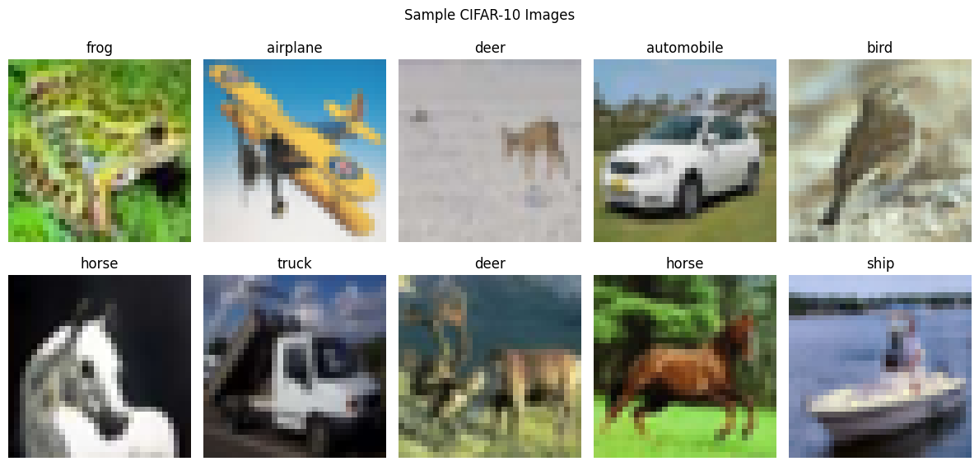
Model Architecture
------------------
CIFAR10CNN(
(conv1): Conv2d(3, 32, kernel_size=(3, 3), stride=(1, 1), padding=(1, 1))
(conv2): Conv2d(32, 64, kernel_size=(3, 3), stride=(1, 1), padding=(1, 1))
(conv3): Conv2d(64, 128, kernel_size=(3, 3), stride=(1, 1), padding=(1, 1))
(pool): MaxPool2d(kernel_size=2, stride=2, padding=0, dilation=1, ceil_mode=False)
(relu): ReLU()
(dropout): Dropout(p=0.3, inplace=False)
(fc1): Linear(in_features=2048, out_features=256, bias=True)
(fc2): Linear(in_features=256, out_features=128, bias=True)
(fc3): Linear(in_features=128, out_features=10, bias=True)
)
========== TRAINING ==========
Epoch [1/10] Loss: 1.5019 Accuracy: 44.93%
Epoch [2/10] Loss: 1.0852 Accuracy: 61.09%
Epoch [3/10] Loss: 0.8835 Accuracy: 68.71%
Epoch [4/10] Loss: 0.7534 Accuracy: 73.58%
Epoch [5/10] Loss: 0.6649 Accuracy: 76.65%
Epoch [6/10] Loss: 0.5845 Accuracy: 79.54%
Epoch [7/10] Loss: 0.5189 Accuracy: 81.60%
Epoch [8/10] Loss: 0.4638 Accuracy: 83.30%
Epoch [9/10] Loss: 0.4167 Accuracy: 85.25%
Epoch [10/10] Loss: 0.3767 Accuracy: 86.65%
================================
MODEL EVALUATION
================================
Accuracy : 0.7633
Precision : 0.7652
Recall : 0.7633
F1 Score : 0.7626
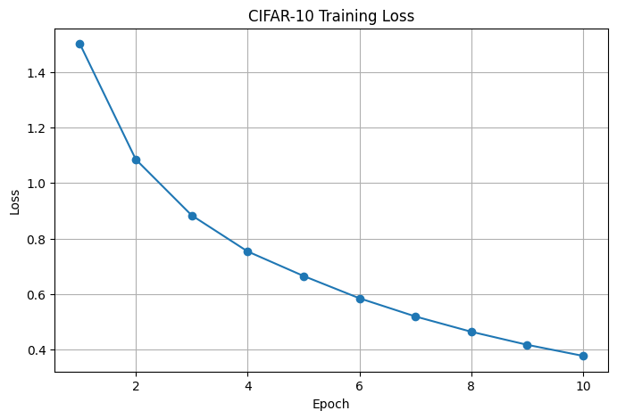
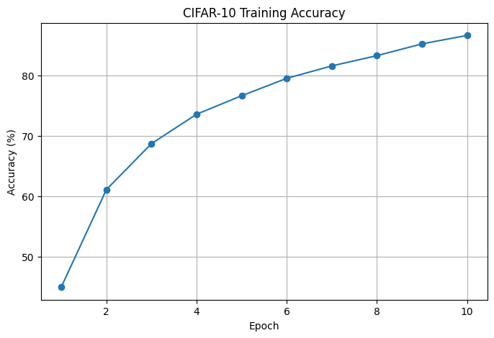
<Figure size 1000x800 with 0 Axes>
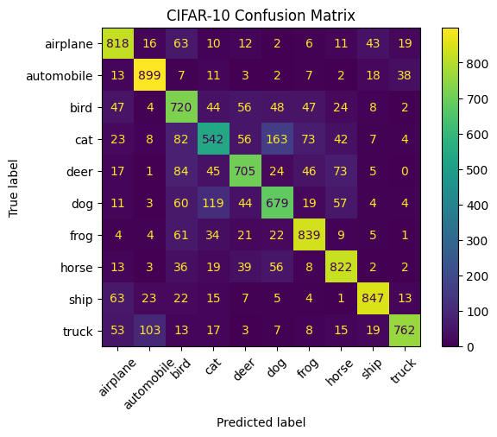
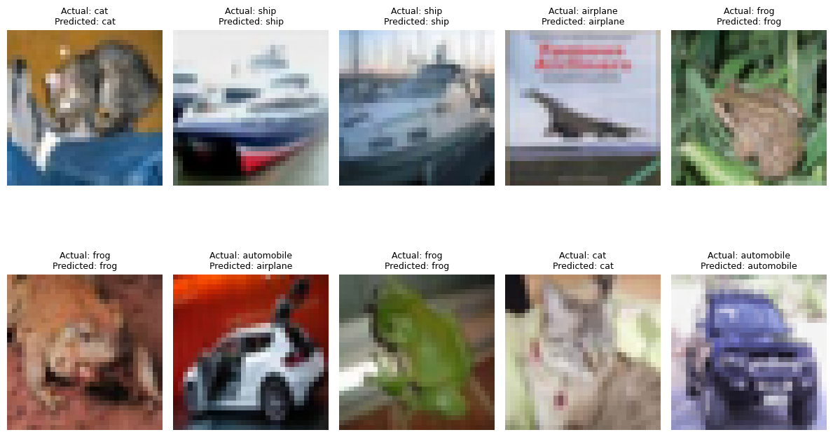
================================
CONCLUSION
================================
The CIFAR-10 dataset was successfully loaded and
preprocessed using PyTorch.
The dataset contains 50,000 training images and
10,000 testing images belonging to 10 classes.
The images were converted into tensors and normalized.
A Convolutional Neural Network (CNN) was built using
three convolutional layers, max-pooling layers,
dropout and fully connected layers.
The model was trained for 10 epochs using the
Adam optimizer and Cross Entropy Loss.
Final Performance:
Accuracy : 0.7633
Precision : 0.7652
Recall : 0.7633
F1 Score : 0.7626
The training loss generally decreases as the number
of epochs increases, while training accuracy improves.
The confusion matrix shows the correctly and
incorrectly classified CIFAR-10 classes.
Overall, the CNN successfully learned image features
and classified the CIFAR-10 images into their
respective categories. More epochs, data augmentation,
or a deeper CNN could further improve performance.

