ROLL NO : 2403A51076
BATCH NO : 03
COURSE NAME : ARTIFICIAL INTELLIGENCE AND DEEP LEARNING
LAB : 05(20-08-2026)

# ============================================================
# CIFAR-10 IMAGE CLASSIFICATION USING PYTORCH
# ============================================================
# ============================================================
# 1. IMPORT LIBRARIES
# ============================================================
import numpy as np
import matplotlib.pyplot as plt
import torch
import torch.nn as nn
import torch.optim as optim
from torch.utils.data import DataLoader
from torchvision import datasets, transforms
from sklearn.metrics import (
accuracy_score,
precision_score,
recall_score,
f1_score,
confusion_matrix,
ConfusionMatrixDisplay
)
# ============================================================
# 2. SET RANDOM SEED AND DEVICE
# ============================================================
torch.manual_seed(42)
np.random.seed(42)
device = torch.device(
"cuda" if torch.cuda.is_available() else "cpu"
)
print("Using device:", device)
# ============================================================
# 3. LOAD AND PREPROCESS CIFAR-10 DATASET
# ============================================================
transform = transforms.Compose([
# Convert images to PyTorch tensors
transforms.ToTensor(),
# Normalize RGB images
transforms.Normalize(
(0.5, 0.5, 0.5),
(0.5, 0.5, 0.5)
)
])
# Automatically download CIFAR-10 dataset
train_dataset = datasets.CIFAR10(
root="./data",
train=True,
download=True,
transform=transform
)
test_dataset = datasets.CIFAR10(
root="./data",
train=False,
download=True,
transform=transform
)
# CIFAR-10 class names
classes = (
"airplane",
"automobile",
"bird",
"cat",
"deer",
"dog",
"frog",
"horse",
"ship",
"truck"
)
print("\nNumber of Training Images:", len(train_dataset))
print("Number of Testing Images:", len(test_dataset))
# ============================================================
# 4. CREATE DATALOADERS
# ============================================================
batch_size = 64
train_loader = DataLoader(
train_dataset,
batch_size=batch_size,
shuffle=True
)
test_loader = DataLoader(
test_dataset,
batch_size=batch_size,
shuffle=False
)
# ============================================================
# 5. VISUALIZE SAMPLE IMAGES
# ============================================================
images, labels = next(iter(train_loader))
plt.figure(figsize=(12, 6))
for i in range(10):
plt.subplot(2, 5, i + 1)
# Reverse normalization for display
image = images[i] / 2 + 0.5
plt.imshow(
np.transpose(
image.numpy(),
(1, 2, 0)
)
)
plt.title(classes[labels[i]])
plt.axis("off")
plt.tight_layout()
plt.show()
# ============================================================
# 6. BUILD CNN MODEL
# ============================================================
class CIFAR10CNN(nn.Module):
def __init__(self):
super(CIFAR10CNN, self).__init__()
# First convolution layer
self.conv1 = nn.Conv2d(
3,
32,
kernel_size=3,
padding=1
)
# Second convolution layer
self.conv2 = nn.Conv2d(
32,
64,
kernel_size=3,
padding=1
)
# Third convolution layer
self.conv3 = nn.Conv2d(
64,
128,
kernel_size=3,
padding=1
)
# Max Pooling
self.pool = nn.MaxPool2d(
kernel_size=2,
stride=2
)
# Activation
self.relu = nn.ReLU()
# Dropout
self.dropout = nn.Dropout(0.3)
# Fully connected layers
self.fc1 = nn.Linear(
128 * 4 * 4,
256
)
self.fc2 = nn.Linear(
256,
128
)
# Output layer for 10 classes
self.fc3 = nn.Linear(
128,
10
)
def forward(self, x):
# Convolution Block 1
x = self.pool(
self.relu(self.conv1(x))
)
# Convolution Block 2
x = self.pool(
self.relu(self.conv2(x))
)
# Convolution Block 3
x = self.pool(
self.relu(self.conv3(x))
)
# Flatten
x = x.view(
x.size(0),
-1
)
# Fully connected layers
x = self.relu(
self.fc1(x)
)
x = self.dropout(x)
x = self.relu(
self.fc2(x)
)
x = self.fc3(x)
return x
# Create model
model = CIFAR10CNN().to(device)
print("\nMODEL ARCHITECTURE:")
print(model)
# ============================================================
# 7. LOSS FUNCTION AND OPTIMIZER
# ============================================================
criterion = nn.CrossEntropyLoss()
optimizer = optim.Adam(
model.parameters(),
lr=0.001
)
# ============================================================
# 8. TRAIN THE MODEL
# ============================================================
epochs = 10
train_losses = []
train_accuracies = []
print("\n========== TRAINING STARTED ==========\n")
for epoch in range(epochs):
model.train()
running_loss = 0
correct = 0
total = 0
for images, labels in train_loader:
# Move data to GPU or CPU
images = images.to(device)
labels = labels.to(device)
# Clear gradients
optimizer.zero_grad()
# Forward pass
outputs = model(images)
# Calculate loss
loss = criterion(
outputs,
labels
)
# Backpropagation
loss.backward()
# Update model weights
optimizer.step()
running_loss += loss.item()
# Calculate predictions
_, predicted = torch.max(
outputs,
1
)
total += labels.size(0)
correct += (
predicted == labels
).sum().item()
# Average loss
epoch_loss = (
running_loss / len(train_loader)
)
# Training accuracy
epoch_accuracy = (
100 * correct / total
)
train_losses.append(
epoch_loss
)
train_accuracies.append(
epoch_accuracy
)
print(
f"Epoch [{epoch + 1}/{epochs}] | "
f"Loss: {epoch_loss:.4f} | "
f"Accuracy: {epoch_accuracy:.2f}%"
)
# ============================================================
# 9. EVALUATE THE MODEL
# ============================================================
model.eval()
all_predictions = []
all_labels = []
with torch.no_grad():
for images, labels in test_loader:
images = images.to(device)
labels = labels.to(device)
outputs = model(images)
_, predicted = torch.max(
outputs,
1
)
all_predictions.extend(
predicted.cpu().numpy()
)
all_labels.extend(
labels.cpu().numpy()
)
# ============================================================
# 10. CALCULATE EVALUATION METRICS
# ============================================================
accuracy = accuracy_score(
all_labels,
all_predictions
)
precision = precision_score(
all_labels,
all_predictions,
average="weighted",
zero_division=0
)
recall = recall_score(
all_labels,
all_predictions,
average="weighted",
zero_division=0
)
f1 = f1_score(
all_labels,
all_predictions,
average="weighted",
zero_division=0
)
print("\n================================")
print("MODEL EVALUATION")
print("================================")
print(f"Accuracy : {accuracy:.4f}")
print(f"Precision : {precision:.4f}")
print(f"Recall : {recall:.4f}")
print(f"F1 Score : {f1:.4f}")
# ============================================================
# 11. VISUALIZE TRAINING LOSS
# ============================================================
plt.figure(figsize=(8, 5))
plt.plot(
range(1, epochs + 1),
train_losses,
marker="o"
)
plt.xlabel("Epoch")
plt.ylabel("Loss")
plt.title("CIFAR-10 Training Loss")
plt.grid(True)
plt.show()
# ============================================================
# 12. VISUALIZE TRAINING ACCURACY
# ============================================================
plt.figure(figsize=(8, 5))
plt.plot(
range(1, epochs + 1),
train_accuracies,
marker="o"
)
plt.xlabel("Epoch")
plt.ylabel("Accuracy (%)")
plt.title("CIFAR-10 Training Accuracy")
plt.grid(True)
plt.show()
# ============================================================
# 13. CONFUSION MATRIX
# ============================================================
cm = confusion_matrix(
all_labels,
all_predictions
)
disp = ConfusionMatrixDisplay(
confusion_matrix=cm,
display_labels=classes
)
disp.plot(
xticks_rotation=45
)
plt.title("CIFAR-10 Confusion Matrix")
plt.show()
# ============================================================
# 14. VISUALIZE ACTUAL VS PREDICTED IMAGES
# ============================================================
images, labels = next(iter(test_loader))
images_device = images.to(device)
with torch.no_grad():
outputs = model(images_device)
_, predicted = torch.max(
outputs,
1
)
plt.figure(figsize=(12, 8))
for i in range(10):
plt.subplot(2, 5, i + 1)
# Reverse normalization
image = images[i] / 2 + 0.5
plt.imshow(
np.transpose(
image.numpy(),
(1, 2, 0)
)
)
actual = classes[
labels[i].item()
]
prediction = classes[
predicted[i].cpu().item()
]
plt.title(
f"Actual: {actual}\nPred: {prediction}",
fontsize=9
)
plt.axis("off")
plt.tight_layout()
plt.show()
# ============================================================
# 15. CONCLUSION
# ============================================================
print("\n================================")
print("CONCLUSION")
print("================================")
print(f"""
The CIFAR-10 dataset was successfully downloaded and
preprocessed using PyTorch torchvision.
The dataset contains 50,000 training images and
10,000 testing images belonging to 10 different classes.
The images were converted into tensors and normalized
before training.
A Convolutional Neural Network (CNN) was built using
three convolutional layers, max pooling, dropout, and
fully connected layers.
The model was trained for {epochs} epochs using the
Adam optimizer and Cross Entropy Loss.
Model Performance:
Accuracy = {accuracy:.4f}
Precision = {precision:.4f}
Recall = {recall:.4f}
F1 Score = {f1:.4f}
The training loss graph shows the reduction in loss
during training.
The training accuracy graph shows how the model improves
its classification performance over multiple epochs.
The confusion matrix shows which image classes are
correctly classified and which classes are commonly
confused.
The Actual vs Predicted visualization allows direct
comparison between the true image category and the
predicted category.
Overall, the CNN successfully learns important image
features and performs multiclass classification on the
CIFAR-10 dataset. Better performance may be achieved
by increasing the number of epochs, adding data
augmentation, or using a deeper CNN architecture.
""")
Using device: cuda
100%|██████████| 170M/170M [34:26<00:00, 82.5kB/s]
Number of Training Images: 50000
Number of Testing Images: 10000
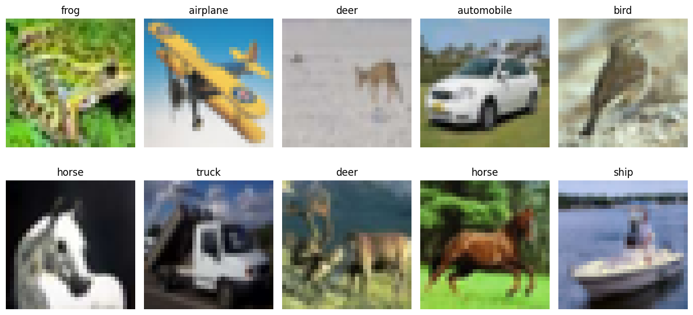
MODEL ARCHITECTURE:
CIFAR10CNN(
(conv1): Conv2d(3, 32, kernel_size=(3, 3), stride=(1, 1), padding=(1, 1))
(conv2): Conv2d(32, 64, kernel_size=(3, 3), stride=(1, 1), padding=(1, 1))
(conv3): Conv2d(64, 128, kernel_size=(3, 3), stride=(1, 1), padding=(1, 1))
(pool): MaxPool2d(kernel_size=2, stride=2, padding=0, dilation=1, ceil_mode=False)
(relu): ReLU()
(dropout): Dropout(p=0.3, inplace=False)
(fc1): Linear(in_features=2048, out_features=256, bias=True)
(fc2): Linear(in_features=256, out_features=128, bias=True)
(fc3): Linear(in_features=128, out_features=10, bias=True)
)
========== TRAINING STARTED ==========
Epoch [1/10] | Loss: 1.4965 | Accuracy: 45.10%
Epoch [2/10] | Loss: 1.0828 | Accuracy: 61.43%
Epoch [3/10] | Loss: 0.8870 | Accuracy: 68.65%
Epoch [4/10] | Loss: 0.7586 | Accuracy: 73.49%
Epoch [5/10] | Loss: 0.6678 | Accuracy: 76.65%
Epoch [6/10] | Loss: 0.5932 | Accuracy: 79.19%
Epoch [7/10] | Loss: 0.5294 | Accuracy: 81.26%
Epoch [8/10] | Loss: 0.4728 | Accuracy: 83.18%
Epoch [9/10] | Loss: 0.4145 | Accuracy: 85.29%
Epoch [10/10] | Loss: 0.3740 | Accuracy: 86.68%
================================
MODEL EVALUATION
================================
Accuracy : 0.7598
Precision : 0.7649
Recall : 0.7598
F1 Score : 0.7606
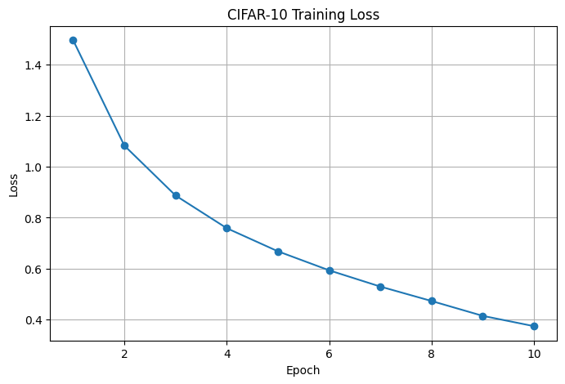
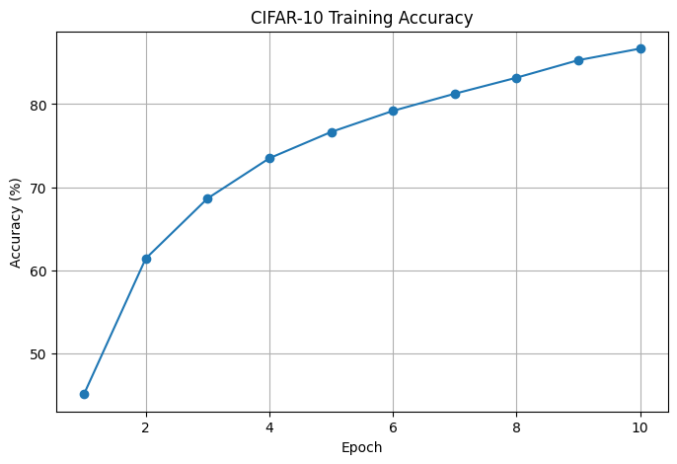
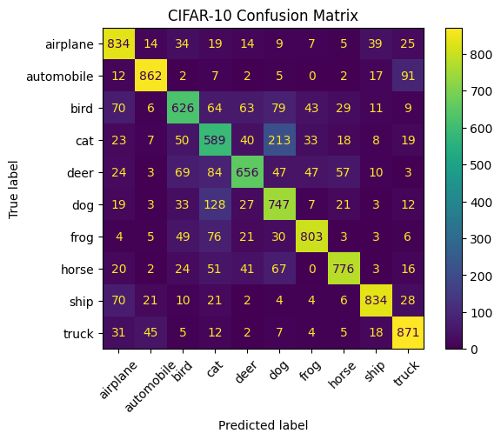
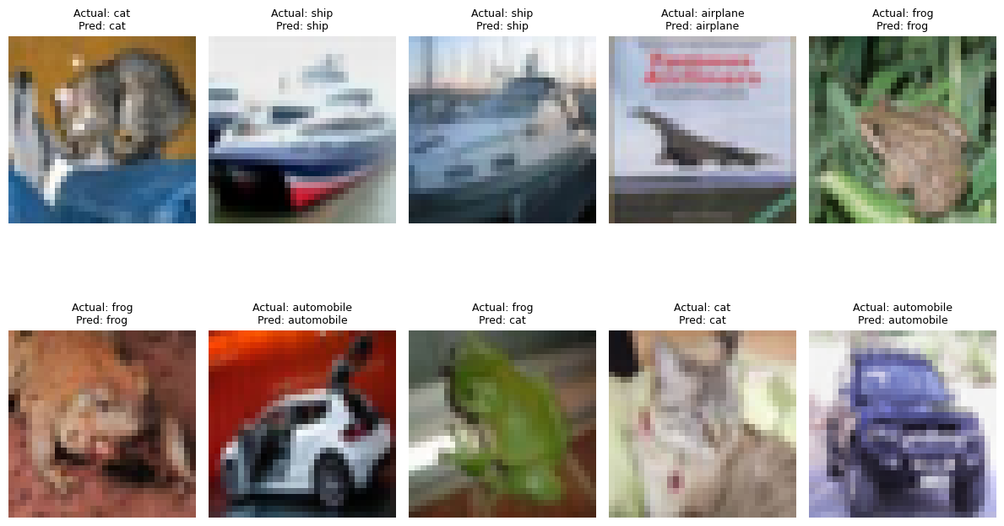
================================
CONCLUSION
================================
The CIFAR-10 dataset was successfully downloaded and
preprocessed using PyTorch torchvision.
The dataset contains 50,000 training images and
10,000 testing images belonging to 10 different classes.
The images were converted into tensors and normalized
before training.
A Convolutional Neural Network (CNN) was built using
three convolutional layers, max pooling, dropout, and
fully connected layers.
The model was trained for 10 epochs using the
Adam optimizer and Cross Entropy Loss.
Model Performance:
Accuracy = 0.7598
Precision = 0.7649
Recall = 0.7598
F1 Score = 0.7606
The training loss graph shows the reduction in loss
during training.
The training accuracy graph shows how the model improves
its classification performance over multiple epochs.
The confusion matrix shows which image classes are
correctly classified and which classes are commonly
confused.
The Actual vs Predicted visualization allows direct
comparison between the true image category and the
predicted category.
Overall, the CNN successfully learns important image
features and performs multiclass classification on the
CIFAR-10 dataset. Better performance may be achieved
by increasing the number of epochs, adding data
augmentation, or using a deeper CNN architecture.

