AI-Driven Customer Segmentation in Marketing Analytics
2.5.1 Introduction
The goal of this project is to segment online retail customers into meaningful groups based on their purchasing behaviour. The dataset contains real-world e-commerce transactional data from the UCI Online Retail II dataset.

By analyzing customer recency, frequency, monetary value, and product diversity, the business can identify high-value customers, inactive users, value-driven shoppers, and occasional but profitable buyers. This project uses data cleaning, feature engineering, PCA for dimensionality reduction, K-Means clustering, and Decision Tree analysis to derive customer personas and business rules.

This segmentation enables targeted marketing, improved revenue planning, and data-driven customer engagement.
2.5.2 Dataset Description
The dataset contains retail transactions made by customers between 2009–2011. Key variables include:
- Invoice – Order ID (same order repeats for multiple products)
- StockCode – Product code
- Description – Product name (e.g., lamp, bottle)
- Quantity – Number of units purchased
- InvoiceDate – Date and time of purchase
- Price – Price per single unit
- Customer ID – Unique identifier for each customer
- Country – Customer’s country

During cleaning, cancelled orders (Invoice starting with “C”), negative values, and missing Customer IDs were removed. A new metric, Amount = Quantity × Price, was created to measure purchase value.

- After grouping by Customer ID, the following customer-level features were engineered:
- Recency (days since last purchase)
- Frequency (number of orders)
- Total Amount spent
- Average Order Value
- Total Items purchased
- Unique Products purchased
- Average Unit Price

These behavioural features form the foundation of customer segmentation.

2.5.3 Exploratory Data Analysis (EDA)
a) Sales Outliers (Boxplots)
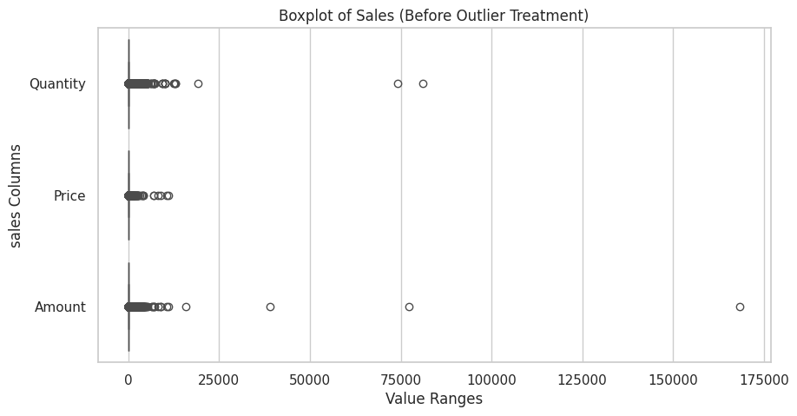
- Before Outlier Treatment (Figure 1):
- Quantity, Price, and Amount contain extreme outliers reaching above 100,000 units in some cases.
- Heavy right-skew indicates abnormal purchases, returns, or wholesale orders.

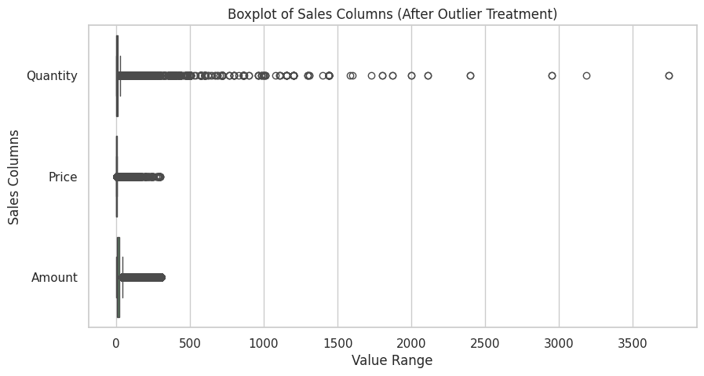
- After Outlier Treatment (Figure 2):
- Outliers significantly reduced using the 99.5% quantile rule.
- Amount and Quantity distributions become more stable and suitable for clustering.

b) Customer Feature Distributions (Histograms)
Using the engineered customer dataset:
- Recency (Figure 3 – Top Left)
• Highest concentration of customers have recency between 0–100 days.
• Several customers have not purchased for 300+ days, indicating churn.
- Number of Orders (Figure 3 – Top Middle)
• Most customers placed 1–5 orders.
• Very few placed more than 20 orders.
- Total Amount Spent (Figure 3 – Top Right)
• Majority spend under 3000 currency units.
• Few customers exceed 10,000+, indicating a premium segment.
- Average Order Value (Figure 3 – Bottom Left)
• Typically ranges between 200–400, with a long tail of high spenders.
- Total Items Purchased (Figure 3 – Bottom Middle)
• Most customers buy between 0–2000 items over the period.
- Unique Products Purchased (Figure 3 – Bottom Right)
• Many customers buy fewer than 50 unique items, while a few explore 100+ categories.
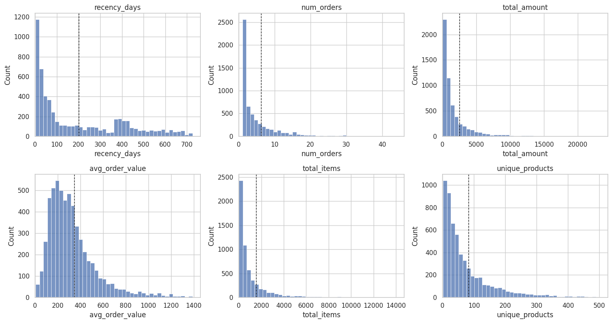
These patterns confirm that different types of customers exist, supporting the need for segmentation.

2.5.4 Customer Segmentation Using PCA & K-Means
- PCA for Dimensionality Reduction
Before clustering, PCA was used to simplify the dataset while retaining key behavioural patterns:
- PC1: Represents total spending power (amount, items, orders).
- PC2: Separates recent buyers from inactive customers (recency).
PCA helped improve cluster separation and model performance.

- Optimal Cluster Selection (Elbow & Silhouette Method)
- Elbow Curve (Figure 4):
• Steep drop until K = 4, then flattening → optimal cluster = 4.

- Silhouette Scores (Figure 5):
• Highest score at K = 2,
• But K = 4 still provides a strong balance between cluster separation and business interpretability.
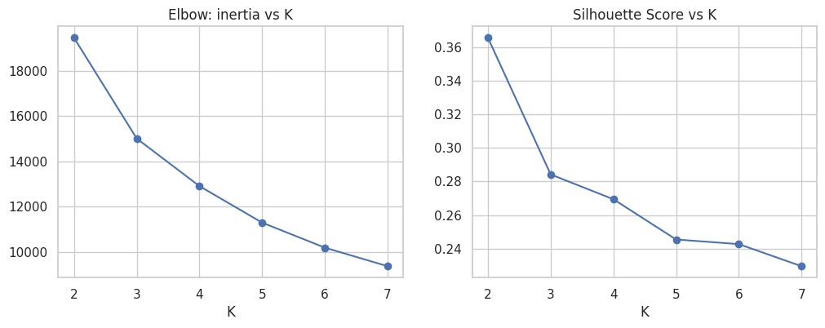
- Resulting Cluster Sizes

Cluster | Counts
0 | 1473
1 | 1092
2 | 2053
3 | 1224

The largest segment is Cluster 2, while Cluster 0 is the smallest.

- Cluster Visualization (PCA Scatter Plot)

- Blue (Cluster 0): High-value, high-spending customers
- Orange (Cluster 1): Low-spending, inactive customers
- Green (Cluster 2): Moderate-value, balanced spenders
- Red (Cluster 3): High-AOV occasional buyers
The clusters show clean separation across PCA components.
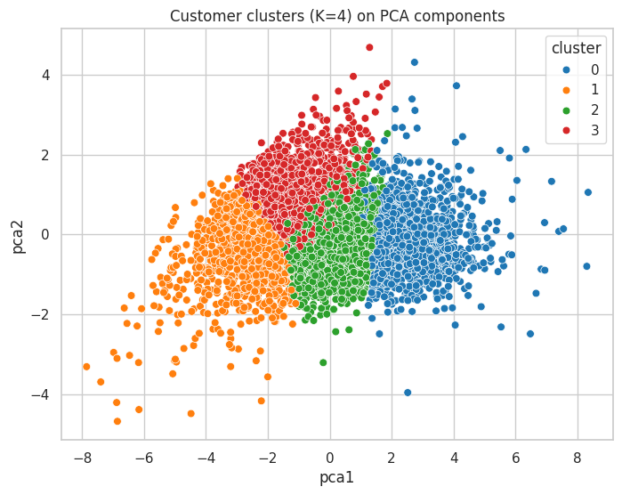

- Boxplot Visualization
Cluster Group – Wise Total Amount Spent
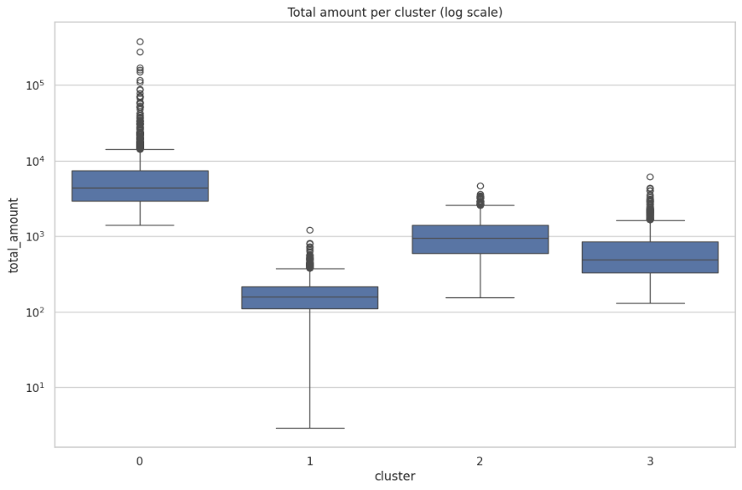
Cluster 0 – Highest Spenders
- Highest median spending with large spread.
- Many high-value outliers → strong revenue drivers.
Cluster 1 – Lowest Spenders
- Very low median spending and tight distribution.
- Minimal contribution to total sales.
Cluster 2 – Moderate Spenders
- Mid-level median spending with wider variation.
- Several outliers → occasional high-value purchases.
Cluster 3 – Occasional High Spenders
- Moderate median spending.
- Outliers indicate rare but large orders.
2.5.6 Decision Tree Rules
The Decision Tree model provides interpretable rules that explain how customers fall into each cluster:
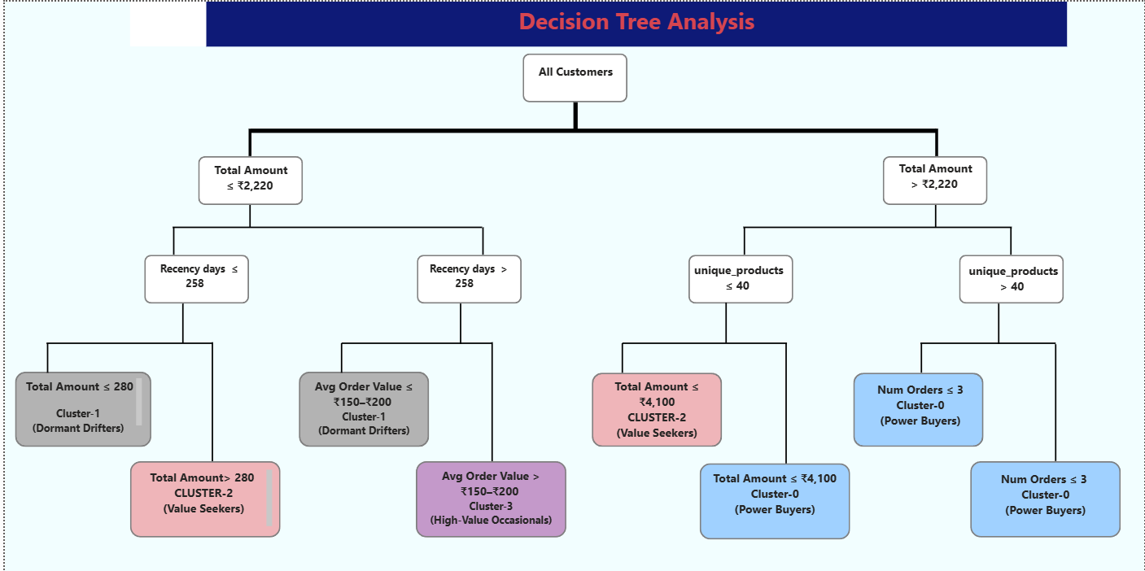

• Rule 1:
If Total Amount ≤ 0.67 & Recency ≤ 0.27 → Cluster 1 (Low-value inactive)
• Rule 2:
If Total Amount > 0.67 & Unique Products > 0.20 → Cluster 0 (High-value, diverse buyers)
• Rule 3:
If Total Amount ≤ 0.67 & Average Order Value > –0.59 → Cluster 3 (Occasional high-value)
• Rule 4:
If Total Amount ≤ 0.67 & Average Order Value ≤ –0.59 → Cluster 2 (Value seekers)
These rules help simplify the segmentation logic for non-technical stakeholders.

These rules help translate machine learning output into business language.
2. Based on cluster characteristics and summary statistics:
- Cluster 0 – Power Buyers (High Value, High Engagement)
• Extremely high spending and wide product exploration.
• Represent the core revenue drivers.
- Recommendations:
– Launch VIP membership and loyalty perks
– Provide early access to new products
– Promote personalized premium bundles
- Cluster 1 – Dormant Drifters (Low Spend, High Recency)
• Long inactivity and low purchase frequency.
• Lowest contribution to revenue.
- Recommendations:
– Win-back campaigns: email/SMS with discounts
– Highlight new arrivals to generate interest
– Use remarketing ads to re-activate abandoned customers

- Cluster 2 – Value Seekers (Moderate Spend, Moderate Engagement)
• Middle-range spending, decent product variety.
• Sensitive to value deals and bundles.
- Recommendations:
– Offer combo deals or “buy more, save more” discounts
– Use recommendation engines to increase cart value
– Gamified reward points to increase frequency

- Cluster 3 – High-Value Occasionals (Low Frequency, High AOV)
• Spend heavily when they do purchase.
• Likely buying for events or seasonal needs.

- Recommendations:
– Seasonal and festival-based reminders
– Curated premium collections
– Free shipping coupons to increase visit frequency
2.5.7 Conclusion
This project successfully segmented online retail customers into four actionable groups using PCA-enhanced K-Means clustering. The Decision Tree model transformed the complex behavioural data into simple business rules.
These insights enable:
- Smarter marketing targeting
- Better inventory planning
- Improved retention strategies
- Personalized customer engagement
The advanced use of PCA and silhouette analysis enhanced cluster quality, making this segmentation robust and business-ready.

