Program 1

a<-matrix(c(18,22,20,2,28,40,20,10,40),nrow=3,byrow=TRUE)

print(a)

rownames(a)<-c("5-6 years","7-8 years","9-10 years")

colnames(a)<-c("A","B","C")

print(a)

b<-a[,"B"]

c<-a[,"C"]

A<-a[,"A"]

h<-cov(b,c)

print(h)

# for a,b,c

cd<-cov(a)

print(cd)

#3

cb<-cor(b,c)

print(cb)

#cor()

fd<-cor(a)

print(fd)

output;

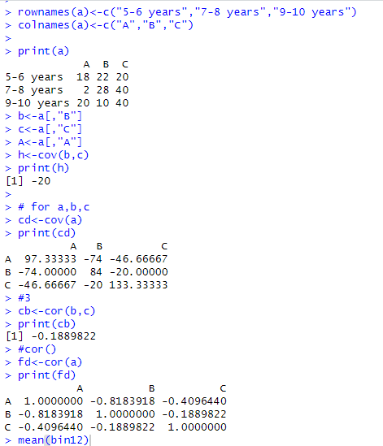

Program 3

Code:

class1<-c(76, 35, 47, 64, 95, 66, 89, 36, 84,76,35,47,64,95,66,89,36,84 )

class2<-c(51, 56, 84, 60, 59, 70, 63, 66, 50,51,56,84,60,59,70,63,66,50 )

a<-mean(class1)

b<-mean(class2)

m1<-median(class1)

m2<-median(class2)

mode=function()

return(names(sort(-table(class1)))[1])

s<-mode()

mode1=function()

return(names(sort(-table(class2)))[1])

s1<-mode1()

# if - else condition

if (a>b & m1>m2 & s>s1){

print("class1")

}else{

print("class2")

}

print("class1 details")

a

b

m1

print("class2 details")

m2

s

s1

output;



Program 4

Code:

a<-c(200,300,400,600,1000)

min=50000

max=100000

v=80

minmax=(v-min(a)/max(a)-min(a))

print(minmax)

#min=0,max=1

minmax2=(v-min/max-min)

print(minmax2)

# z-score

s=sd(a)

m<-mean(a)

z<-(v-m)/s

print(z)

output;

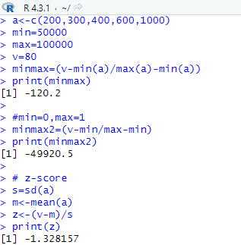

Program 5

head(AirPassengers)

hist(AirPassengers,

xlim=c(100,700),

xlab="passengers",

ylab="flights",

border="yellow",

col="green")

ouput:

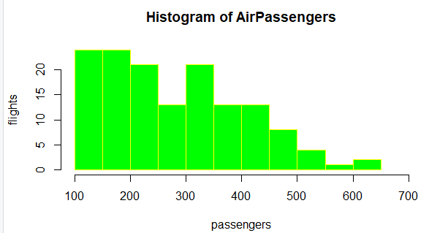

Program 6

head(mtcars)

a<-c(mtcars$mpg)

b<-c(mtcars$qsec)

matplot(a,b,pch=1,type="l",main="dataset mtcars",col=("blue"),xlab="mpg",ylab="qsec",lwd=2)

legend("topright",a,b)

output:

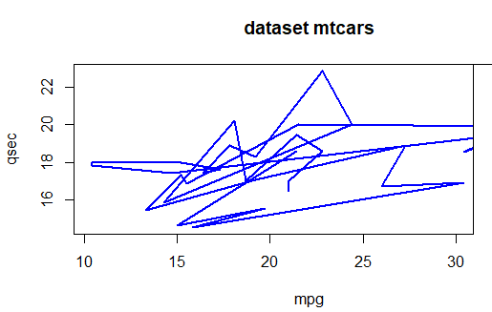

Program 7

# Load the water dataset

water<-read.csv("water.csv",head=TRUE)

plot(water$hardness, water$mortality, xlab = "Hardness", ylab = "Mortality")

lm_water <- lm(mortality ~ hardness, data = water)

summary(lm_water)

hardness_new <- data.frame(hardness = 88)

mortality_pred <- predict(lm_water, newdata = hardness_new)

cat("Predicted mortality for hardness = 88:", mortality_pred)

output:

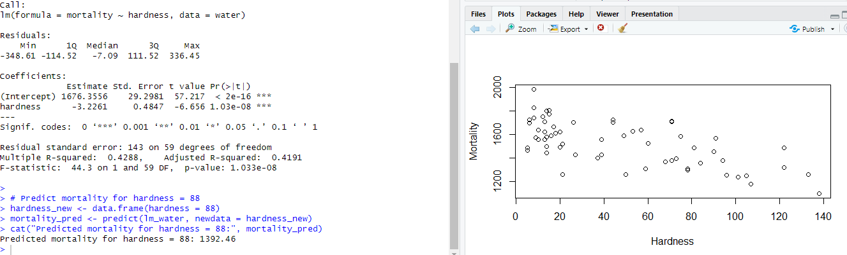

Program 8

head(mtcars)

boxplot(mtcars$mpg,mtcars$cyl,xlab="mpg",ylab="cyl",main="mtcars boxplot",col="blue")

ouput:

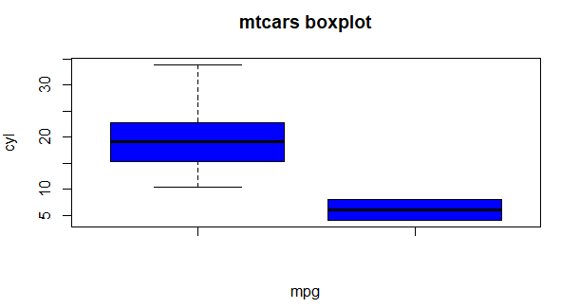

Program 9

points <- c(75, 80, 85, 90, 95, 100, 105, 110, 115, 120, 125, 130)

boxplot(points,xlab="players",ylab="score")

output;

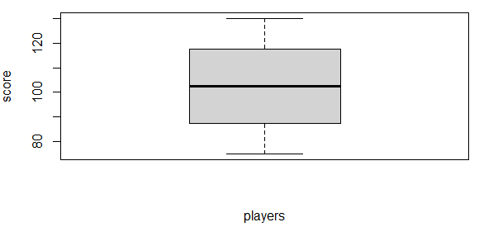

Program 10

a<-read.csv("health.csv",head=TRUE)

a

scatter.smooth(a$bloodpressure,a$age,xlab="bloodpressure",ylab="age of person",main="scatter graph",col="darkblue")

barplot(a$bloodpressure,a$age,xlab="bloodpressure",ylab="age of person",main="bar chart",col="pink")

Output

