DecodeLabs Industrial Training Kit
Project 2: Exploratory Data Analysis (EDA)
E-Commerce Order Dataset — Patterns, Trends & Distributions

1. Goal & Approach
This project analyzes a 1,200-row e-commerce order dataset to uncover patterns, trends, and distributions in customer purchasing behavior. The analysis covers descriptive statistics, time-based trends, categorical breakdowns, and outlier detection using the interquartile range (IQR) method.

2. Dataset Overview
- 1,200 orders spanning January 1, 2023 to June 30, 2025 (~2.5 years)
- 1,189 unique customers; only 11 customers placed more than one order
- 14 columns: order metadata, product, pricing, payment, status, and marketing/referral fields
- CouponCode is the only column with missing values (891 of 1,200 orders used a coupon; 309 did not — this is expected, not a data quality issue)

3. Basic Statistics
Descriptive statistics for the four numeric fields:
Metric | Count | Mean | Median | Min | Max
Quantity (units/order) | 1,200 | 2.95 | 3.00 | 1 | 5
Unit Price ($) | 1,200 | 356.41 | 364.21 | 11.39 | 699.93
Items in Cart | 1,200 | 5.49 | 5.00 | 1 | 10
Total Price ($) | 1,200 | 1,053.97 | 823.62 | 11.39 | 3,456.40

Key reads: the average order totals $1,053.97, but the median ($823.62) is notably lower — the mean is pulled upward by a small number of high-value orders, a sign of right-skewed distribution rather than a symmetric spread.

4. Trends

4.1 Revenue Over Time
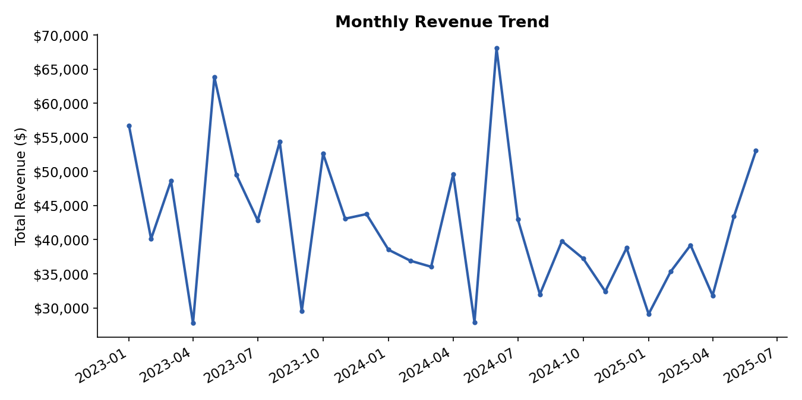
Figure 1 — Monthly revenue, Jan 2023 to Jun 2025
Revenue fluctuates month to month without a strong seasonal pattern or sustained upward/downward trend — consistent with the near-uniform order volume built into the dataset. No single month dominates, suggesting demand is fairly evenly distributed across the period.

4.2 Revenue & Orders by Product
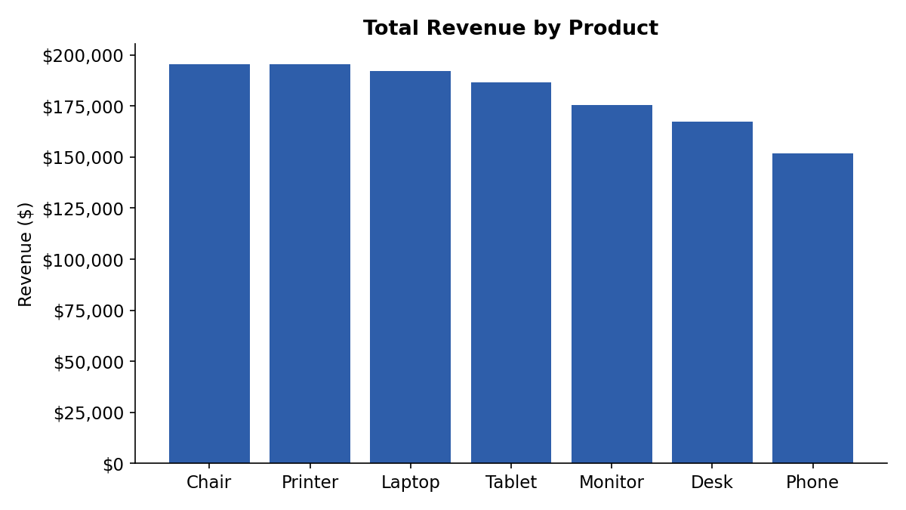
Figure 2 — Total revenue by product category
Product | Total Revenue ($) | Orders
Chair | 195,620.11 | 178
Printer | 195,612.61 | 181
Laptop | 192,126.56 | 173
Tablet | 186,568.95 | 179
Monitor | 175,651.41 | 163
Desk | 167,459.93 | 170
Phone | 151,722.39 | 156

Chairs and Printers lead in total revenue (~$195.6K each), closely followed by Laptops and Tablets. Phones generate the least revenue, both from fewer orders (156) and a lower average price point. The spread across categories is fairly even — no single product dominates the mix.

4.3 Order Status Breakdown
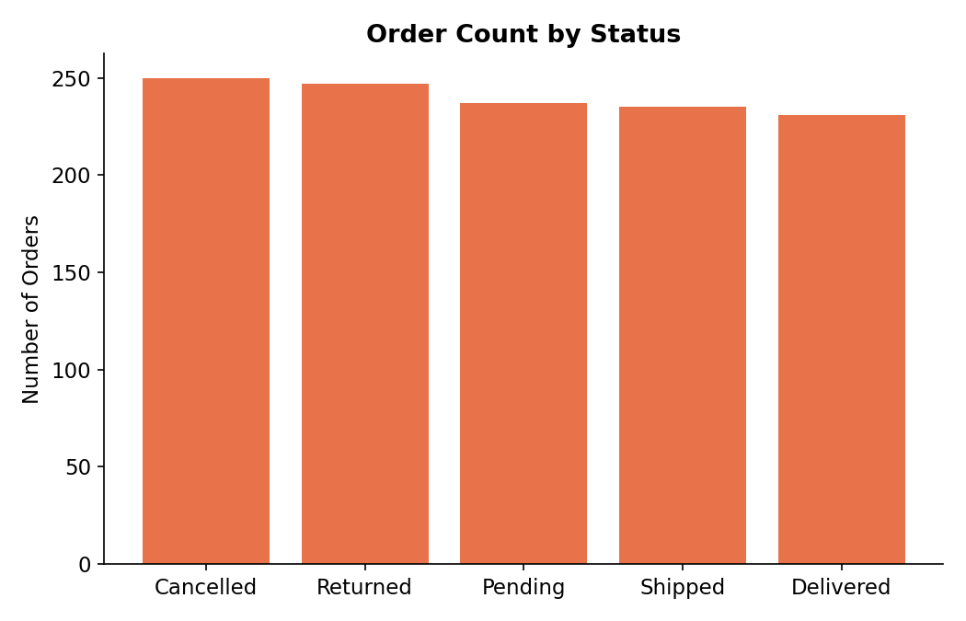
Figure 3 — Orders by fulfillment status
Order statuses are evenly distributed across Cancelled (250), Returned (247), Pending (237), Shipped (235), and Delivered (231). Notably, Cancelled and Returned orders combined (497) represent over 41% of all orders — worth flagging for operations, though this may simply reflect how the sample was constructed.

4.4 Payment Method Distribution
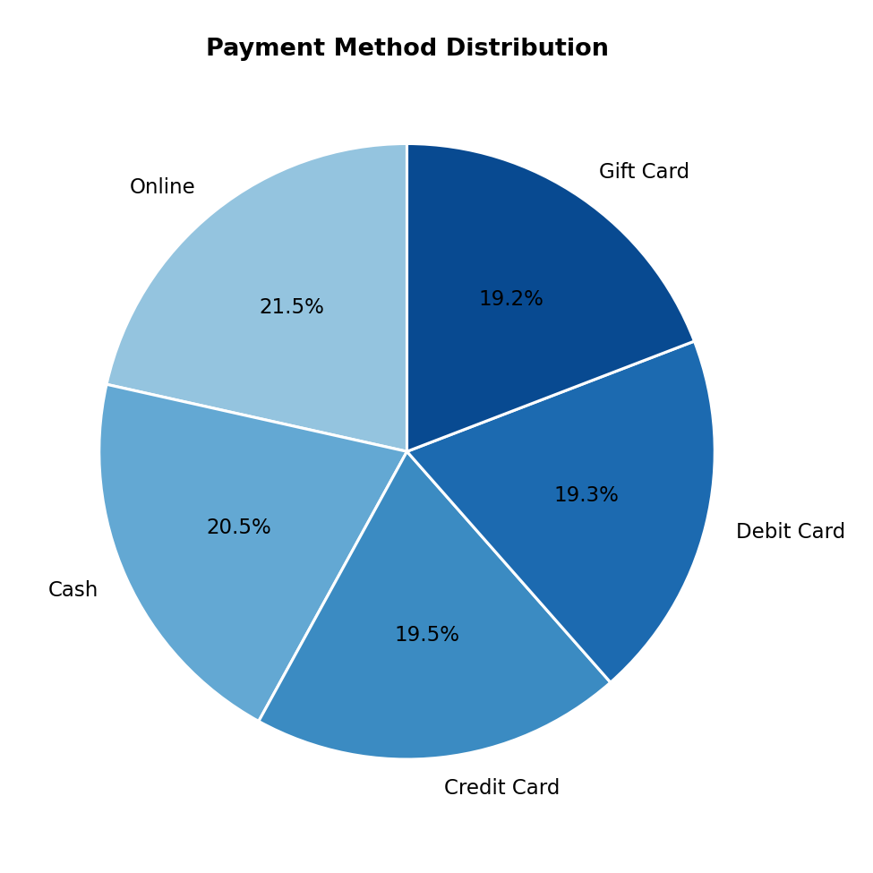
Figure 4 — Share of orders by payment method
Online payment is the most common method (21.5%), with Cash, Credit Card, Debit Card, and Gift Card each in the 19-20% range — customers do not show a strong preference for one payment channel over another.

4.5 Revenue by Referral Source
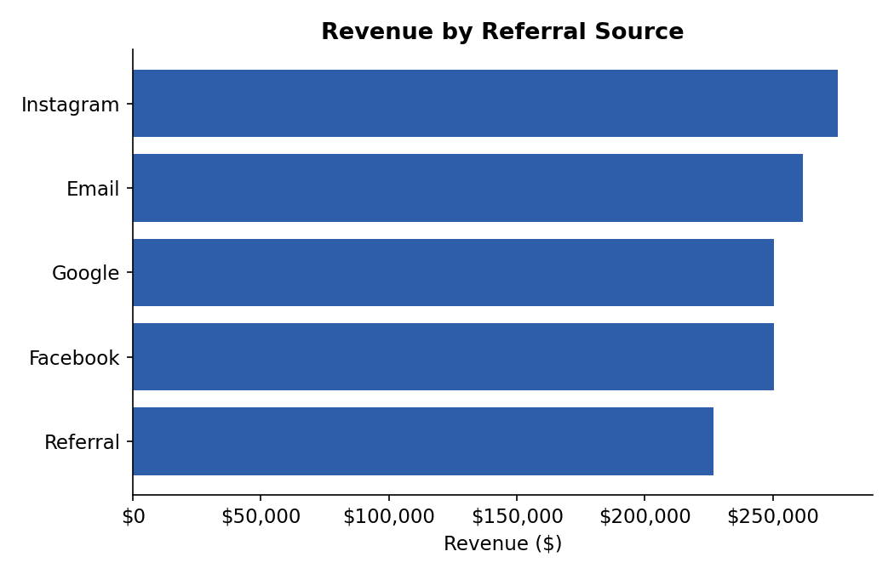
Figure 5 — Total revenue attributed to each referral source
Instagram drives the highest revenue among referral sources, followed by Email and Google. Referral (word-of-mouth) contributes the least, suggesting paid/social channels are currently the stronger revenue drivers in this dataset.

4.6 Coupon Usage
74.3% of orders (891 of 1,200) included a coupon code. Interestingly, average order value is nearly identical for orders with a coupon ($1,057.64) versus without ($1,043.37) — coupon usage does not appear to meaningfully inflate or deflate basket size in this dataset.

5. Distribution & Outlier Analysis

5.1 Distribution of Order Value
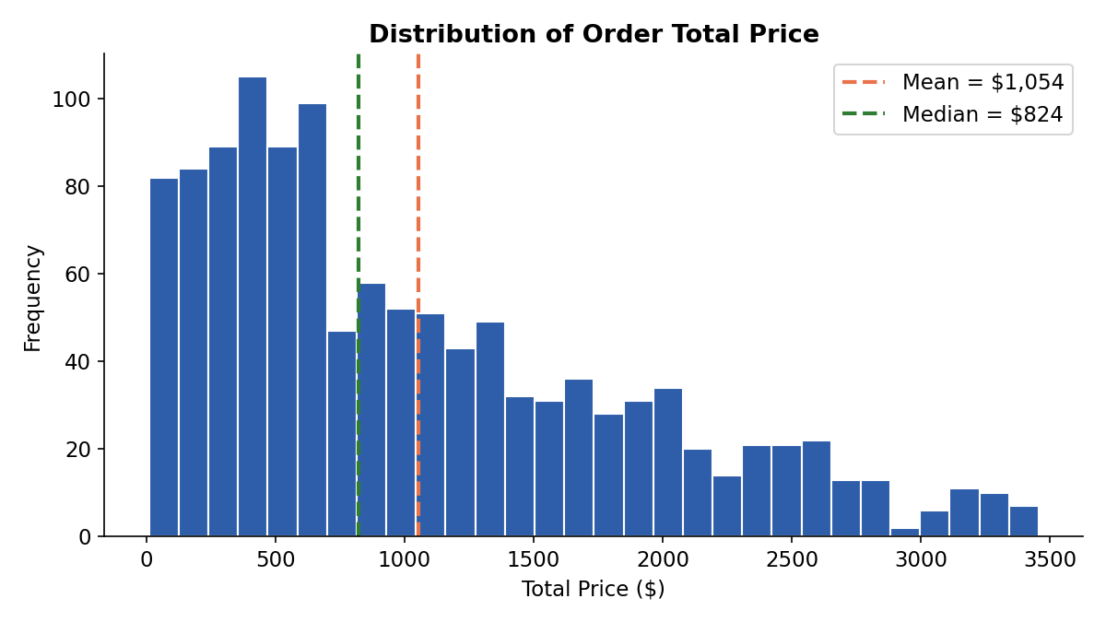
Figure 6 — Histogram of TotalPrice with mean and median markers
The distribution of order totals is right-skewed: most orders cluster below $1,500, while a longer tail extends toward $3,000+. This confirms the earlier observation that the mean sits above the median.

5.2 Outlier Detection (IQR Method)
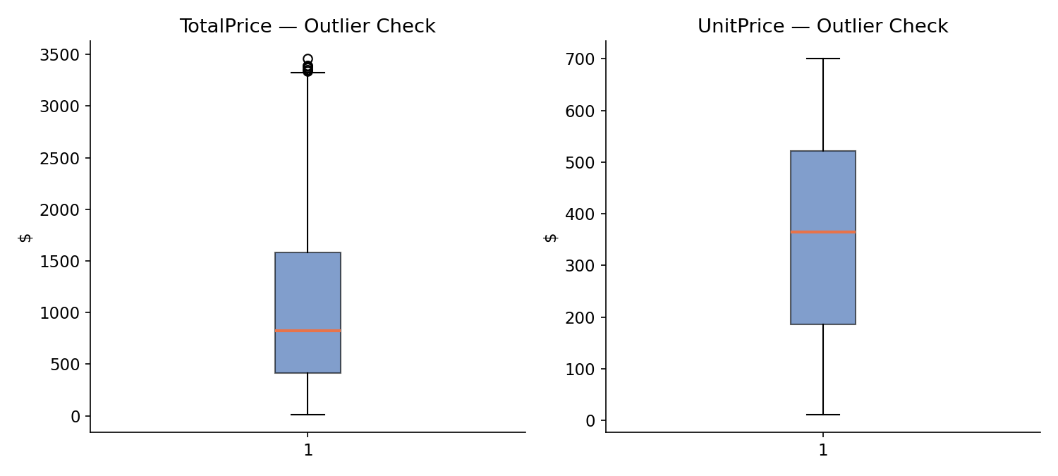
Figure 7 — Boxplots for TotalPrice and UnitPrice
Column | Normal Range (IQR) | Outliers Found | Interpretation
Total Price | $-1,341 to $3,330 | 8 orders | A handful of very large bulk orders
Unit Price | $-317 to $1,025 | 0 | No extreme pricing errors
Quantity | -1 to 7 | 0 | Ordering behavior is consistent
Items in Cart | -0.5 to 11.5 | 0 | No abnormal cart sizes

Using the standard 1.5×IQR rule, only 8 orders (0.7% of the dataset) fall outside the expected range on TotalPrice, and none on UnitPrice, Quantity, or ItemsInCart. This indicates the dataset is largely clean and consistent, with just a small number of legitimately large orders rather than data-entry errors.

6. Key Observations Summary
- The dataset covers 1,200 orders from 1,189 near-unique customers over 2.5 years, with minimal missing data (only CouponCode, which is expected).
- Order value is right-skewed: mean ($1,053.97) exceeds median ($823.62), driven by a small number of high-value orders.
- Revenue is fairly evenly spread across product categories, with Chairs and Printers narrowly leading and Phones trailing.
- No strong seasonal or monthly revenue trend is visible — order volume and revenue are broadly stable across the period.
- Cancelled and Returned orders together account for over 41% of all orders, a pattern worth further investigation from an operations standpoint.
- Payment methods are evenly adopted; Online leads only marginally.
- Instagram and Email are the strongest referral sources by revenue; Referral (word-of-mouth) is weakest.
- Coupon usage is common (74%) but has negligible effect on average order value.
- Outlier analysis confirms the data is clean — under 1% of records are statistical outliers, all on the high end of order value rather than errors.

7. Key Skills Demonstrated
- Descriptive statistics (mean, median, count, standard deviation)
- Trend identification across time and categorical dimensions
- Outlier detection using the IQR method
- Data visualization for pattern communication
- Analytical summarization of findings

