**SAVEETHA SCHOOL OF ENGINEERING**

**CSA12 – COMPUTER ORGANISATION AND ARCHITECTURE**

**LIST OF EXPERIMENTS**

1. Write an assembly language program for adding two 8-bit data A7 A6 A5 A4 A3 A2 A1 A0 and B7 B6 B5 B4 B3 B2 B1 B0 using 8085 processor.

2. Write an assembly language program for subtraction of two 8-bit data A7 A6 A5 A4 A3 A2 A1 A0 and B7 B6 B5 B4 B3 B2 B1 B0 using 8085 processor.

3. Write an assembly language program for multiplication of two 8-bit data A7 A6 A5 A4 A3 A2 A1 A0 and B7 B6 B5 B4 B3 B2 B1 B0 using 8085 processor.

4. Write an assembly language program for division of two 8-bit data A7 A6 A5 A4 A3 A2 A1 A0 and B7 B6 B5 B4 B3 B2 B1 B0 using 8085 processor.

**5. Write an assembly language program for adding two 16-bit data using 8085 processor.**

**6. Write an assembly language program for subtraction two 16-bit data using 8085 processor.**

**7. Write an assembly language program for multiplication of two 16-bit data using 8085 processor.**

**8. Write an assembly language program for division of two 16-bit data using 8085 process**

9. Write an assembly language program for adding two 16-bit data using 8086 processor.

10. Write an assembly language program for subtracting two 16-bit data using 8086 processor.

11. Write an assembly language program for multiplying two 16-bit data using 8086 processor.

12. Write an assembly language program for dividing two 16-bit data using 8086 processor.

13. Write an assembly language program to find the Greatest of 2 numbers.

14. Write an assembly language program to find the Smallest of 2 numbers.

15. Write an assembly language program to swap two 8-bit data using 8085 processor.

16. Write an assembly language program to find 1’s complement of 8-bit number.

17. Write an assembly language program to find 2’s complement of 8-bit number.

18.Write an assembly language program to find the given 8-bit number is Odd or Even using 8085 processor.

19. Write an assembly language program to find the given 8-bit number is Positive or Negative using 8085 processor.

20. Write an assembly language program to arrange numbers in Ascending order.

21. Write an assembly language program to arrange numbers in Descending order.

22. Write an assembly language program to find the largest number in an array

23. Write an assembly language program to find the Minimum number in an array.

24. Write an assembly language program to find the LCM of 2 numbers.

25. Write an assembly language program to find the GCD of 2 numbers.

26. Write an assembly language program to find factorial of n in the given number.

27. Write a program to convert Decimal number to Hexadecimal number

28. Design a circuit for the below mentioned diagram and implement the same using Logisim simulator.

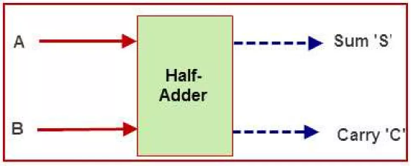

29. Design a circuit for the below mentioned diagram and implement it using Logisim simulator.

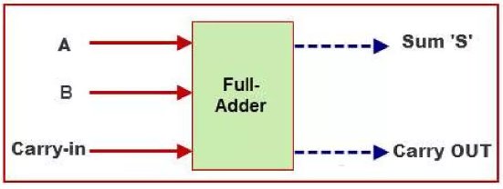

30. Design



and implement it with

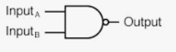

using Logisim simulator.

31. Design and implement 2-bit half adder with the below given gates using Logisim simulator.

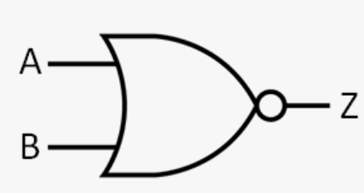

32. Design and implement a Full adder with the below mentioned gate using Logisim simulator.

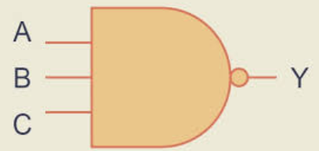

33. Design and implement a Full adder with the below mentioned gate using Logisim simulator.

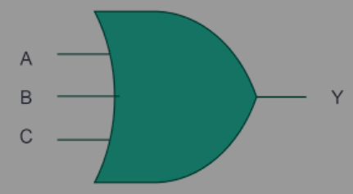

34. Design and implement 4-bit carry look ahead adder circuit using Logisim simulator.

**Note:**

**Red color programs are removed from Update1.**

**Newly added Programs in Update2**

5. Write an assembly language program for adding two 16-bit data using 8085 processor.

6. Write an assembly language program for subtraction two 16-bit data using 8085 processor.

7. Write an assembly language program for multiplication of two 16-bit data using 8085 processor.

8. Write an assembly language program for division of two 16-bit data using 8085 process