The links to the Privacy Policy, Terms, etc are not showing in the ordering flow. Those links should be there.

**Homepage-Non Order Flow:**

* Top Header…Logo  
  
* Footer: Logo and legal disclaimer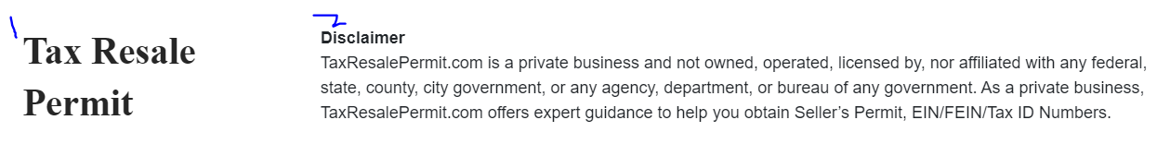
  + 1: The logo should match the top
  + 2: The legal stuff is missing (Terms, Privacy, etc)

**Inside The Order Flow:**

* **Payment Page**

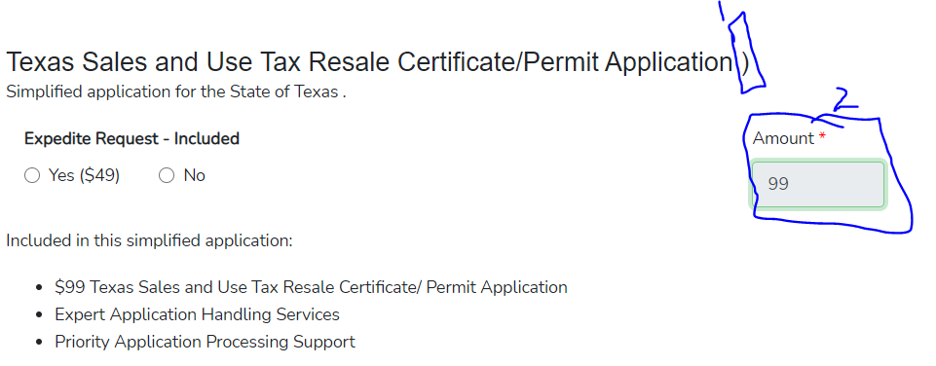

* + #1: See there is an extra “)” at the end of the sentence. That should be removed.
  + #2: I had listed this before that the box needs to be styled better. This don’t look good
  + #2: We would also need to make sure we include the $ sign before any dollar amount.
  + #2: Is should ready in smaller Text below the total: Your Total
  + #2: Have the total styled above it and it doesn’t need to be in a box. It Makes it look cheap.

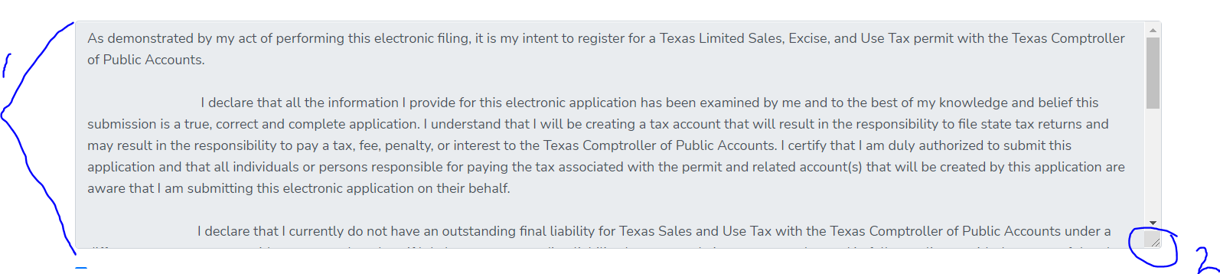

* #1: The length of the form needs to be longer
* #2: The drag to make the box bigger doesn’t work

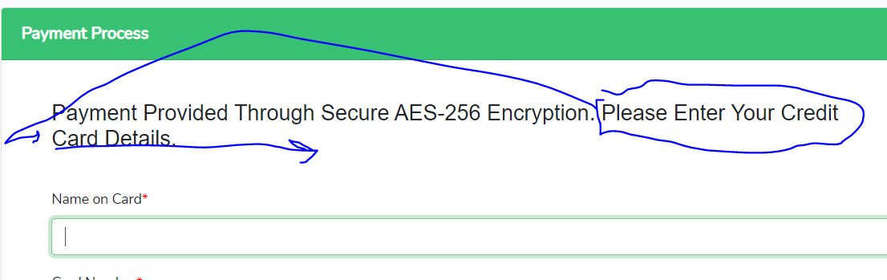

* The “Please Enter Your Credit” text needs to be on the same line as “Card Details”

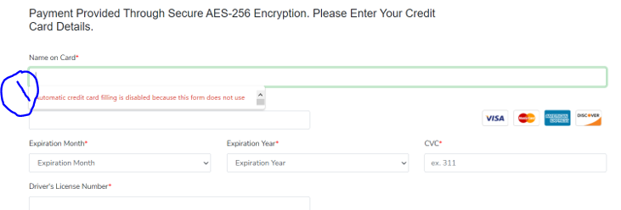

* + #1: For some reason it isn’t auto populating my Credit card details but every other website I use will auto populate content. The box load say that the form isn’t allowing the prepopulation of data. This is normal and should be part of the form.

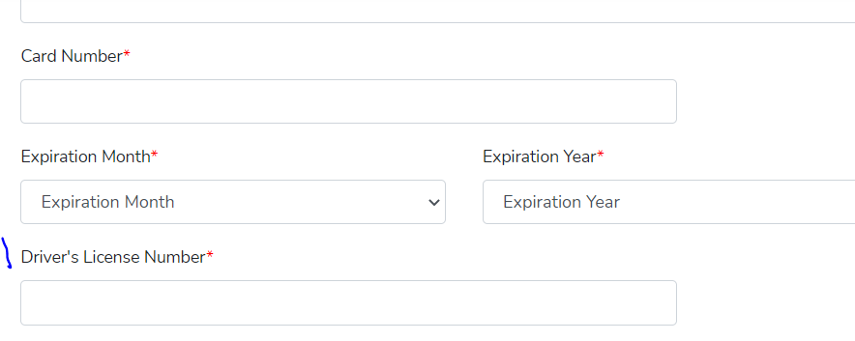

* #1 The Drivers License number field should be removed or hidden as it’s not needed right now.

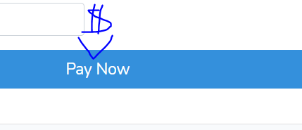

* Please populate the total amount of the order in the Pay Now button.
  + So, it should say: Pay $109 Now *(or whatever the total is based off of the selections)*

**Footer:**

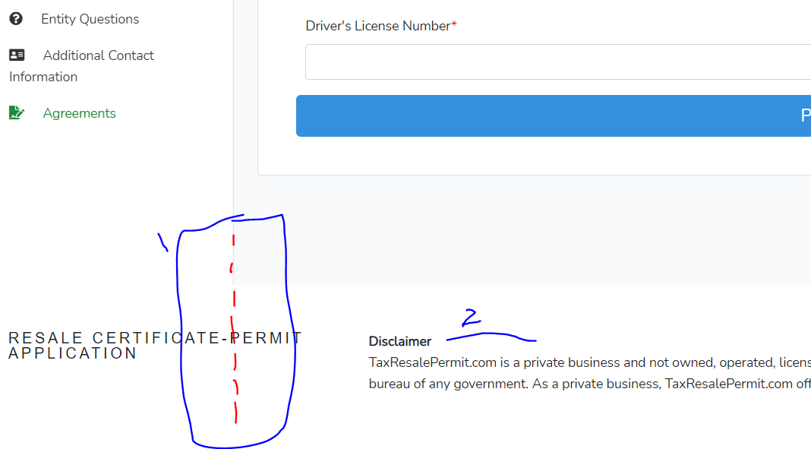

* + #1: See how inside the ordering flow we’re using a different footer. The footer should match the main footer found on the homepage. The main footer doesn’t go all the way to the left edge. For some reason, you’re using a different footer inside r the ordering flow.
  + #2: Like the main footer, there are no legal stuff like terms and Privacy policy. These items need to be added.

Back Admin:

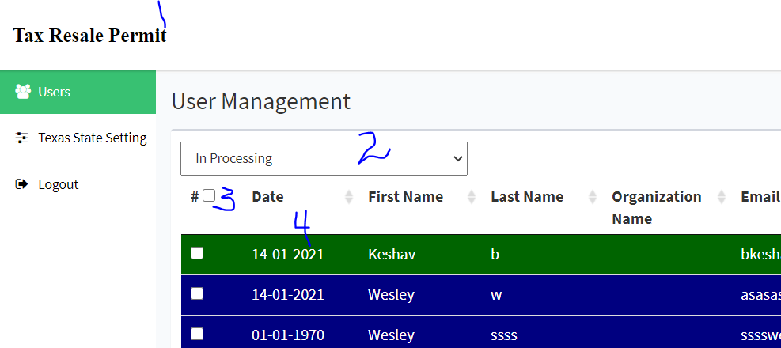

* #1: Please update Logo
* #2: Drop down doesn’t do anything
* #3: What does this checkbox do? There should be a Delete button and it would delete all the checked boxes
* #4: Date format is: DD/MM/YYYY