**Web Development (Web Form) Deliverables Milestones**

**Date:** 01 Feb 2021

**Phase 1:**  Form Design - End Of Lease Cleaning Service

* The full design until the payment completed page.
* EOL form details & pricing (Please take the fields required on the [link](https://docs.google.com/spreadsheets/d/1J6Kwq6CAS5SYC5s_lCqAJuMDrq8QeEaH4sbe2m7Nlr0/edit?usp=drive_web&ouid=114798440084504253194) as a reference, you can adjust the design as you see fit. )

**Phase 2:**

* For the development and implementing the Form to the website, Fetching Values/Price of the selection made by the user. Adding & Removing the items in the cart
* Can you please give me a check in after 14 hours?

**Phase 3: (7 hours)**

* Adding Payment Gateway and Testing

**Deliverables:**

* At the very least, I will need the EOL booking form to be end-to-end, payment ready, with discount codes available
* **Reference:** <https://thisisneat.com.au/end-of-lease-cleaning/sydney>
* Other details were covered in our call previously, but please let me know if you have any questions.

**----------------------------------------------------------------------------------------------------------------------------**

**Web Development Brief:**

**Date:** 28 Jan 2021

**Objective:**

* Create an easy-to-use booking form with a seamless payment gateway for the website.
* It has be mobile friendly

**Website:** servtown.com.au

**Services:**

House Cleaning (HC)

End of Lease (EOL) / Bond cleaning

Carpet Cleaning (CP)

Office Cleaning (OC)

**Ideal booking form:**

**(1)** User friendly layout and flow

**(2)** Each booking form is customised to each services, as each services has different requirements

**(3)** Multiple payment options - Direct Debit / Stripe (Credit card)

**(4)** The backend has to be easy for me/other users to modify the pricing easily or changing the services descriptions etc

**(5)** Must have the discount code functions or the look of it to make it more attractive for the users to book ‘

**(6)** Invoice - outline service (payment methods)

**(7) Future development:**

* Cleaners - Staff key in availabilities

**Deliverables:**

**Research (2 hours)**

A plan outlines the design, development and testing phase which fulfill the criterias above.

Number of hours required. (15-20) (8-10)

What are the options and limitations once the whole form is built.

**(3) Multiple payment options**

(Important ones: Stripe (credit cards) & Bank Transfer)

No surcharge for Bank Transfer, there will be 2% surcharge for credit cards.

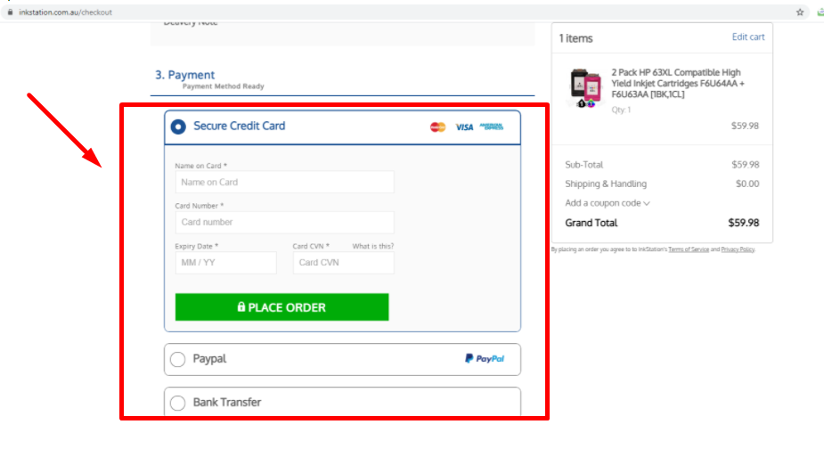

**Reference sites for ideas:**

1. **This Is Neat**

URL: <https://thisisneat.com.au/end-of-lease-cleaning/sydney>

**Services : EOL only**

**Positive:**

I like the entire layout and user flow of the form, placement of discount code and seamlessly connected to the Stripe Payment Gateway

**Negative:**

Can we create something similar (function wise), probably tweak a bit on the UI & UX design , so it doesn’t look exactly the same/ duplicate

1. **Fantastic Cleaners**

**URL**:<https://fantasticcleaners.com.au/melbourne/carpet-cleaning/>

<https://fantasticcleaners.com.au/sydney/carpet-cleaning/>

<https://fantasticcleaners.com.au/sydney/upholstery-cleaning/>

**Services : House, EOL, Carpet & Uph**

**Positive:**

I like their Carpet cleaning booking form layout, very detailed.

<https://fantasticcleaners.com.au/sydney/carpet-cleaning/>

<https://fantasticcleaners.com.au/sydney/upholstery-cleaning/>

**Negative:**

I believe the entire form is linking to a backend operation system, so i don’t think we are at a spot with that sort of budgets.

(Page 1 - The number of rooms needs cleaning)

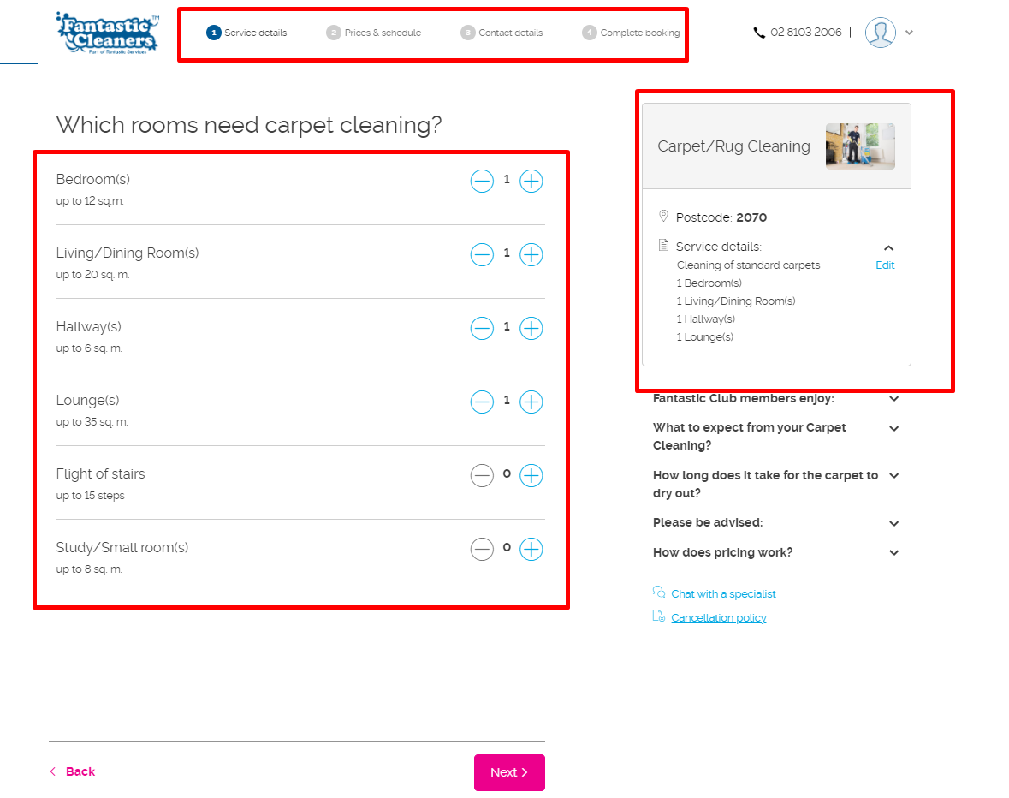

**Step 3: Contact Details (I like that users can attach photos, images, they can show the carpet stains photos, if there is any)**

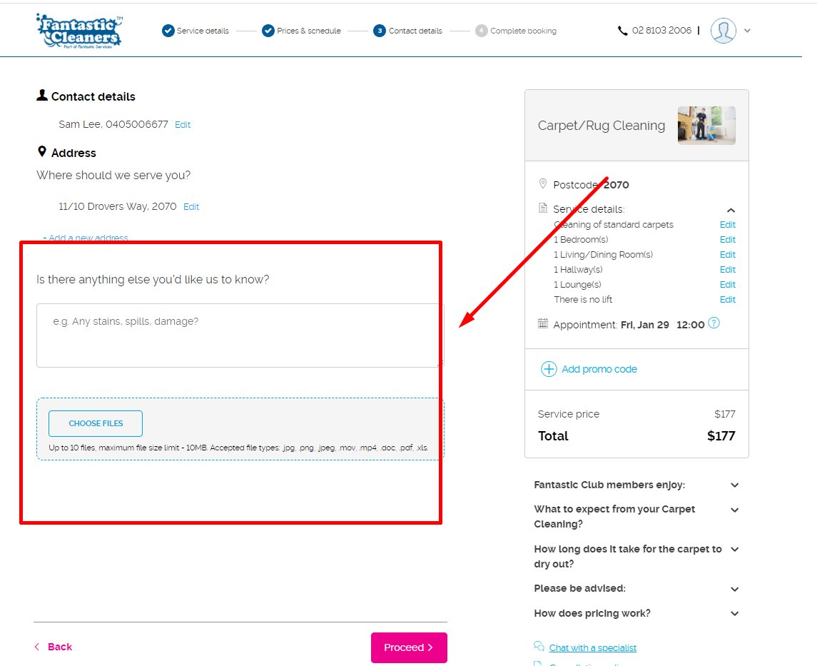

\

**4th Step: Payment Gateway**

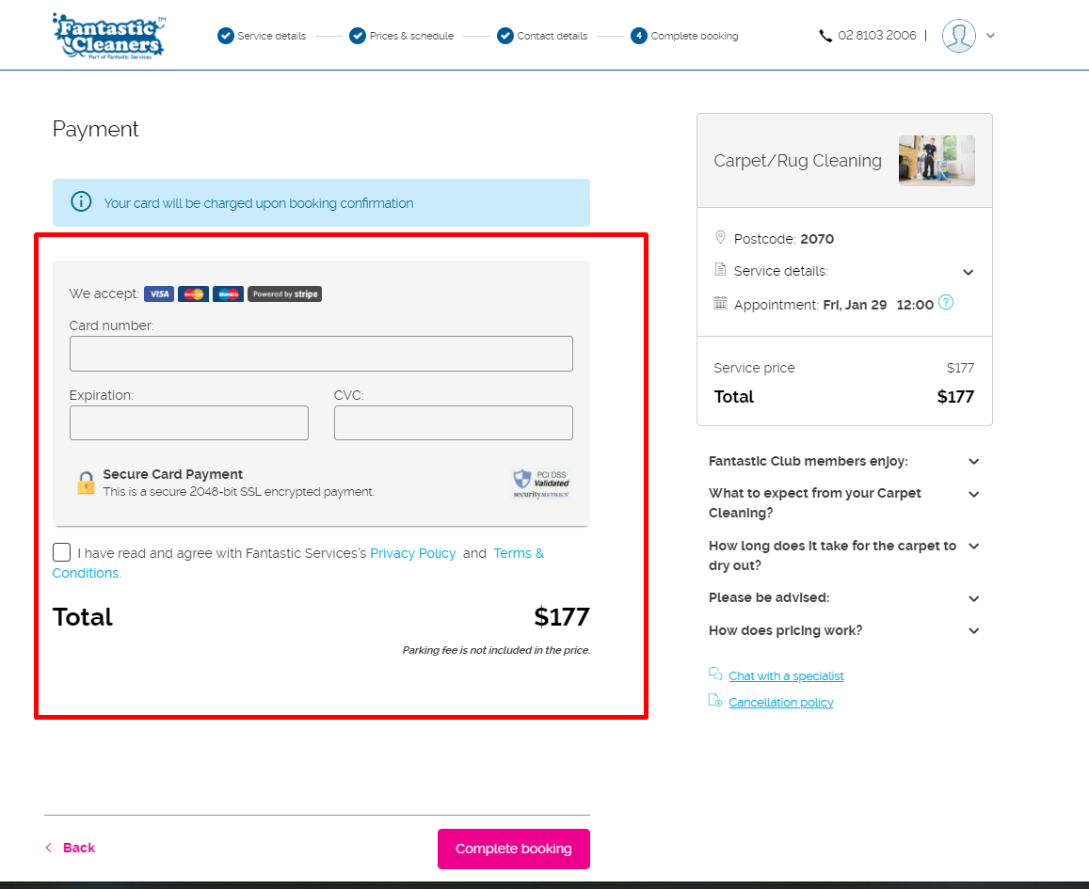

1. **Bond Cleaning Sydney**

**URL**: https://www.bondcleaning.sydney/

**Services :** EOL cleaning only

**Positive:** I like how once you click booking, you will receive an invoice in your mailbox, this is perfect for customers who want to pay via bank transfer.

Would like to know how they configure the invoice issuing system from their backend.

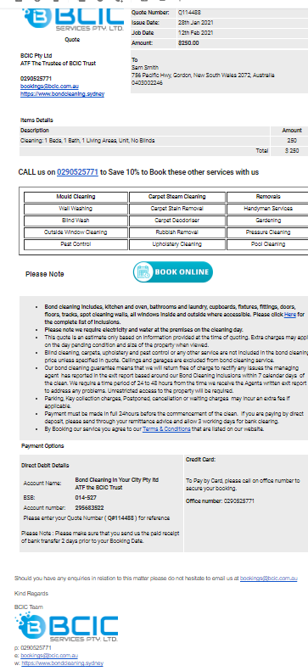

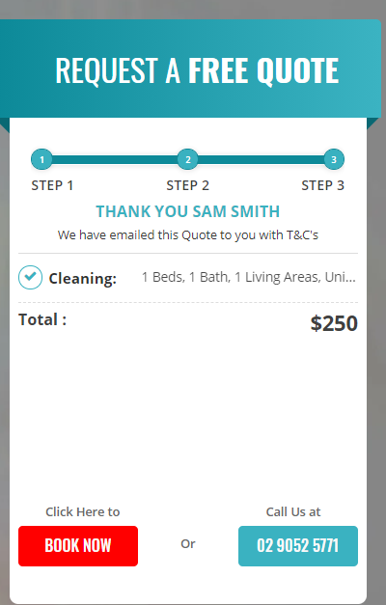

1. **Simply Maid**

**URL**: https://simplymaid.com.au/

**Services :** House & EOL & Carpet cleaning

**Positive:** This website is probably the best layout in House Cleaning, they use a form called Launch27, very clunky, so we eventually scratch the form.

1. **Clean Group**

**URL :** <https://www.clean-group.com.au/sydney/>

**Services:** Office & Commercial Cleaning

**Keypoint: J**ust a simple form will do

1. .Paulscleaningsydney.com.au/