**Done Tasks (check sir I think one task is pending )**

**Some Unwanted issue come Homepage not working solved issue now it come because one error in elementor plugin. So it is fix now.**

1. Recipes and blog Page done.

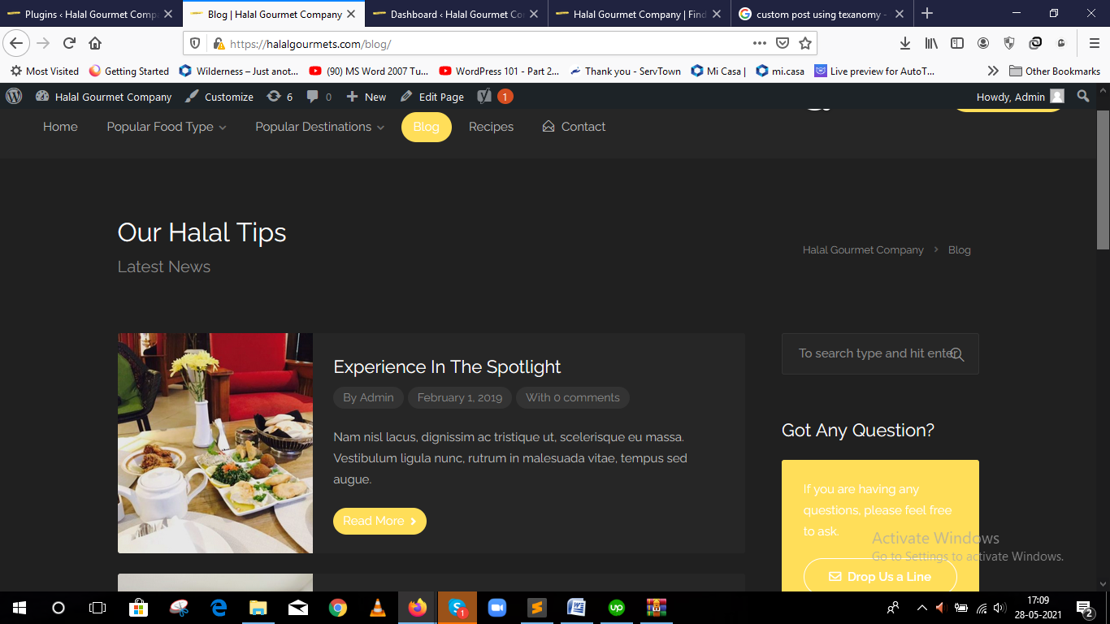

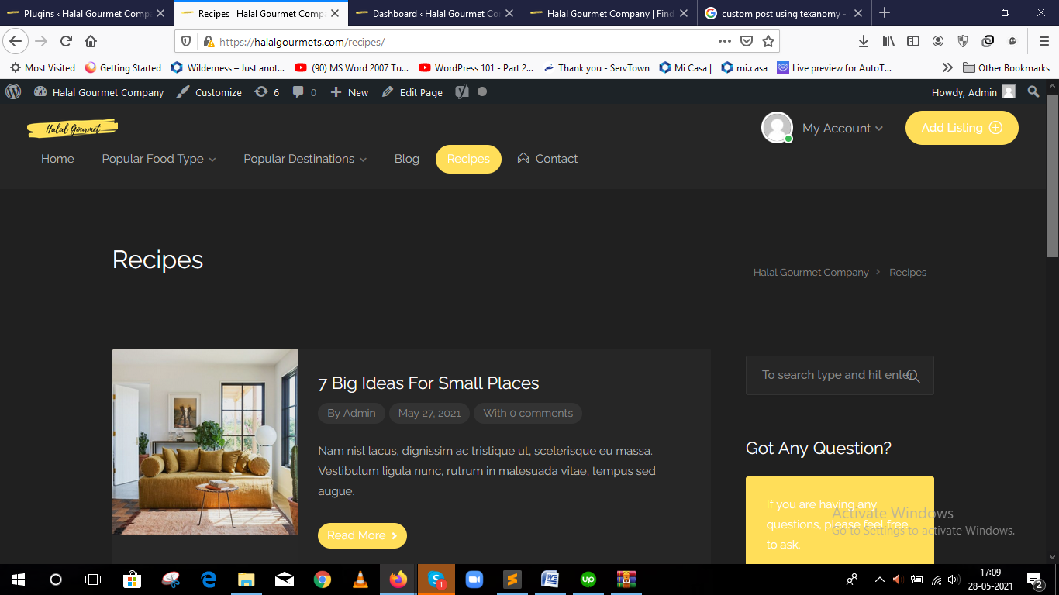

2) Add a Plugin with geolocalization to detect User Ip (**plugin working fine I tested it but need cpanel for custom work**)

3) Integrate Mailchimp (**added on contact form need mailchimp api now its for testing also adding contact form7 db plugin for save form data and export**)

**See below screenshot**

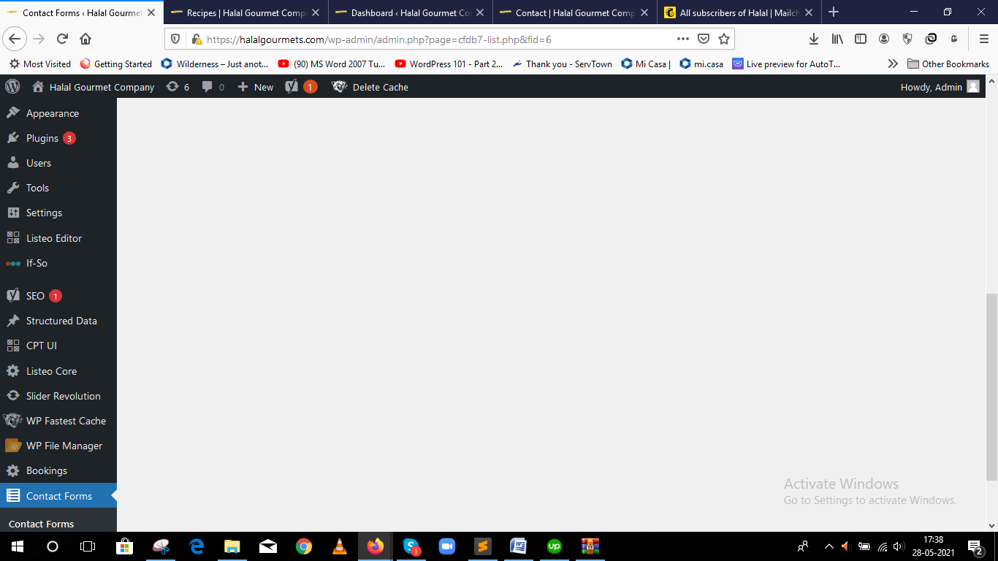

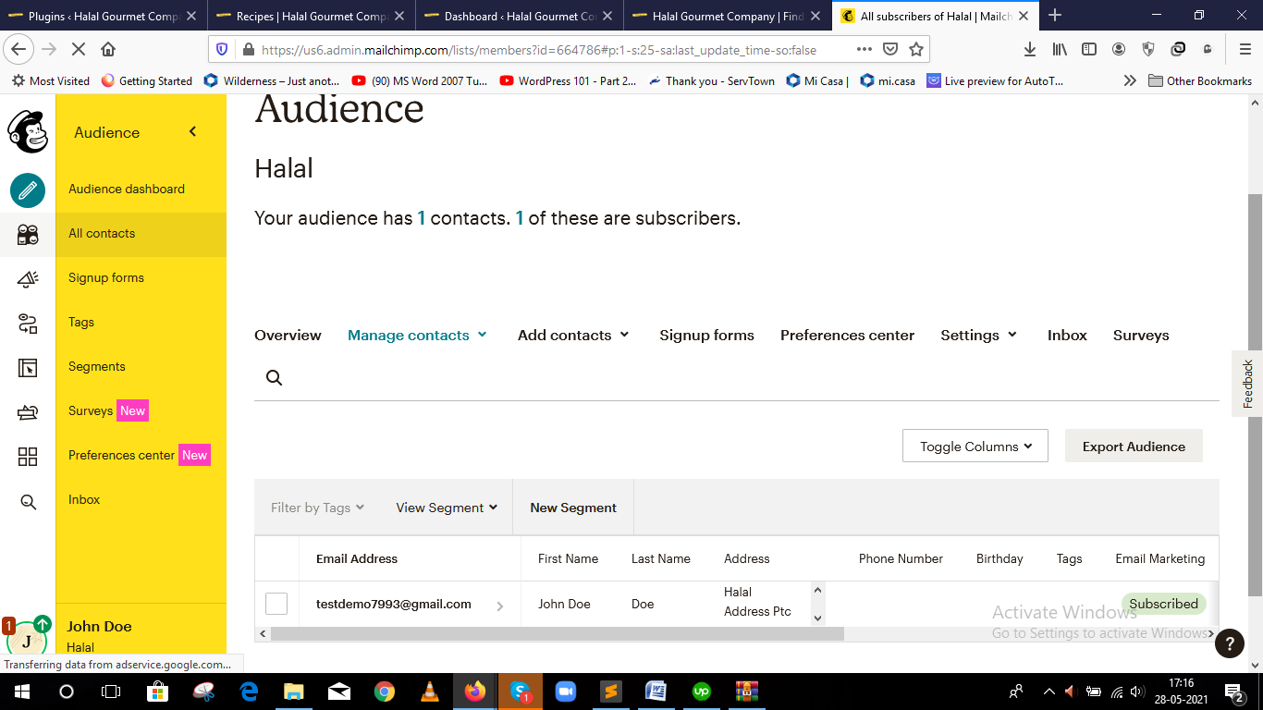

4, Javascript optimize conflicting with elementor and other scripts autoptimize plugin so I am using another plugin for cache

After activating autoptimize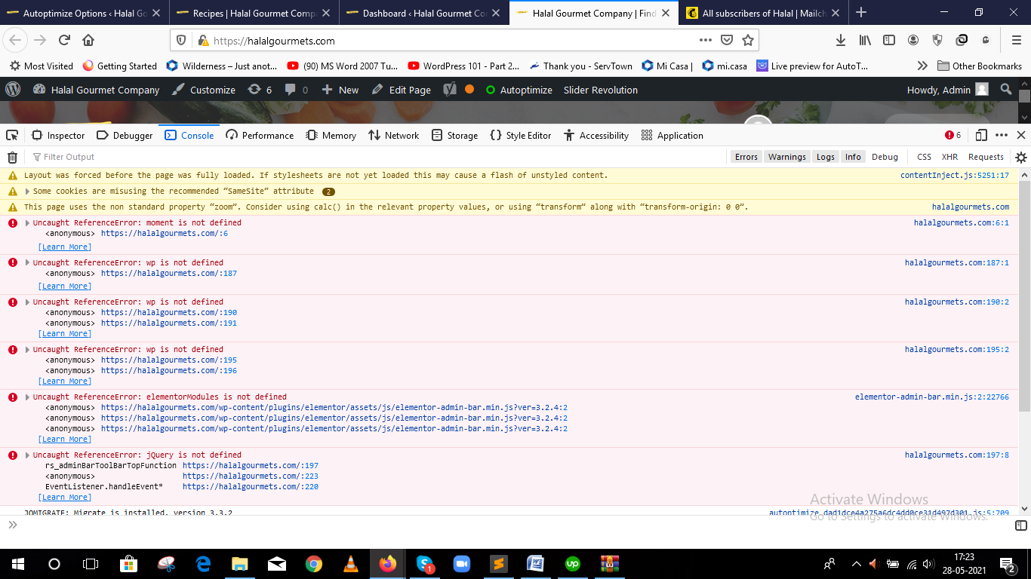

Without autoptimize plugin

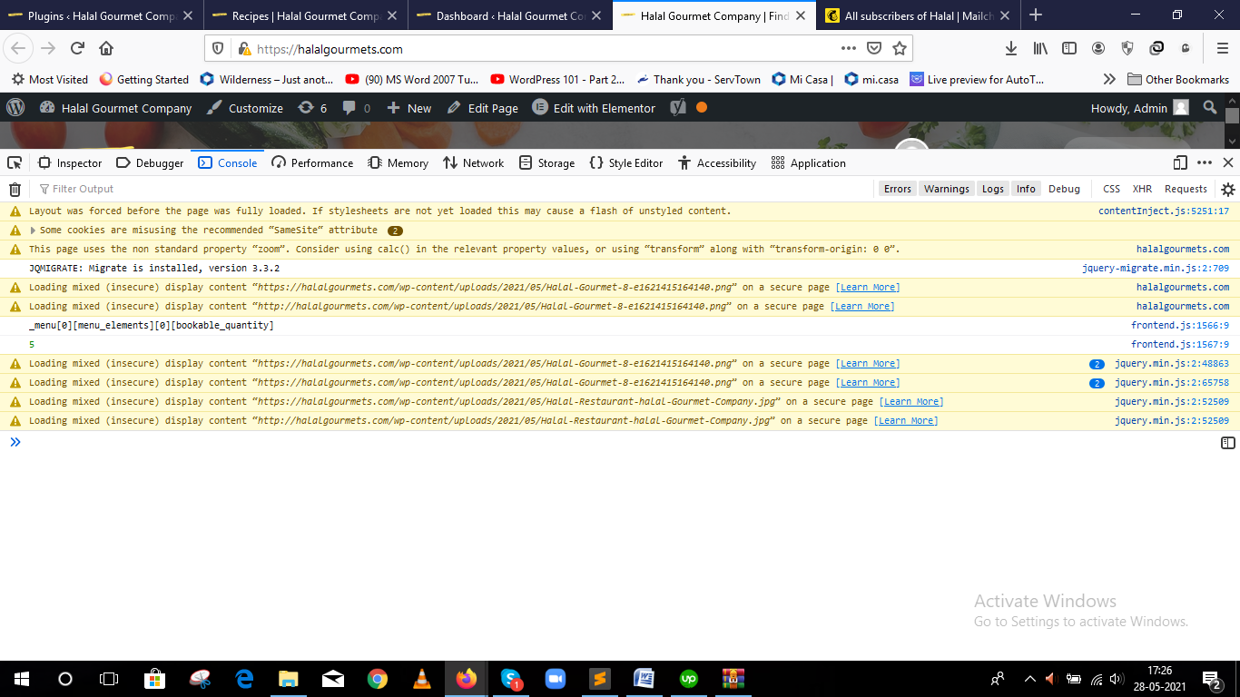

**After Installing another cache plugin (Wp Fastest Cache)**

