SIMATS ENGINEERING (SAVEETHA SCHOOL OF ENGINEERING)
Department of Artificial Intelligence and Data Science

ASSESSMENT TOOL 1 – Pattern Recognition and Text Processing

Course Code: | DSA03 | Course Title: | Natural Language Processing
CO Assessed: | CO1 – Imitation (L1) | Assessment: | Assessment Tool 1 – Pattern Recognition and Text Processing
Weightage: | 40% of CIA
CO5 Statement: | Analyse regular expression patterns. (BL-3)
Student Name: | V Yogeswar | Reg. No.: | 192425175
Section / Batch: |  | Date:
Code of Conduct
I V Yogeswar(192425175) (Name / Reg No) certify that this submission is my original work and that I have adhered to the guidelines specified for this assessment. I understand that any violation of academic integrity rules will result in disciplinary action.
Signature of the Student: V Yogeswar
Instructions
- Show all intermediate steps, calculations, state transitions, and reasoning wherever applicable.
- Use only the Python re (Regular Expressions) module to solve the given problems.
- Clearly mention the Regular Expression (Regex) pattern used before writing the corresponding Python program.
- Display the required output for each question, including extracted values, validation results, counts, and positions wherever applicable.
- Duration: 30 minutes.

Section / Topic | Focus | Q Nos
Regular Expression Pattern Generation | Pattern Matching Information Extraction | 1
Search for a String | Keyword Search and Text Analysis | 2
Split the documentation into sentences and words | Text Tokenization and Sentence Segmentation | 3
Email and Strong Password Validation | Data Validation and Format Verification | 4
Compile Once, Validate Many | Pattern Reusability and Performance Optimization | 5

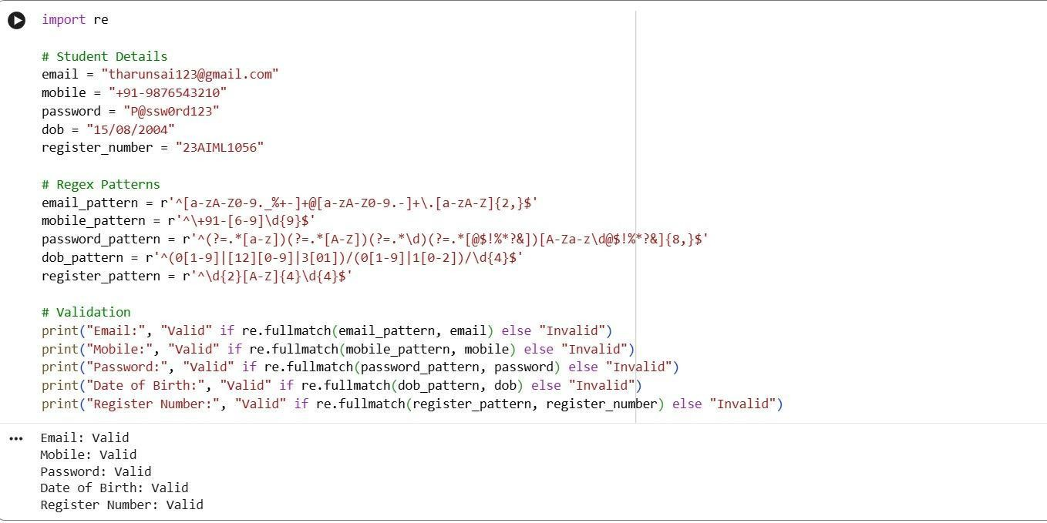
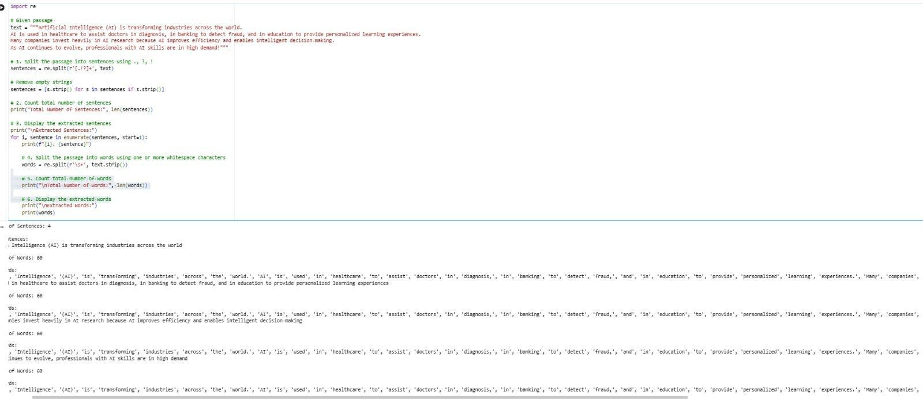

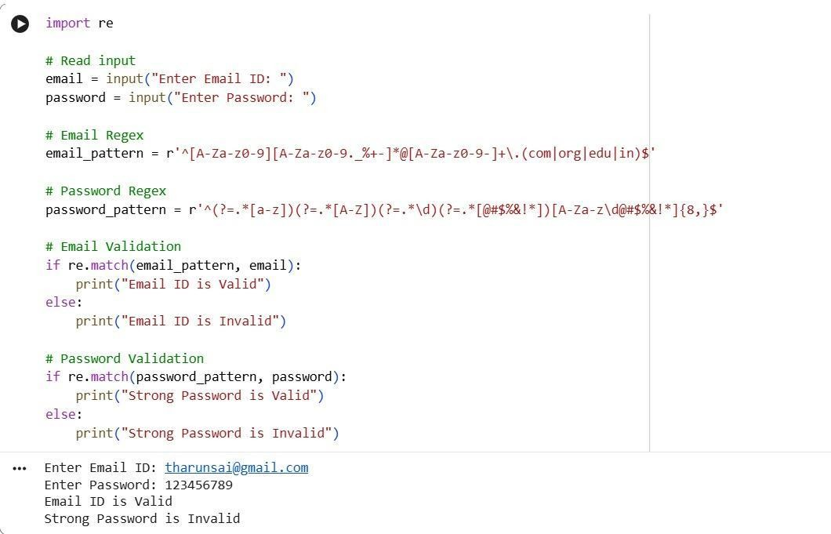

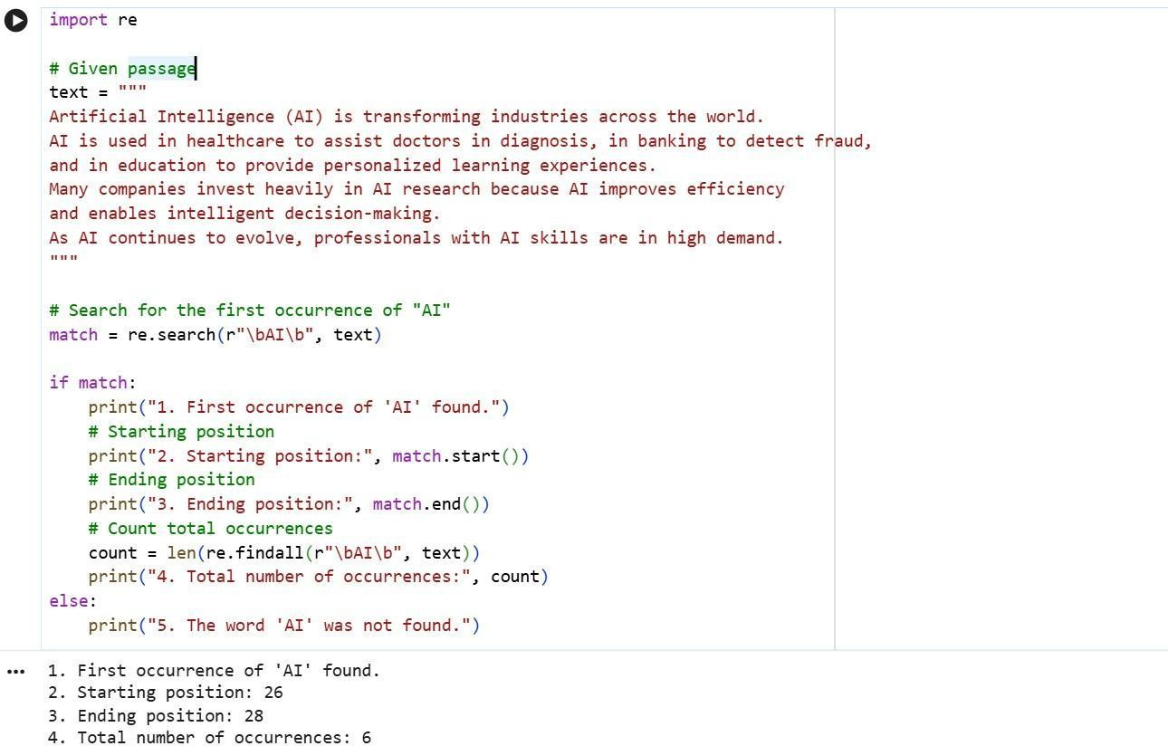
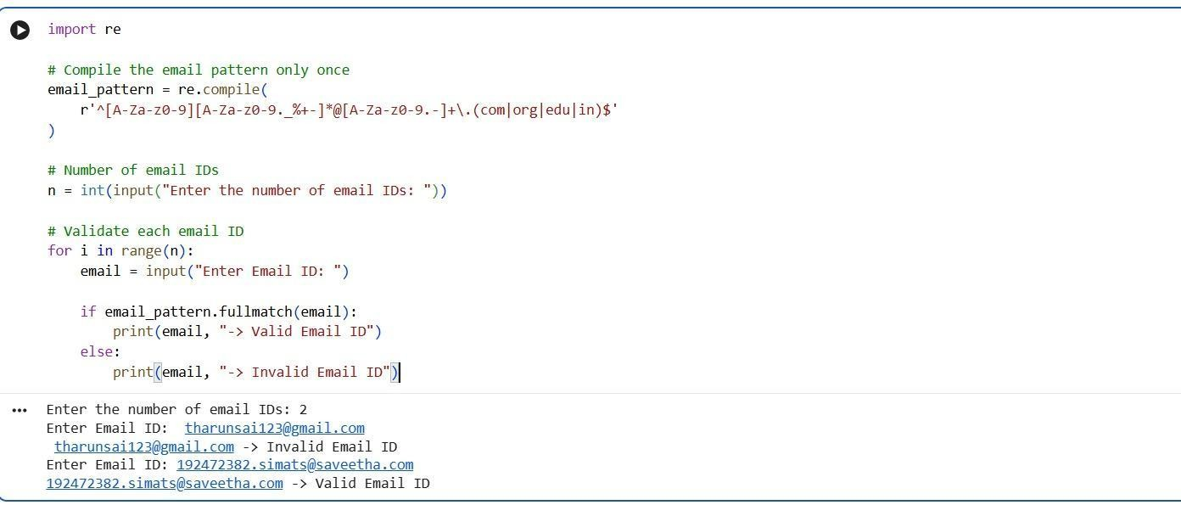

Rubrics for Calculation

Criteria | Weighta ge | Level 4 – Exemplary (5 Marks) | Level 3 –  Proficient (4 Marks) | Level 2 –  Developing (2–3 Marks) | Level 1 – Beginning (0–1 Mark)
Conceptu al Understan ding | 30 | Demonstrates clear and complete understanding of the concept | Good understanding with minor gaps | Basic understanding with some misconceptions | Poor or incorrect understanding
Accuracy of Answer | 25 | Completely correct answer with no errors | Mostly correct with minor errors | Partially correct with noticeable errors | Incorrect or irrelevant answer
Applicatio n of Knowledg e | 20 | Correctly applies concepts to solve the question/problem | Applies concepts with minor mistakes | Limited or partially correct application | No or incorrect application
Complete ness of Response | 15 | Covers all required parts of the question | Covers most parts with minor omissions | Covers only some parts | Incomplete or missing response
Clarity & Presentati on | 10 | Clear, concise, and well-organized answer | Understandable with minor issues | Somewhat unclear or poorly structured | Difficult to understand

Q. No.  / Criteri a | Conceptual Understan ding | Accuracy of Answer | Application of Knowledge | Completen ess of Response | Clarity & Presentati on | Sub. Total | Total  %
1 | 3 | 3 | 3 | 3 | 3 | 15 | 75
2 | 3 | 3 | 3 | 3 | 3 | 15
3 | 3 | 3 | 3 | 3 | 3 | 15
4 | 3 | 3 | 3 | 3 | 3 | 15
5 | 3 | 3 | 3 | 3 | 3 | 15

Faculty In-charge | Course Coordinator | Program Director
Kumaragurubaran T
Signature: | Signature: | Signature:
Date: 25/7/26 | Date: | Date:

