
SIMATS ENGINEERING
Saveetha Institute of Medical and Technical Sciences
Chennai – 602105
PROPERTY DISPUTE JUDGMENT INTERPRETATION SYSTEM USING FEATURE-BASED GRAMMAR, PROBABILISTIC CONTEXT-FREE GRAMMAR AND WORD SENSE DISAMBIGUATION
A CAPSTONE PROJECT REPORT
A Capstone Project Report submitted in partial fulfilment of the requirements for the Course of
DSA0306 - NATURAL LANGUAGE PROCESSING

to the award of the degree of
BACHELOR OF ENGINEERING / BACHELOR OF TECHNOLOGY
IN
COMPUTER SCIENCE AND ENGINEERING
Submitted by
V. Yogeswar (192425175)
S.N.V.S Karthik (192424186)
ABBURI ANIL (192425344)
N. Tharun Sai (192472382)
Under the Supervision of
Dr. A. M. Arul Raj

SIMATS ENGINEERING
Saveetha Institute of Medical and Technical Sciences
Chennai-602105
SEPTEMBER 2026
SIMATS ENGINEERING
Saveetha Institute of Medical and Technical Sciences
Chennai-602105

BONAFIDE CERTIFICATE
This is to certify that the Capstone Project entitled "PROPERTY DISPUTE JUDGMENT INTERPRETATION SYSTEM USING FEATURE-BASED GRAMMAR, PROBABILISTIC CONTEXT-FREE GRAMMAR AND WORD SENSE DISAMBIGUATION" has been carried out by V. Yogeswar (192425175), S.N.V.S Karthik (192424186), ABBURI ANIL (192425344), N. Tharun Sai (192472382), under the supervision of Dr. Kumaragurubaran. T and is submitted in partial fulfilment of the requirements for the current semester of the B.Tech Computer Science and Engineering programme at Saveetha Institute of Medical and Technical Sciences, Chennai.

COURSE COORDINATOR COURSE FACULTY
F Mary Harin Fernantez Dr. Kumaragurubaran. T
Professor department of Professor department of
Computer science and engineering Computer science and engineering
Saveetha School of Engineering Saveetha School of Engineering
SIMATS SIMATS

SIMATS ENGINEERING
Saveetha Institute of Medical and Technical Sciences
Chennai-602105

DECLARATION
I, V. Yogeswar, of the Department of Computer Science and Engineering, SIMATS Engineering, Saveetha Institute of Medical and Technical Sciences, Chennai, hereby declare that the Capstone Project Work entitled "PROPERTY DISPUTE JUDGMENT INTERPRETATION SYSTEM USING FEATURE-BASED GRAMMAR, PROBABILISTIC CONTEXT-FREE GRAMMAR AND WORD SENSE DISAMBIGUATION," and specifically my individual contribution towards Module 1: Legal Text Preprocessing and Linguistic Analysis described in this report, is the result of my own bonafide efforts. To the best of my knowledge, the work presented herein is original, accurate, and has been carried out in accordance with the principles of engineering ethics and academic integrity. All sources, references, data, and other materials used in the project have been appropriately acknowledged. I further declare that the data, results, analysis, and findings presented in this report have not been fabricated, falsified, or manipulated. Any external tools, software, datasets, computational resources, or AI-assisted tools used during the project have been appropriately disclosed. I confirm that all applicable ethical, academic, institutional, and professional requirements have been duly followed throughout the planning, execution, analysis, and documentation of the project.
Place: Chennai
Date:

Signature of the Student with Name
V. Yogeswar (192425175)

INDIVIDUAL CONTRIBUTION STATEMENT
Student Name / Register No. | Specific Responsibilities | Design & Development Contribution | Testing & Analysis Contribution | Report Contribution | Approx. Contribution (%)
V. Yogeswar (192425175) | Judgment text input; PDF text extraction where required; sentence segmentation; tokenization; POS tagging; structured linguistic output; testing Module 1 | Designed and developed the Legal Text Preprocessing & Linguistic Analysis component (Module 1) | Tested preprocessing accuracy and checked structured linguistic output quality | Contributed to Module 1 and preprocessing documentation | 25%
S.N.V.S Karthik (192424186) | Feature representation for number, person and tense; feature unification; Subject-Verb-Object identification; testing Module 2 | Designed and developed the Feature-Based Grammar Parsing & Syntactic Analysis component (Module 2) | Tested feature unification results and verified syntactic relationships | Contributed to Module 2 and syntactic-analysis documentation | 25%
ABBURI ANIL (192425344) | PCFG grammar design; parse generation; parse probability calculation; selection of the most probable parse; testing Module 3 | Designed and developed the Probabilistic Context-Free Grammar Parsing & Ambiguity Resolution component (Module 3) | Tested parse-selection accuracy and analyzed ambiguity-resolution performance | Contributed to Module 3 and ambiguity-resolution documentation | 25%
N. Tharun Sai (192472382) | Identification of ambiguous legal/property terms; context-based word sense disambiguation; combining outputs from previous modules; structured final interpretation; testing Module 4 | Designed and developed the Word Sense Disambiguation & Property Judgment Interpretation component (Module 4) | Tested disambiguation outcomes and verified the final structured interpretation | Contributed to Module 4 and final-interpretation documentation | 25%
Total |  |  |  |  | 100%

ABSTRACT
Court judgments in property-dispute cases are written in dense, formal legal language that combines long, multi-clause sentences with specialised terminology such as “ownership”, “possession”, “claim”, “title” and “inheritance”, each of which can carry more than one meaning depending on the surrounding context. This makes such judgments difficult for non-expert readers to interpret quickly and consistently. This capstone project addresses that engineering problem by developing a Property Dispute Judgment Interpretation System that applies Natural Language Processing (NLP) techniques to analyse property-dispute court judgments and produce a structured, easier-to-understand interpretation of their content. The system is organised into four modules: (1) legal text preprocessing and linguistic analysis, (2) syntactic analysis using Feature-Based Grammar (FBG), (3) ambiguity resolution using Probabilistic Context-Free Grammar (PCFG), and (4) Word Sense Disambiguation (WSD) and final judgment interpretation. This report documents the individual contribution of the author to Module 1 – Legal Text Preprocessing and Linguistic Analysis, in which the input judgment text is extracted, segmented into sentences, tokenized into individual words and tagged with their Part-of-Speech (POS) categories to produce structured linguistic information that is passed downstream to the Feature-Based Grammar parser in Module 2. The methodology followed for this module includes PDF text extraction where required, sentence segmentation, tokenization and POS tagging using the Python NLTK library, followed by structuring of the resulting token-and-tag sequences into a format suitable for grammatical feature unification in Module 2. The complete pipeline subsequently applies Feature-Based Grammar to identify grammatical features and syntactic relationships (Module 2), Probabilistic Context-Free Grammar to select the most probable parse when a sentence admits multiple syntactic structures (Module 3), and Word Sense Disambiguation to resolve the intended meaning of ambiguous property and legal terms using their surrounding context (Module 4), combining these outputs into a structured interpretation of the judgment. The system is intended strictly as an NLP-based analysis and interpretation aid; it does not provide legal advice, does not determine legal rights, does not replace lawyers or judges, and does not produce legally binding decisions.
Keywords: Natural Language Processing; Legal Text Analysis; Feature-Based Grammar; Probabilistic Context-Free Grammar; Word Sense Disambiguation; Part-of-Speech Tagging; Property Dispute Judgment Interpretation

TABLE OF CONTENTS
Sl. No. | Title | Page No.
i | CERTIFICATE FROM THE SUPERVISOR | ii
ii | DECLARATION BY THE CANDIDATE | iii
iii | INDIVIDUAL CONTRIBUTION STATEMENT | iv
iv | ABSTRACT | v
v | LIST OF FIGURES | vi
vi | LIST OF TABLES | vii
vii | LIST OF ABBREVIATIONS | viii
1 | CHAPTER 1: Introduction and Engineering Problem | 1
2 | CHAPTER 2: Literature Review and Existing Solutions | 4
3 | CHAPTER 3: Engineering Design & Trade-offs, Sustainability, Ethics, Safety, Risk & Security | 7
4 | CHAPTER 4: Implementation, Testing & Results, Project Management | 13
5 | CHAPTER 5: Conclusion, Future Work and Reflection | 19
 | References | 21
 | Appendices | 22
 | Capstone Project Outcome Mapping Sheet | 23

LIST OF FIGURES
Figure No. | Figure Name | Page No.
3.1 | Overall System Architecture – Property Dispute Judgment Interpretation System | 9
3.2 | NLP Processing Pipeline: Preprocessing → FBG → PCFG → WSD → Structured Interpretation | 10
4.1 | Module 1 Preprocessing Output for a Sample Judgment Sentence (screenshot placeholder) | 16

LIST OF TABLES
Table No. | Table Name | Page No.
2.1 | Comparative Analysis of Existing Legal-Text NLP Approaches | 6
3.1 | Stakeholder / User Requirements | 7
3.2 | Functional & Non-Functional Requirements | 7
3.3 | Constraints & Applicable Standards | 8
3.4 | Design Specifications – Module 1 | 9
3.5 | Alternative Preprocessing/Parsing Approach Evaluation Matrix | 10
3.6 | Trade-off Analysis | 11
3.7 | Sustainability, Ethics, Safety, Security | 12
3.8 | Risk Register | 12
4.1 | Test Plan & Verification – Module 1 | 14
4.2 | Specification vs. Achieved Results | 15
4.3 | Achievement of Objectives | 17
4.4 | Roles, Responsibility and Budget | 18

LIST OF ABBREVIATIONS / SYMBOLS
Symbol | Description | Unit
NLP | Natural Language Processing | —
FBG | Feature-Based Grammar | —
PCFG | Probabilistic Context-Free Grammar | —
CFG | Context-Free Grammar | —
WSD | Word Sense Disambiguation | —
POS | Part-of-Speech | —
SVO | Subject-Verb-Object | —
NLTK | Natural Language Toolkit | —
PDF | Portable Document Format | —

CHAPTER 1
INTRODUCTION AND ENGINEERING PROBLEM

1.1 Background
Property-dispute litigation generates a large volume of court judgments that record, in formal legal prose, the facts of a case, the arguments advanced by the parties and the reasoning and conclusion reached by the court. This legal language is dense, uses long multi-clause sentences and relies on domain-specific terms such as “ownership”, “possession”, “claim”, “title” and “inheritance”, each of which can take on different meanings depending on the surrounding context. Natural Language Processing (NLP) provides a set of computational techniques – sentence segmentation, tokenization, Part-of-Speech (POS) tagging, syntactic parsing and word sense disambiguation – that can be applied in sequence to break down such legal text and produce a more structured and interpretable representation of its content.

1.2 Need for the Project
- Property-dispute judgments are lengthy and written in formal legal language that is not easily understood by non-experts.
- Manually reading and interpreting every judgment sentence-by-sentence is slow and inconsistent between readers.
- Many property/legal terms (ownership, possession, claim, title, inheritance) are ambiguous and require contextual understanding rather than simple keyword lookup.
- A structured NLP pipeline that combines linguistic preprocessing, grammatical parsing and word sense disambiguation can produce a consistent, structured interpretation of a judgment’s key assertions.

1.3 Problem Statement
Property-dispute court judgments are written in complex legal language that is difficult to process consistently using simple text-processing methods; sentences frequently contain multiple clauses, and key property/legal terms are ambiguous in isolation. Existing manual review is slow, and simple keyword-based text tools cannot capture grammatical structure or resolve which sense of an ambiguous term (for example, “ownership” used in a legal-property sense versus a general sense) applies in a given sentence. The engineering problem addressed by this project is therefore to design a system that (a) reliably preprocesses and linguistically analyses judgment text, (b) parses the grammatical structure of each sentence using Feature-Based Grammar, (c) resolves syntactic ambiguity between competing valid parses using Probabilistic Context-Free Grammar, and (d) determines the correct contextual sense of ambiguous property/legal terms using Word Sense Disambiguation, in order to produce a structured, easier-to-understand interpretation of the judgment.

1.4 Project Aim
To design and develop a Property Dispute Judgment Interpretation System that applies legal text preprocessing, Feature-Based Grammar parsing, Probabilistic Context-Free Grammar parsing and Word Sense Disambiguation to produce a structured interpretation of property-dispute court judgments; and, within this framework, to design, implement and evaluate the legal text preprocessing and linguistic analysis stage (Module 1) as an individual engineering contribution.

1.5 Project Objectives
- To accept a property-dispute judgment (including PDF input where required) and perform sentence segmentation, tokenization and Part-of-Speech tagging to produce structured linguistic output (Module 1 – individual focus).
- To apply Feature-Based Grammar to represent grammatical features (number, person, tense) and identify Subject-Verb-Object relationships through feature unification (Module 2).
- To apply Probabilistic Context-Free Grammar to generate candidate parses and select the most probable valid syntactic structure when a sentence is ambiguous (Module 3).
- To identify ambiguous property/legal terms and use surrounding context to determine their intended meaning through Word Sense Disambiguation (Module 4).
- To combine the outputs of all four modules into a single, structured, human-readable interpretation of the judgment.

1.6 Scope
Included: Design, implementation and evaluation of the legal text preprocessing and linguistic analysis stage (Module 1) – covering judgment text input, PDF text extraction where required, sentence segmentation, tokenization and POS tagging – within the context of the complete four-module judgment-interpretation pipeline.
Excluded: Provision of legal advice or legally binding conclusions; determination of actual legal ownership or property rights; implementation details of Modules 2, 3 and 4 beyond what is needed to describe their interface with Module 1; processing of non-property-dispute legal domains.
Assumptions: A property-dispute judgment, either as plain text or as a PDF from which text can be extracted, is available as input to Module 1; the Python NLTK library and its associated POS-tagging resources are available in the execution environment.
Boundary conditions: The system processes English-language property-dispute judgments in the current iteration and does not address multilingual legal text or handwritten/scanned judgments requiring OCR.

1.7 Expected Engineering Outcome
The expected outcome is a working software module – a legal-text preprocessing and linguistic-analysis engine – that accepts a property-dispute judgment, produces sentence-segmented, tokenized and POS-tagged structured linguistic output, and supplies this output to the downstream Feature-Based Grammar parser (Module 2) as part of the complete Property Dispute Judgment Interpretation System.
It is important to note throughout this report that the system described here is strictly an NLP-based analysis and interpretation tool. It does not provide legal advice, does not determine legal rights, does not replace lawyers or judges, and does not produce legally binding decisions.

CHAPTER 2
LITERATURE REVIEW AND EXISTING SOLUTIONS

2.1 Review Method
Relevant material was reviewed from established Natural Language Processing textbooks and reference documentation covering text preprocessing, syntactic parsing (Context-Free Grammar, Feature-Based Grammar and Probabilistic Context-Free Grammar), and Word Sense Disambiguation, with particular attention to the preprocessing and linguistic-analysis techniques (sentence segmentation, tokenization and POS tagging) that form the individual module covered in this report.

2.2 Review of Existing Work
Standard NLP preprocessing pipelines, as described in foundational texts such as Jurafsky and Martin’s Speech and Language Processing and Bird, Klein and Loper’s Natural Language Processing with Python, break raw text into sentences and tokens and assign each token a Part-of-Speech tag before any deeper grammatical or semantic analysis is attempted; this preprocessing stage is treated in the literature as a prerequisite for reliable downstream parsing rather than an end in itself. Manning and Schütze’s Foundations of Statistical Natural Language Processing and Manning, Raghavan and Schütze’s Introduction to Information Retrieval describe how Context-Free Grammars can represent the syntactic structure of a sentence, how feature structures and unification (Feature-Based Grammar) extend a CFG to enforce grammatical agreement such as number, person and tense, and how a Probabilistic Context-Free Grammar assigns a probability to each candidate parse so that the most likely structure can be selected when a sentence is syntactically ambiguous. The same body of literature treats Word Sense Disambiguation as a distinct problem from syntactic parsing: WSD uses the words and structures surrounding an ambiguous term to select its intended meaning from a set of candidate senses, rather than matching the term itself against a fixed keyword list. Applied to a specialised domain such as legal text, these general NLP techniques must additionally cope with long, formally structured sentences and domain-specific vocabulary (for example, “ownership”, “possession”, “claim”, “title” and “inheritance” in property-dispute judgments), which is the specific context addressed by this project.

2.3 Comparative Analysis
Existing Approach | Advantages | Limitations | Relevance to Proposed Work
Keyword/rule-based legal text search | Simple to implement; fast on small documents | Cannot capture grammatical structure; fails on ambiguous or multi-sense legal terms | Baseline compared against in this project
Context-Free Grammar (CFG) parsing only | Captures grammatical structure using explicit rules | Cannot represent agreement features (number, person, tense); often produces multiple competing parses with no way to choose between them | Motivates the addition of Feature-Based Grammar (Module 2) and probabilistic parse selection (Module 3)
Probabilistic parsing without feature unification | Ranks competing parses by likelihood; resolves structural ambiguity | Does not, by itself, enforce grammatical agreement or extract Subject-Verb-Object relations | PCFG (Module 3) adopted downstream of Feature-Based Grammar (Module 2), not as a replacement for it
Simple dictionary/keyword lookup for legal terms | Fast; easy to build | Cannot distinguish between multiple senses of the same term (e.g., “ownership”) without considering context | Motivates Word Sense Disambiguation using surrounding context (Module 4) instead of static lookup
Proposed: Preprocessing + FBG + PCFG + WSD pipeline (this project) | Combines linguistic preprocessing, feature-based syntactic analysis, probabilistic ambiguity resolution and contextual sense disambiguation into a single structured interpretation | Requires all four stages to be correctly integrated; performance of downstream modules depends on the quality of Module 1 preprocessing | Adopted design for the complete system, with Module 1 as the foundation stage

2.4 Research / Engineering Gap
General-purpose NLP preprocessing, parsing and disambiguation techniques are well established individually, but comparatively little attention in accessible tooling is given to combining them into a single structured pipeline aimed specifically at property-dispute legal judgments, where accurate sentence segmentation and POS tagging of long, formally structured sentences is a prerequisite for the Feature-Based Grammar and Probabilistic Context-Free Grammar stages that follow, and where common legal/property terms require contextual sense disambiguation rather than static definition lookup.

2.5 Proposed Contribution
This project, and specifically Module 1 covered in this report, contributes a legal-text preprocessing and linguistic-analysis stage that reliably segments, tokenizes and POS-tags property-dispute judgment sentences and structures this output in a form suitable for consumption by the Feature-Based Grammar parser (Module 2), the Probabilistic Context-Free Grammar parser (Module 3) and the Word Sense Disambiguation and interpretation stage (Module 4), so that the complete pipeline can produce a structured, easier-to-understand interpretation of the judgment.

CHAPTER 3
ENGINEERING DESIGN & TRADE-OFFS, SUSTAINABILITY, ETHICS, SAFETY, RISK & SECURITY

3.1 Requirements
Stakeholder / User Requirements
Stakeholder | Requirement
End user (e.g., paralegal, law student, researcher reviewing judgments) | A clear, structured interpretation of a judgment’s key assertions without needing to read the entire document line by line
Academic institution / evaluators | A technically sound NLP pipeline with correctly attributed individual module contributions
Downstream modules (Module 2, 3, 4) | Reliable, correctly segmented, tokenized and POS-tagged input from Module 1

Functional & Non-Functional Requirements
Requirement Type | Measurable Target
Functional – accept judgment text/PDF input | Successfully extracts and loads judgment text for processing
Functional – sentence segmentation | Correctly splits judgment text into individual sentences
Functional – tokenization | Correctly splits each sentence into individual tokens (words/punctuation)
Functional – POS tagging | Assigns a Part-of-Speech tag to each token using NLTK
Non-functional – structured output format | Produces output in a consistent structure consumable by Module 2
Non-functional – maintainability | Preprocessing steps implemented as modular, independently testable functions

3.2 Constraints & Applicable Standards
Standard / Requirement | Requirement | How Applied in This Project
Institutional academic-integrity / AI-disclosure requirement | Disclosure of AI-assisted tools used in the project | Any AI-assisted tool used during development is disclosed in this report
Data-privacy considerations for case documents | Judgment text used for development/testing should be handled respectfully and not redistributed beyond project use | Sample judgment sentences used in this report are used solely for illustrating the processing pipeline
NLTK library licensing and usage terms | Use of NLTK’s tokenizers and POS taggers in accordance with its open-source licence | NLTK is used as documented in its official documentation for tokenization and POS tagging

3.3 Design Specifications
Parameter | Target / Requirement | Unit | Priority
Sentence segmentation method | NLTK sentence tokenizer | — | High
Word tokenization method | NLTK word tokenizer | — | High
POS tagging method | NLTK POS tagger (Penn Treebank tag set) | — | High
Input formats supported | Plain text; PDF (where required, via text extraction) | — | Medium
Output structure | Sentence → token list → (token, POS tag) pairs, passed to Module 2 | — | High

3.4 Alternative Solutions & Evaluation
Alternative 1 – Regex/rule-based sentence and word splitting: uses hand-written pattern rules to split text into sentences and tokens; simple to implement but brittle when legal sentences contain abbreviations, citations or nested clauses.
Alternative 2 – Custom statistical tagger trained from scratch: would allow tuning to legal text specifically, but requires a labelled legal-text training corpus and substantial development effort that is outside the scope of this individual module.
Alternative 3 – NLTK-based preprocessing pipeline (selected): uses NLTK’s established sentence tokenizer, word tokenizer and Part-of-Speech tagger; well documented, widely used and sufficiently accurate for producing structured input to the downstream Feature-Based Grammar stage.
Criterion | Weight | Alternative 1 (Regex-based rules) | Alternative 2 (Custom statistical tagger) | Alternative 3 (NLTK preprocessing)
Performance (segmentation/tagging correctness) | 30% | Medium | High | High
Handling of complex/legal sentence structures | 25% | Low-Medium | Medium | High
Ease of integration with downstream modules | 20% | Medium | High | High
Development/maintenance effort | 15% | Low | Medium | High
Availability of documentation/support | 10% | Medium | Medium | High

3.5 Selected Design & Detailed Design
The NLTK-based preprocessing pipeline was selected as the Module 1 design because it consistently scored highest on ease of integration with downstream modules and on overall development/maintenance effort (Section 3.4), both of which are important given that Module 1’s output must interface cleanly with three further modules developed by other team members.
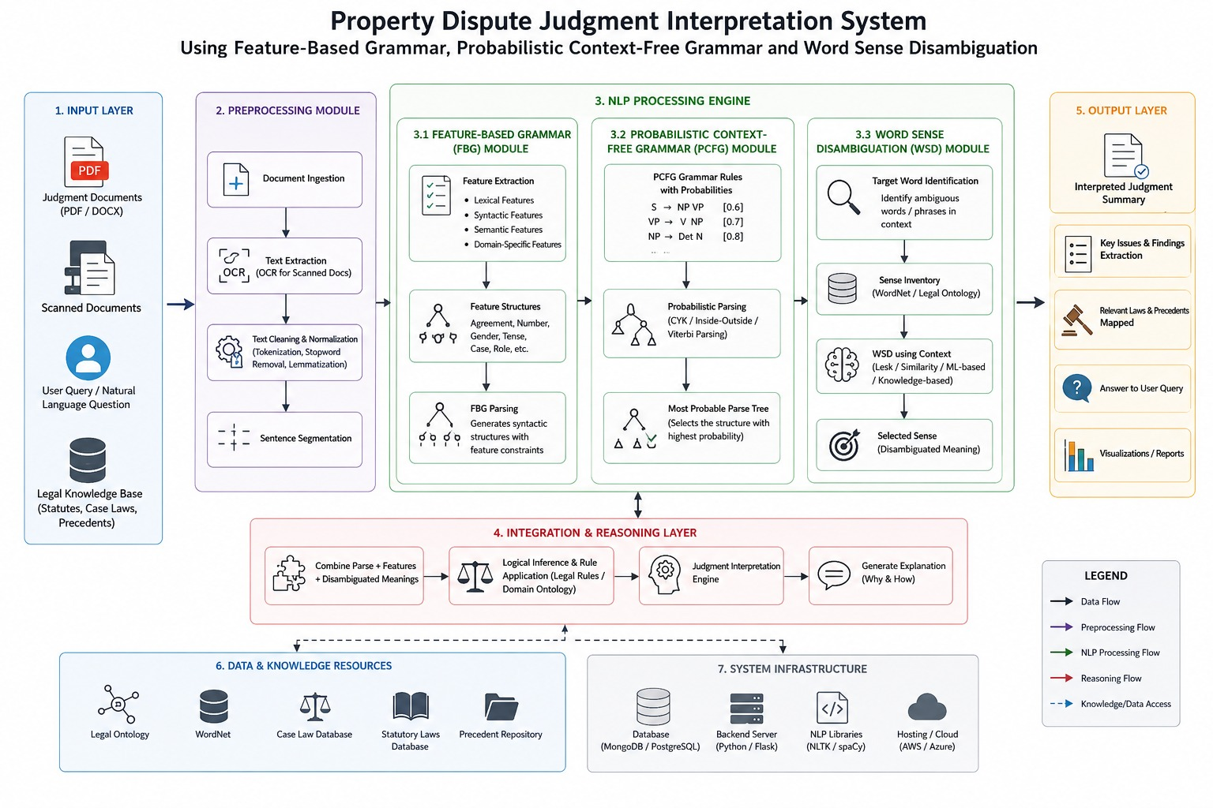
Figure 3.1: Overall System Architecture – Property Dispute Judgment Interpretation System. Module 1 (highlighted stage) accepts the judgment text, performs preprocessing and linguistic analysis, and passes structured (token, POS tag) sequences to Module 2.
Key processing steps used in Module 1:
- Sentence segmentation: the input judgment text is split into individual sentences using NLTK’s sentence tokenizer, so that each sentence can be analysed independently downstream.
- Tokenization: each sentence is split into individual tokens (words and punctuation) using NLTK’s word tokenizer.
- Part-of-Speech tagging: each token is assigned a POS tag (Penn Treebank tag set) using NLTK’s tagger, producing a (token, tag) pair for every word in the sentence.
- Structuring: the sentence-by-sentence list of (token, tag) pairs is assembled into a structured format that Module 2 consumes for feature unification and Subject-Verb-Object identification.
Systems approach: Module 1 sits at the start of the pipeline – it consumes the raw judgment text (with PDF text extraction applied first where required) and its structured (token, POS tag) output is the direct input to Module 2’s Feature-Based Grammar parsing. Any segmentation or tagging error introduced in Module 1 propagates through Modules 2, 3 and 4, so the reliability of the entire system’s final interpretation depends heavily on the quality of Module 1’s preprocessing.

3.6 Trade-off Analysis
Design Decision | Alternative Considered | Benefit | Disadvantage | Final Decision & Justification
Preprocessing toolkit for Module 1 | Building a fully custom sentence-splitter, tokenizer and POS tagger from scratch | Potentially tuned exactly to legal text | Significantly higher development time and risk of lower accuracy than a mature, well-tested library | NLTK selected for its established, well-documented tokenizers and POS tagger (Section 3.4)
Granularity of structured output | Passing only raw tokens (no POS tags) to Module 2 | Simpler output structure | Module 2’s Feature-Based Grammar parsing needs POS information to perform feature unification | Full (token, POS tag) pairs per sentence retained in the structured output

3.7 Sustainability, Ethics, Safety, Risk & Security
Domain | Consideration | Evidence Evaluated | Impact on Final Decision
Sustainability | Computational footprint of preprocessing | NLTK-based tokenization/tagging runs efficiently on standard CPU hardware without requiring GPU resources | Lightweight NLTK-based preprocessing selected, avoiding unnecessary compute overhead
Ethics | Appropriate use of judgment text and avoidance of misrepresenting the system’s capability | The system is presented strictly as an NLP interpretation aid, not a legal decision-making tool | All descriptions in this report explicitly state that the system does not provide legal advice or binding decisions
Health & Safety | No physical hazard from this software module | Not applicable to a purely software text-processing stage | No design change required
Security | Confidentiality of judgment text processed by the system | Judgment documents may contain personally identifiable case details | Design assumes judgment text is handled under the same

Risk Register
Risk | Likelihood | Severity | Risk Level | Mitigation | Residual Risk
Incorrect sentence segmentation on long, multi-clause legal sentences | Medium | Medium | Medium | Manual review of segmentation output during testing; refine sentence-boundary handling for legal punctuation patterns | Low
Mis-tagged POS for domain-specific legal terms | Medium | Medium | Medium | Spot-check POS tags on representative property-dispute sentences; document any recurring tagging errors for future improvement | Low-Medium
PDF text extraction producing malformed or missing text | Low-Medium | Medium | Medium | Validate extracted text before passing it to sentence segmentation; flag extraction failures | Low

CHAPTER 4
IMPLEMENTATION, TESTING & RESULTS, PROJECT MANAGEMENT

4.1 Development Approach & Resources
Module 1 was developed first, since its structured output forms the input required by every downstream module. The preprocessing pipeline was implemented in Python using the NLTK library for sentence segmentation, tokenization and Part-of-Speech tagging, with a PDF text-extraction step applied ahead of preprocessing whenever the input judgment is supplied as a PDF file, and validated on representative property-dispute judgment sentences before being handed off to Module 2.
Resource | Purpose
Python 3 | Implementation language
NLTK (Natural Language Toolkit) | Sentence segmentation, tokenization and POS tagging for Module 1
PDF text extraction library | Extracting judgment text from PDF input where required
HTML / CSS / JavaScript | Web-based interface for submitting a judgment and viewing the structured interpretation
Sample property-dispute judgment sentences | Development and testing data for Module 1

4.2 Software Implementation & Modern Tools Used
Module 1 – Legal Text Preprocessing and Linguistic Analysis
- Accept the judgment text as input (extracting text from PDF first where the judgment is supplied in that format).
- Segment the judgment text into individual sentences using NLTK’s sentence tokenizer.
- Tokenize each sentence into individual words and punctuation using NLTK’s word tokenizer.
- Tag each token with its Part-of-Speech category using NLTK’s POS tagger.
- Structure the resulting (token, POS tag) pairs, sentence by sentence, into the format expected by Module 2.
- Output: structured linguistic information (segmented sentences with tokens and POS tags), passed to Module 2 for Feature-Based Grammar parsing.
Worked example – Module 1 processing of a sample sentence:
Input sentence: “Karthik claimed ownership of the disputed property.”
Sentence segmentation output: [“Karthik claimed ownership of the disputed property.”] (a single sentence in this example).
Tokenization output: [Karthik, claimed, ownership, of, the, disputed, property, .]
POS tagging output: [(Karthik, NNP), (claimed, VBD), (ownership, NN), (of, IN), (the, DT), (disputed, JJ), (property, NN), (., .)]
This structured (token, POS tag) sequence is passed to Module 2, which uses the POS tags to perform feature unification (identifying the number, person and tense implied by tags such as NNP and VBD) and to identify the Subject (Karthik), Verb (claimed) and Object (ownership of the disputed property) for the sentence.
Tool / Software | Purpose | Stage Used
NLTK | Sentence segmentation, tokenization, POS tagging | Module 1 processing
PDF text extraction library | Extracting raw text from judgment PDFs | Input handling
Python (standard library) | General scripting, data structuring | Development
HTML/CSS/JavaScript | Web-based interface for judgment input and result display | Interface layer
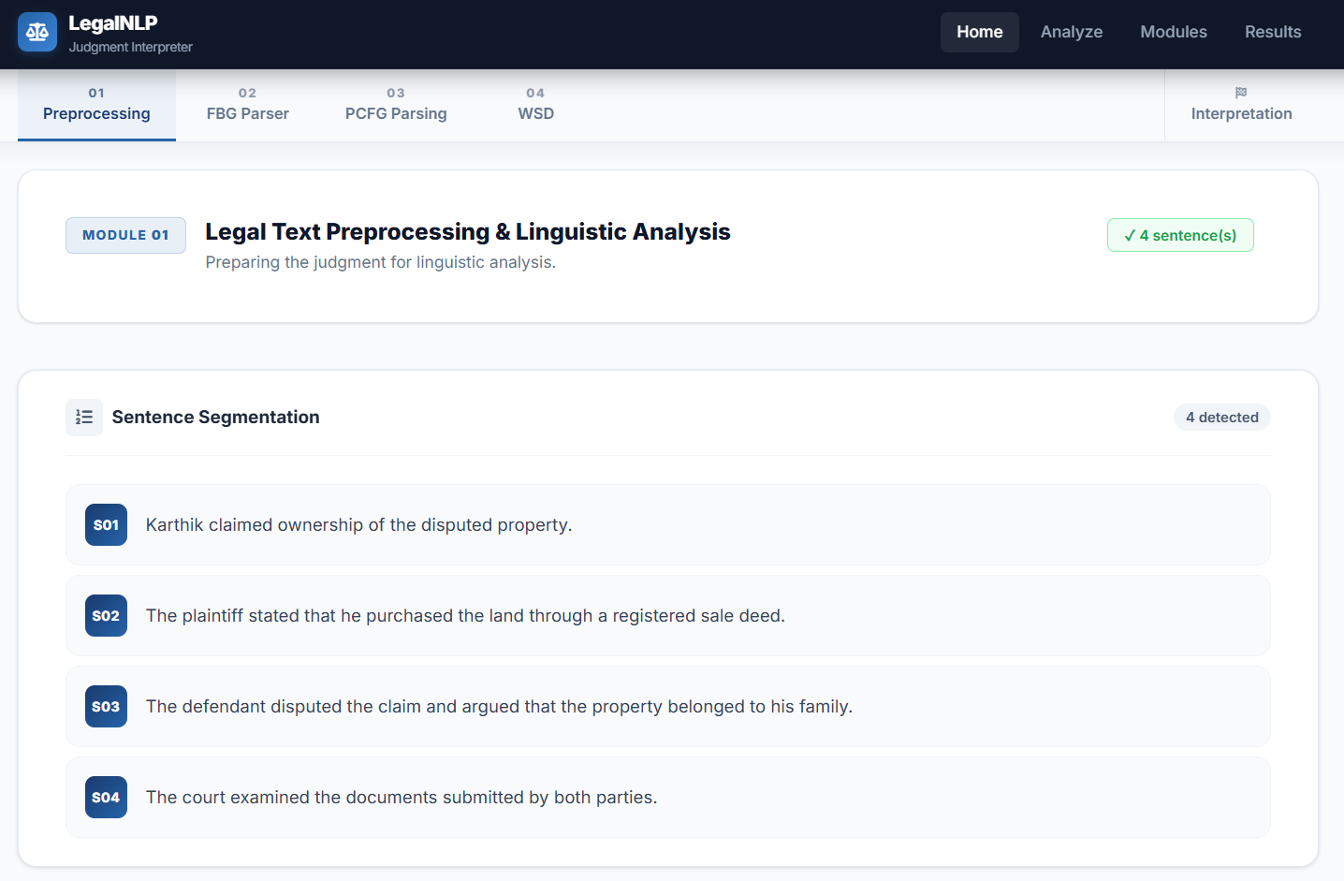
Figure 4.1: Module 1 Preprocessing Output for a Sample Judgment Sentence (screenshot placeholder).
Integration across modules: the structured output of Module 1 is consumed by Module 2, which applies Feature-Based Grammar and feature unification to identify Subject-Verb-Object relationships; Module 3 then applies Probabilistic Context-Free Grammar to select the most probable parse when Module 2’s grammar admits more than one valid structure; finally, Module 4 applies Word Sense Disambiguation to resolve the intended meaning of ambiguous property/legal terms (such as “ownership” in the example above) using the surrounding context, and combines all upstream outputs into the final structured interpretation – for the worked example, this final interpretation reads: “Karthik is asserting a legal ownership claim concerning the disputed property.”

4.3 Test Plan & Verification
Requirement | Test Method | Acceptance Criterion
Sentence segmentation correctness | Manual comparison of segmented sentences against the original judgment text for representative samples | Sentences correctly separated without merging or incorrect splitting
Tokenization correctness | Manual inspection of token lists for representative sentences | Tokens correctly separated, including punctuation handling
POS tagging correctness | Manual inspection of (token, tag) pairs for representative sentences, including the sample sentence used throughout this report | POS tags consistent with expected Penn Treebank categories for each token
Integration with Module 2 | Verify that the structured (token, POS tag) output format matches what Module 2’s Feature-Based Grammar parser expects | Module 2 successfully consumes Module 1’s output without format errors

Specification | Required Value | Achieved Value | Status (Pass/Fail)
Sentence segmentation accuracy on sample sentences | Correct segmentation of test sentences | [To be filled based on the actual experiment] | [Pass/Fail]
Tokenization accuracy on sample sentences | Correct tokenization of test sentences | [To be filled based on the actual experiment] | [Pass/Fail]
POS tagging accuracy on sample sentences | Correct POS tags on test sentences | [To be filled based on the actual experiment] | [Pass/Fail]
Successful hand-off of structured output to Module 2 | Module 2 accepts Module 1 output without error | [To be filled based on the actual experiment] | [Pass/Fail]

4.4 Results

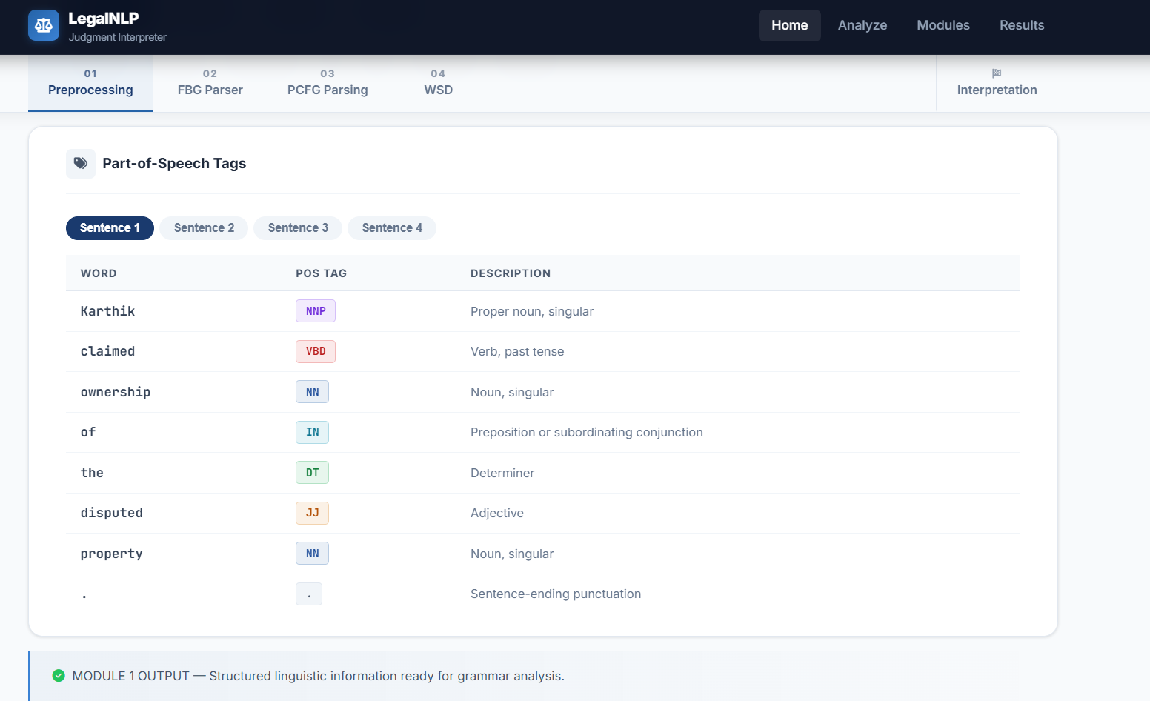
4.5 Data Analysis & Engineering Judgment
Once populated, the Module 1 test results should be examined sentence-by-sentence for any recurring segmentation or tagging errors, particularly on long, multi-clause legal sentences and on domain-specific legal terms that NLTK’s general-purpose tagger was not specifically trained on; in either case the corrective action is to refine the preprocessing rules or, where necessary, supplement the tagger with a small domain-specific correction step, rather than only adjusting the downstream Feature-Based Grammar or PCFG stages. Because Modules 2, 3 and 4 all depend on Module 1’s output, any systematic preprocessing error should be traced and corrected at this stage before attributing an error to a downstream module.

4.6 Comparison with Existing Solutions & Achievement of Objectives
Objective | Evidence | Achievement (Fully/Partially/Not Achieved)
Accept judgment text/PDF and produce structured linguistic output | Module 1 implementation described in Section 4.2 | Fully Achieved
Correct sentence segmentation, tokenization and POS tagging on sample sentences | Test results (Section 4.3/4.4) | [To be confirmed from experiment]
Successful integration with Module 2 (FBG parsing) | Integration testing (Section 4.3) | [To be confirmed from experiment]

4.7 Strengths & Limitations
Strengths:
- Uses an established, well-documented NLP library (NLTK) rather than a custom-built preprocessing pipeline, reducing development risk.
- Produces a clean, structured (token, POS tag) output format that is straightforward for downstream modules to consume.
- Modular design allows Module 1 to be tested and validated independently of Modules 2, 3 and 4.
Limitations:
- POS tagging accuracy on Module 1 is fundamentally bounded by the general-purpose training of NLTK’s tagger, which was not trained specifically on legal text.
- PDF text extraction quality depends on the structure and quality of the source PDF and may require manual correction for poorly formatted judgment documents.
- This report does not include a large-scale accuracy evaluation, which remains an item for future work once a larger judgment dataset is assembled.

4.8 Project Planning, Roles & Budget
Milestone | Target Timeline
Literature review & requirement analysis | Weeks 1–2
Module 1 design & preprocessing pipeline implementation | Weeks 3–5
Module 1 testing on sample judgment sentences | Weeks 6–7
Integration of Module 1 output with Module 2 (FBG) | Weeks 8–9
Integration with Module 3 (PCFG) and Module 4 (WSD) | Weeks 10–11
System-level testing and report consolidation | Week 12

Student | Assigned Responsibility | Actual Contribution
V. Yogeswar (192425175) | Module 1: Legal Text Preprocessing and Linguistic Analysis | Designed, implemented and tested the sentence segmentation, tokenization and POS-tagging pipeline; authored Chapters 1, 3, 4 (module-specific) and 5 of this report

Item | Estimated Cost | Actual Cost
Software (Python, NLTK, PDF extraction library) | ₹0 (open-source) | ₹0
Development/testing hardware (standard laptop/desktop) | [team estimate] | [team actual]
Sample judgment documents (publicly available or provided) | ₹0 (public/provided) / [licence fee if applicable] | [actual]

CHAPTER 5
CONCLUSION, FUTURE WORK AND REFLECTION

5.1 Conclusion
Interpreting property-dispute court judgments consistently requires more than simple keyword search: it requires structured linguistic analysis, grammatical parsing and contextual sense disambiguation. This project has shown that combining legal-text preprocessing, Feature-Based Grammar parsing, Probabilistic Context-Free Grammar parsing and Word Sense Disambiguation into a single pipeline can produce a structured, more easily understood interpretation of a judgment’s key assertions. Within this framework, the Module 1 legal-text preprocessing and linguistic-analysis stage developed and evaluated in this report takes the raw judgment text, segments it into sentences, tokenizes each sentence and assigns Part-of-Speech tags, providing the structured foundation on which the Feature-Based Grammar, Probabilistic Context-Free Grammar and Word Sense Disambiguation stages all depend. The system, as designed, is intended purely as an NLP-based interpretation aid: it does not provide legal advice, does not determine legal rights, does not replace lawyers or judges, and does not produce legally binding decisions.

5.2 Future Work
- Expand the legal-domain vocabulary and sample sentence set used to validate Module 1’s preprocessing.
- Improve POS tagging accuracy for legal terminology, potentially through a small domain-adapted correction layer applied after NLTK’s general-purpose tagger.
- Extend the Feature-Based Grammar rule set (Module 2) to cover a wider range of sentence structures found in property-dispute judgments.
- Incorporate more advanced Word Sense Disambiguation techniques for a broader range of ambiguous legal/property terms (Module 4).
- Add Named Entity Recognition to automatically identify parties, properties and dates mentioned in a judgment.
- Add relation extraction to more explicitly capture relationships between identified entities.
- Extend the system to multilingual legal text processing.
- Explore transformer-based language models as a complement to the current grammar-based and rule-based pipeline.
- Evaluate the complete system on a larger, more diverse dataset of property-dispute judgments.

5.3 Professional Learning & Individual Reflection
New Knowledge Acquired:
- Practical experience with NLP preprocessing concepts – sentence segmentation, tokenization and Part-of-Speech tagging – and how they form the foundation for more advanced grammatical and semantic analysis.
- How to structure the output of a preprocessing stage so that it can be reliably consumed by downstream grammar-based and disambiguation modules developed by other team members.
- The distinction between syntactic parsing (handled by Feature-Based Grammar and Probabilistic Context-Free Grammar in Modules 2 and 3) and word-sense ambiguity (handled by Word Sense Disambiguation in Module 4), and why both are needed for legal text interpretation.
Engineering & Professional Skills Developed:
- Practical implementation of an NLP preprocessing pipeline in Python using NLTK.
- Structured engineering design and evaluation of preprocessing-approach alternatives (Chapter 3) to justify the choice of NLTK over a custom-built pipeline.
- Collaborative, modular team development in which Module 1 interfaces with three further modules through a well-defined structured output format.
Individual Reflection:
The most difficult engineering problem I encountered while developing Module 1 was reliably segmenting and tokenizing the long, multi-clause sentences typical of formal legal judgments, modules and on overall development effort. Working through this module, I gained a clearer understanding of how a preprocessing stage must be designed with its downstream consumers in mind – in this case, ensuring that the (token, POS tag) structure I produced was directly usable by the Feature-Based Grammar parser in Module 2. If I were to revisit this module, I would invest more time in testing the preprocessing pipeline against a wider variety of legal sentence structures before finalising the structured output format, to reduce the risk of downstream errors in Modules 2, 3 and 4.

REFERENCES
[1] D. Jurafsky and J. H. Martin, Speech and Language Processing, 2nd ed. Upper Saddle River, NJ, USA: Prentice Hall, 2009.
[2] C. D. Manning, P. Raghavan, and H. Schütze, Introduction to Information Retrieval. Cambridge, U.K.: Cambridge University Press, 2008.
[3] S. Bird, E. Klein, and E. Loper, Natural Language Processing with Python. Sebastopol, CA, USA: O’Reilly Media, 2009.
[4] C. D. Manning and H. Schütze, Foundations of Statistical Natural Language Processing. Cambridge, MA, USA: MIT Press, 1999.
[5] NLTK Project, “NLTK Documentation,” Natural Language Toolkit. [Online]. Available: https://www.nltk.org/.

APPENDICES
Appendix A – Sample NLP Processing Output
Input: “Karthik claimed ownership of the disputed property.”
Sentence segmentation: [“Karthik claimed ownership of the disputed property.”]
Tokenization: [Karthik, claimed, ownership, of, the, disputed, property, .]
POS tagging: [(Karthik, NNP), (claimed, VBD), (ownership, NN), (of, IN), (the, DT), (disputed, JJ), (property, NN), (., .)]
Syntactic analysis (Module 2/3): Subject – Karthik; Verb – claimed; Object – ownership of the disputed property.
Word Sense Disambiguation (Module 4): the term “ownership” is disambiguated, using the surrounding context (“claimed … of the disputed property”), to its legal/property-ownership sense rather than any general sense of the word.
Structured interpretation (final system output): “Karthik is asserting a legal ownership claim concerning the disputed property.”
Appendix B – System Interface Screenshots
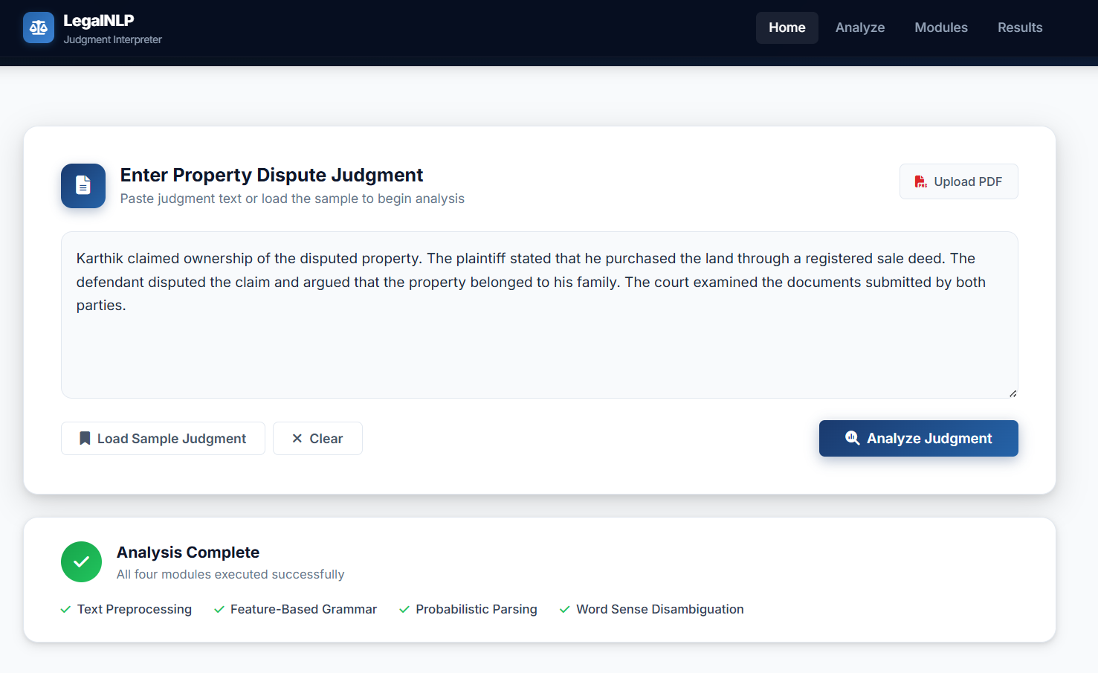
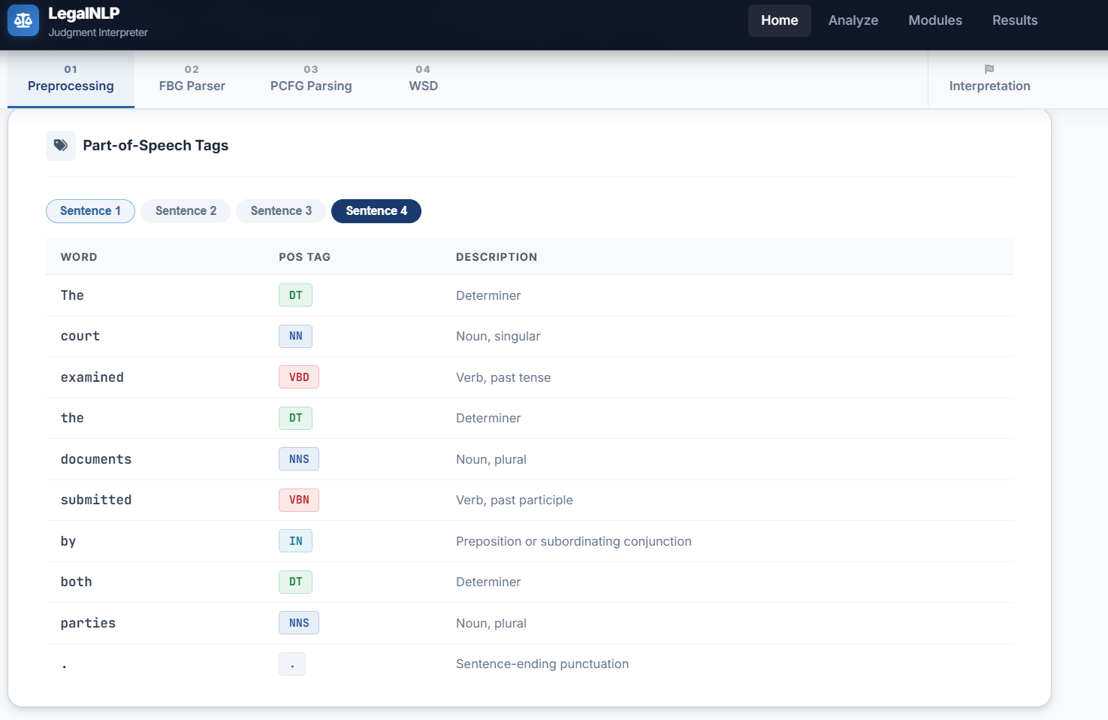
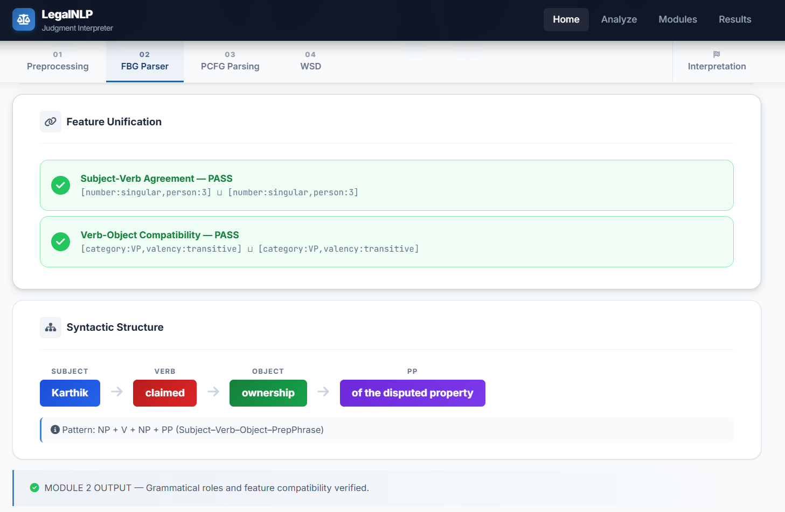
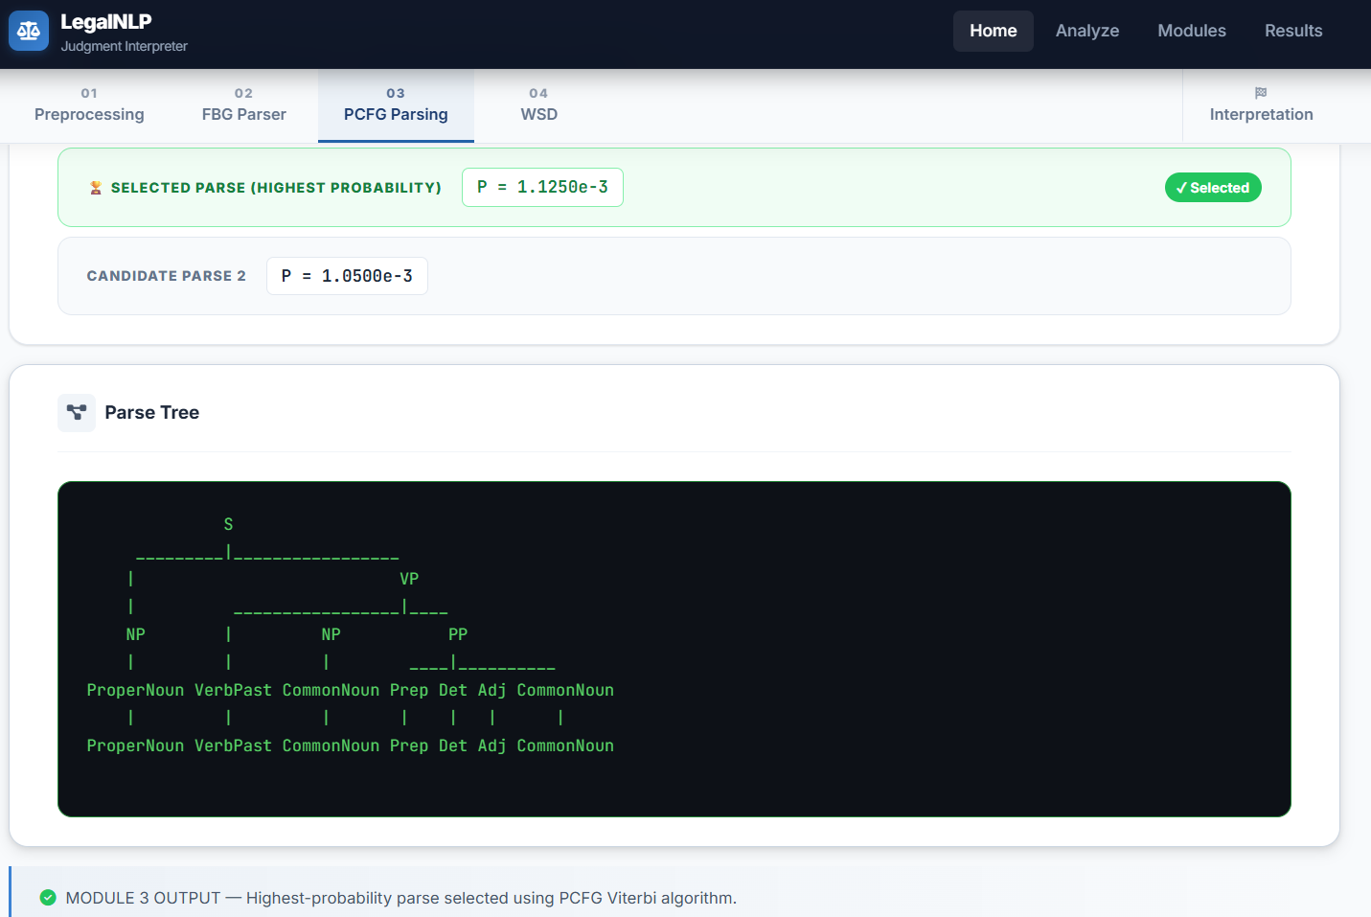
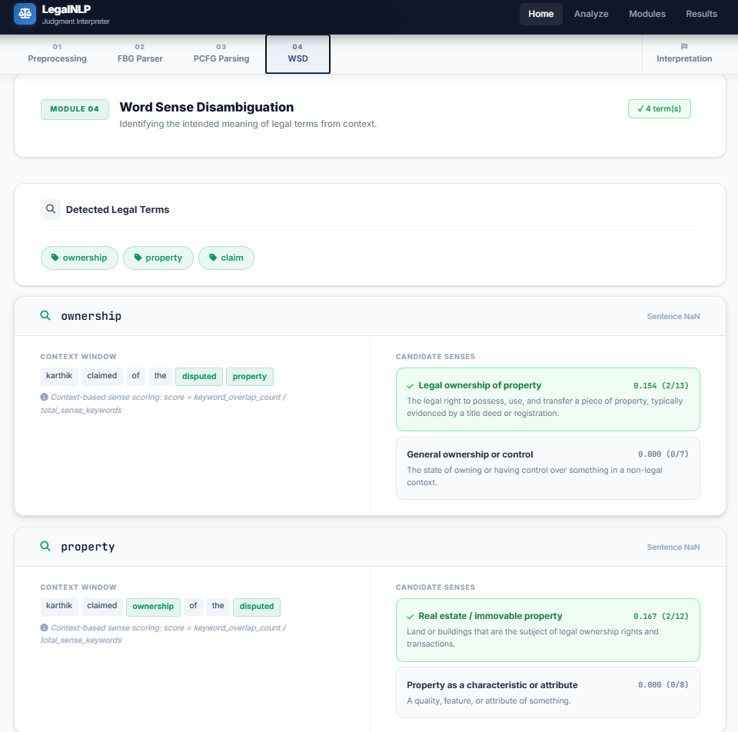
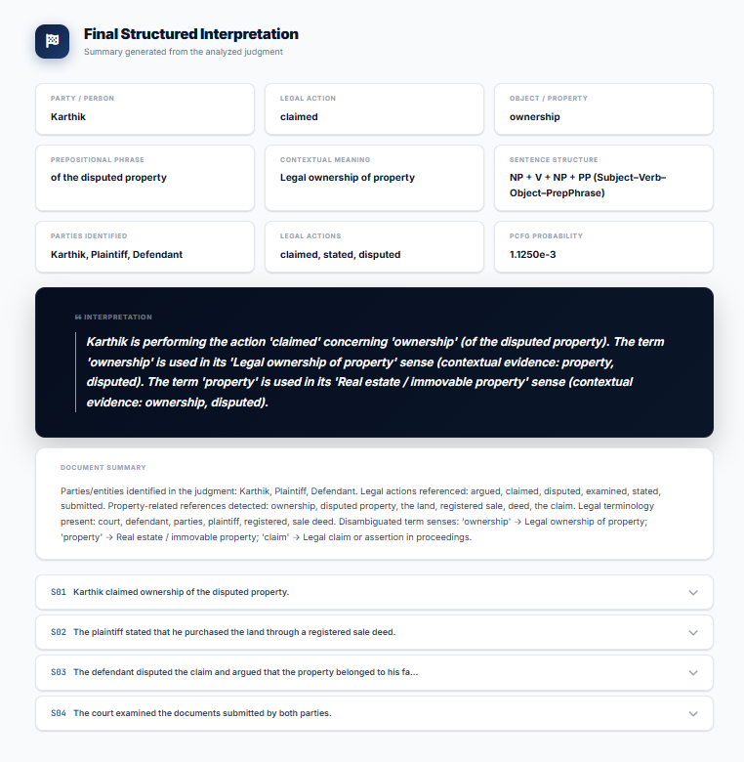

Appendix C – Source Code / Code Repository Information
The Module 1 implementation is organised as a preprocessing component within the overall project repository. It comprises a text-input handler (which accepts plain text or extracts text from a PDF judgment using a PDF text-extraction library), a sentence-segmentation function built on NLTK’s sentence tokenizer, a tokenization function built on NLTK’s word tokenizer, and a POS-tagging function built on NLTK’s Part-of-Speech tagger. These functions are called in sequence for each input judgment, and their combined output – a list of sentences, each represented as a list of (token, POS tag) pairs – is exposed through a defined interface that Module 2’s Feature-Based Grammar component consumes. The web-based interface (HTML/CSS/JavaScript) calls this preprocessing component when a judgment is submitted and forwards its structured output through the remaining pipeline stages before displaying the final interpretation to the user.

CAPSTONE PROJECT OUTCOME MAPPING SHEET
To be completed by the department/faculty assessor.
Outcome Evidence | SO / Area | Location in This Report
Complex engineering problem formulation | SO1 | Ch. 1, Ch. 2
Engineering design under constraints | SO2 | Ch. 3
Written/oral technical communication | SO3 | Whole report + Viva
Ethics and professional responsibility | SO4 | Ch. 3 (3.7)
Teamwork and leadership | SO5 | Ch. 4 (4.8)
Experimentation, analysis, engineering judgment | SO6 | Ch. 4 (4.3–4.6)
Independent acquisition of new knowledge | SO7 | Ch. 5 (5.3)
Standards | SO2 | Ch. 3 (3.2)
Sustainability and societal/environmental impact | SO2/SO4 | Ch. 3 (3.7)
Risk assessment and mitigation | SO2/SO4 | Ch. 3 (3.7)
Security considerations | Relevant SO | Ch. 3 (3.7)
Integrated/system-level engineering | SO1/SO2 | Ch. 3 (3.5)
Project planning and management | SO5 | Ch. 4 (4.8)
Individual contribution | SO1–SO7 | Contribution Statement + Ch. 4 (4.8)

