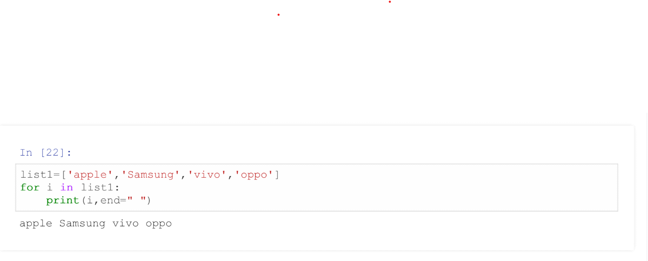 **1.Create a python module with list and import the module in another .py file and change the value in list**

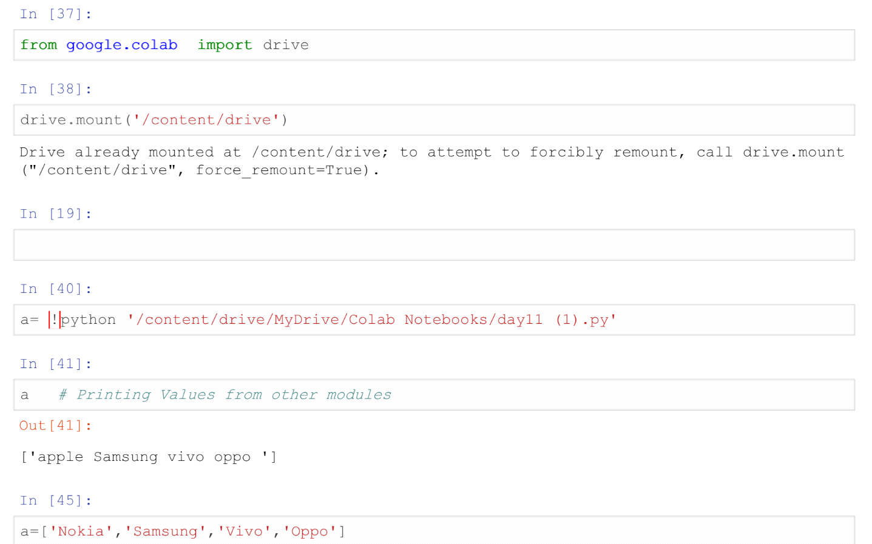

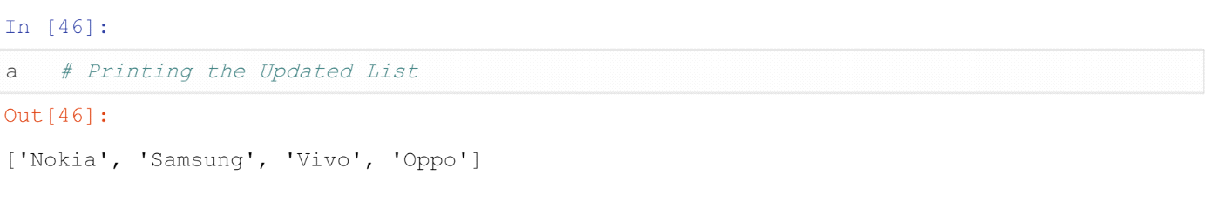

**2.Install pandas package**



**3.Import a module that picks random number and write a program to fetch a random number from 1 to 100 on every run**

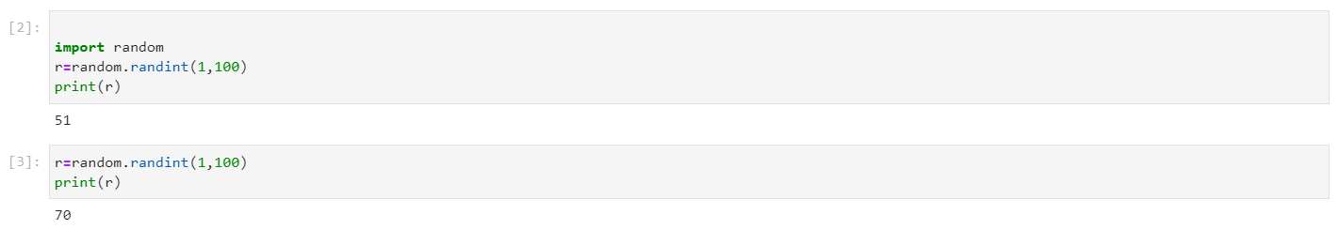

**4.Import sys package and find the python path**

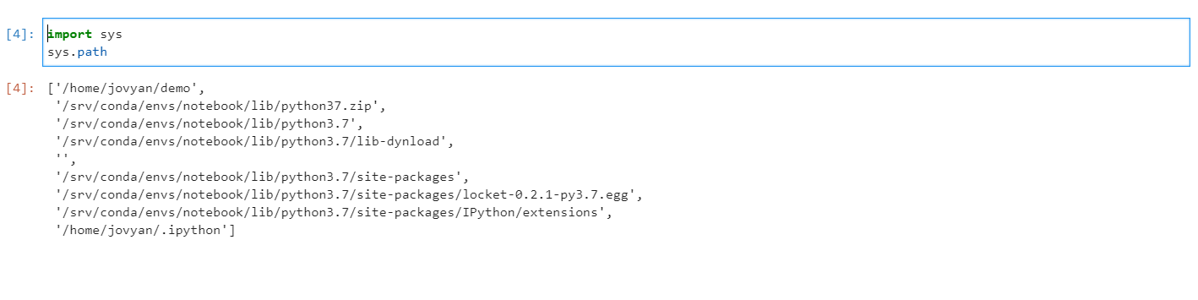

**5.Try to install a package and uninstall a package using pip**

