**EX.NO:2B**

**XML , XSLT AND XQUERY**

**DATE: 12/01/2024**

**AIM:**

To explore xml,xslt and xquery to design web pages and also retrieve essential data from the pages.

**STEPS:**

* Create a simple XML file with tags and values
* Create a XSLT file that gets the data from the XML file.
* Link the XML file with the XSLT file <?xml-stylesheet> tag.
* Run the XML file using a browser that can support XML transformation.

**TOOLS USED**: Oxygen XML Editor, Firefox Browser

1. **Create a Christmas party menu card and reservation form as shown below using XSLT.**

**CODE: (XML)**

|  |
| --- |
| <?xml version="1.0" encoding="UTF-8"?>  <?xml-stylesheet type="text/xsl" href="test.xsl"?>  <event>  <title>CHRISTMAS PARTY MENU</title>  <courses>  <course>  <name>3 courses 25$ per person</name>  </course>  <course>  <name>2 courses 22$ per person</name>  </course>  </courses>  <special>  <name>Thai Style Prawn Cocktail</name>  <line>Little gem,mint,lemon grass and corriander leaf,Sriracha mayo</line>  </special>  <special>  <name>Vine Tomato and Roast Red Pepper Soup</name>  <line>Rustic bread,parmesan crisp</line>  </special>  <special>  <name>Confit Duck Rilletties</name>  <line>toast, spiced orange</line>  </special>  <special>  <name>Caesar Salad Croquettes</name>  <line>chicken croquetties, romaine lettuce, parmesan, caesar dressing</line>  </special>  <special>  <name>Tofu Nori Rolls</name>  <line>Quinoa, avocado, pickled ginger, soy and wasabi dip</line>  </special>  <special>  <name>Traditional Christmas Dinner</name>  <line>Roast turkey,pigs in blankets,stuffing, roast root vegetables, roast potatoes, vegetarian gravy, craberry jelly</line>  </special>  <special>  <name>Vegetarian Christmas Dinner (V)</name>  <line>Red lentil loaf, stuffing, roast root vegetables, steamed vegetables, roast potatoes, gravy , cranberry jelly</line>  </special>  <special>  <name>Slow Cooked Ox Cheeks and Creamed Potatoes</name>  <line>Sautled wild mushrooms, silverskin onions, pancetta, red wine sauce</line>  </special>  <special>  <name>Seafood Singapore Laksa</name>  <line>Seabass, mussels, tiger prawns in spicy coconut broth with noodles beansprouts, sambal and crispy onions</line>  </special>  <special>  <name>Vegan Massaman Curry (Vg,Gf)</name>  <line>Tofu, sweet potato, pineapple, shallots, Massaman sauce, toasted</line>  </special>  </event> |

**CODE: (XSLT)**

|  |
| --- |
| <?xml version="1.0" encoding="UTF-8"?>  **<xsl:stylesheet**  xmlns:xsl="http://www.w3.org/1999/XSL/Transform"  xmlns:xs="http://www.w3.org/2001/XMLSchema"  exclude-result-prefixes="xs"  version="2.0">  **<xsl:template** match="/">  <html>  <head>  <style>  div  {  margin: auto;  width: 50%;  }  .id1  {  padding:30px;  }  .id2  {  border-style:solid  }  body {  background-image: url('C:\\Users\\Yogha\\Downloads\\christmas.jpg');  background-repeat: no-repeat;  background-size: 100% 100%;  }  </style>  </head>  <body>  <div>  <h1>  **<xsl:value-of** select="form/title">**</xsl:value-of>**  </h1>  <div style="border-style:solid;padding-top: 50px;  padding-right: 30px;  padding-bottom: 50px;  padding-left: 80px;">  **<xsl:for-each** select="form/for/t1">  **<xsl:value-of** select="name"/>  <input type="text"/>  <br>  <br></br>  </br>  **</xsl:for-each>**  **<xsl:for-each** select="form/for/t2">  **<xsl:value-of** select="name"/>  <input type="checkbox"/>  <br>  <br></br>  </br>  **</xsl:for-each>**  </div>  <br>  <br>  <br></br>  </br>  </br>  <div style="border-style:solid;padding-top: 50px;  padding-right: 30px;  padding-bottom: 50px;  padding-left: 80px;">  **<xsl:for-each** select="form/for1/t1">  **<xsl:value-of** select="name"/>  <input type="checkbox"/>  <br>  <br></br>  </br>  **</xsl:for-each>**  </div>  </div>  </body>  </html>  **</xsl:template>**  **</xsl:stylesheet>** |

**OUTPUT:**

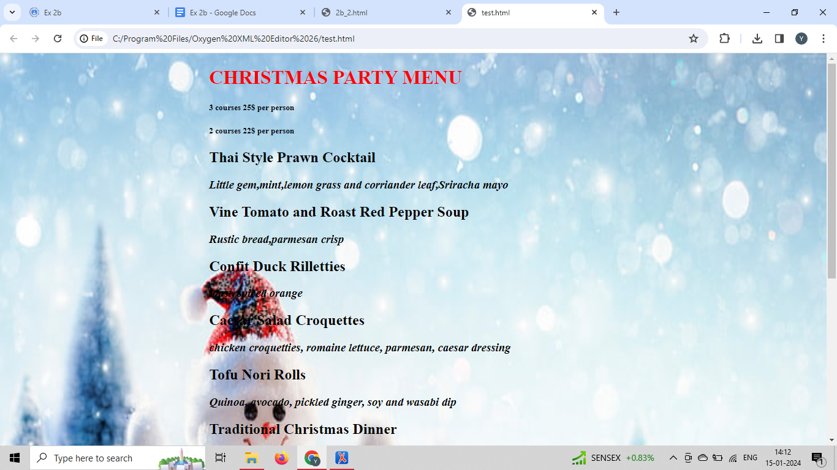

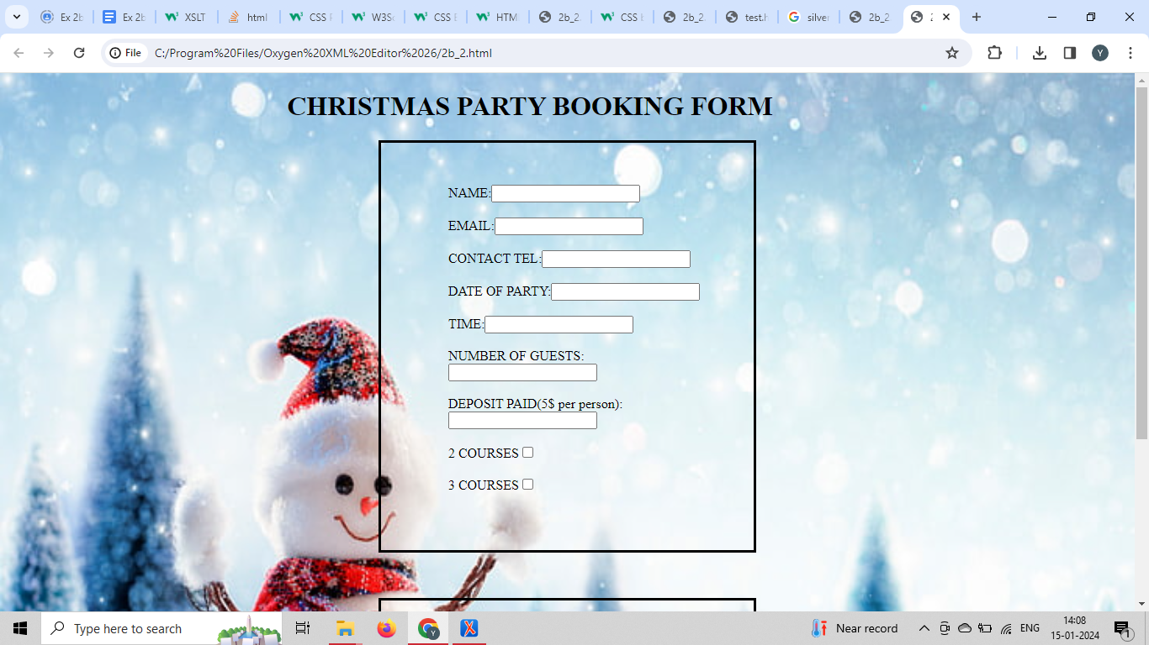

**RESULT :** Thus XML,XSLT was used to create web pages.