**EX.NO:5B**

**DATE: 15/09/2023**

**AIM:**

To perform KMedoids clustering in python and also perform visualization.

**1.Load a dataset and print its shape.**

**PYTHON CODE:**

|  |
| --- |
| **import** **pandas** **as** **pd** **import** **matplotlib.pyplot** **as** **plt** **from** **sklearn.preprocessing** **import** LabelEncoder l1=LabelEncoder() df=pd.read_csv('/content/final_test.csv') df=df[:**100**] cols=df.columns for col **in** cols:  df[col].fillna(**0**,inplace=True) print(df.shape) |

**OUTPUT:**

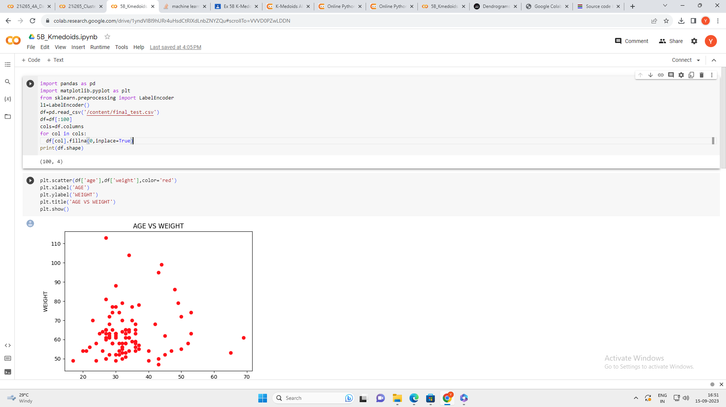

**2. Visualize the data and make inference.**

**PYTHON CODE:**

|  |
| --- |
| plt.scatter(df['age'],df['weight'],color='red') plt.xlabel('AGE') plt.ylabel('WEIGHT') plt.title('AGE VS WEIGHT') plt.show() |

**OUTPUT:**

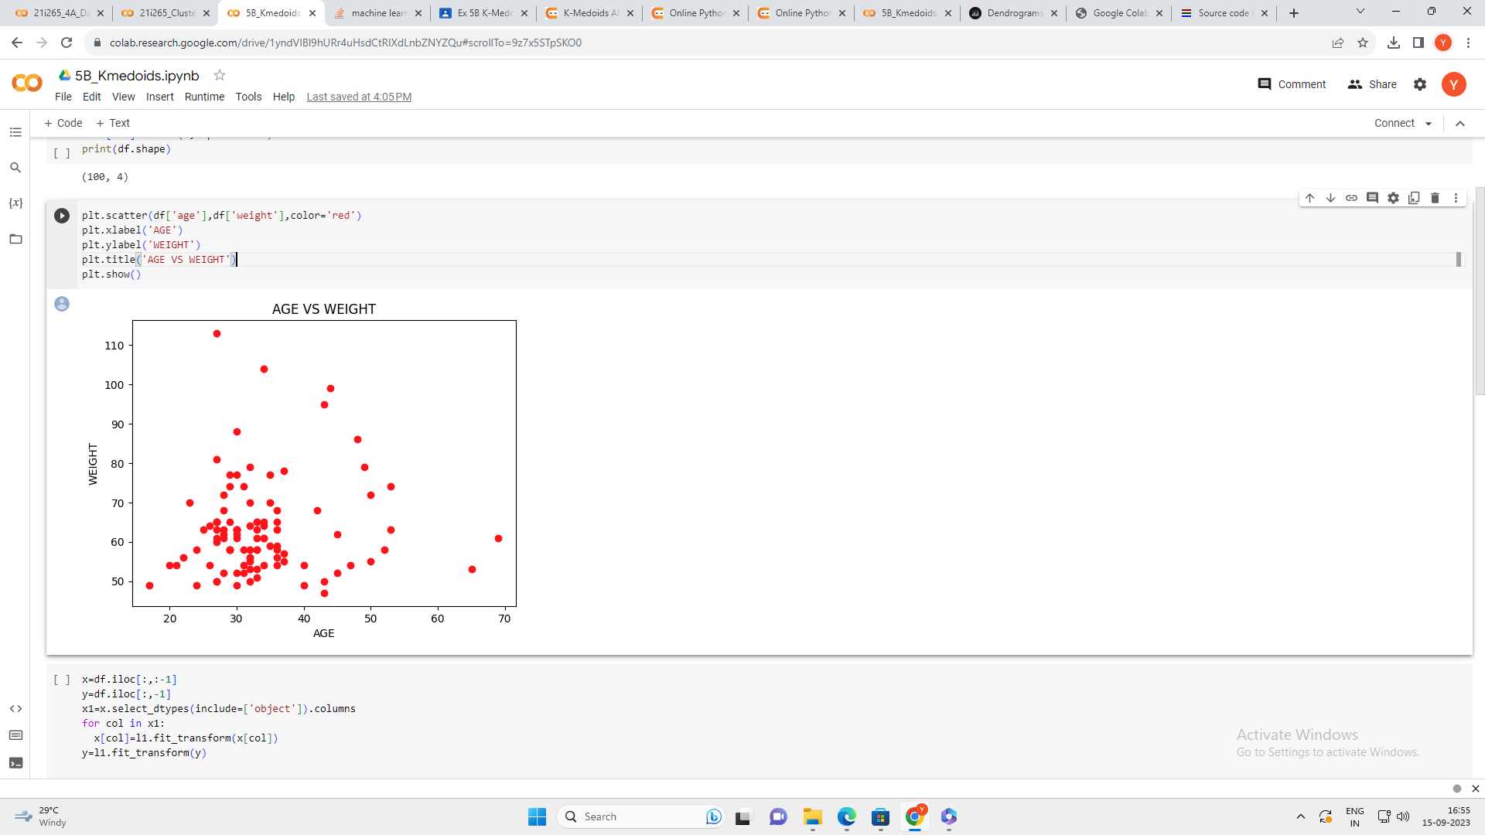

**3.Preprocessing**