**EX.NO:6**

**PHP**

**DATE:18/02/2024**

**AIM:**

To explore php and implement web pages using PHP.

**1.Create a PHP script for designing a calculator application**

**CODE:**

|  |
| --- |
| <?php  // Check if the form has been submitted  **if** (isset($_POST['submit'])) {  // Get the values from the form  $num1 = $_POST['num1'];  $num2 = $_POST['num2'];  $operator = $_POST['operator'];  // Check which operator was chosen and perform the corresponding calculation  **if** ($operator == 'add') {  $result = $num1 + $num2;  } **elseif** ($operator == 'subtract') {  $result = $num1 - $num2;  } **elseif** ($operator == 'multiply') {  $result = $num1 * $num2;  } **elseif** ($operator == 'divide') {  $result = $num1 / $num2;  }  } ?>  <form action="ex_6_1.php" method="post">  <input type="text" name="num1">  <select name="operator">  <option value="add">+</option>  <option value="subtract">-</option>  <option value="multiply">*</option>  <option value="divide">/</option>  </select>  <input type="text" name="num2">  <input type="submit" name="submit" value="Calculate">  </form>  <?php // If the form has been submitted, display the result  **if** (isset($result)) {  **echo** "Result: $result";  }  ?> |

**OUTPUT:**

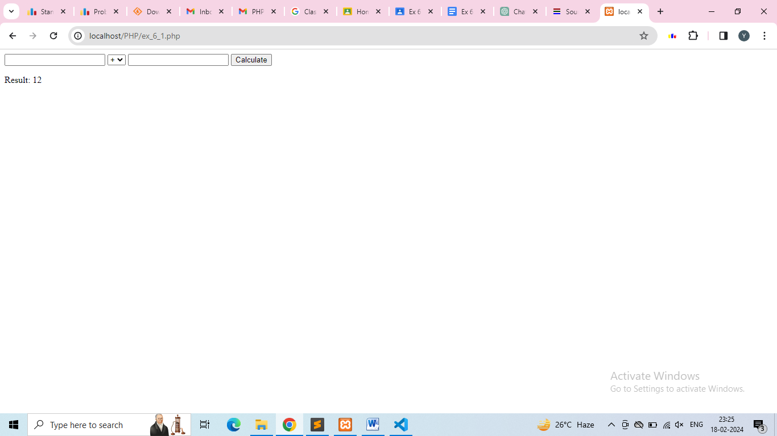

2.**Create a PHP script with function, using include()**

**CODE:**

|  |
| --- |
| <?php **include** 'C:\\xampp\\htdocs\\test_php\\ex_6_2_in.php';  **echo** "I am $x and I am from $y";  ?> |

**CODE: (include )**

|  |
| --- |
| <?php  $x='Yogharaj';  $y='Salem';  ?> |

**OUTPUT:**

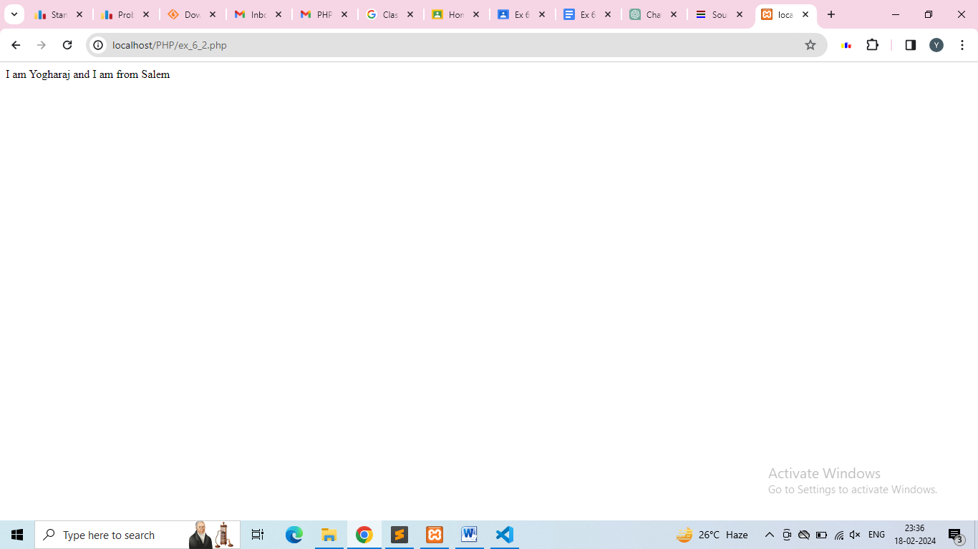

**3.Create a web page using PHP, validate all the fields**

**CODE:**

|  |
| --- |
| <?php  **if**(isset($_GET['submit']))  {  $x=$_GET['Name'];  $y=$_GET['Age'];  **if**(strlen($x)==**0** **or** strlen($y)==**0**)  {  **echo** "All fields are required";  }  }  ?>  <form action="ex_6_3.php" method="get">  <input type="text" name="Name">  <input type="text" name="Age">  <input type="submit" name="submit" value="Calculate">  </form> |

**OUTPUT:**

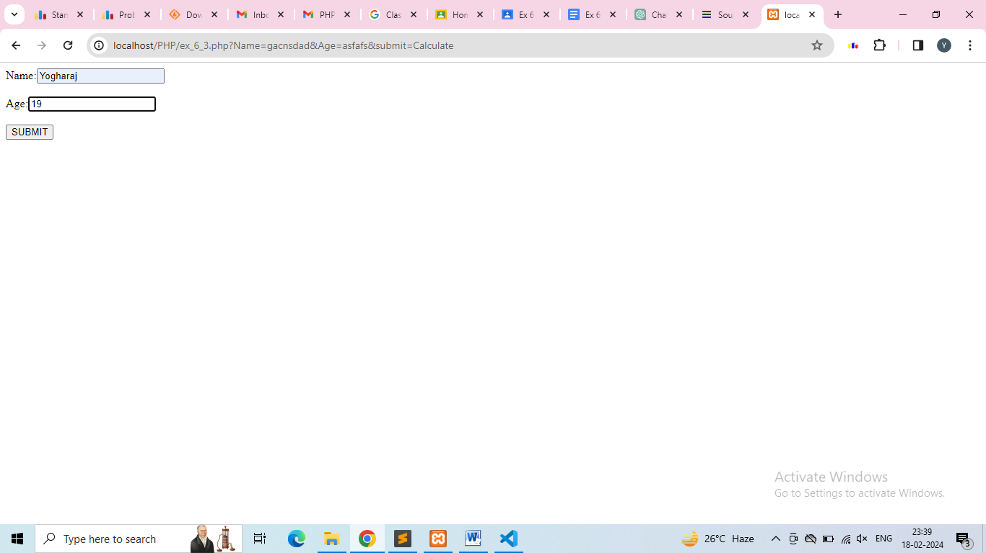

**4.Demonstrate superglobals**

**CODE:**

|  |
| --- |
| <?php  **if**(isset($_GET['name'])) {  $name = $_GET['name'];  **echo** "Hello, $name! <br>";  }  **echo** "The filename of the currently executing script: " . $_SERVER['PHP_SELF'] . "<br>";  **echo** "The IP address of the client: " . $_SERVER['REMOTE_ADDR'] . "<br>";  ?> |

**OUTPUT:**

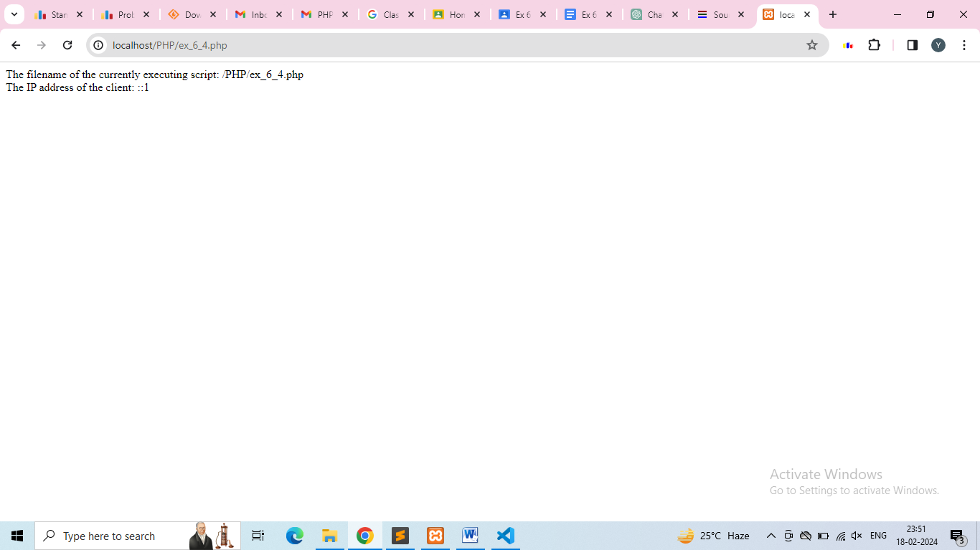

**5.Sort arrays**

**CODE:**

|  |
| --- |
| <?php  $numbers = **array**(**4**, **2**, **8**, **6**, **3**);  sort($numbers);  print_r($numbers);  ?> |

**OUTPUT:**

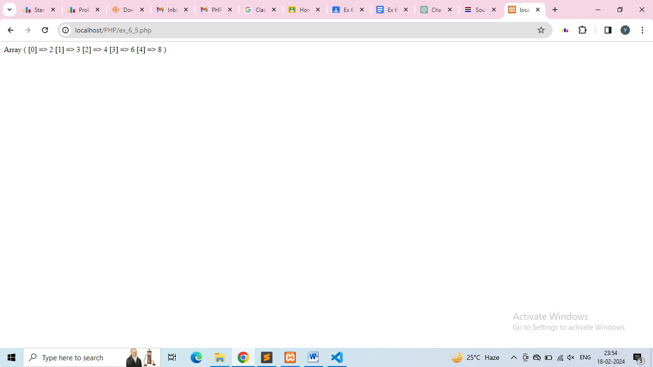

**6.Demonstrate explode and implode**

**CODE:**

|  |
| --- |
| <?php  $string = "apple,banana,orange";  $array = explode(",", $string);  print_r($array);  $array = **array**("apple", "banana", "orange");  $string = implode(",", $array);  **echo** $string;  ?> |

**OUTPUT:**

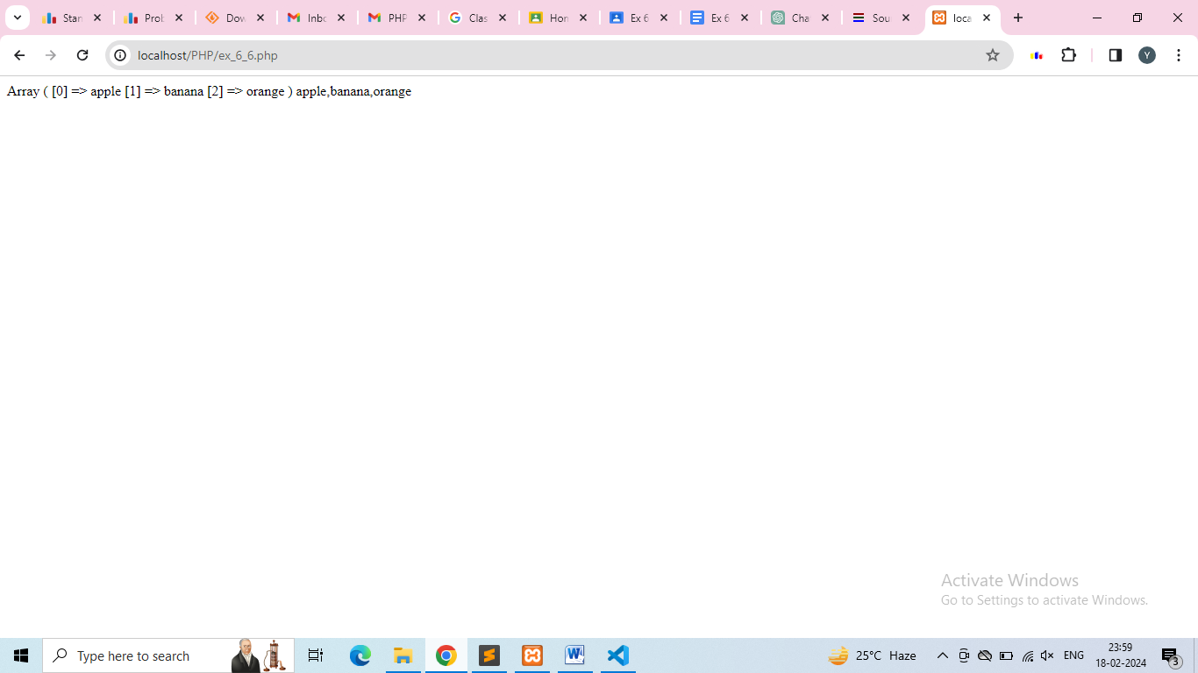

**7.Demonstrate 10 array functions**

**CODE:**

|  |
| --- |
| <?php  $fruits = **array**("apple", "banana");  array_push($fruits, "orange", "grape");  print_r($fruits);  $lastFruit = array_pop($fruits);  **echo** "Removed fruit: $lastFruit <br>";  $firstFruit = array_shift($fruits);  **echo** "Removed fruit: $firstFruit <br>";  array_unshift($fruits, "pear", "kiwi");  print_r($fruits);  $moreFruits = **array**("pineapple", "strawberry");  $allFruits = array_merge($fruits, $moreFruits);  print_r($allFruits);  $slicedFruits = array_slice($allFruits, **2**, **3**);  print_r($slicedFruits);  $keyExists = array_key_exists(**1**, $allFruits);  **echo** "Key 1 exists in array: " . ($keyExists ? 'Yes' : 'No') . "<br>";  $key = array_search("banana", $allFruits);  **echo** "Key for 'banana': $key <br>";  $reversedFruits = array_reverse($allFruits);  print_r($reversedFruits);  $duplicateFruits = **array**("apple", "banana", "orange", "banana", "apple");  $uniqueFruits = array_unique($duplicateFruits);  print_r($uniqueFruits);  ?> |

**OUTPUT:**

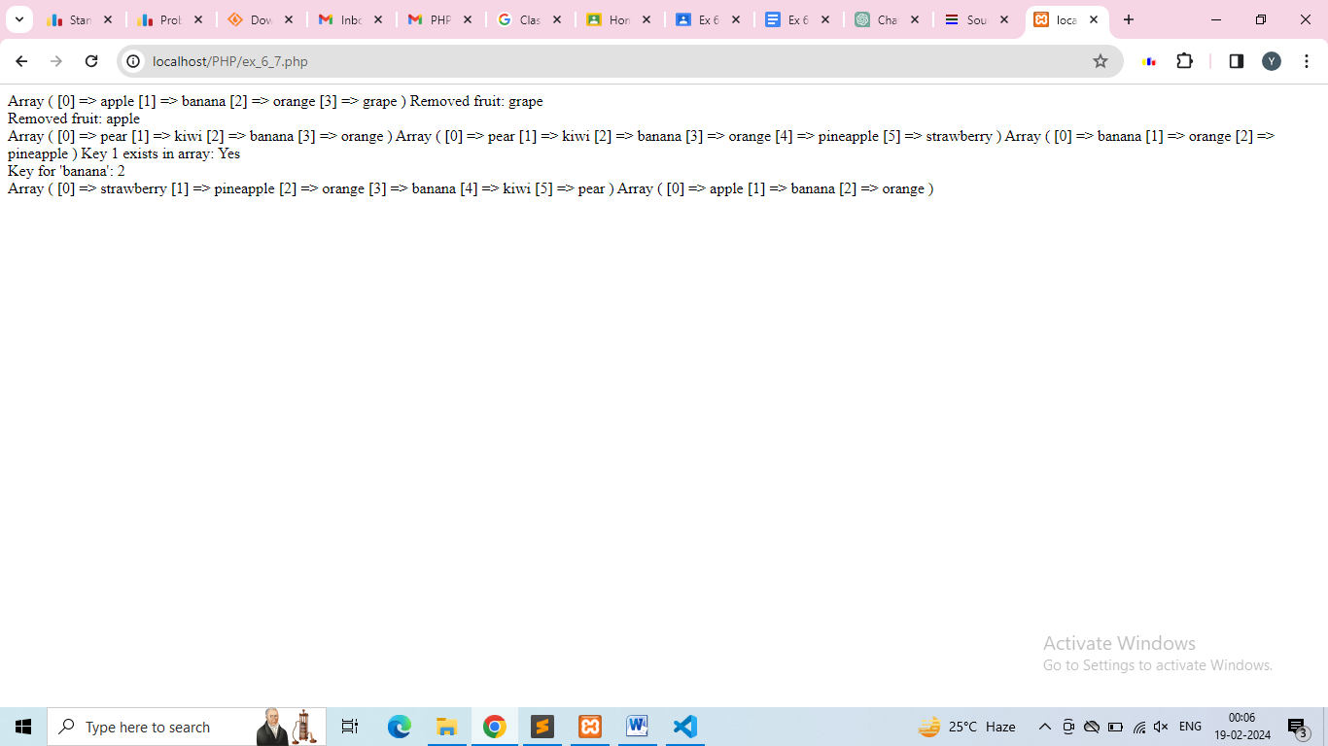

**8.Create a php form and demonstrate the use of regular expressions, use required fields**

**CODE:**

|  |
| --- |
| <form method="post" action="">  Username: <input type="text" name="username" required><br>  Email: <input type="email" name="email" required><br>  Password: <input type="password" name="password" required><br>  <input type="submit" name="submit" value="Submit">  </form>  <?php  **if** ($_SERVER["REQUEST_METHOD"] == "POST") {  $username = $_POST['username'];  $email = $_POST['email'];  $password = $_POST['password'];  $username_pattern = "/^[a-zA-Z0-9]+$/";  $email_pattern = "/^\S+@\S+\.\S+$/";  **if** (!preg_match($username_pattern, $username)) {  **echo** "Invalid username. Username can only contain letters and numbers.";  } **elseif** (!preg_match($email_pattern, $email)) {  **echo** "Invalid email address.";  } **else** {  **echo** "Form submitted successfully!";  }  }  ?> |

**OUTPUT:**

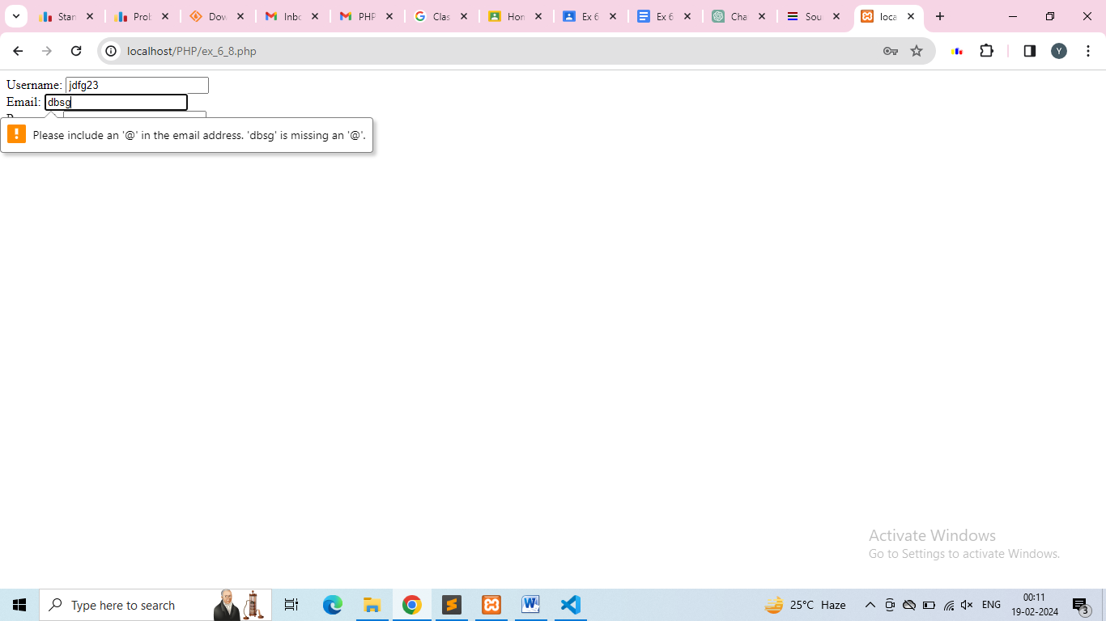

**RESULT:**

Thus PHP has been explored successfully and web pages were created.