Deccan Education Society’s
Fergusson College (Autonomous), Pune
Department of Computer Science

A

Report

on

“Interactive Visualization of Minimum Spanning Tree Algorithms using Kruskal's and Prim's Methods”

In partial fulfillment of Post Graduate course

in

M.Sc. Computer Science – I

(Semester -I)

2025-2026

CSC-520 Practical I

SUBMITTED BY

Abhishek Jaiswar - 256201

Yogiraj Bhilare – 256228

Tejas Patare - 256259

Index

Sr. No | Table of Content | Page No
1 | Case Study description  (Algorithm details and UI design details) | 3
2 | Screenshots | 8
3 | References (if you have used any) | 13

1. Case Study Description

Project Overview
The MST Visualizer is an interactive web-based application designed to visualize and understand two fundamental graph algorithms: Kruskal's Algorithm and Prim's Algorithm. The application provides both automated graph generation and manual graph creation capabilities, making it an excellent educational tool for learning about Minimum Spanning Trees.

Algorithm Details

1.1 Kruskal's Algorithm
Concept: Kruskal's algorithm is a greedy algorithm that finds the Minimum Spanning Tree by selecting edges in ascending order of their weights, while avoiding cycles.
Implementation Approach:
- Data Structure: Union-Find (Disjoint Set Union) with path compression
- Time Complexity: O(E log E) where E is the number of edges
- Space Complexity: O(V) where V is the number of vertices
Algorithm Steps:
- Sort all edges in non-decreasing order of their weights
- Initialize a parent array for Union-Find operations
- For each edge in sorted order:
  - Check if adding this edge creates a cycle using find() operation
  - If no cycle is formed, add edge to MST using union() operation
  - If cycle is formed, skip the edge
- Continue until V-1 edges are added to the MST
Key Functions:
- find(x): Finds the root parent of vertex x with path compression
- union(a, b): Merges two sets if they have different parents
- Returns true if merge successful (no cycle), false otherwise
Visual Feedback:
- Green edges: Added to MST
- Red edges: Skipped (would create cycle)
- Real-time cost calculation and timing information

1.2 Prim's Algorithm
Concept: Prim's algorithm builds the MST by starting from a source vertex and greedily adding the minimum weight edge that connects a visited vertex to an unvisited vertex.
Implementation Approach:
- Data Structure: Set for visited vertices, array for available edges
- Time Complexity: O(E log V) with efficient implementation
- Space Complexity: O(V + E)
Algorithm Steps:
- Start with a user-specified source vertex
- Mark source vertex as visited
- Add all edges connected to the source to available edges list
- Repeat until all vertices are visited:
  - Select edge with minimum weight from available edges
  - If both endpoints are visited, skip (would create cycle)
  - Otherwise, add edge to MST
  - Mark new vertex as visited
  - Add all edges from new vertex to unvisited vertices
Key Functions:
- addEdges(u): Adds all edges from vertex u to unvisited neighbors
- Dynamic sorting of available edges by weight
- Visited set tracking to prevent cycles
Visual Feedback:
- Green edges: Added to MST
- Red edges: Skipped (both endpoints already visited)
- Step-by-step progression with cost tracking

UI Design Details

2.1 Layout Structure
The application features a clean, modern interface divided into four main sections:
Header Section:
- Application title with gradient blue background
- Clear, professional typography
Control Panel (Left Sidebar):
- Graph configuration controls
- Algorithm selection dropdown
- Action buttons for graph generation and algorithm execution
- Source vertex input (conditional display for Prim's algorithm)
Visualization Canvas (Center):
- 500×500px SVG canvas for graph rendering
- Nodes arranged in circular layout for optimal visibility
- Interactive drag-and-drop functionality for edge creation
- Dynamic edge coloring based on algorithm state
Information Panel (Right Sidebar):
- Real-time step-by-step execution log
- Algorithm results display
- Total MST cost calculation
- Execution time tracking

2.2 Visual Design Elements
Color Scheme:
- Primary Blue (#0277bd): Nodes and UI accents
- Light Blue (#90caf9): Default edge color
- Green (#66bb6a): MST edges (accepted)
- Red (#ef5350): Rejected edges (cycles)
- Yellow (#ffd54f): Interactive drag line
- White backgrounds: Clean, professional appearance

Node Design:
- Circular nodes with 18px radius
- White stroke border for visibility
- Centered letter labels (A, B, C, etc.)
- Pointer cursor in interactive mode
Edge Design:
- Lines with 3px stroke width (5px when in MST)
- Weight labels centered on edges
- White rounded rectangle backgrounds for readability
- Proper z-index management (edges behind nodes)

2.3 Interactive Features
Graph Creation Modes:
- Random Graph Generation:
  - Node count selection (3-10 vertices)
  - Density control (Sparse, Medium, Dense)
  - Automatic random weight assignment (1-20)
  - Ensures graph connectivity
- Interactive Manual Mode:
  - Click and drag between nodes to create edges
  - Modal popup for weight input
  - Validation for positive integer weights
  - Duplicate edge prevention
  - Visual feedback with dashed yellow line during drag
Algorithm Execution:
- Start/Pause toggle button
- Step-by-step execution with 1-second delay
- Real-time update of visualization and logs
- Performance timing (milliseconds)
- Auto-scroll for step logs
User Experience Enhancements:
- Responsive button states
- Clear error messages
- Input validation
- Smooth animations
- Scrollable content areas
- Professional modal dialogs

2.4 Technical Implementation
Technology Stack:
- Pure HTML5, CSS3, and Vanilla JavaScript
- SVG for scalable vector graphics
- No external dependencies
- Client-side execution for instant feedback
Code Architecture:
- Modular function design
- Separate concerns (UI, algorithm logic, event handling)
- Global state management for animation control
- Event-driven interaction model
Key Technical Features:
- DOM manipulation for dynamic SVG generation
- Event listeners for interactive drag-and-drop
- setTimeout-based animation loop
- Union-Find with path compression optimization
- Efficient edge sorting and filtering

Conclusion
The MST Visualizer successfully demonstrates both Kruskal's and Prim's algorithms with an intuitive, interactive interface. The application serves as an effective educational tool for understanding graph algorithms, providing real-time visualization, step-by-step execution, and performance metrics.

2. Screenshots

2.1 Initial Interface
Main application interface showing control panel, visualization canvas, and information panel

Features Visible:
- Clean layout with organized controls
- Empty SVG canvas ready for graph creation
- Algorithm selection dropdown
- Node count and density controls

2.2 Random Graph Generation
Generated graph with 7 nodes and medium density
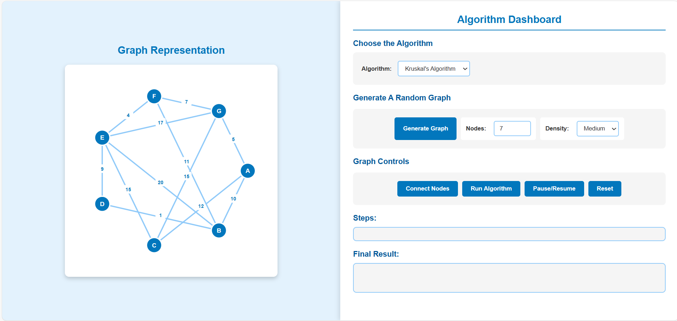
Elements Shown:
- Nodes arranged in circular pattern
- Multiple edges with weight labels
- Blue default edge coloring
- Letter-labeled vertices (A through G)

2.3 Interactive Mode
User creating edges manually with drag-and-drop

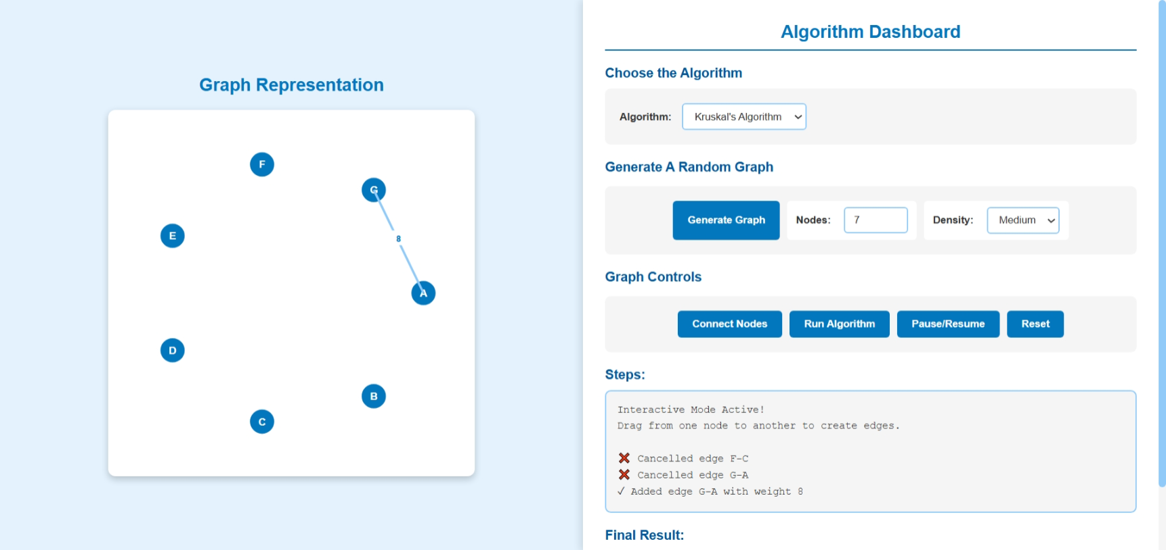
Interaction Display:
- Dashed yellow line during drag
- Weight input modal dialog
- Real-time feedback in steps panel
- Confirmation and cancellation options

2.4 Kruskal's Algorithm Execution
Mid-execution showing accepted and rejected edges
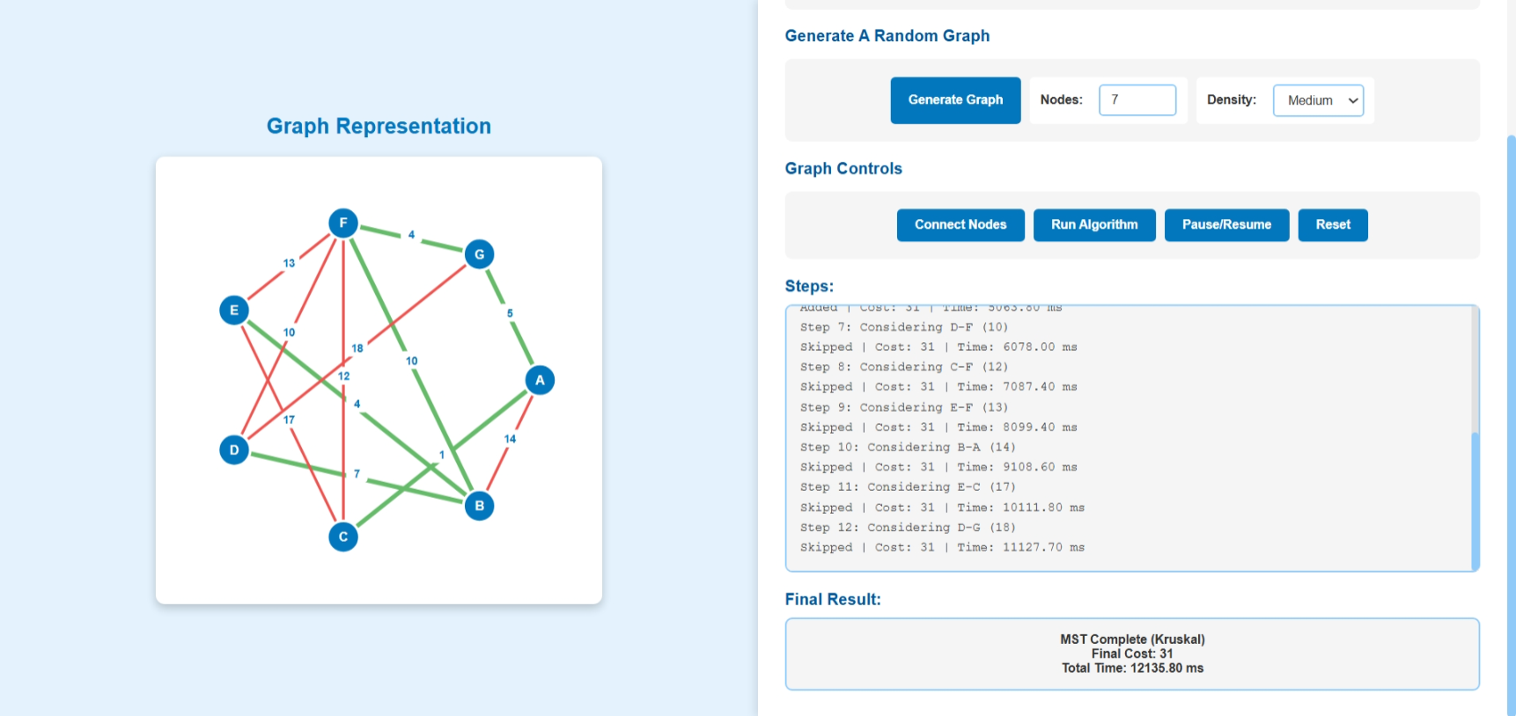
Algorithm Visualization:
- Green edges: Part of MST
- Red edges: Rejected (would create cycles)
- Step-by-step log with edge considerations
- Running cost calculation
- Timestamp for each step

2.5 Prim's Algorithm Execution
Prim's algorithm showing tree growth from source vertex
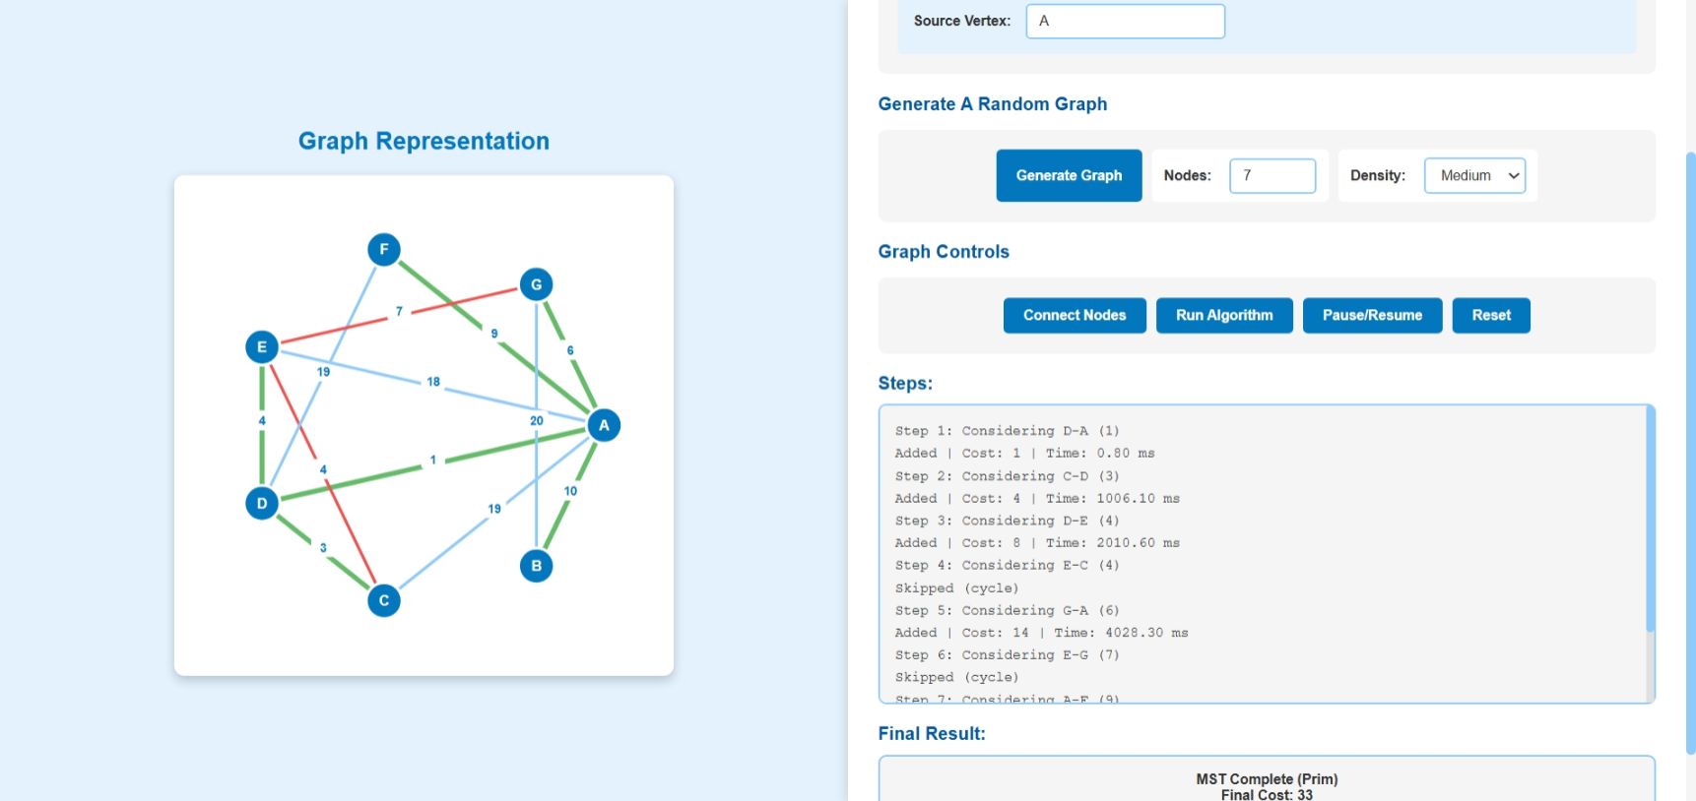
Visualization Features:
- Source vertex input field
- Progressive tree building
- Green edges showing MST formation
- Red edges showing rejected connections
- Visited vertex tracking

References

Algorithm Resources
- Cormen, T. H., Leiserson, C. E., Rivest, R. L., & Stein, C. (2009) Introduction to Algorithms (3rd ed.) MIT Press
  - Chapter 23: Minimum Spanning Trees
  - Kruskal's Algorithm (Section 23.2)
  - Prim's Algorithm (Section 23.2)
- Sedgewick, R., & Wayne, K. (2011) Algorithms (4th ed.) Addison-Wesley
  - Graph Algorithms Chapter
  - Union-Find Data Structure

Web Development Resources
- MDN Web Docs - SVG Tutorial Mozilla Developer Network https://developer.mozilla.org/en-US/docs/Web/SVG/Tutorial
  - SVG element creation and manipulation
  - Event handling in SVG
- W3C SVG Specification World Wide Web Consortium https://www.w3.org/TR/SVG2/
  - SVG standards and best practices

Algorithm Visualization Concepts
- VisuAlgo https://visualgo.net/en/mst
  - Inspiration for interactive algorithm visualization
  - UI/UX patterns for educational tools
- GeeksforGeeks - Graph Algorithms https://www.geeksforgeeks.org/
  - Kruskal's Algorithm implementation
  - Prim's Algorithm implementation
  - Union-Find optimization techniques

Design Resources
Material Design Guidelines Google Material Design https://material.io/design
  - Color palette selection
  - Button and interaction design
  - Modal dialog patter

Project completed as part of Algorithm Visualization Study Date: November 2025

