**SQL CODING CHALLENGE**

**AGGREGATE FUNCTIONS- GROUP BY-HAVING-JOINS**

use burger_bash;

**1. For each customer, how many total burgers did they order?**

select customer_id, count(*) as total_burgers_ordered

from customer_orders group by customer_id;

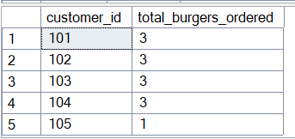

**2. What is the average distance travelled by each runner?**

select runner_id,avg(distance) as avg_distance_travelled

from runner_orders

group by runner_id;

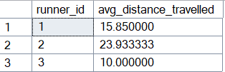

**3. Find the minimum and maximum delivery time for each runner.**

select runner_id,min(duration) as min_time,max(duration) as max_time

from runner_orders where duration is not null

group by runner_id;

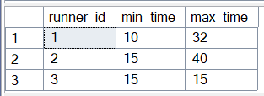

**4. Which menu item was ordered the most number of times?**

select top 1 c.burger_id,b.burger_name,count(*) as most_ordered

from customer_orders c join burger_names b on c.burger_id=b.burger_id

group by c.burger_id,b.burger_name

order by most_ordered desc;

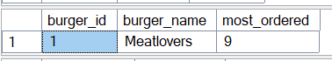

**5. Find the average number of burgers ordered per customer, but only include customers who ordered more than 2 times.**

select customer_id, count(*) as total_orders, avg(burger_id*1.0) as avg_order_value

from customer_orders

group by customer_id

having count(*) > 2;

