PROJECT REPORT
Name: Yogini Deshpande
Date: December 09, 2025

Charging Ahead: Analyzing Electric Vehicle Adoption and Charging Infrastructure in the U.S. with a Focus on Washington State

Summary:
The objective of this project is to evaluate electric vehicle (EV) adoption in Washington State and assess whether the current charging infrastructure is keeping pace with this growth. Using two authoritative government datasets, the Electric Vehicle Population Data from the Washington State Department of Licensing and the Alternative Fueling Stations Database from the U.S. Department of Transportation, EV registrations and charging station availability were analyzed at the ZIP-code level. While the charging data covers the entire U.S., the focus on Washington allows for a detailed, localized comparison. King County was found to have the highest EV count, with cities like Seattle, Bellevue, and Redmond showing both high EV adoption and substantial infrastructure, aligning with correlation analysis results. Log-scaled visualizations were employed to address the wide differences in EV and charging counts, revealing underlying patterns that raw numbers obscure. To quantify infrastructure gaps, a normalized deficit score was developed, highlighting areas where EV growth is outpacing charging expansion. Interestingly, some locations were found to have more charging ports than EVs, indicating over-provision. Regression models were attempted but proved less informative due to data skewness and outliers, making correlation analysis a more reliable indicator. Overall, while major metropolitan areas demonstrate alignment between EV adoption and infrastructure, the distribution is uneven, emphasizing the need for proactive, data-driven planning to ensure that charging capacity anticipates future EV growth across the state.

- Introduction

As the United States moves toward sustainable transportation, electric vehicles (EVs) have become increasingly widespread. However, adoption alone does not guarantee success—EV growth must be supported by accessible charging infrastructure. This project analyzes EV adoption trends in Washington State and compares them to available charging station infrastructure.
Two primary datasets were used:
- Electric Vehicle Population Data – Washington State Department of Licensing
- Alternative Fueling Stations Database – U.S. Department of Transportation / NREL
Together, these datasets allow exploration of both the demand side (EV adoption) and the supply side (charging stations).

- Research Questions

To guide this project, the Kitchen Sink Method was applied, allowing broad exploration before narrowing the focus. This approach helps uncover patterns, gaps, and relationships in EV adoption and charging infrastructure across Washington State.
EV Adoption:
- Which cities and counties show the highest EV adoption, how has it changed from 2020 to 2025, and what is the prevalence of BEVs versus PHEVs?
- Which manufacturers dominate the EV market, and how do ranges differ across models and make?
Charging Infrastructure:
- How many charging stations exist by state and city, and which companies operate them?
- What is the distribution of Level 2 versus DC fast chargers in Washington?
- Does charging infrastructure growth align with EV adoption trends?

- Dataset Collection:

This project uses two authoritative, government-sourced datasets to analyze EV adoption in Washington State and compare it with the availability of charging infrastructure.
- Alternative Fueling Stations – BTS (U.S. Bureau of Transportation Statistics):
  - Provides daily updated EV charging and alternative fuel station data across the U.S.
  - Data collected through federal and state reporting systems.
  - Available in CSV, JSON, GeoJSON, shapefiles, and via API.
- Electric Vehicle Population Data (Washington State DOL):
  - Contains official registrations of BEVs and PHEVs in Washington State.
  - Provided in CSV format with geographic and temporal details.
  - Enables analysis of EV distribution across cities, counties, and ZIP codes.
- Combined value:
  - Together, these datasets support a reliable comparison of EV usage and charging infrastructure at multiple geographic levels.

- Data Structures

The Electric Vehicle Population Data from the Washington State DOL is a structured CSV file where each row represents a registered EV and includes details such as vehicle type, model year, and location. The U.S. Department of Transportation’s Alternative Fueling Stations dataset is much larger and was filtered to include only Washington State EV charging stations for this analysis. After cleaning, both datasets were merged using ZIP codes to compare EV registrations with available charging infrastructure across the state.

Metadata of utilized data columns from both dataset:
Electric Vehicle Population Data (Washington State DOL):
Field Name | Description | Data Type / Example Value
VIN (1-10) | The first 10 digits of the Vehicle Identification Number, used as the primary key. | String
Model Year | The production model year | Integer
Make | The manufacturer of the vehicle. | String
Model | The specific model name of the vehicle. | String
Electric Vehicle Type | Classification indicating if it's purely electric or a hybrid. | String
Electric Range | The EPA-estimated electric range of vehicles in miles. | Integer
Base MSRP | Manufacturer’s suggested retail price at the time of sale (often null/approximate). | Integer
Electric Utility | The electric utility company provides service to the vehicle's location. | String

Alternative Fueling Stations Metadata:
Field Name | Description | Data Type / Example Value
fuel_type_code | The type of fuel available at the station | String
ev_network | Name of the EV charging network the station belongs to | String
ev_connector_types | A list of connector types available at the station location | String
ev_level1_evse_num | The number of Level 1 (120V) EVSE ports at the station. | Integer
ev_level2_evse_num | The number of Level 2 (240V) EVSE ports at the station. | Integer
ev_dc_fast_num | The number of DC Fast Charging | Integer
access_code | Indicates the access type. | String
access_days_time | Text description of the station's hours of operation. | String
status_code | Current operational status of the station | String
date_last_confirmed | The date of the station information was last verified and confirmed by the data providers. | Date
open_date | The date the station first began operation. | Date
station_name | The common or formal name of the fueling station location. | String
street_address | The primary street address of the location. | String

Both datasets contain address-specific columns for analyzing EV growth and infrastructure in Washington.
Field Name | Description | Data Type / Example Value
city | The incorporated city where the station is located. | String
state | The two-letter state abbreviation. | String
zip | The US Postal Service ZIP code. | Integer
county | The county name where the station is located. | String
country | The country code (primarily US and CA). | String
longitude | Geospatial coordinates for mapping the station location. | Float
latitude | Geospatial coordinates for mapping the station location. | Float

- Data Cleaning
Before analysis, both datasets were cleaned and standardized for accuracy and compatibility.
  - Electric Vehicle Population Data (WA State)
- Data type conversion: Numeric fields stored as text, such as Electric Range and Base MSRP, were converted to numeric.
- Categorical handling: Postal Code, Legislative District, and 2020 Census Tract were treated as categorical in Python.
- Missing values:
a. Categorical columns were filled with mode.
b. Electric Range values 0–5 were replaced with the median of valid entries.
c. Base MSRP was excluded due to excessive zeros.
  - Alternative Fueling Stations Dataset
4. Removed empty columns: Deleted columns with 100% null values (e.g., plus4).
5. Type conversion: Numeric fields (OBJECTID, id, cng_psi, ev_dc_fast_num, zip) converted using toNumber().
6. Date formatting: date_last_confirmed, open_date, and expected_date converted to proper date format.
7. Text standardization: Standardized capitalization for access_days_time and station_name.
8. Coordinate cleaning: Latitude and longitude converted to numeric for GIS compatibility.

- Data Analysis

The cleaned datasets were analyzed using a combination of descriptive statistics, geospatial comparisons, and visualizations to evaluate the relationship between electric vehicle registrations and charging-station infrastructure.

6.1 EV ADOPTION ANALYSIS

County Level:
- King County leads with 131,186 EVs, followed by Snohomish (32,714) and Pierce (21,855).
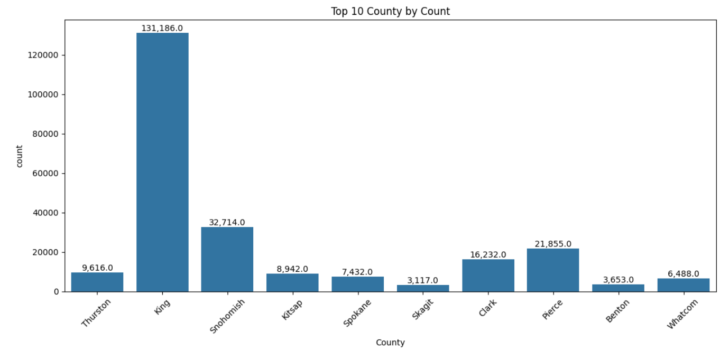
Graph 1
City Level:
- Seattle has the highest EV count (41,541), followed by Bellevue, Redmond, and Kirkland.
- BEVs dominate over PHEVs, reflecting Washington’s clean-energy policies and Tesla popularity.
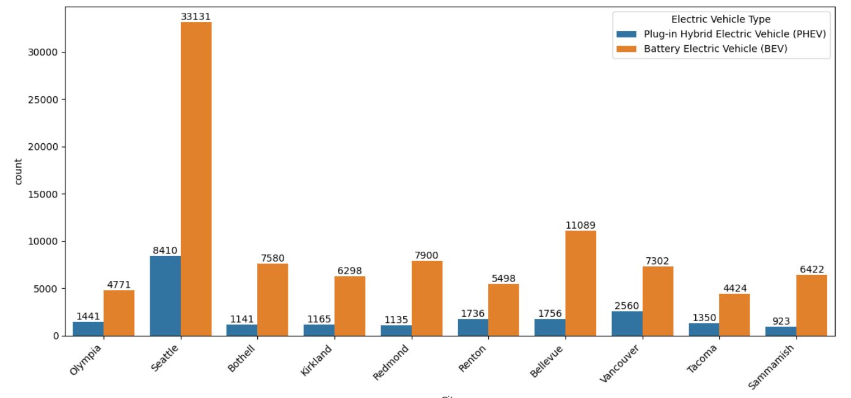
Graph 2: Top 10 Cities with PHEV and BEV count.

Model Year Trends:
- EV registrations steadily increased from 2020 to 2025.
- Initial correlation suggested newer models had slightly lower ranges, but illogical Electric Range values (0–5) skewed results. After cleaning, no clear link between model year and range was found.
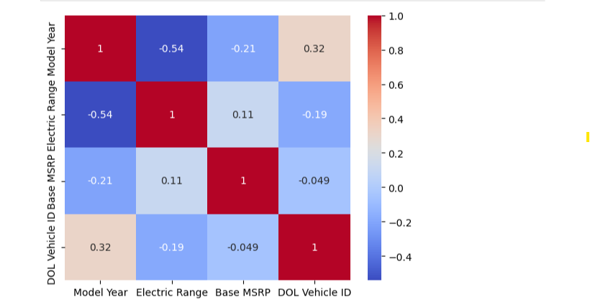
Graph 4:Correlation Heat map (before cleaning the illogical Electric Range values)
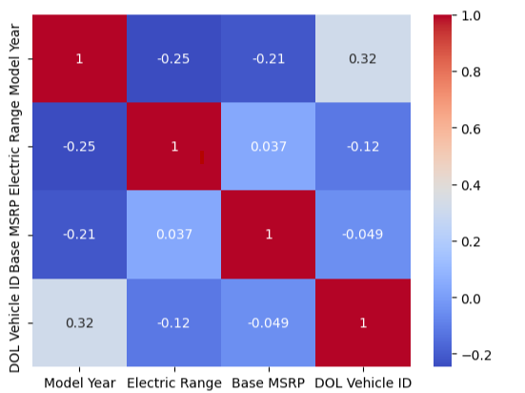
Graph 5: Correlation Heat map (before cleaning the illogical Electric Range values

Manufacturer Trends:
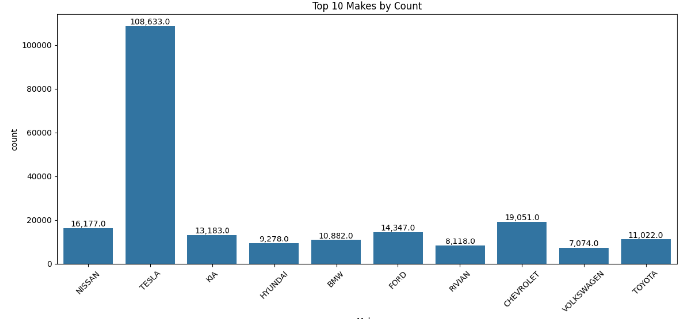
Graph 6

Tesla dominates (108,633), followed by Chevrolet (19,051) and Nissan (16,177).

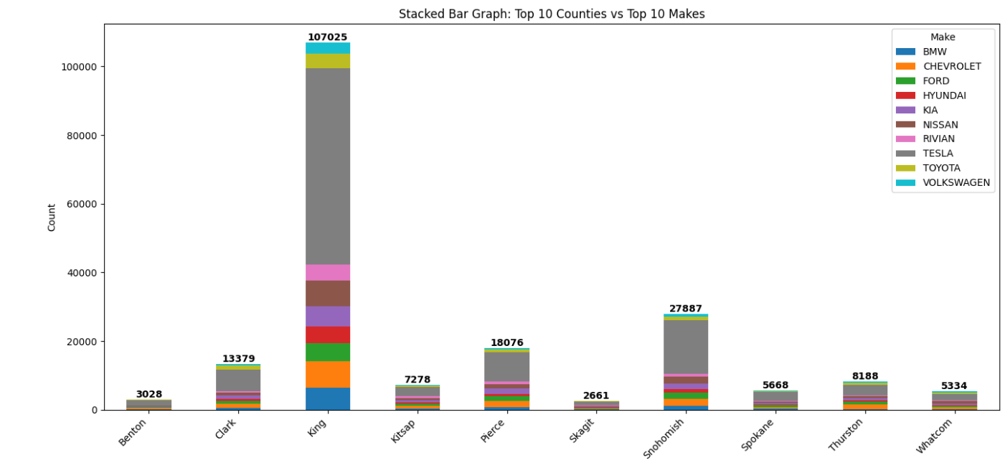
Graph 7: Stacked Bar Graph
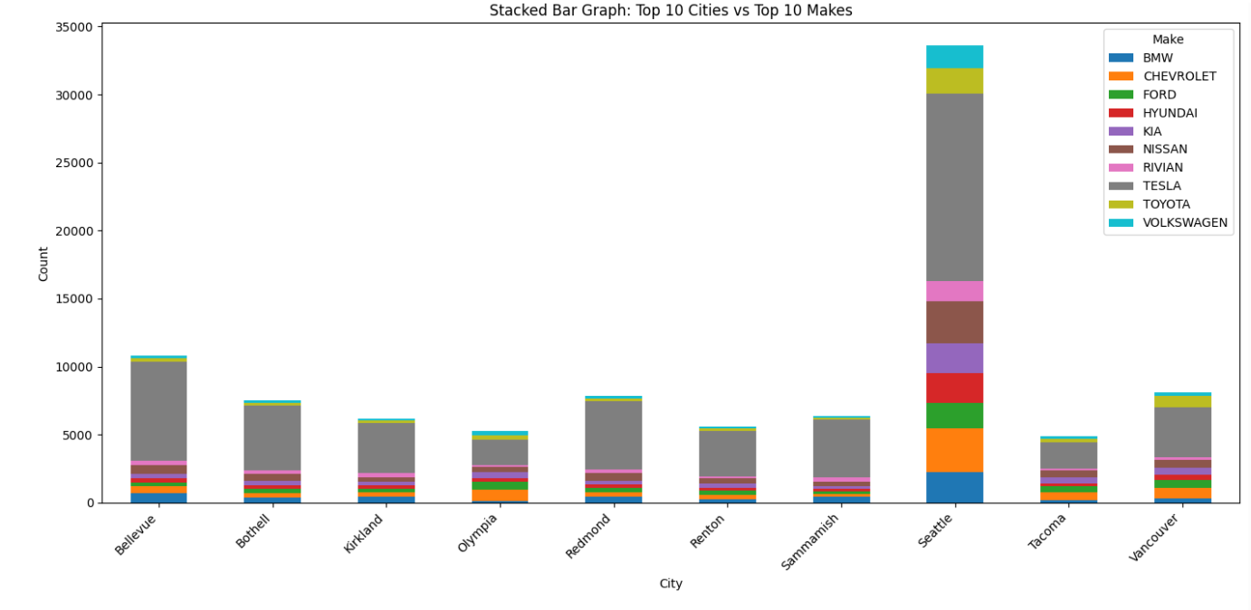
Graph 8: Tesla leads in all top cities.

Electric Range Analysis
Initial Electric Range data contained illogical values (e.g., Rivian showing 0 miles), which were excluded to ensure meaningful analysis. After cleaning, the distribution of ranges across the top 10 makes became clearer. Battery Electric Vehicles (BEVs) consistently exhibited higher average ranges than Plug-in Hybrid Electric Vehicles (PHEVs), regardless of manufacturer. This confirms that BEVs offer longer driving range, and highlights differences in performance across brands once erroneous data is removed. Below graph shows the analysis:
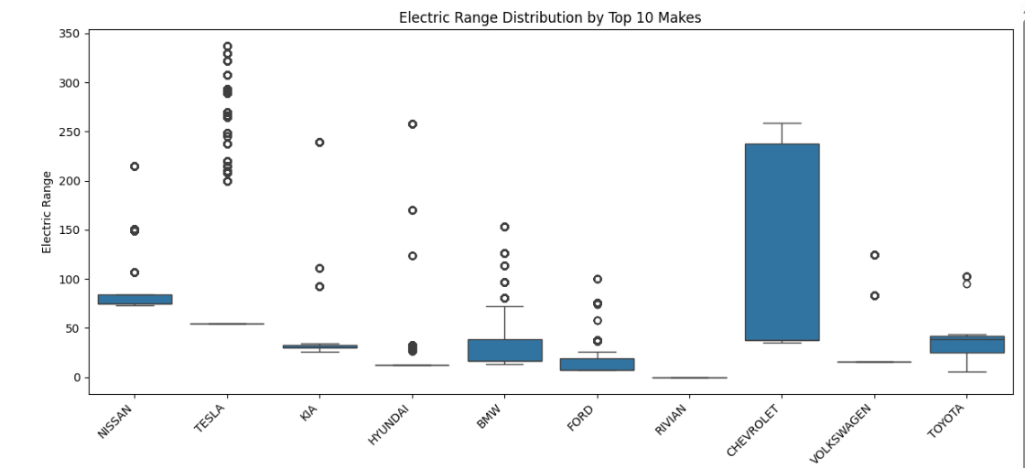
Graph 9: Electric Range Distribution 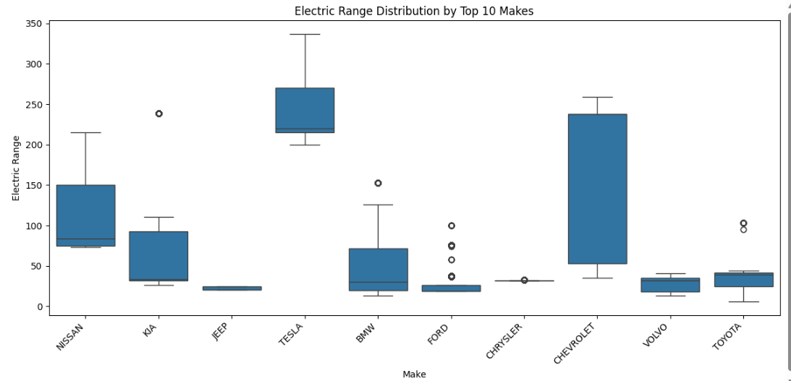
Graph 10: Electric range Distribution (After excluding entries with illogical Values)
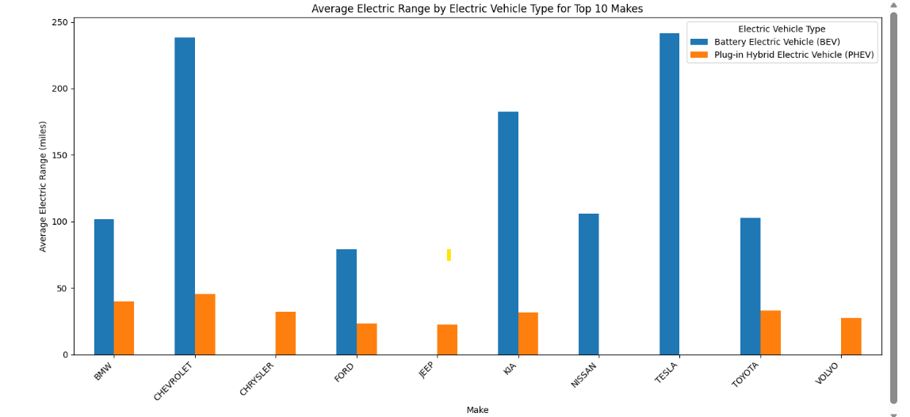
Graph 11: Average Electric Range by Electric Vehicle Type
One-Sided Anova Test:
A one-way ANOVA tested whether average Electric Range differs across manufacturers. With F = 32,561 and p = 0, the null hypothesis was rejected, showing significant differences.
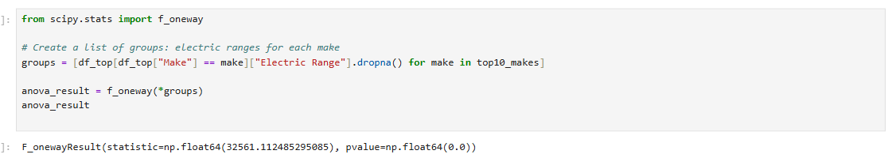
Screenshot 1: ANOVA Test results
Tukey’s Test Analysis:
Tukey’s post hoc test revealed that Tesla, Jaguar, and Polestar have higher mean ranges, while BMW also exceeds brands like Chevrolet, Ford, and Toyota. Some manufacturers, such as Chrysler and Toyota, did not differ significantly. These results clarify which brands lead in range, complementing the ANOVA findings.
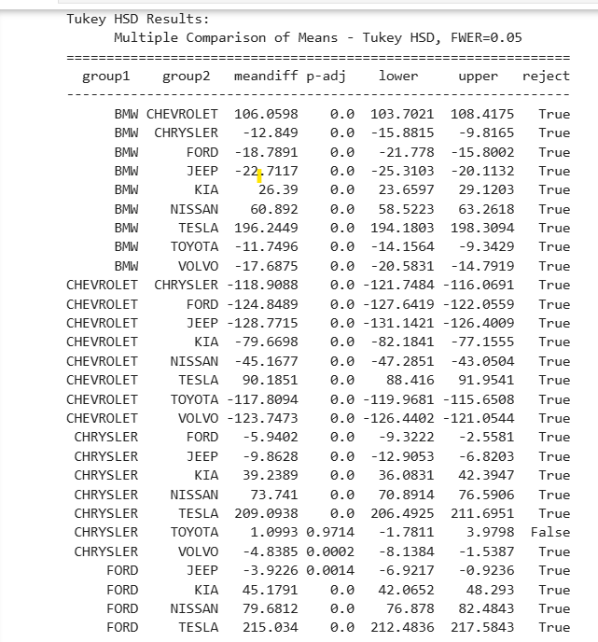
Screenshot2: Tukey’s Test Result Snippet

5.2 CHARGING INFRASTRUCTURE ANALYSIS

- Washington State has ~8854 ports.
- Highest concentration in:
  - Seattle
  - Bellevue
  - Tacoma
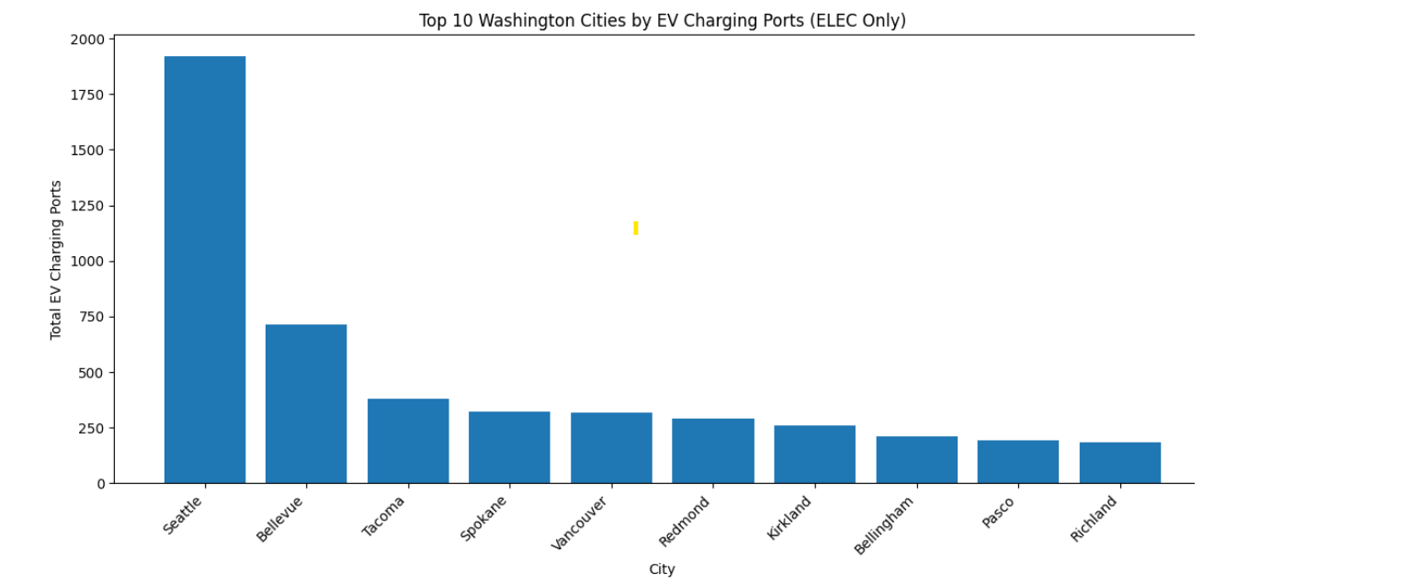
Graph 13: Top 10 Washington Cities by EV charging Ports (Elec Only)

EV station count shows a growth in Washington State specifically after 2020, which can be clearly seen in below plot:
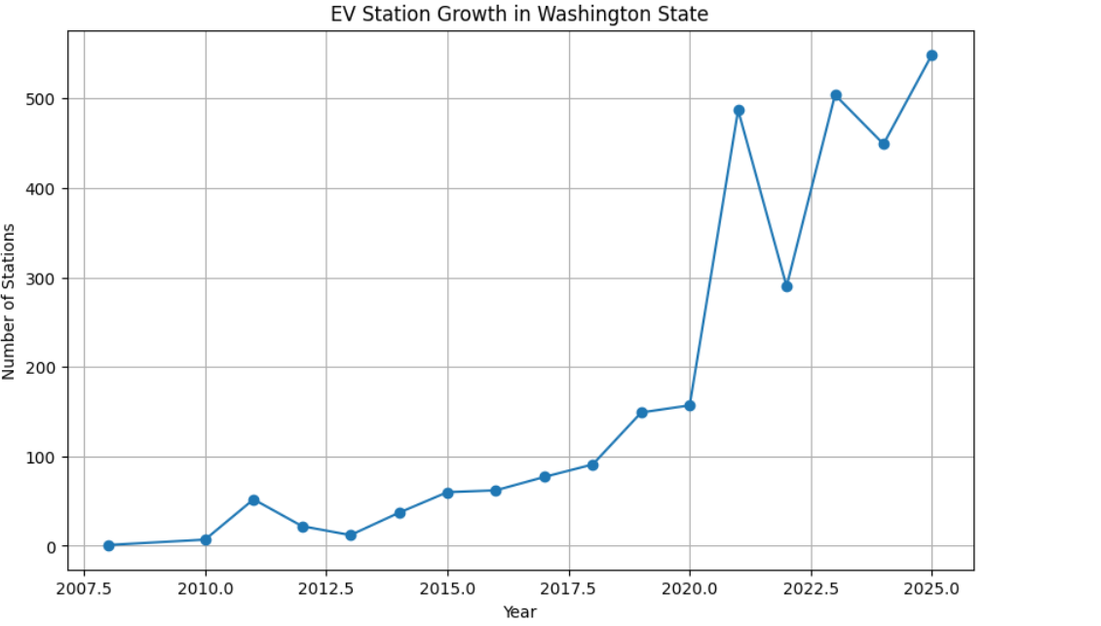
Graph 14: EV Station Growth in Washington State

US as whole shows similar kind of percentage distribution related to charging port types.

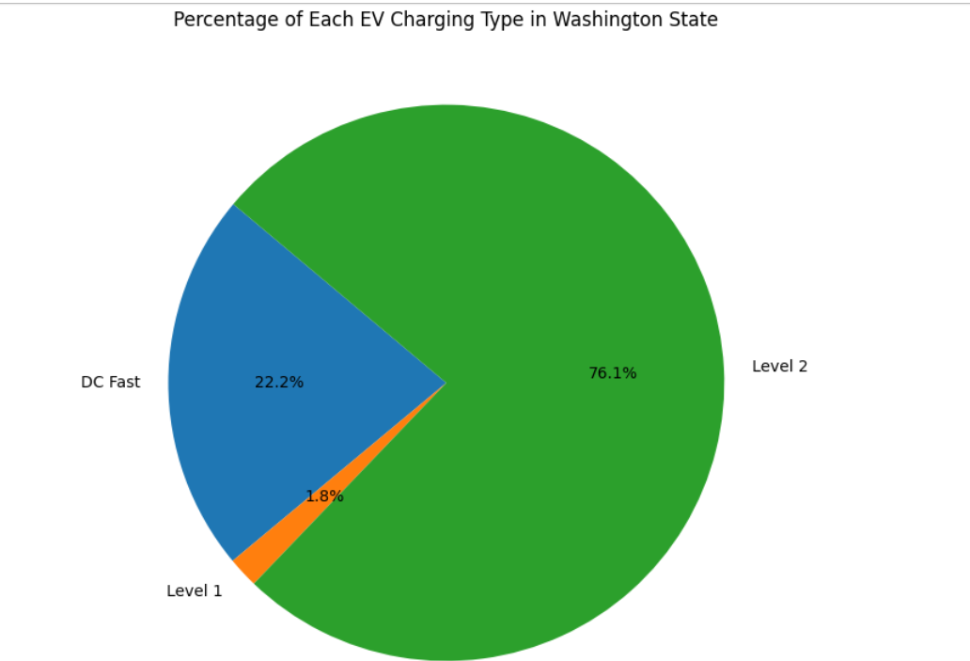

Graph 15: Pie Chart explains percentage of each EV Charging type in Washing State.

The ev_connector_types lists were flattened, and Python’s Counter used to count each type, identifying the top five connectors to reveal prevalent standards in Washington State.
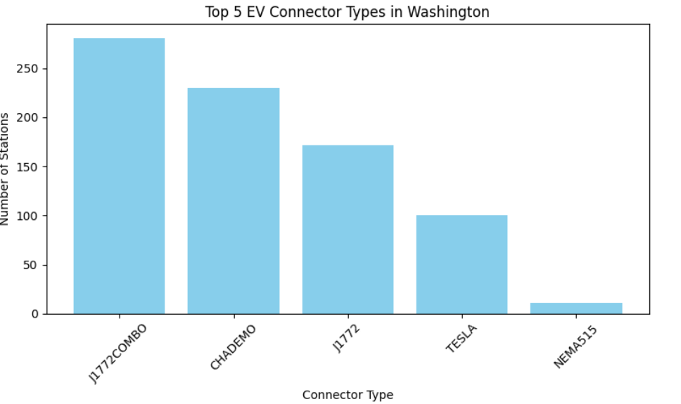
Graph 16: Top 5 EV Connectors Make Types in Washington.

To examine whether EV charging infrastructure is keeping pace with adoption in Washington, both datasets were aggregated at the ZIP-code level and merged. After summarizing total EVs and charging ports per ZIP, a scatter plot initially showed no clear pattern, so a log transformation was applied. The log-scale plot revealed a generally positive relationship: ZIP codes with more EVs tend to have more charging ports, though metropolitan areas like Seattle, Redmond, and Bellevue were outliers. Overall, infrastructure growth aligns with adoption but is uneven and concentrated in major cities.
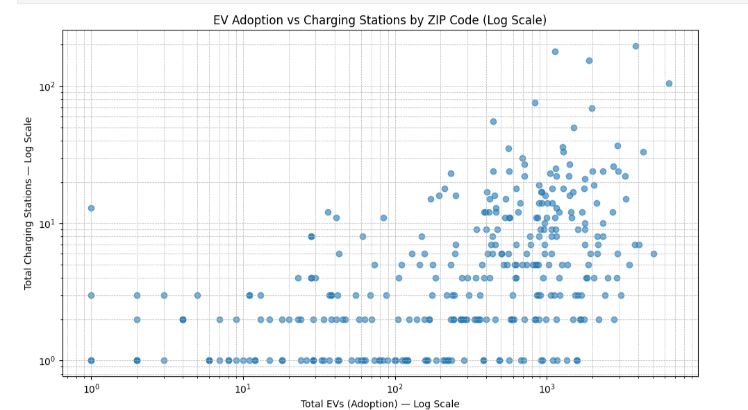

Graph 17: Scatter Plot EV Adoption vs Charging Stations by ZIP Code (Log Scale)

To quantify gaps, a standardized deficit score was calculated by normalizing EV and port counts to a 0–1 scale and subtracting infrastructure from adoption (ev_scaled − infra_scaled). Positive values indicate ZIP codes where EV adoption exceeds charging capacity; negative values indicate over-provision.
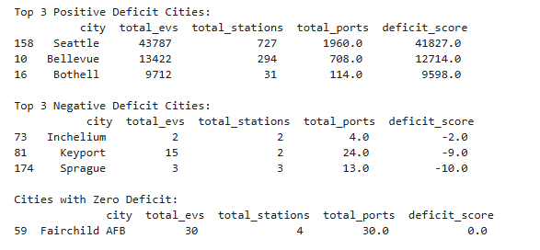
Screenshot 3: Results showing cities based on deficit score

Seattle, Bellevue, and Bothell have the largest positive deficits, suggesting EV growth outpaces charging expansion. Even with substantial infrastructure, high adoption can create strain.
Regression analysis was explored to assess deviations from expected infrastructure.

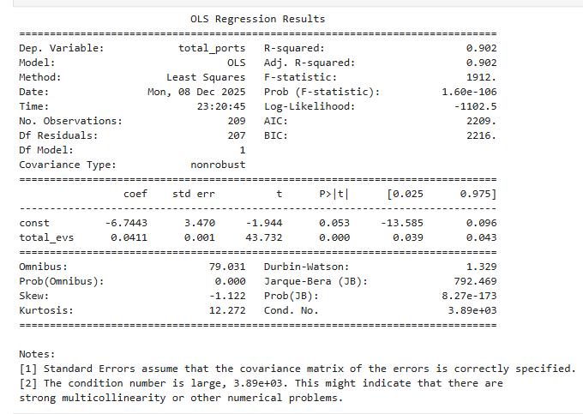
Screenshot4: Regression test output

The regression model produced a high R-squared value (0.902), indicating that EV counts explain a substantial proportion of the variance in charging port availability across cities. However, the model fit was strongly influenced by a small number of high-adoption cities, and the underlying data exhibited significant skewness. As a result, the regression captured broad statewide trends rather than city-specific infrastructure adequacy.

Correlation analysis offered a simpler measure of overall association. The Pearson correlation coefficient of 0.49 shows that while infrastructure generally increases with EV adoption, the relationship is moderate, emphasizing the importance of deficit scores to identify localized gaps.

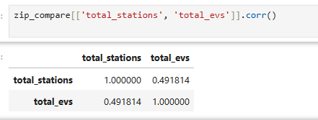
Screenshot 5: Correlation matrix of EV and Port based on Zip codes

- Discussion and Conclusions

EV adoption in Washington State continues to rise, with the highest concentrations in Seattle, Bellevue, and Redmond. King County leads overall, and Battery Electric Vehicles (BEVs) remain more common than Plug-in Hybrid Electric Vehicles (PHEVs), reflecting preference for long-range vehicles and the influence of higher-income urban areas. Tesla dominates registrations across high-adoption regions.
Range analysis initially appeared misleading due to missing or erroneous values, but after cleaning, no strong link between model year and range was observed. Brands such as Tesla, Jaguar, Polestar, and BMW consistently exhibited higher average ranges, demonstrating real performance differences and the importance of thorough data cleaning.
Charging infrastructure in Washington is substantial but uneven. Level 2 chargers dominate, while DC fast chargers remain limited outside major metro areas. ZIP-code-level analysis shows only moderate correlation between EV counts and charging ports, and deficit-score evaluation identifies Seattle, Bellevue, and Bothell as areas where adoption exceeds infrastructure.
Comparing with recent findings from a graph-theoretic study, the relationship between EV adoption and infrastructure growth is bidirectional but often lagged, with adoption sometimes preceding infrastructure deployment (Alrasheedi & Ali, 2025). In Washington, high EV adoption in metro areas appears to outpace charger deployment, aligning with the study’s observation that adoption often precedes infrastructure expansion. This emphasizes the need for proactive, spatially aware planning to ensure equitable access, particularly in smaller cities and rural areas.

Limitations and Future Work:
This study has several limitations. The charging infrastructure data excludes private and home chargers, meaning some areas may have more options than reported. ZIP-code analysis can also overlook neighborhood-level differences. Future research could use precise latitude and longitude for EVs and chargers to better track infrastructure needs over time. Combining geographic levels, such as cities, counties, and ZIP codes, would provide a clearer view of EV growth and charger availability, improving the usefulness of the analysis for planning.

- References

- Publisher data.wa.gov. (2025b, November 22). State of Washington - Electric Vehicle Population Data. Catalog. https://catalog.data.gov/dataset/electric-vehicle-population-data
- Alternative fueling stations. Geospatial at the Bureau of Transportation Statistics. (n.d.). https://geodata.bts.gov/datasets/usdot::alternative-fueling-stations/about
- One Sided ANOVA test: YouTube. (n.d.). YouTube. https://www.youtube.com/watch?v=ITf4vHhyGpc
- Kipp, M. (2025). [Course notes]. 582: Introduction to Data Science, University of Wisconsin-Milwaukee. Creative Commons Attribution-Noncommercial-Share Alike 3.0 United States License.
- Shron, Max. 2014. Thinking with Data: How to Turn Information into Insight. O'Reilly Media.
ISBN: 978-1449362935 (Available free through the UWM Library login with your pantherid
http://ebookcentral.proquest.com/lib/uwm/detail.action?docID=1598508
- Zach BobbittHey there. My name is Zach Bobbitt. I have a Masters of Science degree in Applied Statistics and I’ve worked on machine learning algorithms for professional businesses in both healthcare and retail. I’m passionate about statistics. (2021, March 13). A guide to using post hoc tests with ANOVA. Statology. https://www.statology.org/anova-post-hoc-tests/
- Alrasheedi, F. S., & Ali, H. H. (2025, May 4). A graph theoretic approach for exploring the relationship between EV adoption and charging infrastructure growth. arXiv.org. https://arxiv.org/abs/2504.13902

AI Usage Statement:
I used OpenAI’s ChatGPT (GPT-5 mini) to improve grammar, clarify sentences, summarize explanations, and suggest Python code corrections. All data cleaning, calculations, visualizations, and conclusions were performed by me. AI was only used to enhance readability, and I verified all suggestions for accuracy.

