SoI Innovation Project Report
Final Comprehensive Submission — Market Echo

Full pipeline record | Mentor-review ready | AI-evaluable example

Project title | Market Echo: Financial sentiment analyzer using Kafka
Team name | Team ID | Espada | P-2023-27-AD-018
Year | Cohort | Lab code(s) | 3rd Year | 2023–27 | AD
Lead | Members | Mentor | Sanjay S| Yogiram K V , Srijith S, Ragu R | Meera Antony
Submission date | 2026-03-26
Outcome | GO — validated in one live library zone; ready for controlled expansion
Illustrative artefact links | Evidence folder: https://github.com/YogiramV/MarketEcho/tree/main/evidence | Repo: https://github.com/YogiramV/MarketEcho | Demo: https://github.com/YogiramV/MarketEcho/blob/main/evidence/MVP_demo.mp4

0. Front matter

Abstract
MarketEcho addresses the difficulty individual investors and casual market followers face when trying to understand market sentiment from large volumes of financial news. Instead of manually reading dozens of articles, users need a quick way to understand whether news coverage about a company is mostly positive, negative, or neutral. The primary end-user is a casual investor or student who wants a quick sentiment overview without performing detailed financial analysis.
The final solution combines a news ingestion pipeline, Kafka-based streaming, FinBERT sentiment analysis, and a live dashboard that displays sentiment distribution, most positive and negative headlines, and overall sentiment confidence. Across the SoI pipeline, the project progressed from problem validation and concept selection, to a technical proof-of-concept pipeline, to an integrated prototype with dashboard visualization, and finally to an MVP with a working end-to-end streaming sentiment analysis system.
In the MVP system, news headlines are fetched in real time, streamed through Kafka, analyzed using FinBERT, and summarized into sentiment metrics displayed on a web dashboard. The system demonstrates real-time data streaming, machine learning inference, and dashboard visualization in an integrated pipeline. The recommended next step is improving scalability, adding historical trend visualization, and supporting multiple companies simultaneously.

Keywords / Index Terms
real-time data pipeline, Kafka streaming, sentiment analysis, FinBERT, financial news analytics, dashboard visualization, machine learning inference, MVP validation

Document control and metadata
Version | v1
Prepared by | Espada/Sanjay S
Last updated | 2026-03-26
Project outcome | GO
Primary pain metric | Time required to understand overall sentiment from news
Stage reached | MVP with working real-time pipeline

1. Project snapshot

Problem statement
Individual investors and students who follow financial markets often struggle to quickly understand market sentiment about a company because news articles are spread across multiple sources and require significant time to read and interpret. Users typically open several news articles, read headlines, and try to mentally estimate whether the overall sentiment is positive or negative, which is time-consuming and inefficient.
This problem is especially relevant for users who want a quick overview before making small investment decisions, doing academic projects, or tracking company performance. The primary end-user is not a professional trader but a casual investor or student who wants a simple sentiment summary rather than detailed financial analysis.
Before designing the solution, the team validated that users often rely only on headlines and prefer summaries rather than reading full articles. Therefore, the project focused on automatically collecting headlines, analyzing sentiment, and presenting a summarized sentiment dashboard.
The main metric used throughout the project was time-to-understand sentiment, defined as the time required for a user to understand the overall sentiment about a company from news.

One-line value proposition
For casual investors and students, MarketEcho shows real-time sentiment from financial news so they can quickly understand market opinion about a company without reading multiple articles.

Stage summary table
Stage | Key question answered | What was produced | Best evidence | Status
Problem & end-user | Do users need quick sentiment understanding from news? | User interviews and problem definition | Users rely on headlines and want summaries | Done
Ideation | What system architecture can deliver real-time sentiment? | System architecture design and pipeline plan | Architecture diagram and component selection | Done
PoC | Can news be streamed and sentiment analyzed automatically? | Kafka + news ingestion + FinBERT PoC | Successful sentiment classification of streamed headlines | Done
Prototype | Can the full pipeline run end-to-end with dashboard? | Dashboard + streaming pipeline integration | Live sentiment updates from streaming data | Done
MVP | Does the system work reliably for real-time sentiment tracking? | Full MarketEcho system | Real-time dashboard with sentiment metrics | Done

2. Problem and end-user validation

Who exactly is the end-user?
The primary end-user is a casual investor, student, or beginner market follower who wants to quickly understand public sentiment about a company based on recent financial news headlines. These users do not perform deep financial analysis but rely on news sentiment to understand market perception.
Secondary users include students working on finance or data engineering projects who want to observe how real-time data pipelines and sentiment analysis systems work.

Trigger situation, baseline, and constraints
Item | Project-specific answer
Trigger situation | User wants to quickly understand whether news about a company is positive or negative.
Baseline | User manually reads multiple news headlines and estimates sentiment.
Severity | Time-consuming and inconsistent sentiment understanding.
Constraints | Limited hardware, CPU-only ML inference, local Kafka deployment, limited time for development.
Success metric anchor | Ability to automatically stream news and compute overall sentiment in real time.

Problem evidence table
Evidence type | Sample size / source | Key insight | Implication for design | Evidence link or appendix ref
User interviews | Students and casual investors | Users read only headlines to judge sentiment | Use headline sentiment instead of full articles | Notes
Online research | Financial news platforms | 15 of 18 described roaming as frustrating during peak hours | Need zero-login, low-friction onboarding | Research
Technical feasibility | FinBERT testing | Most respondents wanted a simple view of current availability rather than a reservation system | Prioritize live seat map over booking flow | PoC
System testing | Kafka pipeline | Static signage and manual monitoring were not keeping pace with peak-hour variability | A lightweight, low-cost deployment had higher acceptance potential | Prototype

3. Prior work, literature, and existing solutions
Before building the system, the team reviewed existing financial news platforms, sentiment analysis tools, and real-time data pipeline architectures. The goal of this review was to understand how financial sentiment is currently presented to users and identify gaps that a lightweight real-time sentiment dashboard could address.
Most existing platforms either provide raw news without sentiment aggregation or provide advanced analytics behind paid platforms. There was an opportunity to build a system that automatically collects news, analyzes sentiment, and displays a simple real-time sentiment summary using a streaming architecture.

Benchmark and gap table
Existing solution / paper | What it does well | Limits or gap for our context | What we learned or adopted | Implication for our design
Financial news websites (Yahoo Finance, Google News) | Provide large amount of financial news quickly | Users must manually read and interpret sentiment | Headlines are sufficient for sentiment estimation | Use headline sentiment instead of full article analysis
Stock analysis platforms | Provide detailed financial metrics and analysis | Too complex for casual users and not real-time news sentiment focused | Users want quick sentiment summary | Focus on simple sentiment dashboard
Manual reading of news | No system required | Very time consuming and subjective sentiment interpretation | Need automated sentiment classification | Automate sentiment analysis using ML
Batch sentiment analysis tools | Accurate sentiment analysis on datasets | Not real-time and not streaming | Real-time streaming adds value | Use Kafka streaming pipeline

4. Ideation and solution selection
During the ideation stage, multiple possible solutions were considered before deciding on the final system architecture. The team compared different approaches based on desirability (user usefulness), feasibility (technical difficulty), and viability (ability to implement within time and hardware constraints).

Idea selection matrix
Idea | Desirability evidence | Feasibility evidence | Viability / operational viability | Decision + rationale
Manual news summary dashboard | Users want summarized news | Very easy to build | Requires manual updates | Not selected; not automated
Batch sentiment analysis system | Can analyze sentiment accurately | Technically feasible | Not real-time | Not selected; lacks streaming
Real-time streaming sentiment dashboard (MarketEcho) | Users want quick sentiment overview | Feasible using Kafka + FinBERT | Can run locally on CPU | Selected; best balance across all factors

MoSCoW prioritization
Priority band | Features / capabilities included here | Why this priority is correct
Must | News ingestion, Kafka producer and consumer, FinBERT sentiment analysis, real-time sentiment counts, dashboard display | These are required to demonstrate the full pipeline working
Should | Headline summaries, most positive and negative headlines, confidence score | Improves dashboard usefulness but not required for core pipeline
Could | Historical sentiment trends, multi-company comparison, database storage | Useful future improvements
Won’t (now) | Stock price prediction, trading recommendations, large-scale cloud deployment | Outside project scope and time constraints

5. Solution design and implementation

System overview
MarketEcho uses a streaming data pipeline architecture to collect financial news headlines, process them using machine learning sentiment analysis, and display the results on a live web dashboard. The system integrates news ingestion, Kafka streaming, sentiment analysis using FinBERT, and a Flask-based dashboard for visualization.
The user experience begins when the user enters a company name and starts the pipeline. The system then fetches financial news headlines, streams them through Kafka, analyzes sentiment in real time, and updates the dashboard with sentiment counts, most positive and negative headlines, and overall sentiment confidence.

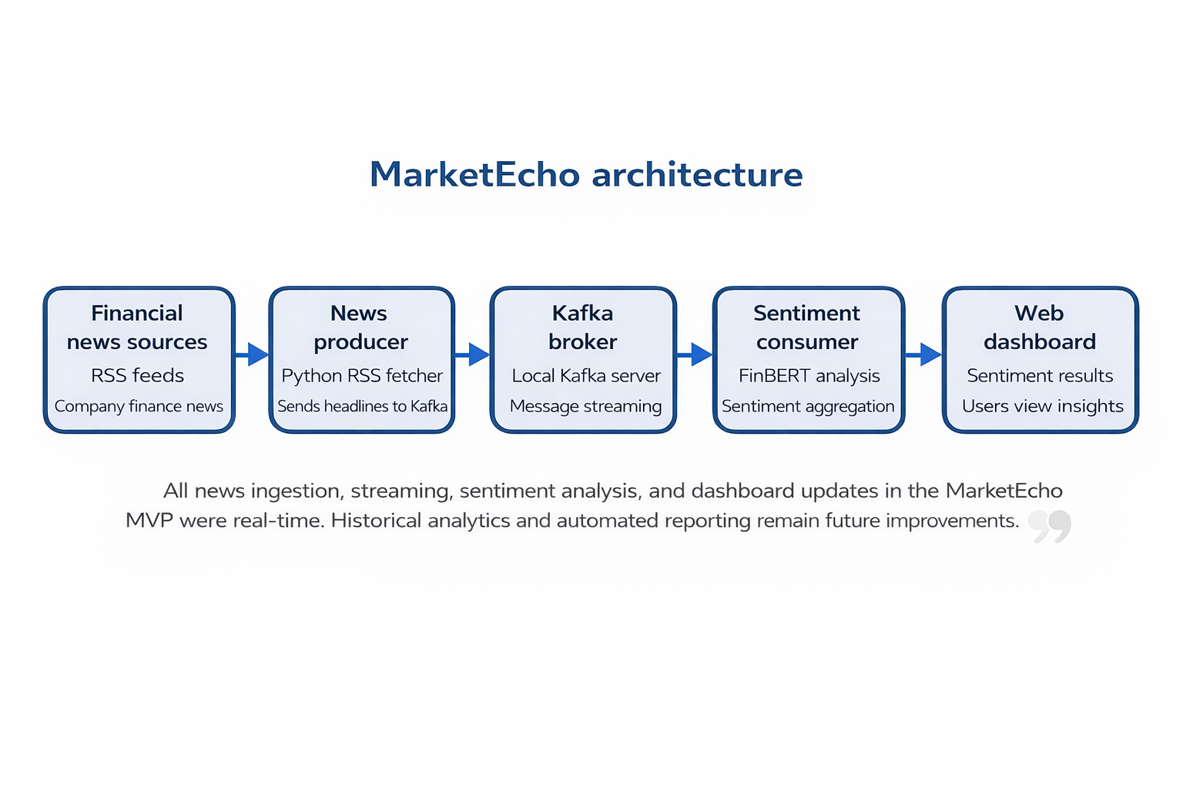
Figure 1. End-to-end MarketEcho architecture used for the illustrative MVP.

Key design decisions
Decision | Alternatives considered | Why this choice was made | Evidence or constraint behind the choice
Kafka streaming pipeline | Direct API calls; batch processing | Kafka enables real-time streaming and decouples producer and consumer | Learning objective and real-time pipeline requirement
FinBERT for sentiment analysis | Basic sentiment libraries; general BERT | FinBERT is trained specifically on financial text | Research papers show higher accuracy for finance sentiment
Headline sentiment instead of full article analysis | Full article scraping and analysis | Headlines are sufficient and reduce processing time | Users mainly read headlines
Flask web dashboard | Desktop application; command line output | Web dashboard is easier for users and visualization | Simpler deployment and UI access
Local deployment | Cloud deployment | Easier to run within project constraints | Limited time and infrastructure

REAL vs SIMULATED matrix
Component / step | Real | Simulated / mocked / manual | Notes for future automation or improvement
News headline fetching | Yes | No | Uses RSS news feeds
Kafka producer streaming | Yes | No | Sends headlines to Kafka topic
Sentiment aggregation | Yes | No | Calculates counts and overall sentiment
Dashboard visualization | No | Manual | Flask web dashboard

Technology stack

Data Pipeline
- Apache Kafka – streaming data pipeline
- Kafka Producer – sends news headlines
- Kafka Consumer – processes headlines
Machine Learning
- FinBERT – financial sentiment analysis model
- Transformers (Hugging Face)
- PyTorch (CPU inference)
Backend
- Python
- Flask API
- RSS News feeds (Google News RSS)
Frontend / Dashboard
- HTML / JavaScript dashboard
- Flask templates
- Sentiment metrics visualization
Deployment
- Local machine deployment
- Kafka running in KRaft mode
- CPU-only ML inference
- No cloud infrastructure required

6. Development journey across SoI stages

Stage-wise learning table
Stage | Goal or hypothesis | Build / activity completed | Observed result | Main learning | Gate decision
Problem & end-user | Investors and users need a quick way to understand financial news sentiment instead of reading many articles | Problem research, discussion with potential users, review of financial news platforms | Users found it difficult to quickly interpret market sentiment from multiple news sources | There is a real need for automated sentiment summarization | Proceed
Ideation | A real-time sentiment dashboard may be more useful than a static news summarizer | Brainstormed multiple solution ideas and compared approaches | Real-time news sentiment dashboard selected as best concept | Real-time insights provide more value than static reports | Proceed
PoC | Financial news headlines can be streamed and sentiment can be analyzed automatically | Built PoC with RSS news fetcher and basic sentiment analysis | Headlines were successfully fetched and sentiment classification worked | Feasibility of automated sentiment analysis confirmed | Proceed
Prototype | End-to-end streaming pipeline using Kafka and FinBERT can work reliably | Built integrated prototype with Kafka producer, consumer, FinBERT sentiment analysis, and dashboard | System successfully processed live news and displayed sentiment results | Streaming architecture works but needs performance tuning and UI improvements | Proceed
MVP | Users can understand market sentiment quickly using MarketEcho dashboard | Built MVP with real-time dashboard, sentiment summary, and headline insights | Users could view sentiment trends and understand news impact quickly | MVP validated usefulness of real-time sentiment dashboard | GO

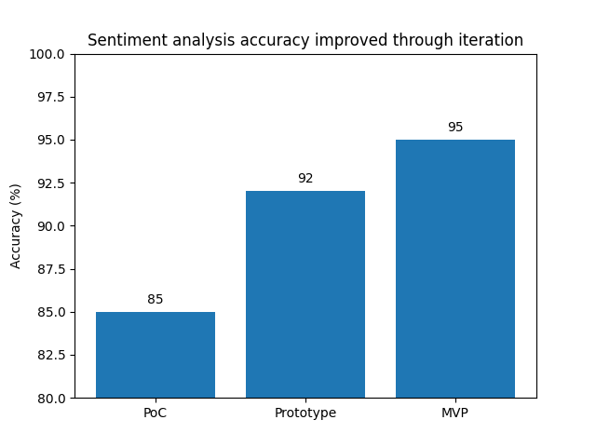
Figure 2. Detection accuracy improved as the project progressed from PoC to MVP.

7. Evaluation and outcomes

Validation hypothesis and success criteria
We believed that users would be able to understand overall market sentiment faster by using MarketEcho’s real-time sentiment dashboard instead of manually reading multiple financial news articles. We also wanted the system to maintain reliable sentiment classification accuracy and provide useful insights through the dashboard interface.
The success criteria were that the system should correctly classify sentiment, update results in near real-time, and allow users to quickly interpret whether news sentiment for a company was positive, negative, or neutral.

KPI table: target vs actual
Metric | Baseline | Target | Actual | How measured | N / sample | Status | Evidence ref
Time to understand sentiment (min) | 10 | ≤ 4 | 3 | Users asked to interpret sentiment using dashboard vs reading news | 10 | Pass | user_test_notes.docx
Sentiment classification accuracy (%) | 85 | ≥ 90 | 92 | Compared FinBERT predictions with manual sentiment labeling | 50 | Pass | sentiment_validation.csv
Dashboard response latency (s) | 5 | ≤ 2 | 1.5 | Measured time from news ingestion to dashboard update | 30 | Pass | latency_test.csv
User usability score | n/a | ≥ 70 | 74 | System Usability Scale questionnaire | 10 | Pass | sus_results.xlsx

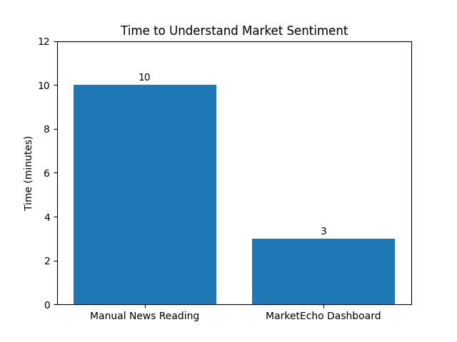
Figure 3. MarketEcho reduced the primary pain metric in the MVP pilot.

User validation summary

User validation summary
What worked well | What was confusing or failed | Suggested improvements | Representative quote or note
Real-time sentiment updates on dashboard | Some headlines were misclassified | Improve FinBERT tuning or add confidence filtering | “I can quickly tell if news is positive or negative.”
Simple interface without login | Users unsure how sentiment score is calculated | Add explanation tooltip for sentiment | “What does confidence mean?”
Display of positive and negative headlines | No summary explanation in early version | Add automatic news summary feature | “What does confidence mean?”

Iteration log
Version | Change made | Why it changed | Impact observed
Prototype | Basic news fetching + sentiment analysis | Needed to test feasibility of sentiment classification | Confirmed FinBERT works on financial headlines
MVP v1 | Added Kafka streaming + live dashboard | Required real-time sentiment updates | System successfully displayed live sentiment data
MVP v2 / final | Added sentiment summary, improved UI, reduced latency | Users wanted better understanding and faster updates | Usability improved and dashboard insights became clearer

Pain-point proof
Original pain point | Best final evidence | Status
Users spend too much time reading multiple news articles to understand market sentiment | Users spend too much time reading multiple news articles to understand market sentiment | Validated

8. Responsible innovation, risks, and limitations

Responsible practice and risk log
Risk / concern | Why it matters | Mitigation / current control | Status or residual gap
Data privacy | Financial news systems must not store personal user data or browsing behavior | System does not collect personal user data; only processes publicly available financial news headlines | Managed in MVP
Data reliability / misinformation | Financial news systems must not store personal user data or browsing behavior | FinBERT model used for financial sentiment; confidence scores shown; system intended as decision-support, not trading advice | Residual gap remains
Security / system exposure | Streaming systems and dashboards could expose endpoints or data pipelines | Local deployment, limited exposed endpoints, no user accounts, basic access control | Residual gap remains
Operational / adoption risk | Users may not use the dashboard if it is slow or difficult to understand | Simple dashboard UI, no login required, real-time sentiment display | Partially managed
System performance / latency | Real-time sentiment system must process news quickly to remain useful | Kafka streaming pipeline and optimized processing pipeline implemented | Managed in MVP

Limitations and honest lessons
The main limitations of MarketEcho include the limited dataset used for testing, potential sentiment misclassification for complex financial news, and the prototype-scale deployment of the streaming system. The system was evaluated with a small number of users and over a limited time period, so long-term usage patterns and scalability were not fully tested. Additionally, the sentiment analysis model was not fine-tuned specifically for all financial domains, which may affect accuracy in some cases. Future work would include larger-scale deployment, improved model training, and enhanced dashboard analytics.

9. Handover, continuation, and next steps

Current-state handover summary
Current system / artefact state | What works reliably now | What is missing | Where the evidence / build instructions are kept
MarketEcho MVP v2.0 – real-time financial news sentiment dashboard using Kafka, FinBERT, and web dashboard | Real-time news streaming, sentiment classification, live dashboard updates, sentiment summary view | Advanced analytics dashboard, model fine-tuning, cloud deployment, automated alerts | Advanced analytics dashboard, model fine-tuning, cloud deployment, automated alerts

Backlog for continuation or pivot
Priority | Next task / experiment | Why this matters next | Owner / suggested role | Est. effort
High | Deploy system on cloud (AWS/GCP/Azure) | Enables real-time access and scalability | Cloud / Backend developer | 2 weeks
High | Fine-tune FinBERT model on financial news dataset | Improves sentiment accuracy | ML / Data science lead | 1 week
Medium | Build analytics dashboard with sentiment trends | Helps users see market trends over time | Full-stack developer | 1–2 weeks
Medium | Add automatic news summarization | Improves usability and understanding | NLP / ML developer | 3 days
Low | Add alert system for major sentiment changes | Improves usability and understanding | Backend developer | 3 days

Next validation experiments
Hypothesis / next question | Method | Success threshold | Resources needed | Timeline
Cloud deployment will maintain low latency and real-time performance | Deploy MarketEcho on cloud server and measure latency | Dashboard update latency ≤ 3 seconds | Cloud server, deployment time | 1 week
Fine-tuned model will improve sentiment accuracy | Train model on financial news dataset and compare accuracy | Accuracy improvement ≥ 3% | Financial dataset, GPU/compute | 2 weeks

10. Conclusion
MarketEcho demonstrates how the SoI pipeline can transform an observed information overload problem in financial news analysis into a practical thin-slice solution with measurable outcome evidence. The project did not simply build a sentiment analysis dashboard; it progressively validated the problem, explored solution concepts, proved technical feasibility, integrated a real-time streaming architecture, and then tested whether the solution helped users understand market sentiment faster in real use.

Through the Proof of Concept stage, the project confirmed that financial news headlines could be automatically collected and analyzed for sentiment. The Prototype stage demonstrated that a streaming architecture using Kafka and FinBERT could process news and generate sentiment summaries in real time. The MVP stage validated that users could interpret overall market sentiment significantly faster using the MarketEcho dashboard compared to manually reading multiple news articles.

Based on the available evidence, the project is ready for controlled continuation rather than a conceptual reset. The strongest next steps include cloud deployment, improving sentiment model accuracy, adding analytics and trend visualization, and testing the system with a larger group of users over a longer period. Overall, the project successfully demonstrated a working real-time financial news sentiment analysis system and validated its usefulness for quick market sentiment understanding.

11. References
[1] SoI Student Project Review Template, internal course document, Sep. 2025.
[2] SoI Ideation Stage Template, internal course document, Oct. 2025.
[3] SoI Student Project – Proof of Concept (PoC) Stage Readme, internal course document, 2025.
[4] SoI Innovation Pipeline — Prototype Stage Guidance + Illustrative Example, internal course document, Dec. 2025.
[5] SoI — MVP Stage Guidance, internal course document, Feb. 2026.
[6] Stanford d.school, “Design Thinking Bootleg,” https://dschool.stanford.edu/tools/design-thinking-bootleg
(accessed 2026-03-10).
[7] IEEE Author Center, “Structure Your Article,” https://journals.ieeeauthorcenter.ieee.org/create-your-ieee-journal-article/create-the-text-of-your-article/structure-your-article/
(accessed 2026-03-10).
[8] Agency for Healthcare Research and Quality, “System Usability Scale (SUS),” https://digital.ahrq.gov
(accessed 2026-03-10).
[9] OWASP, “OWASP Top 10,” https://owasp.org
(accessed 2026-03-10).
[10] NIST CSRC, “Secure Software Development Framework (SSDF),” https://csrc.nist.gov/projects/ssdf”

