SYSTEM DESIGN HACKATHON
SALESTORM
High-Scale E-Commerce Sale
1. System requirement Specification(SRS)
1.1 Executive Summary & Core Intent
The SALESTORM platform is an enterprise-grade e-commerce flash-sale engine engineered specifically to handle extreme, sub-second traffic bursts. The system is designed to seamlessly manage 10,000 concurrent purchase requests competing for 100 units of a flagship smartphone within a fraction of a second.
1.2 Functional Requirements (FR)
FR-01: Flash Sale Discovery & Real-Time Stock Status
- FR-01.1: Users shall be able to view smartphone specifications, pricing, and live stock availability on the catalog page.
- FR-01.2: The platform shall display a synchronized countdown timer preceding the flash-sale opening.
- FR-01.3: The "Buy Now" button shall remain disabled until the system time reaches the official sale start epoch.
FR-02: Atomic Stock Reservation
- FR-02.1: Upon clicking "Buy Now", the system shall validate user authorization and execute an atomic inventory decrement check.
- FR-02.2: If stock is available ($Quantity>0$), the system shall decrement the stock count by 1 and issue a 10-minute temporary reservation hold linked to the user account.
- FR-02.3: If stock is depleted ($Quantity=0$), the system shall instantly short-circuit the request and return an HTTP 409 Conflict (Sold Out) response without burdening persistent storage.
FR-03: Automated Reservation Expiry & Inventory Recovery
- FR-03.1: Reserved items shall remain locked for exactly 600 seconds (10 minutes) awaiting payment completion.
- FR-03.2: A background worker service shall automatically monitor expired reservations. If payment is not confirmed within 10 minutes, the reservation status shall transition to EXPIRED and the held stock count shall be atomically incremented back into the pool.

FR-04: Idempotency & Payment Integration
- FR-04.1: All checkout and reservation calls must require a unique, client-generated Idempotency-Key UUID header.
- FR-04.2: Duplicate requests carrying identical idempotency keys shall return the cached initial response, preventing duplicate charges or multiple reservations for a single customer.
- FR-04.3: Upon successful payment gateway confirmation, the system shall finalize the reservation state from RESERVED to CONFIRMED.
FR-05: Order Lifecycle Management
- FR-05.1: The order service shall maintain an explicit state machine tracking orders through the following states: CREATED $→$ PAYMENT_PENDING $→$ CONFIRMED $→$ PROCESSING $→$ SHIPPED $→$ DELIVERED.
- FR-05.2: Customers shall receive immediate asynchronous order status updates via WebSockets/Push notifications.
1.3 Non-Functional Requirements (NFR)
NFR-01: Extreme Concurrency & Scalability
- NFR-01.1 (Peak Throughput): System edge and service layers must sustain a minimum of 10,000 requests per second (RPS) during flash-sale launch spikes.
- NFR-01.2 (Zero Overselling Guarantee): The system must guarantee that total confirmed orders + active reservations never exceed total available units ($ActiveHolds+Sold≤100$).
NFR-02: Latency & Performance Targets
- NFR-02.1 (Response Time): $P_{95}$ latency for reservation attempts shall be $<50\text{ ms}$, and $P_{99}$ latency shall be $<200\text{ ms}$ under peak surge load.
- NFR-02.2 (Database Isolation): Direct synchronous writes to PostgreSQL must be offloaded using in-memory stock counters and asynchronous event queues to eliminate row-level lock contention.
NFR-03: High Availability & Fault Tolerance
- NFR-03.1 (Uptime): Core checkout APIs shall maintain 99.99% availability during designated sale windows.
- NFR-03.2 (Graceful Degradation): In the event of downstream payment service latency or failure, API Gateways must trip circuit breakers to prevent cascade failures.

NFR-04: Security & Compliance
- NFR-04.1 (Authentication): Requests must be authorized using cryptographic JWTs verified at the API Gateway layer.
- NFR-04.2 (Bot & Rate Protection): Per-IP and per-user token-bucket rate limiters must block automated bots before reaching microservice instances.
- NFR-04.3 (Data Encryption): All payload data in transit must enforce TLS 1.3 encryption, with sensitive data encrypted at rest using AES-256.
2. High-Level Design (HLD) & Architecture
2.1 System Context & Context Diagram
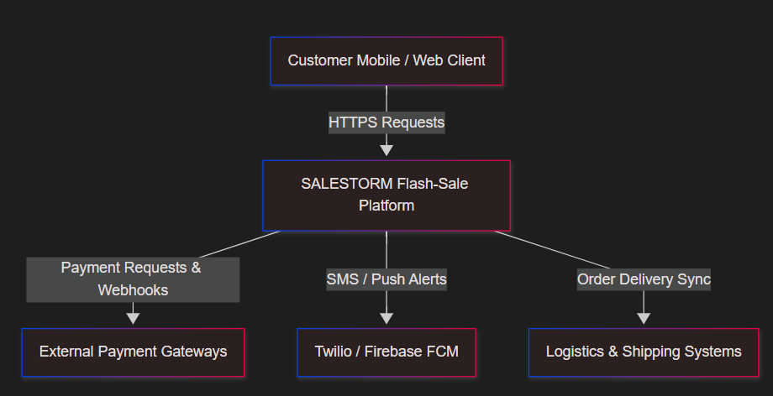
2.2 Container & Service Architecture Diagram
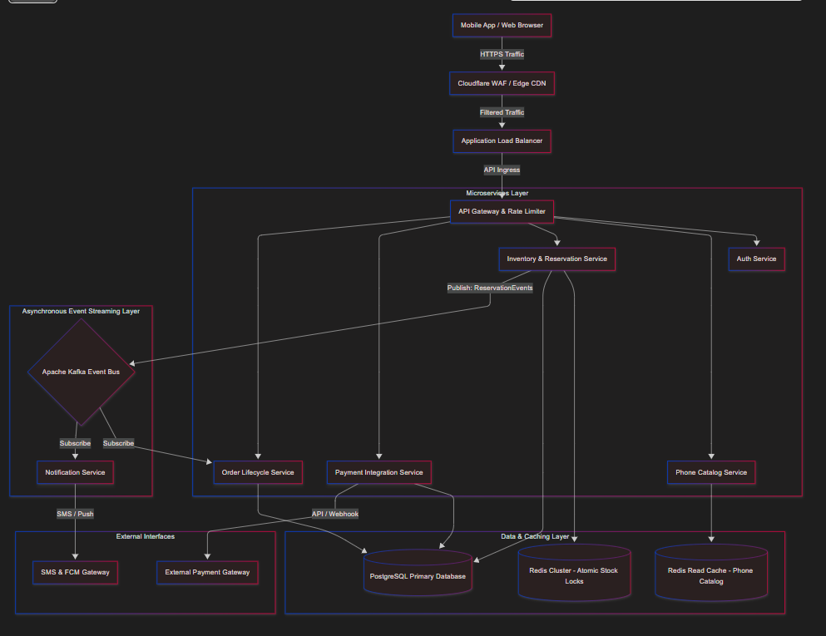

2.3 Deployment Architecture Overview
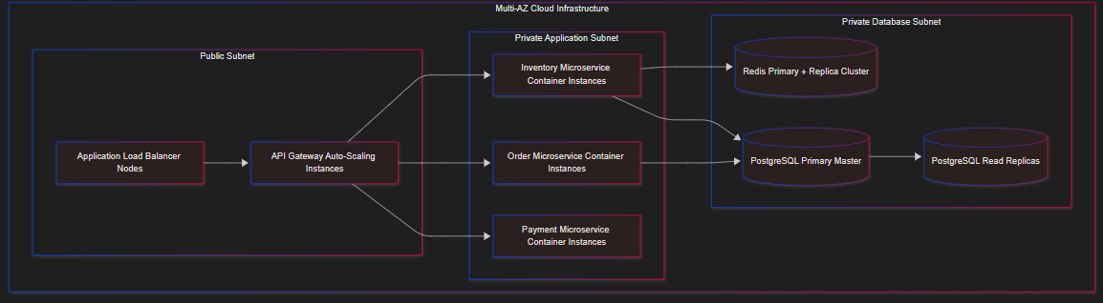
3. Low-Level Design (LLD) & Architecture
3.1 Class Diagram (Core Inventory, Checkout & Payment Modules)
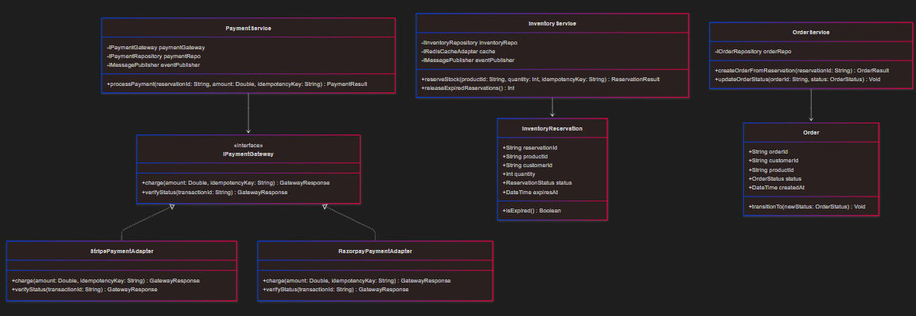
3.2 Sequence Diagram 1: Phone Reservation Workflow (10,000 Concurrent Requests)
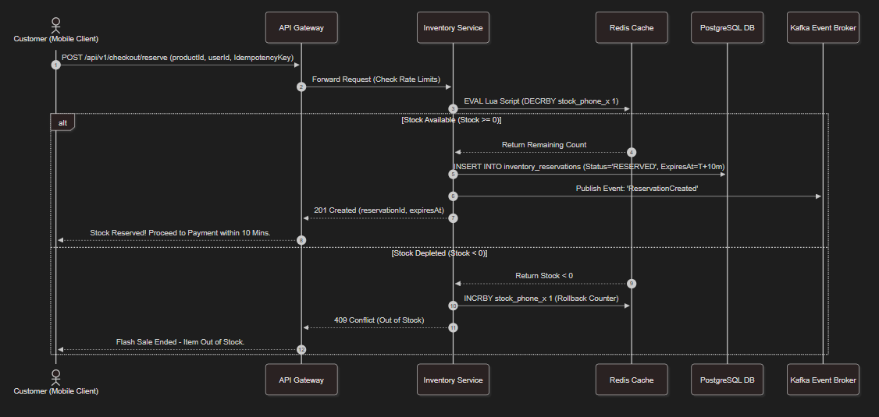

3.3 Sequence Diagram 2: Payment Processing & Timeout Recovery Workflow
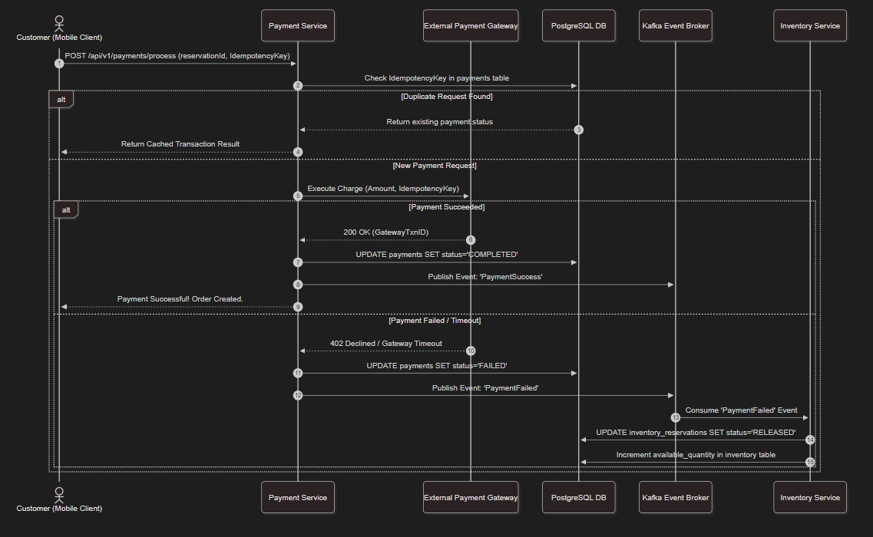
3.4 State Diagram: Phone Order Lifecycle & Reservation Transitions
