CUSTOMER SHOPPING BEHAVIOR
Customer & Sales Intelligence: An End-to-End Analysis
Business Analytics Report
Python (EDA & Data Cleaning) → PostgreSQL (Analysis) → Power BI (Dashboard)
Prepared for: Retail Management Team
Dataset: Customer Shopping Behavior (3,900 records, 18 attributes)
Report Date: July 2026

1. Executive Summary
This report analyzes a retail customer shopping behavior dataset of 3,900 transactions to help the management team understand purchasing patterns across demographics, product categories, and sales channels, and to identify which factors — discounts, reviews, seasonality, and payment preferences — most influence customer decisions and repeat purchases.
The analysis followed a three-stage pipeline: data was cleaned and prepared in Python (Jupyter Notebook), business questions were answered using PostgreSQL queries, and results were consolidated into an interactive Power BI dashboard for ongoing monitoring.
Headline results:
- Total revenue across the dataset is $233.08K, generated by 3.9K customers, with an average order value (AOV) of $59.76 and an average review rating of 3.75/5.
- Clothing is the dominant category, generating $104K in revenue — more than Accessories, Footwear, and Outerwear combined.
- Loyal customers (10+ previous purchases) make up 79.9% of the customer base, indicating a strong repeat-purchase culture, while genuinely new customers are only 3.97%.
- Only 7.3% of customers are on an active subscription, pointing to a significant untapped opportunity to convert one-time and returning shoppers into subscribers.
- Young Adults are the highest-revenue age group ($62K), but revenue is fairly evenly spread across all four age bands — no single group dominates.

2. Problem Statement
A leading retail company wants to better understand its customers' shopping behavior in order to improve sales, customer satisfaction, and long-term loyalty. Management has observed shifting purchasing patterns across demographics, product categories, and sales channels (online vs. offline), and is particularly interested in which factors — discounts, reviews, seasons, or payment preferences — drive consumer decisions and repeat purchases.
Overarching business question:
“How can the company leverage consumer shopping data to identify trends, improve customer engagement, and optimize marketing and product strategies?”

3. Methodology & Tools
The project was executed across three tools, each suited to a stage of the analytics workflow:
Stage | Tool | Purpose
Data Preparation | Python (Pandas, Jupyter Notebook) | Load raw CSV, audit data quality, clean and engineer features
Analysis | PostgreSQL | Load cleaned data into a relational table and run SQL queries to answer 10 targeted business questions
Reporting & Monitoring | Power BI | Build an interactive dashboard with slicers for gender, subscription, category, shipping, payment, and location

3.1 Data Cleaning & Preparation (Python)
The raw dataset (customer_shopping_behavior.csv) contained 3,900 rows and 18 columns. The following steps were performed in the Jupyter notebook before the data was loaded into PostgreSQL:
- Data audit: used df.info(), df.describe(include='all'), and df.isnull().sum() to inspect data types, distributions, and missing values.
- Missing values: 37 missing Review Rating values (0.9% of rows) were imputed using the median rating within each product Category, preserving category-level rating patterns rather than using a single global median.
- Column standardization: all column names were lower-cased and spaces replaced with underscores (e.g. 'Purchase Amount (USD)' → purchase_amount) for SQL compatibility.
- Feature engineering — age_group: customers were split into four equal-sized bands (Young Adult, Adult, Middle-Aged, Senior) using quartile binning (pd.qcut) on age.
- Feature engineering — purchase_frequency_days: the categorical frequency_of_purchases field (e.g. 'Weekly', 'Fortnightly', 'Annually') was mapped to a numeric day count to support quantitative comparisons.
- Redundant column removal: discount_applied and promo_code_used were found to be identical for every single row, so promo_code_used was dropped to avoid duplicated signal.
- Export: the cleaned DataFrame was written directly to PostgreSQL using SQLAlchemy (df.to_sql) into a table named customer_behavior_table, ready for SQL analysis.

3.2 Analysis (PostgreSQL)
Ten business questions were translated into SQL queries against customer_behavior_table, covering revenue by gender, discount behavior, product ratings, shipping cost comparisons, subscription value, customer segmentation, and age-group revenue contribution. Window functions (ROW_NUMBER) were used for top-N-per-category rankings, and a CTE was used to classify customers into New, Returning, and Loyal segments. The full query set is included in Appendix A.

3.3 Reporting (Power BI)
Query outputs and the cleaned dataset were visualized in a Power BI dashboard with cross-filtering slicers (Subscription, Gender, Category, Shipping Type, Payment Method, Location), enabling management to self-serve deeper cuts of the data beyond the ten core questions.

4. Dashboard Overview
The dashboard below summarizes overall performance and the key segments driving revenue.
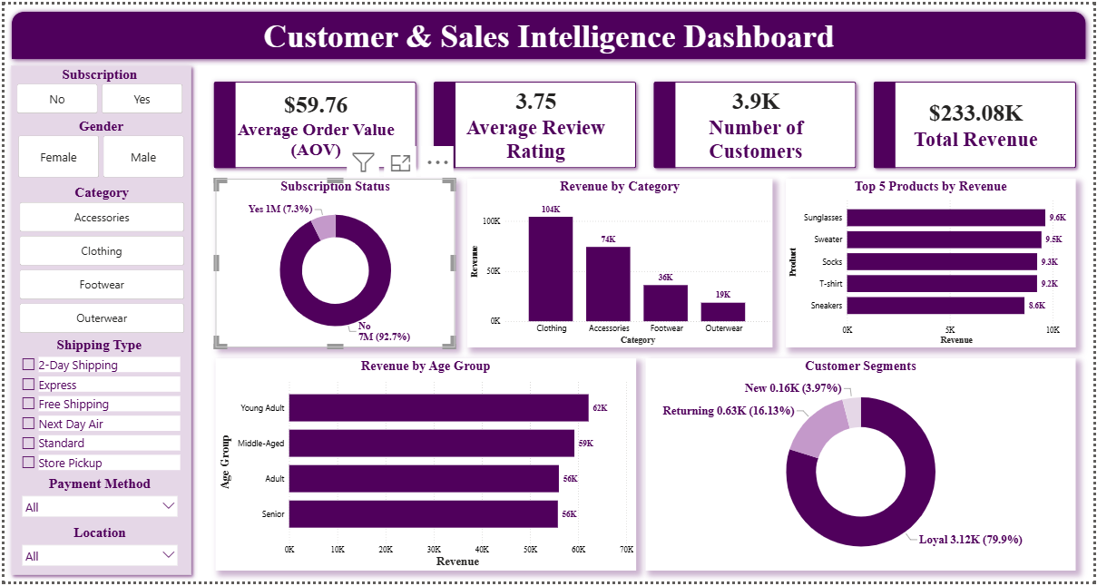
Figure 1. Customer & Sales Intelligence Dashboard (Power BI)

4.1 Top-Line Metrics
$233.08K  Total Revenue | 3.9K  Number of Customers | $59.76  Average Order Value | 3.75 / 5  Average Review Rating

4.2 Revenue by Category
Category | Revenue
Clothing | $104K
Accessories | $74K
Footwear | $36K
Outerwear | $19K
Clothing alone accounts for roughly 45% of total revenue, making it the category with the greatest influence on overall sales performance and the most sensitive to any pricing, discount, or inventory decisions.

4.3 Top 5 Products by Revenue
Rank | Product | Revenue
1 | Sunglasses | $9.6K
2 | Sweater | $9.5K
3 | Socks | $9.3K
4 | T-shirt | $9.2K
5 | Sneakers | $8.6K
Revenue is closely clustered among the top 5 products (within ~$1K of each other), suggesting broad-based demand rather than dependence on a single hero product.

4.4 Revenue by Age Group
Age Group | Revenue
Young Adult | $62K
Middle-Aged | $59K
Adult | $56K
Senior | $56K
Revenue contribution is fairly balanced across age bands (a ~$6K spread from highest to lowest), indicating the customer base is not concentrated in any single generation — marketing spend can reasonably be spread across age segments rather than narrowly targeted.

4.5 Customer Segments (by Previous Purchases)
Segment | Customers | Share
Loyal (2+ purchases) | 3.12K | 79.9%
Returning | 0.63K | 16.13%
New (1st purchase) | 0.16K | 3.97%
Nearly 8 in 10 customers already qualify as Loyal, meaning the file is dominated by repeat purchasers. This is a strong retention signal, but it also means new-customer acquisition is currently a very small share of activity and may deserve renewed marketing investment.

4.6 Subscription Status
Only 7.3% of customers hold an active subscription versus 92.7% who do not, despite Loyal customers making up the vast majority of the base. This gap — high repeat-purchase behavior but low subscription enrollment — is one of the clearest conversion opportunities in the data (see Section 6).

5. Business Questions & Findings
The ten questions below were the analytical brief for the SQL stage (Appendix A). Findings are reported where the Power BI dashboard provides a direct read-out; for questions not visualized on the current dashboard, the SQL logic used is summarized so results can be reproduced or added to the dashboard as a next iteration.
Q1. What is the total revenue generated by male vs. female customers?
Answered via a GROUP BY gender query summing purchase_amount. The dashboard's Gender slicer supports live drill-down by sex; the exact split was not captured in the current dashboard view and is recommended as a dashboard addition (see Section 7).
Q2. Which customers used a discount but still spent more than the average purchase amount?
Identified via a subquery comparing each discounted transaction's purchase_amount against the dataset-wide average ($59.76 AOV). This customer-level list is useful for identifying price-insensitive, high-value shoppers who could be prime candidates for premium or loyalty offers rather than discount-led promotions.
Q3. Which are the top 5 products with the highest average review rating?
Answered via GROUP BY item_purchased ordered by average review_rating. Note this is a distinct ranking from 'Top 5 Products by Revenue' (Section 4.3) — a product can rate highly without being a top revenue driver, or vice versa; cross-referencing both rankings can highlight under-marketed, well-loved products.
Q4. Compare the average purchase amount between Standard and Express shipping.
Answered via GROUP BY shipping_type filtered to the two methods. This comparison tests whether customers who pay for faster shipping also spend more per order — a useful input for shipping-tier pricing and promotion strategy.
Q5. Do subscribed customers spend more? Compare average spend and total revenue between subscribers and non-subscribers.
Answered via GROUP BY subscription_status with count, average, and total revenue. Combined with the dashboard's 7.3%-subscribed figure (Section 4.6), this tells management not just whether subscribers spend more per order, but how much upside exists if that 92.7% non-subscriber base were converted.
Q6. Which 5 products have the highest percentage of purchases made with a discount applied?
Answered via GROUP BY item_purchased, computing the share of transactions with discount_applied = 'Yes' per product. This flags products that may be over-reliant on discounting to sell, versus products (like the Section 4.3 top performers) that sell well at full price.
Q7. Segment customers into New, Returning, and Loyal based on total previous purchases, and show the count of each segment.
Implemented with a CTE classifying previous_purchases = 1 as New, 2–10 as Returning, and 11+ as Loyal. The dashboard's Customer Segments donut (Section 4.5) reflects this logic and confirms Loyal customers dominate the base at 79.9%.
Q8. What are the top 3 most purchased products within each category?
Implemented with ROW_NUMBER() OVER (PARTITION BY category ORDER BY order count DESC), returning the 3 best-selling items per Clothing, Accessories, Footwear, and Outerwear. This is the right granularity for category-level assortment and inventory decisions, complementing the overall Top 5 Products view.
Q9. Are repeat buyers (more than 5 previous purchases) also likely to subscribe?
Answered via a filtered GROUP BY on subscription_status restricted to previous_purchases > 5. Given only 7.3% of the overall base subscribes (Section 4.6), this query tests whether high-frequency buyers subscribe at a meaningfully higher rate — if not, it suggests subscription is being under-marketed specifically to the company's best customers.
Q10. What is the revenue contribution of each age group?
Answered via GROUP BY age_group summing purchase_amount, ordered by revenue descending. Fully reflected in the dashboard (Section 4.4): revenue is close to evenly split across Young Adult, Middle-Aged, Adult, and Senior groups.

6. Key Insights & Recommendations

6.1 Grow subscription enrollment
With 79.9% of customers already Loyal but only 7.3% subscribed, the biggest single lever available is converting existing repeat buyers into subscribers. Recommend a targeted subscription offer aimed specifically at the Returning and Loyal segments, using Q5/Q9 output to size the expected revenue lift.

6.2 Protect and expand Clothing, but reduce category concentration risk
Clothing drives ~45% of revenue. Recommend using the Q8 top-3-per-category output to ensure Accessories, Footwear, and Outerwear each have a clear 'hero' assortment, reducing dependence on a single category.

6.3 Re-balance discount strategy
Q6 identifies products that sell disproportionately on discount. Recommend comparing this list against the Q3 top-rated and Section 4.3 top-revenue products — well-rated, high-revenue products that don't need discounting are candidates for margin protection, while discount-dependent products may need a pricing or bundling review.

6.4 Reinvest in new-customer acquisition
New customers are only 3.97% of the base. While the high Loyal share is healthy for retention, the small New-customer share warrants attention to top-of-funnel marketing to sustain long-term growth rather than relying solely on the existing base.

6.5 Extend the dashboard
Add explicit visuals for revenue by gender (Q1), the discount-vs-average-spend customer list (Q2), and Standard-vs-Express spend comparison (Q4), since these currently exist only as SQL output and are not yet part of the live Power BI view.

7. Limitations
- Figures in this report for Sections 4 and 6 are drawn from the Power BI dashboard screenshots provided; underlying row-level SQL result sets for Q1, Q2, Q4, Q6, and Q9 were not exported alongside this report and are noted as reproducible-but-not-yet-visualized.
- The dataset represents a single snapshot in time (3,900 transactions); trend analysis over time (e.g. month-over-month or seasonal revenue movement) was not available in the source data beyond the Season attribute.
- Review ratings were imputed for 37 records (0.9%) using category-level medians; this is a minor, standard adjustment but is noted for transparency.

Appendix A: SQL Queries Used
The following queries were run against customer_behavior_table in PostgreSQL to answer Q1–Q10:
- Q1 — Total revenue by gender: SELECT gender, SUM(purchase_amount) AS total_revenue FROM customer_behavior_table GROUP BY gender;
- Q2 — Discount users spending above average: SELECT customer_id, purchase_amount FROM customer_behavior_table WHERE discount_applied = 'Yes' AND purchase_amount >= (SELECT AVG(purchase_amount) FROM customer_behavior_table);
- Q3 — Top 5 products by average review rating: SELECT item_purchased, ROUND(AVG(review_rating::numeric),2) FROM customer_behavior_table GROUP BY item_purchased ORDER BY AVG(review_rating) DESC LIMIT 5;
- Q4 — Standard vs Express average spend: SELECT ROUND(AVG(purchase_amount),2), shipping_type FROM customer_behavior_table WHERE shipping_type IN ('Express','Standard') GROUP BY shipping_type;
- Q5 — Subscriber vs non-subscriber spend: SELECT subscription_status, COUNT(customer_id), ROUND(AVG(purchase_amount),2), ROUND(SUM(purchase_amount),2) FROM customer_behavior_table GROUP BY subscription_status;
- Q6 — Top 5 products by discount rate: SELECT item_purchased, ROUND(100*SUM(CASE WHEN discount_applied='Yes' THEN 1 ELSE 0 END)/COUNT(*),2) FROM customer_behavior_table GROUP BY item_purchased ORDER BY discount_rate DESC LIMIT 5;
- Q7 — Customer segmentation (New/Returning/Loyal): CTE classifying previous_purchases, then COUNT(*) GROUP BY customer_segment.
- Q8 — Top 3 products per category: CTE with ROW_NUMBER() OVER (PARTITION BY category ORDER BY COUNT(customer_id) DESC), filtered to rank <= 3.
- Q9 — Repeat buyers (>5 purchases) subscription rate: SELECT subscription_status, COUNT(customer_id) FROM customer_behavior_table WHERE previous_purchases > 5 GROUP BY subscription_status.
- Q10 — Revenue by age group: SELECT age_group, SUM(purchase_amount) FROM customer_behavior_table GROUP BY age_group ORDER BY total_revenue DESC.

