**Project : LOCKEME.COM**

**Developer details : Yogita Shende**

* **Sprints planned and the tasks achieved in them.**

1. It has total 2 weeks of plan in which need to decide functionality of this application. It is used to perform various file operations like add , delete search and display all the files.

2. In first weeks , we discussed the flow of operation and input requirement provided into that application. Eclipse IDE is used for Java coding and module programming need to done into Java code

3. Created different module separately, for deletion, searching the file, adding the file and displaying file present at a instance and validated test case with different input

4. Implemented of all this module into single programs and validate it in combined. Validated every possible cases where exception thrown and handled it.

* **Algorithms and flowcharts of the application**

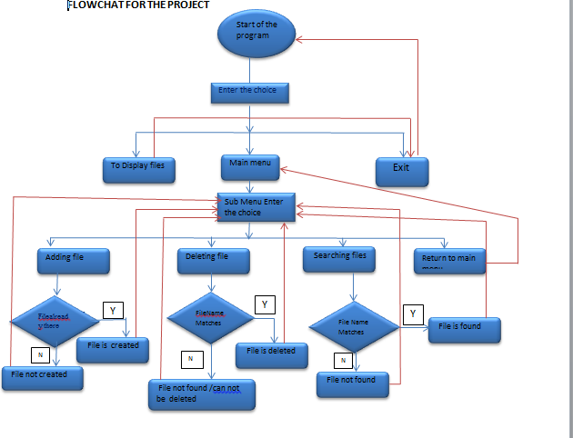

* **Core concepts used in the project**

1.Created program module for display , Main menu and exit operation from main program.

2.Created program module to perform following operations i.e Add , delete, search file , then exit from these operation and returned to main menu.

3. Using Switch cases, program flow goes into choice provided by the end user

4. Then source code pushed Into GitHub repository.

* **Links to the GitHub repository to verify the project completion**

**Link :https://github.com/Yogita5678/-JAVA--FSD-Phase1project-**

* **Your conclusion on enhancing the application and defining the USPs (Unique Selling Points)**

1.This application is specifically designed to perform various operation of file handling like displaying all the file present into particular directory.

2. There is also option for adding and deletion of files form the directory.

3. Application allowed to search an specific files into directory . It enabled proper flow to return to main menu and exist from application at any point.