01. Write a program that takes radius of a circle as input. Read the entered radius using Scanner class. Then calculate and print the area and circumference of the circle.

**import java.util.Scanner;**

**class Q1**

**{**

**public static void main(String[] args)**

**{**

**Scanner sc=new Scanner(System.in);**

**System.out.print("Enter radius of circle: ");**

**int r=sc.nextInt();**

**System.out.println("Area of circle is: "+ (r*r));**

**System.out.println("Circumference of circle is: "+(2*3.24*r));**

**}**

**}**

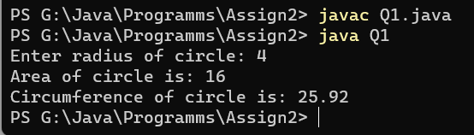

02. Write a program to calculate sum of 5 subject’s marks & find percentage. Take the obtained marks from user using Scanner class. Output should be in this format [ percentage marks = 99 % ]. Use concatenation operator here.

import java.util.Scanner;

class Q2

{

static public void main(String[] args)

{

Scanner sc=new Scanner(System.in);

System.out.println("Enter marks for Linux: ");

int m1=sc.nextInt();

System.out.println("Enter marks for Cloud: ");

int m2=sc.nextInt();

System.out.println("Enter marks for python: ");

int m3=sc.nextInt();

System.out.println("Enter marks for R: ");

int m4=sc.nextInt();

System.out.println("Enter marks for Java: ");

int m5=sc.nextInt();

int total=m1+m2+m3+m4+m5;

float avg=total/5;

//int per= int(avg);

System.out.println("Total Marks are: "+ total);

//System.out.println("Average marks: " + avg);

System.out.println("Percentage marks= " + avg + "%");

}

}

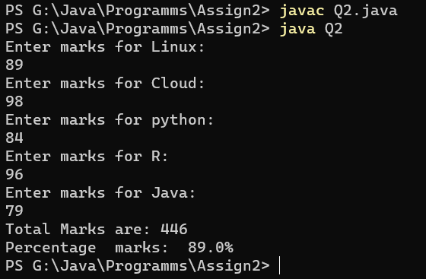

03. Write a program to find the simple interest. Take the principle amount, rate of interest and time from user using Scanner class.

import java.util.Scanner;

class Q3

{

public static void main(String[] args)

{

Scanner sc=new Scanner(System.in);

System.out.println("Enter Priciple amount: ");

int p=sc.nextInt();

System.out.println("Enter time in years: ");

int t=sc.nextInt();

System.out.println("Enter rate of interest: ");

Float r=sc.nextFloat();

float interest=(p*t*r)/100;

System.out.print("Simple Interest is: "+interest);

}

}

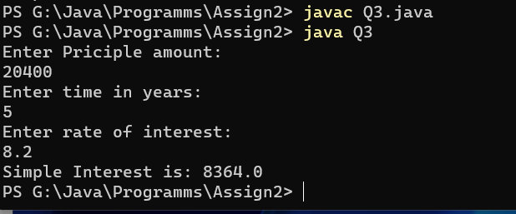

04. Write a program to read the days (eg. 670 days) as integer value using Scanner class. Now convert the entered days into complete years, months and days and print them.

**import java.util.Scanner;**

**class Q4**

**{**

**public static void main(String[] args)**

**{**

**Scanner sc=new Scanner(System.in);**

**System.out.println("Enter number of days you want to convert to years, months and days: ");**

**int t_day=sc.nextInt();**

**int year,month,days;**

**year=t_day/365;**

**int rem=t_day%365;**

**month=rem/12;**

**days=rem%12;**

**System.out.print("years:"+ year+ " months:"+month+ " days: "+days);**

**}**

**}**

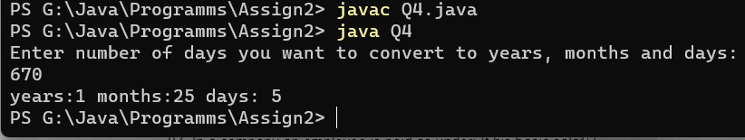

05. Write a program to convert temperature from Fahrenheit to Celsius. Take Fahrenheit as input using Scanner class. [ formula : C= 5*(f-32)/9 ]

**import java.util.Scanner;**

**class Q5**

**{**

**public static void main(String[] args)**

**{**

**Scanner sc=new Scanner(System.in);**

**System.out.println("Enter temperature in Fahrenheit to conver to Celsius");**

**int f=sc.nextInt();**

**float C= 5*(f-32)/9;**

**System.out.print("Temperature in Celsius: "+C);**

**}**

**}**

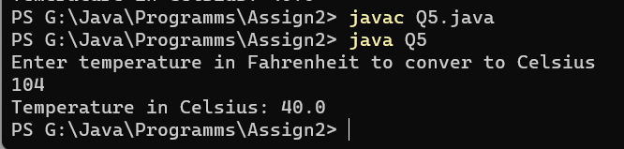

06. Write a program to swap two numbers without using third variable.

import java.util.Scanner;

**class Q6**

**{**

**public static void main(String[] args)**

**{**

**Scanner sc=new Scanner(System.in);**

**System.out.println("Enter two numbers: ");**

**int a=sc.nextInt();**

**int b=sc.nextInt();**

**System.out.println("Numbers before swap are: "+a+" "+b);**

**b=a+b;**

**a=b-a;**

**b=b-a;**

**System.out.println("Numbers after swap are: "+a+" "+b);**

**}**

**}**

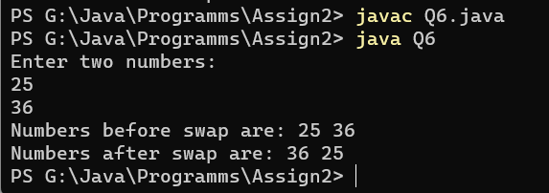

07. In a company an employee is paid as under: If his basic salary is less than Rs. 10000, then HRA = 10% of basic salary and DA = 90% of basic salary. If his salary is either equal to or above Rs. 10000, then HRA = Rs. 2000 and DA = 98% of basic salary. If the employee's salary is input by the user write a program to find his gross salary. [ formula : GS= Basic + DA + HRA ]

import java.util.Scanner;

class Q7

{

public static void main(String[] args)

{

Scanner sc=new Scanner(System.in);

System.out.println("Enter your Salary: ");

int sal=sc.nextInt();

Double hra=0.0;

Double da=0.0;

if (sal<10000)

{

hra=sal*.10;

da=sal*.90;

}

else if(sal>=10000)

{

hra=2000.0;

da=sal*.98;

}

double gr_sal=sal+hra+da;

System.out.print("Gross Salary is: "+gr_sal);

}

}

