**Assingment-1**

1. Basic HTML Document An element called HTML surrounds the whole document. This element contains two sub-elements, HEAD and BODY. These elements are required to form any HTML document.

<html>

<head>

<title> The First Page </title>

</head>

<body>

Hello World

</body>

</html>

Just write down above code in the notepad editor and save this file with the extension of .html or .htm and then double click on that file you will get output on the default web browser.

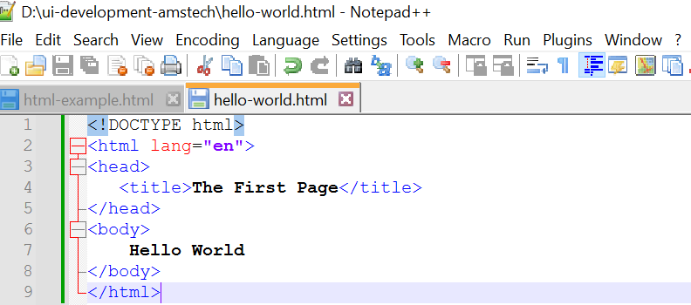

**Output:**

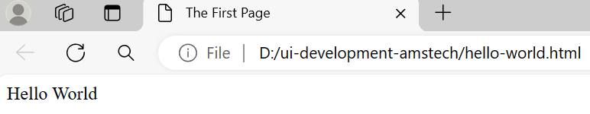

1. Create a static webpage using table tags of HTML

**Program:**

|  |
| --- |
| <!DOCTYPE html>  <html lang="en">  <head>      <meta charset="UTF-8">      <meta name="viewport" content="width=device-width, initial-scale=1.0">      <title>Table</title>  </head>  <style>      table, th, td {        border:1px solid black;      }      </style>  <body>      <table>          <tr>              <th>Unit no.</th>              <th>Unit Title</th>              <th>Teaching Hours</th>              <th colspan="4">Distribution of theory label</th>          </tr>          <tr>              <td></td>              <td></td>              <td></td>              <td>R Level</td>              <td>U Level</td>              <td>A Level</td>              <td>Total Marks</td>          </tr>          <tr>              <td>I</td>              <td>Introduction to Internet Technology</td>              <td>2</td>              <td>4</td>              <td>4</td>              <td>0</td>              <td>8</td>          </tr>          <tr>              <td>II</td>              <td>Basics of HTML & CSS</td>              <td>6</td>              <td>0</td>              <td>2</td>              <td>6</td>              <td>8</td>          </tr>          <tr>              <td>III</td>              <td>Active Server Pages 3.0</td>              <td>6</td>              <td>4</td>              <td>8</td>              <td>0</td>              <td>12</td>          </tr>          <tr>              <td>IV</td>              <td>Server Side Coding with VBScript and XML</td>              <td>6</td>              <td>2</td>              <td>4</td>              <td>8</td>              <td>14</td>          </tr>          <tr>              <td>V</td>              <td>ASP Objects & Components</td>              <td>10</td>              <td>4</td>              <td>4</td>              <td>6</td>              <td>14</td>          </tr>          <tr>              <td>VI</td>              <td>Accessing database with ASP & ADO</td>              <td>10</td>              <td>4</td>              <td>4</td>              <td>6</td>              <td>14</td>          </tr>          <tr>              <td></td>              <td><b>Total</b></td>              <td>42</td>              <td>18</td>              <td>26</td>              <td>26</td>              <td>70</td>          </tr>      </table>  </body>  </html> |

**Output:**

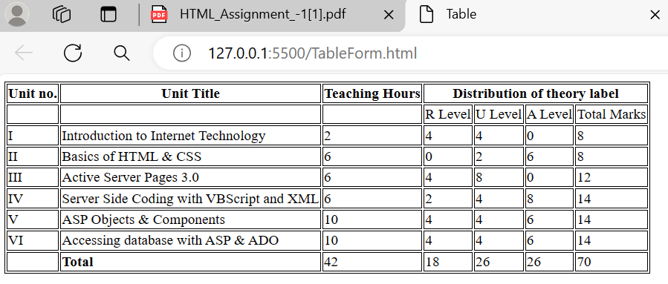

1. **Create employee registration webpage using HTML form objects**

|  |
| --- |
| <!DOCTYPE html>  <html lang="en">  <head>      <meta charset="UTF-8">      <meta name="viewport" content="width=<device-width>, initial-scale=1.0">      <title>Document</title>  </head>  <body>      <h1 style="color: #f41717; text-align: center;"> Employee Registration Form</h1>      <form>          <div class="container">              <table style="text-align: center; margin-left: 200px;">                  <tr>                      <td> <input type="radio" name="Mr." /> Mr.</td>                      <td> <input type="radio" name="Mrs." /> Mrs. </td>                      <td> <input type="radio" name="Ms." /> Ms.</td>                  </tr>              </table> <br><br>              <label style=" margin-left: 10px;" for="fisrt name">First Name</label>              <input style=" margin-left: 130px;" type="text" placeholder="First Name" name="first name" id="first name"                  required><br><br>              <label style=" margin-left: 10px;" for="last name">Last Name</label>              <input style=" margin-left: 130px;" type="text" placeholder="Last Name" name="last name" id="last name"                  required><br><br>              <label style=" margin-left: 10px;" for="mail address1">Mail Address1</label>              <input style=" margin-left: 105px;" type="text" name="mail address1" id="mail address1"><br><br>              <label style=" margin-left: 10px;" for="mail address2">Mail Address2</label>              <input style=" margin-left: 105px;" type="text" name="mail address2" id="mail address2"><br><br>              <label style=" margin-left: 10px;" for="city">City</label>              <input style=" margin-left: 170px;" type="text" name="city" id="city"><br><br>              <label style=" margin-left: 10px;" for="state">State</label>              <select style=" margin-left: 165px;">                  <option value="=Madhya Pradesh"> Madhya Pradesh</option>                  <option value="Gujarat">Gujarat</option>   1. <option value="Mumbai">Mumbai</option>                   <option value="Delhi">Delhi</option>                  <option value="Uttar Pradesh">Uttar Pradesh</option>                  <option value="Hydrabad">Hydrabad</option>              </select><br><br>              <label style=" margin-left: 10px;" for="zip">Zip</label>              <input style=" margin-left: 175px;" type="text" name="zip" id="zip" size="20"><br><br>              <label style=" margin-left: 10px;" for="uploadfile">Upoad File</label>              <button style=" margin-left: 125px;" type="button" name="browse" id="browse">Browse</button><br><br>              <label style=" margin-left: 10px;" for="email">E-mail</label>              <input style=" margin-left: 155px;" type="text" name="email" id="email"><br><br>              <label style=" margin-left: 10px;" for="mobilenumber">Mobile-Number</label>              <input style=" margin-left: 90px;" type="text" placeholder="+91" name="mobilenumber" id="mobilenumber"><br><br>              <label style=" margin-left: 10px;" for="text" name="language">Language known</label>              <input style=" margin-left: 80px;" type="checkbox" name="hindi" id="hindi" checked>Hindi</input><br>              <input style=" margin-left: 200px;" type="checkbox" name="gujarati" id="gujarati">Gujarati</input><br>              <input style=" margin-left: 200px;" type="checkbox" name="english" id="english" checkbox>English</input><br>              <input style=" margin-left: 200px;" type="checkbox" name="marathi" id="marathi">Marathi</input><br>              <table>                  <tr>                      <td> <label style=" margin-left: 10px; width: 30%;" for="additionalinformation">Additional-Information</label>                      </td>                      <td style=" margin-left: 50px;"> <textarea id="additionalinformation" name="additionalinformation" rows="5" cols="40"                              placeholder="Optional"></textarea>                      </td>                  </tr>              </table>              <br> <button style=" margin-left: 200px;" type="submit" name="submit" id="submit">Submit</button>              <button style=" margin-left: 10px;" type="reset" name="reset" id="reset">Reset</button>          </div>      </form>  </body>  </html> |

**Output:**

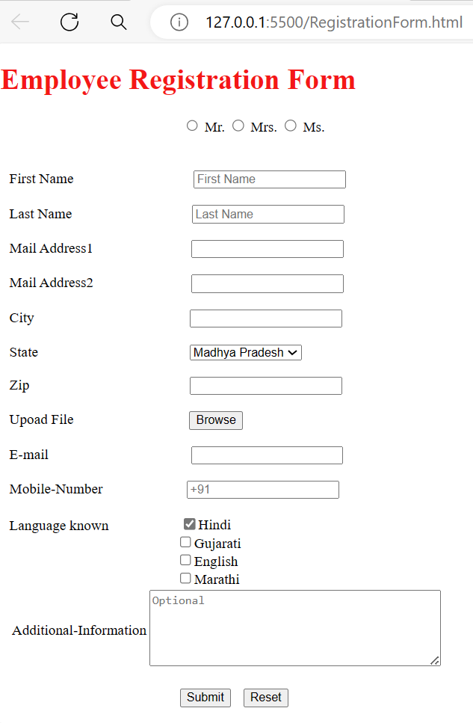

**4.Create a static web page which defines all text formatting tags of HTML in tabular format .**

**Program:**

<!DOCTYPE html>

<html lang="en">

<head>

    <meta charset="UTF-8">

    <meta name="viewport" content="width=device-width, initial-scale=1.0">

    <title>TextFormatting</title>

</head>

<style>

    table,th,td{

        border: 1px solid black;

    }

</style>

<body>

    <h2 style="color: red;">Text-Formatting Tags</h2>

    <table>

        <tr>

            <th>HTML Tags</th>

            <th>Output</th>

        </tr>

        <tr>

            <td>normal text</td>

            <td>hello word</td>

        </tr>

        <tr>

            <td>Font & its attributes</td>

            <td style="font-size: large; color: blue;">hello word </td>

        </tr>

        <tr>

            <td>&ltB&gt</td>

            <td><b>bold</b></td>

        </tr>

        <tr>

            <td>&ltI&gt</td>

            <td><u>Underline</u></td>

        </tr>

        <tr>

            <td>&ltEM&gt</td>

            <td><em>Emphasis</em></td>

        </tr>

        <tr>

            <td>&ltSTRONG&gt</td>

            <td><strong>STRONG</strong></td>

        </tr>

        <tr>

            <td>&ltTELETYPE&gt</td>

            <td><teletype>TELETYPE</teletype></td>

        </tr>

        <tr>

            <td>&ltCITE&gt</td>

            <td><cite>Citation</cite></td>

        </tr>

        <tr>

            <td>&ltSTRIKE&gt</td>

            <td><strike>strike through text</strike></td>

        </tr>

        <tr>

            <td>&ltBIG&gt</td>

            <td><big>text in a big font</big></td>

        </tr>

        <tr>

            <td>&ltSMALL&gt</td>

            <td><small>text in small font</small></td>

        </tr>

        <tr>

            <td>&ltSUB&gt</td>

            <td>a<sub>b</sub></td>

        </tr>

        <tr>

            <td>&ltSUP&gt</td>

            <td>a<sup>b</sup></td>

        </tr>

    </table>

    </body>

</html>

**Output:**

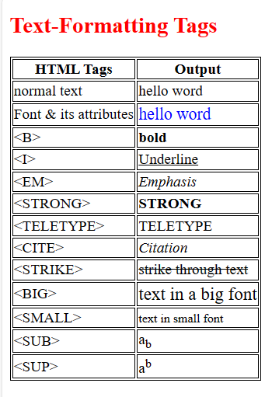

1. **Create webpage using list tags of HTML.**

**Program:**

<!DOCTYPE html>

<html lang="en">

<head>

    <meta charset="UTF-8">

    <meta name="viewport" content="width=device-width, initial-scale=1.0">

    <title>listTags</title>

</head>

<body>

    <h2>HTML List: Ordered,Unordered & Definition List</h2><hr>

    <h4>Following is the list proposed student sctivities like:</h4><hr>

    <ol>

        <li> Develop Programs releted with unit vice topics in computer laboratory.</li>

        <li>Develop any module of to be useful in real life application.</li>

        <li>Multimedia presentation of module developed by students.</li>

    </ol><hr>

    <h4>List of Software/Learning websites</h4>

    <ul>

        <li><u>ASP Tutorial-W3School</u></li>

        <a href="www.w3school.com/asp">www.w3school.com/asp</a>

        <li><u>Classic ASP Toturials & Articles-web Wiz</u></li>

        <a href="www.webwiz.co.uk-knowledgebase">www.webwiz.co.uk-knowledgebase</a>

        <li><u>HTML Tutorial - w3school</u></li>

        <a href="www.w3schools.com/html">www.w3schools.com/html</a>

        <li><u>CSS Tutorial</u></li>

        <a href="www.csstutorial.net">www.csstutorial.net</a>

        <li><u>VBScript Tutorial-Tutorial Point</u></li>

        <a href="www.tutorialpoints.com/vbscript/index.htm">www.tutorialpoints.com/vbscript/index.htm</a>

        <li><u>ADO Tutorial - W3Schools</u></li>

        <a href="www.w3schools.com/ADO/default.asp">www.w3schools.com/ADO/default.asp</a>

    </ul>

<hr>

    <dl>

        <dt><b>HTML</b></dt>

        <dd>Hyper Text Markup Language</dd>

        <dt><b>XML</b></dt>

        <dd>eXtensible Markup Language</dd>

    </dl>

</body>

</html>

**Output:**

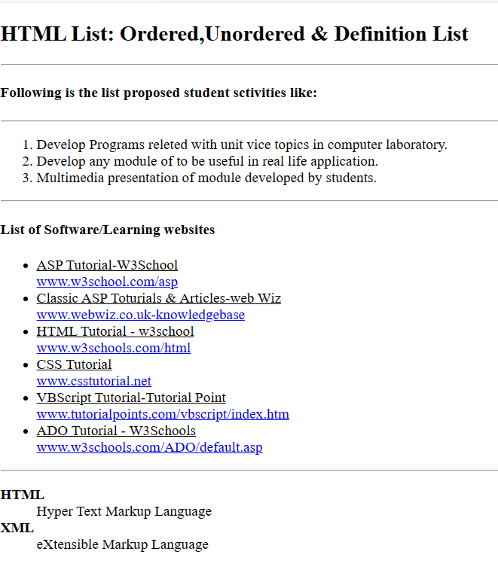

1. **. Create webpage to include image using HTML tag.**

**Program:**

<!DOCTYPE html>

<html lang="en">

<head>

    <meta charset="UTF-8">

    <meta name="viewport" content="width=device-width, initial-scale=1.0">

    <title>Image</title>

</head>

<body>

    <h2>Image-Example</h2>

    <img src="ietdavvmblock.webp"alt="It is a bird image" width="400" height="300">

</body>

</html>

**Output:**

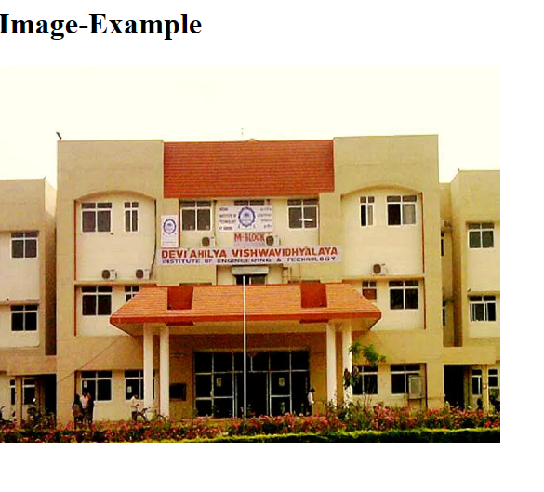

1. **Modify your page so that the picture that is on your page will also serve as a link that leads to another page.**

**Program:**

<!DOCTYPE html>

<html lang="en">

<head>

    <meta charset="UTF-8">

    <meta name="viewport" content="width=device-width, initial-scale=1.0">

    <title>Documents</title>

</head>

<body>

    <h2>Create a link to connect another page</h2>

    <a href="image.html">Go to Image page</a>

</body>

</html>

**Output:**

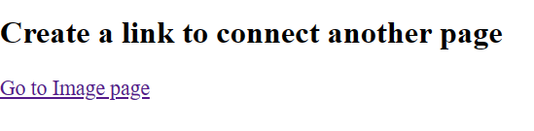



**Assignment-2**

1. **Write a JavaScript program to find all the index positions of a given word within a given string**

**Program:**

<!DOCTYPE html>

<html>

<body>

<h1>JavaScript Strings</h1>

<h2>The indexOf() Method</h2>

<p>This is find index program in javascript.</p>

<p>Find "program":</p>

<p id="demo"></p>

<script>

let text = "This is find index program in javascript.";

let result = text.indexOf("program");

document.getElementById("demo").innerHTML = result;

</script>

</body>

</html>

**Output:**

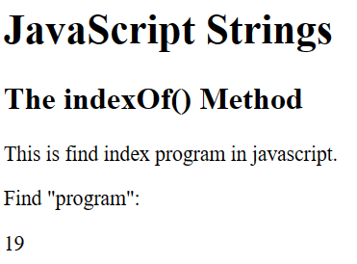

1. **Write a JavaScript program to find the first index of a given element in an array using the linear search algorithm.**

**Program:**

function linearSearch(arr, target) {

for (let i = 0; i < arr.length; i++) {

if (arr[i] === target) {

return i; // Return the index if found

}

}

return -1; // Return -1 if the element is not found in the array

}

// Example usage:

const array = [5, 10, 15, 20, 25];

const targetElement = 15;

const index = linearSearch(array, targetElement);

if (index !== -1) {

console.log(The element ${targetElement} is found at index ${index}.);

} else {

console.log(The element ${targetElement} is not found in the array.);

}

Output:



**3.Write a JavaScript program to sort a list of elements using Quick sort**

**Program:**

<!DOCTYPE html>

<html lang="en">

<head>

    <meta charset="UTF-8">

    <meta name="viewport" content="width=device-width, initial-scale=1.0">

    <title>Document</title>

</head>

<body>

   <p>Unsorted Array: 0, 10, 4, 1, 3,20,65,43</p>

       <script>

        function Quicksort(array){

           if (array.length < 2){

              return array;

           }

           let pivot_element = array[array.length - 1]

           let left_sub_array = [];

           let right_sub_array = [];

           for (let i = 0; i < array.length - 1; i++){

              if (array[i] < pivot_element) {

                 left_sub_array.push(array[i])

              } else {

                 right_sub_array.push(array[i])

              }

           }

           return [...Quicksort(left_sub_array), pivot_element, ...Quicksort(right_sub_array)];

        }

        const array = [0, 10, 4, 1, 3,20,65,43];

        document.write(“The sorted array: “,Quicksort(array));

     </script>

</body>

</html>

**Output:**

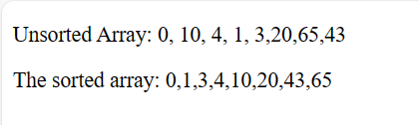

4.Write a JavaScript program to sort a list of elements using Merge sort.

**Program:**

<!DOCTYPE html>

<html lang="en">

<head>

    <meta charset="UTF-8">

    <meta name="viewport" content="width=device-width, initial-scale=1.0">

    <title>Document</title>

</head>

<body>

   <p>

      Unsorted Array: 39, 28, 44, 4, 10, 83, 11 </p>

    <script>

        function merge_Arrays(left_sub_array, right_sub_array) {

           let array = []

           while (left_sub_array.length && right_sub_array.length) {

              if (left_sub_array[0] < right_sub_array[0]) {

                 array.push(left_sub_array.shift())

              } else {

                 array.push(right_sub_array.shift())

              }

           }

           return [ ...array, ...left_sub_array, ...right_sub_array ]

        }

        function merge_sort(unsorted_Array) {

           const middle_index = unsorted_Array.length / 2

           if(unsorted_Array.length < 2) {

              return unsorted_Array

           }

           const left_sub_array = unsorted_Array.splice(0, middle_index)

           return merge_Arrays(merge_sort(left_sub_array),merge_sort(unsorted_Array))

        }

        unsorted_Array = [39, 28, 44, 4, 10, 83, 11];

        document.write("The sorted array will be: ",merge_sort(unsorted_Array));

     </script>

</body>

</html>

**Output:**

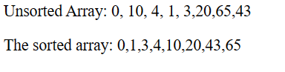

**5. Write a JavaScript program to sort a list of elements using heap sort.**

**Program:**

function heapSort(arr) {

  buildMaxHeap(arr);

  for (let i = arr.length - 1; i > 0; i--) {

  swap(arr, 0, i);

  heapify(arr, 0, i);

  }

  return arr;

  }

  function buildMaxHeap(arr) {

  const mid = Math.floor(arr.length / 2);

  for (let i = mid; i >= 0; i--) {

  heapify(arr, i, arr.length);

  }

  }

  function heapify(arr, i, max) {

  let largest = i;

  const left = 2 * i + 1;

  const right = 2 * i + 2;

  if (left < max && arr[left] > arr[largest]) {

  largest = left;

  }

  if (right < max && arr[right] > arr[largest]) {

  largest = right;

  }

  if (largest !== i) {

  swap(arr, i, largest);

  heapify(arr, largest, max);

  }

  }

  function swap(arr, i, j) {

  const temp = arr[i];

  arr[i] = arr[j];

  arr[j] = temp;

  }const unsortedArray = [5, 3, 7, 2, 9, 1, 6, 4, 8];

  const sortedArray = heapSort(unsortedArray);

  console.log("Sorted array using Heap Sort:", sortedArray);

**Output:**

Sorted Array: 1,2,3,4,5,6,7,8,9

**6 .** **Write a JavaScript program to sort a list of elements using Insertion sort.**

**Program:**

<!DOCTYPE html>

<html lang="en">

<head>

    <meta charset="UTF-8">

    <meta name="viewport" content="width=<device-width>, initial-scale=1.0">

    <title>Document</title>

</head>

<body>

    <p>Unsorted array: 12, 11, 13, 5, 6,76,9 </p>

    <p>Sorted Array</p>

    <script>

function insertionSort(arr, n) {

            let i, key, j;

            for (i = 1; i < n; i++) {

                key = arr[i];

                j = i - 1;

                while (j >= 0 && arr[j] > key) {

                    arr[j + 1] = arr[j];

                    j = j - 1;

                }

                arr[j + 1] = key;

            }

        }

        function printArray(arr, n) {

            let i;

            for (i = 0; i < n; i++)

                document.write(arr[i] + " ");

            document.write("<br>");

        }

let arr = [12, 11, 13, 5, 6, 76, 9];

        let n = arr.length;

insertionSort(arr, n);

        printArray(arr, n);

    </script>

</body>

</html>

**Output:**

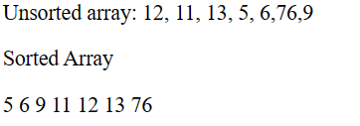

1. **Write a JavaScript program to sort a list of elements using Bubble sort.**

**Program:**

function bubbleSort(arr) {

    const len = arr.length;

    let swapped;

    do {

    swapped = false;

    for (let i = 0; i < len - 1; i++) {

    if (arr[i] > arr[i + 1]) {

    const temp = arr[i];

    arr[i] = arr[i + 1];

    arr[i + 1] = temp;

    swapped = true;

    }

    }

    } while (swapped);

    return arr;

    }

    const unsortedArray = [5, 3, 7, 2, 9, 1, 6, 4, 8];

    const sortedArray = bubbleSort(unsortedArray);

    console.log("Sorted array using Bubble Sort:", sortedArray)

**Output:**

Sorted Array: 1,2,3,4,5,6,7,8,9

1. **Write a JavaScript program to sort the characters in a string alphabetically.**

**Program:**

function sortStringAlphabetically(str) {

    return str.split('').sort().join('');

    }

    const inputString = "I LOVE INDIA";

    const sortedString = sortStringAlphabetically(inputString);

    console.log("Sorted characters in the string:",

    sortedString);

**output:**

Sorted characters in the string: ADEIIILNOV

1. **Write a JavaScript program to check if a numeric array is sorted or not.**

**Program:**

function isArraySorted(arr) {

    for (let i = 1; i < arr.length; i++) {

    if (arr[i] < arr[i - 1]) {

    return false;

    }

    }

    return true;

    }

    const sortedArray = [1, 2, 3, 4, 5];

    console.log(`${sortedArray ? "array is sorted": "array is not sorted"}`);

**Output:**

array is sorted

1. **Write a JavaScript function to validate whether a given value type is null or not.**

**Program:**

function isNull(value) {

    return value === null;

    }

    const value1 = null;

    const value2 = 57;

    console.log("Is value1 null?", isNull(value1));

    console.log("Is value2 null?", isNull(value2));

**Output:**

Is value1 null? true

Is value2 null? False

1. **Write a JavaScript function to validate whether a given value is a number or not.**

**Program:**

function isNumber(value) {

    return typeof(value) === 'number' && !isNaN(value);

    }

    const value1 = 63;

    const value2 = "COUNTRY";

    console.log("Is value1 a number?", isNumber(value1));

    console.log("Is value2 a number?", isNumber(value2));

**Output:**

**Is value1 a number? true**

**Is value2 a number? false**

**12. Write a JavaScript function to validate whether a given value is RegExp or not**

**Program:**

function isRegExp(value) {

    return value instanceof RegExp;

    }

    const value1 = /test/;

    const value2 = "fail or pass";

    console.log("Is value1 a RegExp?", isRegExp(value1));

    console.log("Is value2 a RegExp?", isRegExp(value2));

**output:**

Is value1 a RegExp? true

Is value2 a RegExp? False

1. **Write a JavaScript program to delete the rollno property from the following object. Also print the object before or after deleting the property. Sample object:**

**var student = {**

**name : "David Rayy",**

**sclass : "VI",**

**rollno : 12**

**};**

**Program:**

var student = {

  name: "David Rayy",

  sclass: "VI",

  rollno: 12

  };

  console.log("Before deleting rollno property:", student);

  delete student.rollno;

  console.log("After deleting rollno property:", student);

**Output:**

**Before deleting rollno property: { name: 'David Rayy',**

**sclass: 'VI', rollno: 12 }**

**After deleting rollno property: { name: 'David Rayy',**

**sclass: 'VI' }**

**14.** **Write a JavaScript program to display the reading status (i.e. display book name, author name and reading status) of the following books.**

**var library =**

**[ { author: 'Bill Gates',**

**title: 'The Road Ahead',**

**readingStatus: true**

**},**

**{ author: 'Steve Jobs',**

**title: 'Walter Isaacson',**

**readingStatus: true**

**},**

**{ author: 'Suzanne Collins',**

**title: 'Mockingjay: The Final Book of The Hunger Games',**

**readingStatus: false**

**}];**

**Program:**

<html>

    <head>

<script>

var library = [

{

author: 'Bill Gates',

title: 'The Road Ahead',

readingStatus: true

},

{

author: 'Steve Jobs',

title: 'Walter Isaacson',

readingStatus: true

},

{

author: 'Suzanne Collins',

title: 'Mockingjay: The Final Book of The Hunger Games',

readingStatus: false

}];

var i=0;

for(i=0;i<library.length;i++)

{

    if(library[i].readingStatus == true)

    {

        document.write("<br><p><h3>" + library[i].title + "</h3> Book <b>Is</b> In Reading Status</p>");

    }

    else

    {

        document.write("<br><p><h3>" + library[i].title + "</h3> Book <b>Is Not</b> In Reading Status</p>");

    }

}

</script>

</head>

    <body>

    </body>

</html>

**Output:**

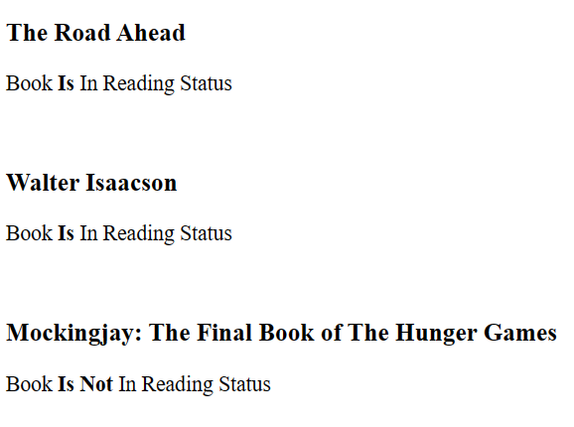

1. Write a JavaScript program to create a clock. Note: The output will come every second. Expected Console Output : "14:37:42" "14:37:43" "14:37:44" "14:37:45" "14:37:46" "14:37:47".
2. function updateClock() {
3. const now = new Date();
4. console.log(`${(now.getHours()).toFixed(0)}:${now.getMin
5. utes()}:${now.getSeconds()}`);
6. }
7. setInterval(updateClock, 1000);

Output:

17:10:11

17:10:12

17:10:13

17:10:14

17:10:15

17:10:17

**16. Write a JavaScript function to split a string and convert it into an array of words.**

**Program:**

function splitStringIntoWords(str) {

    return str.split(" ").filter(word => word !== '');

    }

    const sentence = "you can do it.";

    console.log(splitStringIntoWords(sentence))

**output:**

[ 'you', 'can', 'do','it' ]

**17. Write a JavaScript function that takes a string with both lowercase and upper case letters as a parameter. It converts upper case letters to lower case, and lower case letters to upper case.**

**Program:**

function convertCase(str) {

    return str.replace(/[a-z]/ig, function(match) {

    return match === match.toLowerCase() ?

    match.toUpperCase() : match.toLowerCase();

    });

    }

    const upperCase= "uppercase";

    const lowerCase="LOWERCASE";

    console.log("Converted string:", convertCase(upperCase));

    console.log("Converted string:", convertCase(lowerCase));

**Output:**

Converted string: UPPERCASE

Converted string: lowercase

**18. Write a JavaScript program to implement a stack that checks if a given element is present or not in the stack.**

**Program:**

class Stack {

    constructor() {

    this.items = [];

    }

    push(element) {

    this.items.push(element);

    }

    pop() {

    if (this.isEmpty()) {

    return "Underflow";

    }

    return this.items.pop();

    }

    peek() {

    return this.items[this.items.length - 1];

    }

    isEmpty() {

    return this.items.length === 0;

    }

    contains(element) {

    return this.items.includes(element);

    }

    }

    const stack = new Stack();

    stack.push(7);

    stack.push(2);

    stack.push(9);

    console.log("Is 2 present in the stack?",

    stack.contains(2));

    console.log("Is 4 present in the stack?",

    stack.contains(4));

**Output:**

Is 2 present in the stack? true

Is 4 present in the stack? False

**19. Write a JavaScript program to check whether a single linked list is empty or not. Return true otherwise false.**

**Program:**

class Node {

    constructor(data) {

    this.data = data;

    this.next = null;

    }

    }

    class LinkedList {

    constructor() {

    this.head = null;

    }

    isEmpty() {

    return this.head === null;

    }

    }

    const list = new LinkedList();

    console.log("Is the list empty?", list.isEmpty());

**Output:**

Is the list empty? True

1. **Write a JavaScript program to create a class called 'Rectangle' with properties for width and height. Include two methods to calculate rectangle area and perimeter. Create an instance of the 'Rectangle' class and calculate its area and perimeter.**

**Program:**

class Rectangle {

    constructor(width, height) {

    this.width = width;

    this.height = height;

    }

    area() {

    return this.width * this.height;

    }

    perimeter() {

    return 2 * (this.width + this.height);

    }

    }

    const rectangle = new Rectangle(8, 2);

    console.log("Area:", rectangle.area());

    console.log("Perimeter:", rectangle.perimeter())

**Output:** Area: 10

Perimeter: 14

1. **Write a JavaScript program that uses a try-catch block to catch and handle a 'SyntaxError' when parsing an invalid JSON string.**

**Program:**

const jsonString = '{"name": "John", "age": 30, "city": "New York"';

try {

const jsonData = JSON.parse(jsonString);

console.log("Parsed JSON data:", jsonData);

} catch (error) {

if (error instanceof SyntaxError) {

console.error("Invalid JSON:", error.message);

} else {

throw error;

}

}

**Output:**

Invalid JSON: Unexpected end of JSON input

**22. Write a JavaScript program to redirect to a specified URL**

Program:

function redirectTo(url) {

    window.location.href = url;

    }

    redirectTo("https://www.google.com");