Module: Digital Forensics and eDiscovery
Assessment: Continuous Assessment 1 (CA1)
College: National College of Ireland
Programme: MSc in Cybersecurity
Semester: Semester 1 – 2025

Executive Summary:
- Objective:
Modern social media application like Facebook claims to offer strong privacy features which includes ability to permanently “unsend” the messages and end to end encryption. However, these claims are rarely tested by forensic examiners. My investigation has the following objectives:
- Test if the “unsend” truly deletes contents and
- What additional artifacts are available in the database (analysing account information, timelines and end to end encryption data).
- Also understand the Facebook’s complex database structure.

- Key findings:
- The “unsend” feature deletes the contents of the message but leaves behind information like who was the sender, time it was unsent, to whom was it sent, etc.
- While message content disappeared, the prefs_db database preserved complete account details (name, profile photo, user ID 61582371911836), device identifiers (device_id, machine_id) and login timestamps. This allows examiners to build timelines, link devices to accounts, and establish communication patterns even without message text.
- The separate crypto_db database contains end to end encryption implementation with pre-keys, session states, and decrypt/encrypt journals.
- The ssus.61582371911836.android_facebook_contacts_db file gave information about the friends in the user test account.

Methodology:
To understand how forensic examiners investigate the social media applications on Android devices, I reviewed five academic papers published between 2012 and 2021. I searched Google Scholar using keywords like "Android forensics", "Facebook app analysis", and "social media forensics". These papers were selected because they come from trusted academic and forensic research sources, and they directly support the methods and tools adopted in this analysis. The justification can be found in the next section “Literature review”.
- Investigation Framework: NIST method
Phase 1: Collection
Test Environment setup: I used Memu Emulator v9.2.8.0 with root access running on Windows 11 (Intel i7, 16GBRAM). In the emulator I had selected a Samsung Galaxy Note 10+ with Android 9, which matched real-world device configurations analysed in (Eriş and Akbal, 2021; Agrawal, Sharma and Khatri, 2018). Once the setup was done I downloaded Facebook apk version 531.0.0.47.70 (package name: com.facebook.katana) from apkmirror website and created a test account (username: Athena Sharma, User ID: 61582371911836). Over three days (October 20-23, 2025), I sent 26 messages in a conversation with another test account, then used the "unsend" feature on 6 messages to delete them.
Data Acquisition:
I used Android Debug Bridge (ADB) to pull the database and files to the host machine (Windows 11) so that I can analyse the artifacts. With root access enabled in the emulator I executed the commands on host CMD. Commands are listed in Appendix section.
I immediately calculated SHA-256 hashes for each file to establish a chain of custody and copied everything to write-protected storage, following NIST guidelines for evidence preservation (Kent et al., 2006).

Phase 2: Examination
I used DB Brower SQLite v3.13.1 as my primary examination tool because it is open source and widely accepted for digital forensic analysis. Next, I also used Autopsy v4.22.1 to dig more on the files folder extracted from the /data/data/com.facebook/katana directory.

Phase 3: Analysis
The evidence of the analysis is provided in the Appendix section of this report.

Phase 4: Reporting
All the findings are documented in the Appendix section of this report. It includes SQL queries, screenshots and the hash values. This investigation showed that Facebook's unsend feature removes message content from the local database while preserving some data. It also purges the unsent messages making the content unavailable.

Literature review:
I have selected five papers that shows how digital forensics can be done on the Facebook app. The papers were selected because they are peer reviewed, and their main focus is on finding or recovering data from Facebook or other social apps. All the papers help understand how and where the data can be found and recovered from Facebook Application, either on Android or Windows 10.
The first paper by Eriş and Akbal (2021) shows Facebook and other social media apps on the Sony Xperia Z2 Android device. The authors used three forensic tools namely: Oxygen Forensic, Paraben E3:DS, and Magnet Axiom to see what data is possible to be extracted with each of these tools.
They found:
- All tools could get basic data like account info, contacts, messages, media files, and cache.
- Deleted messages could only be seen using manual method, not by the tools.
- Magnet Axiom was better at getting more data from the app, while Paraben was good at details like file information.
- Some things like posts, comments, likes, Group sharing and stories could not be retrieved by any tool.
This shows that for Facebook on Android, different tools find data like account info, contacts, messages, media files, and cache and deleted messages need manual access to the app’s database.
The second paper by Al Mutawa, Baggili and Marrington (2012) analysed Facebook and other apps on Android, iPhone, and BlackBerry devices. They followed the NIST digital forensic process (Acquisition, Examination, Analysis, and Reporting). The main aim of this research was to see whether the activities performed on Facebook and other apps through a smartphone was stored on the internal memory of the phones and if this data can be recovered. Here the researchers analysed a logical image of the internal memory for all the devices. They used MyBackup application to take logical backup of the Samsung GT-i9000 Galaxy S Android phone and stored it into a Micro SD external card. The researchers were able to gather user and friend data, contact and profile details, photos, albums and chat messages through this analysis.
The third paper by Agrawal, Sharma and Khatri (2021) focused only on the Facebook app and used a virtual Android environment for testing. They used a setup created using emulator named Genymotion. They installed Facebook app from Playstore on an Android version 8.0 (Oreo) phone created on Genymotion emulator. They analysed the image via FTK imager. They were able to get data about username, contact details, email address, user credentials, user activities and analysed that data through Fiddler a tool to capture network traffic.
The fourth paper by AlThebaity, Mishra and Shukla (2020) explored forensic recovery of deleted Facebook data tested on Android phone. FTK imager was used to image the android phone. The researchers observed that after uninstalling the app the installation folder was moved to the deleted app folder under the path: %Program File%Apps\Deleted.
Finally, the IJCA paper by Dusu and Riadi (2021), Mobile Forensic of Facebook Services using NIST Framework, discussed how NIST’s steps can be used directly for Facebook forensics. It described how to restore and analyse a deleted post using the NIST forensic method. The researchers used Odin to root the Samsung Galaxy J5 Android device, MOBILedit forensic tool for backup and DB Browser for SQL lite tool to analyse the database.
Together, these five papers show that Facebook keeps a large amount of recoverable data on devices. They also show that both physical and virtual Android devices can be examined in similar ways using the NIST forensic process. While the tools and systems used in each paper are different, they all agree that deleted or hidden Facebook data can still be found and used as digital evidence. The current CA builds on this knowledge by using a virtual Android environment to confirm what kind of Facebook data can be extracted and analysed.

App Investigation & Findings:
- Sources of Forensic Artifacts:
The key Facebook data directories and files are included at /data/data/com.facebook.katana. The following are the databases that present artifacts for this report:
Type | File Name / Path | Description | Size
Database file | /data/data/com.facebook.katana/app_mib_msys/v2/61582371911836/msys_database_61582371911836  Hash: fca8ca850de345fe6157325f8e73fc3982243b4901fbbc2fab5d1f6477cb0233 | Database for messages and threads. | 6709248 bytes
Database file | /data/data/com.facebook.katana/databases/prefs_db  Hash: c2fa7331ada96c1547e1fc0419f68b149285de80ec693456f39df5d7da10a785 | Contains app-level configurations, notifications, and user settings. | 262144 bytes
Database file | /data/data/com.facebook.katana/databases/time_in_app_61582371911836.db  Hash: bd62f3f7442f32b90b7656fa13ceb83b84564f4cd0fbfa9c7d1a844f5df9956c | Records session times, activity durations, and possibly timestamps of when the app was opened and closed. | 28672 bytes
Database file | /data/data/com.facebook.katana/app_mib_msys/v2/61582371911836/crypto_db_61582371911836.db  Hash: 320684e5b2f9b2c8efc2c6b2fbcc5b86f44c51f1a0adf52305ceb8a8addc09a2 | Encrypted database for message content. | 249856 bytes
Database file | ssus.61582371911836.android_facebook_contacts_db file  Hash: 3bfc17408bb08ff17b159944ccf8bfbf9ec7a5cc938632f6581743b97e915ee0 | Stores information about the contacts (friends) of the test user account. | 90112 bytes
Table 1: Artifacts found in Facebook application

- Application Structure:
The Facebook app uses a modular architecture comprising:
- App Core: User interface, feeds, profile management, notifications.
- Messaging Subsystem (MSYS): Handles chat functionality, message synchronization, and encryption.
- Shared Preferences: XML-based files that store configurations and session data.
- Files: photo uploads, newsfeed is seen.
The figure below shows the applications structure. The number 61582371911836 is a unique user ID assigned to the Facebook account (user: Athena Sharma).

Figure 1: Facebook Application Architecture
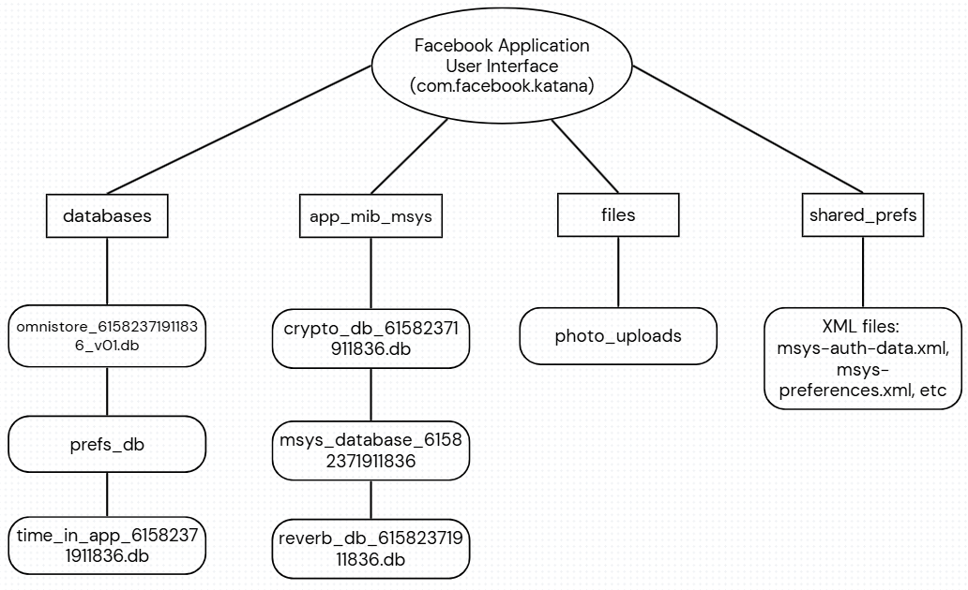

- App Behaviour:
- Facebook, owned by Meta, is a social networking application that offers services like content watching, share content like photos and videos, and staying connected with people/groups through messaging or calls.
- The application uses SQLite databases with WAL journaling (there were -wal/-shm files found) and XML files.
- Following are the main directories:
- /data/data/com.facebook.katana/databases (primary database)
- /data/data/com.facebook.katana/shared_prefs (XML state; minimal direct message content)
- /data/data/com.facebook.katana/app_mib_msys (encrypted messages database)
- When installed on the device the application interacts with the Android and makes use of phone’s hardware to take photos, calls, videos.
- Also, a set of permissions are required to access location, microphone and camera.
- The application’s files are stored in Internal shared storage at /Android/data/com.facebook.katana. This location is accessible without root privileges.

- Recommendations:
The forensic examiners can use the database found in this application for following tasks:
- The app_mib_msys directory stores the messages, threads and user info tables which can we useful to see chat content and unsend evidence.
- The crypto_db shows session keys which proves that the application maintains end to end encryption.
- The pref_db can be used for device identification and timelines.
- The time_in_app db shows about the timeline of app usage and session times. Can correlate with messages like was the user active when the message was sent.
- The files folder can be explored to see the uploads and photos in the account.
Important: All user related DBs include the user ID (e.g., 61582371911836) in path/filename which is important factor for multiple users’ device analysis.

Conclusions:
This investigation examined Facebook application on an Android emulator to understand how messages are stored and whether deleted messages can be recovered. The main message database is called msys_database and it sits inside the app_mib_msys directory. I analysed some more databases:
- Crypto_db_61582371911836: which stores the encryption keys
- prefs_db: which stores the account information
- time_in_app_61582371911836.db: screen time and user activity tracking
This investigation successfully recovered account information from prefs_db which included the user name (Athena Sharma), user ID (61582371911836), profile picture URL and device ID (30261379-a349-450b-bb61-b4f57436e38f).
In the message database (msys_database), I found that when the user Athena Sharma “unsend” the messages, Facebook completely removes the message text but keeps the details like who sent it, when was it sent and when was it deleted. I identified 6 unsent messages and all had empty text fields but still showed the timestamps and send information which created a audit trail even when the content of the message was not available.
The application uses end to end encryption, and the keys are stored separately in crypto_db.
What I could not do:
I did not capture phone’s RAM while the application was running. This might have shown the deleted messages like while being typed. I also did not do a physical extraction of the phone which could have captured the entire storage at the hardware level.
Why this matters:
The deleted messages are permanently gone from the database but some traces like to whom they talked, when and proof that the messages were deleted still exists in the database. The account information, photo uploads helps identify whose phone it is and when they were active. Forensic Examiners should quickly take memory dumps while the apps are running.
What should I do next:
If I had more time and resources, I would have:
- Done physical extraction and search for deleted messages in unallocated space.
- RAM capture to if Facebook displays messages in plain text while typing.
- I should have captured traffic to monitor and understand how requests travel between user and the Facebook servers.
Final Thoughts:
This investigation proves that Facebook’s unsend feature removes message contents from the local database. However other information like account information, timing, etc remains in the database creating an audit trail to dig in further. The databases msys_database stores conversations, crypto_db protects them with encryption, prefs_db reveals who the user is and when they were active and contacts_db stores friends’ information.

References:
Eriş, F.G. & Akbal, E. (2021) “Forensic Analysis of Popular Social Media Applications on Android Smartphones”, Balkan Journal of Electrical & Computer Engineering, 9(4), pp. 386–397. DOI: https://doi.org/10.17694/bajece.761271.

Al Mutawa, N., Baggili, I. & Marrington, A. (2012) “Forensic Analysis of Social Networking Applications on Mobile Devices”, Digital Investigation, 9, pp. S24–S33. DOI: https://doi.org/10.1016/j.diin.2012.05.007.

Agrawal, A.K., Sharma, A. & Khatri, P. (2019) “Digital Forensic Analysis of Facebook App in Virtual Environment”, in Proceedings of the 6th International Conference on Computing for Sustainable Global Development (INDIACom 2019), IEEE, pp. 1–5. Available at: https://ieeexplore.ieee.org/document/8991287 (Accessed: 24 October 2025).

Dusu, S.M. & Riadi, I. (2021) “Mobile Forensic of Facebook Services using National Institute of Standard Technology (NIST) Method”, International Journal of Computer Applications, 183(33), pp. 9–15. DOI: https://doi.org/10.5120/ijca2021921716.

Kent, K., Chevalier, S., Grance, T. & Dang, H. (2006) Guide to Integrating Forensic Techniques into Incident Response, NIST Special Publication 800-86, National Institute of Standards and Technology, Gaithersburg, MD. DOI: https://doi.org/10.6028/NIST.SP.800-86.

Appendix

- Download Facebook apk from apkmirror.com and verify the hash of the downloaded file.
Hash of the file-
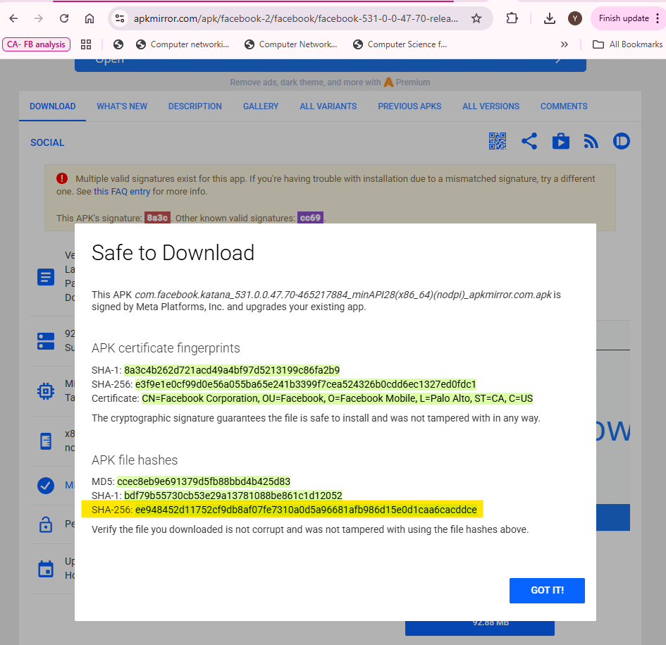

Verified hash using certutil command:
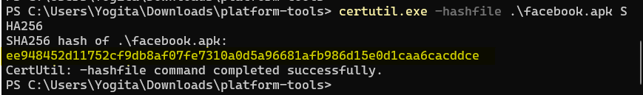

Login to the Facebook account:
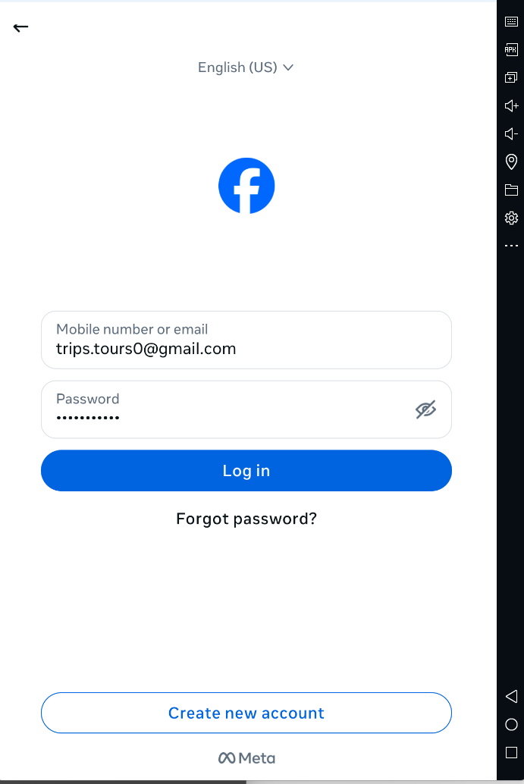

- Download and install Memu emulator and make sure the root access is enabled.
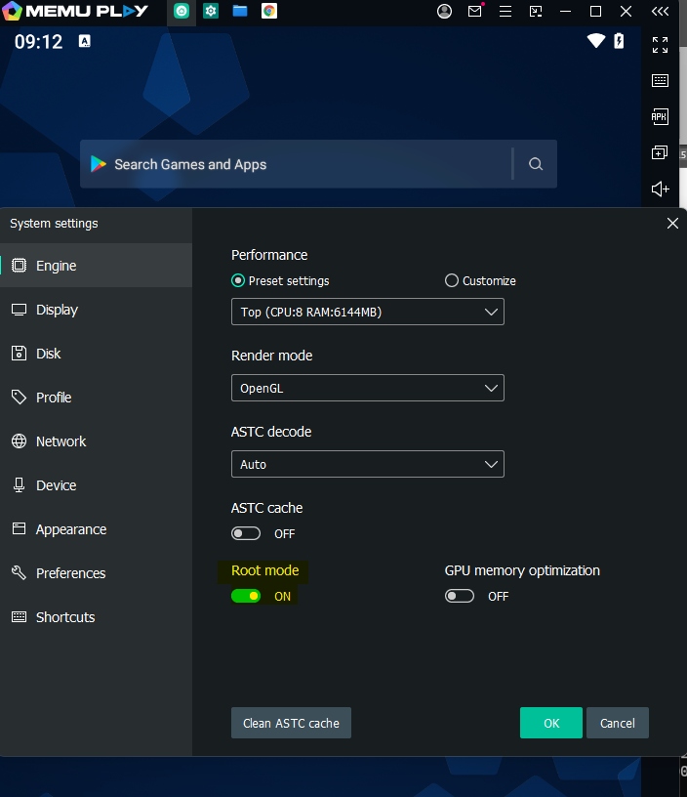

Device Model:
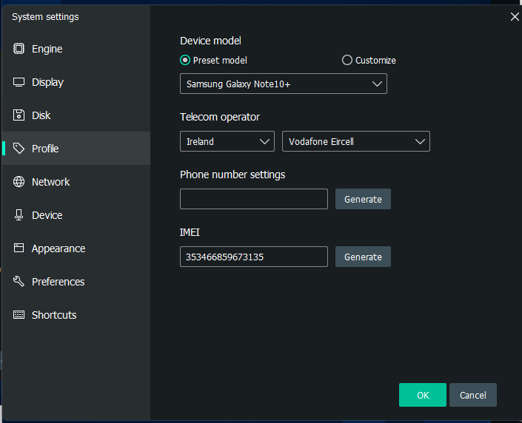

Android version:
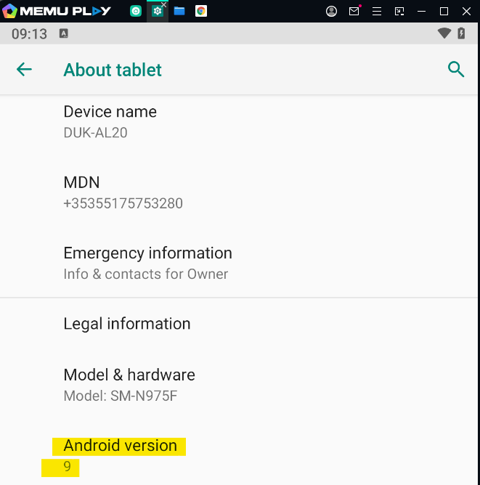

- Restart the ADB as root.
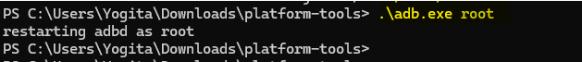

- ADB Connection: .\adb.exe devices showing 127.0.0.1:21503 device
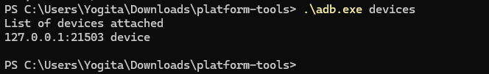

- Get the shell access once the device is connected to the ADB.
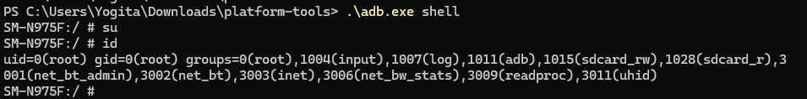

- Pull all the required databases and directories to local storage (i.e. on host machine).
- The app_mib_msys directory:

- The files directory:

- The shared_prefs database:

- The /data/data/com.facebook.katana/databases:

- Calculate the hash for all:
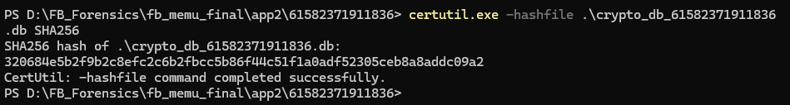
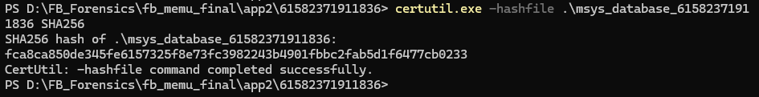
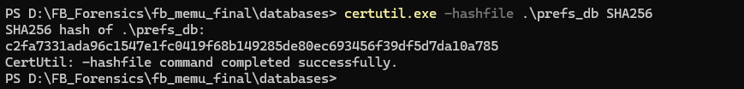
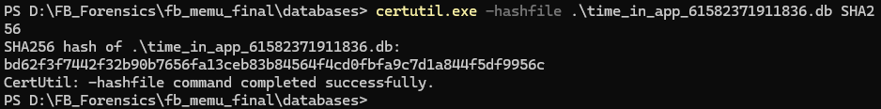

- Let’s analyse the artifact in msys_database_61582371911836 file:
- Opened msys_database_61582371911836 file in DB Browser for SQLite.
- Command:
SELECT COUNT(*) AS total_messages FROM messages;
This command shows how many messages exist in the message table in this database.
OUTPUT:
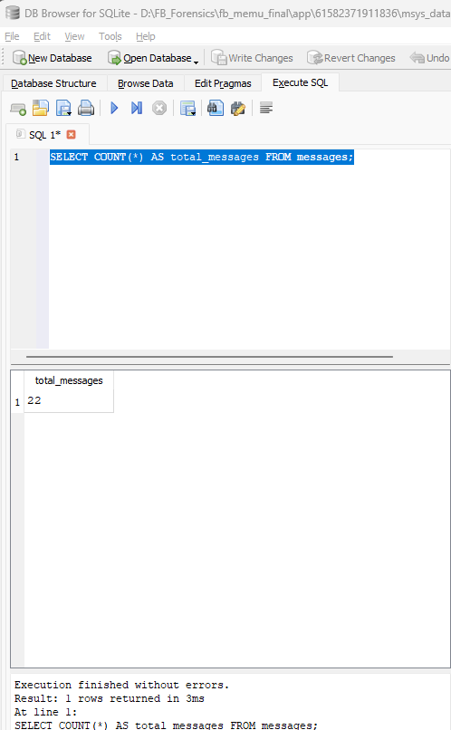

- Command:
SELECT
datetime(timestamp_ms/1000,'unixepoch','localtime') AS time,
sender_id,
text,
is_unsent,
message_id
FROM messages
WHERE thread_key='61582717975736'
ORDER BY timestamp_ms;
This SQL query lists all the messages with timestamps present in the message table.
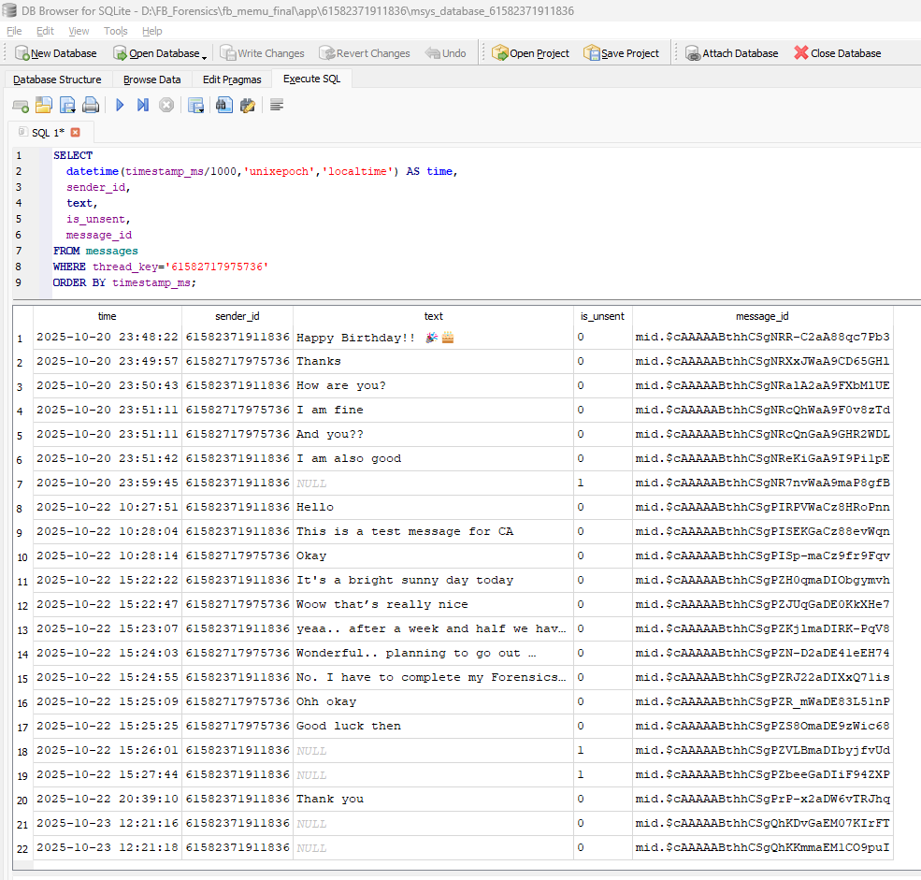

- Command:
SELECT
datetime(timestamp_ms/1000,'unixepoch','localtime') AS sent_time,
datetime(unsent_timestamp_ms/1000,'unixepoch','localtime') AS unsent_time,
sender_id,
text,
is_unsent,
message_id
FROM messages
WHERE thread_key='61582717975736'
AND is_unsent=1
ORDER BY timestamp_ms;
Using this SQL query we can see the deleted messages with deletion timestamp.
OUTPUT:
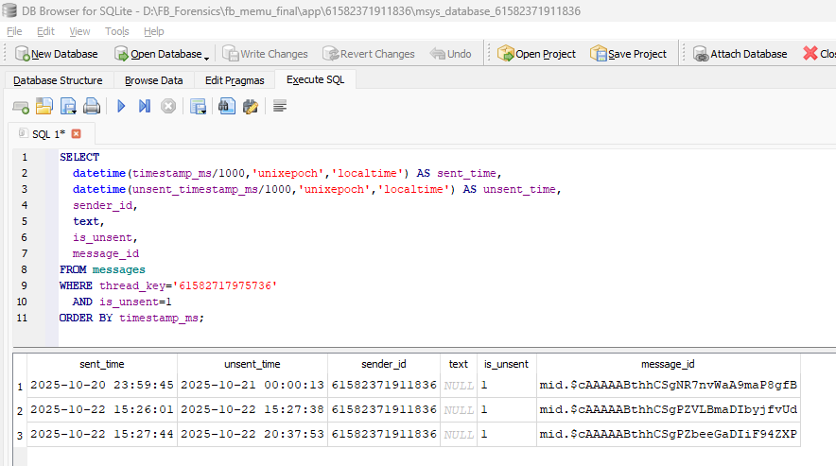

- Command:
SELECT COUNT(*) AS deleted_count
FROM local_message_persistence_store_deleted_messages;
This table (local_message_persistence_store_deleted_messages) lists the deleted messages present on the database.
OUTPUT:
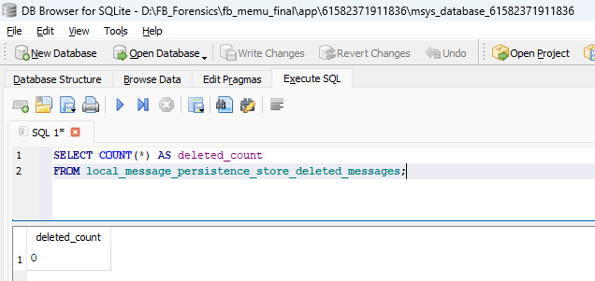

- Command:
SELECT seq FROM sqlite_sequence
WHERE name='local_message_persistence_store_deleted_messages';
This SQL query checks the sqlite_sequence table that keeps track of the last “auto-increment” value used for each table in the database.
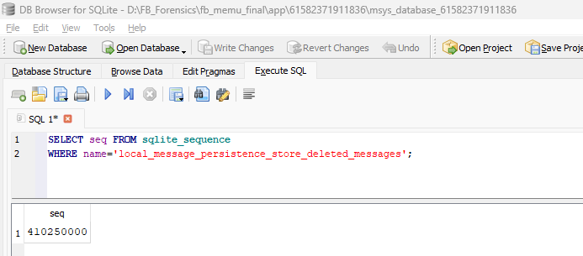

This means:
- At some point in the past, Facebook inserted 410+ million deletion records into this table.
- If Facebook just left deleted message records in the table forever, we would see:
COUNT(*) = 410,250,000 rows
Sequence = 410,250,000
- Instead, we see:
COUNT(*) = 0 rows (i.e. empty)
Sequence = 410,250,000 (proves rows existed before)
This gap proves Facebook is actively running delete from local_message_persistence_store_deleted_messages or similar cleanup operations hence this confirms active purging behaviour by the Facebook application.

- Command:
SELECT
datetime(timestamp_ms/1000,'unixepoch','localtime') AS time,
sender_id,
is_unsent,
sticker_id,
message_id
FROM messages
WHERE thread_key='61582717975736'
AND (text IS NULL OR text='')
ORDER BY timestamp_ms;
This SQL query shows empty messages.
OUTPUT:
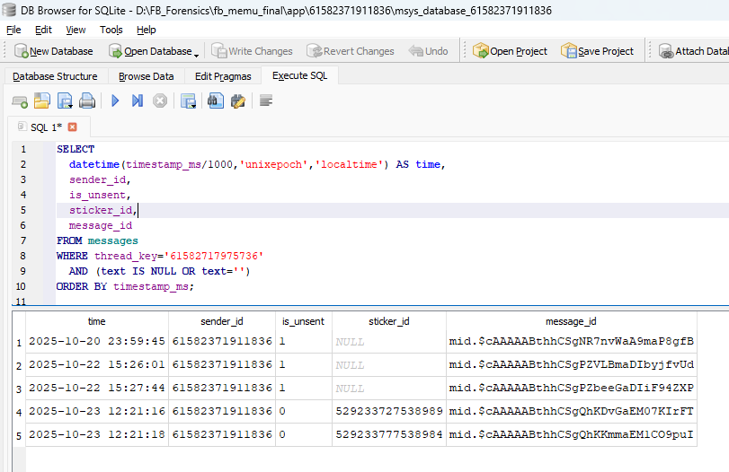
Here,
is_unsent = 1 → The message WAS deleted/unsent by the user
is_unsent = 0 → The message was NOT unsent (it's still active)

Evidence of Deletion:
Text content: Completely gone, cannot be recovered.
Data available:
Who sent it (sender_id: 61582371911836)
When it was sent (timestamp_ms)
When it was deleted (unsent_timestamp_ms)
Message ID (mid.$...)
Deletion flag (is_unsent=1)

- Using the sticker ID here in above screenshot we can find out which sticker was sent:
- For this I have used Autopsy tool and selected the source data type as a logical file. Then added the source of ‘files’ directory that was pulled using adb command.
OUTPUT:
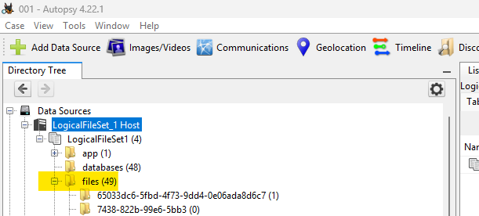
Expand Files and scroll down to find stickers folder. Match the ID of the sticker sent with the sticker_id as shown in the previous bullet point.
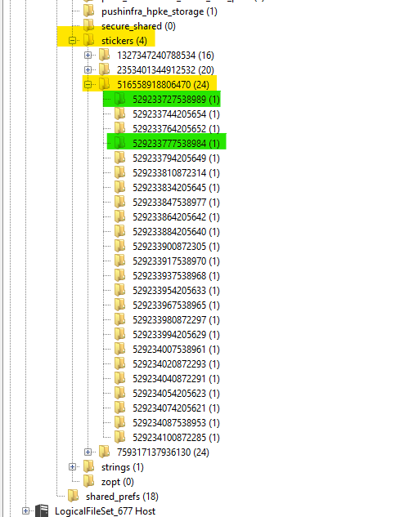



sticker_id: 529233727538989 sticker_id: 529233777538984

Another way to find out the stickers used is by going to ssus.61582371911836.stickers_db in the database directory/folder of the com.facebook.katana. The recent_stickers table holds the data for the recent stickers that were used in the chat.
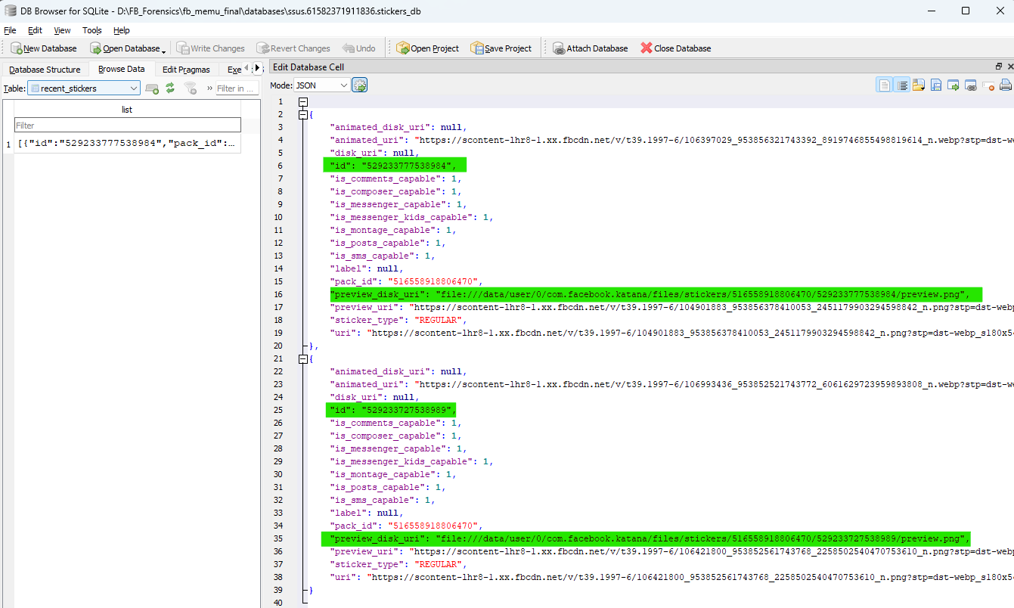

- Command:
SELECT * FROM edit_message_history
this SQL query will give the output related to the edited messages.
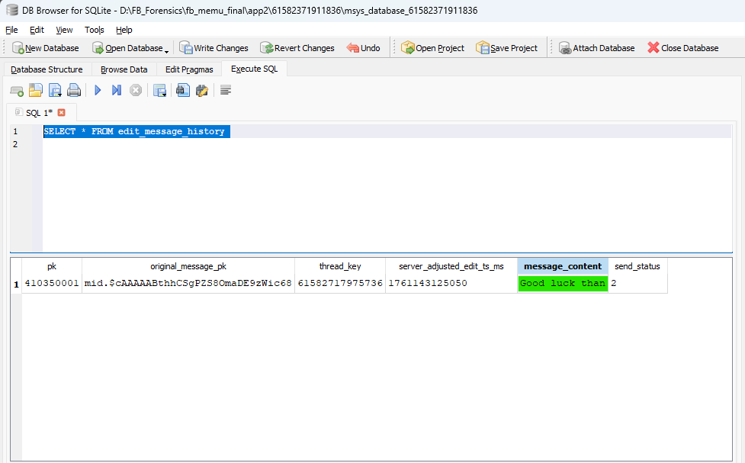
This the original message that cannot be found in the chats.
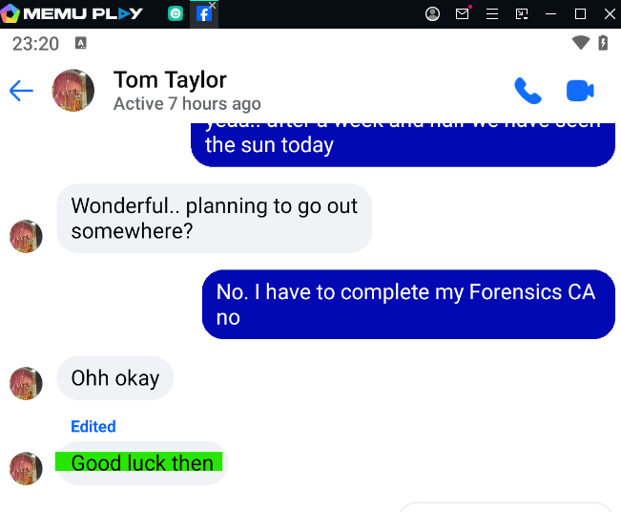
This is the edited message.

- Let’s analyse the artifacts in crypto_db_61582371911836.db database:
- Open crypto_db_61582371911836 file in DB Browser.
- Command:
SELECT name FROM sqlite_master
WHERE type='table' AND name LIKE 'secure_message%'
ORDER BY name;
This SQL query lists all the encrypted tables in the database proving that there is end to end encryption implemented.
OUTPUT:
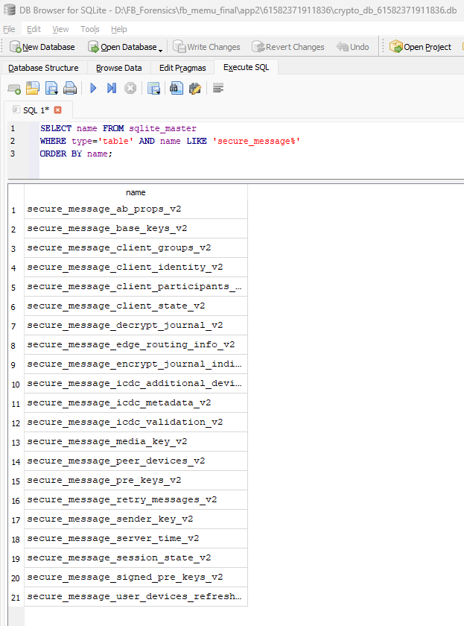

- Command:
SELECT
datetime(timestamp_ms/1000,'unixepoch','localtime') AS created_time,
crypto_mailbox_type,
pre_key_id,
is_synced_to_server
FROM secure_message_pre_keys_v2
ORDER BY timestamp_ms DESC
LIMIT 10;
This SQL query shows when the encryption keys were generated and synced.
OUTPUT:
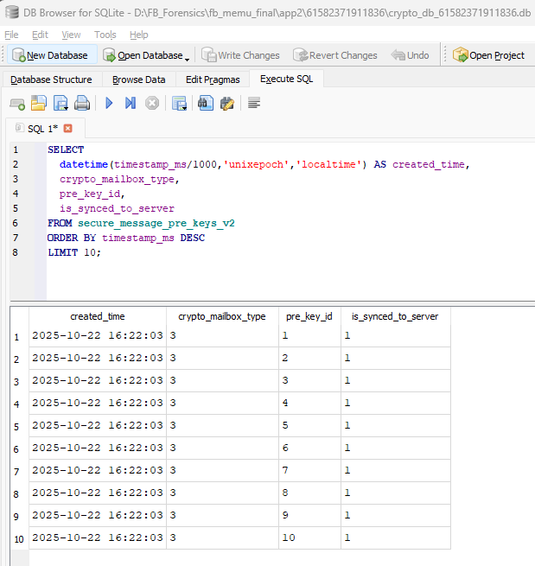

- Command:
SELECT
crypto_mailbox_type,
device_id,
platform,
manufacturer,
model,
datetime(registration_timestamp_seconds,'unixepoch','localtime') AS registered_time,
datetime(last_seen_timestamp_seconds,'unixepoch','localtime') AS last_seen_time,
latitude,
longitude,
location,
ip
FROM secure_message_peer_devices_v2;
This SQL query shows detailed information devices associated with the current user.
OUTPUT:
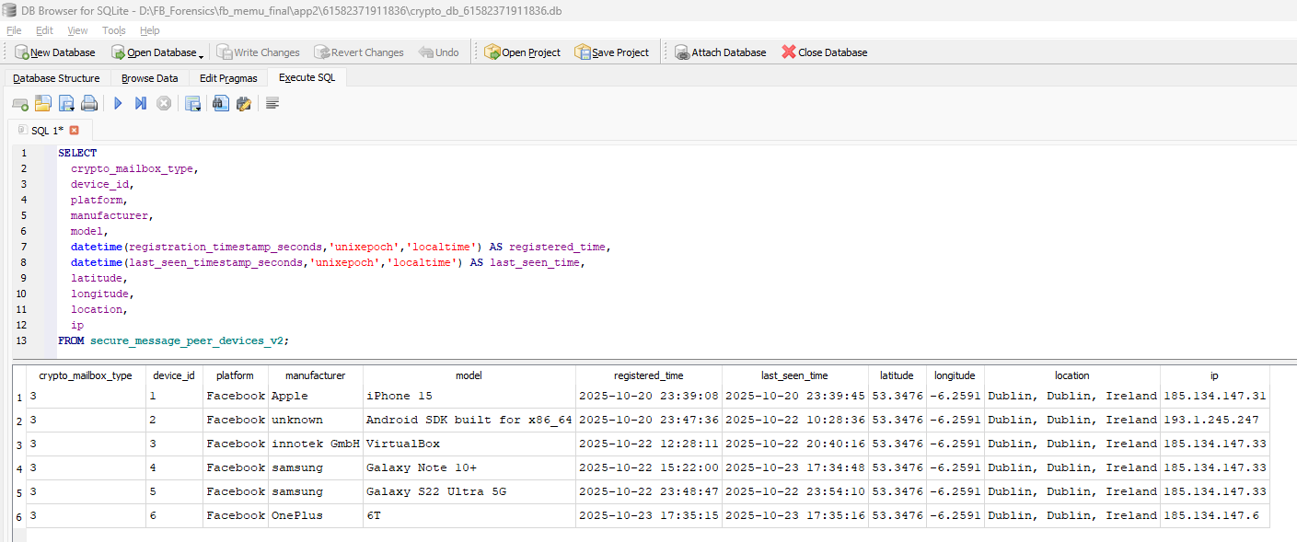
The secure_message_peer_devices_v2 table contains 6 device entries but it lacks a user ID column to explicitly link devices to specific contacts. The test user account (61582371911836) has only one conversation partner (61582717975736) and hence these devices listed here are related to test user account only.

- Let’s analyse the artifacts in prefs_db file:
- Open prefs_db in DB Browser.
- Command:
SELECT key, value
FROM preferences
WHERE key LIKE '%dbl_password_account_credentials%';
This SQL query shows full account profile information in JSON format.
OUTPUT:
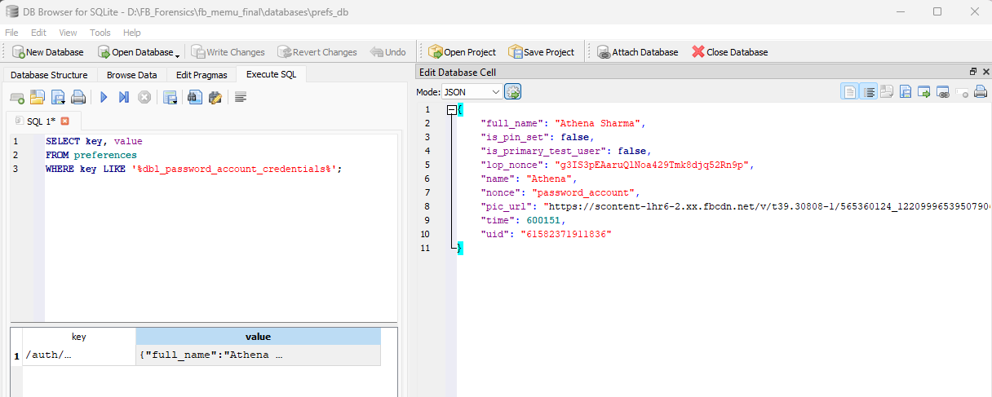
upon opening the pic_url: https://scontent-lhr6-2.xx.fbcdn.net/v/t39.30808-1/565360124_122099965395079063_4494228579417762432_n.jpg?stp=cp0_dst-jpg_e15_fr_q65_tt6&cstp=mx225x225&ctp=s225x225&_nc_cat=100&ccb=1-7&_nc_sid=e99d92&_nc_ohc=w5OlwBBjowEQ7kNvwEs07BB&_nc_oc=Admqn4gPsVa-6Y0CLh3_0orfK18f8u76z1fKCv9jUBTcjj_InAlRyoiFj7_3uH9tzo8&_nc_ad=z-m&_nc_cid=0&_nc_zt=24&_nc_ht=scontent-lhr6-2.xx&oh=00_AfdBuCV_Xo7ko4AijZi9AGl2BAX86EXAs6JV8yKXdToDmA&oe=68FECB4E in a browser, we get the following data:


- Command:
SELECT key, value
FROM preferences
WHERE key IN (
'/shared/device_id',
'/shared/sfdid',
'/auth/auth_machine_id'
);
This SQL query will give information about device binding.
OUTPUT:
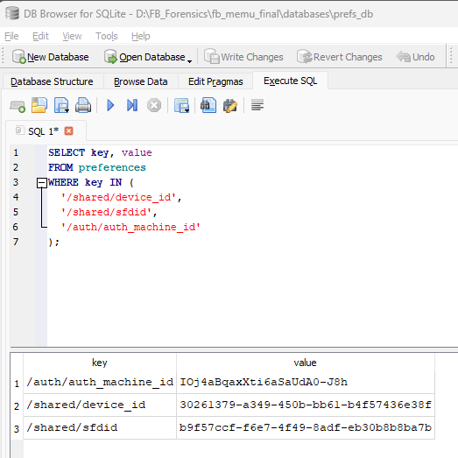

- Command:
SELECT
key,
datetime(CAST(value AS INTEGER)/1000,'unixepoch','localtime') AS timestamp
FROM preferences
WHERE key IN (
'/fb_android/last_login_time',
'/notifications/last_app_foreground_time',
'/fb_android/user_last_used_app_time'
);
This SQL query gives information about when the test user logged in and last used the application.
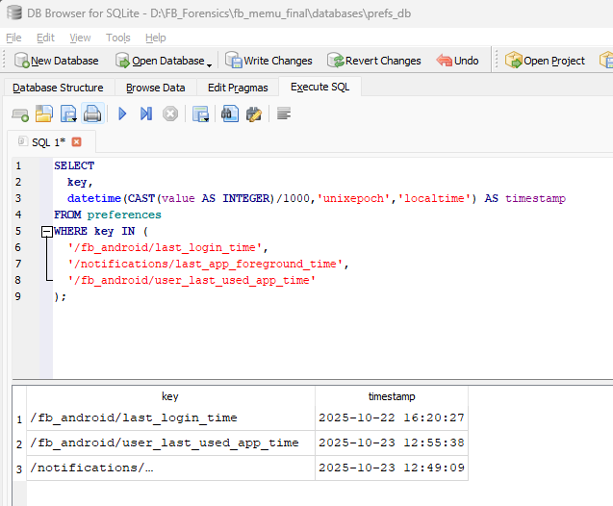

- Command:
SELECT key, value
FROM preferences
WHERE key LIKE '%privacy/default_privacy_option%';
This SQL query shows test user's default privacy settings in JSON format.
OUTPUT:
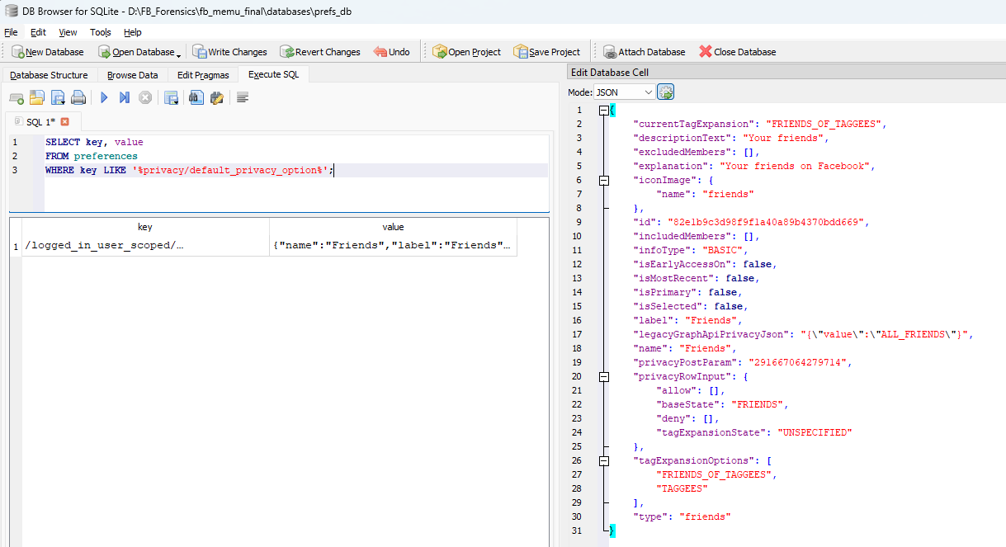

- Let’s analyse the artifacts in time_in_app_61582371911836.db database:
- Command:
SELECT
datetime(1761146867,'unixepoch','localtime') AS last_eviction,
datetime(1761218446,'unixepoch','localtime') AS last_logging;
OUTPUT:
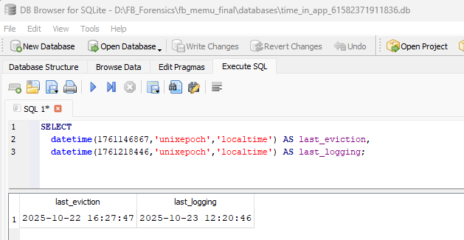
last_eviction_timestamp:
- When the app last cleared/cleaned old screen time data
- Facebook removes old usage records to save space
last_logging_timestamp:
- When the application last recorded screen time data
- Shows the most recent time app usage was logged

- Command:
SELECT
start_event,
end_event,
start_uptime,
end_uptime,
datetime(start_walltime,'unixepoch','localtime') AS start_time,
datetime(end_walltime,'unixepoch','localtime') AS end_time,
seq_num
FROM intervals;
This SQL query tells that the intervals table records every time the user opends and closes the Facebook application. This helps in tracking the exact timestamps and how long each session lasted.
OUTPUT:
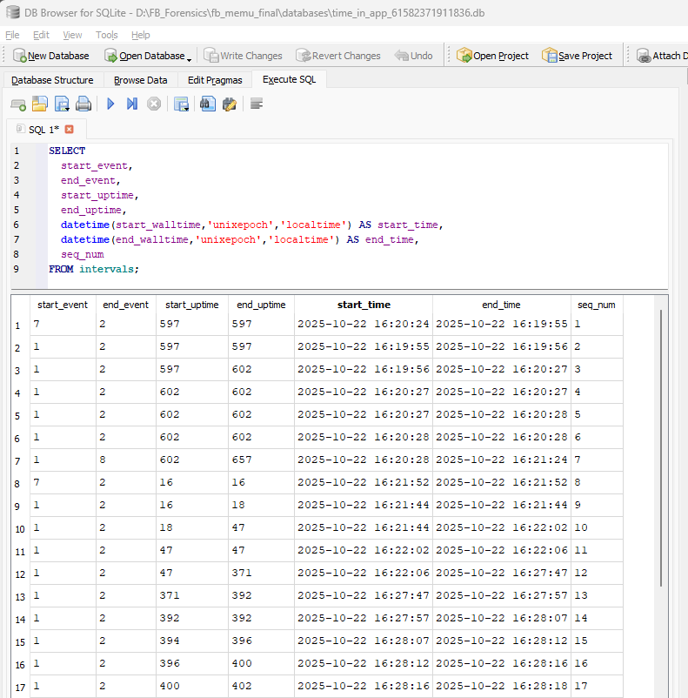
- start_event = 1 means App opened/foreground
- end_event = 2 means App closed/background
- start_event = 7 means Screen unlocked or special event
- end_event = 8 means Screen locked or special even

Example:
On Oct 22, 2025 (16:19:55-16:27:57) total tracked time is ~8 minutes of activity in 13 intervals.

- Let’s check the photo_uploads folder in the files folder:
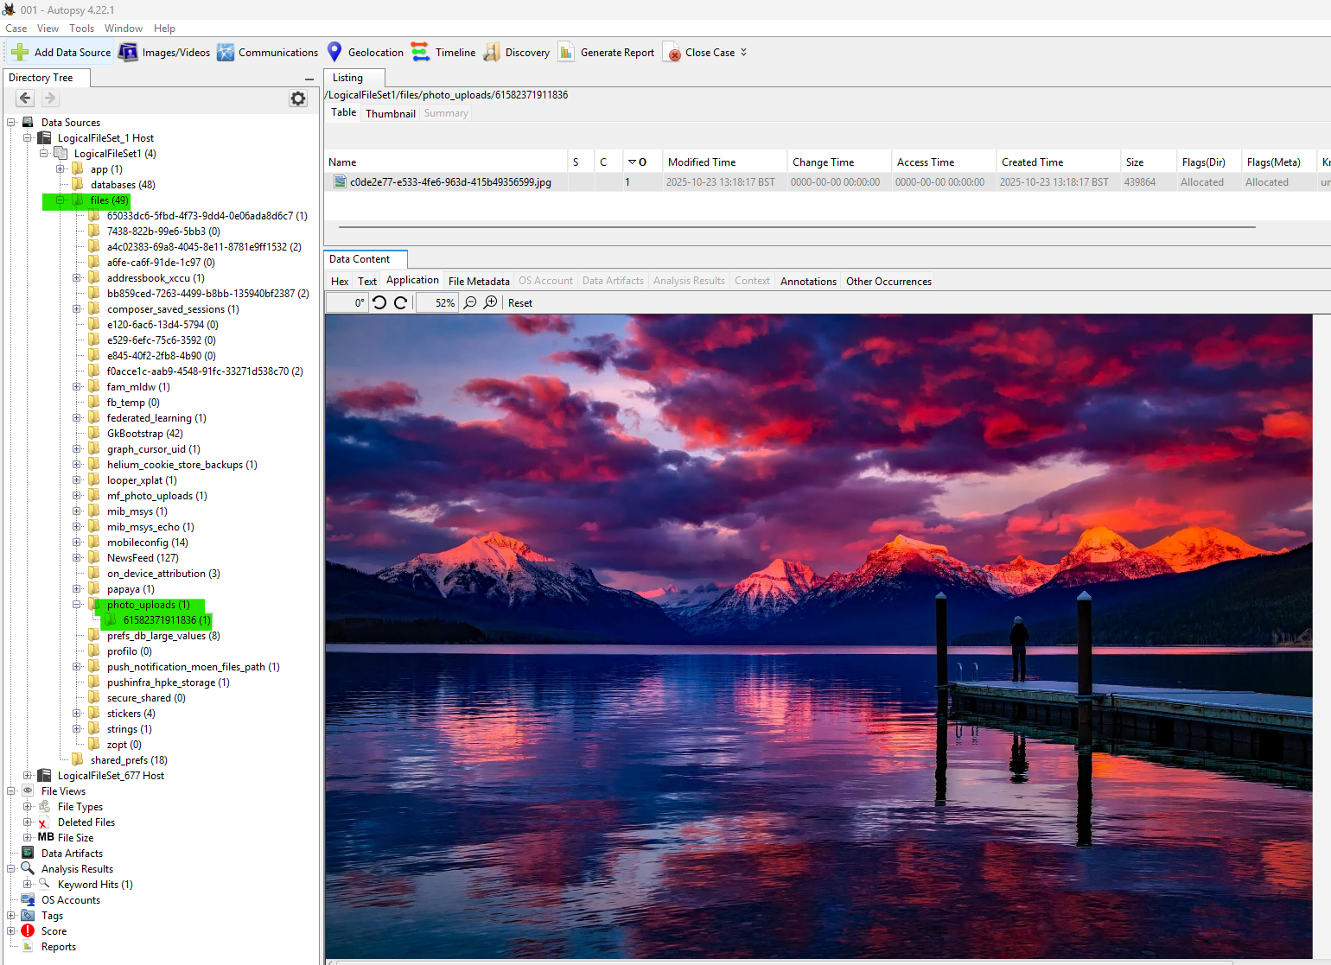
We can see that the picture that was uploaded to the test user account was successfully captured here.

- Let’s analyse the artifacts in ssus.61582371911836.android_facebook_contacts_db file:
- Open the ssus.61582371911836.android_facebook_contacts_db file with Db Browser.
- Command:
SELECT * FROM contacts;
This SQL command will list the contents of the contacts’ table. This table includes profile information of all the contacts (i.e. friends) present in the test user account.
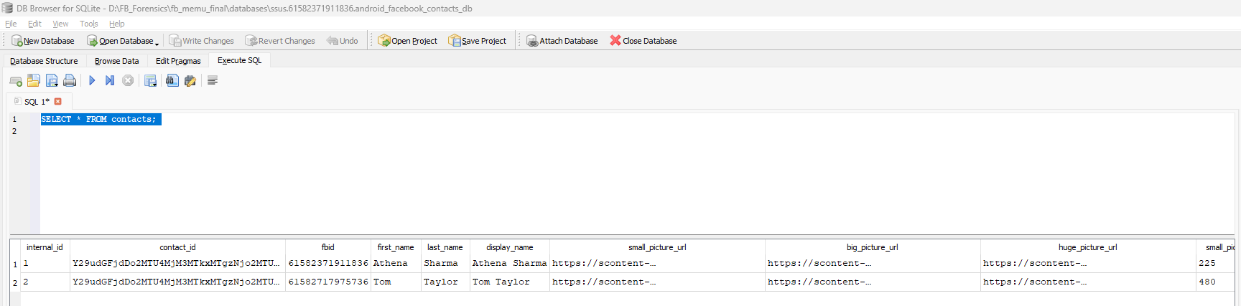
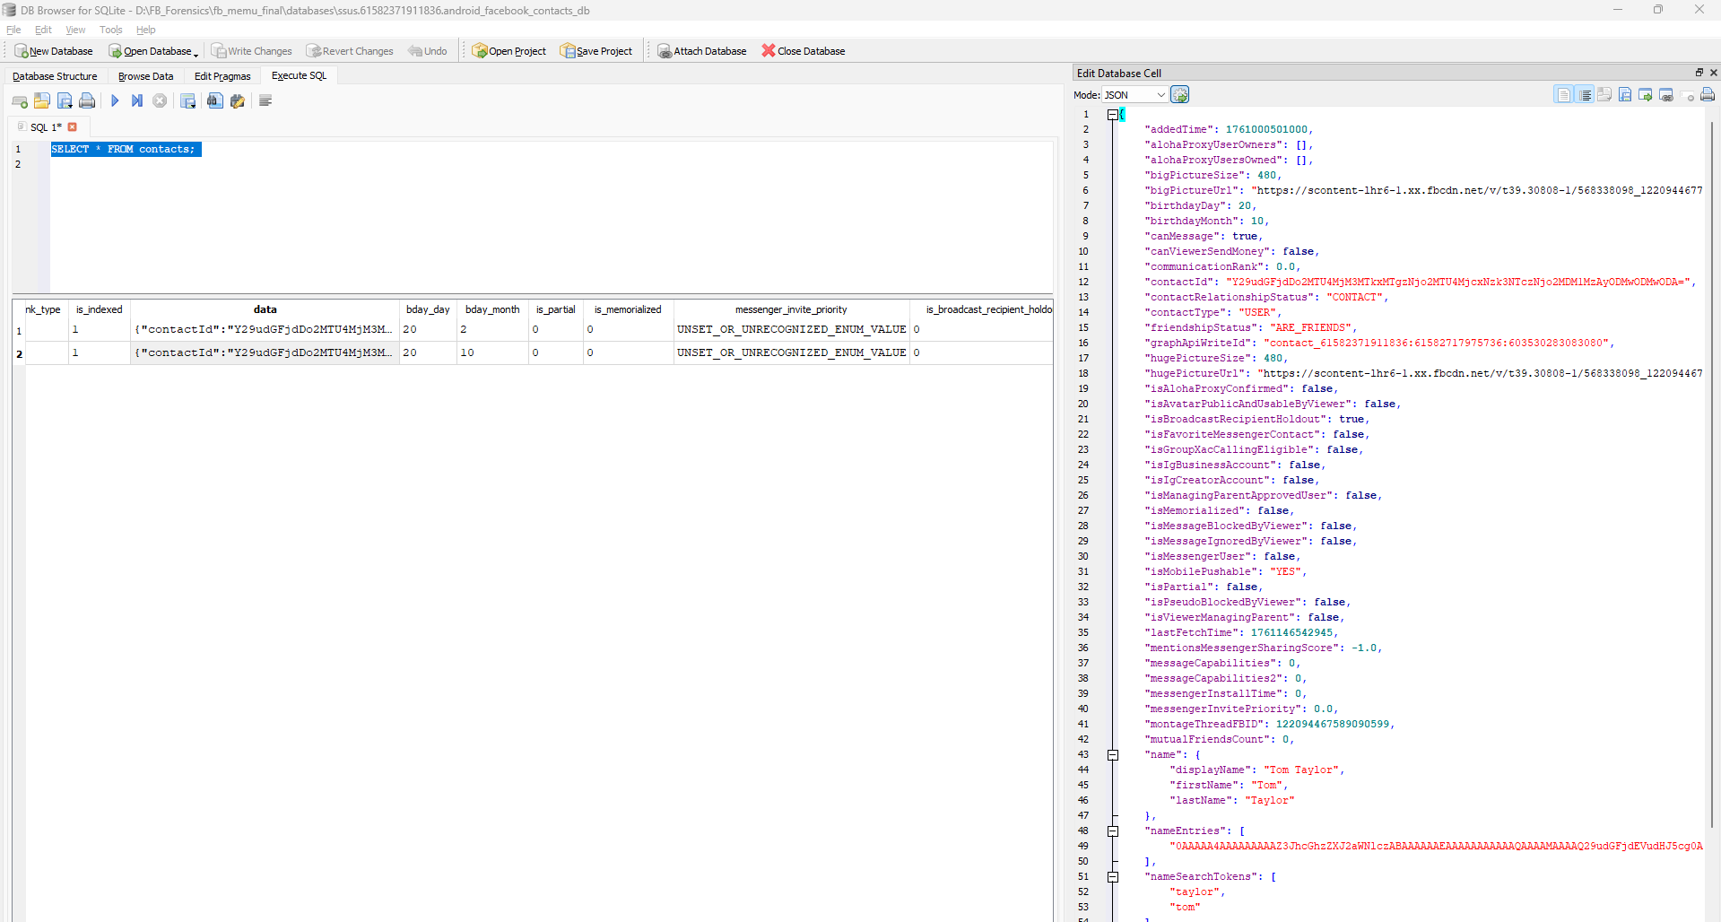

END OF REPORT

