- Executive Summary
The increased growth of Electronically Stored Information (ESI) has changed the approach of how the forensics investigators and lawyers review the all the case related documents. But Artificial Intelligence (AI), Machine Learning (ML) and Data Analytics have changed the amount of time required to review these documents (for a court case) from months to a few weeks. This report investigates how the use of Machine Learning and Data Analytics can be useful and supportive for digital forensics and eDiscovery and how these technologies are applied with the Electronic Discovery Reference Model (EDRM) framework.
The objectives of this study are:
- To understand the Natural Language Processing (NLP), the supervised and unsupervised learning, Technology Assisted Review (TAR) and Continuous Active Learning (CAL) document review.
- To examine how these technologies integrate with EDRM.
- To compare advantages and disadvantages of ML technologies with manual review method.
These objectives are challenging because they are required to connect to technical models with legal workflows.
Studies show that CAL achieves high recall (90-95%) giving human reviewers to review only 1-2% of the full collection (Cormack and Grossman 2016). The research also shows that NLP techniques and similarity algorithms like shingling and MinHash reduce duplicate content and improve the speed of finding important documents (Broder 1998; Manning et al. 2008). This report concludes that though data analytics and machine learning are critical in modern eDiscovery and digital forensics, their effective usage, considerations of data characteristics and human involvement is necessary.
- Methodology and Literature Review
  - Methodology:
This section explains about the research process used to understand how data analytics and machine learning support digital forensics and eDiscovery. The research followed a systematic structured approach and includes combination of legal, technical and forensic sources. The papers were searched using query terms like: “Technology-assisted review”, “digital forensics”, “machine learning in eDiscovery” and “active learning legal discovery”. Eight peer-reviewed papers were selected from IEEE Xplore, ACM Digital Library and academic repositories covering 1997-2021 publication period. The papers were categorised into:
- Practical eDiscovery studies: (Grossman and Cormack 2011)- TAR effectiveness evidence, recall, accuracy; (Cormack and Grossman 2016)- Active learning validation, S-CAL; (The Sedona Conference 2023)- Guidance on defensible legal review
- Algorithm studies: (Broder, 1997)- Near-duplicate detection algorithms (“roughly the same” (resemblance) and “roughly contained” (containment)); (Manning et al. 2008)- Information retrieval and NLP; (Devlin et al. 2019)- Transformer based language modelling
- Frameworks and Digital Forensics: (EDRM 2019)- Framework for eDiscovery; (Garfinkel 2010)- Digital forensics review to understand how data analytics supports investigations with large datasets
This selection covers initial algorithms, practical implementations and transformed based approaches.
  - Literature Review:
The main challenge in modern eDiscovery is exponential data growth and the legal review budget that remains constrained. Garfinkel (2010) identifies the growing gap between the volume of digital evidence and the resources for its examination. The currently available tools are not correctly fragmented, standardized and are not stable to scale modern datasets, massive storage, multiple devices, encryption and cloud computing.
TAR Effectiveness: Grossman and Cormack (2011) compared two TAR systems (H5 and Waterloo) against TREC 2009 Legal Track Interactive Task dataset and found that TAR systems had higher recall rates and precision score compared to manual reviews. Cormack and Grossman (2016) compared Simple Passive Learning (SPL), Simple Active Learning (SAL), CAL and Scalable CAL (S-CAL) on legal documents (TREC Legal Track) and news articles (Reuters RCV1) datasets. This study showed that the CAL continuously retrains after each human decision hence the efficiency is increased and the model becomes better than SAL, which trains once and stops learning (Cormack and Grossman 2016).
EDRM Integration: The Electronic Discovery Reference Model defines nine stages: Information Governance, Identification, Preservation, Collection, Processing, Review, Analysis, Production, Presentation (EDRM 2019). The ML and data analytics mostly work in Collection (filtering duplicates, irrelevant files or sensitive data), Processing (text extraction, deduplication), Review (active learning for relevance classification) and Analysis (topic modelling, anomaly detection, and fact development) stages of the EDRM (EDRM 2019).
Natural Language Processing (NLP): NLP enables machines to extract meaningful data from the unstructured text. Techniques include TF-IDF (Term Frequency-Inverse Document Frequency) for word weighting based on frequency and rarity and vector space model for ranking documents by relevance and partial matching (Manning et al. 2008). Text transformation to a form that can be analysed involves tokenization, normalization, stop word removal and stemming. These steps reduce noise, combine word variants and build a consistent vocabulary (Manning et al. 2008).
Modern approaches make use the transformer architectures like BERT (Bidirectional Encoder Representations from Transformers), which learns language bidirectionally through two training steps: Masked Language Model (MLM) and Next Sentence Prediction (NSP). After pre-training, with small changes only BERT can be fine-tuned to handle many tasks like classification or question answering (Devlin et al. 2019). Devlin et al. (2019) compared BERT with datasets such as GLUE, MultiNLI, SWAG and SQuAD (v1.1 and v2.0). On SQuAD v1.1, BERT achieved F1 scores above 90, surpassing previous state‑of‑the‑art models.
Supervised vs Unsupervised Learning: Supervised learning (CAL) means teaching the model to tell the difference between “relevant” and “not relevant” documents by showing it examples. CAL is considered the best method for reviewing large sets of documents because it combines human judgements with machine learning in a loop (Cormack and Grossman, 2016).
Unsupervised learning is about finding patterns in data when we do not know the categories. K-means clustering means the algorithm places documents into K groups by repeatedly assigning each document to the closest “centre” and then updating those centres until things settle. In hierarchical clustering, a tree-like structure is built instead of a fixed group (Manning et al. 2008).
  - Use cases in eDiscovery and Digital Forensics:
Email Threading: Email threading groups related emails and their attachments into a conversation tree by analysing email headers like From, To, Cc, Bcc, Subject and Body. This reduces the effective document volume because the reviewers can now focus on inclusive messages instead of repeatedly reviewing earlier segments. It also helps to present communications in their conversational context during Processing and Review stages of EDRM (Cross 2017).
Textual Near-Duplicate Identification: Broder (1998) shows that documents can be reduced to small sketches using the shingling and Rabin fingerprints. This enables efficient estimation of resemblance and containment throughout very large collections. This is demonstrated in his experiment with 30 million web pages where large-scale clustering of near-duplicate documents is supported. The accuracy of this method depends on the shingle size, sample size and fingerprint length. Short documents and small sample size can lead to wrong estimations (Broder 1998).
Name Normalization: This is an ML supported step that analyses email headers in segments of an email, identifies the email addresses and links those addresses to where they belong. When an alias appears in combined formats like “Doe, John” john.doe@example.com, the system stores both (the display name and the email address) as separate aliases but joins them to the same entity and then uses “alias sibling” and segment‑matching logic to associate additional aliases (for example “Doe, John” jdog99@domain.com) with that same person. This creates one record for each person and avoid multiple name versions, makes easy to find the right person faster and makes people based search easy (Relativity 2025).
CAL Document Review: CAL trains model step by step using documents that humans have already reviewed. Then it selects the most uncertain documents, sends it to the reviewer, the reviewer marks them and then the model learns from the feedback given by the reviewer. This method finds more relevant documents than keyword search or one time training. Research shows CAL can reach more than 95% recall with human review of only 1-2% of documents (Cormack and Grossman 2016).
- Findings
  - Application in eDiscovery and Cybersecurity:
eDiscovery: ML helps reduce the amount of time spent on document review. CAL method can be used to cut human review work by 98 to 99% while finding more than 95% of relevant documents (Cormack and Grossman, 2016). NLP speeds up searching and classification by turning raw text into numbers the model can understand and use (Manning et al. 2008; Devlin et al. 2019). Near duplicate detection (based on shingling and MinHash) removes repeated content so reviewers do not read the same content many times (Broder 1997). Guidance from The Sedona Conference (2021) explains that these techniques must be documented, tested and easy to audit so that they can be defended in court (The Sedona Conference 2023).
Cybersecurity: ML helps analysts to classify threat reports, malware types and detect unusual activities in the network using system logs. These tasks also face same problem of large and mixed data that appear in eDiscovery (Garfinkel 2010). Techniques like name normalization can help identify the attacker aliases and related system logs. Clustering helps analysts see patterns in large collections. However, cybersecurity applications are less standardized than legal TAR and there is less published evidence about high recall and defensible work. This creates weaker consistency across tools and methods.
  - Advantages and Disadvantages:
Table 1: Advantages and disadvantages
Algorithm/ Method | Advantage | Disadvantage | Use case
CAL/S-CAL | High recall (75-100%) with very little human review required, learn from human feedback, effective for large collections (Cormack and Grossman, 2016) | Require quality seed, depends on reviewer feedback, computation is heavy on large datasets (Cormack and Grossman, 2016) | High-risk cases where missing a document can cause severe consequences, large collections, can be used on domain other than legal requiring high recall
Shingling and MinHash | Used on billions of documents, accuracy can be tuned by adjusting parameters such as shingle size, sample size, and fingerprint length (Broder 1997) | Results depend on parameter choices: small shingles and resemblance is not transitive (Broder 1997) | Email deduplication and near duplication identification
NLP (BERT) | High accuracy on NER (Name Entity Recognition) , handles multiple languages, uses a single transformer encoder with minimal task-specific changes Devlin et al. 2019) | Need large computing resources and struggle with specific datasets without additional training, fine-tuning can be unstable on small datasets Devlin et al. 2019) | Work best for named entity classification and extraction
Clustering (K-means) | Works on group documents without labels and explores unknown collections (Manning et al. 2008) | Needs a preset number of clusters (K), slow on very large datasets, sensitive to outliers (Manning et al. 2008) | Used in early-stage document organization and analysis.
  - Algorithm Selection Based on Data Characteristics:
Structured vs. Unstructured Data: Supervised learning (like CAL) performs better with unstructured documents (like emails, reports). Similarity detection methods can handle mixed formats. NLP handles both structured fields (headers) and free-text content.
Data Volume: K-means clustering handles millions of documents with preprocessing. CAL can also handle large datasets, but it needs people to review documents during training which in turn can slow it down.
Language Complexity: BERT handles multiple languages; TF-IDF fails when the language has complex word forms. Legal terms often require domain-specific fine-tuning for NER tasks.
Domain Sensitivity: Legal work requires methos that can find almost every relevant document and can be explained in court so CAL with proper documentations fits this need. Cybersecurity incident response prioritizes speed so clustering may be useful for this initial stage.
- Conclusion
  - Main findings:
This investigation reveals a field where experimental evidence has beaten professional assumptions. Both fields of Forensics and eDiscovery are facing a challenge of exponential growth in digital data and constrained resources so investigators should use the tools with proper governance and guidance (Garfinkel 2010). Cormack and Grossman's (2016) demonstrate that CAL achieve higher recall (more than 75% often 95-100%) with 1-2% human review and this contradicts with the legal industry beliefs. The findings from studies by Grossman and Cormack aligns with current industry practice and The Sedona Conference which advises to use methods that be explained in court (The Sedona Conference 2023).
NLP, similarity hashing and clustering help with large data collections manageable. Shingling and MinHash reduces duplicate files. Transformer models like BERT help find names and terms. Clustering helps to group documents at an early stage in a case. These techniques help a search team to collect all the relevant data. These techniques are used at different stages of the EDRM (for e.g. Processing stage: text extraction, de-duplication, Review: active learning, Analysis: clustering). Supervised learning and active learning help with review analysis.
Model accuracy depends on the quality of the data that is being provided to it. Human mistakes, biased samples, noise and poor seed sets reduces the performance of the model. When the model is new, it can make review mistakes which can be fixed by monitoring and documenting. The Sedona Conference guidance highlights this issue The courts expect to see clear methods and repeatable results. Legal standards and technology must work together to make this model a success. Devlin et al. (2018) states that BERT needs to be fine-tuned on specific labelled datasets after its pre-training. Manning et al. (2008) states that TF-IDF does not capture word order or semantic relationships between terms i.e. sentences like “dog bites man” and “man bites dog” are treated identically.
  - Limitations and Implications:
Limitations: The literature review focuses on eDiscovery. Cybersecurity forensics does not have strong studies or shared testing standards. The eight papers give good coverage, but they do not include new generative AI tools like GPT models, which still need proper testing. Model performance depends on the quality of the training data. Poor seed sets or biased samples reduces accuracy. Most studies use English data. Many real investigations involve different languages which creates challenges.
Implications: Courts expect methods that are clear, defensible and easy to audit. Data quality matters more than the algorithm type used. Poor input produces poor output. Human experts are still required. ML speeds up work but cannot replace expert judgement. New LLMs look promising, but they need strong evidence and testing before they can be used for legal or forensic cases.
  - Future Scope:
If more time was available, I would have taken then following steps:
- Test CAL and new LLM approaches on the same datasets to compare accuracy and efficiency.
- Run experiments on cybersecurity datasets to measure how CAL performs.
- Test BERT models on non-English datasets to measure its performance.
- Get a deeper explanation of how legal standards interact with algorithms

References
- Broder, A.Z. (1997) “On the resemblance and containment of documents,” in Proceedings. Compression and Complexity of SEQUENCES 1997 (Cat. No.97TB100171). Compression and Complexity of SEQUENCES 1997, Salerno, Italy: IEEE Computer Society, pp. 21–29. Available at: https://doi.org/10.1109/SEQUEN.1997.666900.
- Cormack, G.V. and Grossman, M.R. (2016) “Scalability of Continuous Active Learning for Reliable High-Recall Text Classification,” in Proceedings of the 25th ACM International on Conference on Information and Knowledge Management. CIKM’16: ACM Conference on Information and Knowledge Management, Indianapolis, Indiana, USA: ACM, pp. 1039–1048. Available at: https://doi.org/10.1145/2983323.2983776.
- Cross, J. (2017) “Email Threading 101: An Introduction to an Essential e-Discovery Tool,” Relativity Blog, 19 April. Available at: https://www.relativity.com/blog/email-threading-101-an-introduction-to-an-essential-e-discovery-tool/ (Accessed: December 8, 2025).
- Devlin, J. et al. (2019) “BERT: Pre-training of Deep Bidirectional Transformers for Language Understanding,” in 2019 Conference of the North American Chapter of the Association for Computational Linguistics: Human Language Technologies (NAACL HLT 2019), pp. 4171–4186. Available at: https://doi.org/10.48550/arXiv.1810.04805.
- EDRM (2019) “TECHNOLOGY ASSISTED REVIEW (TAR) GUIDELINES.” Available at: https://edrm.net/wp-content/uploads/2019/02/TAR-Guidelines-Final.pdf (Accessed: December 8, 2025).
- Garfinkel, S.L. (2010) “Digital forensics research: The next 10 years,” Digital Investigation, 7, pp. S64–S73. Available at: https://doi.org/10.1016/j.diin.2010.05.009.
- Grossman, M.R. and Cormack, G.V. (2011) “Technology-Assisted Review in E-Discovery Can Be More Effective and More Efficient Than Exhaustive Manual Review,” Richmond Journal of Law and Technology, 17(3), p. 48. Available at: http://scholarship.richmond.edu/jolt/vol17/iss3/5 (Accessed: December 8, 2025).
- Manning, C.D., Raghavan, P. and Schütze, H. (2008) Introduction to information retrieval. Cambridge: Cambridge university press.
- Relativity (2025) Name normalization, Relativity Help. Available at: https://help.relativity.com/RelativityOne/Content/Relativity/Analytics/Name_normalization.htm#Namenormalization (Accessed: December 8, 2025).
- The Sedona Conference (2023) “The Sedona Conference TAR Case Law Primer, Second Edition,” in. The Sedona Conference Journal, The Sedona Conference, p. 92. Available at: https://www.thesedonaconference.org/sites/default/files/publications/Tar-Case-Law-Primer-2nd-Edition-2023.pdf (Accessed: December 8, 2025).

Appendix
  - Clustering Experiments
- K-means clustering algorithm illustration:
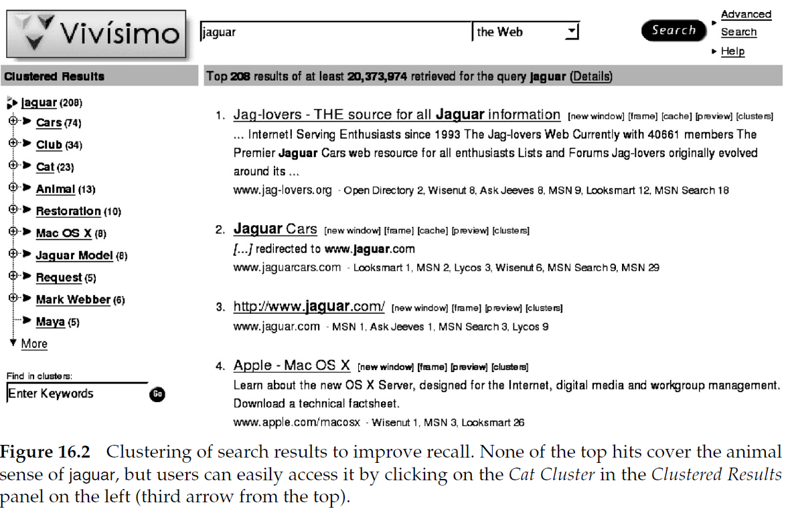

- Effect of different choices of K:
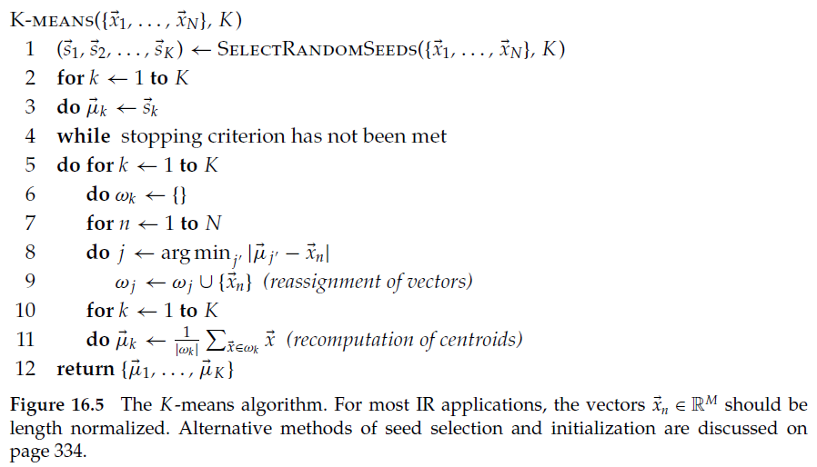
Source: Manning, C.D., Raghavan, P., and Schütze, H. (2008). Introduction to Information Retrieval. Cambridge University Press.

  - Near-Duplicate Detection:
- Shingling example for document similarity:
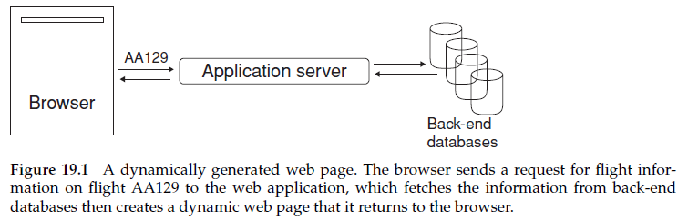
- MinHash estimation of Jaccard similarity:
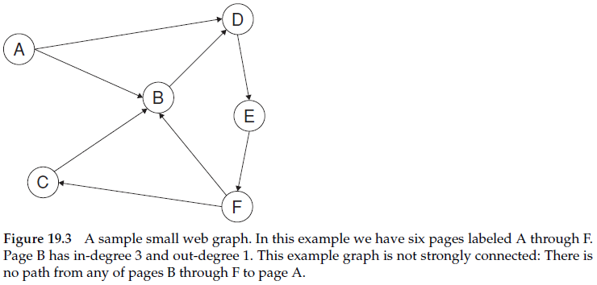Source: Manning, C.D., Raghavan, P., and Schütze, H. (2008). Introduction to Information Retrieval. Cambridge University Press.
  - BERT Model:
- BERT model architecture — shows the Transformer encoder stack and how inputs (tokens, segment embeddings, position embeddings) are combined:
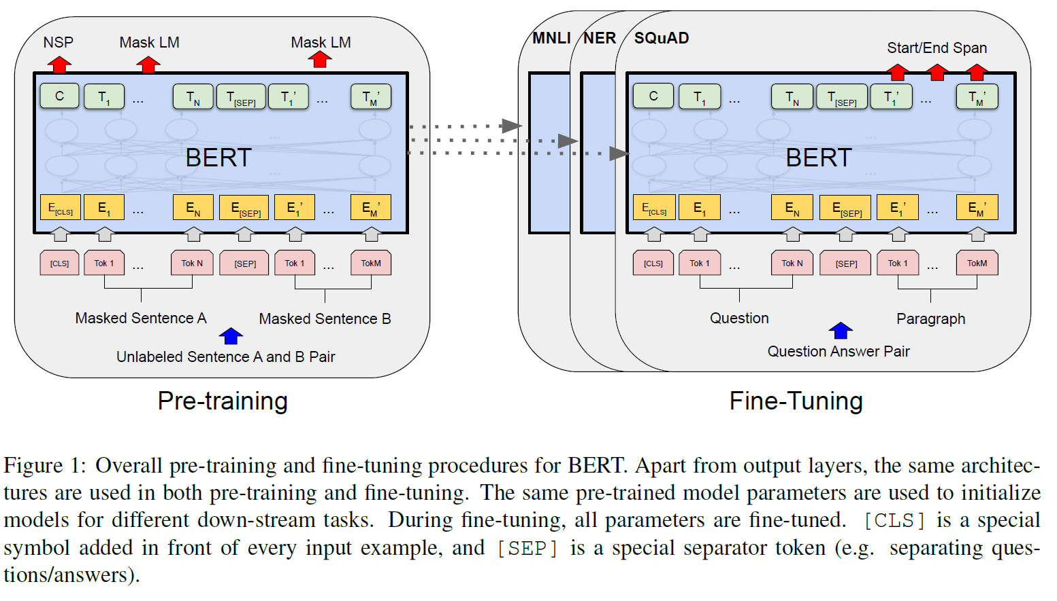
- Pre-training tasks — illustrates Masked Language Modeling (MLM) and Next Sentence Prediction (NSP):
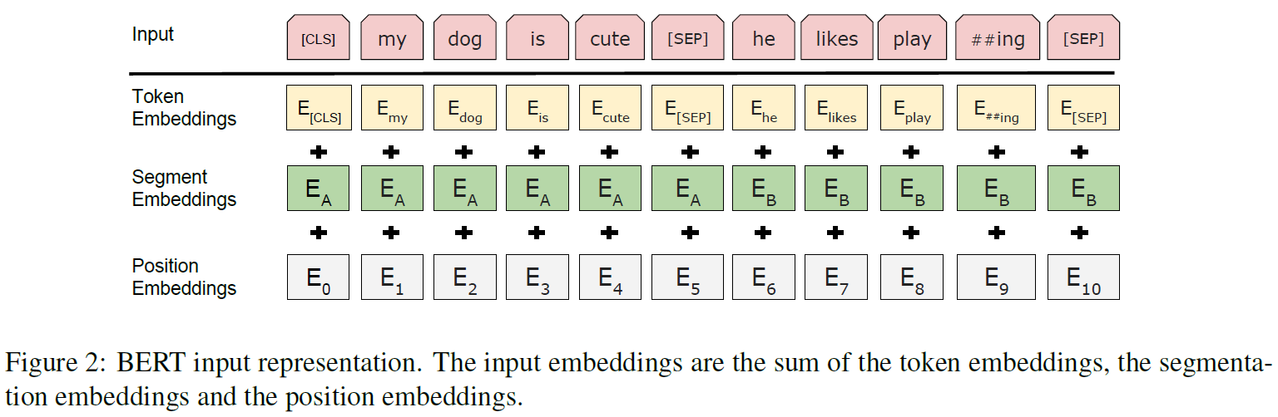

- Fine-tuning BERT for different tasks — demonstrates how minimal task-specific layers are added for classification, QA, or sequence labelling:
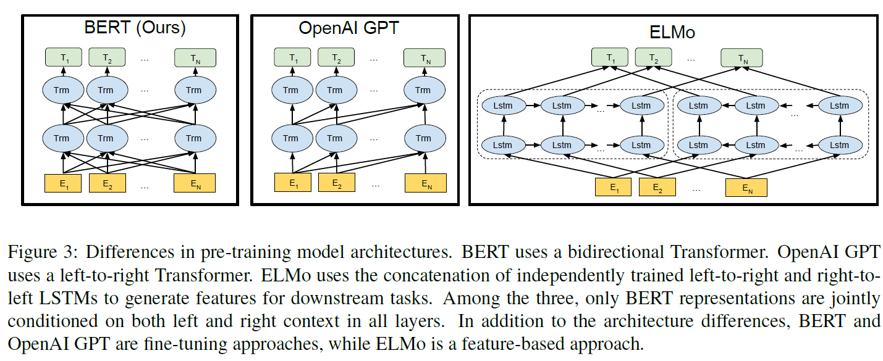

- Results on GLUE benchmark — compares BERT against prior models:
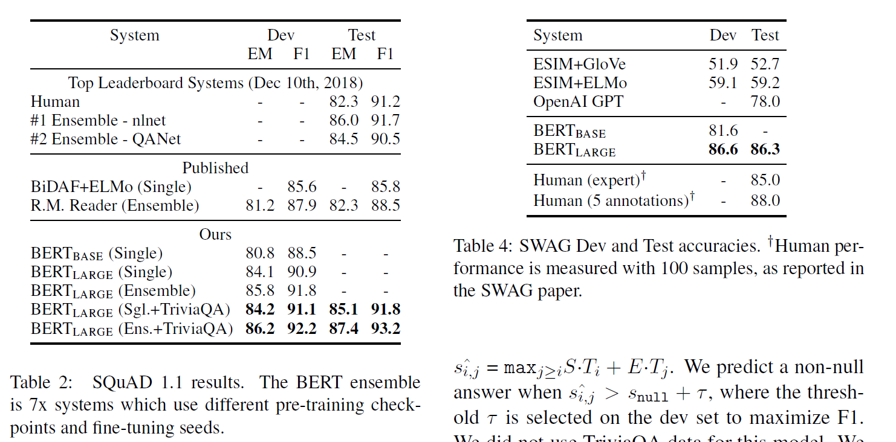

- Results on SQuAD v1.1 — shows BERT achieving F1 > 90:
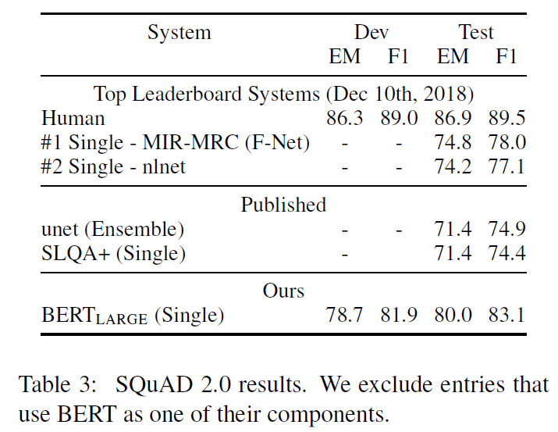

- Results on SQuAD v2.0 — shows BERT’s performance on unanswerable questions:

Source- Devlin, J., Chang, M.-W., Lee, K. and Toutanova, K. (2019). BERT: Pre-training of Deep Bidirectional Transformers for Language Understanding. In: 2019 Conference of the North American Chapter of the Association for Computational Linguistics: Human Language Technologies (NAACL HLT 2019). June 2019, pp. 4171–4186
  - CAL:
- Recall achieved by CAL vs SAL vs manual review across topics:
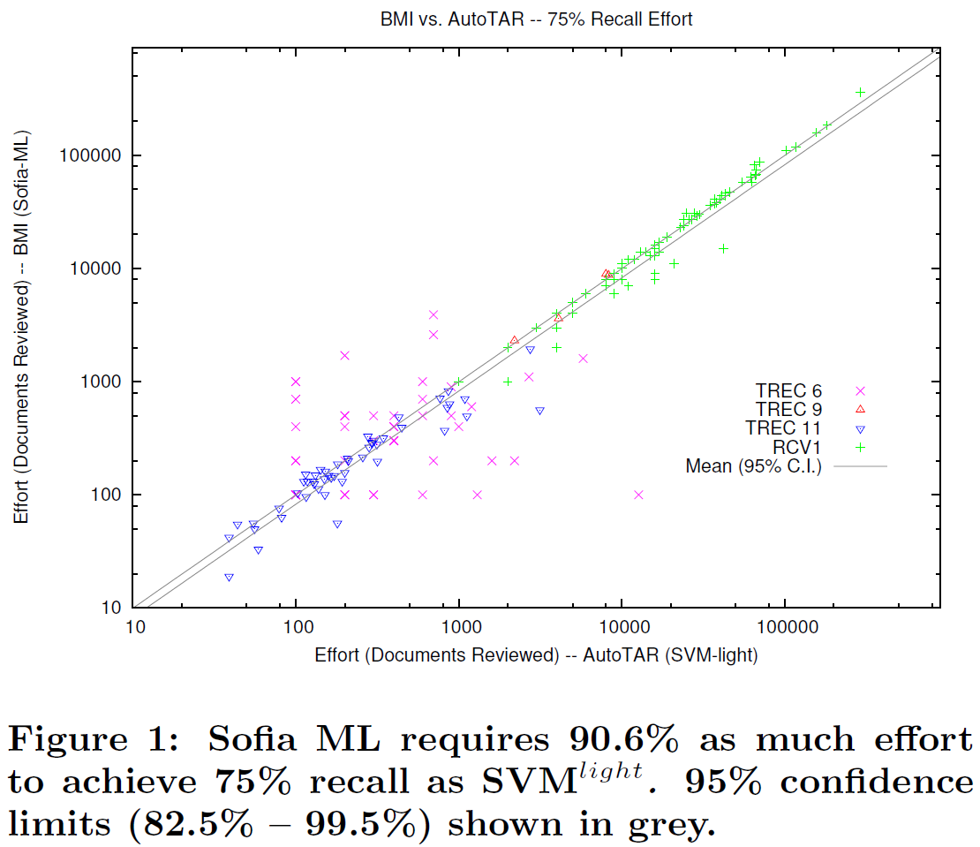
- Scalability of S‑CAL — effort vs collection size (logarithmic growth):
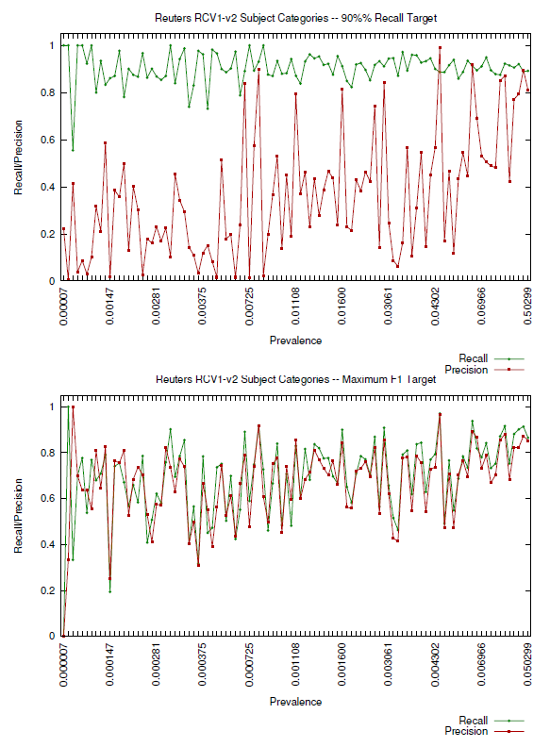
- Effort required for CAL and S‑CAL to achieve 75% recall:
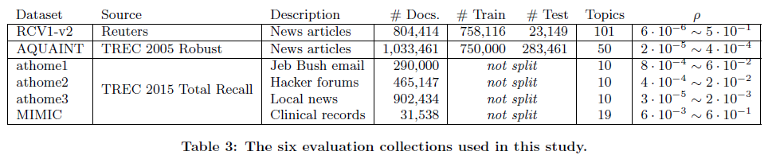
- Effort required for CAL and S‑CAL to achieve 95% recall:
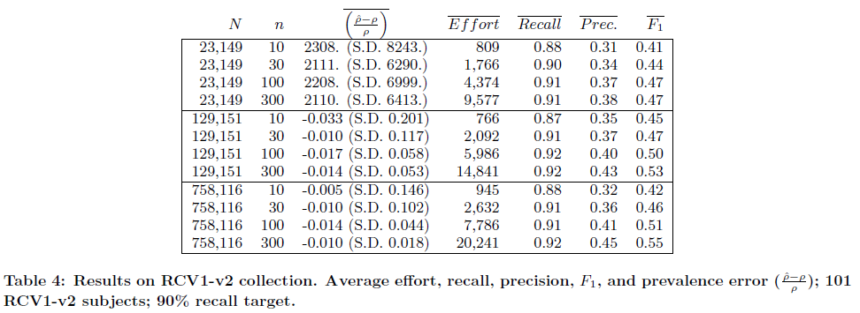
Source: Cormack, G.V. and Grossman, M.R. (2016). Scalability of Continuous Active Learning for Reliable High-Recall Text Classification. In: Proceedings of the 25th ACM International on Conference on Information and Knowledge Management. [Online]. 24 October 2016, Indianapolis Indiana USA: ACM, pp. 1039–1048. Available from: https://dl.acm.org/doi/10.1145/2983323.2983776. [Accessed: 6 December 2025]

